Date :  15-Mar-24

GOTO MeETING Data adapter version: 1.0.1

# **Overview**

## The GoToMeeting data adapter provides seamless integration of GoToMeeting provisioning and meeting management into your application, so that you can perform operations like create, update, start or delete a meeting from within your application.

## **A. Use case**

Consider a case that you want to embed the schedule meetings feature in the field services mobile app. The feature enables collaboration among the field service employees and their superiors to provide effective services to customers. You can use the GoToMeeting data adapter that helps create, update, and delete meetings. To design and develop the app, do the following:

1. Design and develop the user interface and functionality of the mobile app using Volt MX Iris.
2. Import the GoToMeeting data adapter into Volt MX Foundry and create an integration service to connect to the GoToMeeting.
3. Create operations with required APIs to fetch or set required details.
4. Integrate the mobile app with the integration service and invoke the operations to execute as required.

## **B. Percentage of re-use:**

80% (Data can be customizable and customer need to implement UI by themselves).

# **Getting Started**

## **Prerequisites**

Before you start using the GoToMeeting data adapter, ensure you have the following:

* [HCL Foundry](https://manage.hclvoltmx.com/)
* Volt MX Iris

## **Platforms Supported**

#### Mobile

##### iOS

##### Android

#### Tablets

#### PWA

## **Importing the adapter**

**To import the Data Adapter to Volt Foundry, do the following:**

1. Sign in to the  [HCL Foundry](https://manage.hclvoltmx.com/).
2. From the left navigation menu, select API Management.
3. In API Management, select Custom Data Adapters.

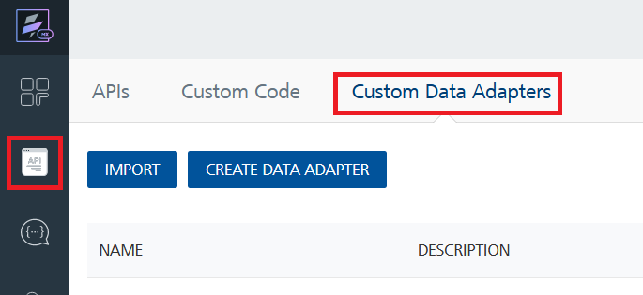

1. Click **IMPORT** to import a custom data adapter.  
   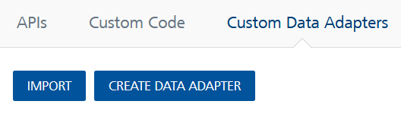
2. On the Import Data Adapter dialog box, click browser to import.  
   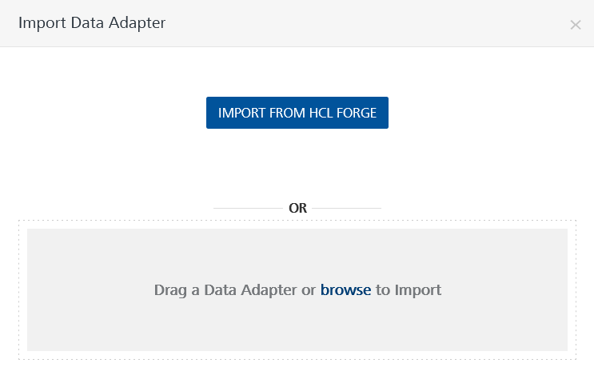
3. Selected GoToMeeting data adapter zip file and click **IMPORT**.

After importing the data adapter, Volt Foundry opens a window that shows the metadata of the data adapter.



After you import the data adapter, you can view it on the Custom Data Adapters page and use it to create services on Volt Foundry.

After you add the data adapter to your Volt Foundry app. You can refer to below section for more information.

**Follow the given steps in GoTo Meeting official website.**

1. Go to [GOTO Meeting](https://www.goto.com/meeting/trial)

2.Create an Account for GOTO Meeting and click on “**Start My Trail**” Button

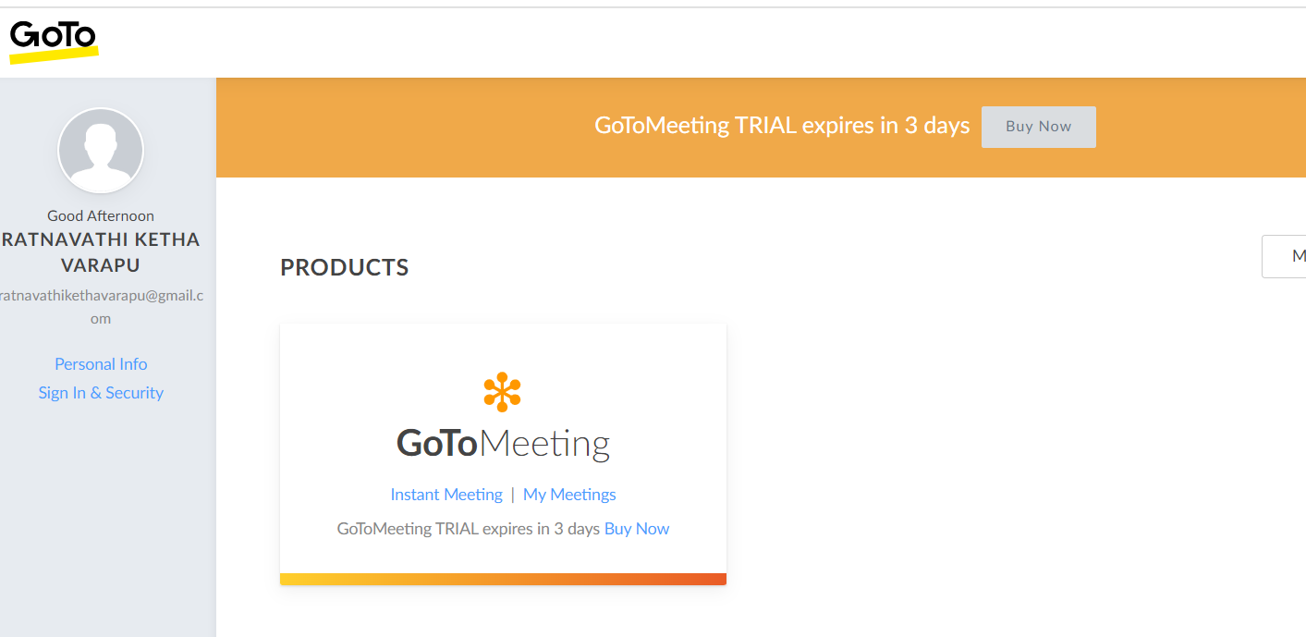

3. After creating an account, you can see a product called Goto Meeting was added to your account.

**i. Creating an Identity service.**

After you import the data adapter into Volt Foundry, you can use it to create an Identity Service. Select **OAuth 2.0 as** type of Identity**.**

[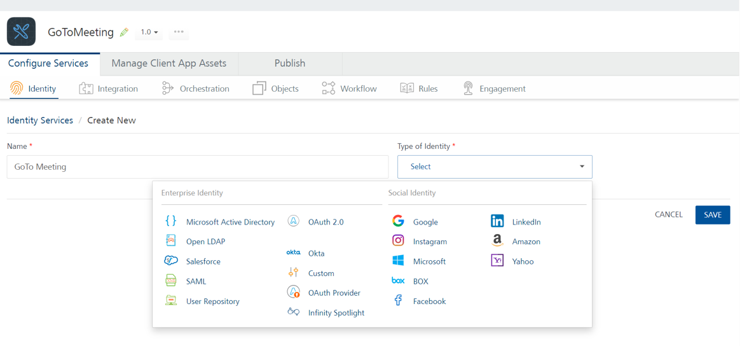](https://manage.hclvoltmx.com/)

1. Log on to your [VoltMX Foundry Account](https://manage.hclvoltmx.com" \t "_blank) . The Dashboard page appears by default.
2. In the left pane, click the API Management menu. The APIs tab opens by default.
3. Click the Identity tab. The Identity tab opens with a list of existing identity services.
4. Click CONFIGURE NEW. The Create New page appears.
5. In the Name box, type a unique name for your service.
6. From the Type of Identity list, select OAuth 2.0. The Provider Details and Client Details sections appears.
7. In the Grant Type box, by default, Authorization Code is selected.
8. In the Authorization Endpoint box, copy and paste <https://authentication.logmeininc.com/oauth/authorize> link.
9. In the Token Endpoint box, copy and paste the [https://authentication.logmeininc.com/oauth/token](https://authentication.logmeininc.com/oauth/token ) link.
10. Goto [GoTo Developer Center](https://developer.goto.com/GoToMeetingV1) and follow the steps to how to generate ClientID and client secret key.
11. In the Client ID box, type the consumer key issued by [GoToMeeting](https://developer.goto.com/GoToMeetingV1#section/GoTo-Meeting-API-Overview/Automate-and-Administer).
12. In the Client Secret box, type the consumer secret issued by [GoToMeeting.](https://developer.goto.com/GoToMeetingV1#section/GoTo-Meeting-API-Overview/Automate-and-Administer)
13. Click Test Login. The Identity Response dialog appears with a response like as shown in the following figure:

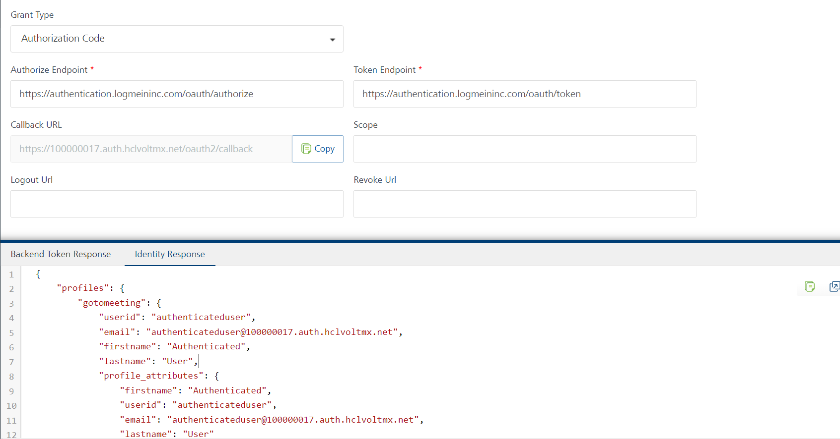

**[Open](javascript:void(0);)****ii.** [**Creating an Integration service**](javascript:void(0);)

After Creating Identity service Volt Foundry, you can use it to create an Integration Service.

Follow the given steps to create an Integration service using the GoToMeeting Data Adapter.

1. Sign in to the [HCL Foundry](https://manage.hclvoltmx.com/).
2. From the left navigation menu, select API Management.
3. In API Management, select Integration.

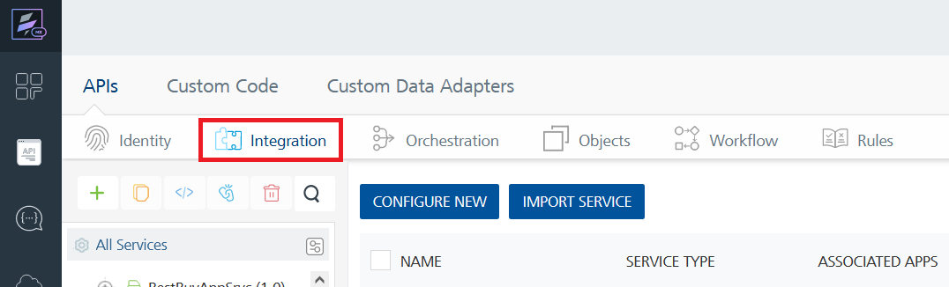

1. To create a new service, click the **+** button or the **CONFIGURE NEW** button.

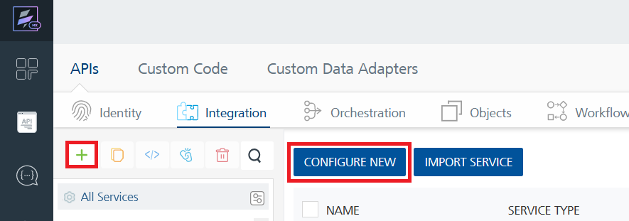

1. On the Service Definition tab, select the service type as GoTo Meeting, and click **SAVE**.

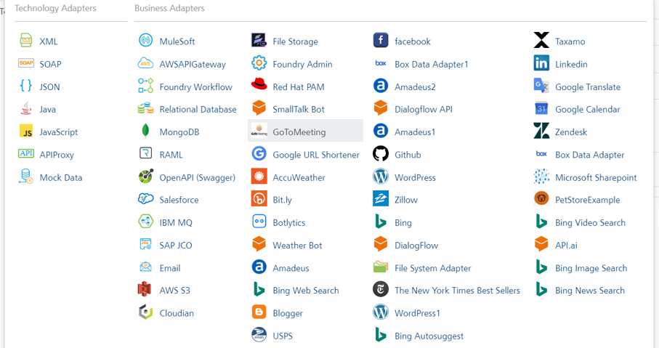

**[Open](javascript:void(0);)****[Creating and Executing operations](javascript:void(0);)**

After you create an integration service, you can create and execute operations using the service.

#### **Creating an operation**

1. In **API Management**, in the **Integration** section, select the service that you created.
2. After you select the service, navigate to the **Operation List** tab.  
   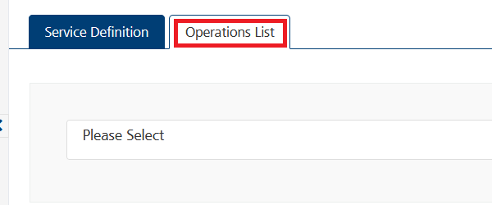
3. From the drop down list, select an operation that you want to execute, and click **ADD OPERATION**.  
   A screenshot of a computer

   Description automatically generated

In the Integrations tab, From the Service Definition page, give the Host URL and Base Path and Scheme as shown below.

1. From the **Operations List** tab, in the **Configured Operations** section, select the operation you want to execute.

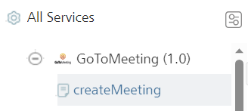

1. On the Operation Page, in the Request Input tab, enter a TEST VALUE for all the fields.

Sample output response for create meeting operation.

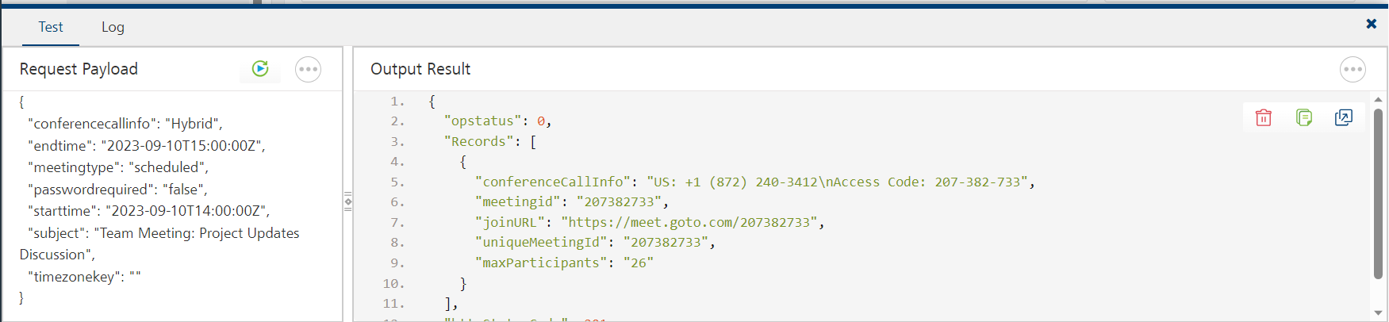

**[Open](javascript:void(0);)****2.** [**Publishing your application**](javascript:void(0);)

If you want to use the services in client applications, you need to publish the app to a run-time environment.

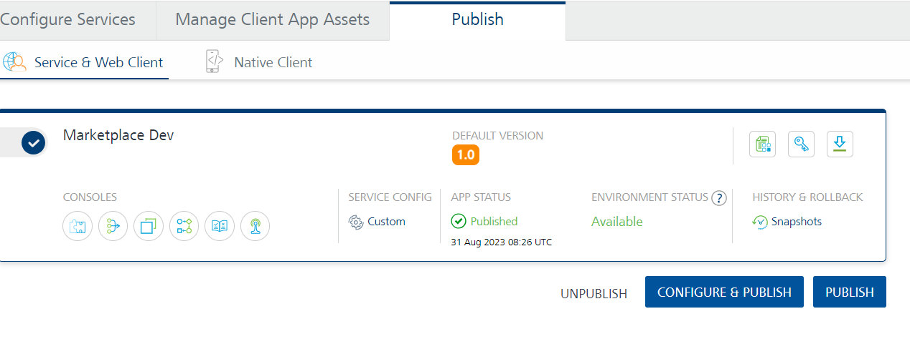

# **References**

## **Dynamic Usage**

You need to configure the Request Input variables on Volt Foundry based on the operation you want to perform. You can refer to the following drop-down sections for sample requests and responses for the operations.

**i. CreateMeeting**

#### Description:

You can use this operation to get a desired response.

#### Request Input Variables:

|  |  |  |
| --- | --- | --- |
| **Variable Name** | **Required/Optional** | **Description & Allowed Values** |
| conferencecallinfo | Required | A required string. Can be one of the following options: PSTN (PSTN only), Free (PSTN and VoIP), Hybrid, (PSTN and VoIP), Private (you provide numbers and access code), or VoIP (VoIP only). You may also enter plain text for numbers and access codes with a limit of 255 characters |
| endtime | Required | The ending time of the meeting. Required ISO8601 UTC string, e.g. 2023-09-21T23:00:00Z |
| starttime | Required | The starting time of the meeting. Required ISO8601 UTC string, e.g. 2023-09-T22:00:00Z |
| meetingtype | Required | string (MeetingType)  Enum: "immediate" "recurring" "scheduled" |
| passwordrequired | Required | Indicates whether a password is required to join the meeting. Required parameter |
| subject | Required | The subject of the meeting. 100 characters maximum. The characters '>' and '<' have to be replaced with the corresponding html character code (> for '>' and < for '<') |
| timezonekey | Required | DEPRECATED. Must be provided and set to empty string '' |

#### **Sample Request**

{

"conferencecallinfo": "Hybrid",

"endtime": "2023-09-13T15:00:00Z",

"meetingtype": "scheduled",

"passwordrequired": "false",

"starttime": "2023-09-13T13:00:00Z",

"subject": "Team Meeting: Project Updates Discussion",

"timezonekey": ""

}

#### **Sample Response**

1. {
2. "opstatus": 0,
3. "Records": [
4. {
5. "conferenceCallInfo": "US: +1 (872) 240-3212\nAccess Code: 642-902-285",
6. "meetingid": "642902285",
7. "joinURL": "https://meet.goto.com/642902285",
8. "uniqueMeetingId": "642902285",
9. "maxParticipants": "26"
10. }
11. ],
12. "httpStatusCode": 201
13. }

## **Properties**

-- None of the properties are exposed.

## **Events**

-- None of the events are exposed.

## **API’s**

-- None of the APIs are exposed.

# **Revision History**

App version 1.0.1

## **Known Issues**

None

## **Limitations**

It has a participant limit of up to 250 people, which might be insufficient for large-scale events. Additionally, the free version caps meetings at 40 minutes, which can be restrictive for lengthy discussions. Limited customization options are available, making it less versatile for branding or unique user experiences. It lacks some advanced features like breakout rooms, webinar capabilities, and integrations compared to more comprehensive platforms.