Date: 09-Jan-25

Google Translate

VERSION: 1.0.1

- OVERVIEW
Google Translate is a language translation service that supports over a hundred languages. The Google Translate data adapter integrates the Cloud Translate APIs with VoltMX Foundry. Under the hood, the data adapter uses Integration Services to make API calls to the Google Console.

Use case
A Google Translate use case involves leveraging its powerful translation capabilities to facilitate communication, enhance accessibility, or automate workflows requiring multilingual support.

Percentage of re-use:
70% (Data can be customizable and customers need to implement UI by themselves).

- GETTING STARTED

Prerequisites
Before you start using the Google Translate data adapter, ensure you have the following:

- HCL Foundry
- Volt MX Iris
- Google account.

Platforms Supported
    - Mobile
      - iOS
      - Android

Importing the adapter
To import the Data Adapter to Volt Foundry, do the following:
- Sign in to the HCL Foundry.
- From the left navigation menu, select API Management.
- In API Management, select Custom Data Adapters.
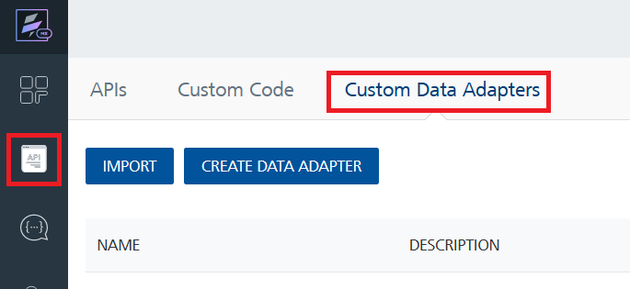
- Click IMPORT to import a custom data adapter.
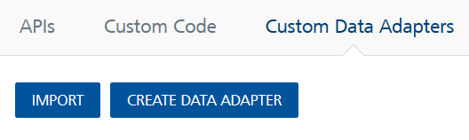
- On the Import Data Adapter dialog box, click browser to import.
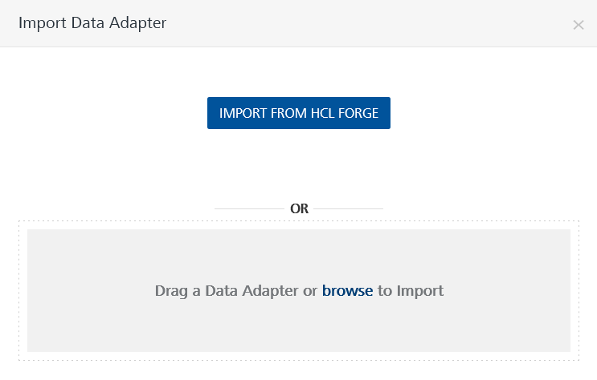
- Selected Google Translate data adapter zip file and click IMPORT.
After you import the data adapter, Volt Foundry opens a window that shows the metadata of the data adapter.
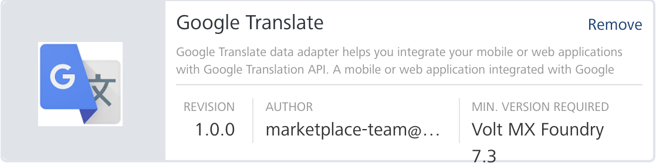
After you import the data adapter, you can view it on the Custom Data Adapters page and use it to create services on Volt Foundry.

Creating an Integration service
After you import the data adapter into Volt Foundry, you can use it to create an Integration Service.
Follow the given steps to create an Integration service using the Google Translate Data Adapter.
- Sign in to the HCL Foundry.
- From the left navigation menu, select API Management.
- In API Management, select Integration.
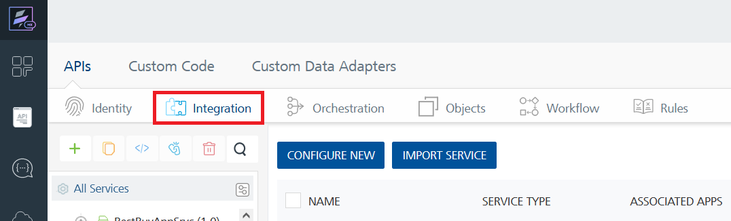
- To create a new service, click the + button or the CONFIGURE NEW button.
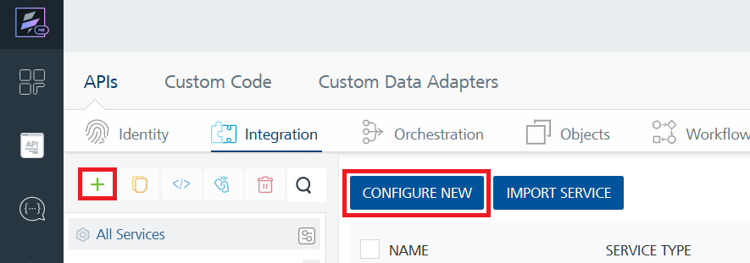
- On the Service Definition tab, select the service type as Google translate, and click SAVE.
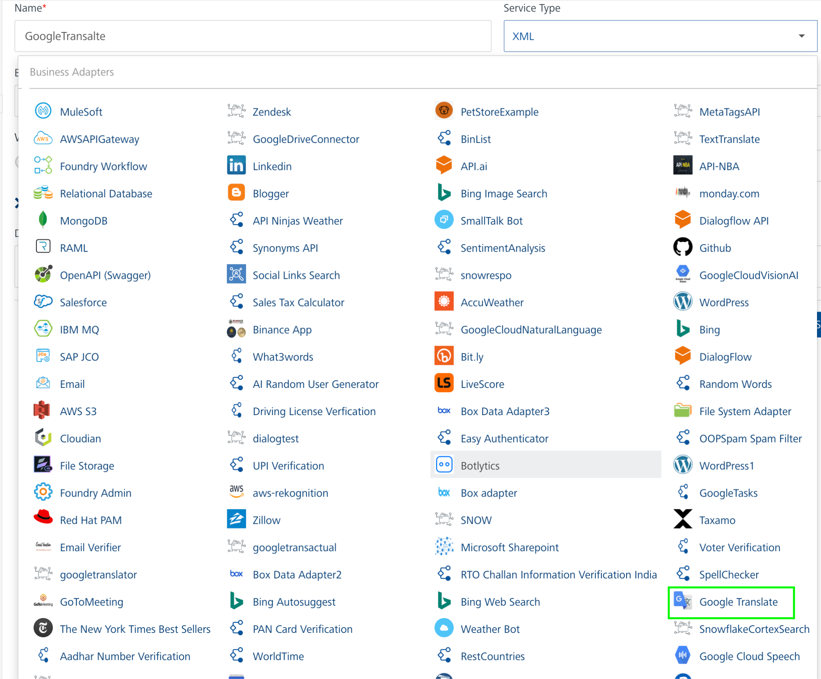

Executing an operation
After you create an integration service, you can create and execute operations using the service.
- In API Management, in the Integration section, select the service that you created.
- After you select the service, navigate to the Operation List tab.
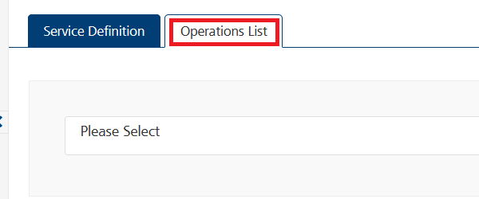
- From the drop down list, select an operation that you want to execute, and click ADD OPERATION.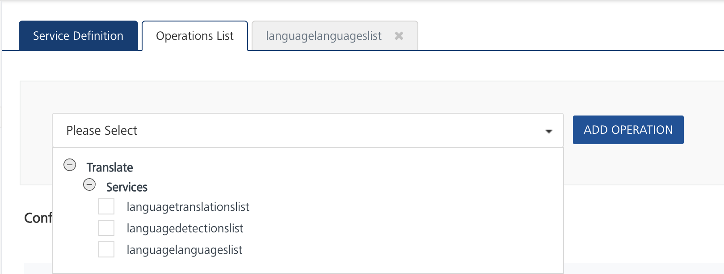
- From the Operations List tab, in the Configured Operations section, select the operation you want to execute.
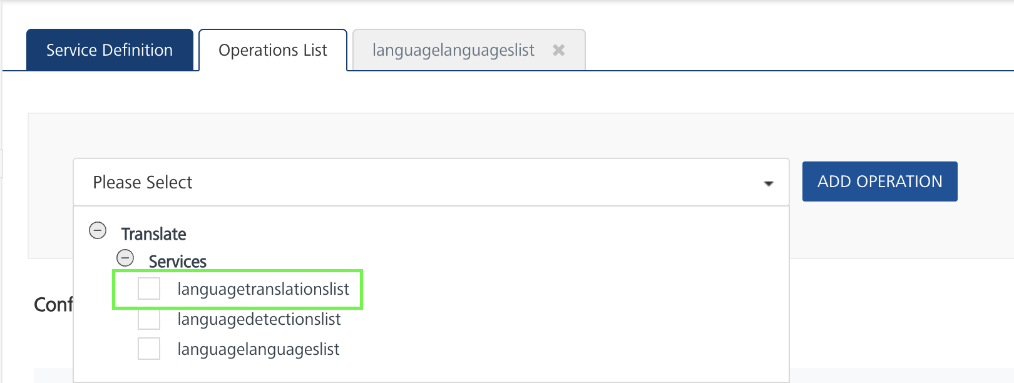
- On the Operation Page, in the Request Input tab, enter a TEST VALUE for all the fields.
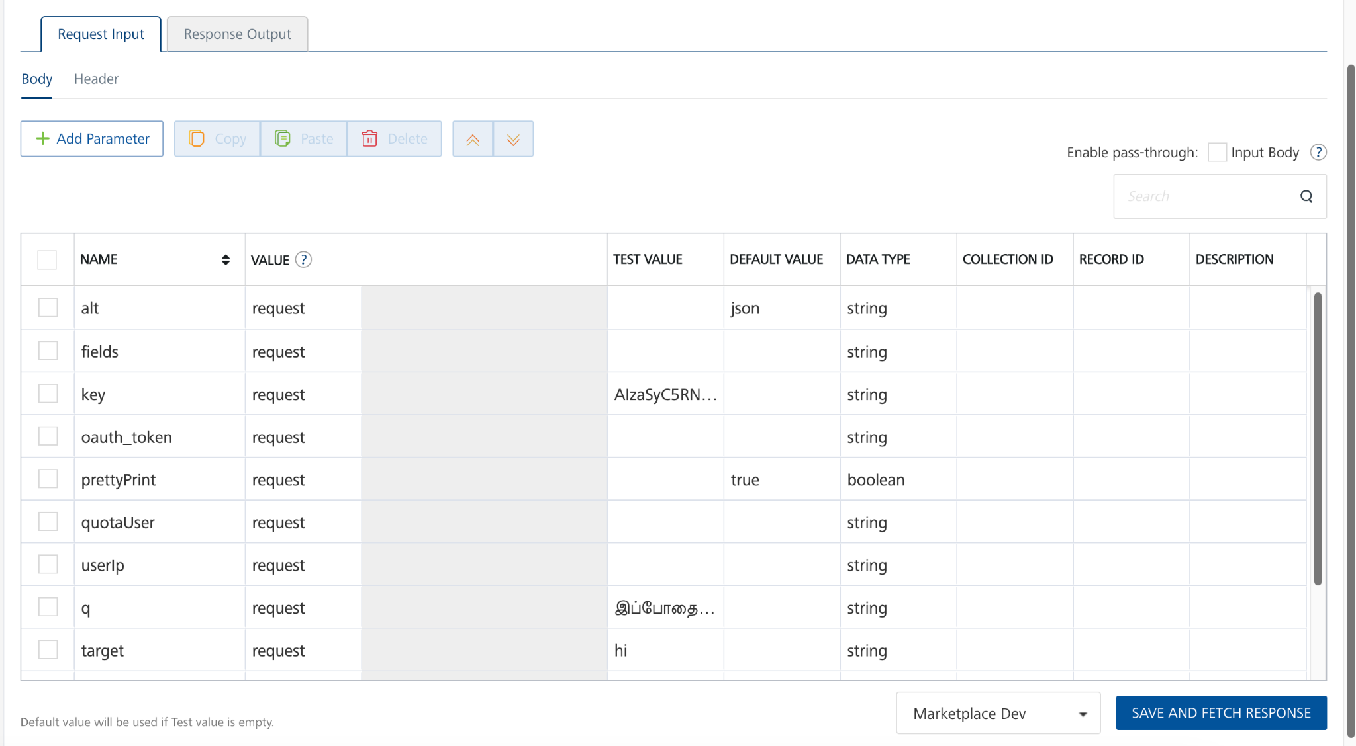
- key:Specifies the Translate API key that you obtained from Google.
- q: Specifies the text that you want to translate.
- target: Specifies the code of the target language. The code must be in the ISO-639-1 format.
For more information about language codes, refer to Language Support in the Google Cloud documentation.

Note:
- The operations use APIs from Google Translate. For more information on the APIs, refer to Cloud Translation API in the Google Cloud documentation.
- You can use the Integration Service and the operations in your VoltMX Foundry applications. For more information, you can refer to How to Use an Existing Integration Service in the VoltMX Foundry User Guide.
- Select a run-time environment and click Save and Fetch Response to get a response from Google Translate based on your inputs.
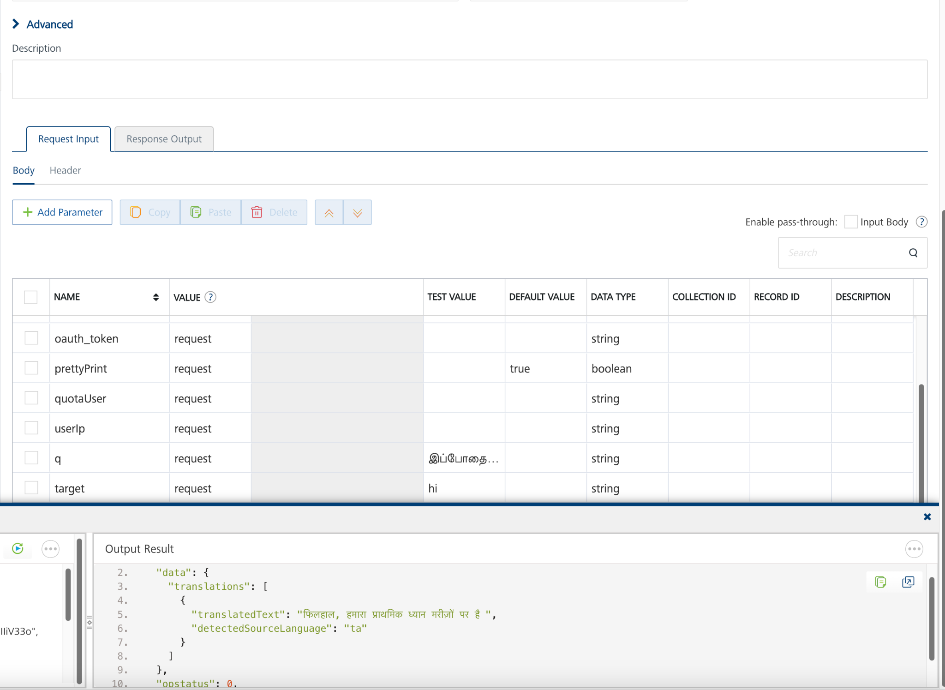

Publishing your application
If you want to use the services in client applications, you need to publish the app to a run-time environment.
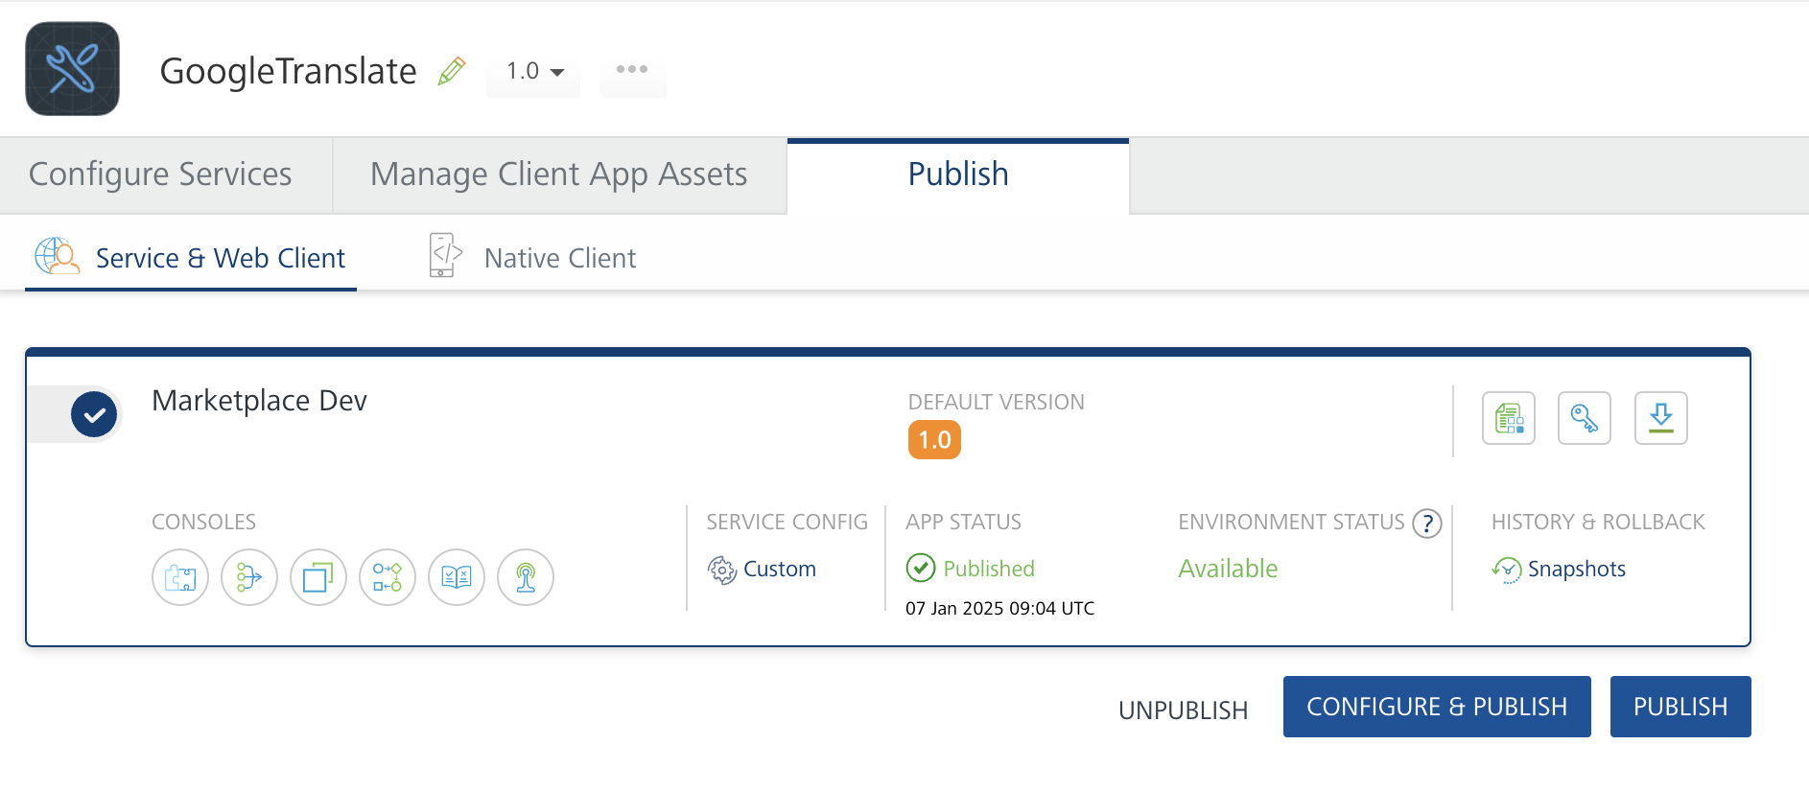
You can also link the Volt Foundry app to a client application.

REFERENCES

Properties

-- None of the properties are exposed.

Events
-- None of the events are exposed.

API’s
-- None of the APIs are exposed.

D. REVISION HISTORY

Adapter version 1.0.1

Known Issues
None

Limitations
None

