Date: 04-05-2025

GOOGLE TIME ZONE API
version: 1.0.0

OVERVIEW
The Time Zone API is a service that accepts an HTTP request of latitude/longitude coordinates and a chosen date and time. It returns the time zone data for the location, including offsets for UTC and daylight savings time.

Why use the Time Zone API

With the Time Zone API, we can develop applications that provide the time zone ID and name for dates and times at specific locations on a map. For example, you can show the following time zone data:

• Localized time zone names for map locations from the Google Maps Platform.

• Time zone offsets from UTC and for daylight savings.

Time zone data can be particularly useful when you want to have your website or app displaying time-based data relevant to your users.

Features:
- timezone: With the Time Zone API, you can request the time zone for locations on the surface of the earth, with the time offset from UTC and for daylight savings time for each of those locations.

Percentage of re-use:
Approximately (80-90) % of reuse.

GETTING STARTED

Prerequisites

Before you start using the Google Time Zone API App, ensure the following:
- HCL Foundry
- Volt MX Iris

Generating google time zone API key

- Log on to the https://console.cloud.google.com/ and create a new
project or select an existing project.

- In the Navigation Menu (☰):

    - Go to "APIs & Services" > "Library".
    - In the search bar, type “Time Zone API”.
    - Click on Time Zone API, then click "Enable".

- After enabling the API, go to “APIs & Services” > “Credentials” then choose API key.

- A dialog box will appear showing your newly created API key and Click Close.

- You will now see your new API key listed under API keys on the same page.

Importing the Data Adapter

You can import Google Time Zone API Data Adapter into HCL Foundry directly from the VoltMX website or by importing the data adapter zip file.

To import the Data Adapter to Volt Foundry, do the following:
- Sign in to the HCL Foundry.
- From the left navigation menu, select API Management.
- In API Management, select Custom Data Adapters.
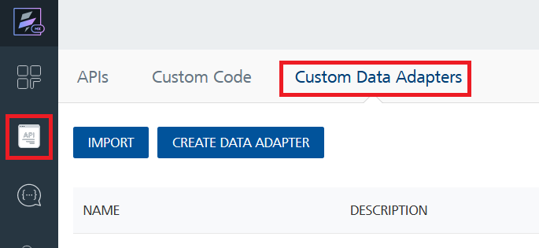
- Click IMPORT to import a custom data adapter.
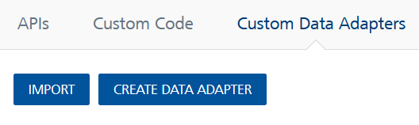

- On the Import Data Adapter dialog box, click browser to import.
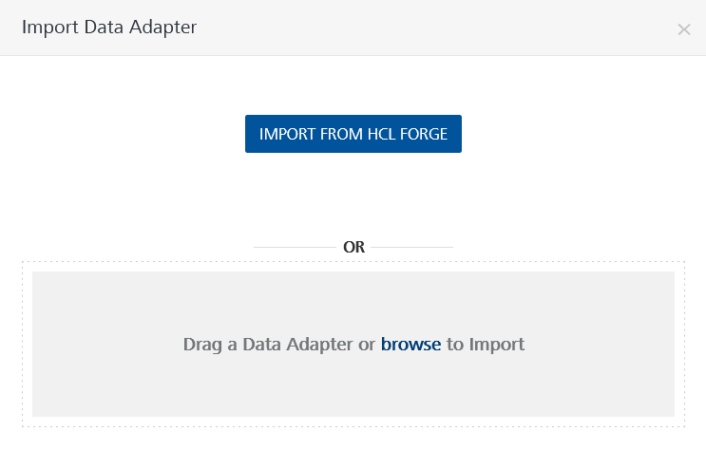
- Drag the data adapter zip file into the Drag a Data Adapter box.
Or
Click browse. The Open dialog appears.
Navigate to the location where you downloaded the data adapter (zip file) on your computer, select the data adapter, and click Open. The Import Data Adapter dialog shows the selected data adapter.
Note: Click Remove if the selected data adapter is not the one that you want to import.

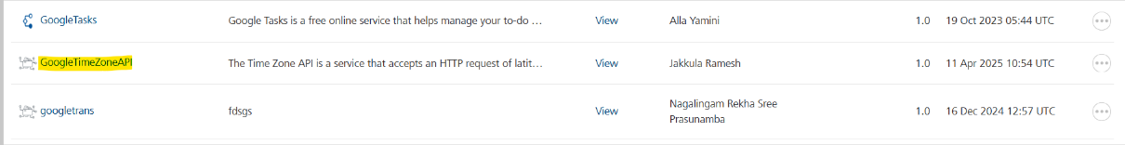

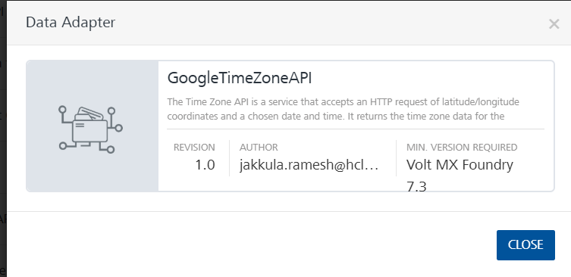
To import the data adapter zip file, do the following:
- Perform steps 1 through 4 in the above procedure
- Drag the data adapter zip file into the Drag a Data Adapter box.
Or
Click browse. The Open dialog appears.
Navigate to the location where you downloaded the data adapter (zip file) on your computer, select the data adapter, and click Open. The Import Data Adapter dialog shows the selected data adapter.

Note: Click Remove if the selected data adapter is not the one that you want to import.

Request Header:
Authorization: Use API key
x-goog-user-project: The project ID can be obtained from the Google Cloud project that was created.
Link: https://console.cloud.google.com/home/dashboard
Select a project:
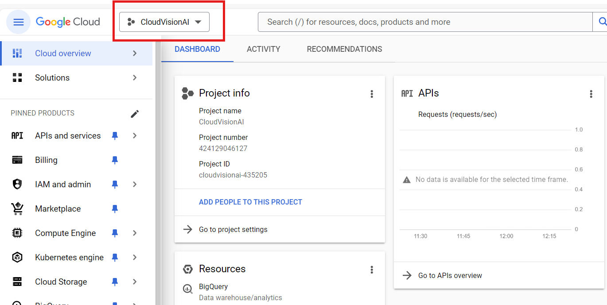

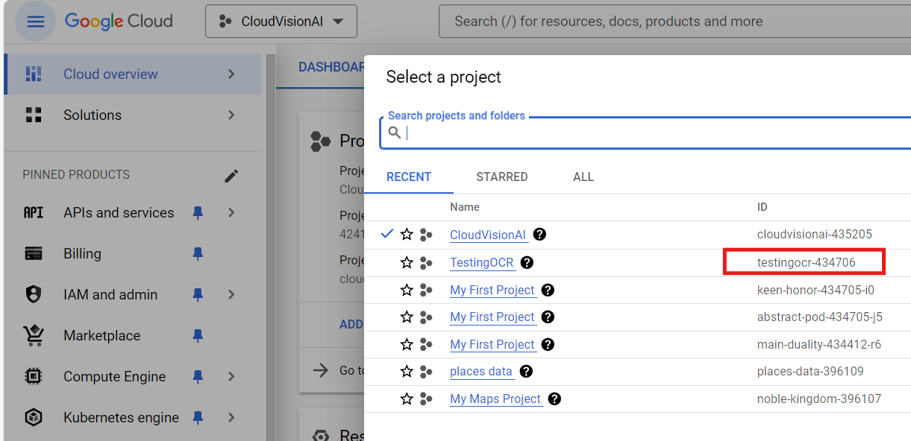

Creating an Integration Service with Google Time Zone API
After you import Google Time Zone API Data Adapter into Foundry, you must create an integration service with service type as GoogleTimeZoneAPI to connect with your GoogleTimeZone developer site.
To create an integration service with Google Time Zone API, do the following:
- Log on to your Foundry. The Dashboard page appears by default.
- In the left panel, click the API Management menu. The APIs tab opens by default.
- Click the Integration tab. The Integration tab opens with a list of existing integration services.
- Click CONFIGURE NEW. The Service Definition tab opens.
- In the Name box, type a unique name for your service.
- From the Service Type list, select GoogleTimeZoneAPI.
Note: The Google Time Zone API is listed only after you import the Google Time Zone API Data Adapter into Volt MX Foundry.
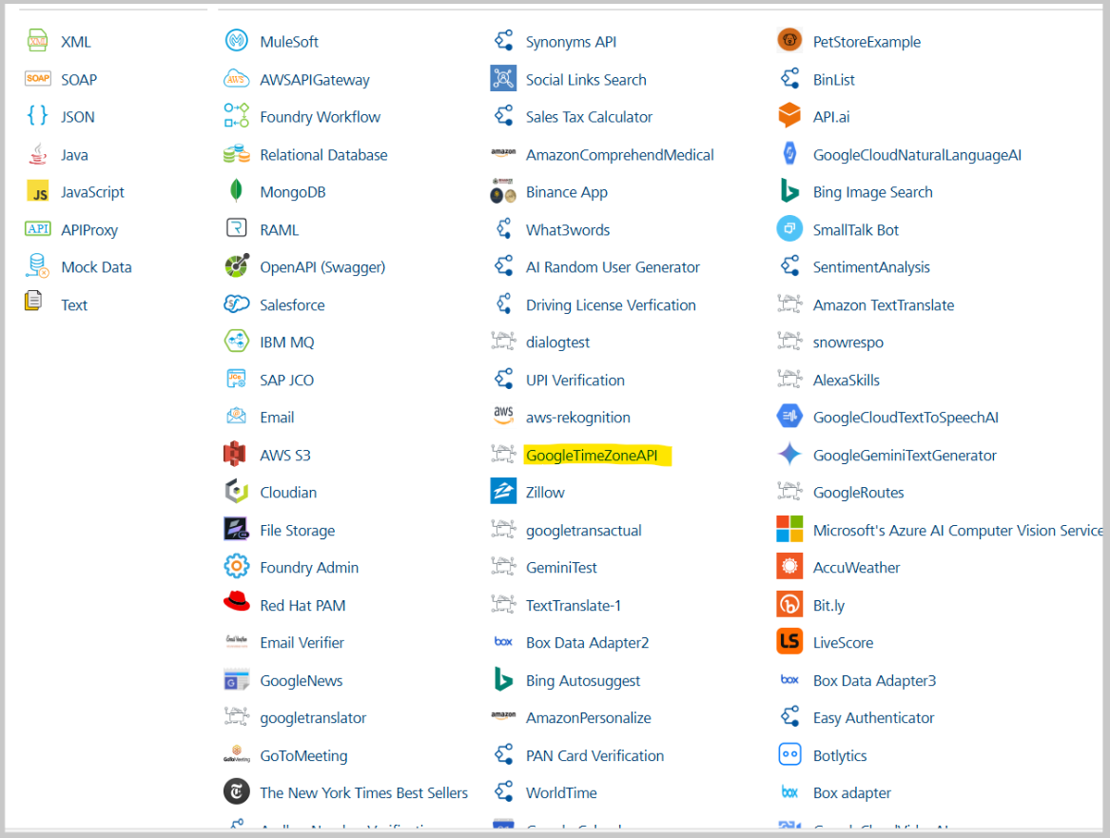

- Click Save.

If the details provided are valid, the Foundry service connects to your Google Time Zone API developer site and allows you to make the API calls.
Refer to Integration Services for more information on creating and using integration services.

- Creating an operation

To make any API call in the Foundry console, you must create an operation for the respective API and then execute the operation. Executing an operation involves making the API call and displaying the response. For more information, see Executing an operation.

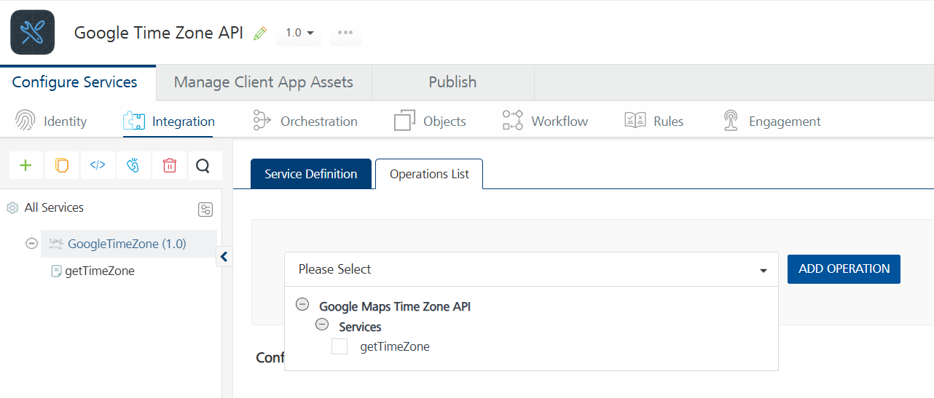

- Executing an operation

Under the Configured Operations section, click the operation. The Request Input sub-tab opened by default. Provide Body and Headers.

Enter the value of the API key as the default value created during the Generating google time zone API key.

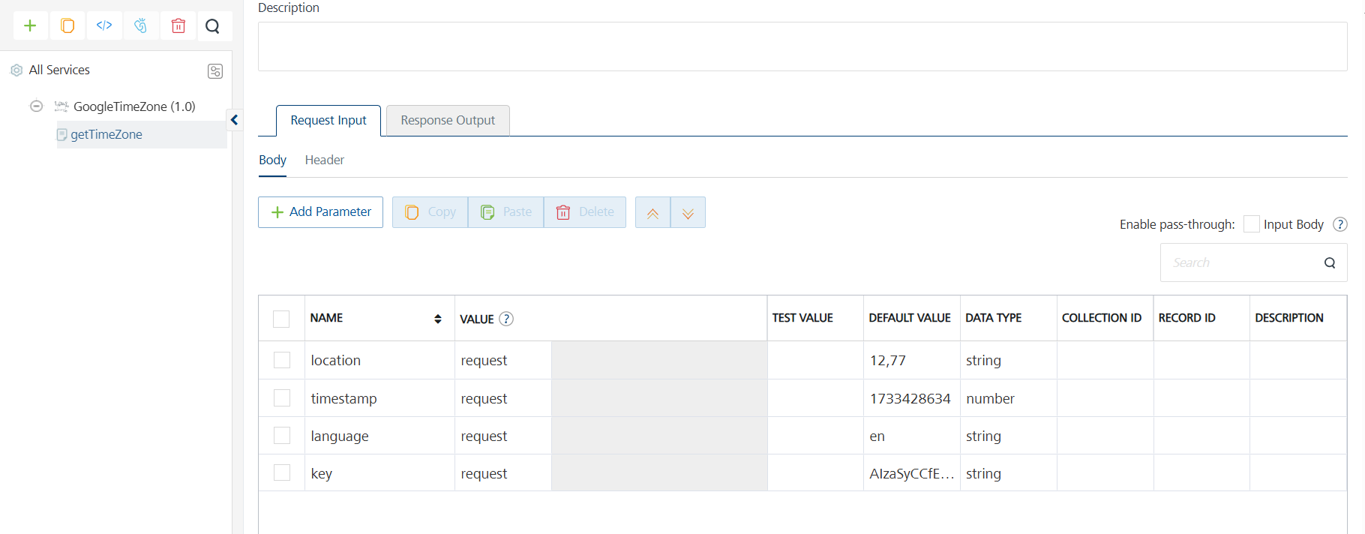

- Click SAVE AND FETCH RESPONSE. The Output Result dialog appears with the response. Otherwise, the Output Result shows an error.

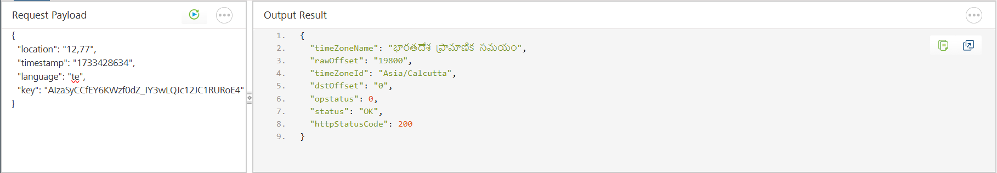

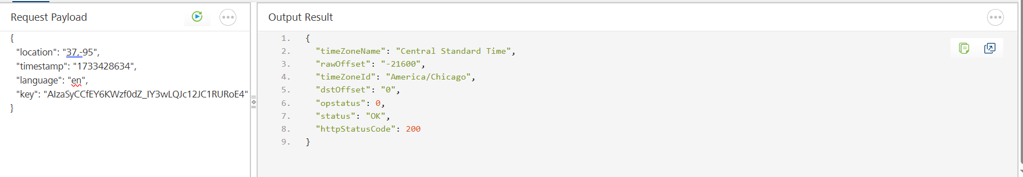

Publishing your application
If you want to use the services in client applications, you need to publish an app to a run-time environment. You can create the service (as described above) in an application or import the service into an application and publish the application.

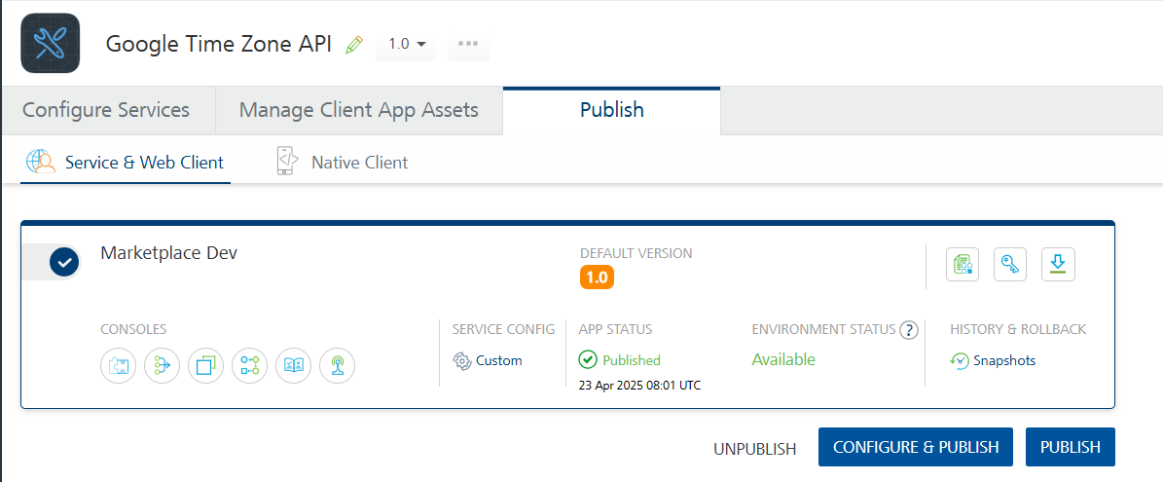

References

Endpoint Documentation
Time Zone API overview | Google for Developers

Revision History
App version 1.0.0:

Known Issues
- No Known Issues

Limitations
- No Limitations

