Date :  19-02-2024

**Google Tasks**

**VERSION: 1.0.0**

# **Overview**

Google tasks is a free online service that helps manage your to-do lists. You can access google tasks via your google account.

# **Getting Started**

# The following sections help you use the google tasks:

## **Prerequisites**

## Before you start using the Google Tasks, make sure that you have the following:

* [HCL Foundry](https://manage.hclvoltmx.com/)
* Volt MX Iris
* Domain: [www.google.com](https://mail.google.com/tasks/canvas)
* A Google account with the following:
  + OAuth Client ID
  + OAuth Client Secret

## **How to get credentials:**

1. When you create your application, you register it using the [Google API Console](https://console.developers.google.com/). Google then provides information you’ll need later, such as a client ID and a client secret.
2. Activate the Google Tasks API in the Google API Console. (If the API isn’t listed in the API Console, then skip this step)
3. When your application needs access to user data, it asks Google for a particular scope of access.
4. Google displays a consent screen to the user, asking them to authorize your application to request some of their data.
5. If the user approves, then Google gives your application a short-lived access token.

OR

## **Obtaining the Client ID and Client Secret**

To obtain the client ID and client secret from Google, you need to perform the following steps:

[Open](javascript:void(0);)**[Authorizing the Foundry Domain](javascript:void(0);)**

To use the Google APIs in a domain, you need to authorize the domain on the Google Developer Console.

* To authorize the Foundry cloud domain, follow these steps:

1. Sign in to the [Google Developer Console](https://console.developers.google.com/).
2. From the left pane, select **OAuth consent screen**.
3. Under **Authorized Domains**, in the text box, type **hclvoltmx.net**, and then press Enter.
4. Click **Save**.

* [Open](javascript:void(0);)[Obtaining the Callback URL](javascript:void(0);)

1. Sign in to the [HCL Foundry Console.](https://manage.hclvoltmx.com/)
2. Open or Edit the [Identity Service that you created](https://docs.kony.com/marketplace/V8Marketplace/Content/Marketplace/googlecalendar.htm#Creating_Identity) earlier.
3. Under **Provider Details**, for the **Callback URL**, click **Copy**.  
   A screenshot of a computer

   Description automatically generated

* [Open](javascript:void(0);)[Adding a Redirect URL on Google](javascript:void(0);)

1. Sign in to the [Google Developer Console](https://console.developers.google.com/).
2. From the left pane, select **Credentials**.
3. On the **Credentials** page, click **Create credentials**, and then select **OAuth client ID**.
4. Under **Application** type, select **Web application**.
5. Under **Authorized redirect URIs**, in the text box, type the **Callback URL** that you Obtained from Volt Foundry.
6. Click **Create**.

* After you create the credentials, the Google Developer Console displays your **Client ID** and **Client Secret**.
* You need to add the Client ID and Client Secret to the [Identity Service that you created](https://docs.kony.com/marketplace/V8Marketplace/Content/Marketplace/googlecalendar.htm#Creating_Identity) earlier.

## **Importing the adapter**

**To import the Data Adapter to Volt Foundry, do the following:**

1. Sign in to the  [HCL Foundry](https://manage.hclvoltmx.com/).
2. From the left navigation menu, select **API Management**.
3. In **API Management**, select **Custom Data Adapters**.

1. Click **IMPORT** to import a custom data adapter.

1. On the Import Data Adapter dialog box, click browser to import.

1. Select Google Tasks zip file and click **IMPORT**.

After you import the data adapter, Volt Foundry opens a window that shows the metadata of the data adapter.

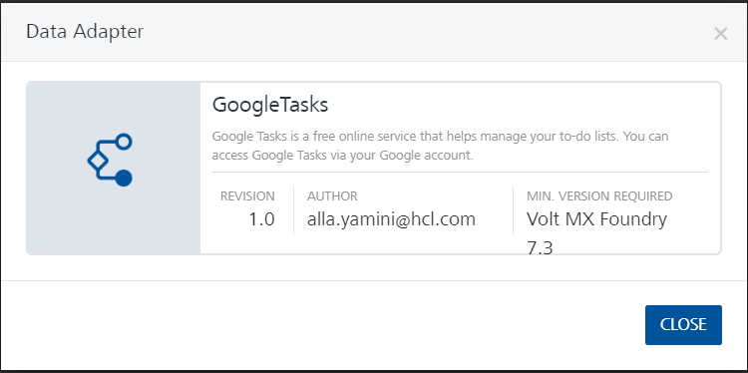

After you import the data adapter, you can view it on the Custom Data Adapters page and use it to create services on Volt Foundry.

## [**Creating an Identity service**](javascript:void(0);)

To use the Google Tasks APIs, you need to create an identity service that uses OAuth 2.0 for authentication.

To create an identity service, follow these steps:

1. Sign in to the [HCL Foundry](https://manage.hclvoltmx.com/).
2. On the left pane, click **API Management**.
3. Under **APIs**, on the **Identity** tab, click **CONFIGURE NEW**.
4. From the **Type of Identity** list, select **OAuth 2.0**.
5. In the **Authorize Endpoint** box, type this link:

https://accounts.google.com/o/oauth2/v2/auth

1. In the **Token Endpoint** box, type this link:

https://www.googleapis.com/oauth2/v4/token

1. In the **Scope** box, type either of the following links:

* <https://mail.google.com/>
* For **Read and Write** access to Tasks:

https://www.googleapis.com/auth/tasks

* For **Read only** access to Tasks:

https://www.googleapis.com/auth/tasks.readonly

1. Under **Client Details**, type the Client ID and Client Secret that you received from Google.

For information on obtaining the **Client Details**, refer to [Obtaining the Client ID and Client Secret](https://docs.kony.com/marketplace/V8Marketplace/Content/Marketplace/googlecalendar.htm#Obtaining)

**Note:**  
If you want to verify the details, click **TEST LOGIN** and sign in by using your Google credentials.

1. Click **SAVE**.

## [**Creating an Integration service**](javascript:void(0);)

After you import the data adapter into Volt Foundry, you can use it to create an Integration Service.

Follow the given steps to create an Integration service using the Google Tasks Adapter.

1. Sign in to the [HCL Foundry](https://manage.hclvoltmx.com/).
2. From the left navigation menu, select **API Management**.
3. In **API Management**, select **Integration**.  
   A screenshot of a computer

   Description automatically generated
4. To create a new service, click the **+** button or the **CONFIGURE NEW** button.  
   A screenshot of a computer

   Description automatically generated

## On the Service Definition tab, select the service type as Google Tasks and click **SAVE**.

Alternatively, you can also create a Foundry app and create an Integration service inside it.

[Open](javascript:void(0);)**E.** [**Creating and Executing operations**](javascript:void(0);)

After you create an integration service, you can create and execute operations using the service.

#### **Creating an Operation**

* In **API Management/Foundry app you created**, in the **Integration** section, select the service that you created.
* After you select the service, navigate to the **Operation List** tab.

## From the drop-down list, select an operation that you want to execute, and click **ADD OPERATION**.

## 

#### 2. **Executing an Operation**

## From the **Operations List** tab, in the **Configured Operations** section, select the operation you want to execute.

## On the Operation Page, in the Request Input tab, enter a TEST VALUE for all the fields.

* Select a run-time environment and click **Save and Fetch Response** to get a response based on your inputs.

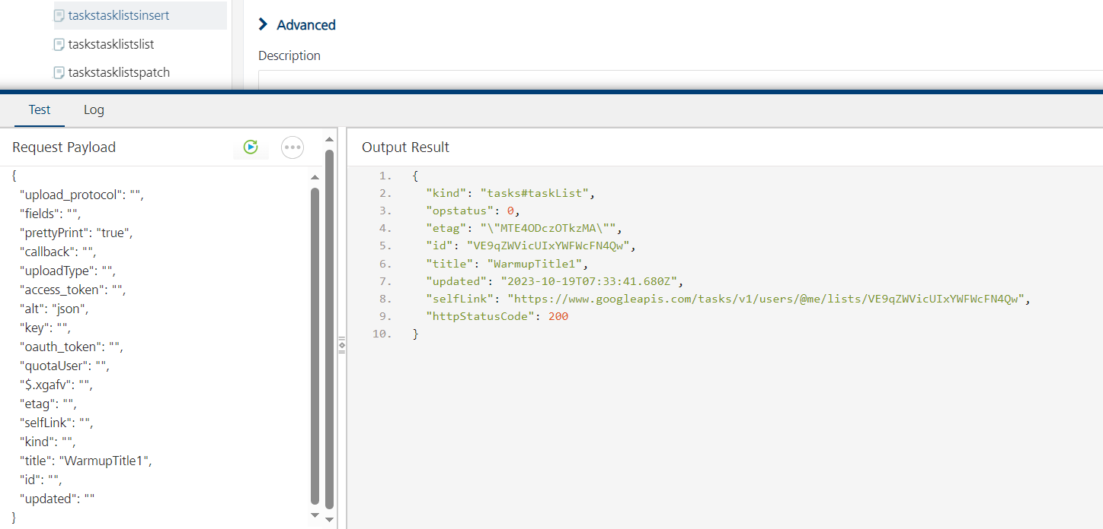

## **F.** [**Publishing your application**](javascript:void(0);)

If you want to use the services in client applications, you need to publish an app to a run-time environment. You can create the service (as described above) in an application or import the service into an application and publish the application.

# **References**

# [Google Tasks API | GOOGLE for Developers](https://developers.google.com/tasks/reference/rest)

## Endpoint Documentation

## **Service: tasks.googleapis.com**

To call this service, we recommend that you use the Google-provided [client libraries](https://cloud.google.com/apis/docs/client-libraries-explained). If your application needs to use your own libraries to call this service, use the following information when you make the API requests.

### Discovery document:

A [Discovery Document](https://developers.google.com/discovery/v1/reference/apis) is a machine-readable specification for describing and consuming REST APIs. It is used to build client libraries, IDE plugins, and other tools that interact with Google APIs. One service may provide multiple discovery documents. This service provides the following discovery document:

* <https://www.googleapis.com/discovery/v1/apis/tasks/v1/rest>

### Service endpoint:

A [service endpoint](https://cloud.google.com/apis/design/glossary#api_service_endpoint) is a base URL that specifies the network address of an API service. One service might have multiple service endpoints. This service has the following service endpoint and all URIs below are relative to this service endpoint:

* https://tasks.googleapis.com

## **REST Resource: [tasklists](https://developers.google.com/tasks/reference/rest/v1/tasklists)**

| **Methods** | |
| --- | --- |
| [delete](https://developers.google.com/tasks/reference/rest/v1/tasklists/delete) | DELETE /tasks/v1/users/@me/lists/{tasklist} Deletes the authenticated user's specified task list. |
| [get](https://developers.google.com/tasks/reference/rest/v1/tasklists/get) | GET /tasks/v1/users/@me/lists/{tasklist} Returns the authenticated user's specified task list. |
| [insert](https://developers.google.com/tasks/reference/rest/v1/tasklists/insert) | POST /tasks/v1/users/@me/lists Creates a new task list and adds it to the authenticated user's task lists. |
| [list](https://developers.google.com/tasks/reference/rest/v1/tasklists/list) | GET /tasks/v1/users/@me/lists Returns all the authenticated user's task lists. |
| [patch](https://developers.google.com/tasks/reference/rest/v1/tasklists/patch) | PATCH /tasks/v1/users/@me/lists/{tasklist} Updates the authenticated user's specified task list. |
| [update](https://developers.google.com/tasks/reference/rest/v1/tasklists/update) | PUT /tasks/v1/users/@me/lists/{tasklist} Updates the authenticated user's specified task list. |

## **Method: tasklistsinsert:**

Creates a new task list and adds it to the authenticated user’s task lists.

| **Field** | **Type** | **Description** |
| --- | --- | --- |
| updated | DatePicker | Last modification time of the task list (as a RFC 3339 timestamp). |
| selfLink | String | URL pointing to this task list. Used to retrieve, update, or delete this task list. |
| Title | String | Title of the task list. |
| Etag | String | ETag of the resource. |
| Id | String | Task list identifier. |
| Kind | Select | Type of the resource. |
| Fields | List | List of [fields.To](http://fields.to/" \t "_blank) display all fields, use \*. Examples: id |

## **Method: tasklistslist:**

Returns all the authenticated user’s task lists.

| **Field** | **Type** | **Description** |
| --- | --- | --- |
| accessToken | String | Access Token. Use getAccessToken to get it. |
| maxResults | Number | Maximum number of task lists returned on one page. Optional. The default is 100. |
| pageToken | String | Token specifying the result page to return. Optional. |
| Fields | List | List of [fields.To](http://fields.to/" \t "_blank) display all fields, use \*. Examples: id |

## **Method: tasklistsget:**

Returns the authenticated user’s specified task list.

| **Field** | **Type** | **Description** |
| --- | --- | --- |
| Tasklist | String | Task list identifier. |
| Fields | List | List of [fields.To](http://fields.to/" \t "_blank) display all fields, use \*. Examples: id |

## **Method: tasklistsupdate:**

Updates the authenticated user’s specified task list.

| **Field** | **Type** | **Description** |
| --- | --- | --- |
| updated | DatePicker | Last modification time of the task list (as a RFC 3339 timestamp). |
| selfLink | String | URL pointing to this task list. Used to retrieve, update, or delete this task list. |
| Title | String | Title of the task list. |
| Etag | String | ETag of the resource. |
| Id | String | Task list identifier. |
| Kind | Select | Type of the resource. |
| Fields | List | List of [fields.To](http://fields.to/" \t "_blank) display all fields, use \*. Examples: id |

## **Method: tasklistspatch:**

Updates the authenticated user’s specified task list. This method supports patch semantics.

| **Field** | **Type** | **Description** |
| --- | --- | --- |
| updated | DatePicker | Last modification time of the task list (as a RFC 3339 timestamp). |
| selfLink | String | URL pointing to this task list. Used to retrieve, update, or delete this task list. |
| Title | String | Title of the task list. |
| Etag | String | ETag of the resource. |
| Id | String | Task list identifier. |
| Kind | Select | Type of the resource. |
| Fields | List | List of [fields.To](http://fields.to/" \t "_blank) display all fields, use \*. Examples: id |

## **Method: tasklistsdelete:**

Deletes the authenticated user’s specified task list.

| **Field** | **Type** | **Description** |
| --- | --- | --- |
| Tasklist | String | Task list identifier. |

## **REST Resource:**[**tasks**](https://developers.google.com/tasks/reference/rest/v1/tasks)

| **Methods** | |
| --- | --- |
| [clear](https://developers.google.com/tasks/reference/rest/v1/tasks/clear) | POST /tasks/v1/lists/{tasklist}/clear Clears all completed tasks from the specified task list. |
| [delete](https://developers.google.com/tasks/reference/rest/v1/tasks/delete) | DELETE /tasks/v1/lists/{tasklist}/tasks/{task} Deletes the specified task from the task list. |
| [get](https://developers.google.com/tasks/reference/rest/v1/tasks/get) | GET /tasks/v1/lists/{tasklist}/tasks/{task} Returns the specified task. |
| [insert](https://developers.google.com/tasks/reference/rest/v1/tasks/insert) | POST /tasks/v1/lists/{tasklist}/tasks Creates a new task on the specified task list. |
| [list](https://developers.google.com/tasks/reference/rest/v1/tasks/list) | GET /tasks/v1/lists/{tasklist}/tasks Returns all tasks in the specified task list. |
| [move](https://developers.google.com/tasks/reference/rest/v1/tasks/move) | POST /tasks/v1/lists/{tasklist}/tasks/{task}/move Moves the specified task to another position in the task list. |
| [patch](https://developers.google.com/tasks/reference/rest/v1/tasks/patch) | PATCH /tasks/v1/lists/{tasklist}/tasks/{task} Updates the specified task. |
| [update](https://developers.google.com/tasks/reference/rest/v1/tasks/update) | PUT /tasks/v1/lists/{tasklist}/tasks/{task} Updates the specified task. |

* **Method: taskinsert**

Creates a new task on the specified task list.

| **Field** | **Type** | **Description** |
| --- | --- | --- |
| Links | Array | Collection of links. This collection is read-only. |
| Hidden | Select | Flag indicating whether the task is hidden. This is the case if the task had been marked completed when the task list was last cleared. The default is False. This field is read-only. |
| completed | Select | Flag indicating whether the task has been deleted. The default if False. |
| completed | DatePicker | Completion date of the task (as a RFC 3339 timestamp). This field is omitted if the task has not been completed. |
| Due | DatePicker | Due date of the task (as a RFC 3339 timestamp). Optional. |
| Status | Select | Status of the task. This is either needsAction or completed. |
| Notes | String | Notes describing the task. Optional. |
| tasklistId | String | Task list identifier. |
| Position | String | String indicating the position of the task among its sibling tasks under the same parent task or at the top level. If this string is greater than another task’s corresponding position string according to lexicographical ordering, the task is positioned after the other task under the same parent task (or at the top level). This field is read-only. Use the move method to move the task to another position. |
| Parent | String | Parent task identifier. This field is omitted if it is a top-level task. This field is read-only. Use the move method to move the task under a different parent or to the top level. |
| selfLink | String | URL pointing to this task. Used to retrieve, update, or delete this task. |
| updated | DatePicker | Last modification time of the task (as a RFC 3339 timestamp). |
| Title | String | Title of the task. |
| Etag | String | ETag of the resource. |
| Id | String | Task identifier. |
| Kind | Select | Type of the resource. |
| Parent | String | Parent task identifier. If the task is created at the top level, this parameter is omitted. Optional. |
| previous | String | Previous sibling task identifier. If the task is created at the first position among its siblings, this parameter is omitted. Optional. |
| Fields | List | List of [fields.To](http://fields.to/" \t "_blank) display all fields, use \*. Examples: id. |

* **Method: taskget**

Returns the specified task.

| **Field** | **Type** | **Description** |
| --- | --- | --- |
| tasklistId | String | Task list identifier. |
| taskId | String | Task list identifier. |
| Fields | List | List of [fields.To](http://fields.to/" \t "_blank) display all fields, use \*. Examples: id |

* **Method: tasklist**

Returns all tasks in the specified task list.

| **Field** | **Type** | **Description** |
| --- | --- | --- |
| Tasklist | String | Task list identifier. |
| updatedMin | DatePicker | Lower bound for a task’s last modification time (as a RFC 3339 timestamp) to filter by. Optional. The default is not to filter by last modification time. |
| showHidden | Select | Flag indicating whether hidden tasks are returned in the result. Optional. The default is False. |
| showDeleted | Select | Flag indicating whether deleted tasks are returned in the result. Optional. The default is False. |
| showCompleted | Select | Flag indicating whether completed tasks are returned in the result. Optional. The default is True. |
| pageToken | String | Token specifying the result page to return. Optional. |
| maxResults | Number | Maximum number of task lists returned on one page. Optional. The default is 100. |
| dueMin | DatePicker | Lower bound for a task’s due date (as a RFC 3339 timestamp) to filter by. Optional. The default is not to filter by due date. |
| dueMax | DatePicker | Upper bound for a task’s due date (as a RFC 3339 timestamp) to filter by. Optional. The default is not to filter by due date. |
| completedMax | DatePicker | Upper bound for a task’s completion date (as a RFC 3339 timestamp) to filter by. Optional. The default is not to filter by completion date. |
| completedMin | DatePicker | Lower bound for a task’s completion date (as a RFC 3339 timestamp) to filter by. Optional. The default is not to filter by completion date. |
| Fields | List | List of [fields.To](http://fields.to/" \t "_blank) display all fields, use \*. Examples: id |

* **Method: taskmove**

Moves the specified task to another position in the task list. This can include putting it as a child task under a new parent and/or move it to a different position among its sibling tasks.

| **Field** | **Type** | **Description** |
| --- | --- | --- |
| tasklistId | String | Task list identifier. |
| taskId | String | Task identifier. |
| Parent | String | New parent task identifier. If the task is moved to the top level, this parameter is omitted. Optional. |
| previous | String | New previous sibling task identifier. If the task is moved to the first position among its siblings, this parameter is omitted. Optional. |
| Fields | List | List of [fields.To](http://fields.to/" \t "_blank) display all fields, use \*. Examples: id |

* **Method: taskupdate**

Creates a new task on the specified task list.

| **Field** | **Type** | **Description** |
| --- | --- | --- |
| Links | Array | Collection of links. This collection is read-only. |
| Hidden | Select | Flag indicating whether the task is hidden. This is the case if the task had been marked completed when the task list was last cleared. The default is False. This field is read-only. |
| completed | Select | Flag indicating whether the task has been deleted. The default if False. |
| completed | DatePicker | Completion date of the task (as a RFC 3339 timestamp). This field is omitted if the task has not been completed. |
| Due | DatePicker | Due date of the task (as a RFC 3339 timestamp). Optional. |
| Status | Select | Status of the task. This is either needsAction or completed. |
| Notes | String | Notes describing the task. Optional. |
| tasklistId | String | Task list identifier. |
| Position | String | String indicating the position of the task among its sibling tasks under the same parent task or at the top level. If this string is greater than another task’s corresponding position string according to lexicographical ordering, the task is positioned after the other task under the same parent task (or at the top level). This field is read-only. Use the move method to move the task to another position. |
| Parent | String | Parent task identifier. This field is omitted if it is a top-level task. This field is read-only. Use the move method to move the task under a different parent or to the top level. |
| selfLink | String | URL pointing to this task. Used to retrieve, update, or delete this task. |
| updated | DatePicker | Last modification time of the task (as a RFC 3339 timestamp). |
| Title | String | Title of the task. |
| Etag | String | ETag of the resource. |
| Id | String | Task identifier. |
| Kind | Select | Type of the resource. |
| Parent | String | Parent task identifier. If the task is created at the top level, this parameter is omitted. Optional. |
| previous | String | Previous sibling task identifier. If the task is created at the first position among its siblings, this parameter is omitted. Optional. |
| Fields | List | List of [fields.To](http://fields.to/" \t "_blank) display all fields, use \*. Examples: id. |

* **Method: taskpatch**

Updates the specified task. This method supports patch semantics.

| **Field** | **Type** | **Description** |
| --- | --- | --- |
| Links | Array | Collection of links. This collection is read-only. |
| Hidden | Select | Flag indicating whether the task is hidden. This is the case if the task had been marked completed when the task list was last cleared. The default is False. This field is read-only. |
| completed | Select | Flag indicating whether the task has been deleted. The default if False. |
| completed | DatePicker | Completion date of the task (as a RFC 3339 timestamp). This field is omitted if the task has not been completed. |
| Due | DatePicker | Due date of the task (as a RFC 3339 timestamp). Optional. |
| Status | Select | Status of the task. This is either needsAction or completed. |
| Notes | String | Notes describing the task. Optional. |
| tasklistId | String | Task list identifier. |
| Position | String | String indicating the position of the task among its sibling tasks under the same parent task or at the top level. If this string is greater than another task’s corresponding position string according to lexicographical ordering, the task is positioned after the other task under the same parent task (or at the top level). This field is read-only. Use the move method to move the task to another position. |
| Parent | String | Parent task identifier. This field is omitted if it is a top-level task. This field is read-only. Use the move method to move the task under a different parent or to the top level. |
| selfLink | String | URL pointing to this task. Used to retrieve, update, or delete this task. |
| updated | DatePicker | Last modification time of the task (as a RFC 3339 timestamp). |
| Title | String | Title of the task. |
| Etag | String | ETag of the resource. |
| Id | String | Task identifier. |
| Kind | Select | Type of the resource. |
| Parent | String | Parent task identifier. If the task is created at the top level, this parameter is omitted. Optional. |
| previous | String | Previous sibling task identifier. If the task is created at the first position among its siblings, this parameter is omitted. Optional. |
| Fields | List | List of [fields.To](http://fields.to/" \t "_blank) display all fields, use \*. Examples: id. |

* **Method: taskdelete**

Deletes the specified task from the task list.

| **Field** | **Type** | **Description** |
| --- | --- | --- |
| tasklistId | String | Task list identifier. |
| taskId | String | Task list identifier. |

* **Method: taskclear**

Deletes the specified task from the task list.

| **Field** | **Type** | **Description** |
| --- | --- | --- |
| tasklistId | String | Task list identifier. |

# **Revision History**

Adapter version 1.0.0:

## Known Issues

-

## Limitations