Date :  18-Oct-23

Google Slides(1.0.0)

# Overview

Apps can integrate with the Google Slides API to create beautiful slide decks automatically from user- and system-provided data.

## Use case

## you could use customer details from a database and combine them with predesigned templates and selected configuration options to create finished presentations in a fraction of the time it would take to create them manually.

## Percentage of re-use:

70% (Data can be customizable and customer need to implement UI by themselves).

# Getting Started

## Prerequisites

Before you start using the Google Slides data adapter, ensure you have the following:

* [HCL Foundry](https://manage.hclvoltmx.com/)
* Volt MX Iris
* Google Account

## Importing the adapter

**To import the Data Adapter to Volt Foundry, do the following:**

1. Sign in to the  [HCL Foundry](https://manage.hclvoltmx.com/).
2. From the left navigation menu, select **API Management**.
3. In **API Management**, select **Custom Data Adapters**.  
   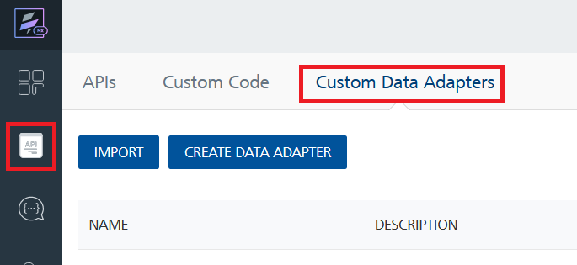
4. Click **IMPORT** to import a custom data adapter.  
   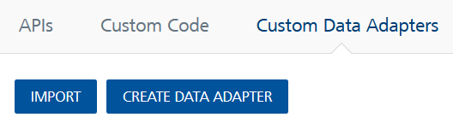
5. On the Import Data Adapter dialog box, click browser to import.  
   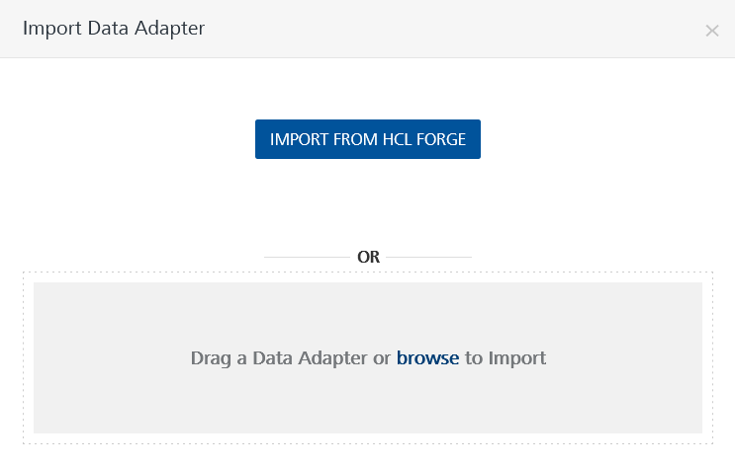
6. Selected Google slides data adapter zip file and click **IMPORT**.

After you import the data adapter, Volt Foundry opens a window that shows the metadata of the data adapter.

After you import the data adapter, you can view it on the Custom Data Adapters page and use it to create services on Volt Foundry.

After you add the data adapter to your Volt Foundry app, you need to get your **API key and Oauth ClientID and ClientSecret** from Google Cloud Console. You can refer to below section for more information.

[Open](javascript:void(0);) **Creating an Identity Service**

To use the Google Calendar APIs, you need to create an identity service that uses OAuth 2.0 for authentication.

**To create an identity service, follow these steps:**

1. Sign in to the [HCL Foundry](https://manage.hclvoltmx.com/).
2. From the left navigation menu, select **API Management**.
3. Under **APIs**, on the **Identity** tab, click **CONFIGURE NEW**.
4. From the **Type of Identity** list, select **OAuth 2.0**.
5. In the **Authorize Endpoint** box, type this link:

https://accounts.google.com/o/oauth2/v2/auth

1. In the **Token Endpoint** box, type this link:

https://www.googleapis.com/oauth2/v4/token

1. In the **Scope** box, type either of the following links:

* https://www.googleapis.com/auth/drive
* https://www.googleapis.com/auth/drive.file
* https://www.googleapis.com/auth/presentations

8.Under **Client Details**, type the Client ID and Client Secret that you received from Google.  
For information on obtaining the **Client Details**, refer to [Obtaining the Client ID and Client Secret](https://docs.kony.com/marketplace/V8Marketplace/Content/Marketplace/googlecalendar.htm#Obtaining)

**Note:**  
If you want to verify the details, click **TEST LOGIN** and sign in by using your Google credentials.

9.Click Save

## **Obtaining the Client ID and Client Secret**

To obtain the client ID and client secret from Google, you need to perform the following steps:

[Open](javascript:void(0);)[Authorizing the Quantum Cloud Domain](javascript:void(0);)

To use the Google APIs in a domain, you need to authorize the domain on the Google Developer Console.

To authorize the Quantum Cloud domain, follow these steps:

1. Sign in to the [Google Developer Console](https://console.developers.google.com/).
2. From the left pane, select **OAuth consent screen**.
3. Under **Authorized Domains**, in the text box, type **hclvoltmx.net**, and then press Enter.
4. Click **Save**.
5. Enable the Google slides api in the Enabled API services.

[Open](javascript:void(0);)[Obtaining the Callback URL](javascript:void(0);)

1. Sign in to the [Google developer console](https://manage.hclvoltmx.com/).
2. Open or Edit the [Identity Service that you created earlier](https://docs.kony.com/marketplace/V8Marketplace/Content/Marketplace/googlecalendar.htm#Creating_Identity).
3. Under **Provider Details**, for the **Callback URL**, click **Copy**.

[Open](javascript:void(0);)[Adding a Redirect URL on Google](javascript:void(0);)

1. Sign in to the [Google Developer Console](https://console.developers.google.com/).
2. From the left pane, select **Credentials**.
3. On the **Credentials** page, click **Create credentials**, and then select **OAuth client ID**.
4. Under **Application** type, select **Web application**.
5. Under **Authorized redirect URIs**, in the text box, type the **Callback URL** that you Obtained from Volt Foundry.
6. Click **Create**.

After you create the credentials, the Google Developer Console displays your **Client ID** and **Client Secret**.

You need to add the Client ID and Client Secret to the [Identity Service that you created earlier](https://docs.kony.com/marketplace/V8Marketplace/Content/Marketplace/googlecalendar.htm#Creating_Identity)

[Open](javascript:void(0);)[Creating an Integration service](javascript:void(0);)

After you import the data adapter into Volt Foundry, you can use it to create an Integration Service.

Follow the given steps to create an Integration service using the Google slides Data Adapter.

1. Sign in to the [HCL Foundry](https://manage.hclvoltmx.com/).
2. From the left navigation menu, select **API Management**.
3. In **API Management**, select **Integration**.  
   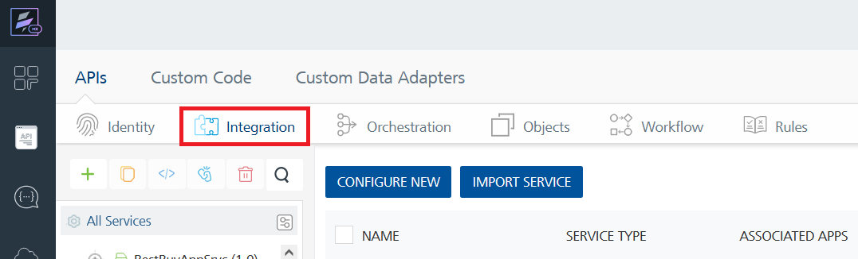
4. To create a new service, click the **+** button or the **CONFIGURE NEW** button.  
   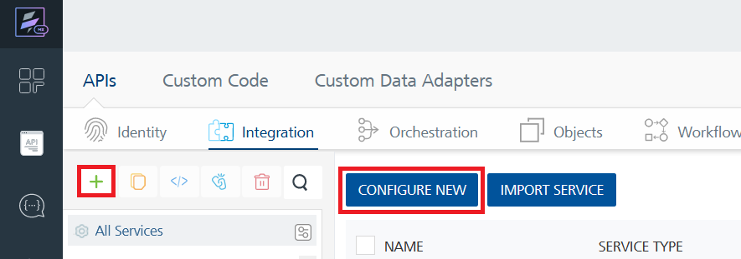
5. On the Service Definition tab, select the service type as Slides, and click **SAVE**.

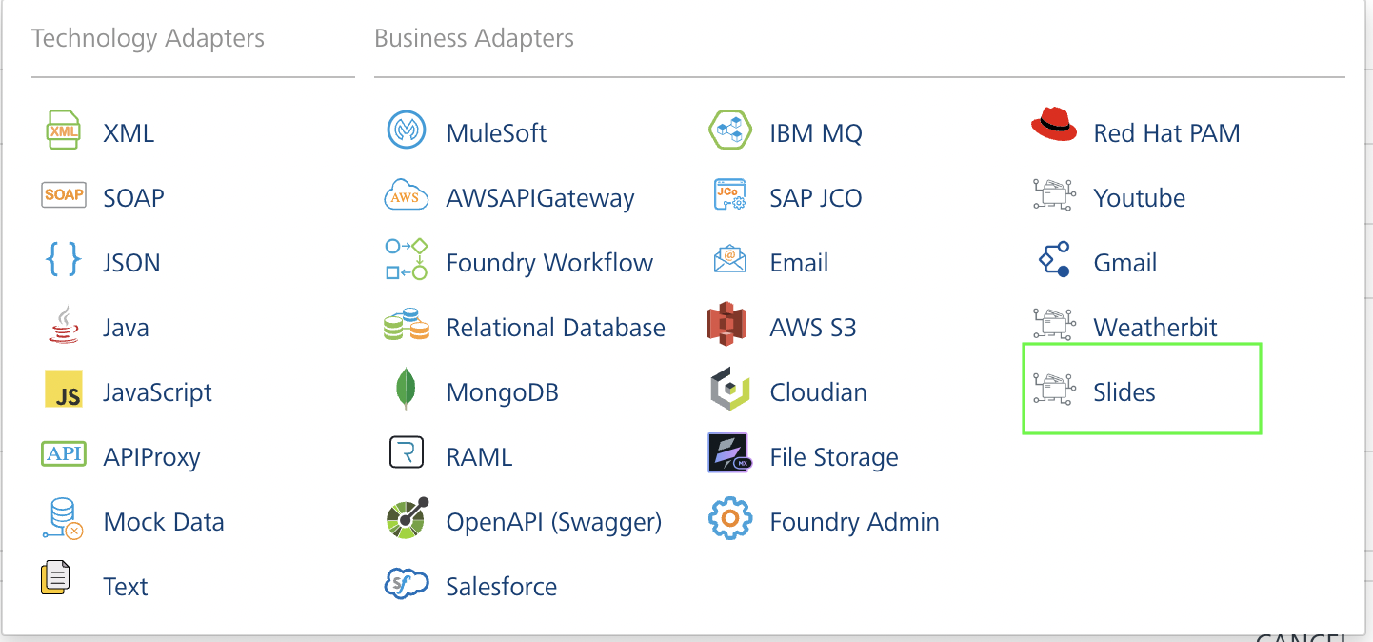

[Open](javascript:void(0);)[Creating and Executing operations](javascript:void(0);)

After you create an integration service, you can create and execute operations using the service.

#### Creating an Operation

1. In **API Management**, in the **Integration** section, select the service that you created.
2. After you select the service, navigate to the **Operation List** tab.  
   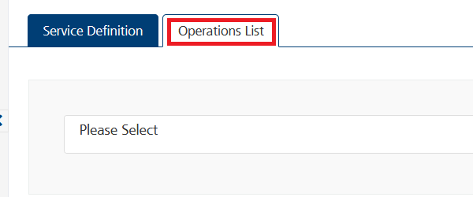
3. From the drop down list, select an operation that you want to execute, and click **ADD OPERATION**.  
   A screenshot of a computer

   Description automatically generated

#### Executing an Operation

1. From the **Operations List** tab, in the **Configured Operations** section, select the operation you want to execute.  
   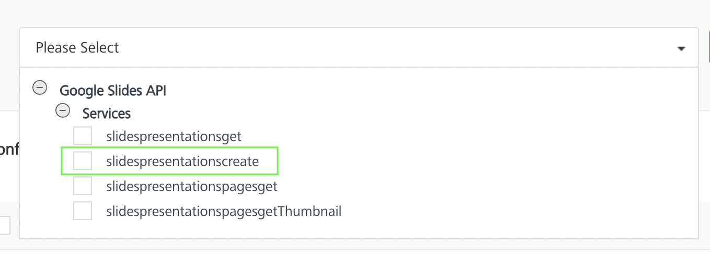
2. On the Operation Page, in the Request Input tab, enter a TEST VALUE for all the fields.  
   A screenshot of a test

   Description automatically generated

You can view this <https://developers.google.com/slides/api/reference/rest/v1/presentations/create> for giving input parameters

1. Select a run-time environment and click **Save and Fetch Response** to create a slide based on your inputs.  
   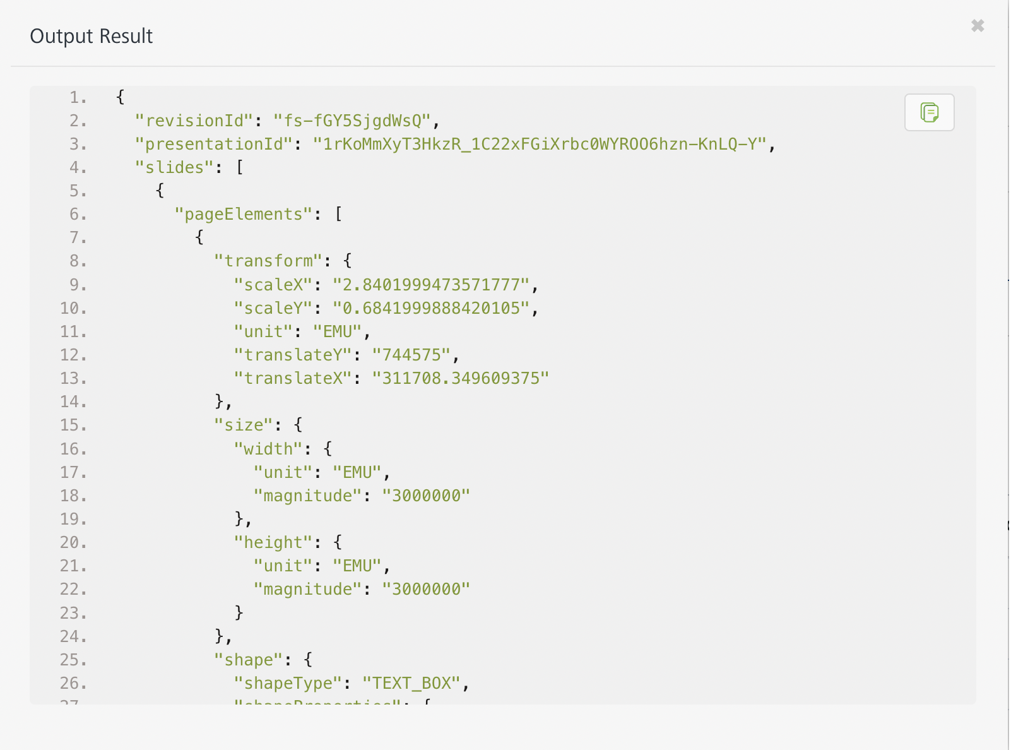

[Open](javascript:void(0);)[Publishing your application](javascript:void(0);)

If you want to use the services in client applications, you need to publish the app to a run-time environment.

You can also link the Volt Foundry app to a client application.

# References

# EndPoints:

# 1.Method: presentations.get

# 2.Method: presentations.create

{

"slides": [

{

"pageElements": [

{

"transform": {

"scaleX": "2.8401999473571777",

"scaleY": "0.28060001134872437",

"translateX": "311700",

"translateY": "2150850",

"unit": "EMU"

},

"elementGroup": {

"children": [

{}

]

},

"objectId": "",

"title": "Testing",

"description": "create to test slides API",

"size": {}

}

],

"pageProperties": {

"colorScheme": {

}

},

"slideProperties": {

"layoutObjectId": "",

"masterObjectId": "",

"notesPage": {}

},

"objectId": "",

"pageType": "Notes",

"revisionId": ""

}

],

"notesMaster": {},

"pageSize": {

"width": {

"magnitude": "9144000",

"unit": "EMU"

},

"height": {}

},

"access_token": "",

"alt": "",

"callback": "",

"fields": "",

"key": "",

"oauth_token": "",

"prettyPrint": "",

"quotaUser": "",

"upload_protocol": "",

"uploadType": "",

"$.xgafv": "",

"presentationId": "",

"title": "Testing from Foundry",

"locale": "en_US",

"revisionId": "",

"masters": [

],

"layouts": [

]

}

# 3.Method: presentations.pages.get

# 4.Method: presentations.pages.getThumbnail

## Known Issues

None

## Limitations

The input data should match the format of Google slides API requirements to get the expected result.