Date: 03-June-2024

Google sheets back-end services

VERSION: 1.1.0

Overview
Google Sheets is a web-based spreadsheets service offered by Google. The Google Sheets data adapter integrates the Sheets APIs with HCL Volt MX Foundry. Under the hood, the data adapter uses Identity Services and Integration Services to make API calls to Google Sheets. You can use the data adapter to perform CRUD operations in a spreadsheet from an app.
The following sections help you use the Google Sheets back end service:

Features
- Import, export and format Google Sheets data
- Control conditional formatting
- Build and edit charts embedded in a sheet
- Configure data validation
- Create and update named and protected ranges
- Add and adjust filtered views
- Create and manipulate pivot tables

Percentage of re-use:
70% (Data can be customizable and customer need to implement UI by themselves).

Getting Started

Prerequisites
Before you start using the Google Sheets back-end service, make sure that you have the following:
- A HCL Foundry
- HCL Volt MX Foundry
- A Google account with the following:
  - Authorized Domain of your HCL Volt MX Foundry authentication cloud
  - OAuth Client ID
  - OAuth Client Secret
For more information, refer to the following links:
- Obtaining the Client ID and Client Secret
- Using OAuth 2.0 to Access Google APIs

Importing the back-end service
- Download the Google Sheets back-end service zip file from HCL Forge.
- Sign in to the HCL Foundry Console.
- On the Foundry Apps page, click IMPORT.
- On the Import App dialog box, drag and drop the zip file that you downloaded earlier. Alternatively, you can browse for the zip file on your system.
After the zip file is uploaded, the console displays the default App Name and Version.
- Click IMPORT.

Obtaining the Client ID and Client Secret

To obtain the client ID and client secret from Google, you need to perform the following steps:

Authorizing the HCL Volt MX Cloud Domain
To use the Google APIs in a domain, you need to authorize the domain on the Google Developer Console.
To authorize the HCL Volt MX Cloud domain, follow these steps:
- Sign in to the Google Developer Console.
- From the left pane, select OAuth consent screen.
- Under Authorized Domains, in the text box, type hclvoltmx.net, and then press Enter.
- Click Save.

Obtaining the Callback URL
- Sign in to the HCL Foundry Console.
- Open or Edit the Identity Service of the component.
- Under Provider Details, for the Callback URL, click Copy.
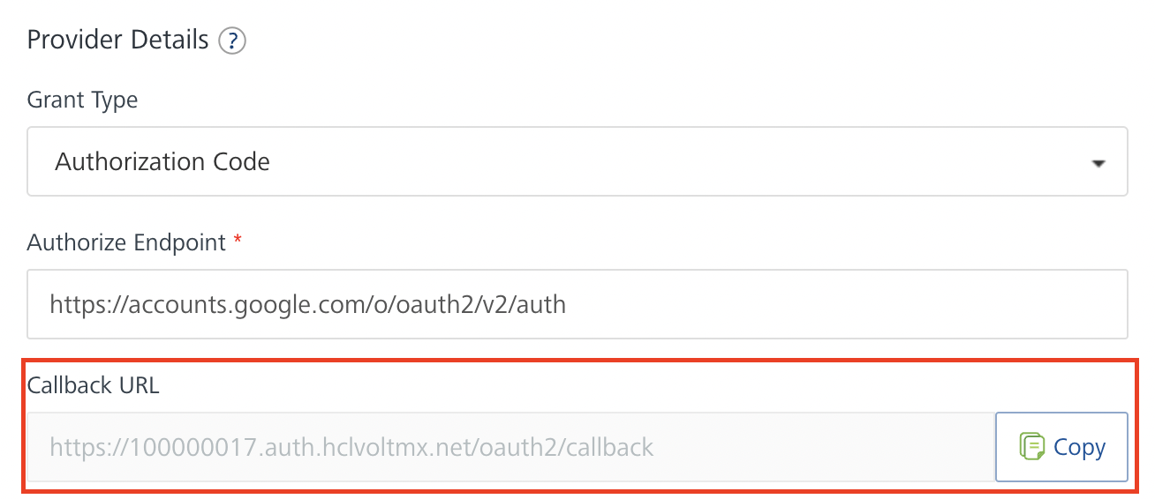
Adding a Redirect URL on Google
- Sign in to the Google Developer Console.
- From the left pane, select Credentials.
- On the Credentials page, click Create credentials, and then select OAuth client ID.
- Under Application type, select Web application.
- Under Authorized redirect URIs, in the text box, type the Callback URL that you obtained from HCL Volt MX Foundry
- Click Create.
After you create the credentials, the Google Developer Console displays your Client ID and Client Secret.
You need to add the Client ID and Client Secret to the Identity Service of the component.

Configuring the Identity Service
- Sign in to the HCL Foundry Console.
- From the Foundry Apps page, select the app that you imported earlier.
- Under Configure Services, on the Identity tab, select the googlesheetsauth identity service.
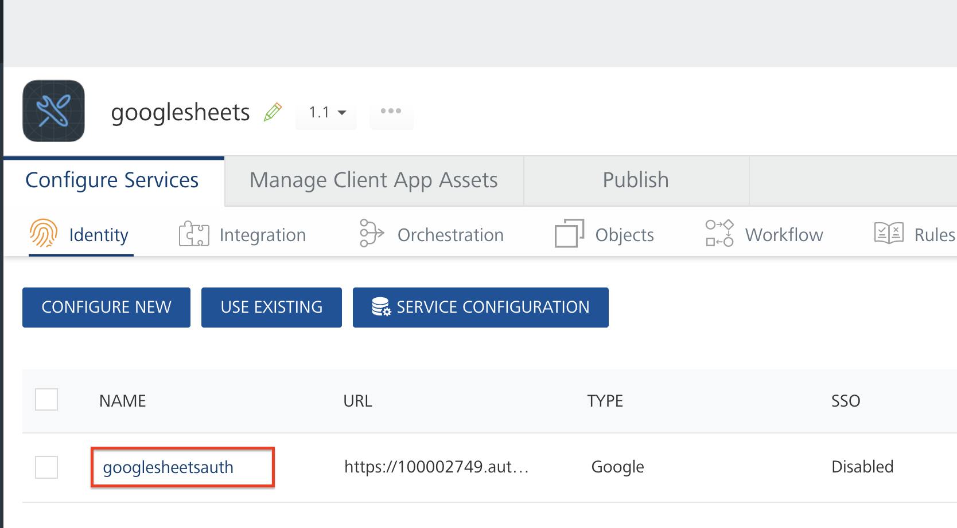
- Under Client Details, type the Client ID and Client Secret that you obtained from Google.
Note:
If you want to verify the details, click TEST LOGIN and sign in by using your Google credentials.
- Click Save.

Using the Integration Service
- Sign in to the HCL Foundry Console.
- From the Foundry Apps page, select the app that you imported earlier.
- Under Configure Services, on the Integration tab, expand the voltmxMpGoogleSheets service.
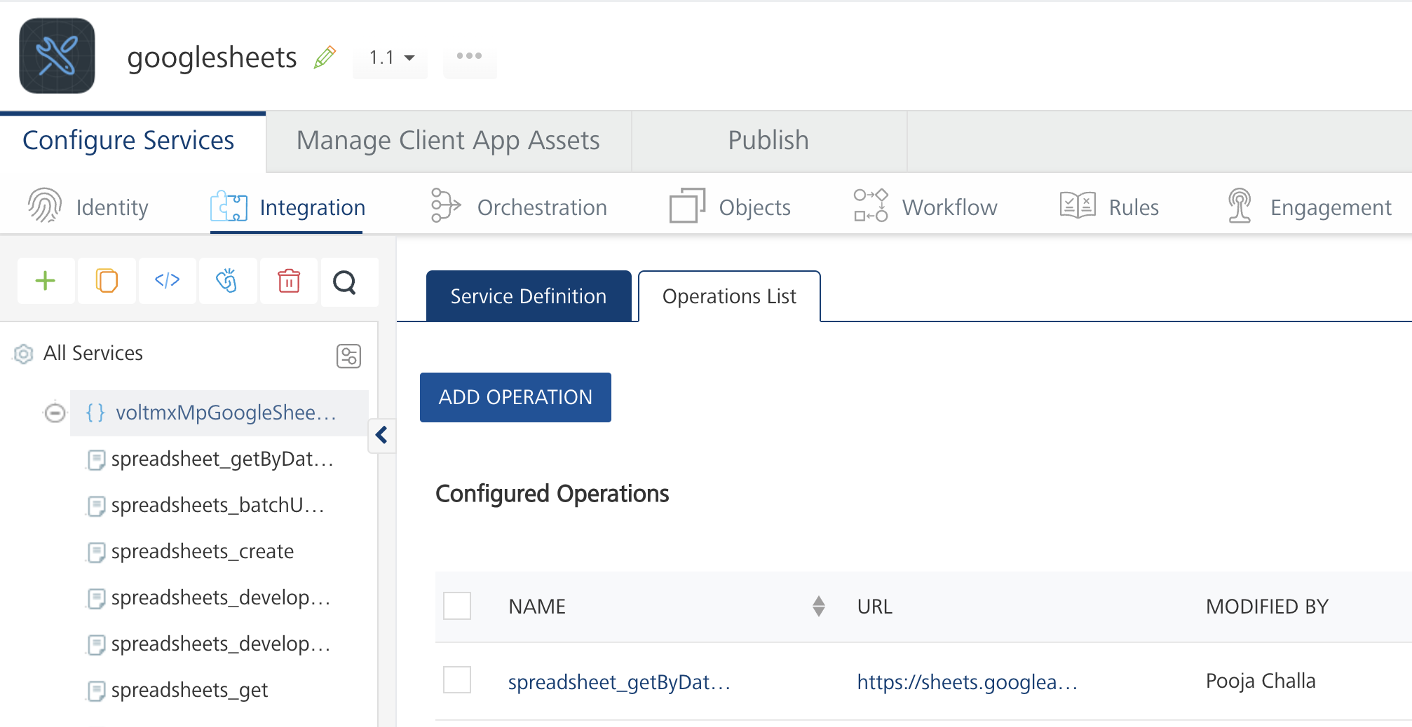
- From the list of operations, select an operation that you want to test.
- On the Request Input tab, enter a TEST VALUE or a DEFAULT VALUE for the parameters.
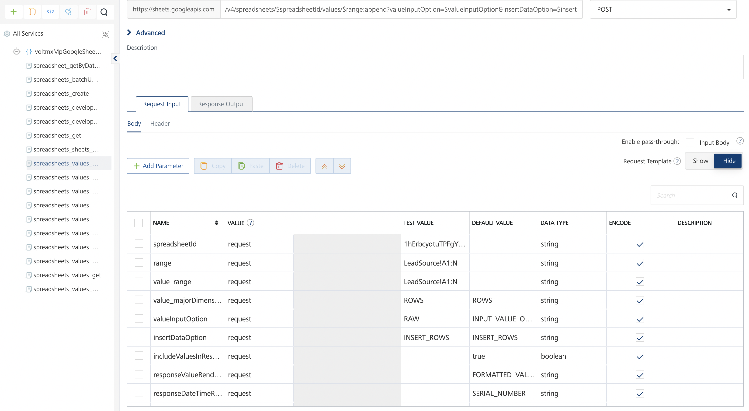

Note:

  - To fetch the response onVolt MX Foundry, clear the Enable pass-through check box on the Response Output tab.
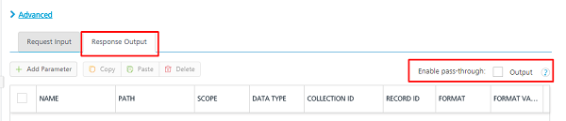
  - The values parameter must contain comma separated arrays in the following format:
[value1, value 2],[value 1, value 2, values 3]

- Click SAVE.

Miscellaneous
- The values parameter in the operations that create, update, or append data must contain comma separated arrays in the following format:
[value1, value 2],[value 1, value 2, values 3]
- For APIs with POST calls, check the parameter names configured on Volt MX Foundry, as the parameters with the same names in a single request body will be renamed according to the context.

Revision History
App version 1.1.0:

Known Issues

N/A

Limitations

N/A

