Date : 18-Jul-2025

GOOGLE ROUTES
version: 1.0.0

OVERVIEW
The Google Routes API is a service from the Google Maps Platform that provides powerful routing capabilities to help developers compute directions, estimated travel times, and distances between geographic locations. It enables applications to deliver accurate and optimized routes for various transportation modes including driving, walking, bicycling, transit, and two-wheelers.

Features:
- Preconfigured back-end service that helps your app to connect with Google database instantly.
- Facilitates to invoke services easily from Google Routes APIs.
- Provides secure interaction with Google services using the authentic API key, generated specific to your login.
- Easy to attain details through simple interaction directly fromVoltMX Foundry.

Percentage of re-use:
70% (Data can be customizable and customers need to implement UI by themselves).

GETTING STARTED

Prerequisites
Before you start using the Google Routes, ensure the following:
- HCL Foundry
- Volt MX Iris
- Get a Google API Key

Importing the Data Adapter

You can import Google Routes Data Adapter into HCL Foundry directly from the VoltMX website or by importing the data adapter zip file.

To import the Data Adapter to Volt Foundry, do the following:
- Sign in to the HCL Foundry.
- From the left navigation menu, select API Management.
- In API Management, select Custom Data Adapters.
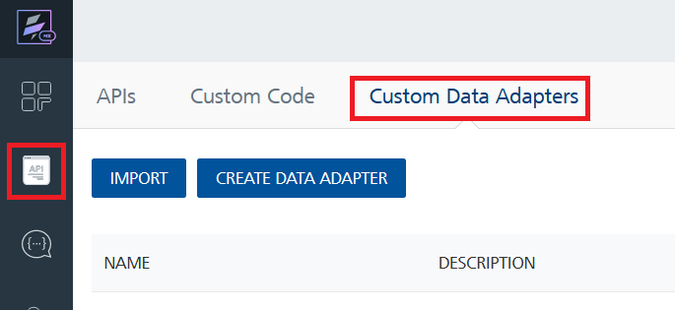

- Click IMPORT to import a custom data adapter.
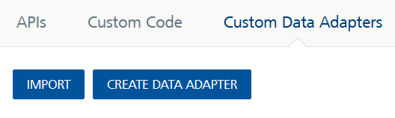
- On the Import Data Adapter dialog box, click browser to import.
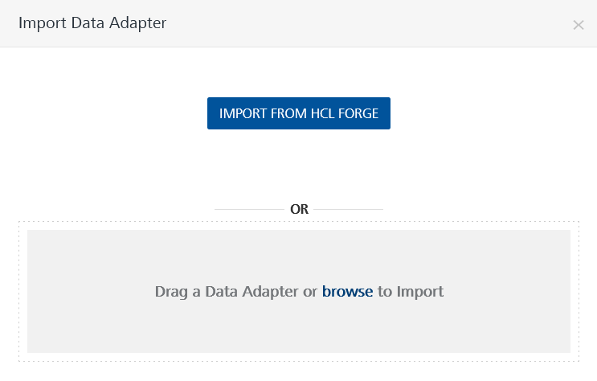
- Select Google Routes zip file and click IMPORT.
After you import the data adapter, VoltMX Foundry opens a window that shows the metadata of the data adapter.
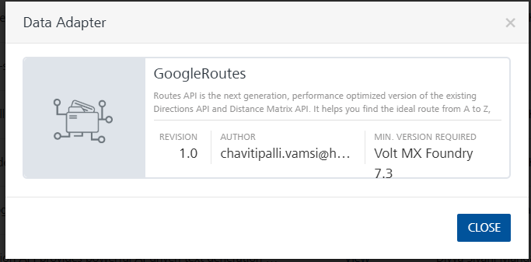

To import the data adapter zip file, do the following:
- Perform steps 1 through 4 in the above procedure
- Drag the data adapter zip file into the Drag Data Adapter box.
Or
Click browse. The Open dialog appears.
Navigate to the location where you downloaded the data adapter (zip file) on your computer, select the data adapter, and click Open. The Import Data Adapter dialog shows the selected data adapter.

C. GENERATING GOOGLE ROUTES KEY
To use Google Services generate an API key. To generate the API key visit Google Routes and select the appropriate service and generate a key for the selected service. Provide the Routes key based on the type of request placed to fetch the responses.
To view the object service, do the following:
- Log on to your Google Routes. The Google Places API page appears by default.
- Select the required service from the left pane.
- In the top-right pane, click the GET A KEY button.
The following confirmation message along with your generated API key appears.
D. Creating an Integration Service with Google Routes
After you import Google Routes Data Adapter into Foundry, you must create an integration service with service type as Google Routes to connect with your Google Routes developer site.
To create an integration service with Google Routes, do the following:
- Log on to your Foundry. The Dashboard page appears by default.
- In the left panel, click the API Management menu. The APIs tab opens by default.
- Click the Integration tab. The Integration tab opens with a list of existing integration services.
- Click CONFIGURE NEW. The Service Definition tab opens.
- In the Name box, type a unique name for your service.
- From the Service Type list, select Google Routes
Note: The Google Routes is listed only after you import the Google Routes Adapter into Foundry.

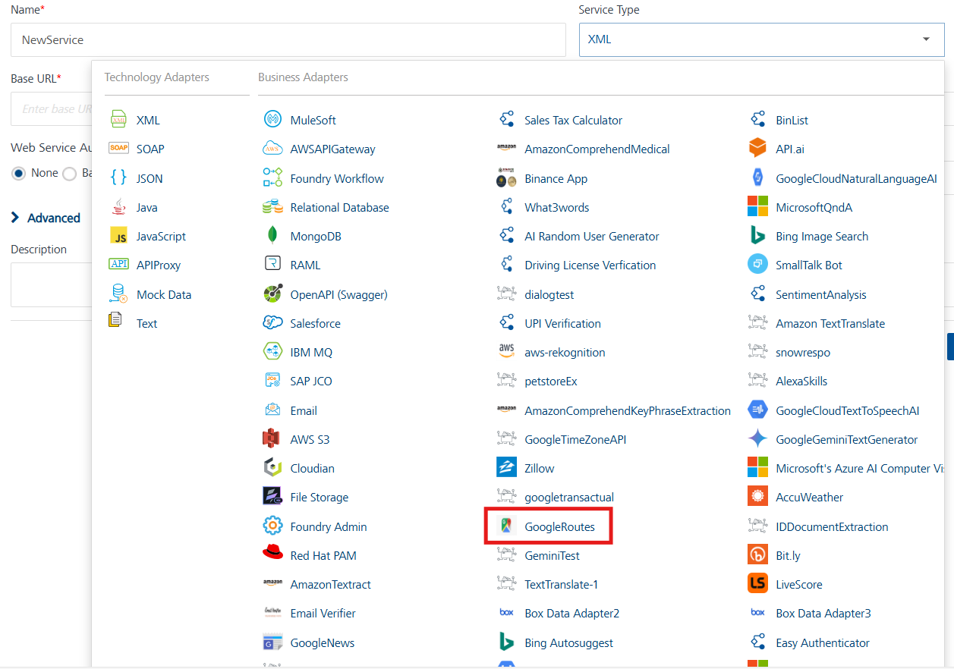

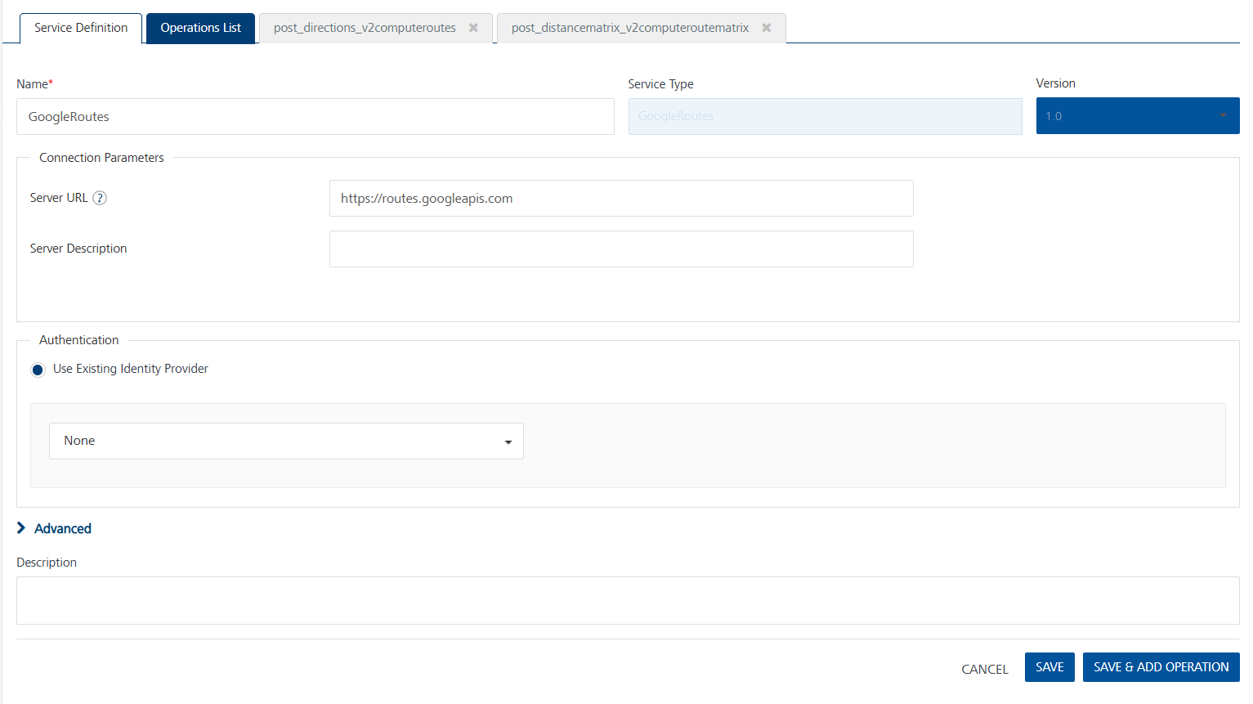
- Click Save.
If the details provided are valid, the Foundry service connects to your Google Routes developer site and allows you to make the API calls.
Refer to Integration Services for more information on creating and using integration services.
8. Creating an Operation
To make any API call in the Foundry console, you must create an operation for the respective API and then execute the operation. Executing an operation involves making the API call and displaying the response.
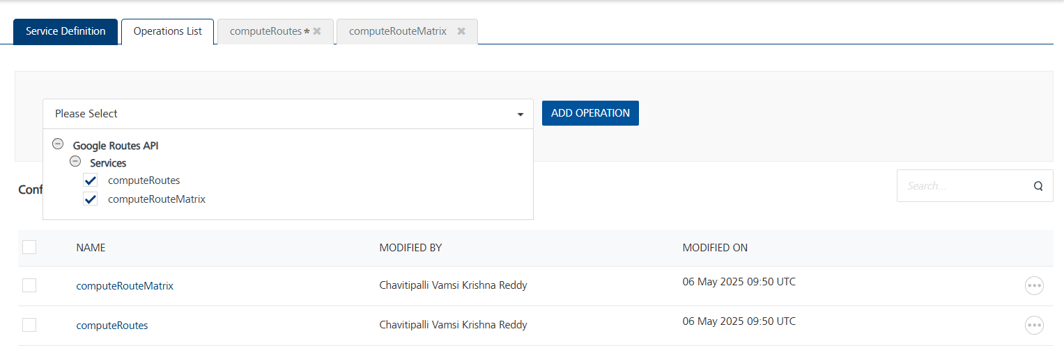
You can create multiple operations with required APIs and save them in the Configured Operations section. You can then execute the operations whenever required.

E. Executing an Operation
Executing an operation involves making the API call by setting the necessary parameters and displaying the response. The procedure to execute any operation is the same, but the request parameters of the APIs vary. For more information on request parameters of API, refer Google RoutesAPI.
Steps to execute the computeRoutes operation:
- Log on to your HCL Foundry. The Dashboard page appears by default.
- In the left pane, click the API Management menu. The APIs tab opens by default.
- Click the Integration tab. The Integration tab opens with a list of existing integration services.
- From the list of integration services, select the integration service that you have created with the service type as GoogleRoutes. The Service Definition tab of the selected integration service opens by default.
- Click the Operations List tab.
- Under the Configured Operations section, click the computeRoutes operation. The computeRoutes tab opens with the Request Input sub-tab opened by default.
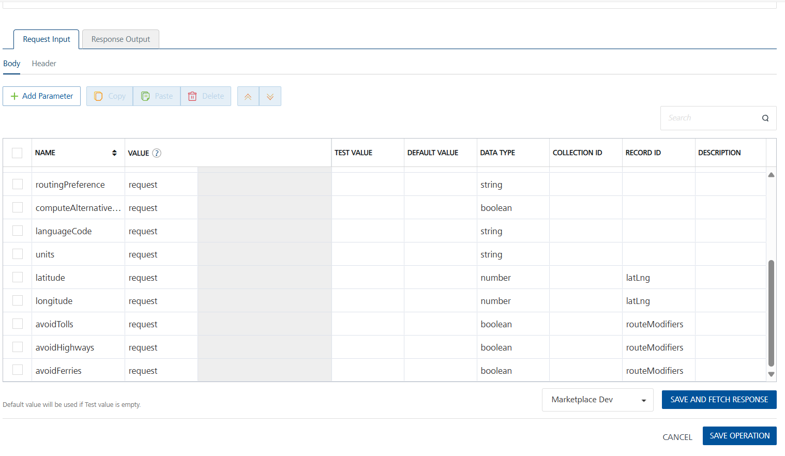
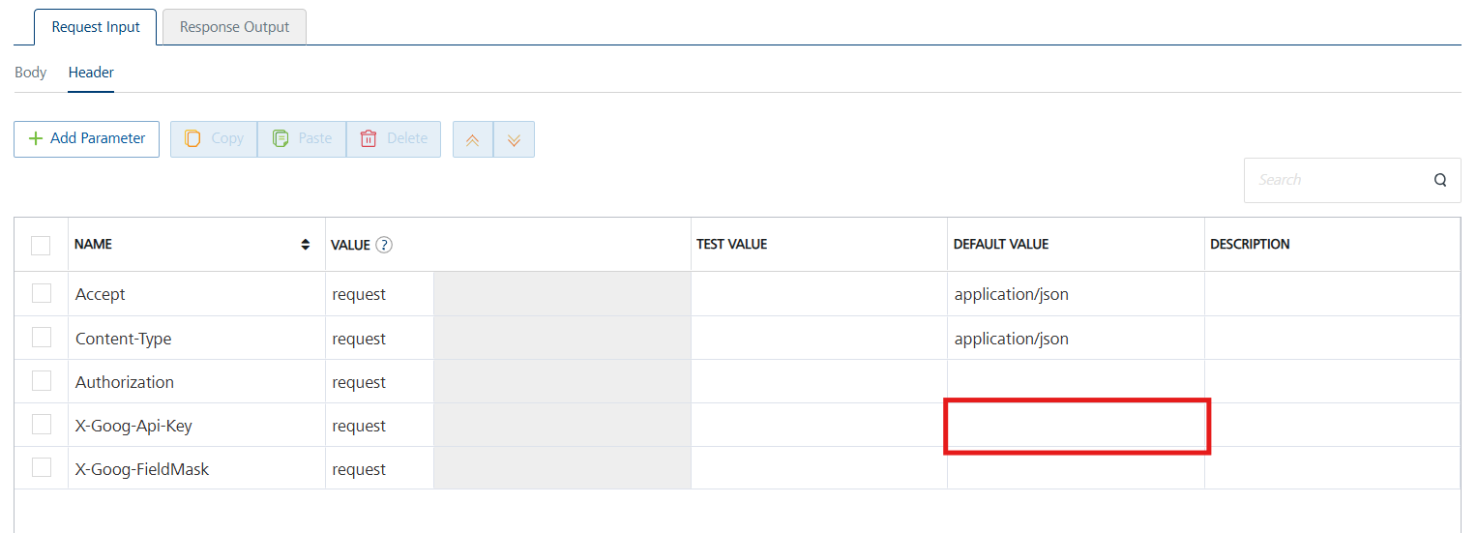
- In the Name box, the name of the operation is displayed by default. If you want, you can change the name.
- On the Request Input tab, in the Body section, for the following parameters, specify the values in the respective boxes under the Test Value or Default value column.

Mandatory Parameters
Headers:
- X-Goog-Api-Key: To use the Google Routes API, an API key is required, which can be created by following the steps in Generating a Google Routes API Key. Enter the Generated API Key as default value in the Headers Section.
- X-Goog-FieldMask: add X-Goog-FieldMask as default value in required header.
Refer to this link: https://developers.google.com/maps/documentation/routes/compute_route_directions.

Request Body:

- Origin and Destination (Lat/Lng):To calculate a route, the Google Routes API needs both the origin and destination specified as latitude and longitude coordinates
For more information refer to this https://developers.google.com/maps/documentation/routes/compute_route_directions
- Click SAVE OPERATION.
- Click SAVE AND FETCH RESPONSE. The Output Result dialog appears with the response. Otherwise, the Output Result shows an error.

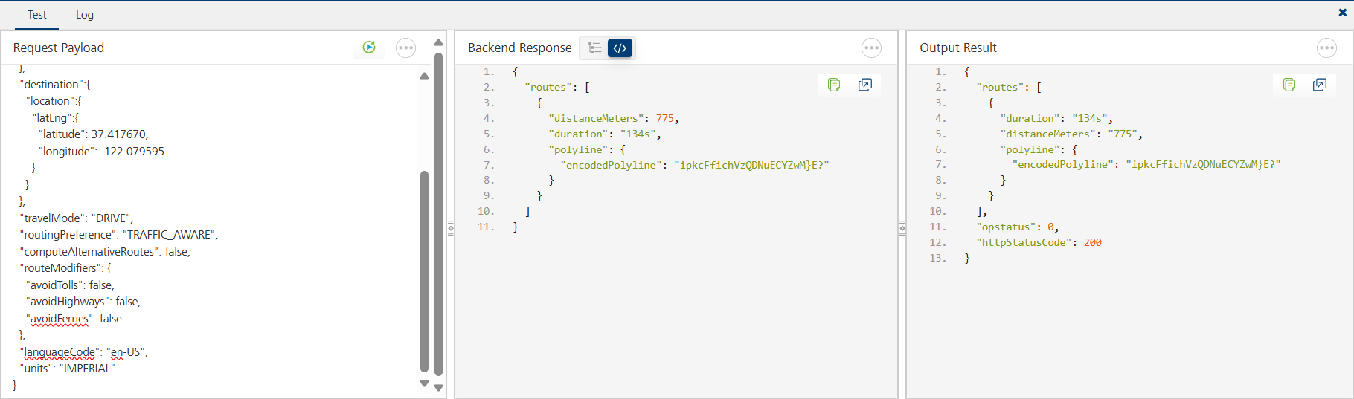

For the remaining operations, follow the same steps mentioned for Executing an Operation. Refer to this link https://developers.google.com/maps/documentation/routes/compute-route-over

Publishing your application
If you want to use the services in client applications, you need to publish an app to a run-time environment. You can create the service (as described above) in an application or import the service into an application and publish the application.
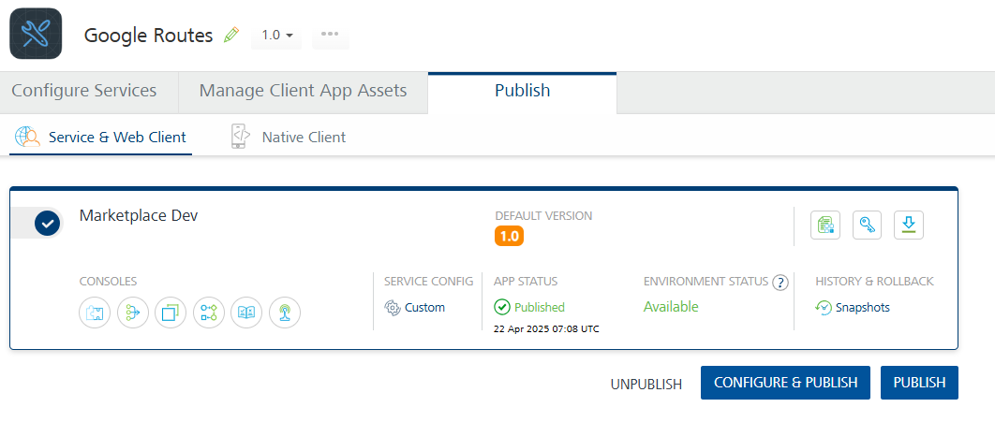

REFERENCES
A. Endpoint Documentation
https://developers.google.com/maps/documentation/routes

REVISION HISTORY
App version 1.0.0

