08 March 2024

GooGLE LOGIN

version: 1.1.3

- OVERVIEW
Add Google Login to your app in minutes-just drag and drop the component in your Volt MX Iris app, configure few properties and voila! Users can now login to your app with their Google credentials.

Use case:
Google Sign-In is an authentication service that uses OAUTH 2.0. By using Google Sign-In, you can also integrate other Google APIs with your app. The Google Login component adds the Google Sign-In feature to your app. Under the hood, the component uses Identity Services on Volt MX Foundry.

Features:
- Ready to use Google Login.
- Configure UI properties and service parameters directly from Volt MX Iris panel.

Percentage of re-use:
Approximate 90% of reuse.

Getting Started

Prerequisites
Before you start using the Google Login component, ensure the following:
• HCL Foundry
• Volt MX Iris
• A Google account with the following:
- Authorized Domain of your Volt MX Foundry authentication cloud
- OAuth Client ID
- OAuth Client Secret
For more information, refer to the following links:
- Obtaining the Client ID and Client Secret
- Using OAuth 2.0 to Access Google APIs

Platforms Supported

Mobile

iOS

Android

Tablet & iPad

PWA & Responsive Web

Importing the app

You can import the Forge components only into the apps that are of the Reference Architecture type.

To import the Google Login component, do the following:

Open your app project in Volt MX Iris.
- In the Project Explorer, click the Templates tab.

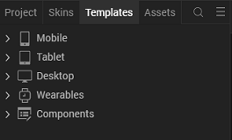

- Right-click Components, and then select Import Component. The Import Component dialog box appears.

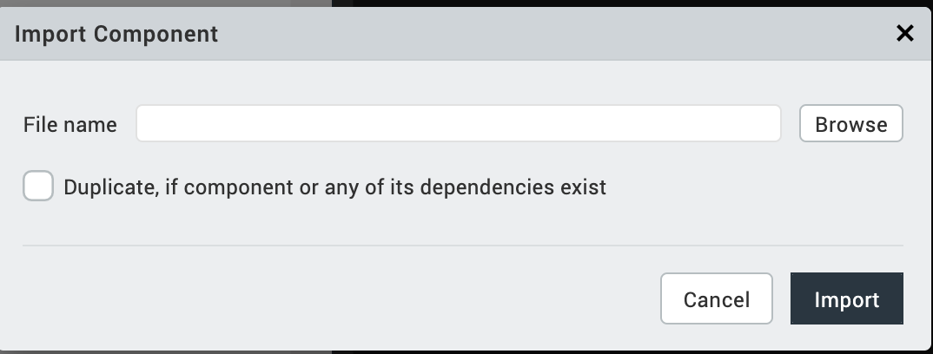
- Click Browse to navigate to the location of the component, select the component, and then click Import. The component and its associated widgets and modules are added to your project.

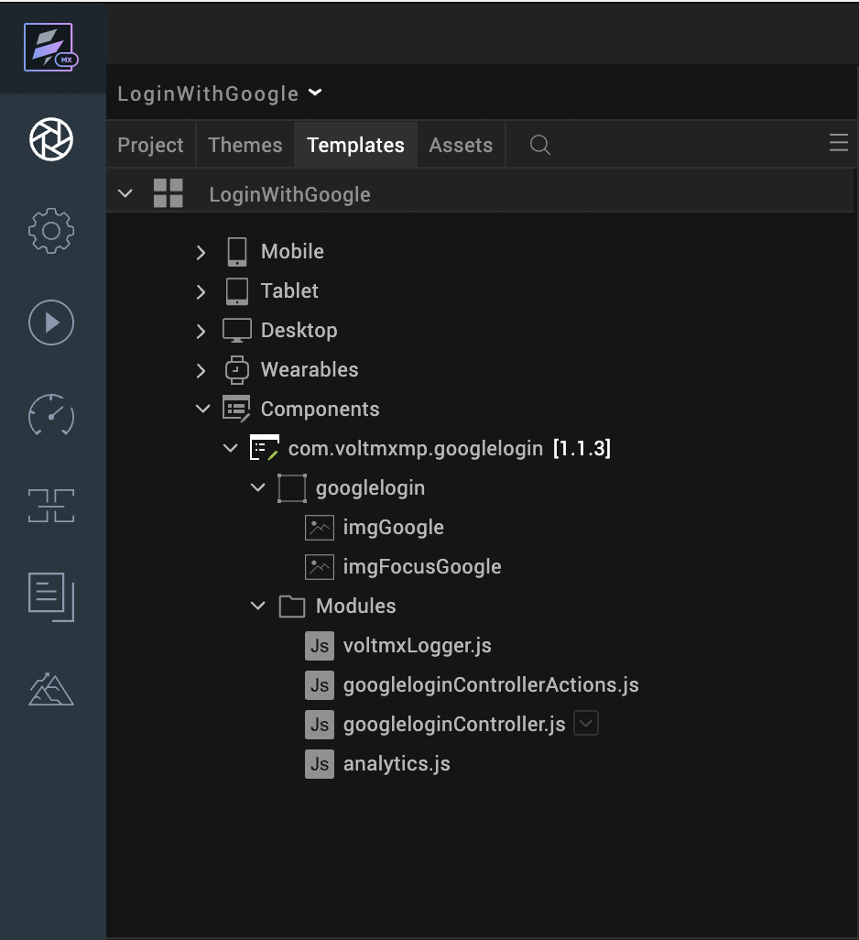
Once you have imported a component to your project, you can easily add the component to a form. For more information, refer Add a Component to a Form

Obtaining the Client ID and Client Secret
To obtain the client ID and client secret from Google, you need to perform the following steps:
- Authorizing the HCL Volt MX Foundry Cloud Domain
To use the Google APIs in a domain, you need to authorize the domain on the Google Developer Console.
To authorize the HCL Volt MX Foundry Cloud domain, follow these steps:
- Sign in to the Google Developer Console.
- From the left pane, select OAuth consent screen.
- Under Authorized Domains, in the text box, type hclvoltmx.net, and then press Enter.
- Click Save.
- Obtaining the Callback URL
- Sign in to the HCL Foundry.
- Open or edit the Identity Service of the component.
- Under Provider Details, for the Callback URL, click Copy.
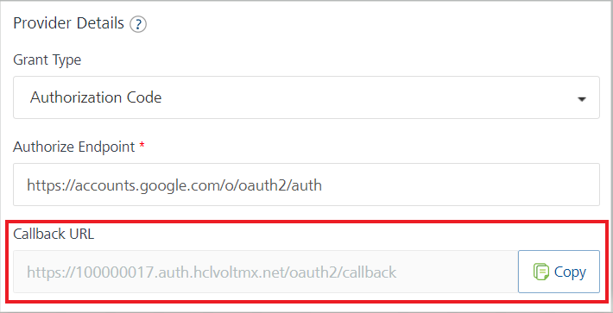
- Adding a Redirect URL on Google:
- Sign in to the Google Developer Console.
- From the left pane, select Credentials.
- On the Credentials page, click Create credentials, and then select OAuth client ID.
- Under Application type, select Web application.
- Under Authorized redirect URIs, in the text box, type the Callback URL that you obtained from Volt MX Foundry.
- Click Create.
After you create the credentials, the Google Developer Console displays your Client ID and Client Secret.
You need to add the Client ID and Client Secret to the Identity Service of the component.

Service Parameters
The Service Parameters of the component are the Client Details of the Identity Service that is linked to the component. For more information, refer to Obtaining the Client ID and Client Secret.

Client ID
Description: | Specifies the Client ID that you received from the Google Developer Console.
Remarks: | - If you change the Client ID, make sure that you select Publish Changes.  - You can only change this property at the design time.

Client Secret
Description: | Specifies the Client Secret that you received from the Google Developer Console.
Remarks: | - If you change the Client Secret, make sure that you select Publish Changes.  You can only change this property at the design time.

Configuring Native Settings
The Google Login component requires Deeplink Configuration for the Android and iOS platforms. Refer to the following sections for more information.
Android
- From the left navigation menu, select Project Settings.
- In the Project Settings window, go to Native → Android.
- Under Manifest Properties & Grade Build Entries, select Deeplink URL Scheme.
- Type the following names and values in the Deeplink URL Scheme table.
Name | Value
Scheme | http (or) https
Host | Googlelogin

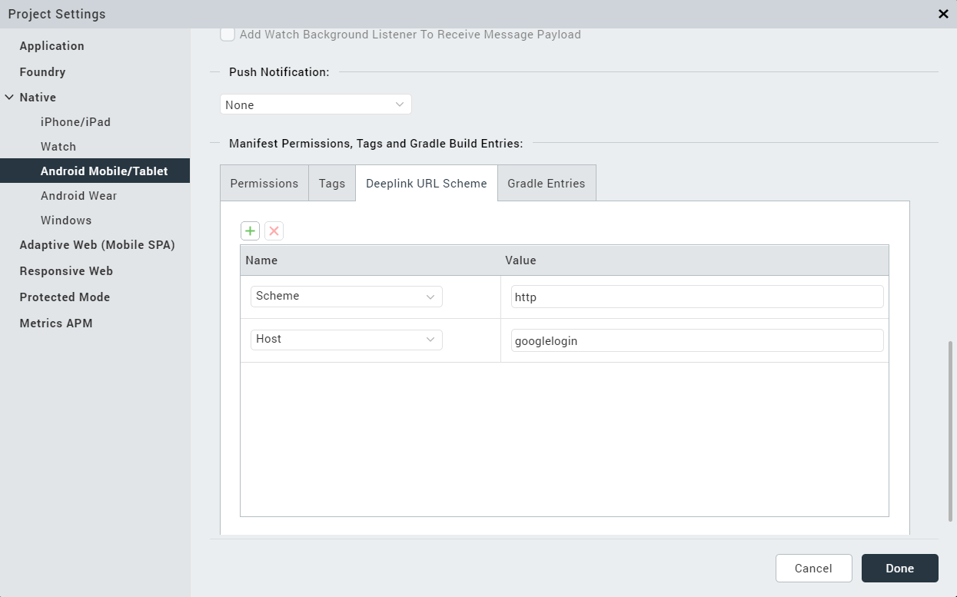

Click Finish.

iOS
- From the left navigation menu, select Project Settings.
- In the Project Settings window, go to Native → iPhone/iPad/Watch.
- In the Deeplink URL Scheme box, type googlelogin.

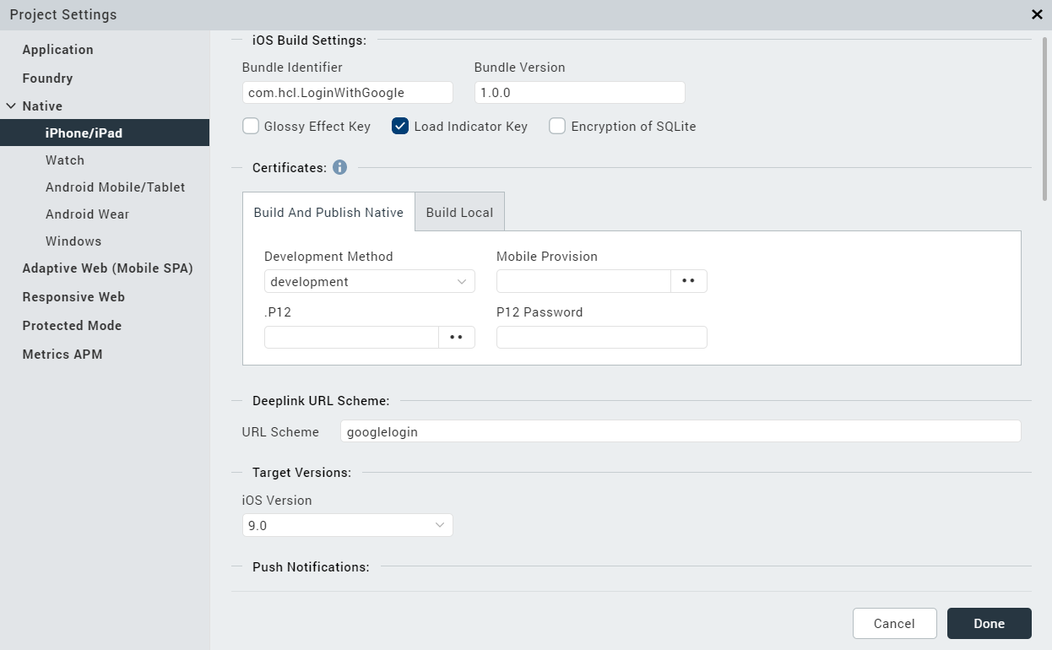

Responsive Web
- From the left navigation menu, select Project Settings.
- In the Project Settings window, go to Responsive Web → General Settings.
- Enable JS library mode (Legacy)
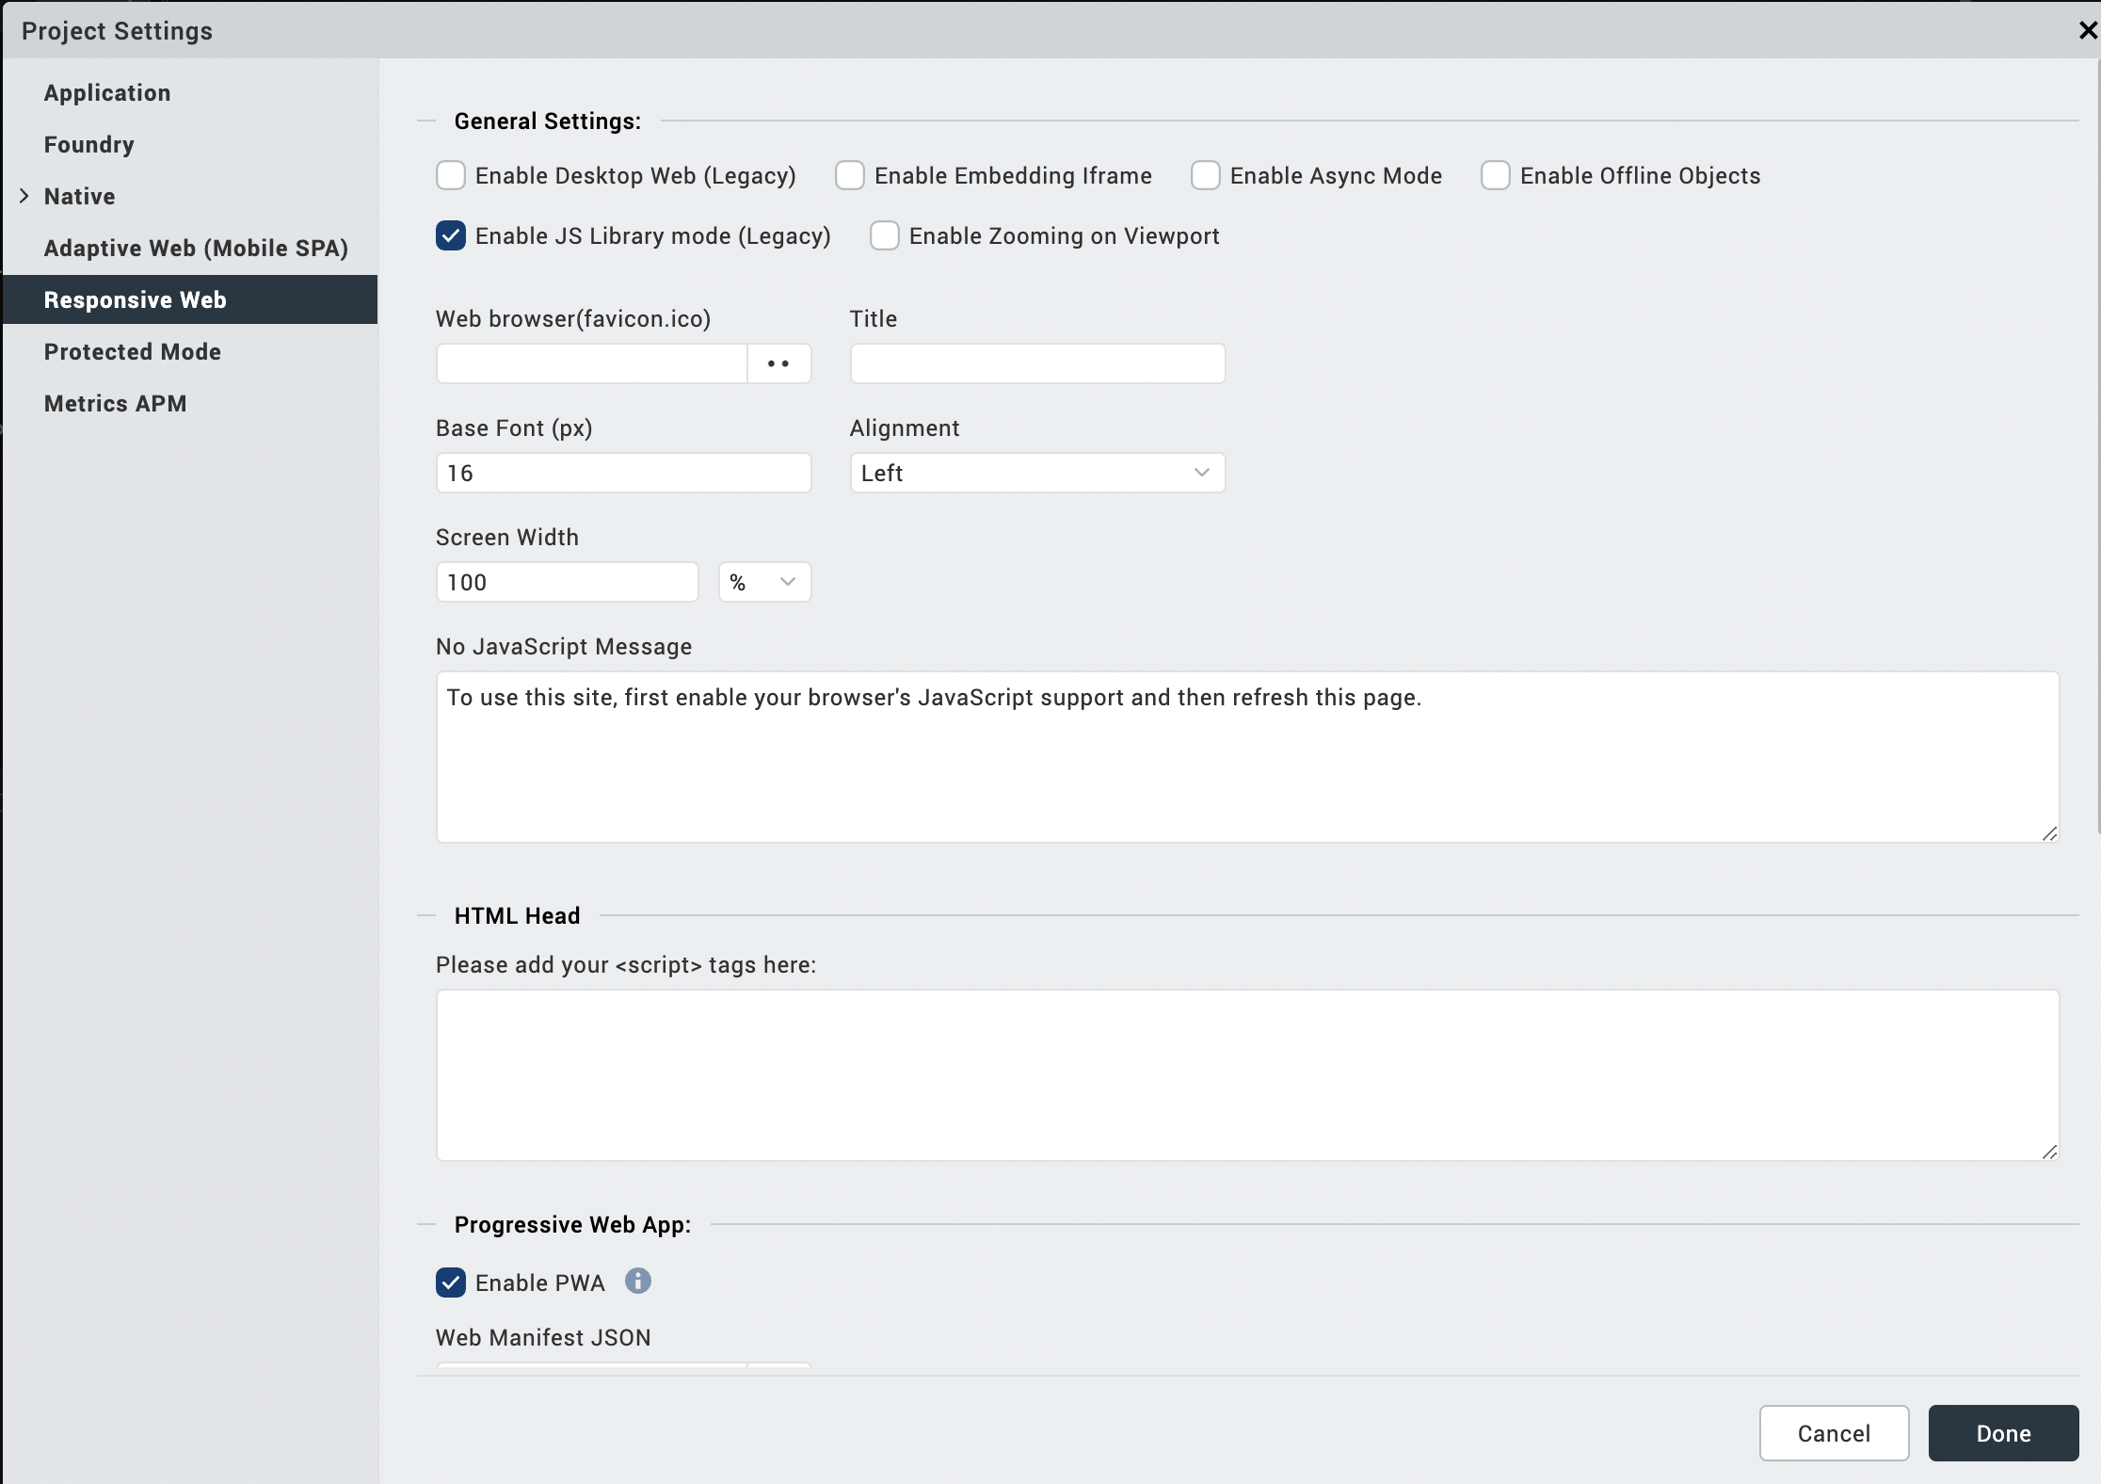
- Click Finish.

Configuring the Identity Service on HCL Volt MX Foundry
- Sign in to the HCL Foundry
- From the Apps page, select the app that contains the Google Login component services.
- Under Configure Services, on the Identity tab, select the GoogleLoginIdentity Identity Service.
- Under Client Details, type the Client ID and Client Secret that you obtained from Google.
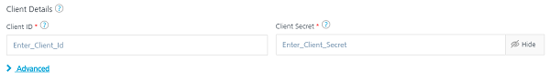
Note:
If you want to verify the details, click TEST LOGIN, and sign in by using your Google credentials.
- In the Advanced section, under Redirect URL on successful authentication, select Allowed URL list.

In the URL boxes, type the URLs that you configured in the Project Settings.
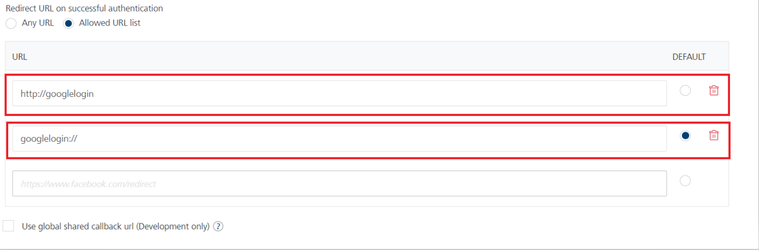
- For Responsive web, create a separate Identity service with the same client ID and Client Secret keys. To do that, repeat the above 4 steps for Responsive web.
In the Advanced section, under Redirect URL on successful authentication, select Any URL.
Identity Service for Responsive Web is GoogleLoginIdentityWeb.

Click SAVE.
Note:
Make sure that you select the Redirect URL for iOS as the Default.

Adding the Deeplink Code in the App Events
- From the Project explorer, select Mobile and Tablet.
- From the Properties panel, under App Events, for Deeplink, click Edit for App Service. The Action Editor opens.
- On the left menu of the Action Editor, from Functions, click Add Snippet.
- In the code snippet, type the following code:
/* handleDeeplinkCallback function checks whether the eventobject is a deeplink */
handleDeeplinkCallback(eventobject);
return voltmx.application.getCurrentForm();

Publishing an APP

After adding the googlelogin component to your app, you must publish the Volt MX Foundry app. For more information, refer to Publish an app on Volt MX Foundry

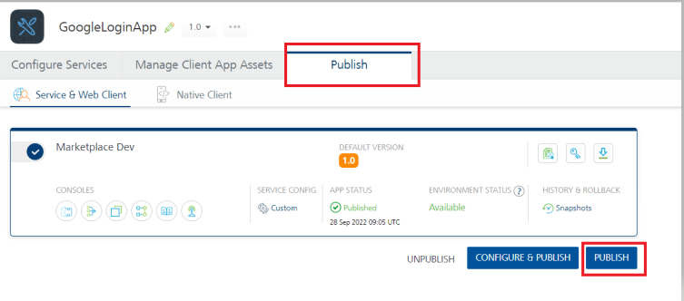

Building and previewing the app
After performing all the above steps, you can build your app and run it on your device. For more information, you can refer to the Building and Viewing an Application section of the Volt MX User Guide.
You can then run your app to see the Google Login work in real time.

References

Dynamic Usage
You can also add Google Login component dynamically. To do so,
- In Project Explorer, on the Projects tab, click Controllers section to access the respective Form Controller. Create a method and implement the code snippet like the sample code mentioned below.
var GoogleLogin = new com.voltmxmp.googlelogin(
{
"autogrowMode": voltmx.flex.AUTOGROW_NONE,
"clipBounds": true,
"height": "50dp",
"id": "GoogleLogin",
"isVisible": true,
"left": "45%",
"top": "45%",
"width": "205dp"
}, {}, {});

/* Setting the component's properties */
GoogleLogin.logoScaleMode = constants.IMAGE_SCALE_MODE_MAINTAIN_ASPECT_RATIO;
GoogleLogin.iconSource = "voltmxmp_gl_btn_google_signin_light.png";
GoogleLogin.redirectUrlAndroid = "http://googlelogin";
GoogleLogin.redirectUrlIos = "googlelogin://";
GoogleLogin.iconFocusSource = "voltmxmp_gl_btn_google_signin_light_pressed.png";

/* Adding the component to a form */
this.view.add(GoogleLogin);

In the code snippet, you can edit the properties of the component as per your requirement. For more information, see Setting Properties.
2. Save the file

Properties
The properties provided on the Component tab allow you to customize the elements in the Google Login component. These elements can be UI elements, service parameters, and so on. You can set the properties from the Volt MX Iris Properties panel on the right-hand side. You can also configure these properties using JavaScript code.
Note: If you copy code from any example, make sure that you replace componentID with the name of your component.
General Properties

logoScaleMode
Description: | Specifies the scale mode of the icon.
Syntax: | logoScaleMode
Type: | - List Selector  - Constant
Read/Write: | Read + Write
Values: | - Fit to Dimensions  - Maintain Aspect Ratio  - Crop
Default Values: | Maintain Aspect Ratio
Remarks: | For more information on scale modes, refer to Image Scale Mode Volt MX Iris Widget guide.
Example: | this.view.componentID.logoScaleMode = constants.IMAGE_SCALE_MODE_MAINTAIN_ASPECT_RATIO;

- iconSource
Description: | Specifies the image that you want to set as the icon.
Syntax: | iconSource
Type: | String
Read/Write: | Read + Write
Example: | this.view.componentID.iconSource = "voltmxmp_gl_btn_google_signin_light.png";

- iconFocusSource
Description: | Specifies the image that you want to set as the icon when it is in focus.
Syntax: | iconFocusSource
Type: | String
Read/Write: | Read + Write
Example: | this.view.componentID.iconFocusSource = "voltmxmp_gl_btn_google_signin_light_pressed.png";

- redirectUrlAndroid
Description: | Specifies the Redirect URL for a successful sign-in from the Android platform.
Syntax: | redirectUrlAndroid
Type: | String
Read/Write: | Read + Write
Remarks: | - Make sure that you type the value as http://hostname or https://hostname.  You can replace hostname with the name of the host that you want to use.  - Make sure that the Redirect URL in the property is the same as the Redirect URL on HCL Volt MX Foundry.  Otherwise, the navigation from the browser to the app fails.  - This property can only be changed at the design time.
Example: | this.view.componentID.redirectUrlAndroid = "http://googlelogin";

- redirectUrlIos
Description: | Specifies the Redirect URL for a successful sign-in from the iOS platform.
Syntax: | redirectUrlIos
Type: | String
Read/Write: | Read + Write
Remarks: | - Make sure that the Redirect URL in the property is the same as the Redirect URL on HCL Volt MX Foundry.  Otherwise, the navigation from the browser to the app fails.  - This property can only be changed at the design time.
Example: | this.view.componentID.redirectUrlIos = "googlelogin://";

Events

onLoginSuccess
Description: | Invoked when the user sign-in to Google is successful.
Syntax: | onLoginSuccess(response)
Parameters: | response [JSON]:  The response from the Identity Service on HCL Volt MX Foundry.
Example: | this.view.componentID.onLoginSuccess = function(response)  {  alert("Login Successful. Response: " + JSON.stringify(response));  }.bind(this);

onLoginFailure
Description: | Invoked when the user sign-in to Google fails.
Syntax: | onLoginFailure(response)
Parameters: | response [JSON]:  The response from the Identity Service on HCL Volt MX Foundry.
Example: | this.view.componentID.onLoginFailure = function(response)  {  alert("Login Failed. Response: " + JSON.stringify(response));  }.bind(this);

API’s

No API’s used.

Revision History
App version 1.1.3:

Known Issues

No Known Issues

Limitations
The component does not support landscape mode.

