Date : 18-Aug-25

GOOGLE GEMINI TEXT TO SPEECH APP

VERSION: 1.0.0

OVERVIEW
The Gemini API offers advanced text-to-speech (TTS) capabilities that convert text into high-quality single or multi-speaker audio. It allows fine-grained control over tone, accent, pace, and style using natural language instructions. Unlike the Live API, which supports real-time, interactive audio generation, Gemini TTS is optimized for precise text narration—ideal for applications like podcasts, audiobooks, and voiceovers.

Use case:
- Audiobook and Podcast Generation: Create natural, expressive narrations with custom tone and style.
- Virtual Assistants & Chatbots: Provide lifelike voice responses with controlled accent and pacing.
- E-learning & Accessibility: Generate clear, engaging audio for educational materials or screen readers.
- Marketing & Media Production: Produce voiceovers for ads, videos, or announcements with consistent quality.

Features:
- Controllable Speech Generation: Adjust style, tone, pace, and accent using natural language prompts.
- Multi-Speaker Support: Generate dialogues or multi-character audio content.
- High-Quality, Natural Voices: Delivers realistic, human-like speech output.
- Fine-Grained Audio Control: Ideal for structured, non-interactive scenarios like storytelling or training modules.
- Seamless API Integration: Easily integrates with applications for automated audio generation.

GETTING STARTED

Prerequisites
Before you start using the Google Gemini Text to Speech App, ensure you have the following:

- HCL Foundry
- Volt MX Iris
- Get a Gemini API Key from Google AI studio.
Reference document: https://ai.google.dev/gemini-api/docs/speech-generation

Devices
- Mobile

Platforms
- Android
- IOS

Importing the App
To import the Gemini Text to Speech App to Volt MX Iris, do the following:

To import the Gemini Text to Speech App, do the following:
- Launch Volt MX Iris.
- Click project, and then select Import. The Import dialog box appears.
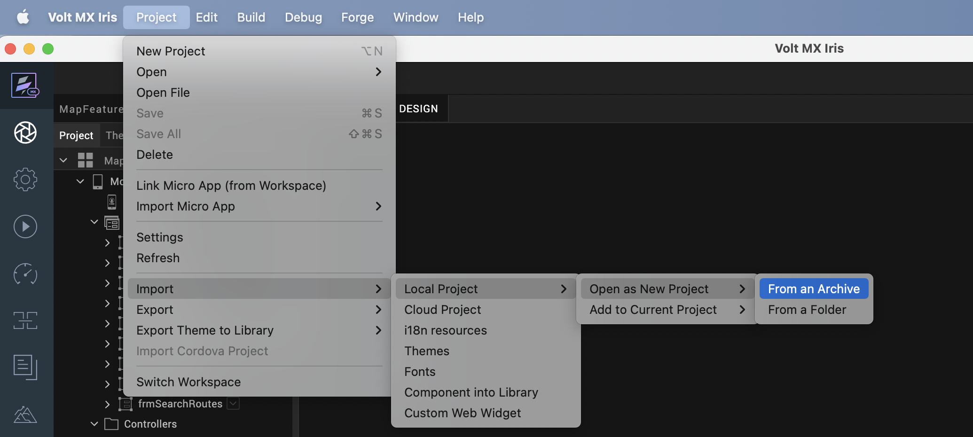

- Click From an Archive to navigate to the location of the project, select the files, and then click Import.
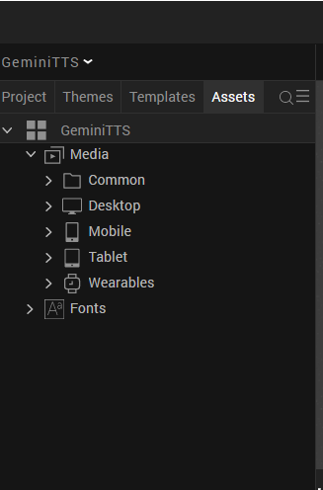

After you import the application, you can view the associated Foundry app connected at the Data & Services section.
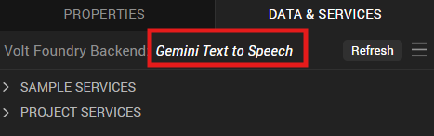

Gemini Text to Speech Volt MX Foundry Services:
The Gemini Text to Speech app contains an Integration Service :
GeminiTexttoSpeech Service: This service is used to convert text to speech.
Operations :
    - TexttoSpeech- Provide the prompt as input text, and it will be converted to Base64-encoded PCM audio.

Configure Native Settings
1. While building the app for Android in Debug and Release mode, need to add below permissions in project settings.
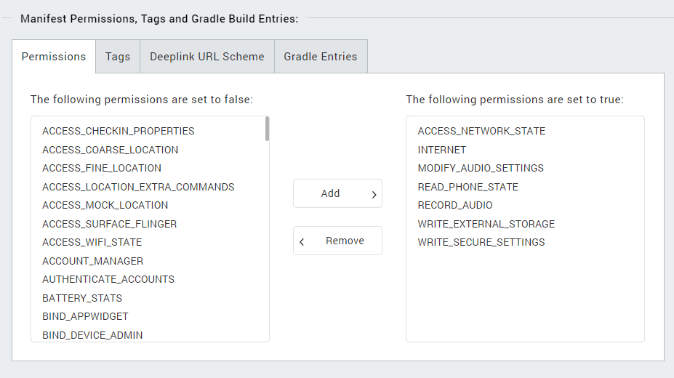
Enter the given snippet in Child tag entries under <manifest > tag
For Android below permissions are required in IRIS project setting > Native> Android Mobile/Tablet -> Tags (Child tag entries under tag) depending on the target version.

<uses-permission android:name="android.permission.MANAGE_EXTERNAL_STORAGE" /> <uses-permission android:name="android.permission.READ_MEDIA_IMAGES" /> <uses-permission android:name="android.permission.READ_MEDIA_VIDEO" /> <uses-permission android:name="android.permission.READ_MEDIA_AUDIO" />
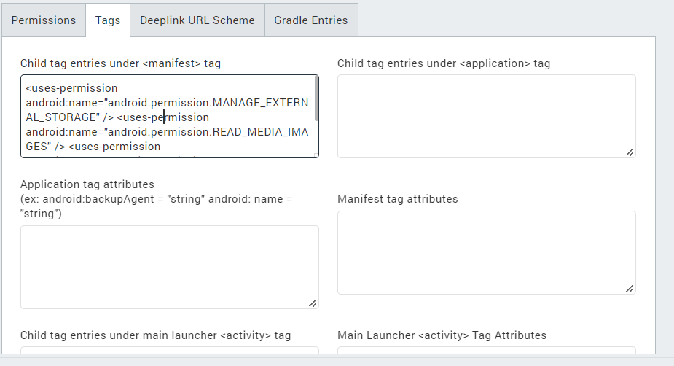

Building the app
From the menu bar, go to Build and then select Build Native Local.
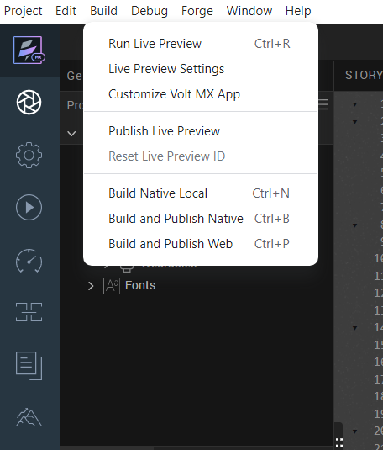

For Mobile, select Android and iOS. Click Build.
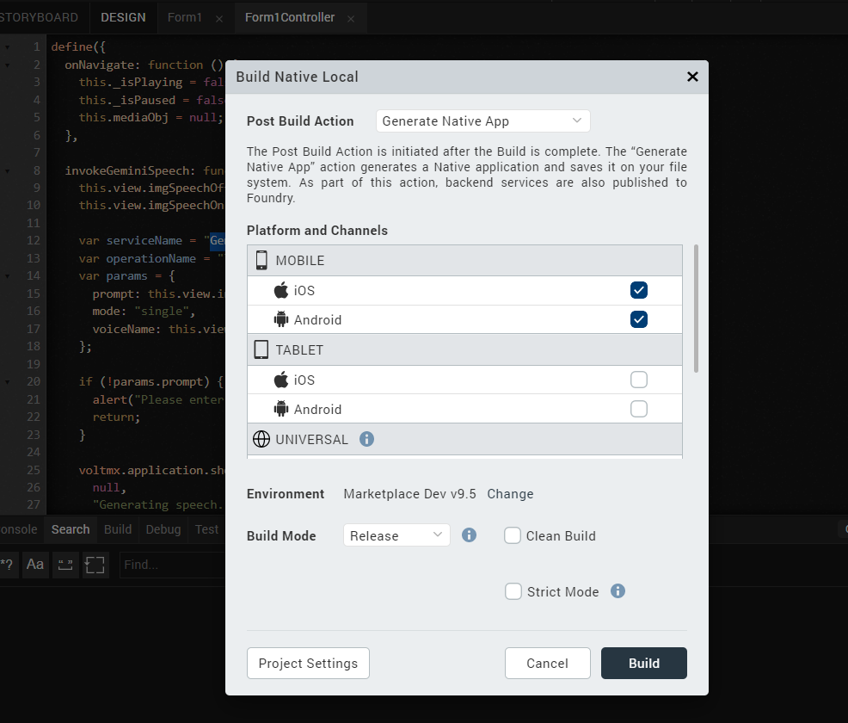

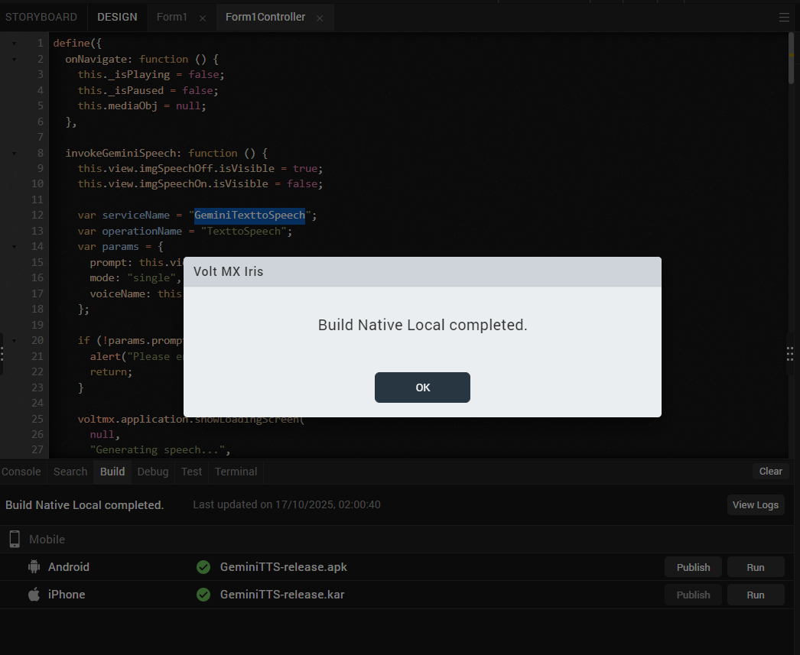

After the build is successful, run the app on your mobile device.

Application Flow
The landing page for the app is as follows:
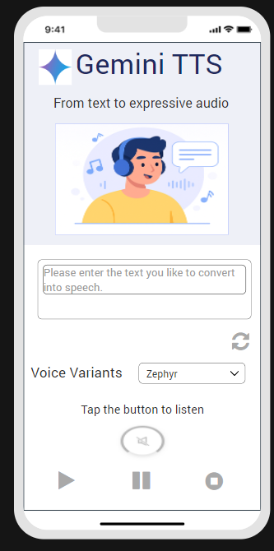

Enter text as input, select a voice variant, and then click the play button to hear the text as audio. Click pause to stop the audio temporarily, and click play again to resume from where it was paused. Click stop to restart the audio from the beginning.

REVISION HISTORY
App version 1.0.0:

A. Limitations
NA

B. Known Issue
- NA

