Date : 04-March-25

GOOGLE GEMINI TEXT GENERATOR

VERSION: 1.0.0

OVERVIEW
The Google Gemini Text Generator API by Google enables developers to generate high-quality, context-aware text using advanced AI models. It supports features like content generation, summarization, and conversational AI, making it ideal for chatbots, writing assistants, and automated responses. Disclaimer: Gemini is a trademark of Google LLC.

Use case:
- Conversational AI & Chatbots – Gemini Text Generation API can power intelligent chatbots and virtual assistants, enabling them to generate human-like responses, maintain context in conversations, and provide personalized interactions.
- Content Creation & Summarization – It assists in generating high-quality articles, blog posts, marketing copy, and summaries, helping writers, businesses, and content creators streamline their workflow efficiently.

Features:
- Context-Aware Text Generation – Produces high-quality, coherent, and contextually relevant text based on user input.
- Content Generation – Assists in writing blog posts, stories, marketing content, and more.
- Summarization & Paraphrasing – Generates concise summaries and rephrases content while maintaining meaning.
- Multilingual Capabilities – Supports multiple languages for global accessibility.
- Code Assistance – Helps with generating and explaining code snippets for developers.
- Conversational AI Support – Enables natural and engaging interactions for chatbots and virtual assistants.
- Seamless API Integration – Easily integrates into applications, websites, and business workflows.

Percentage of re-use:
90% (Data can be customizable and customers need to implement UI by themselves).

GETTING STARTED

Prerequisites
Before you start using the Google Gemini Text Generator data adapter, ensure you have the following:

- HCL Foundry
- Volt MX Iris
- Get a Gemini API Key in Google AI Studio
Reference document: https://ai.google.dev/gemini-api/docs/quickstart?lang=rest

Importing the adapter
To import the Google Gemini Text Generator Adapter to Volt MX Foundry, do the following:
- Sign in to the HCL Foundry
- In the left pane, click the API Management menu. The APIs tab opens by default.
- In API Management, select Custom Data Adapters.
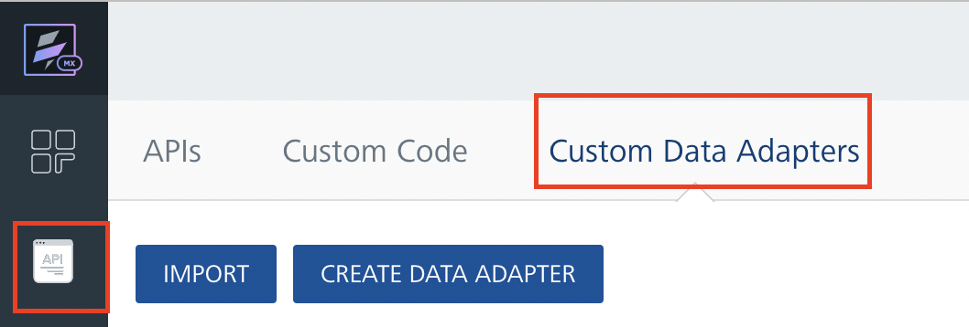
- Click IMPORT to import a custom data adapter.
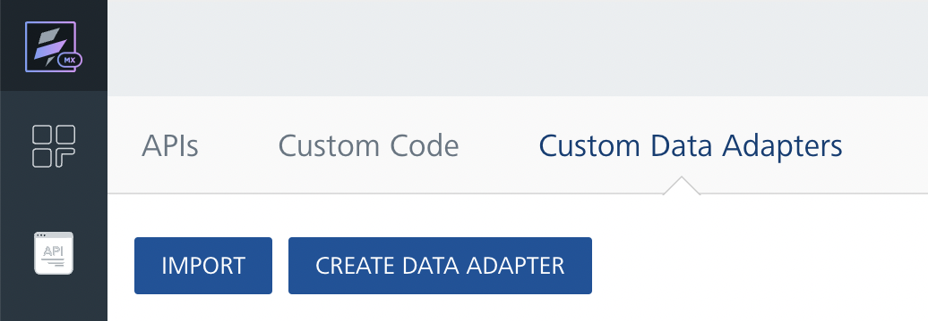
- On the Import Data Adapter dialog box, click browser to import.
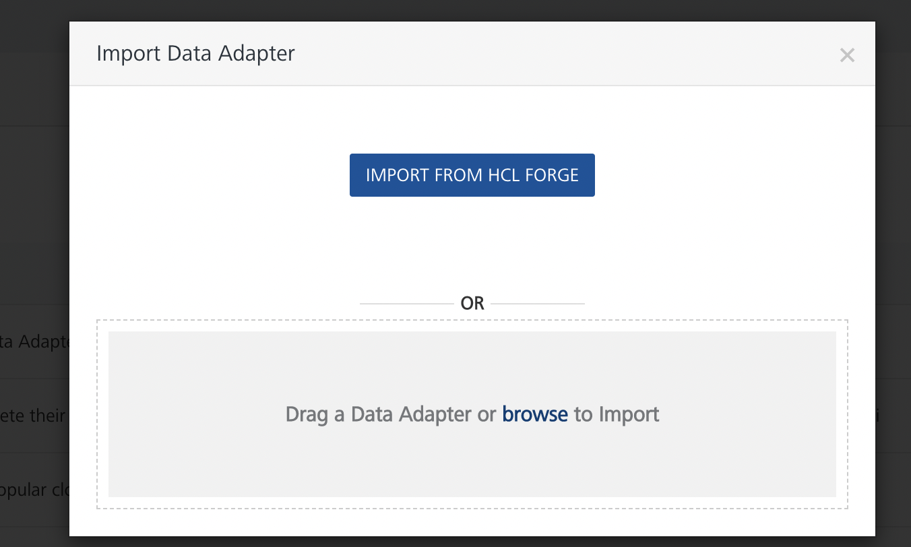
- Drag the data adapter zip file into the Drag a Data Adapter box.
Or
Click browse. The Open dialog appears.
Navigate to the location where you downloaded the data adapter (zip file) on your computer, select the data adapter, and click Open. The Import Data Adapter dialog shows the selected data adapter.
Note: Click Remove if the selected data adapter is not the one that you want to import.
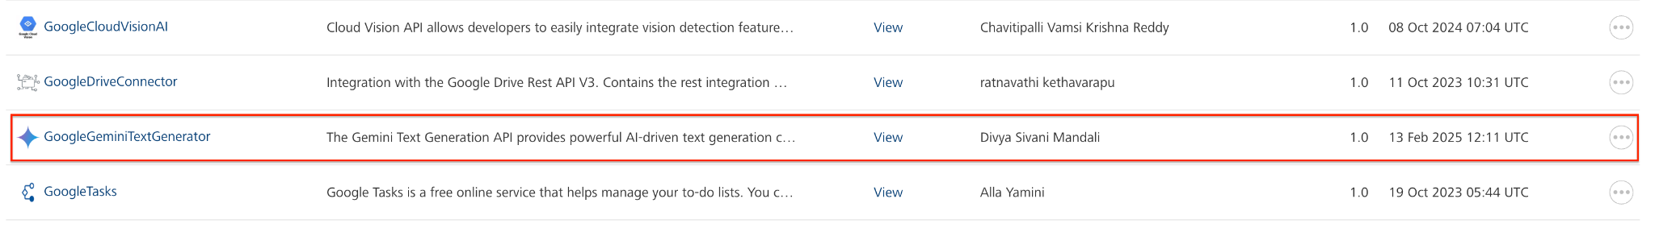
OR
To import the data adapter zip file, do the following:
- Perform steps 1 through 4 in the above procedure
- Click IMPORT FROM HCL FORGE. The Import Data Adapter from HCL Forge dialog appears with a list of available data adapters.
- Click Import. The Google Gemini Text Generator data adapter is listed on the Custom Data Adapters page.
After you import the data adapter, you can view it on the Custom Data Adapters page and use it to create services on Volt MX Foundry.
After you add the data adapter to your Volt Foundry app, you need to get your api key from Google AI Studio. You can refer to Google AI Studio.

Creating an Integration Service with Google Gemini Text Generator
After you import Google Gemini Text Generator API Data Adapter into Volt MX Foundry, you must create an integration service with service type as GoogleGeminiTextGenerator.
To create an integration service with Google Gemini Text Generator, do the following:
- Log on to your HCL Foundry The Dashboard page appears by default.
- In the left pane, click the API Management menu. The APIs tab opens by default.
- Click the Integration tab. The Integration tab opens with a list of existing integration services.
- Click CONFIGURE NEW. The Service Definition tab opens.
- In the Name box, type a unique name for your service.
- From the Service Type list, select GoogleGeminiTextGenerator.
Note: The Google Gemini Text Generator API is listed only after you import the Google Gemini Text Generator Data Adapter into Volt MX Foundry.
- Under Authentication select Use Existing Identity provider. From the drop-down list select Google Gemini Text Generator API.
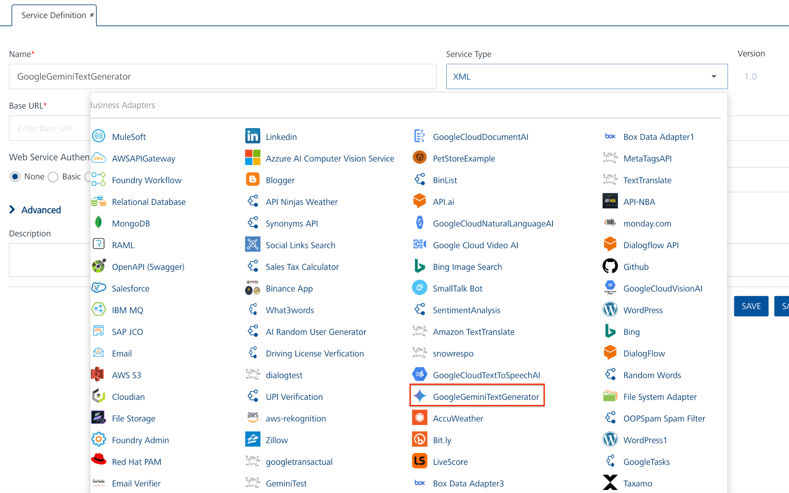
- Click Save.
If the details provided are valid, the Volt MX Foundry service connects to your Google Gemini Text Generator API developer site and allows you to make the API calls.
Refer to Integration Services for more information on creating and using integration services.

Creating an Operation
To make any API call in the Volt MX Foundry console, you must create an operation for the respective API and then execute the operation. Executing an operation involves making the API call and displaying the response. For more information, see Executing an Operation.
This section provides steps to create an operation for the textGeneration API.
Steps to create an operation for the textGeneration API:
- Log on to your HCL Foundry. The Dashboard page appears by default.
- In the left pane, click the API Management menu. The APIs tab opens by default.
- Click the Integration tab. The Integration page appears with a list of existing integration services.
- From the list of integration services, select the integration service that you have created with service type as textGeneration. The Service Definition tab of the selected integration service opens by default.
- Click the Operations List tab. The Operations List tab opens.
- Click the context menu arrow to expand the Please Select list. The service is displayed.
- Click the plus icon to expand the list.
- Click the plus icon to expand the Services list and select textGeneration.
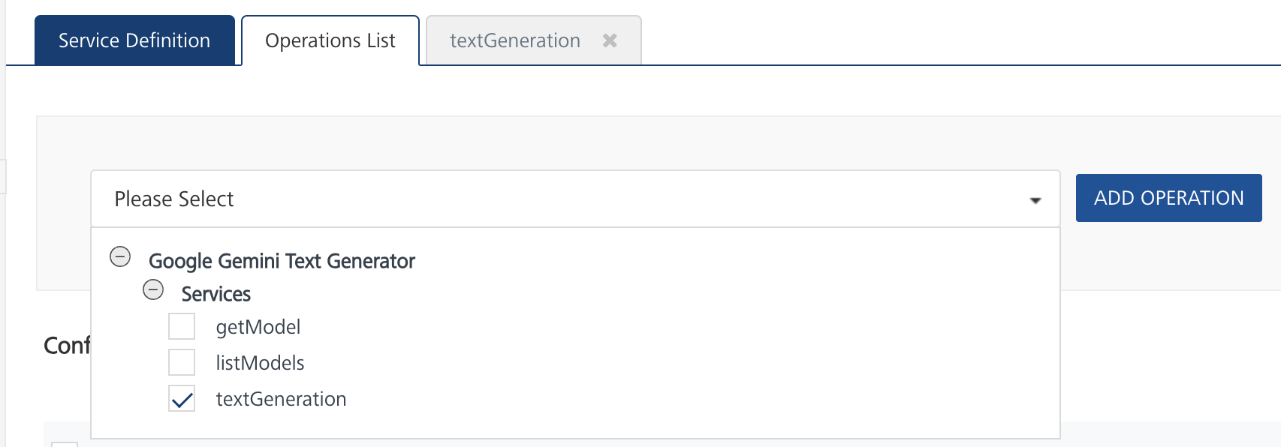
- Click ADD OPERATION. The textGeneration operation is listed in the Configured Operations section.
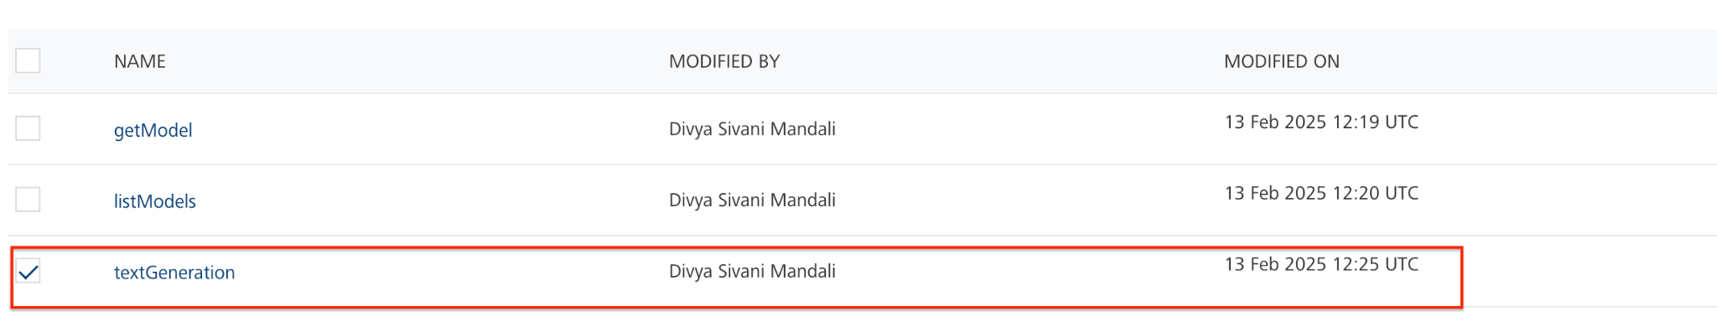
Note: You can follow the same steps to create operations for other methods, but ensure that you select the required API.
You can create multiple operations with required APIs and save them in the Configured Operations section. You can then execute the operations whenever required.

Executing an Operation
Executing an operation involves making the API call by setting the necessary parameters and displaying the response. The procedure to execute any operation is the same, but the request parameters of the APIs vary. For more information on request parameters of API, refer Gemini Text Generation.
This section provides steps to execute the textGeneration operation (explained in Creating an Operation).
Steps to execute the textGeneration operation:
- Log on to your HCL Foundry. The Dashboard page appears by default.
- In the left pane, click the API Management menu. The APIs tab opens by default.
- Click the Integration tab. The Integration tab opens with a list of existing integration services.
- From the list of integration services, select the integration service that you have created with the service type as textGeneration. The Service Definition tab of the selected integration service opens by default.
- Click the Operations List tab.
- Under the Configured Operations section, click the textGeneration operation. The textGeneration tab opens with the Request Input sub-tab opened by default.
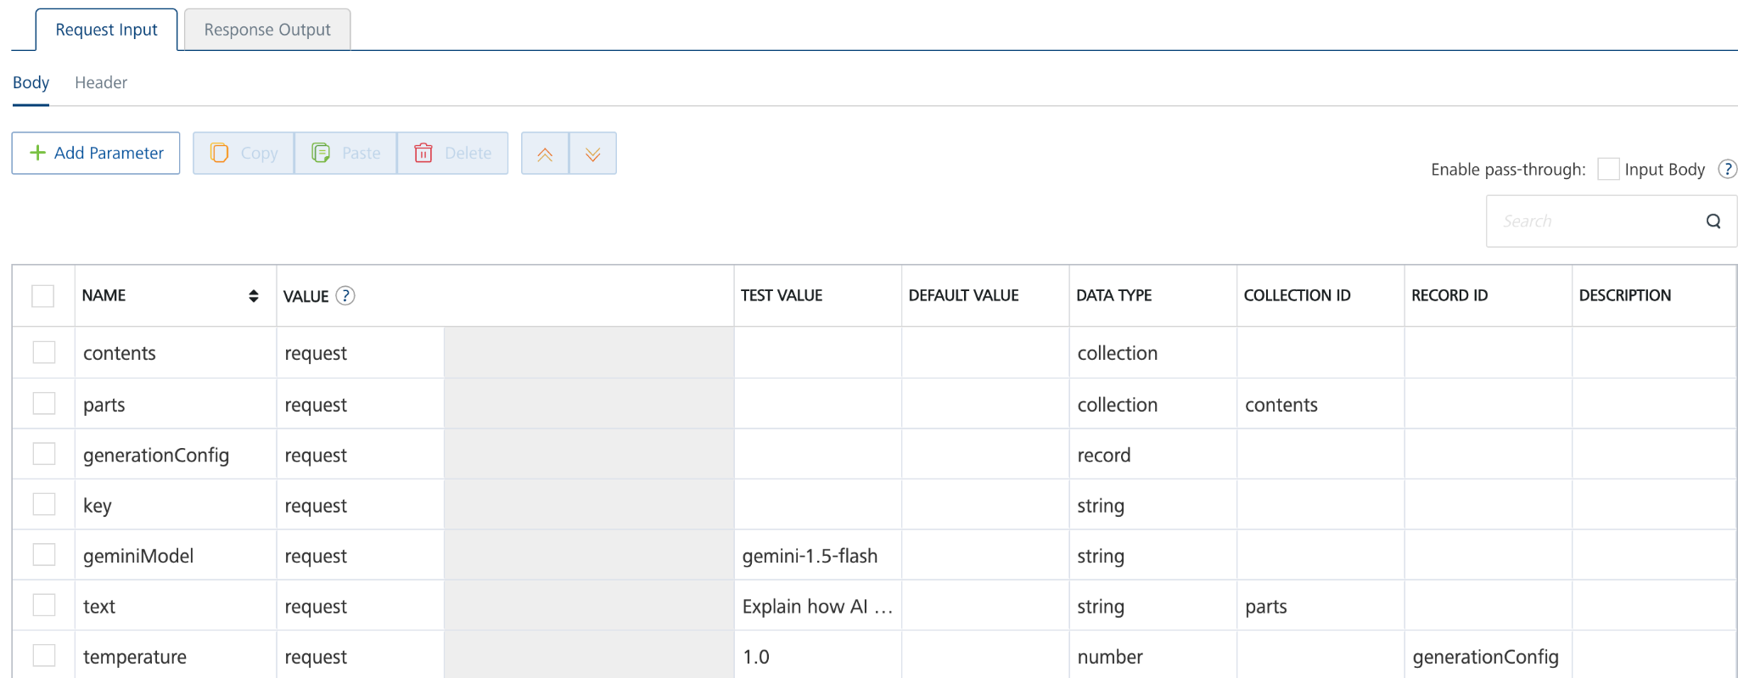
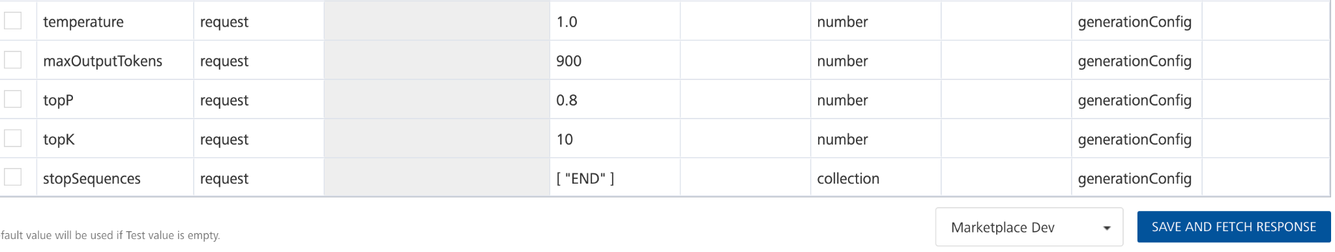
- In the Name box, the name of the operation is displayed by default. If you want, you can change the name.
- On the Request Input tab, in the Body section, for the following parameters, specify the values in the respective boxes under the Test Value column.
Mandatory Parameters
- Key: To use the Gemini API, you need an API key. You can create a key with a few clicks in Google AI Studio.
- geminiModel: The name of the Model to use for generating the completion. The Gemini API offers different models that are optimized for specific use cases. Refer this https://ai.google.dev/gemini-api/docs/models/gemini#model-variations
- text: Represents the input prompt that the Gemini model will process to generate a response.
- stopSequences specifies the set of character sequences (up to 5) that will stop output generation. If specified, the API will stop at the first appearance of a stop_sequence. The stop sequence won't be included as part of the response.
- temperature controls the randomness of the output. Use higher values for more creative responses, and lower values for more deterministic responses. Values can range from [0.0, 2.0].
- maxOutputTokens sets the maximum number of tokens to include in a candidate.
- topP changes how the model selects tokens for output. Tokens are selected from the most to least probable until the sum of their probabilities equals the topP value. The default topP value is 0.95.
- topK changes how the model selects tokens for output. A topK of 1 means the selected token is the most probable among all the tokens in the model's vocabulary, while a topK of 3 means that the next token is selected from among the 3 most probable using the temperature. Tokens are further filtered based on topP with the final token selected using temperature sampling.
For more information refer to this https://ai.google.dev/api/generate-content
- Click SAVE OPERATION.
- Click SAVE AND FETCH RESPONSE. The Output Result dialog appears with the response. Otherwise, the Output Result shows an error.
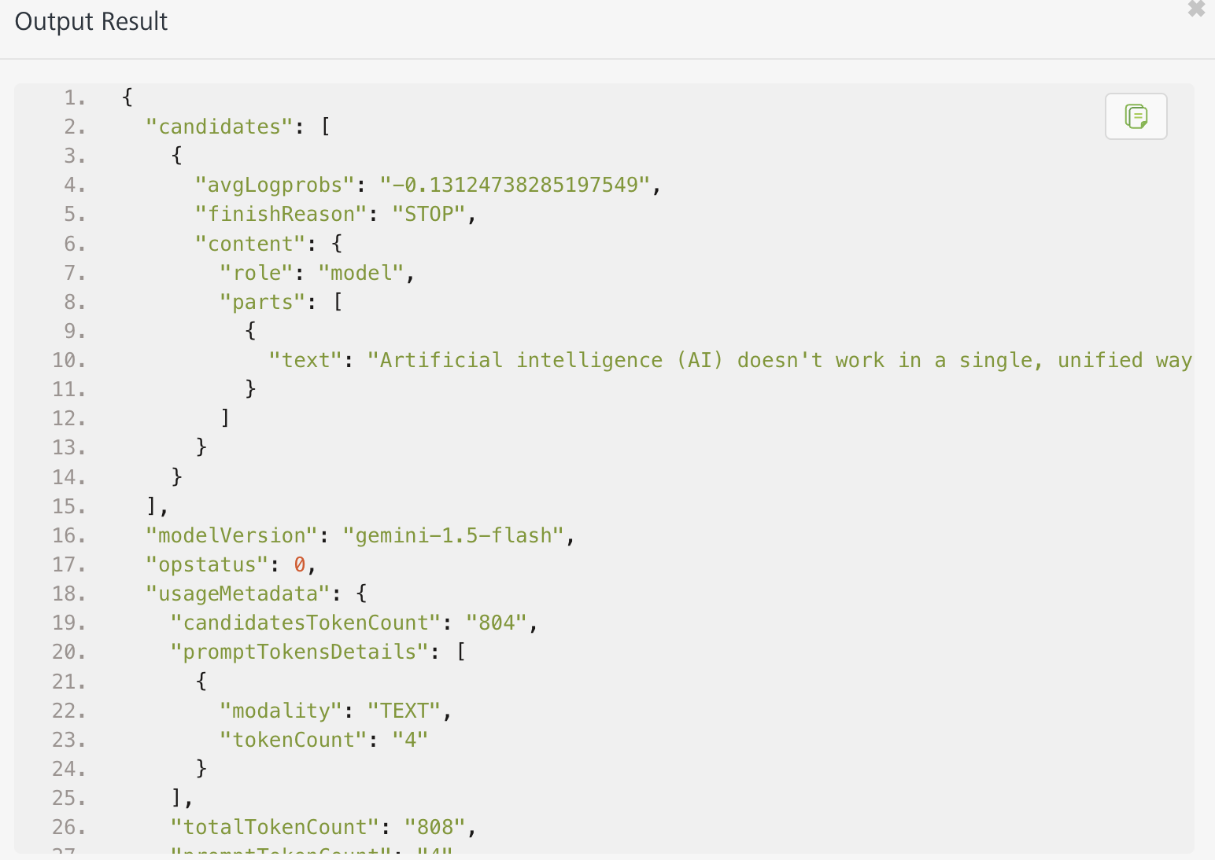

Publishing the App to Volt MX Foundry
After adding Google Gemini Text Generator to your app and configuring the necessary configurations, you must publish the app to Volt MX Foundry. For more information, refer to Publish a Project to Volt MX Foundry.
If you want to use the services in client applications, you need to publish the app to a run-time environment.
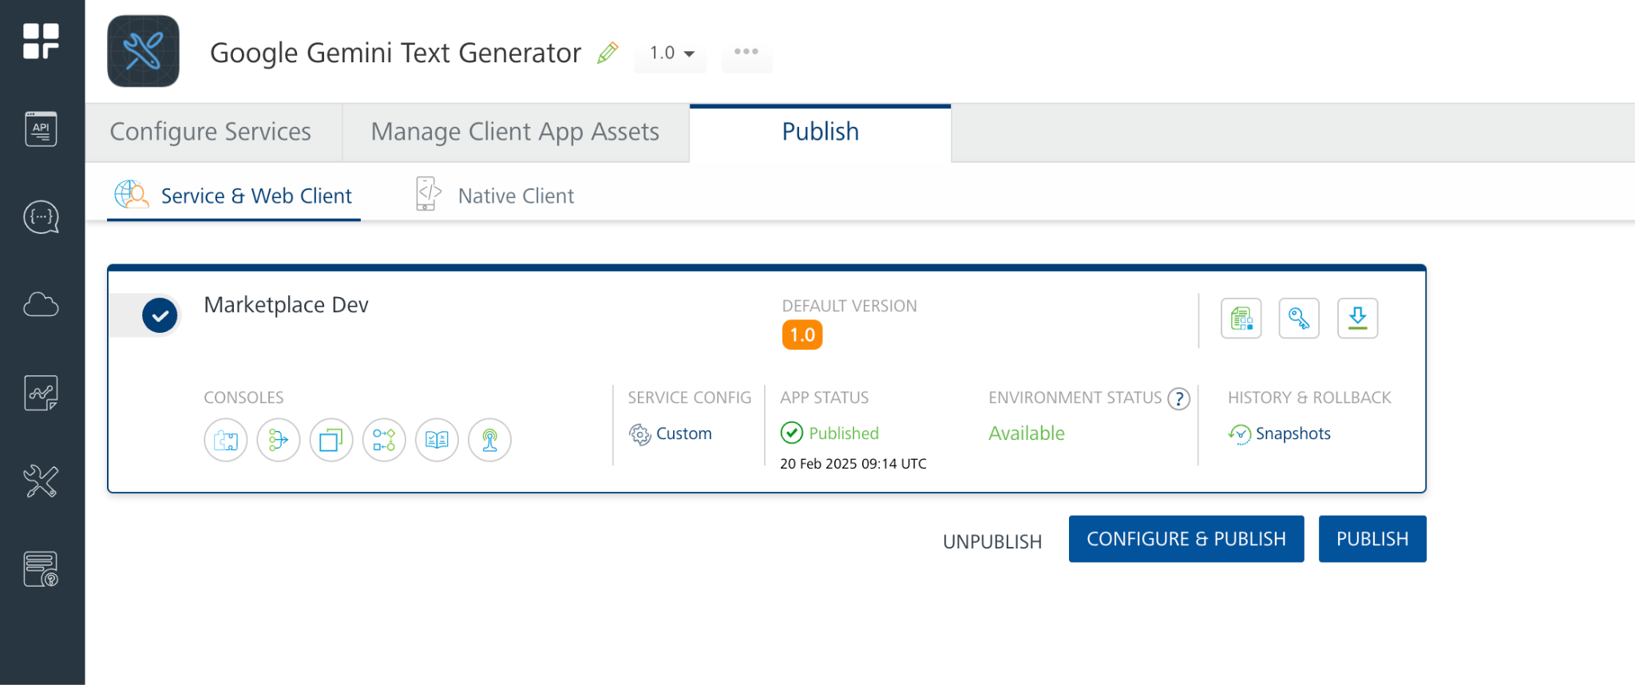
You can also link the Volt Foundry app to a client application.

Reference Document: https://ai.google.dev/gemini-api/docs/text-generation?lang=rest

REVISION HISTORY
App version 1.0.0:

Known Issues
None

Limitations
None

