Date : 30-Oct-25

GOOGLE GEMINI IMAGE UNDERSTANDING APPLICATION

VERSION: 1.0.0

OVERVIEW
Google Gemini Image Understanding Application enables seamless interaction with Google’s Gemini multimodal AI models for intelligent image analysis. This component allows you to upload image files (JPG, PNG, etc.) along with a text prompt, and receive AI-generated responses derived from both the visual and textual elements present in the image.
Google Gemini Image Understanding is a capability of Google’s Gemini multimodal AI models that allows them to see, interpret, and analyze images in their entirety — not just detecting objects or text, but understanding layout, composition, visual context, and relationships between elements to derive deeper meaning and insights.
Key features of the application:
- Full-Context Visual Analysis
Understands entire images holistically — including layout, composition, and spatial relationships — to derive context-aware insights beyond basic object or text detection.
- Multi-Modal Intelligence
Processes both visual and textual elements such as charts, diagrams, graphs, infographics, and handwritten content, enabling deeper semantic interpretation.
- Structured Output Generation
Delivers results in JSON, plain text, or tabular formats, suitable for integration into analytics, automation, or reporting systems.
- Flexible Input Methods
Supports image uploads (JPG, PNG) or Base64-encoded image data for inline or API-based processing, ensuring compatibility across web and mobile applications.
- Technical Capabilities
- Maximum file size: up to 20 MB per image
- Supported formats: JPG, JPEG, PNG

Requirements:

- HCL Foundry
- Volt MX Iris
- To use the Gemini API, you need an API key. You can create a key with a few clicks in Google AI Studio.Get a Gemini API key in Google AI Studio
- Image Requirements
- Supported formats: JPG, JPEG, PNG
- Maximum file size: 20 MB per image (for inline Base64 uploads)
- Image quality: Use clear, high-resolution images — avoid blurry, cropped, or low-contrast visuals.
- Orientation: Ensure images are upright for accurate interpretation.
- Content: Images may include charts, diagrams, handwritten notes, or scanned pages for best multimodal analysis.
Reference Image: ​​https://ai.google.dev/gemini-api/docs/image-understanding

Devices:
- Mobile

Platforms:
- Android
- IOS

App Functionality

When you build and run the app, you can upload a Image file (≤20MB), enter a text prompt, and retrieve AI-generated responses based on both the textual and visual elements of the Image.
Home Screen (frmHome)
- The user uploads an image (≤20MB) either from the device gallery or by capturing it using the camera.
- The user enters a text prompt or query (e.g., “Describe this image” or “Extract text from this photo”).
- The uploaded image, the entered query, and the AI-generated result are all displayed in the UI for reference.
- Google Gemini Image Understanding processes both the visual and textual inputs to generate a context-aware response.
Image Processing
- The app passes the uploaded image (Base64-encoded) and the text prompt to the Google Gemini Image Understanding Component.
- Gemini AI analyzes the image, interpreting both visual and textual elements — such as objects, handwriting, diagrams, and embedded text — to generate a meaningful response.
Response Handling
- Displays the AI-generated response (e.g., description, extracted text, detected objects, or summarized insights).
- Shows the user’s entered query and the uploaded image for context in the UI.
Error Handling
- If image analysis fails, the app displays a failure alert and resets the response area, allowing the user to retry with a new image or prompt.

Importing the app
To import the Google Gemini Image Understanding Application into your workspace, follow these steps:
- Open Volt MX Iris
- On the main menu select Forge → Browse.
- Search for the Google Gemini Image Understanding Application, and then click Import to Workspace. The app is imported to your workspace. A dialog box appears, confirming that the app has been imported. Click OK.
- Switch to your project containing the Google Gemini Image Understanding Application. To switch to your project, click File → Open → Reference Architecture → <project name>

Building the app
After performing all the above steps, you can build your app and run it on your device. For more information, you can refer to the Building and Viewing an Application section of the Volt MX User Guide.
You can then run your app to see the Google Gemini Image Understanding Application work in real time.

Configure the UI and settings of the Google Gemini Image Understanding Application

The Google Gemini Image Understanding Application consists of the following key components:
- Google Gemini Image Understanding Component – Used to read, interpret, and analyze Image files (≤20MB) with text prompts, and generate AI-powered responses based on both textual and visual elements such as layout, tables, images, and charts.
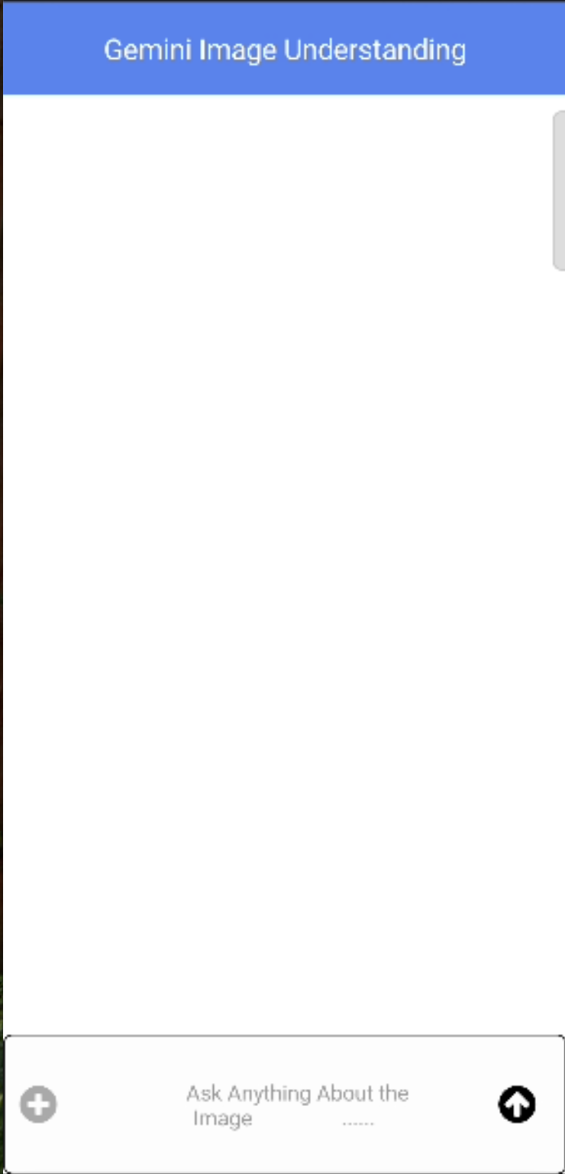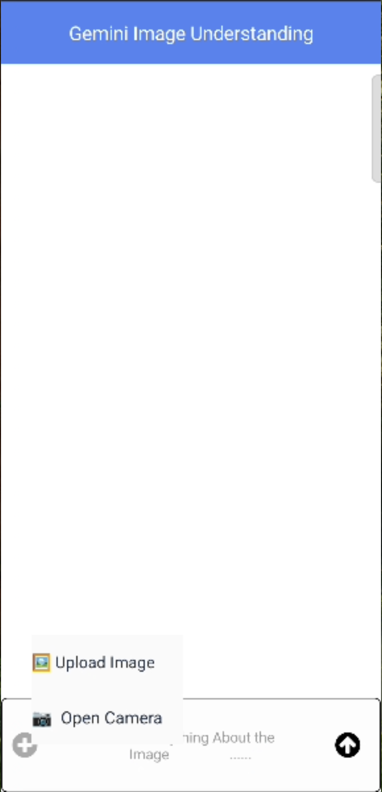

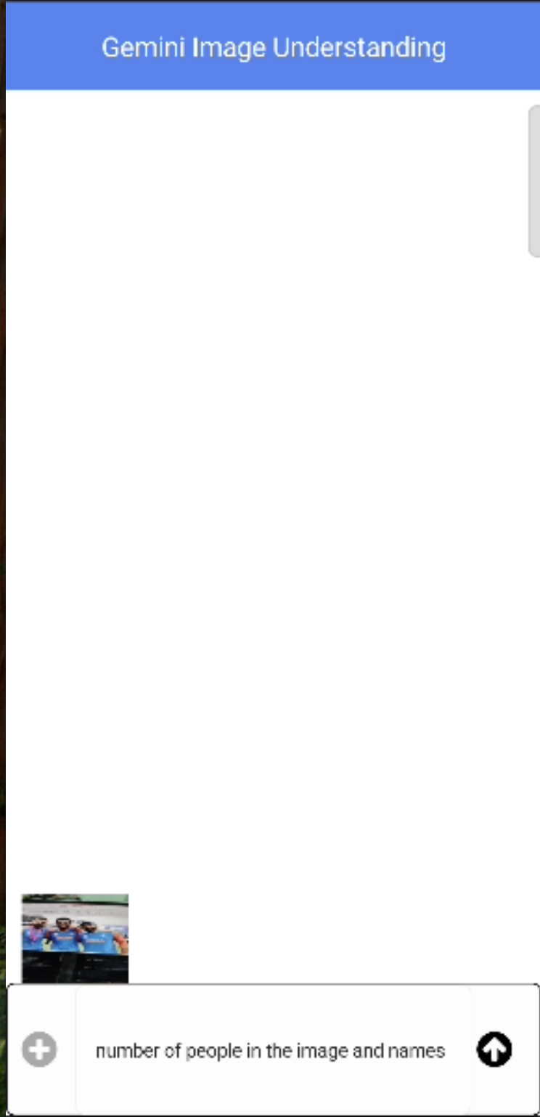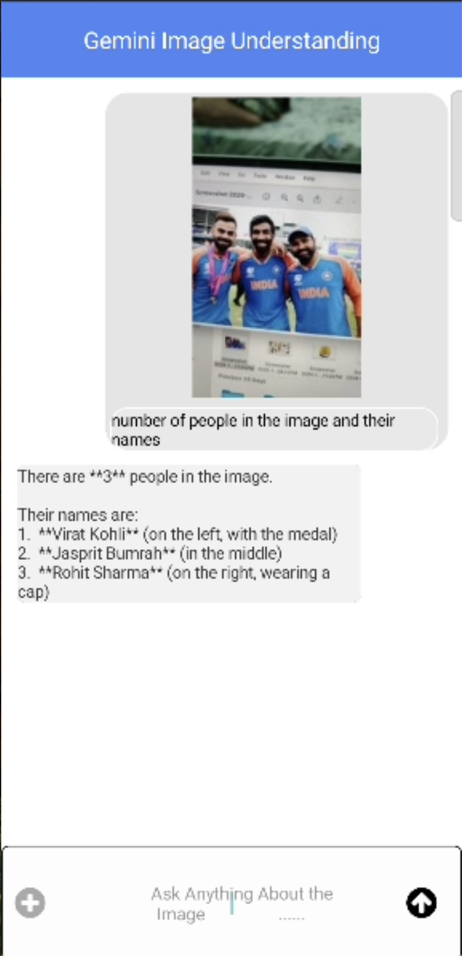

Configuring Native Settings (Android)

To configure the native settings for Android, follow these steps:
1. From the left navigation menu, click Project Settings.
2. In the Project Settings window, go to Native → Android Mobile/Tablet.
3. We need to give the below permissions for Android Mobile.
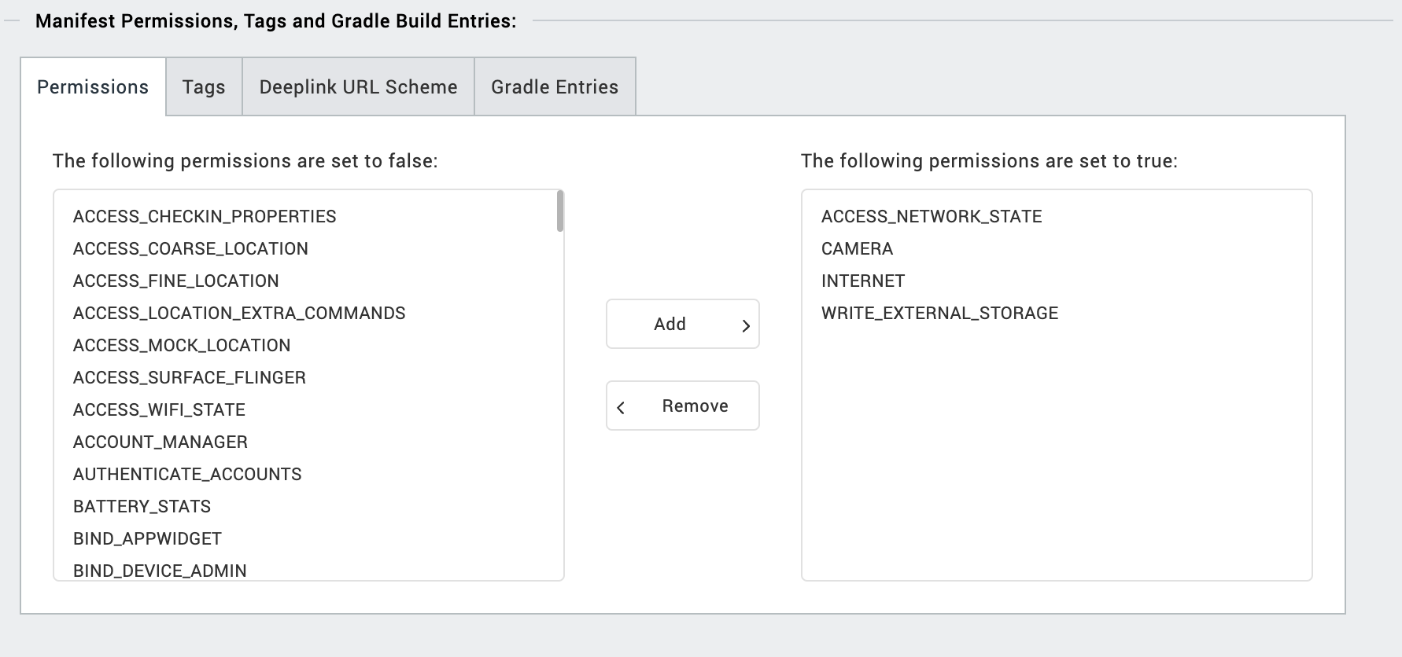
4. Enter the given snippet in Child tag entries under <manifest > tag

<uses-permission android:name="android.permission.READ_MEDIA_VISUAL_USER_SELECTED"/>
<uses-permission android:name="android.permission.READ_MEDIA_IMAGES" />
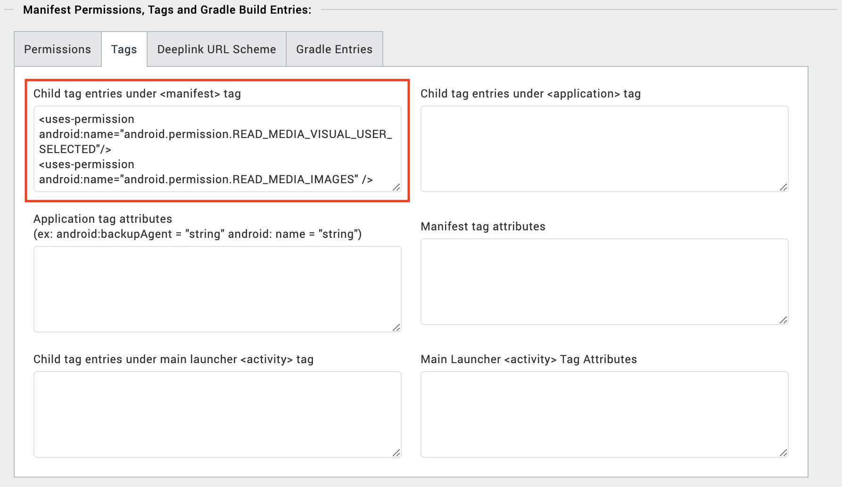
IOS:
Follow the steps given to enable the permissions.
1. From the Project explorer, navigate to the Assets tab.
2. Right click Media and select Resource Location to open the project resources folder.
3. In the browser window that opens, navigate to the common folder.
4. Open the infoplist_configuration.json file with a text or code editor.
5. Add the given code at the end of the file. You can replace the values with your own descriptions.
{
"NSCameraUsageDescription" : " This app uses Camera ",
"NSPhotoLibraryUsageDescription" : "This app uses photo library"
}

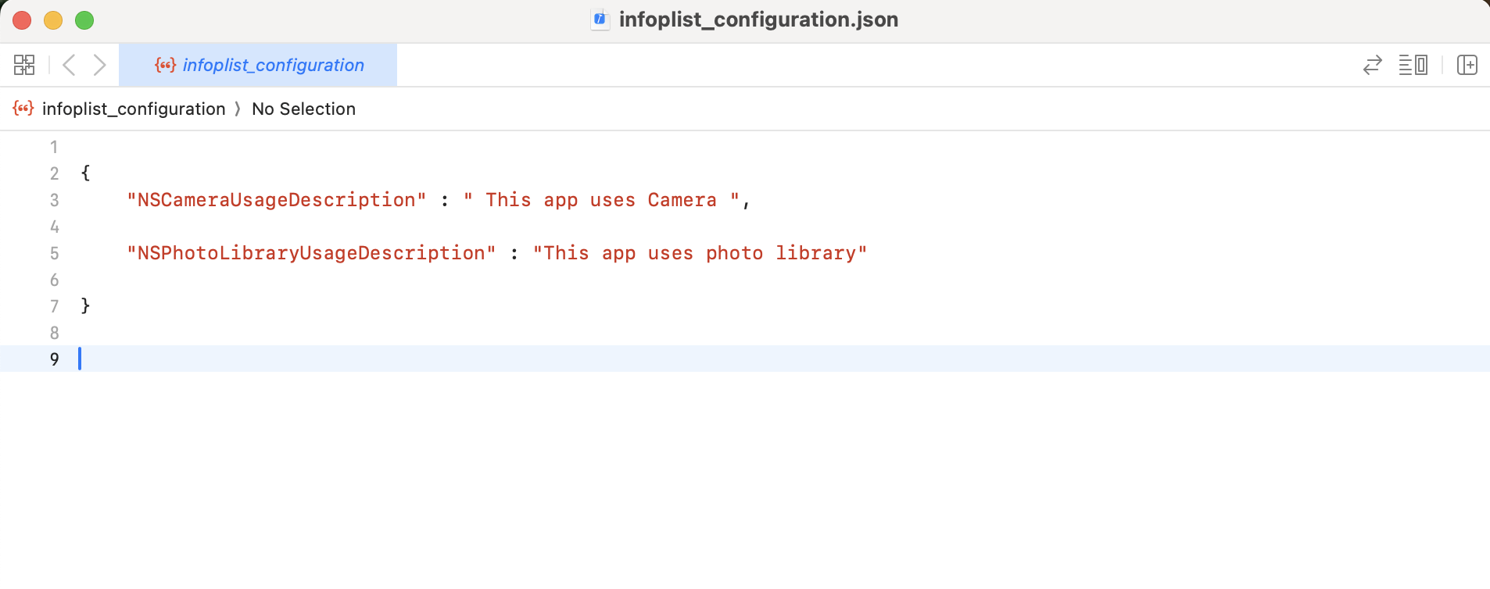
- Foundry APP Setup
When you import the component to your Volt MX Iris project, the HCL Volt MX Foundry services of the Google Gemini Image Understanding are added to the HCL Volt MX Foundry app, which is associated with the Volt MX Iris project. While importing the Google Gemini Image Understanding Component to your Volt MX Iris project, if there is no HCL Volt MX Foundry app associated with the existing Volt MX Iris project, a new HCL Volt MX Foundry app is automatically added to your HCL Volt MX Foundry environment and is associated with your Volt MX Iris.
To set the Foundry app, follow these steps:
- Click the HCL Volt MX Foundry app associated with your Volt MX Iris project from the Project Explorer. Click DATA & SERVICES.
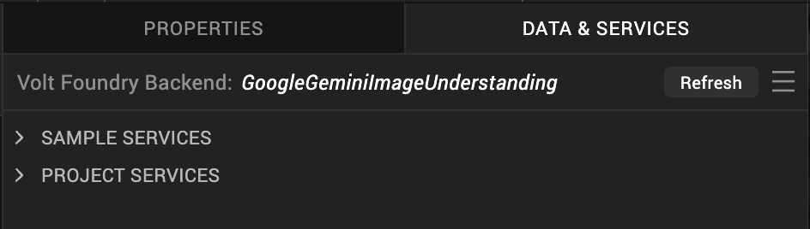
- Under the Configure Services tab, click Integration and can see the GeminiImageUnderstanding Integration service. Click on that Integration service to add the keys.
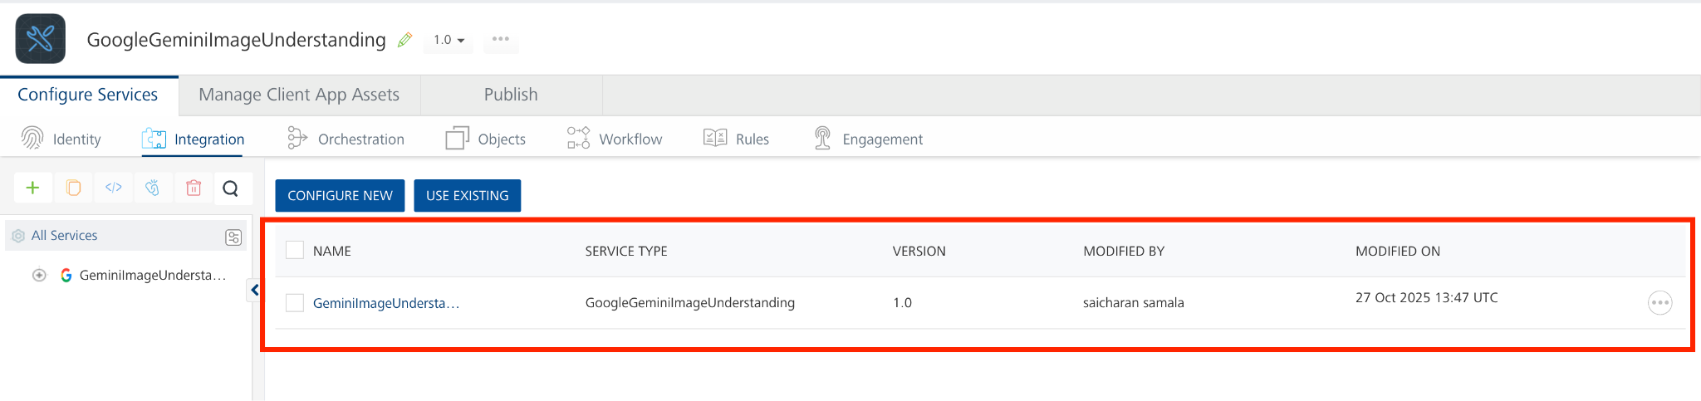
- Click the Operations List tab. The Operations List tab opens with the list of operations available.
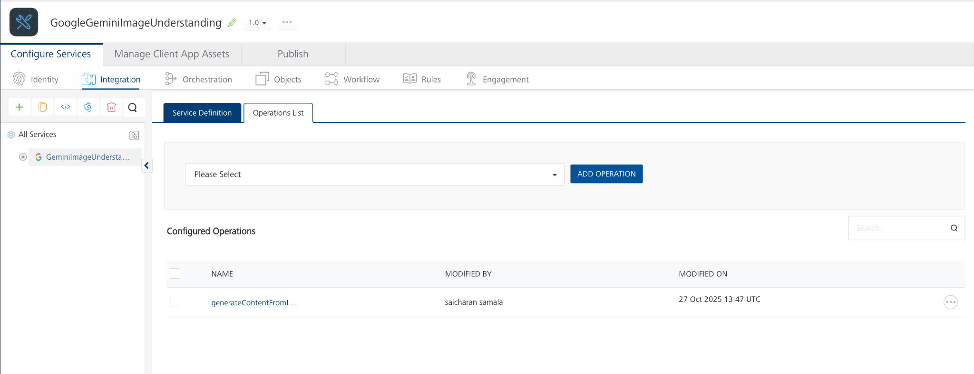
- Executing an Operation
Executing an operation involves making the API call by setting the necessary parameters and displaying the response. The procedure to execute any operation is the same, but the request parameters of the APIs vary. For more information on request parameters of API, refer Passing Inline Image Data (Base64).
This section provides steps to execute the generateContentFromImage operation.
A) Under the Configured Operations section, click the generateContentFromImage operation. The generateContentFromImage tab opens with the Request Input sub-tab opened by default.
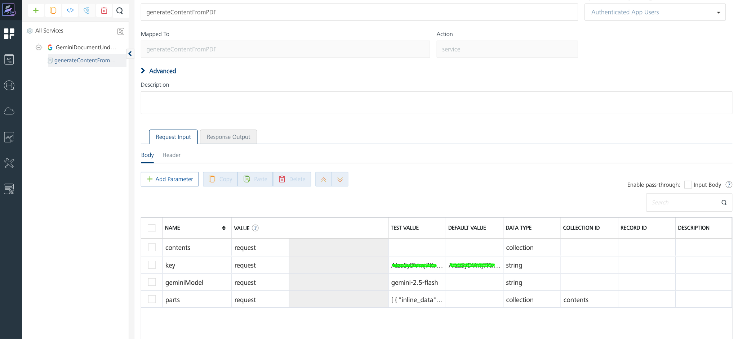

B) On the Request Input tab, in the Body section, for the following parameters, specify the values in the respective boxes under the Test Value column.
Mandatory Parameters
- key: To use the Gemini API, you need an API key. You can create a key with a few clicks in Google AI Studio. In the box under the TEST VALUE and DEFAULT VALUE columns, type the API Key generated
- geminiModel: The name of the Model to use for generating the completion. The Gemini API offers different models that are optimized for specific use cases. For Example : gemini-2.5-flash
- parts: The parts parameter specifies the input data passed to the Gemini API for processing. Each part represents either Image content (inline data) or instructions/questions (text prompt).
- inline_data – Used to send the actual Image for Gemini to process. Image File Size should be less than 20MB
  - mime_type: The file type (e.g., application/Image).
  - data: The Base64-encoded file content (Image.).
- text – Used to provide instructions, questions, or prompts related to the Image.
We need to pass the parts value in request body like this

[
{
"inline_data": {
"mime_type": "image/jpeg",
"data": "base64 encoded image "
}
},
{
"text": "Caption this image."
}
]

C) Click SAVE OPERATION.
D) Click SAVE AND FETCH RESPONSE. The Output Result dialog appears with the response. Otherwise, the Output Result shows an error.
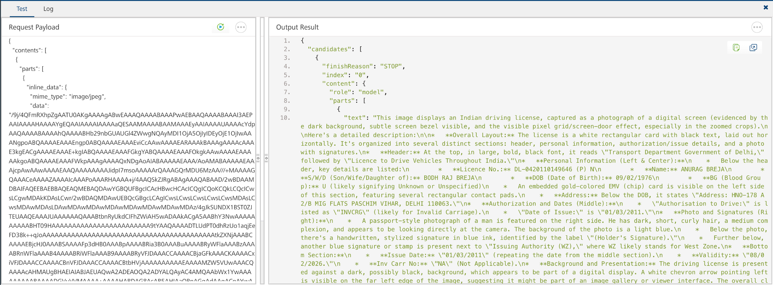

Publish the HCL Volt MX Foundry App
After you set the Operation Security Level, you must publish the HCL Volt MX Foundry app. To publish the HCL Volt MX Foundry, follow these steps:
In Volt MX Iris, click DATA & SERVICES, and then click Publish Project Services to Publish to your foundry app.
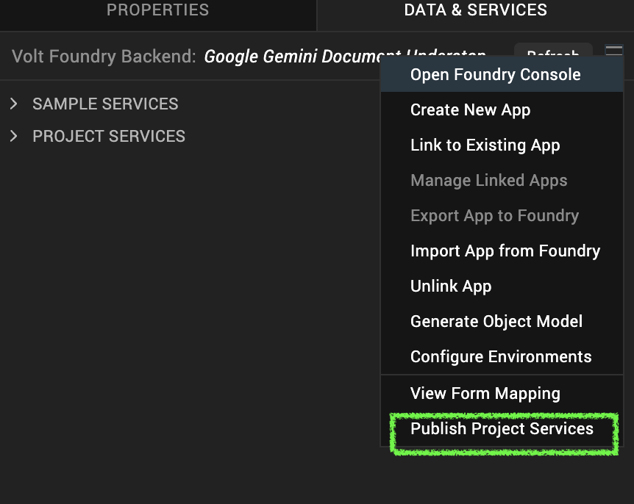
Select the environment to which you want to publish your app, and then click Publish.
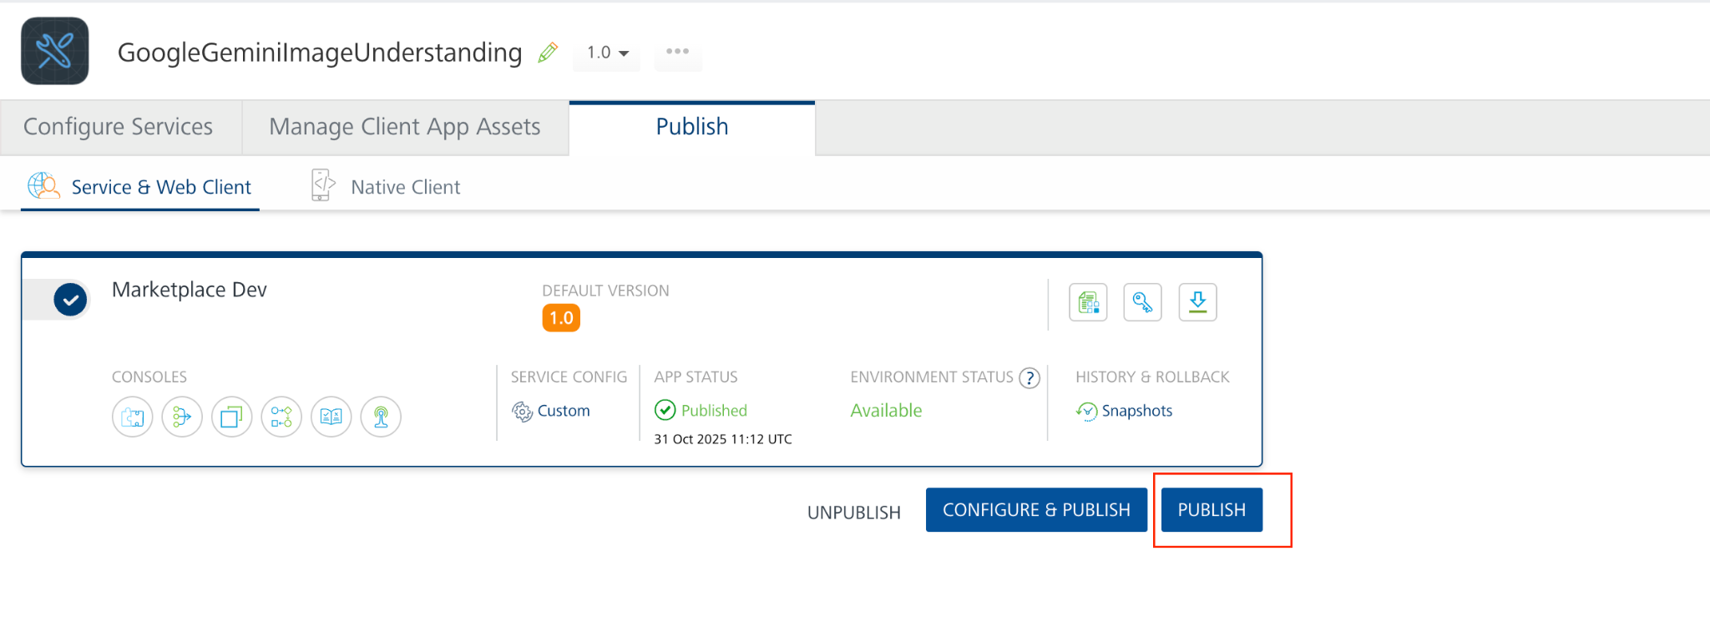
After the app is published to your environment, the following window appears confirming the publish.
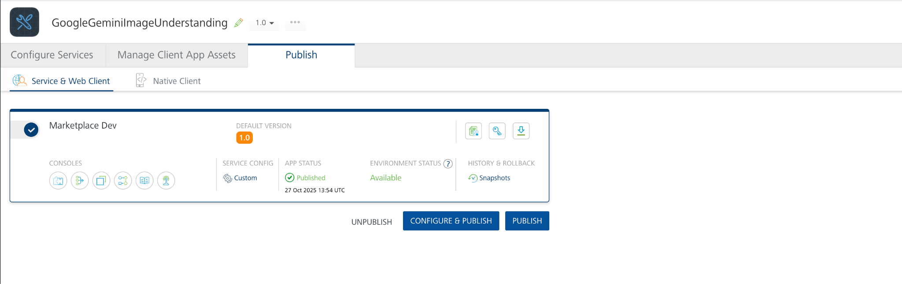

Building and previewing the app
After performing all the above steps, you can build your app and run it on your device. For more information, you can refer to the Building and Viewing an Application section of the Volt MX User Guide.
You can then run your app to see the Google Gemini Image Understanding work in real time.

Reference Image: https://ai.google.dev/gemini-api/docs/Image-processing

REVISION HISTORY
App version 1.0.0:

Known Issues
None

Limitations
- Use Image less than 20 MB for base64 encoded Images. Refer this https://ai.google.dev/gemini-api/docs/Image-processing#inline_data

