Date : 08-Sep-25

GOOGLE GEMINI DOCUMENT UNDERSTANDING APPLICATION

VERSION: 1.0.0

OVERVIEW

The Google Gemini Document Understanding Application is a sample app that demonstrates how to leverage Google’s Gemini multimodal AI models for intelligent document analysis. It is built using the Google Gemini Document Understanding Component and provides an end-to-end workflow for users to interact with PDF documents.
Google Gemini Document Understanding is a capability of Google’s Gemini multimodal AI models that allows them to read, interpret, and analyze PDF documents in their entirety — not just extracting text, but understanding the layout, formatting, images, charts, and tables to derive meaning and context.
Key features of the application:
- PDF Upload & Preview: Users can upload a PDF file (≤20MB) and view the selected document directly within the application.
- Prompt Input & Display: Users can enter a text prompt or query, which is displayed in the UI for clarity and context.
- AI-Powered Response: The application processes the uploaded PDF and user prompt with Gemini AI to generate context-aware responses, interpreting both text and visual elements.
- Response Display with Copy Option: The AI-generated output is displayed on-screen with a convenient “Copy” option for quick reuse.
- Seamless UI Workflow: The application resets and updates the UI for each request, showing the uploaded file, entered query, and AI response in a clear and interactive way.

Requirements:

- HCL Foundry
- Volt MX Iris
- To use the Gemini API, you need an API key. You can create a key with a few clicks in Google AI Studio.Get a Gemini API key in Google AI Studio
- Document Requirements
- PDF format for full visual understanding
- Max 1000 pages
- Max file size:
- 20MB for inline Base64 uploads
- Clear, high-resolution pages (avoid blurry scans)
- Correct page orientation
Reference document: https://ai.google.dev/gemini-api/docs/document-processing

Devices:
- Mobile

Platforms:
- Android
- IOS

Features
- Full-Context Analysis - Reads the document as a whole, considering layout, order, and visual context.
- Multi-Modal Understanding - Interprets both text and images (charts, diagrams, scanned handwriting).
- Structured Output - Can output JSON, tables, or text summaries for downstream processing.
- Flexible Input Methods
a) Inline PDF (Base64-encoded) for quick processing (≤20MB)

App Functionality

When you build and run the app, you can upload a PDF file (≤20MB), enter a text prompt, and retrieve AI-generated responses based on both the textual and visual elements of the document.

Home Screen (frmHome)
- The user uploads a PDF file (≤20MB).
- The user enters a text prompt/query (e.g., “Summarize this document”).
- Sample filename(Static data) to view the PDF and entered query are displayed in the UI.
Document Processing
- The app passes the PDF (Base64-encoded) and the text prompt to the Gemini Document Understanding Component.
- Gemini AI analyzes the document, interpreting both text and visual elements (layout, tables, charts, images).
Response Handling
- Displays the AI-generated response (e.g., summary, extracted info, answers).
- Provides a Copy option (Using CopyToClipboard component) for users to copy the response to the clipboard.
- Shows the user’s entered query and selected PDF file for context.
PDF Viewing
- Users can tap the filename to view the uploaded PDF directly within the app using Browser Widget.
Error Handling
- If document analysis fails, the app shows a failure alert and resets the response area.

Importing the app
To import the Google Gemini Document Understanding Application into your workspace, follow these steps:
- Open Volt MX Iris
- On the main menu select Forge → Browse.
- Search for the Google Gemini Document Understanding Application, and then click Import to Workspace. The app is imported to your workspace. A dialog box appears, confirming that the app has been imported. Click OK.
- Switch to your project containing the Google Gemini Document Understanding Application. To switch to your project, click File → Open → Reference Architecture → <project name>

Building the app
After performing all the above steps, you can build your app and run it on your device. For more information, you can refer to the Building and Viewing an Application section of the Volt MX User Guide.
You can then run your app to see the Google Gemini Document Understanding Application work in real time.

Configure the UI and settings of the Google Gemini Document Understanding Application

The Google Gemini Document Understanding Application consists of the following key components:
- Google Gemini Document Understanding Component – Used to read, interpret, and analyze PDF files (≤20MB) with text prompts, and generate AI-powered responses based on both textual and visual elements such as layout, tables, images, and charts.
UI Configuration
- Create the Home Screen
  - In Form, add the Google Gemini Document Understanding Component.
  - Add a Browser Widget to display the uploaded PDF.
  - Add a Label to display the user’s entered query.
  - Add a Typing/Loading Animation Widget to show while Gemini is generating the response.
  - Add a Label to display the AI-generated response.
  - Add a Copy Button to allow users to copy the response text.
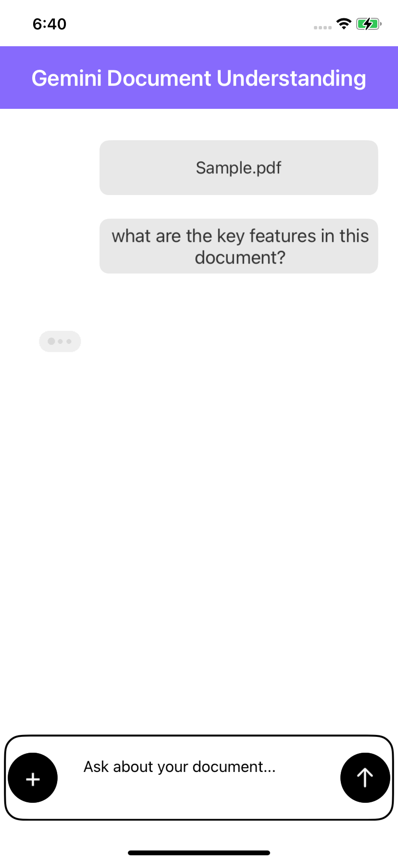 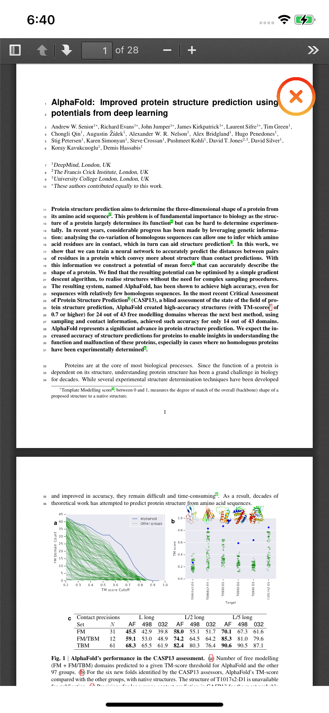
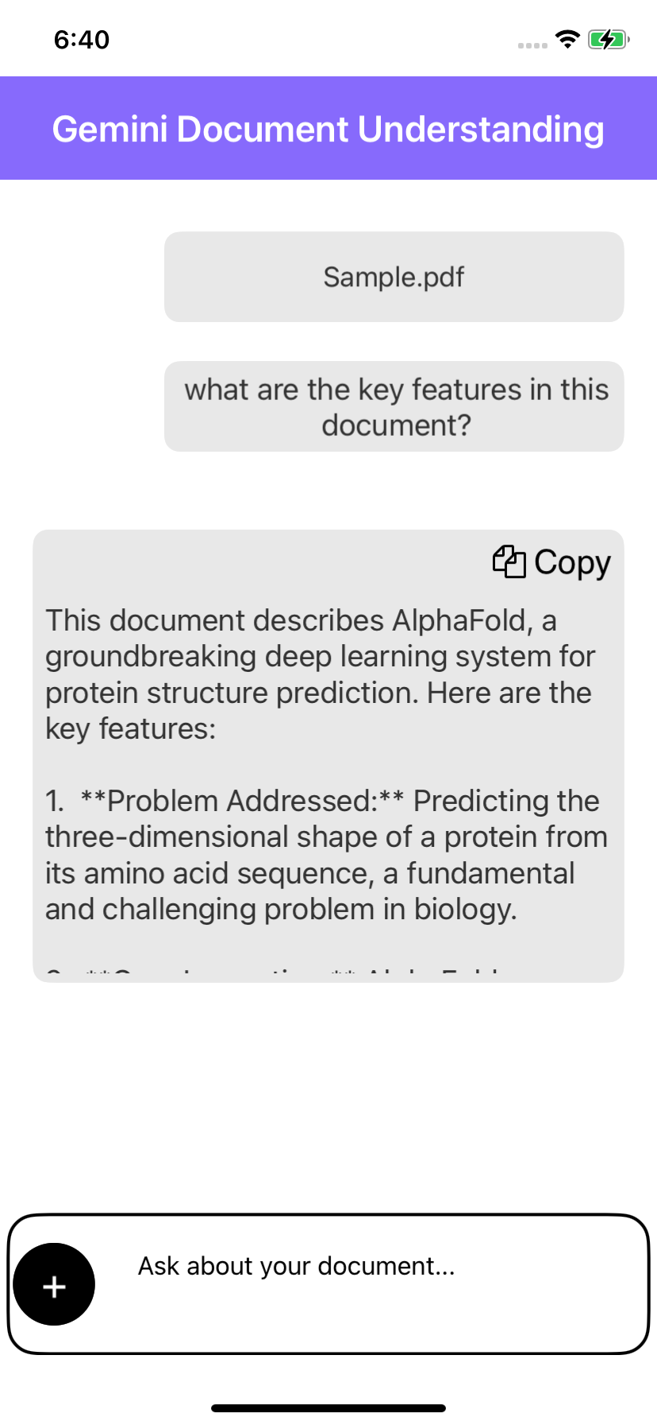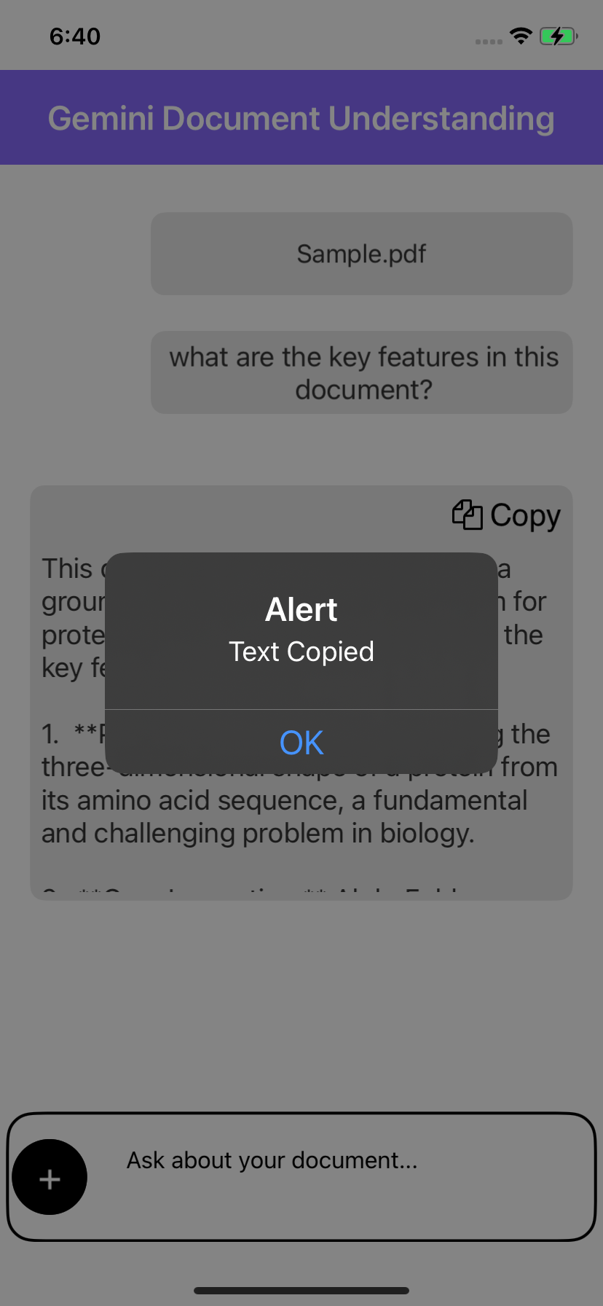
Configuring Native Settings (Android)

To configure the native settings for Android, follow these steps:
1. From the left navigation menu, click Project Settings.
2. In the Project Settings window, go to Native → Android Mobile/Tablet.
3. Set the Minimum SDK version to 24
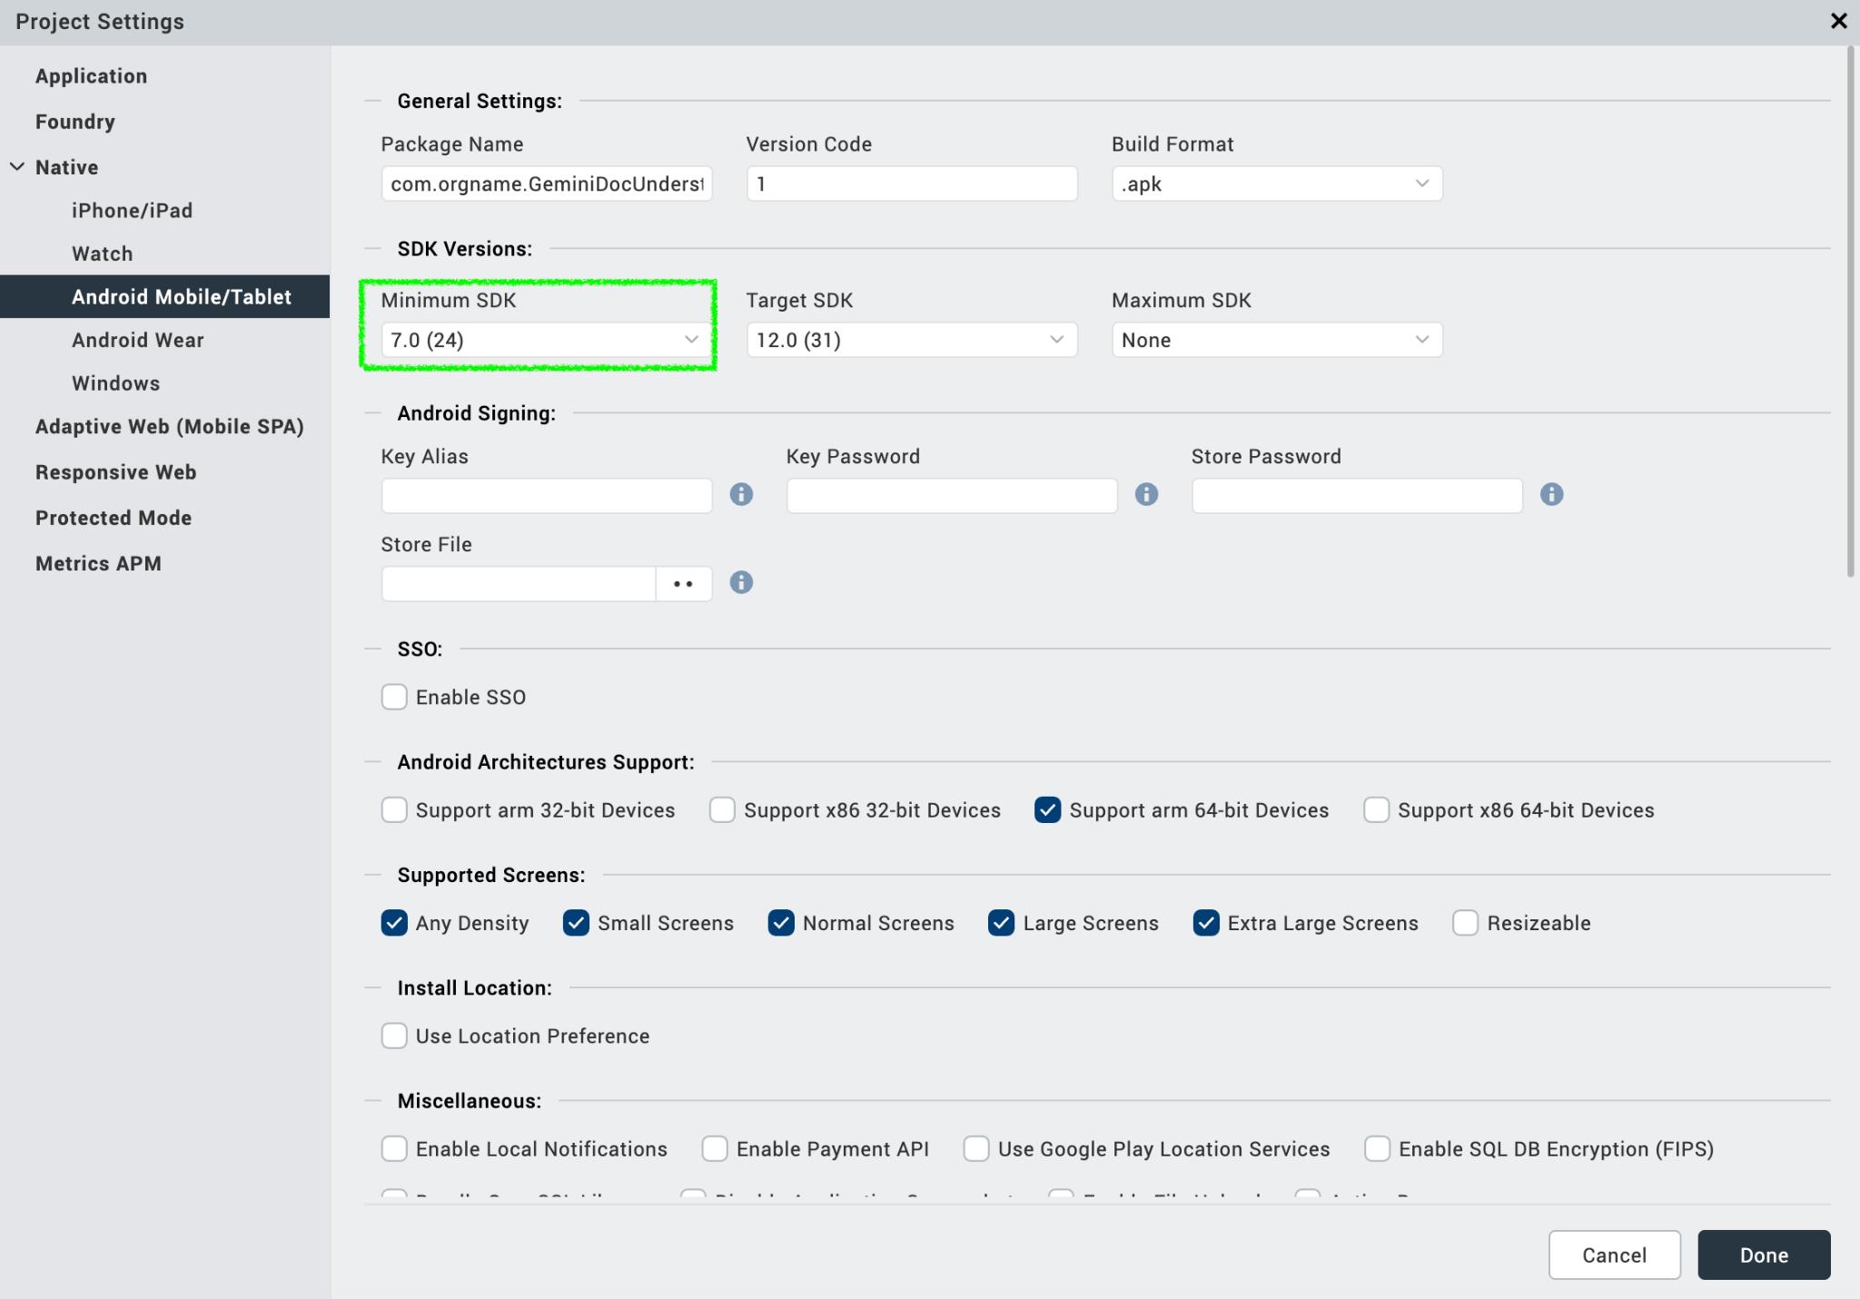
- Foundry APP Setup
When you import the component to your Volt MX Iris project, the HCL Volt MX Foundry services of the Google Gemini Document Understanding are added to the HCL Volt MX Foundry app, which is associated with the Volt MX Iris project. While importing the Google Gemini Document Understanding Component to your Volt MX Iris project, if there is no HCL Volt MX Foundry app associated with the existing Volt MX Iris project, a new HCL Volt MX Foundry app is automatically added to your HCL Volt MX Foundry environment and is associated with your Volt MX Iris.
To set the Foundry app, follow these steps:
- Click the HCL Volt MX Foundry app associated with your Volt MX Iris project from the Project Explorer. Click DATA & SERVICES.
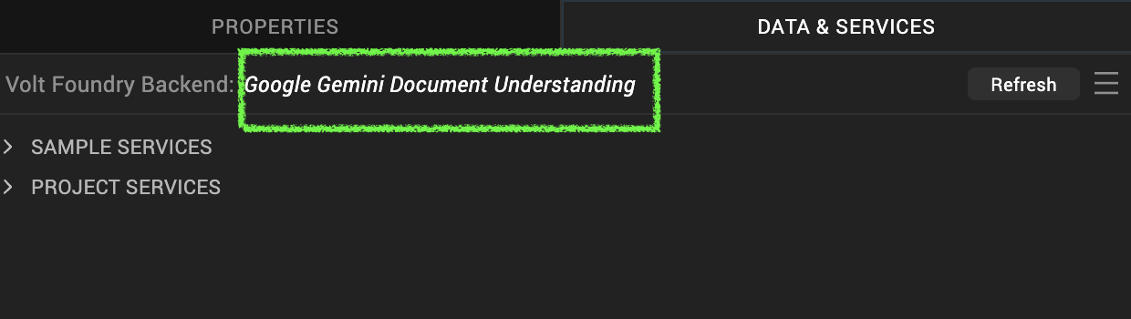
- Under the Configure Services tab, click Integration and can see the GeminiDocumentUnderstanding Integration service. Click on that Integration service to add the keys.
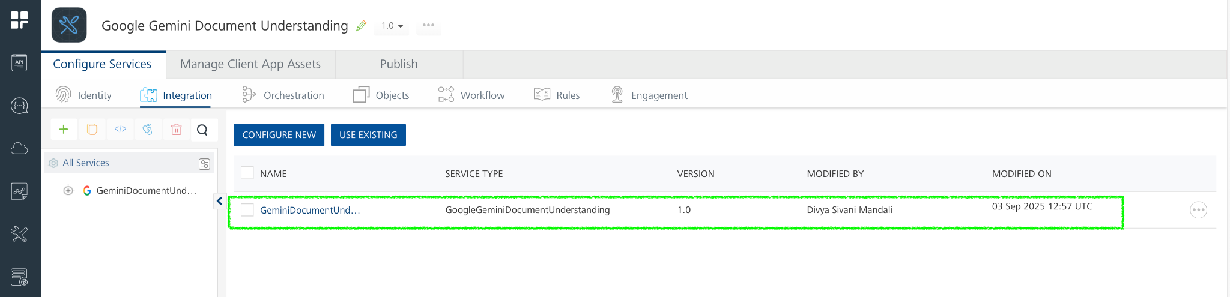
- Click the Operations List tab. The Operations List tab opens with the list of operations available.
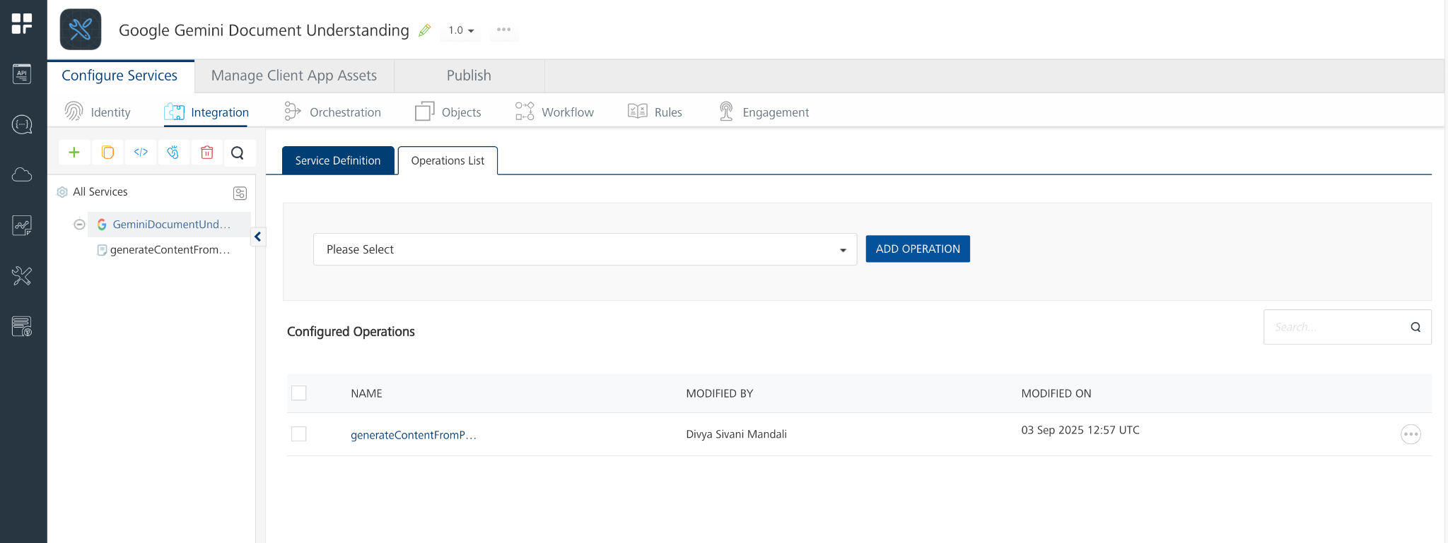
- Executing an Operation
Executing an operation involves making the API call by setting the necessary parameters and displaying the response. The procedure to execute any operation is the same, but the request parameters of the APIs vary. For more information on request parameters of API, refer Passing Inline PDF Data (Base64).
This section provides steps to execute the generateContentFromPDF operation.
A) Under the Configured Operations section, click the generateContentFromPDF operation. The generateContentFromPDF tab opens with the Request Input sub-tab opened by default.
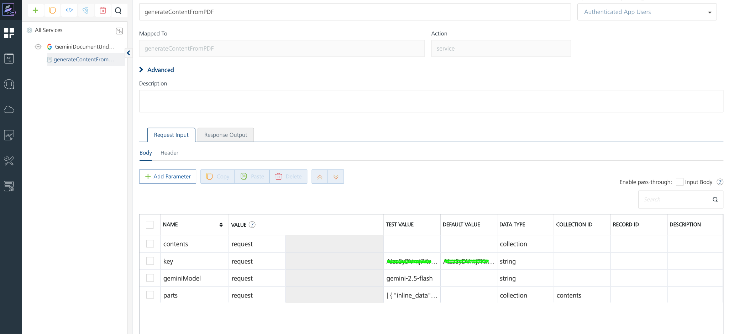

B) On the Request Input tab, in the Body section, for the following parameters, specify the values in the respective boxes under the Test Value column.
Mandatory Parameters
- key: To use the Gemini API, you need an API key. You can create a key with a few clicks in Google AI Studio. In the box under the TEST VALUE and DEFAULT VALUE columns, type the API Key generated
- geminiModel: The name of the Model to use for generating the completion. The Gemini API offers different models that are optimized for specific use cases. For Example : gemini-2.5-flash
- parts: The parts parameter specifies the input data passed to the Gemini API for processing. Each part represents either document content (inline data) or instructions/questions (text prompt).
- inline_data – Used to send the actual document for Gemini to process. PDF File Size should be less than 20MB
  - mime_type: The file type (e.g., application/pdf).
  - data: The Base64-encoded file content (PDF.).
- text – Used to provide instructions, questions, or prompts related to the document.
We need to pass the parts value in request body like this

[
{
"inline_data": {
"mime_type": "application/pdf",
"data": "base64 encoded PDF "
}
},
{
"text": "Summarize this document."
}
]

C) Click SAVE OPERATION.
D) Click SAVE AND FETCH RESPONSE. The Output Result dialog appears with the response. Otherwise, the Output Result shows an error.
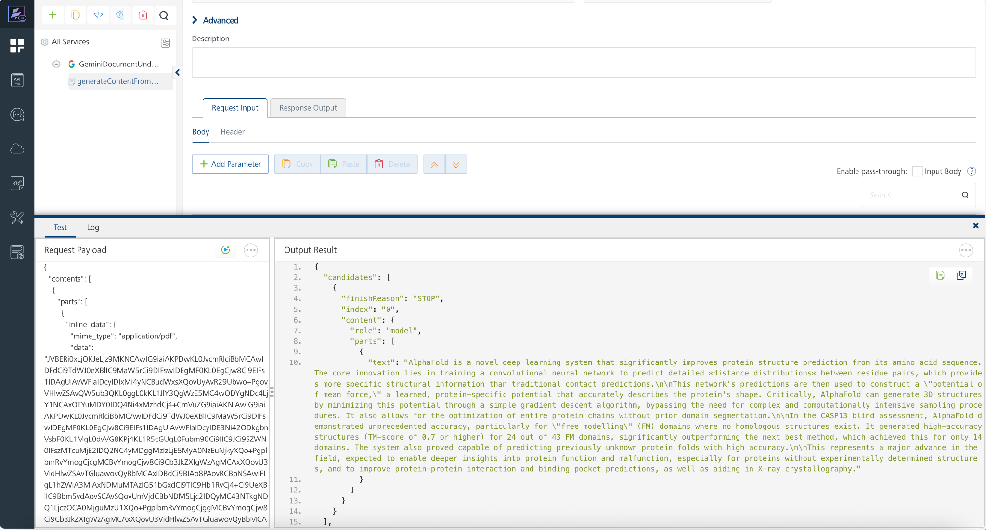

Publish the HCL Volt MX Foundry App
After you set the Operation Security Level, you must publish the HCL Volt MX Foundry app. To publish the HCL Volt MX Foundry, follow these steps:
In Volt MX Iris, click DATA & SERVICES, and then click Publish Project Services to Publish to your foundry app.
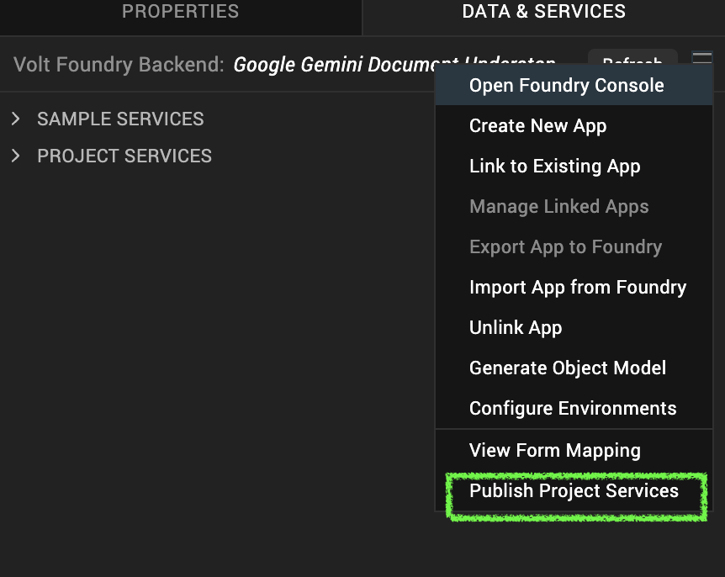
Select the environment to which you want to publish your app, and then click Publish.
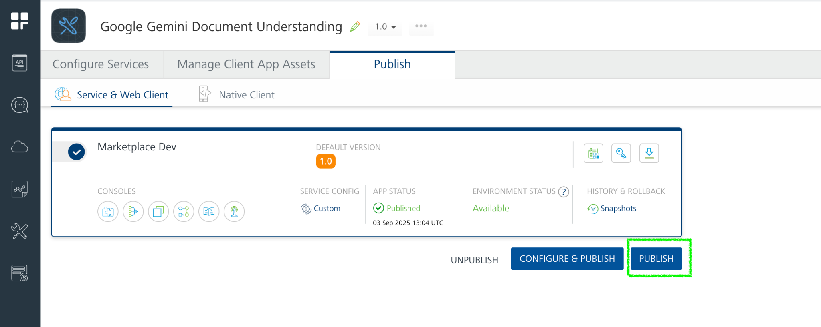
After the app is published to your environment, the following window appears confirming the publish.
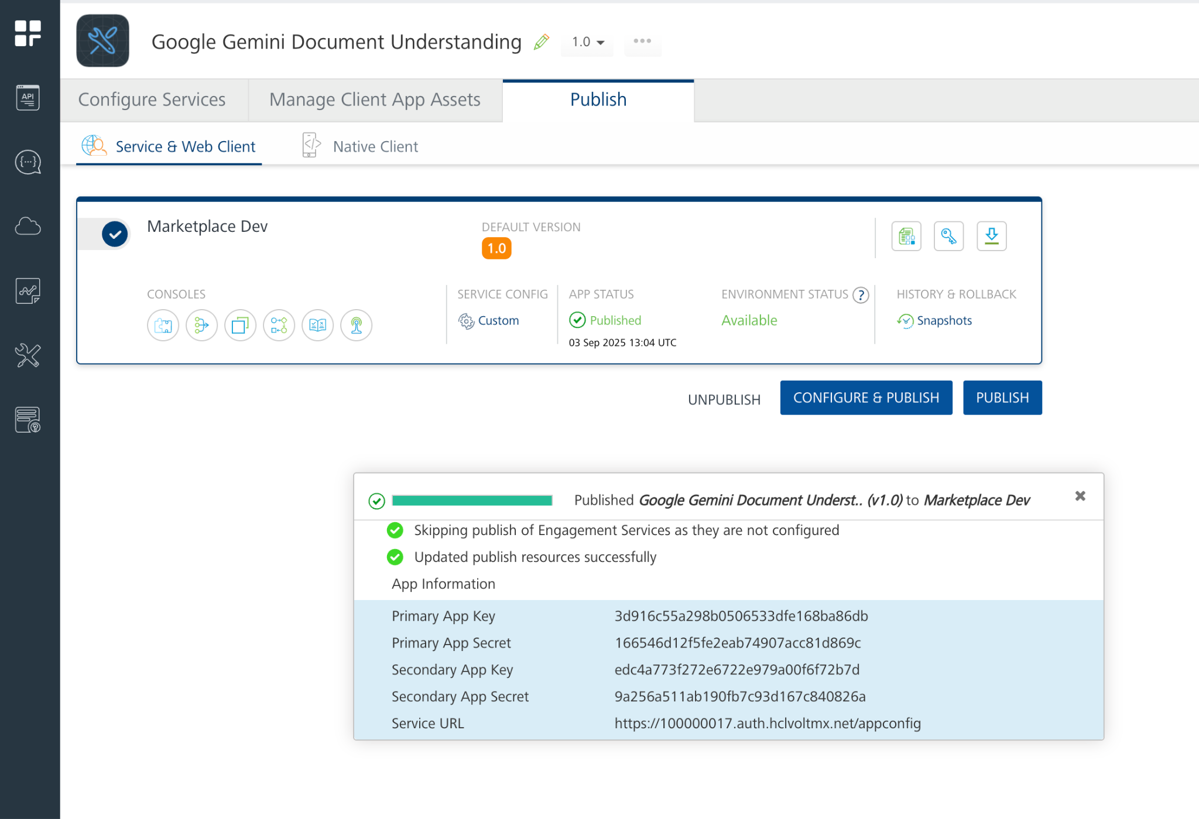

Building and previewing the app
After performing all the above steps, you can build your app and run it on your device. For more information, you can refer to the Building and Viewing an Application section of the Volt MX User Guide.
You can then run your app to see the Google Gemini Document Understanding work in real time.

Reference Document: https://ai.google.dev/gemini-api/docs/document-processing

REVISION HISTORY
App version 1.0.0:

Known Issues
None

Limitations
- Use PDF less than 20 MB for base64 encoded documents. Refer this https://ai.google.dev/gemini-api/docs/document-processing#inline_data

