Date : 12-Nov-25

GOOGLE GEMINI ADAPTER

VERSION: 1.0.0

OVERVIEW
Google Gemini AI Adapter connects Volt MX Foundry with Google’s Gemini AI APIs, enabling applications to send text, image, or audio inputs and receive intelligent outputs such as summaries, classifications, and insights. It supports multimodal processing (text, image, and audio) and provides a unified interface that allows developers to easily leverage Gemini’s generative and analytical AI capabilities within Volt MX apps.

Key Capabilities
- Unified Multimodal Intelligence
Processes and understands text, images, PDFs, screenshots, charts, diagrams, and mixed content in a single request.
- Full-Context Analysis
understands text, images, and documents holistically, taking into account structure, layout, tables, headings, relationships, and other visual elements.
- Structured Output Generation
produces responses in JSON, key-value pairs, tables, summaries, and natural-language text depending on the required use case.
- Flexible Input Handling
supports raw text, Base64-encoded images, Base64 PDFs (≤20MB), multimodal mixes, and chat-style conversational prompts in a single unified interface.

Use case:

Education & Learning
Transform textbooks, lecture notes, or recorded lectures into interactive study guides, quizzes, or multimedia summaries — combining text understanding, image interpretation (diagrams, tables), and audio/video analysis of classroom sessions.

Research & Analysis
Summarize long academic papers, compare multiple studies, and extract key findings from text, charts, graphs, or research videos — helping researchers accelerate literature reviews with multimodal insights.

Business Intelligence & Reporting
Automatically extract KPIs, revenue figures, and trends from financial reports, presentations, and meeting recordings — even when data is buried in charts, tables, or spoken commentary.

Legal & Compliance
Identify, extract, and summarize contract clauses, policy terms, or compliance videos (like training sessions) — maintaining context from formatted sections, transcripts, and visual exhibits.

Technical Documentation & Manuals
Convert manuals, SOPs, or engineering videos into structured, searchable formats (HTML/JSON) while preserving diagrams, workflows, and procedural visuals for easier knowledge reuse.

Healthcare & Medical Research
Analyze clinical documents, medical images, and diagnostic videos, extracting insights like trial results, radiology chart interpretations, or treatment summaries while maintaining medical context.

Government & Public Sector
Summarize policy papers, census datasets, recorded hearings, and planning videos into structured datasets or accessible summaries — enabling data-driven decision-making from multimodal content.

Features:
- Full-Context Analysis
Enables Gemini to process and interpret diverse data types — text, images, audio, video, and documents — holistically, understanding context, sequence, and relationships across multiple modalities for richer, more accurate comprehension.
- Multimodal Intelligence
Interprets both textual and visual elements such as images, charts, diagrams, and even scanned handwriting, providing deep, contextual understanding of complex documents.
- Structured Output Generation
Transforms raw, unstructured data from any source (text, image, video, or document) into structured formats like JSON, summarized text, or tabular data — ideal for analytics, dashboards, and intelligent automation.
- Flexible Input Handling
Accepts inline Base64-encoded inputs for text, images (JPEG/PNG), audio, video, and PDFs (≤20MB) — enabling smooth integration within Volt MX apps and backend services without external storage dependencies.

Percentage of re-use:
85% (Data can be customizable and customers need to implement UI by themselves).

GETTING STARTED

Prerequisites
Before you start using the Google Gemini Adapter, ensure you have the following:

- HCL Foundry
- Volt MX Iris
- To use the Gemini API, you need an API key. You can create a key with a few clicks in Google AI Studio.Get a Gemini API key in Google AI Studio

Reference document: https://ai.google.dev/gemini-api/docs

Importing the adapter
To import the Google Gemini Adapter Adapter to Volt MX Foundry, do the following:
- Sign in to the HCL Foundry
- In the left pane, click the API Management menu. The APIs tab opens by default.
- In API Management, select Custom Data Adapters.
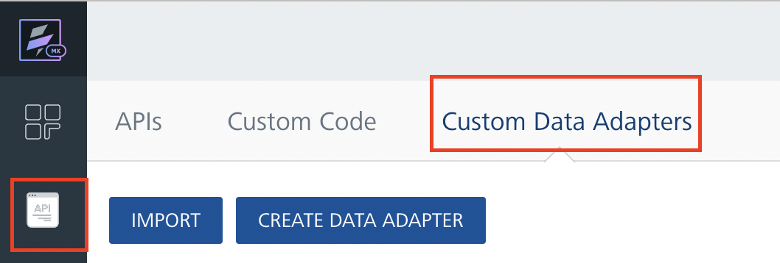
- Click IMPORT to import a custom data adapter.
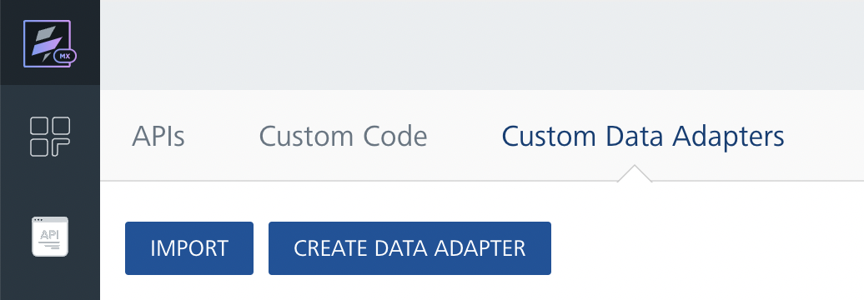
- On the Import Data Adapter dialog box, click browser to import.
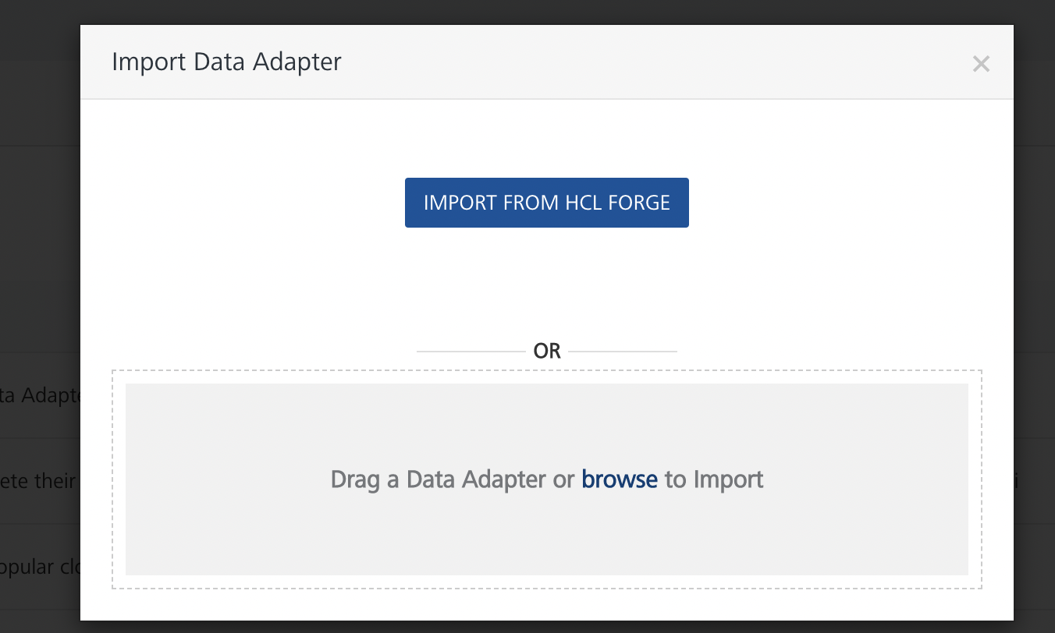
- Drag the data adapter zip file into the Drag Data Adapter box.
Or
Click browse. The Open dialog appears.
Navigate to the location where you downloaded the data adapter (zip file) on your computer, select the data adapter, and click Open. The Import Data Adapter dialog shows the selected data adapter.
Note: Click Remove if the selected data adapter is not the one that you want to import.
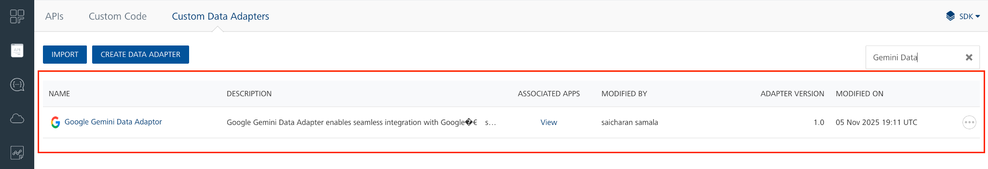
OR
To import the data adapter zip file, do the following:
- Perform steps 1 through 4 in the above procedure
- Click IMPORT FROM HCL FORGE. The Import Data Adapter from HCL Forge dialog appears with a list of available data adapters.
- Click Import.The Google Gemini Adapter data adapter is listed on the Custom Data Adapters page.
After you import the data adapter, you can view it on the Custom Data Adapters page and use it to create services on Volt MX Foundry.
After you add the data adapter to your Volt Foundry app, you need to get your key from Google Gemini Adapter .

Creating an Integration Service with Google Gemini Adapter
After you import Google Gemini Adapter Data Adapter into Volt MX Foundry, you must create an integration service with service type as Google Gemini Adapter .
To create an integration service with Google Gemini Adapter , do the following:
- Log on to your HCL Foundry The Dashboard page appears by default.
- In the left pane, click the API Management menu. The APIs tab opens by default.
- Click the Integration tab. The Integration tab opens with a list of existing integration services.
- Click CONFIGURE NEW. The Service Definition tab opens.
- In the Name box, type a unique name for your service.
- From the Service Type list, select Google Gemini Adapter
Note: The Google Gemini Adapter is listed only after you import the Google Gemini Adapter Data Adapter into Volt MX Foundry.
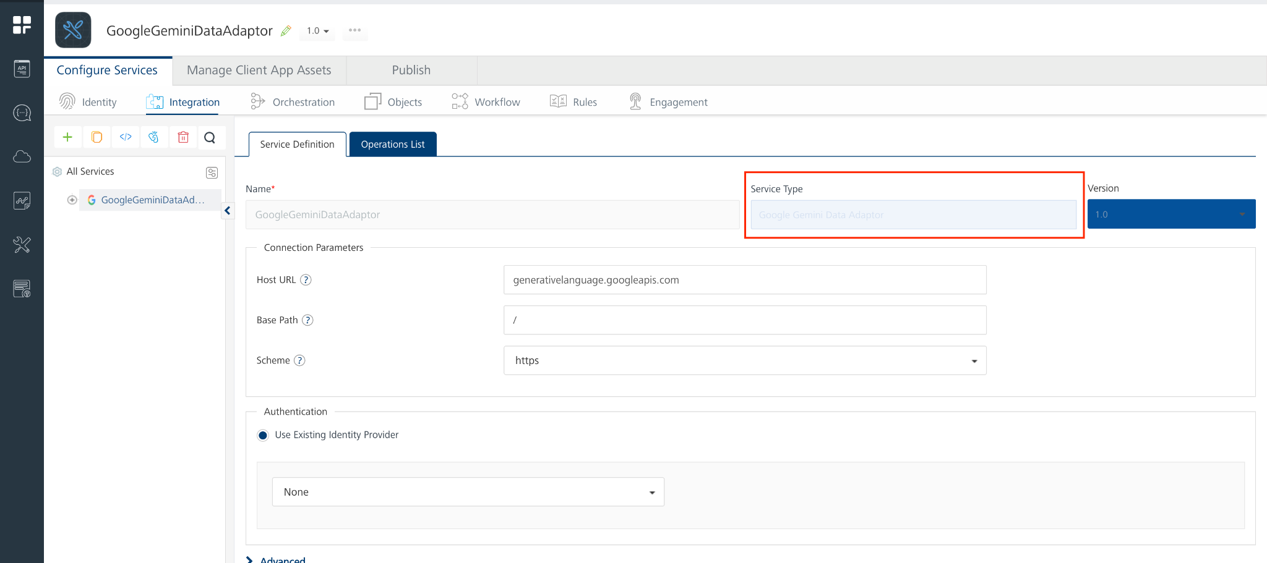

- Click Save.
If the details provided are valid, the Volt MX Foundry service connects to your Google Gemini Adapter developer site and allows you to make the API calls.
Refer to Integration Services for more information on creating and using integration services.

Creating an Operation
To make any API call in the Volt MX Foundry console, you must create an operation for the respective API and then execute the operation. Executing an operation involves making the API call and displaying the response. For more information, see Executing an Operation.
This section provides steps to create an operation for the generateContent API.
Steps to create an operation for the generateContent:
- Log on to your HCL Foundry. The Dashboard page appears by default.
- In the left pane, click the API Management menu. The APIs tab opens by default.
- Click the Integration tab. The Integration page appears with a list of existing integration services.
- From the list of integration services, select the integration service that you have created with service type as Google Gemini Adapter . The Service Definition tab of the selected integration service opens by default.
- Click the Operations List tab. The Operations List tab opens.
- Click the context menu arrow to expand the Please Select list. The service is displayed.
- Click the plus icon to expand the list.
- Click the plus icon to expand the Services list and select generateContent.
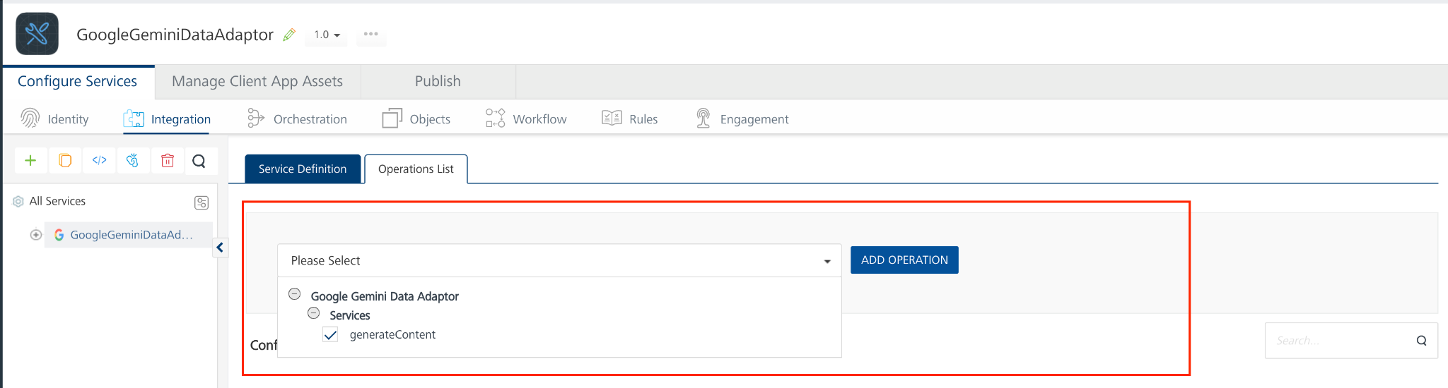
- Click ADD OPERATION. The generateContent operation is listed in the Configured Operations section.
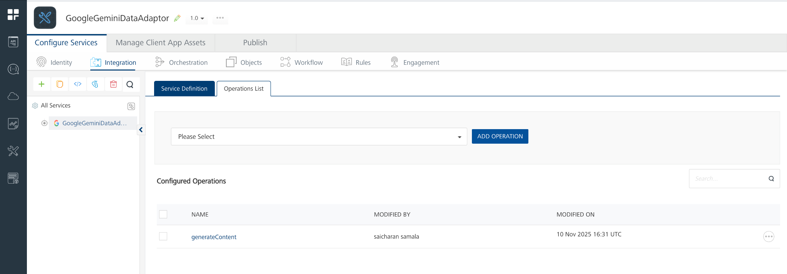
Note: You can follow the same steps to create operations for other methods, but ensure that you select the required API.
You can create multiple operations with required APIs and save them in the Configured Operations section. You can then execute the operations whenever required.

Executing an Operation
Executing an operation involves making the API call by setting the necessary parameters and displaying the response. The procedure to execute any operation is the same, but the request parameters of the APIs vary. For more information on request parameters of API, refer Passing Inline PDF Data (Base64).
This section provides steps to execute the generateContent operation (explained in Creating an Operation).
Steps to execute the generateContent operation:
- Log on to your HCL Foundry. The Dashboard page appears by default.
- In the left pane, click the API Management menu. The APIs tab opens by default.
- Click the Integration tab. The Integration tab opens with a list of existing integration services.
- From the list of integration services, select the integration service that you have created with the service type as Google Gemini Adapter . The Service Definition tab of the selected integration service opens by default.
- Click the Operations List tab.
- Under the Configured Operations section, click the generateContent operation. The generateContent tab opens with the Request Input sub-tab opened by default.
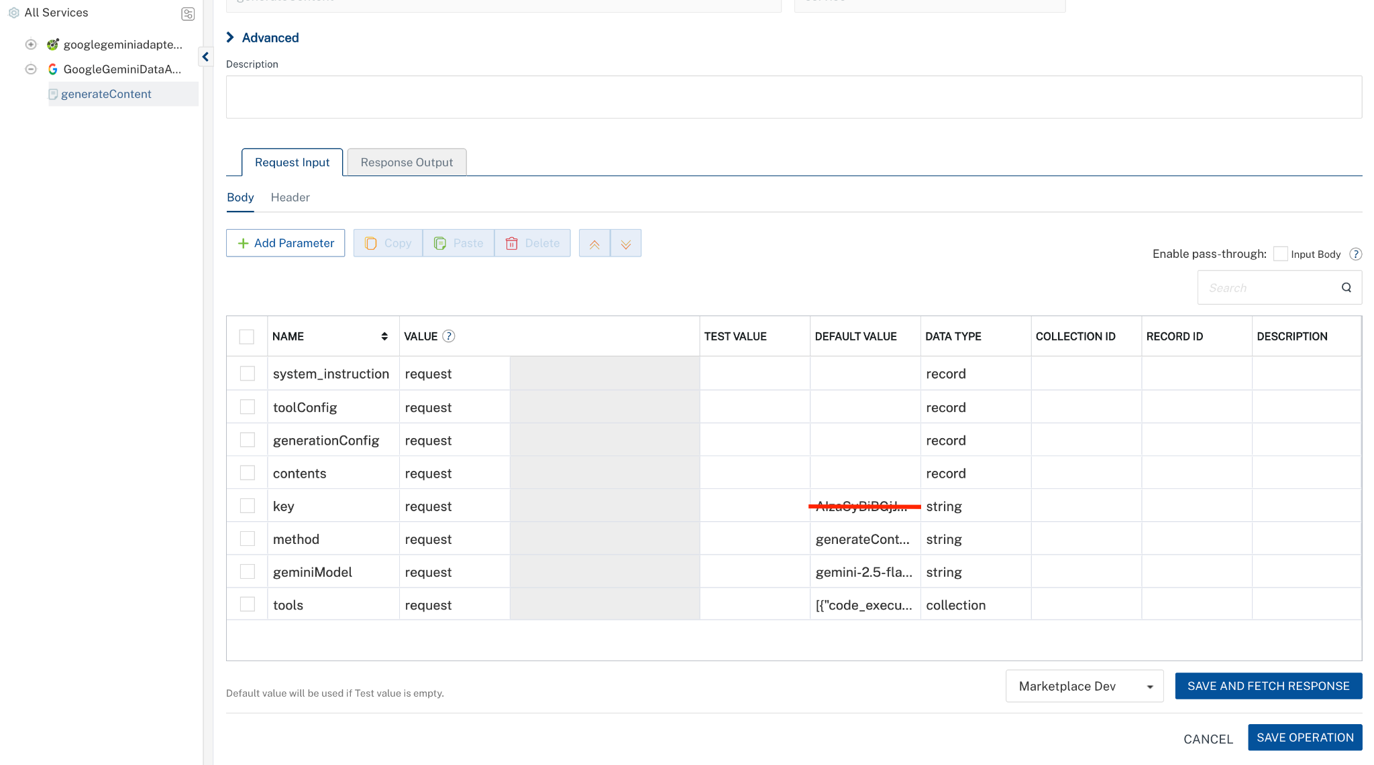
- In the Name box, the name of the operation is displayed by default. If you want, you can change the name.
- On the Request Input tab, in the Body section, for the following parameters, specify the values in the respective boxes under the Test Value column.
Mandatory Parameters
- key: To use the Gemini API, you need an API key. You can create a key with a few clicks in Google AI Studio. In the box under the TEST VALUE and DEFAULT VALUE columns, type the API Key generated
- geminiModel: The name of the Model to use for generating the completion. The Gemini API offers different models that are optimized for specific use cases. For Example : gemini-2.5-flash.
- Method : represents a specific operation or action that you can call on a model endpoint. (eg : generateContent, streamGenerateContent, embedContent..)
- contents: Array of parts that define the input sent to Gemini, where each part may include text, Base64-encoded images, PDFs, or mixed multimodal data.
- inline_data – The binary data (Base64-encoded) for non-text inputs such as images, audio, or video
  - mime_type: The file type (e.g., application/pdf, image/jpeg, video/mp4).
  - data: The Base64-encoded file content (Pdf,image,audio,video.).
- text – Used to provide instructions, questions, or prompts.
We need to pass the contents value in request body like this

[
{
"parts": [
{
"inline_data": {
"mime_type": "image/png",
"data": "<BASE64_IMAGE>"
}
},
{
"text": "Caption this image."
}
]
}
]

Optional parameters
- System_instruction : the system_instruction parameter is a special control field that defines the behavior, personality, and context of the model before it starts processing the user’s input.
We need to pass the System_instruction value in request body like this

{
"parts": [
{
"text": "You are a cat. Your name is Neko."
}
]
}

- generationConfig : generationConfig defines the parameters that control Gemini’s response behavior, such as creativity, randomness, and output constraints.
We need to pass the generationConfig value in request body like this
{
"stopSequences": [
"Title"
],
"temperature": 1.0,
"topP": 0.8,
"topK": 10
}
- tools : The tools parameter in the Gemini API allows you to extend the model’s capabilities by integrating external tools or functions — for example, enabling Google Search, code execution, or custom API calls.
We need to pass the tools value in request body like this
[
{
"google_search": {}
}
]
- toolConfig : toolConfig defines the usage rules and behavior for tools available to Gemini during content generation.
We need to pass the toolConfig value in request body like this
{
"google_search": {
"enable_auto": true,
"max_results": 5
}
}
Note: While testing the Code Execution endpoint in Volt MX Foundry, change the data type of Contents to Record.
- Click SAVE OPERATION.
- Click SAVE AND FETCH RESPONSE. The Output Result dialog appears with the response. Otherwise, the Output Result shows an error.
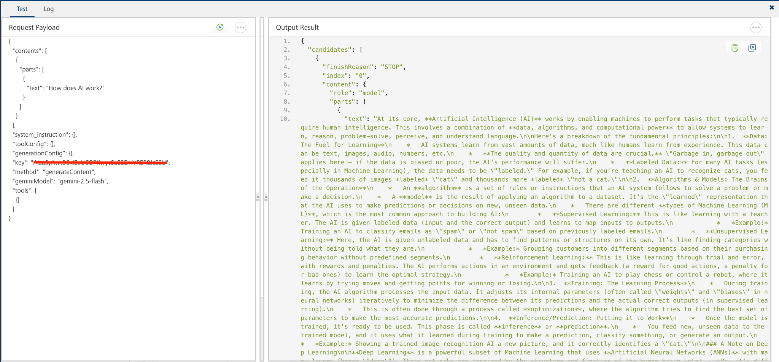

Publishing the App to Volt MX Foundry
After adding Google Gemini Adapter to your app and configuring the necessary configurations, you must publish the app to Volt MX Foundry. For more information, refer to Publish a Project to Volt MX Foundry.
If you want to use the services in client applications, you need to publish the app to a run-time environment.
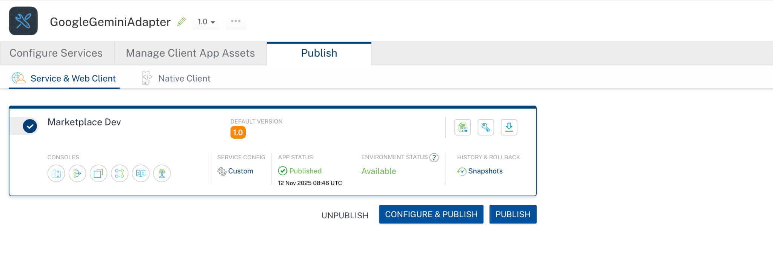

Reference Documents:
- https://ai.google.dev/gemini-api/docs

REVISION HISTORY
App version 1.0.0:

Known Issues
None

