Date : 28-July-26

GOOGLE CLOUD VISION AI-EXTRACT INSIGHTS FROM IMAGE APPLICATION

VERSION: 1.0.2

OVERVIEW
Google Cloud’s Vision AI suite of tools combines computer vision with other technologies to understand and analyse image and easily integrate vision detection features within applications, including image labelling, face and landmark detection, optical character recognition (OCR), and tagging of explicit content.

Use case:
- Cloud Vision API allows developers to easily integrate vision detection features within applications, including image labeling, face and landmark detection, optical character recognition (OCR), and tagging of explicit content.

Features:
- Document text detection
- Detect Landmarks
- Detect Logos
- Detect Multiple Objects
- Detect Web entities and pages
- Detect text in images
- Detect faces
- Detect image properties
- Detect Labels
- Detect explicit content (SafeSearch)

Percentage of re-use:
80% (Data can be customizable and customers need to implement UI by themselves).

GETTING STARTED

Prerequisites
Before you start using the Google Cloud Vision AI App, ensure the following:
- HCL Foundry
- Volt MX Iris
- Download the Google Cloud SDK installer from this link https://dl.google.com/dl/cloudsdk/channels/rapid/GoogleCloudSDKInstaller.exe
- After the installation is complete, restart your terminal or run the following command to initialize the SDK:
gcloud init
- To check if gcloud is installed correctly, run:
gcloud --version
- Authenticate with Google Cloud
gcloud auth login
- To get Print Access token
gcloud auth print-access-token

Devices
- Mobile

Platforms
- Android
- IOS

Importing the App
To import the Google Cloud Vision AI App to Volt MX Iris, do the following:

To import the Google Cloud Vision AI App, do the following:
- Launch Volt MX Iris.
- Click project, and then select Import. The Import dialog box appears.
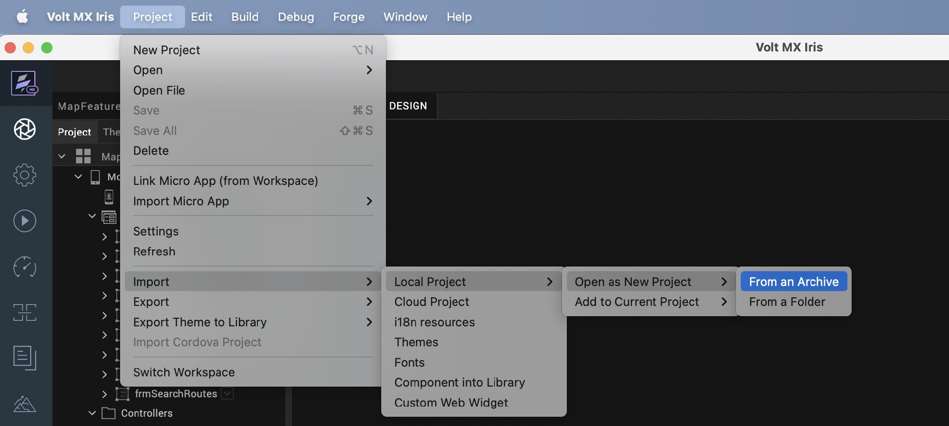

- Click From an Archive to navigate to the location of the project, select the files, and then click Import.
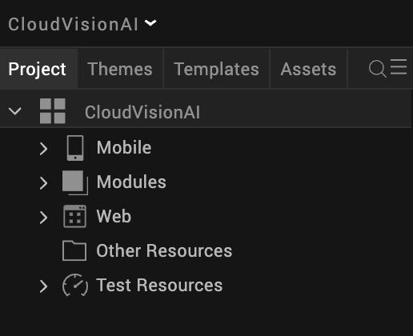

After you import the application, you can view the associated Foundry app connected at the Data & Services section.
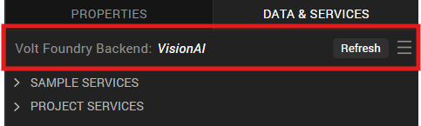

Google Cloud Vision AI Volt MX Foundry Services:
The Google Cloud Vision AI app contains an Integration Service :
GoogleCloudVisionAI Service: This service is used to extract insights from image.
Operations :
    - getInsights - Used to extract Insights from Image, like Detect Text, Detect Logos, Faces etc.

Configure Native Settings
1. While building the app for Android in Debug and Release mode, in order to open the camera and gallery. You need to add CAMERA and WRITE_EXTERNAL_STORAGE permissions in project settings.
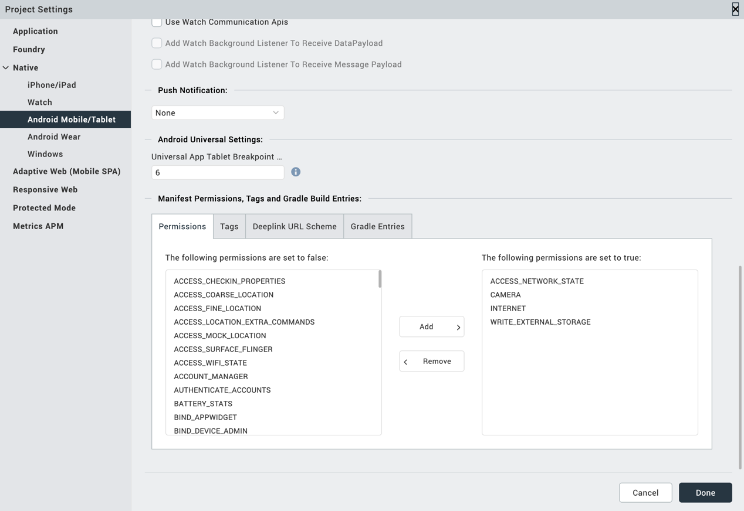

2. Enter the given snippet in Child tag entries under <manifest > tag
For Android below permissions are required in IRIS project setting > Native> Android Mobile/Tablet -> Tags (Child tag entries under tag) depending on the target version.
If target version is 33 and above below media permission must be added.
- <uses-permission android:name="android.permission.READ_MEDIA_IMAGES"/>
If target version is 34 and above below permission must be added along with other media permissions.
- <uses-permission android:name="android.permission.READ_MEDIA_VISUAL_USER_SELECTED"/>

Configuring Native Settings (iOS)
Follow the given steps to enable the permissions.
1. From the Project explorer, navigate to the Assets tab.
2. Right click Media and select Resource Location to open the project resources folder.
3. In the browser window that opens, navigate to the common folder.
4. Open the infoplist_configuration.json file with a text or code editor.
5. Add the given code at the end of the file. You can replace the values with your own descriptions.
{
"NSCameraUsageDescription" : " This app uses Camera ",

"NSPhotoLibraryUsageDescription" : "This app uses photo library"
}

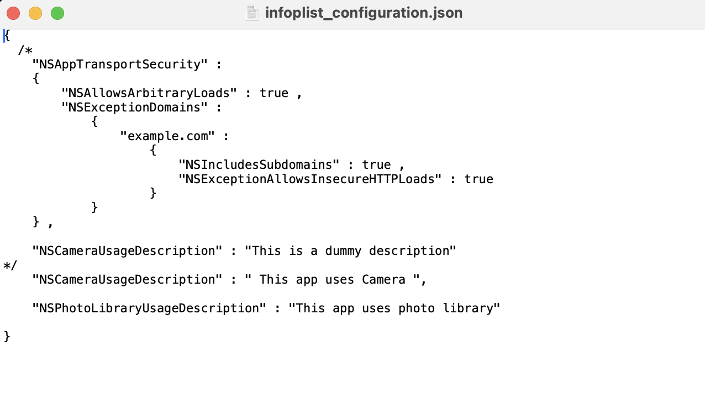
6. Save the file.

Building the app
From the menu bar, go to Build and then select Build Native Local.
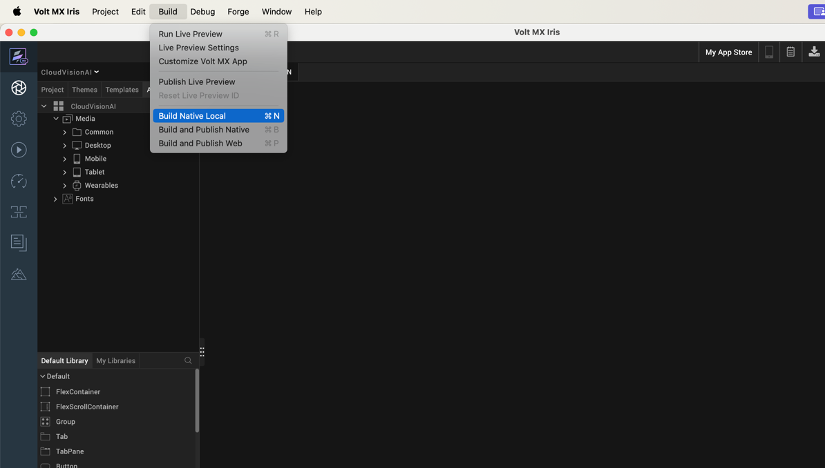

For Mobile, select Android and iOS. Click Build.
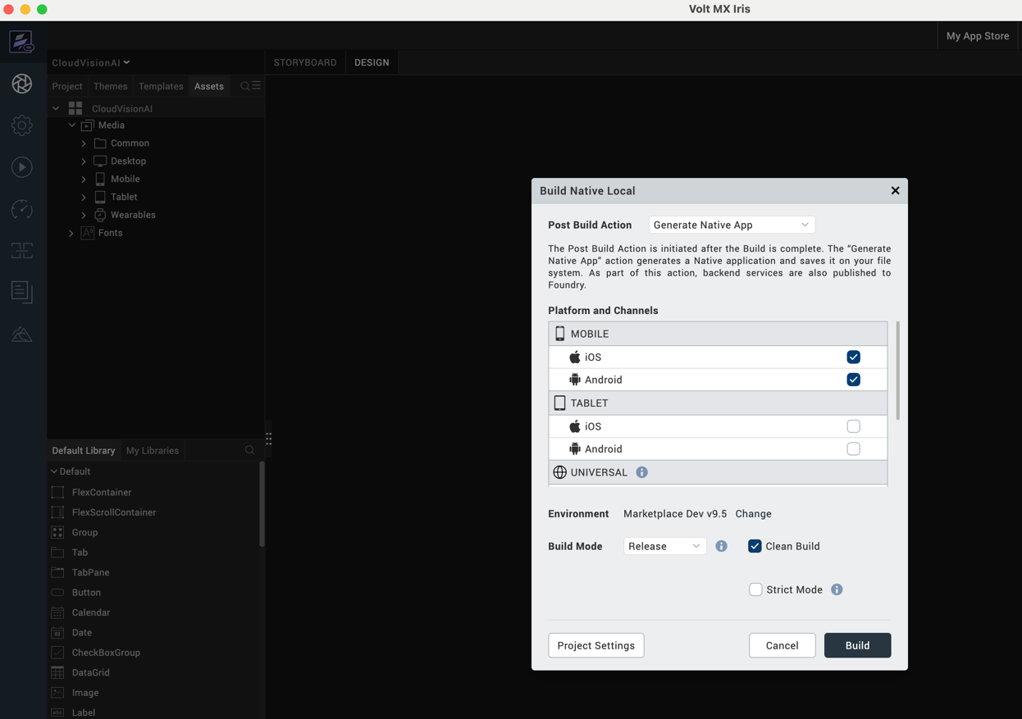

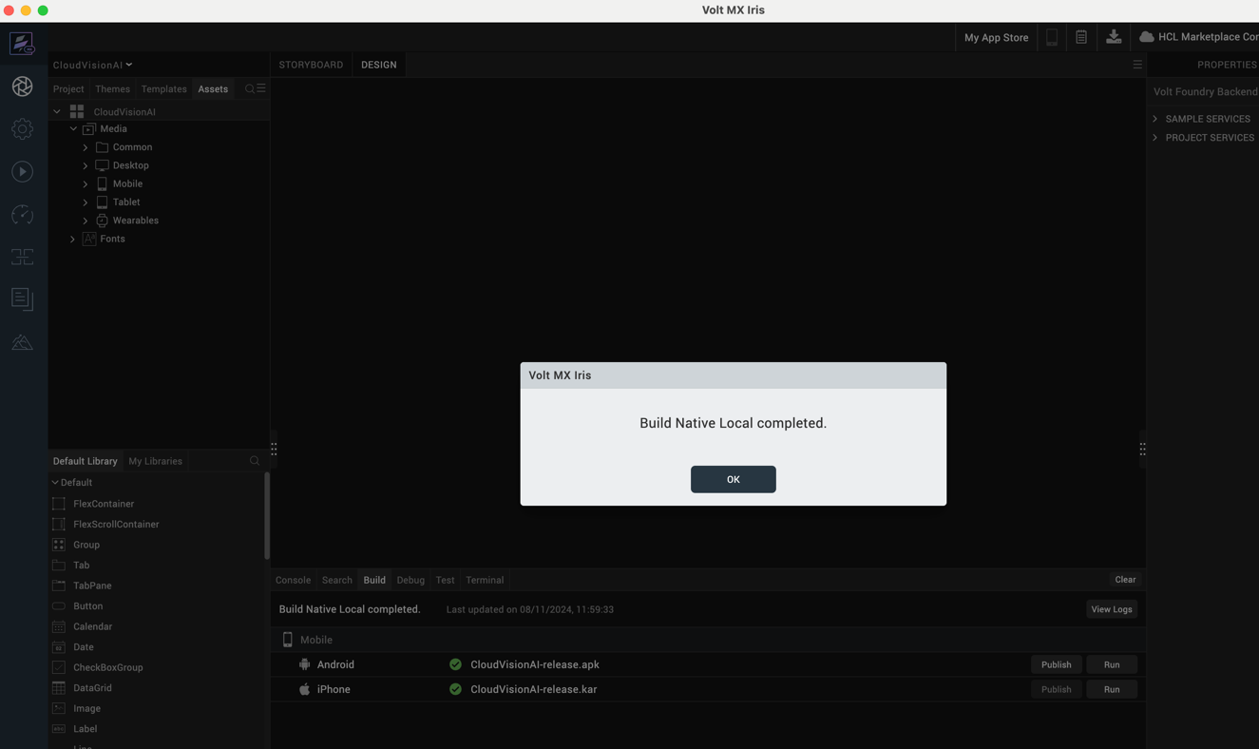

After the build is successful, run the app on your mobile device.

Application Flow
The landing page for the app is as follows:
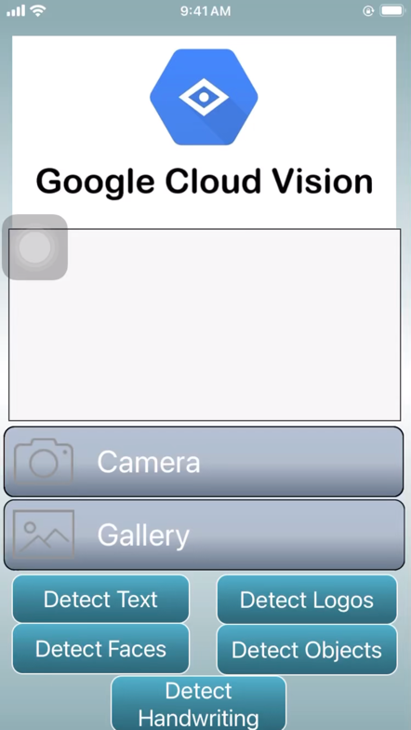

Click on Camera to capture an image, which will be saved to the gallery, or click on Gallery to upload an image from your device. Then, select either button to get insights related to the image.
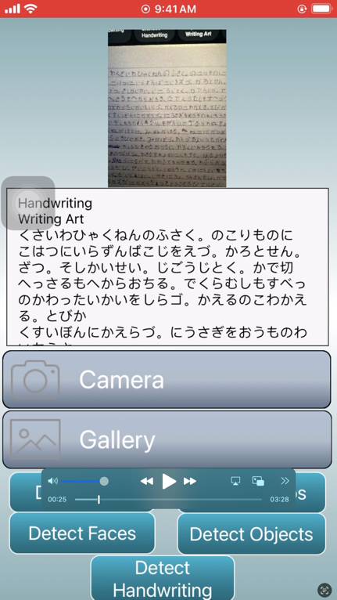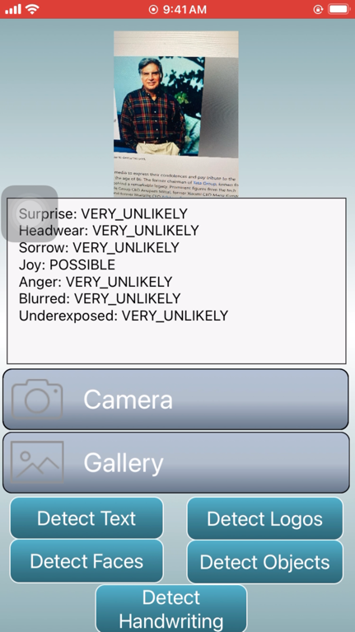
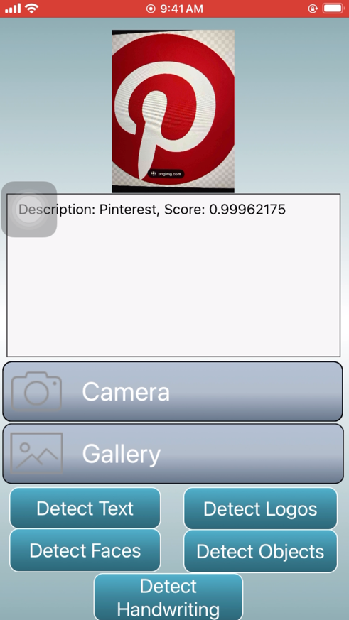

REVISION HISTORY
App version 1.0.2:

A. Limitations
1. Do not have support for Landscape mode.

B. Known Issue
- NA

