Date : 28-July-26

GOOGLE CLOUD NATURAL LANGUAGE AI
version: 1.0.1

OVERVIEW
Google Cloud NLP (Natural Language Processing) refers to a set of tools provided by Google that help computers understand and analyze human language. These tools process and analyze text to identify meanings, sentence structures, sentiments, and other linguistic attributes. NLP is widely used in applications like analyzing customer feedback, sorting emails, and understanding social media sentiments.

Features:

- Sentiment Analysis: Understand emotional tones in customer reviews, social media posts, and other text-based data
- Entity Analysis: Extract key entities such as people, places, and products from text for better context understanding.
- Entity Sentiment Analysis: Combine entity recognition with sentiment analysis to identify opinions about specific entities.
- Syntactic Analysis: Parse sentence structures to understand relationships between words and their grammatical roles.
- Content Classification: Categorize text into predefined topics, such as sports, entertainment, or technology.

Percentage of re-use:
Approximately (80-90)% of reuse.

GETTING STARTED

Prerequisites
Before you start using the Cloud Natural Language AI App, ensure the following:
- HCL Foundry
- Volt MX Iris
- Download the Google Cloud SDK installer from this link https://dl.google.com/dl/cloudsdk/channels/rapid/GoogleCloudSDKInstaller.exe
- After the installation is complete, restart your terminal or run the following command to initialize the SDK:
gcloud init
- To check if gcloud is installed correctly, run:
gcloud --version
- Authenticate with Google Cloud
gcloud auth login
- To get Print Access token
gcloud auth print-access-token

Importing the Data Adapter

You can import Google Cloud Natural Language AI Data Adapter into HCL Foundry directly from the VoltMX website or by importing the data adapter zip file.

To import the Data Adapter to Volt Foundry, do the following:
- Sign in to the HCL Foundry.
- From the left navigation menu, select API Management.
- In API Management, select Custom Data Adapters.
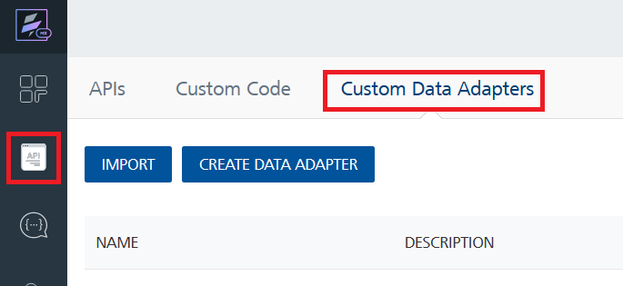
- Click IMPORT to import a custom data adapter.
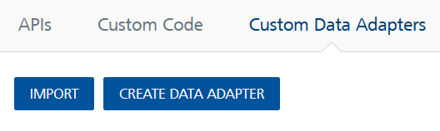
- On the Import Data Adapter dialog box, click browser to import.
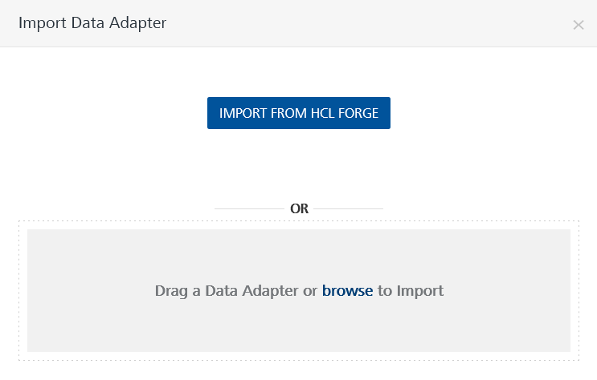
- Select Google Cloud Natural Language AI zip file and click IMPORT.
After you import the data adapter, VoltMX Foundry opens a window that shows the metadata of the data adapter.
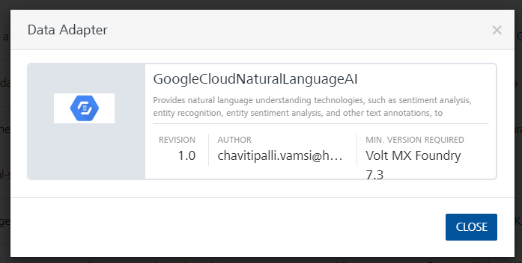

To import the data adapter zip file, do the following:
- Perform steps 1 through 4 in the above procedure
- Drag the data adapter zip file into the Drag Data Adapter box.
Or
Click browse. The Open dialog appears.
Navigate to the location where you downloaded the data adapter (zip file) on your computer, select the data adapter, and click Open. The Import Data Adapter dialog shows the selected data adapter.

Note: Click Remove if the selected data adapter is not the one that you want to import.
Request Header:
Authorization: Print Access Token : follow the steps from the Prerequisites and get print access token
x-goog-user-project: The project ID can be obtained from the Google Cloud project that was created.
Link: https://console.cloud.google.com/home/dashboard
Select a project:
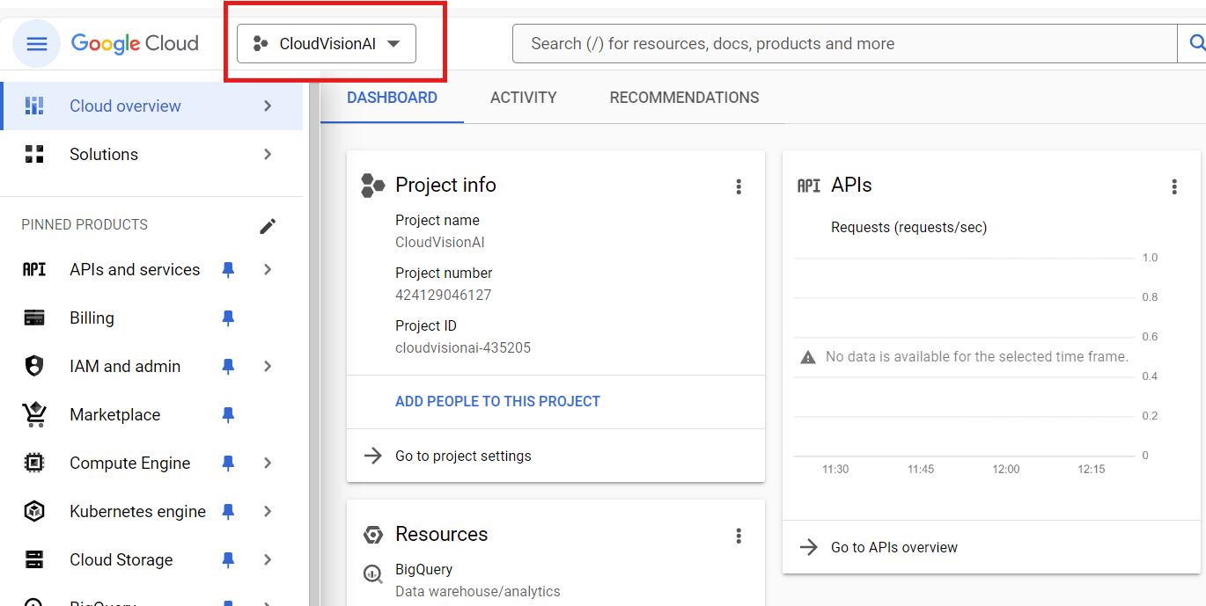

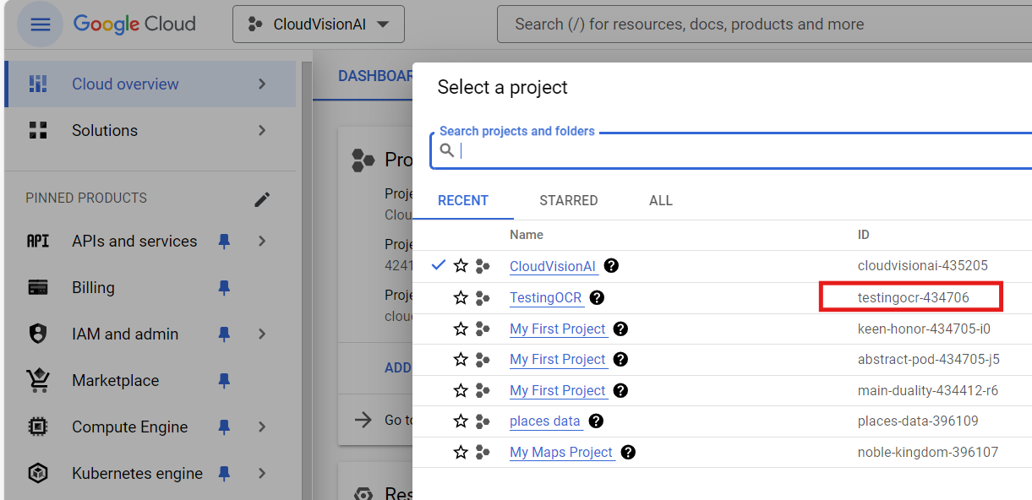

Creating an Integration Service with Google Cloud Natural Language AI
After you import Google Cloud Natural Language AI Data Adapter into Foundry, you must create an integration service with service type as GoogleCloudNaturalLanguageAI to connect with your Google Cloud Natural Language AI developer site.
To create an integration service with Google Cloud Natural Language AI, do the following:
- Log on to your Foundry. The Dashboard page appears by default.
- In the left panel, click the API Management menu. The APIs tab opens by default.
- Click the Integration tab. The Integration tab opens with a list of existing integration services.
- Click CONFIGURE NEW. The Service Definition tab opens.
- In the Name box, type a unique name for your service.
- From the Service Type list, select Google Cloud Natural Language AI.
Note: The Google Cloud Natural Language AI is listed only after you import the Google Cloud Natural Language AI Data Adapter into Foundry.
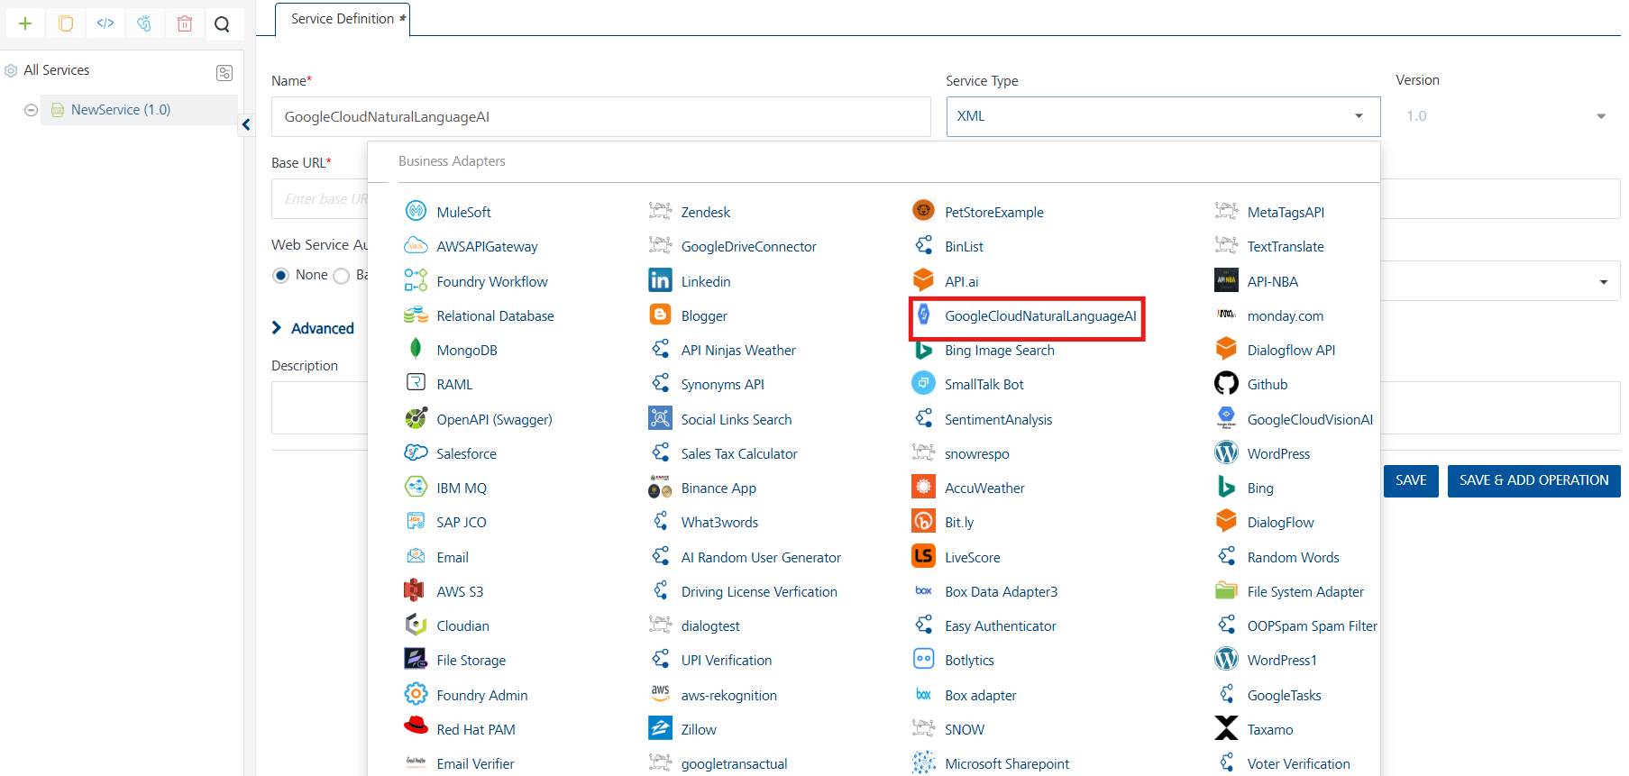
- Click Save.
If the details provided are valid, the Foundry service connects to your Google Cloud Natural Language AI developer site and allows you to make the API calls.
Refer to Integration Services for more information on creating and using integration services.
- Creating an Operation
To make any API call in the Foundry console, you must create an operation for the respective API and then execute the operation. Executing an operation involves making the API call and displaying the response.
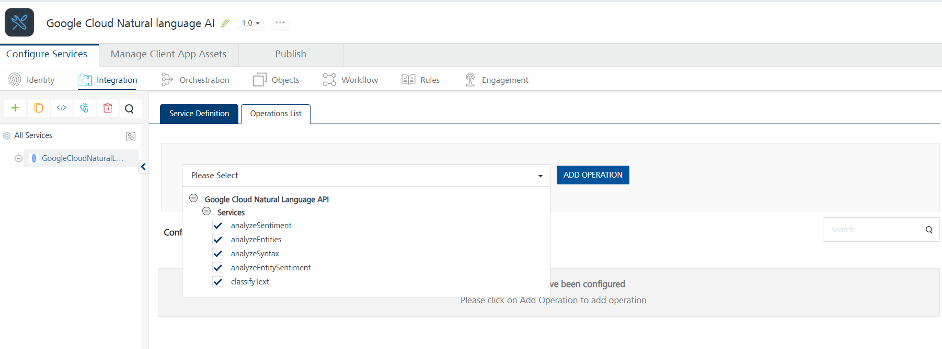

- Executing an Operation

Under the Configured Operations section, click the operation. The Request Input sub-tab opened by default. Provide Body and Headers.
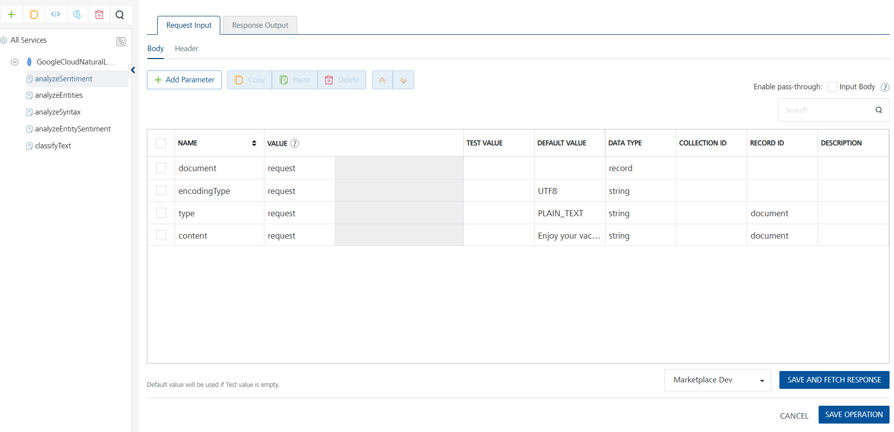
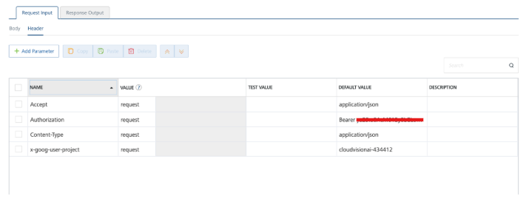

Click SAVE AND FETCH RESPONSE. The Output Result dialog appears with the response. Otherwise, the Output Result shows an error.
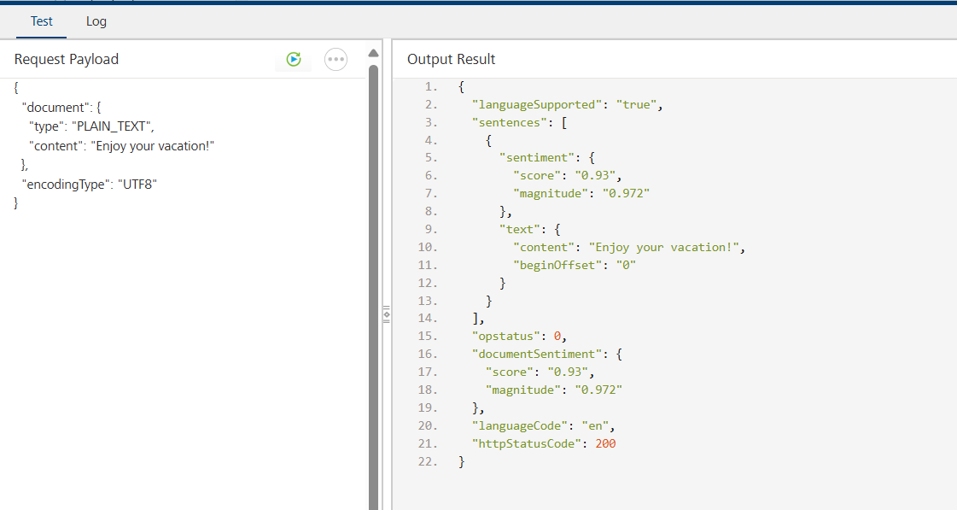

Publishing your application
If you want to use the services in client applications, you need to publish an app to a run-time environment. You can create the service (as described above) in an application or import the service into an application and publish the application.
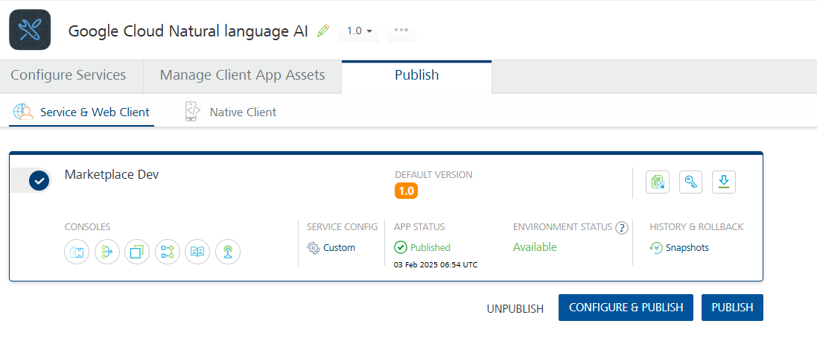

References
A. Endpoint Documentation
How-to Guides | Cloud Natural Language API | Google Cloud

Revision History
App version 1.0.0:

Known Issues
- No Known Issues

Limitations
- No Limitations

