Date: 23-02-2024

Google Calendar Integration Service (Open Api 2.0)

Overview:
This component is an Integration with the Google Calendar Rest API V3. Application that exposes some simplified actions centred on the handling of calendar events.

Getting Started:

Prerequisites
- Volt Foundry
- Google oAuth client id and client secret code.

How to create credentials
- Login to https://console.developers.google.com.
- Create a project open oAuth content screen under APIs & Services and register an application.
- While registering add ../auth/calendar.events in scopes and add test users.
- Select credentials on left panel.
- On the Credentials page, click Create credentials, and then select OAuth client ID.
- Under Application type, select Web application.
- Under Authorized redirect URIs, in the text box, type the Callback URL that you obtained from Voltmx foundry.
For Callback URL:
- Sign in to the HCL Volt Foundry.
- Open or edit an identity service that you create with oAuth2.0.
- Under provider details copy callback URL.
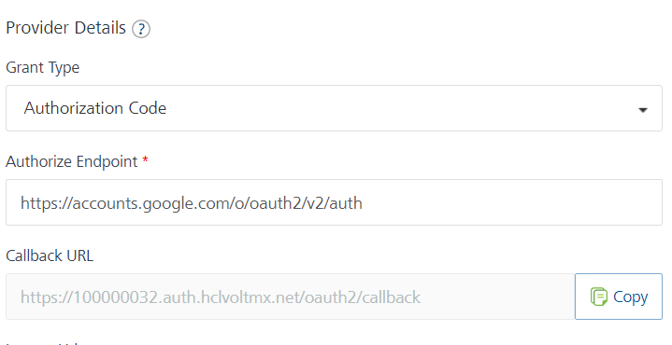
- Click Create.
- After you create the credentials, the Google Developer Console displays your Client ID and Client Secret.
- You need to add the Client ID and Client Secret to the Identity Service that you create.

Importing the adapter
To import the data adapter to Volt foundry, do the following:
- Sign in to the HCL Volt Foundry.
- From the left navigation menu, select API Management.
- In API Management, select Custom Data Adapters.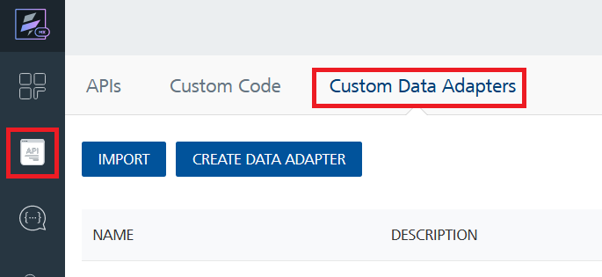
- Click IMPORT to import a custom data adapter.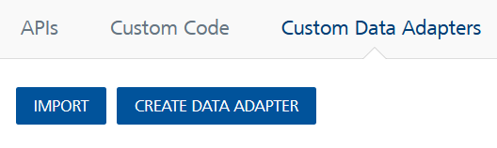
- On the Import Data Adapter dialog box, click browser to import.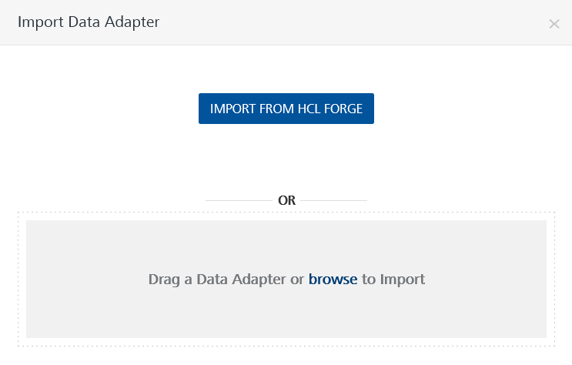
- Select Google Calendar Integration Service Api.zip file and click IMPORT.
- 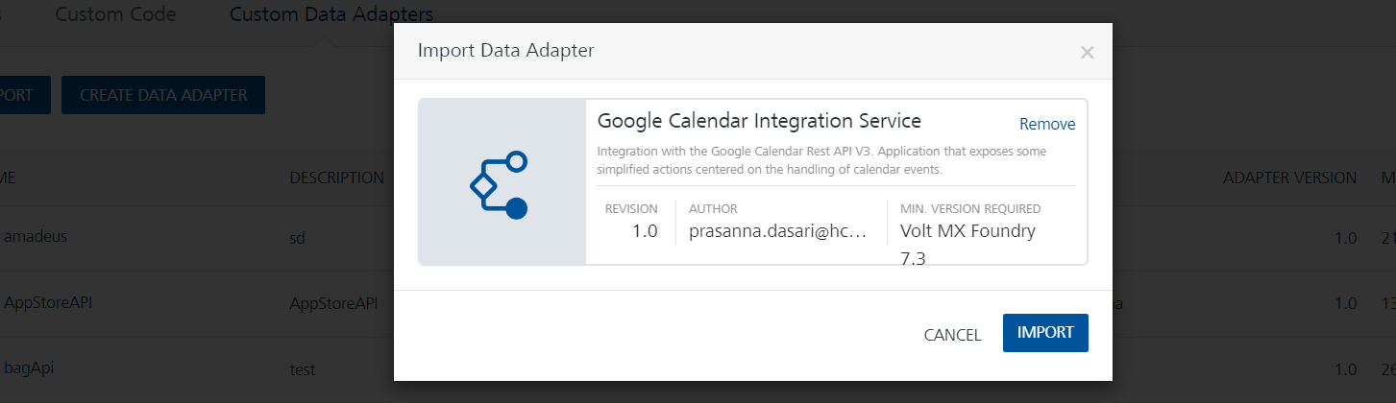
After you import the data adapter, Volt Foundry opens a window that shows the metadata of the data adapter.

Creating an Integration service
After you import the data adapter into Volt Foundry, you can use it to create an Integration Service.
Follow the given steps to create an Integration service using the Google calendar integration service.
- Sign in to the HCL Volt Foundry.
- From the left navigation menu, select API Management.
- In API Management, select Integration.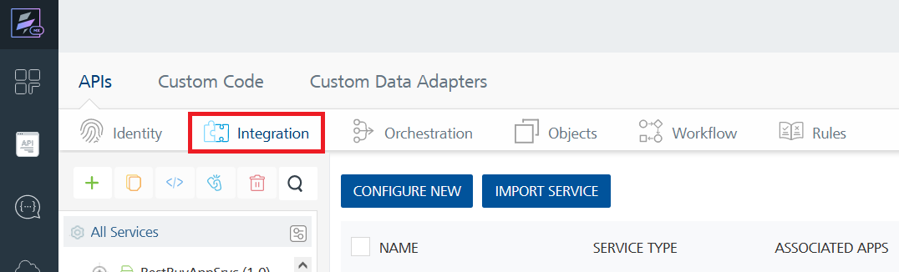
- To create a new service, click the + button or the CONFIGURE NEW button.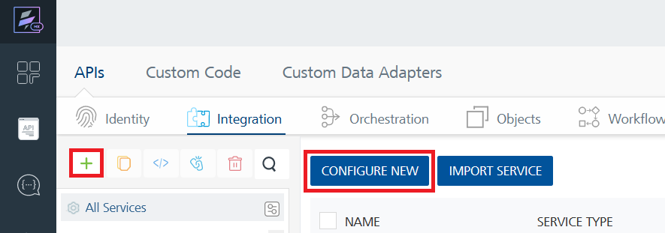
- On the Service Definition tab, select the service type as Google Calendar Integration Service and click SAVE. 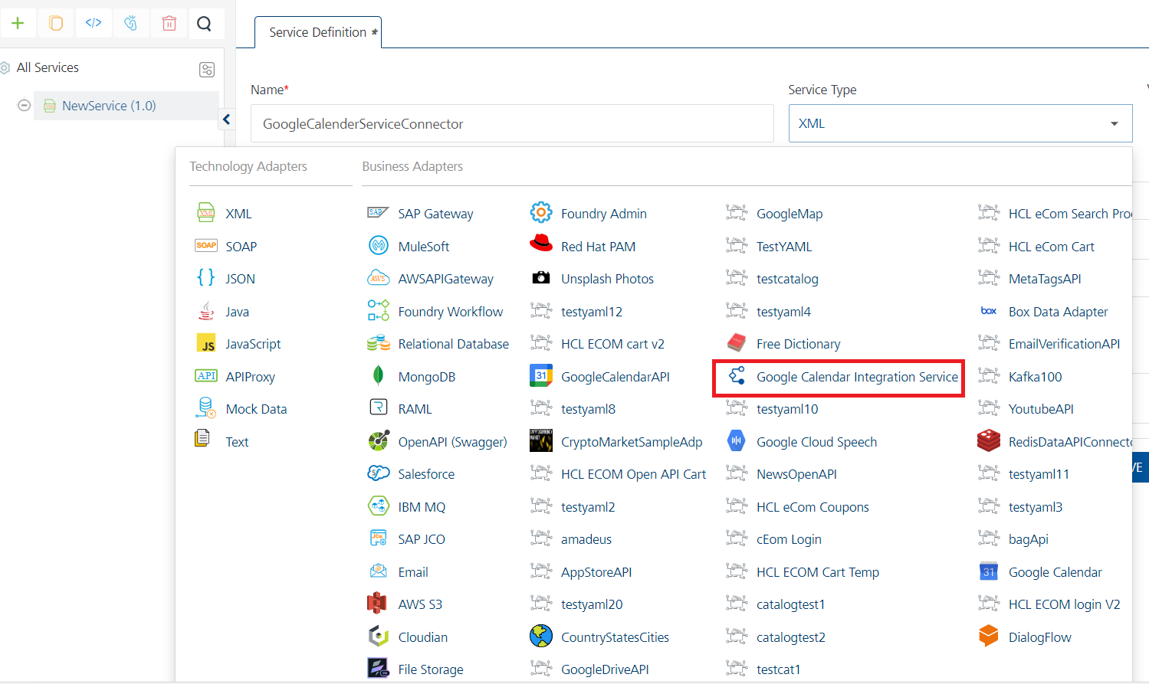
Alternatively, you can also create a Foundry app and create an Integration service inside it.

Creating and executing operations:
After you create an integration service, you can create and execute operations using the service.

Creating an operation
- In API Management/Foundry app you created, in the Integration section, select the service that you created.
- After you select the service, navigate to the Operation List tab.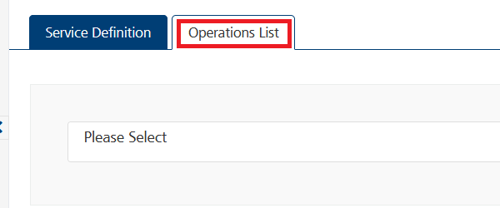
- From the drop-down list, select an operation that you want to execute, and click ADD OPERATION.

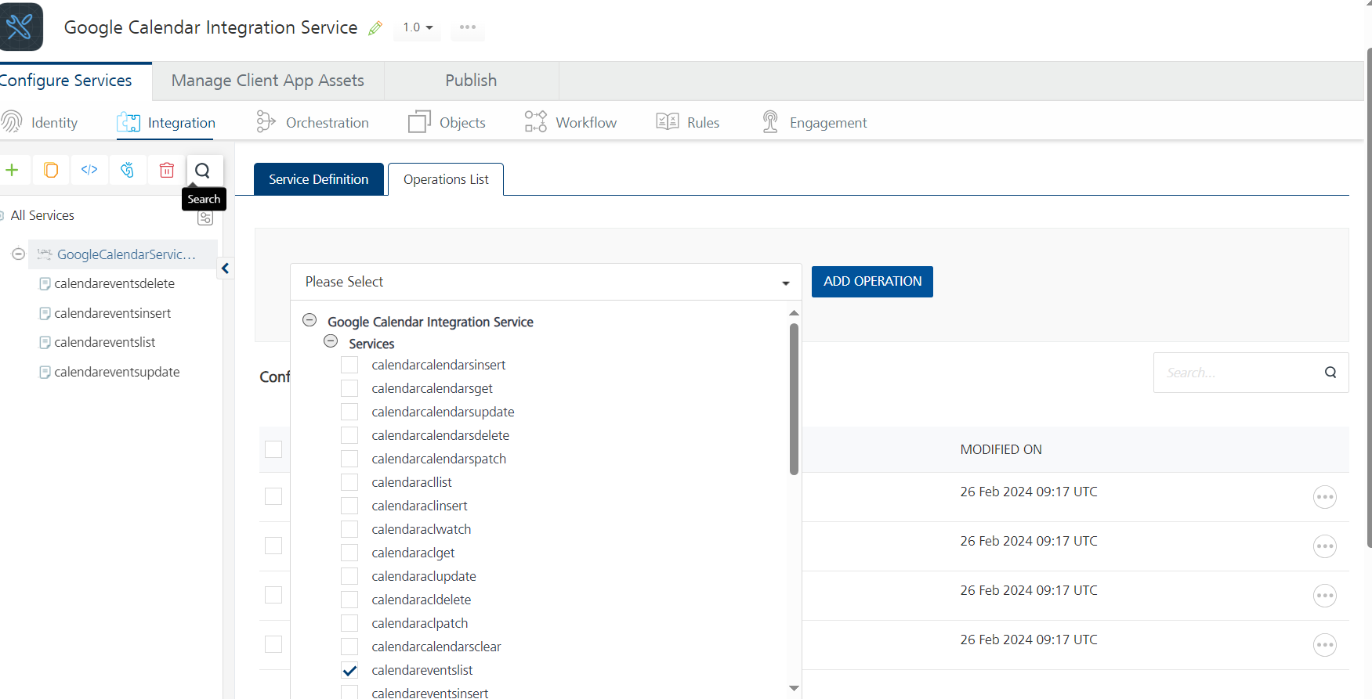

Executing an operation
- From the Operations List tab, in the Configured Operations section, select the operation you want to execute.
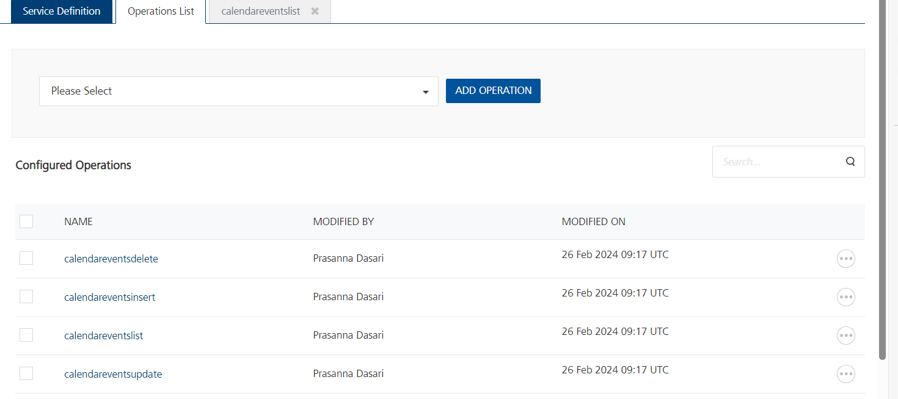

- On the Operation Page, in the Request Input tab, enter a TEST VALUE for all the fields.
- Select a run-time environment and click Save and Fetch Response.
- Provide access to google calendar account and get response based on your inputs.

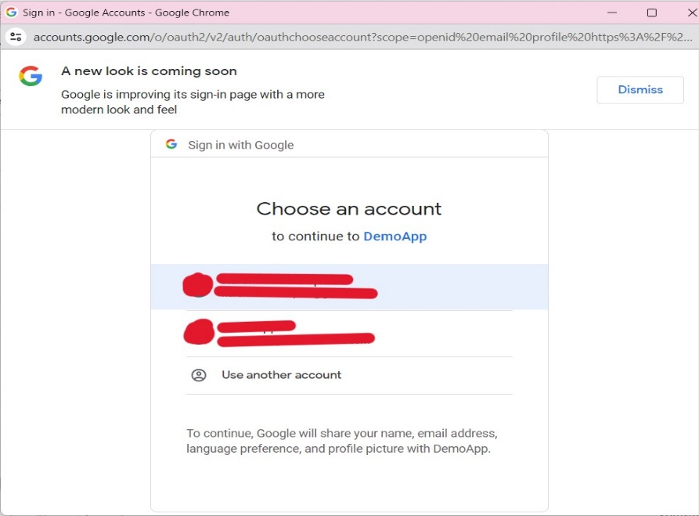
- 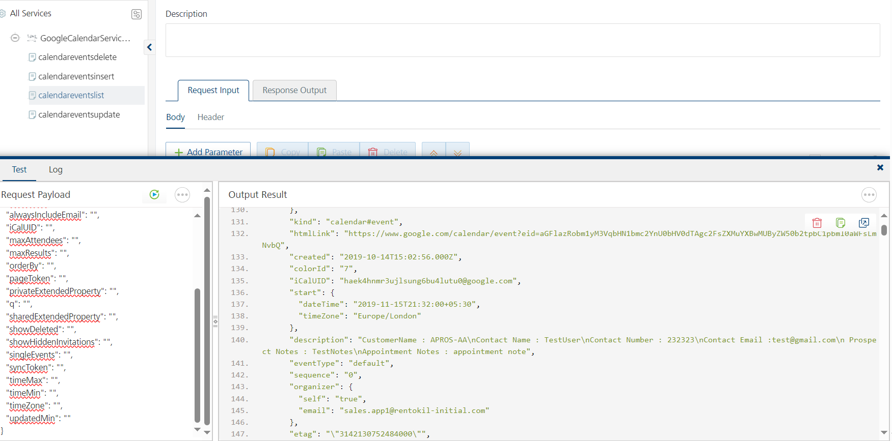

Publishing your application
If you want to use the services in client applications, you need to publish an app to a run-time environment. You can create the service (as described above) in an application or import the service into an application and publish the application.

References

Endpoint Documentation
https://developers.google.com/calendar/api/guides/overview

Revision History
Adaptor version: 1.0.0

Known Issues

Limitations

