Date : 05-Oct-23

Google Analytics Code Module

VERSION:1.0.1

**1. Overview**

Google Analytics is a service offered by Google that collects, measures, and reports data from the traffic of a website. The Google Analytics Code Module integrates the analytics service with Foundry

You can import the module and add it to your web app to implement Google Analytics for all the web pages in your app.

## **A.Use case :**

### Google Analytics helps you understand how visitors interact with your website, which pages are most popular, and how long they stay. This information can be used to optimize website performance, improve user experience, or generate more conversions.

## **B.Percentage of re-use:**

100% (Data can be customizable)

**2. Getting Started**

## **Prerequisites**

Before you start using the Google Analytics code module, make sure that you meet all the prerequisites.

* [HCL Foundry](https://manage.hclvoltmx.com/)
* Volt MX Iris

## **Platforms Supported**

### PWA & Responsive web.

## [Importing the code module to your project](javascript:void(0);)

## **To import the Google Analytics code module do the following:**

1. Make sure that you are signed in to VoltMX Iris.
2. Open the **Forge** menu, and then select **Browse**.

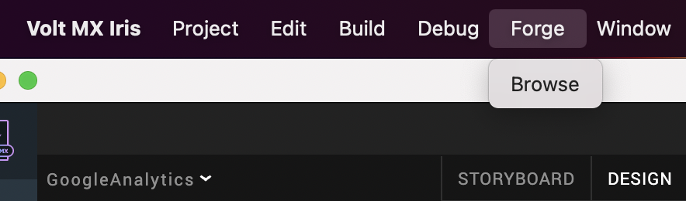

3. In the browser window that opens, search for **Google Analytics** and from the search results, select **Google Analytics**.

1. On the detail page, click **Import To Collection Library**.  
   A blue rectangle with white text

   Description automatically generated
2. You can also download the code module onto your system as a **zip file** from [HCL Forge](https://marketplace.hclvoltmx.com/). You can then import the zip file by selecting the **Import** option in the **File** menu.

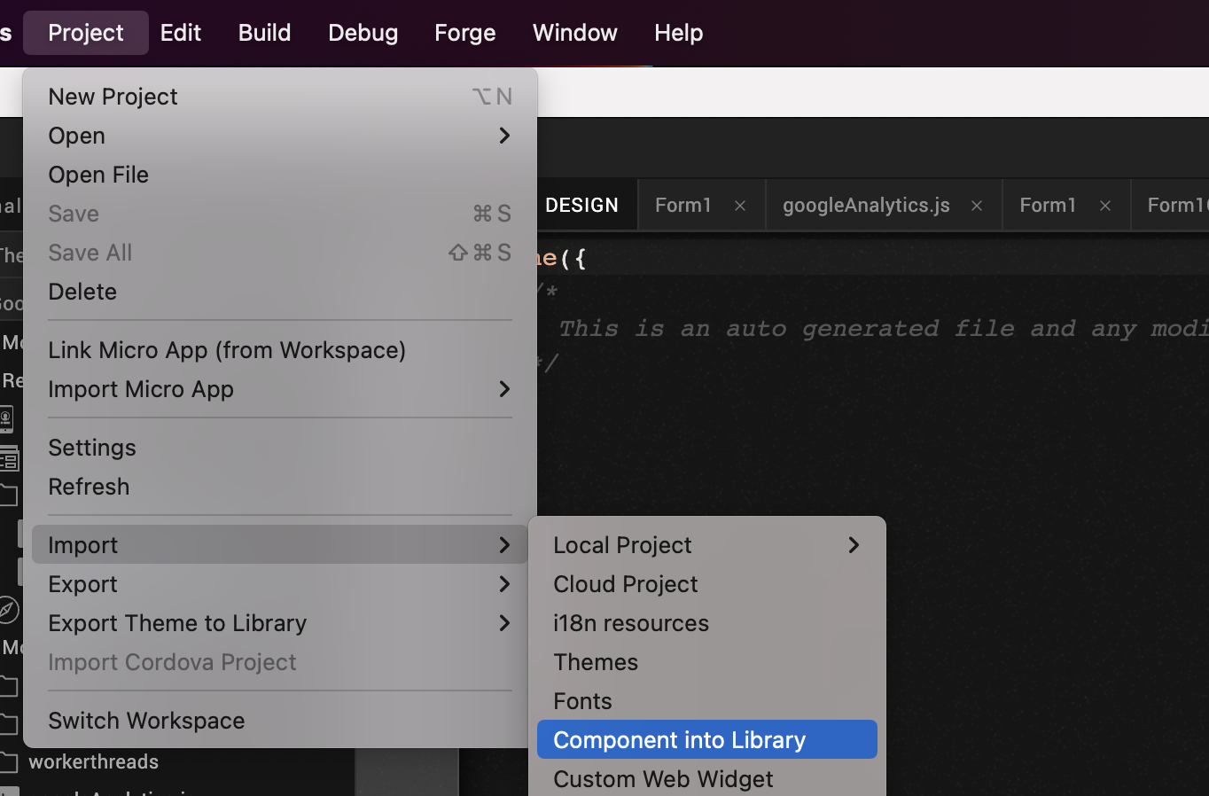

After Iris downloads the code module, it opens a window that asks you to enter metadata for the code module.

Enter a **Library Name**, a **Collection Name**, and a **Description** if you require one.

* **Library Name** - A Library contains component collections and skins. The Library Name specifies the library that you want to import the component into. If the library does not exist, Iris creates a new one.  
  As an example, let us name the Library as **Analytics**
* **Collection Name** - A collection contains multiple components. The Collection Name specifies the collection that you want to import the component into. If the collection does not exist in the specified library, Iris creates a new collection.  
  As an example, let us name the Collection as **CodeModules**.
* **Component Name** - This name specifies the display name you want to use for the component in Iris.  
  By default, the component name is **googleAnalytics**.

After you import the code module, right-click the module and then select **Merge Into**.

Iris adds the code module in the **Modules** folder of your project.

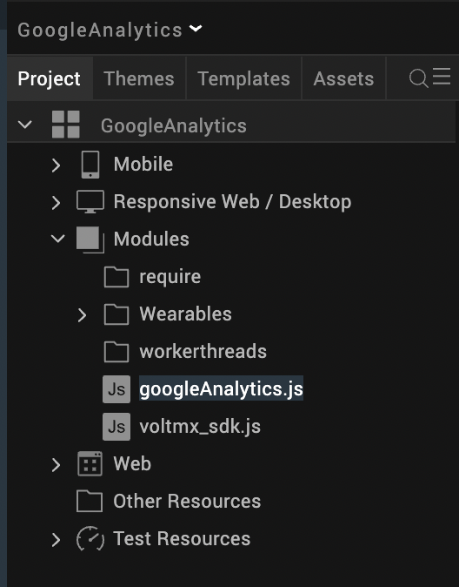

After you add the code module to your project, you need to [configure the analytics key](https://docs.kony.com/marketplace/GoogleAnalyticsModule/Content/Getting_Started.htm#configuring_key) in the JavaScript module. You can refer to the next section for more information.

**C. [Configuring the analytics key](javascript:void(0);)**

After you add the code module to your project, follow these steps to configure your analytics key in the module.

1. From the **Project** explorer, go to **Modules** and select **googleAnalytics.js**.



In the text editor, find and replace G-XXXXXXXXX with your **Google Analytics** **key**.

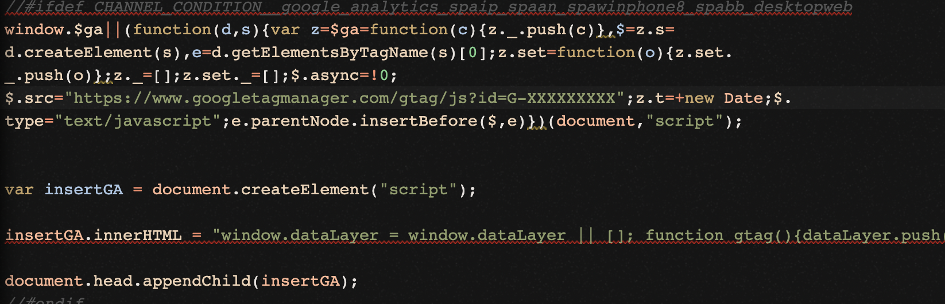

After you configure the analytics key, you can [Build and Preview your app](https://docs.kony.com/marketplace/GoogleAnalyticsModule/Content/Getting_Started.htm#Preview).

**D.**[**Building and Previewing your app**](javascript:void(0);)

After you complete all the specified steps, you can perform either of the following tasks:

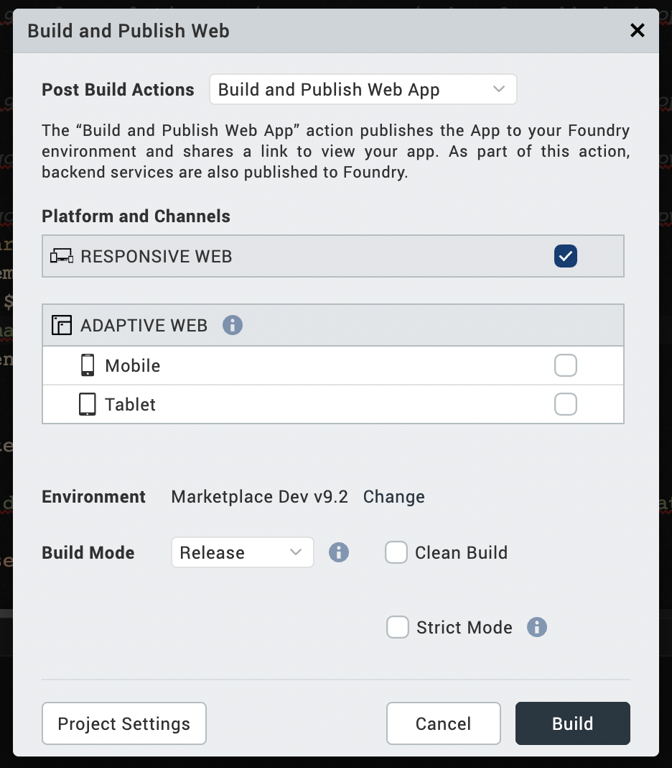

# **References**

# **How to get the Google Analytics GA4 Tracking code**

# Click on <https://analytics.google.com/analytics/web>

# Choose the Google account .

# Click on create dropdown,Click on create property.

# Fill all the relevant details.

# Click on create property to get the tracking code.

# Replace your tracking code with the tracking code in the code module.

# **4.Revision History**

App version 1.0.1

## **A.Known Issues**

-- NA