Date : 18-Oct-23

Google Gmail Connector (1.0.0)

Overview
The Gmail API is a RESTful API that can be used to access Gmail mailboxes and send mail. For most web applications the Gmail API is the best choice for authorized access to a user's Gmail data and is suitable for various applications

Use case

You can use in case of
- Read-only mail extraction, indexing, and backup
- Automated or programmatic message sending
- Email organization including filtering and sorting of messages

Percentage of re-use:
70% (Data can be customizable and customer need to implement UI by themselves).

Getting Started

Prerequisites
Before you start using the Google Gmail data adapter, ensure you have the following:

- HCL Foundry
- Volt MX Iris
- Gmail Account

Importing the adapter
To import the Data Adapter to Volt Foundry, do the following:
- Sign in to the HCL Foundry.
- From the left navigation menu, select API Management.
- In API Management, select Custom Data Adapters.
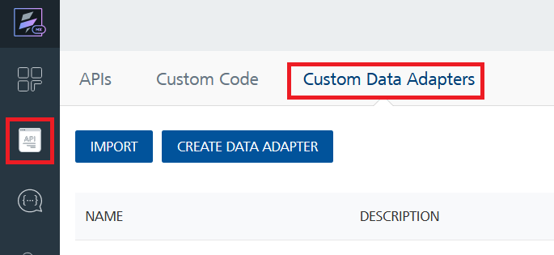
- Click IMPORT to import a custom data adapter.
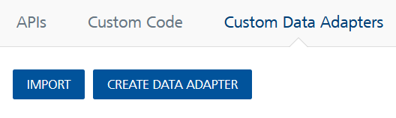
- On the Import Data Adapter dialog box, click browser to import.
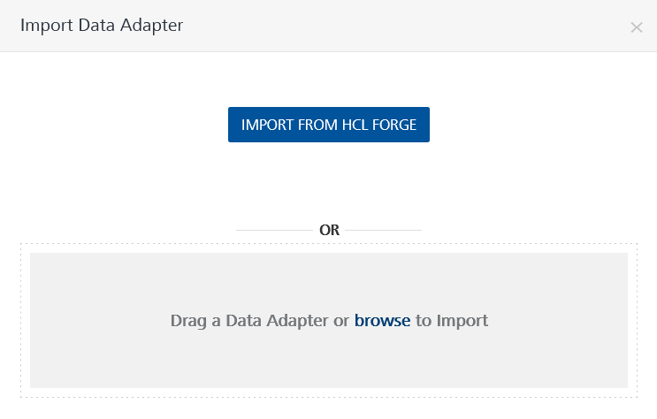
- Selected Gmail data adapter zip file and click IMPORT.
After you import the data adapter, Volt Foundry opens a window that shows the metadata of the data adapter.
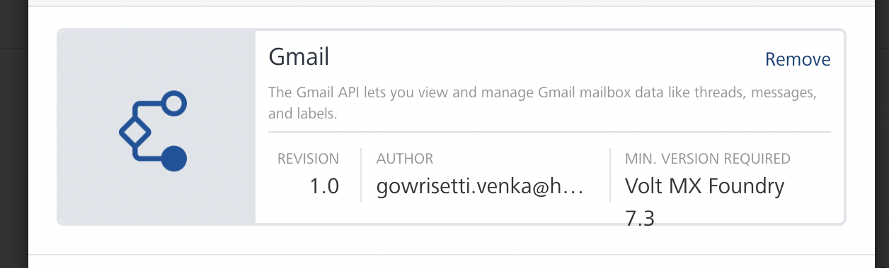
After you import the data adapter, you can view it on the Custom Data Adapters page and use it to create services on Volt Foundry.
After you add the data adapter to your Volt Foundry app, you need to get your API key and Oauth ClientID and ClientSecret from Google Cloud Console. You can refer to below section for more information.
Creating an Identity Service
To use the Gmail connector APIs, you need to create an identity service that uses OAuth 2.0 for authentication.
To create an identity service, follow these steps:
- Sign in to the HCL Foundry.
- From the left navigation menu, select API Management.
- Under APIs, on the Identity tab, click CONFIGURE NEW.
- From the Type of Identity list, select OAuth 2.0.
- In the Authorize Endpoint box, type this link:
https://accounts.google.com/o/oauth2/v2/auth

- In the Token Endpoint box, type this link:

https://www.googleapis.com/oauth2/v4/token
- In the Scope box, type either of the following links:
- https://mail.google.com/
- https://www.googleapis.com/auth/gmail.modify
- https://www.googleapis.com/auth/gmail.compose
- https://www.googleapis.com/auth/gmail.readonly
- https://www.googleapis.com/auth/gmail.metadata

8.Under Client Details, type the Client ID and Client Secret that you received from Google.
For information on obtaining the Client Details, refer to Obtaining the Client ID and Client Secret
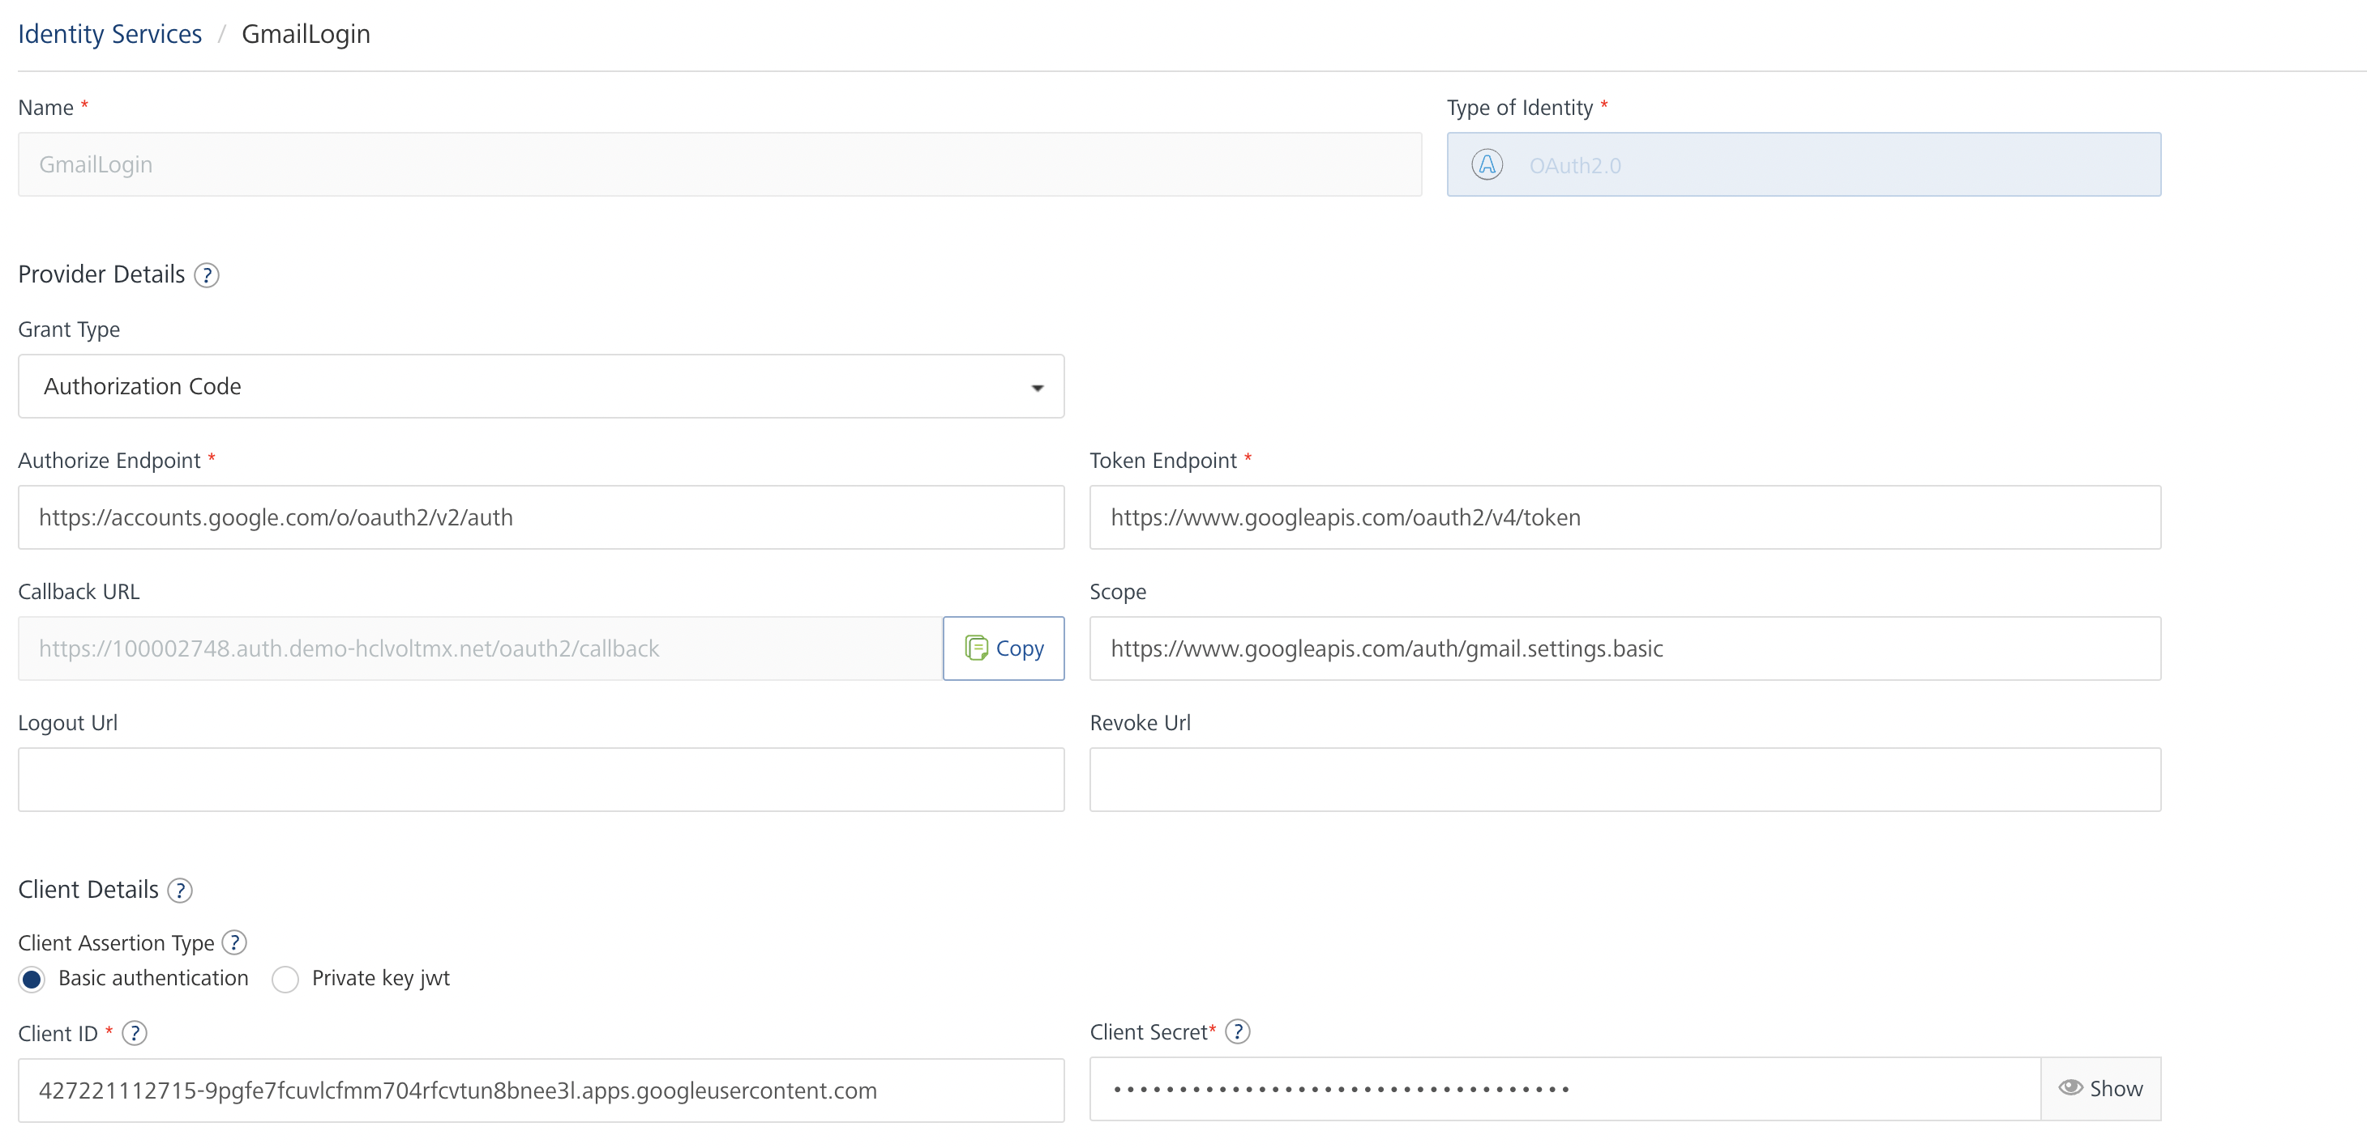
Note:
If you want to verify the details, click TEST LOGIN and sign in by using your Google credentials.

9.Click Save

Obtaining the Client ID and Client Secret
To obtain the client ID and client secret from Google, you need to perform the following steps:
Authorizing the Foundry Domain
To use the Google APIs in a domain, you need to authorize the domain on the Google Developer Console.
To authorize the Foundry Cloud domain, follow these steps:
- Sign in to the Google Developer Console.
- From the left pane, select OAuth consent screen.
- Under Authorized Domains, in the text box, type hclvoltmx.net, and then press Enter.
- Click Save.
Obtaining the Callback URL
- Sign in to the Google developer console.
- Open or Edit the Identity Service that you created earlier.
- Under Provider Details, for the Callback URL, click Copy.
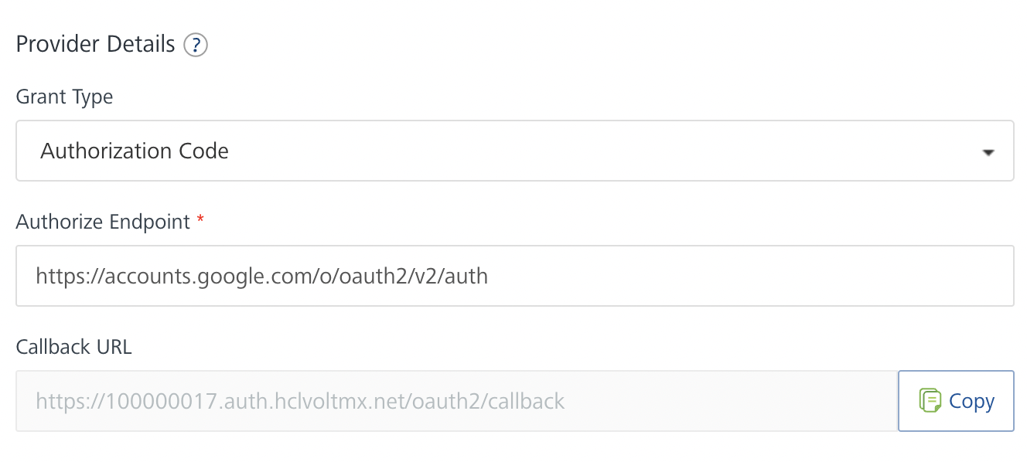
Adding a Redirect URL on Google
- Sign in to the Google Developer Console.
- From the left pane, select Credentials.
- On the Credentials page, click Create credentials, and then select OAuth client ID.
- Under Application type, select Web application.
- Under Authorized redirect URIs, in the text box, type the Callback URL that you Obtained from Volt Foundry.
- Click Create.
After you create the credentials, the Google Developer Console displays your Client ID and Client Secret.
You need to add the Client ID and Client Secret to the Identity Service that you created earlier

Creating an Integration service
After you import the data adapter into Volt Foundry, you can use it to create an Integration Service.
Follow the given steps to create an Integration service using the Gmail Data Adapter.
- Sign in to the HCL Foundry.
- From the left navigation menu, select API Management.
- In API Management, select Integration.
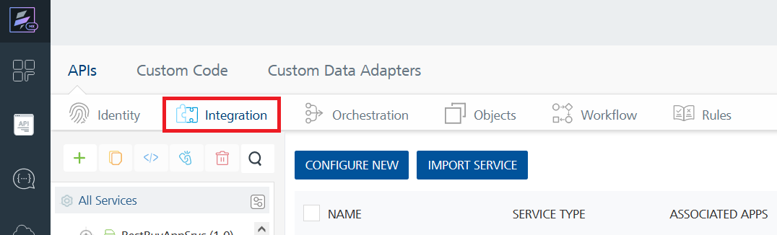
- To create a new service, click the + button or the CONFIGURE NEW button.
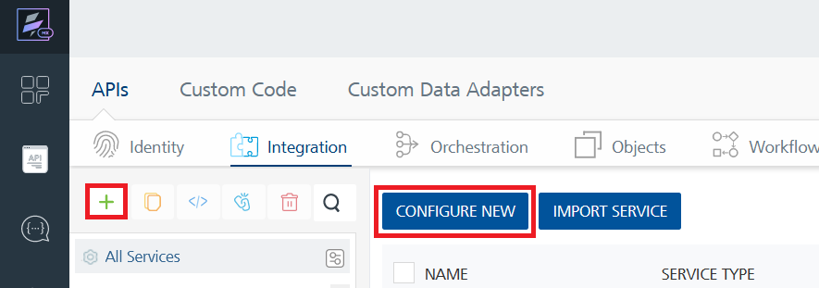
- On the Service Definition tab, select the service type as Gmail, and click SAVE.
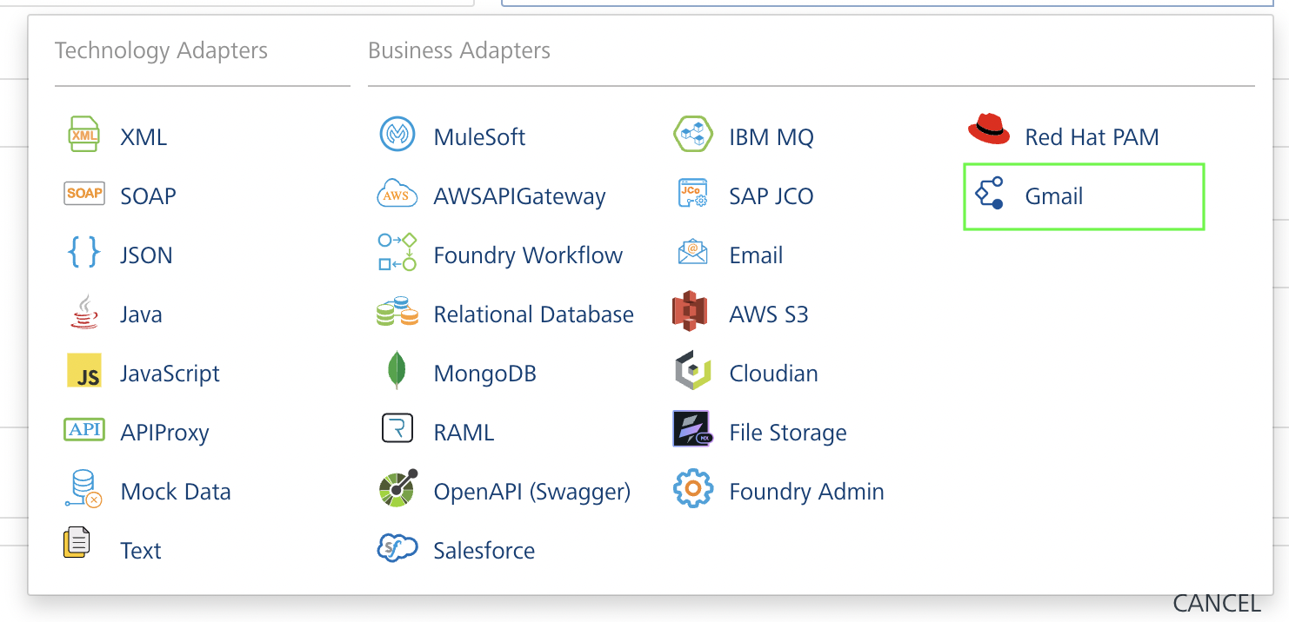
Creating and Executing operations
After you create an integration service, you can create and execute operations using the service.

Creating an Operation
- In API Management, in the Integration section, select the service that you created.
- After you select the service, navigate to the Operation List tab.
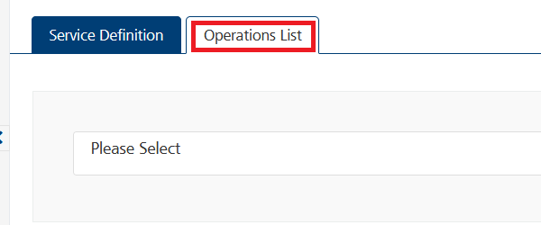
- From the drop down list, select an operation that you want to execute, and click ADD OPERATION.
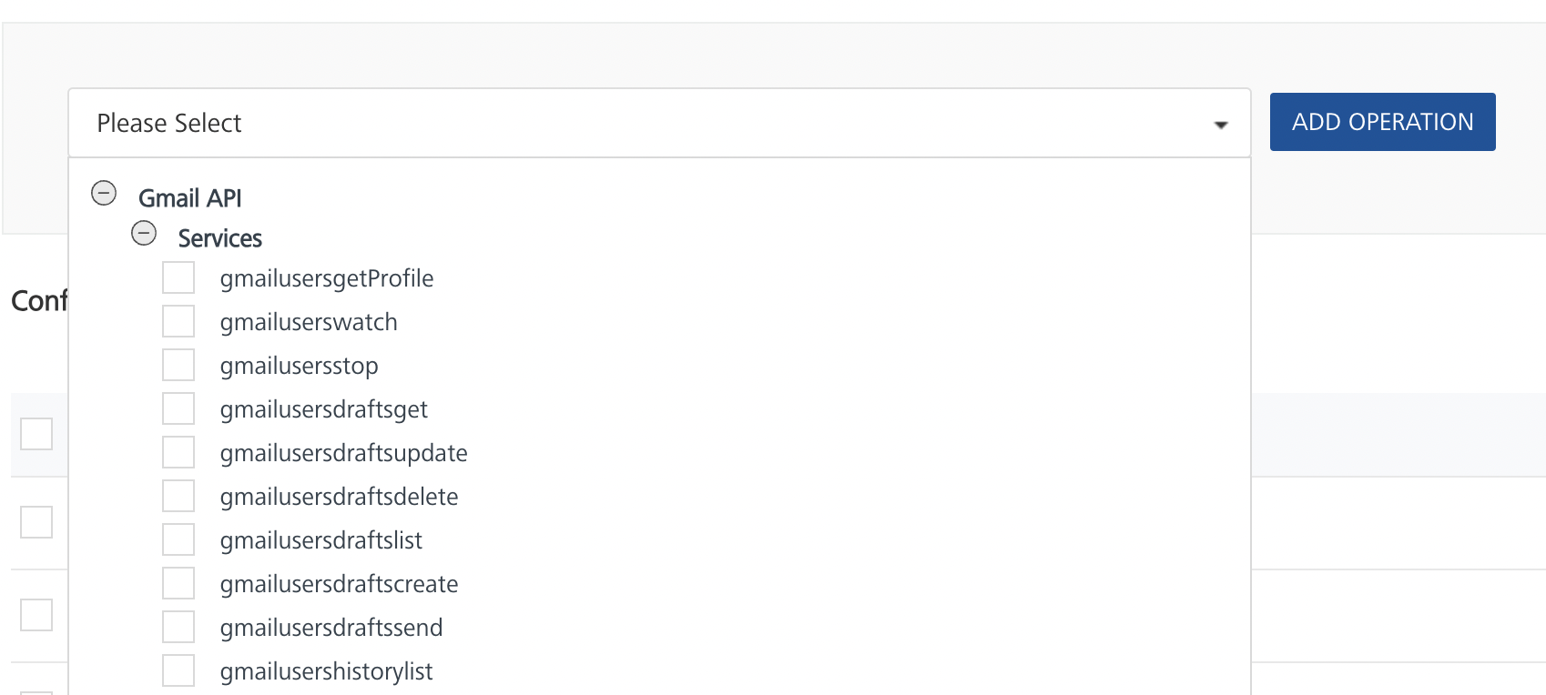

Executing an Operation
- From the Operations List tab, in the Configured Operations section, select the operation you want to execute.
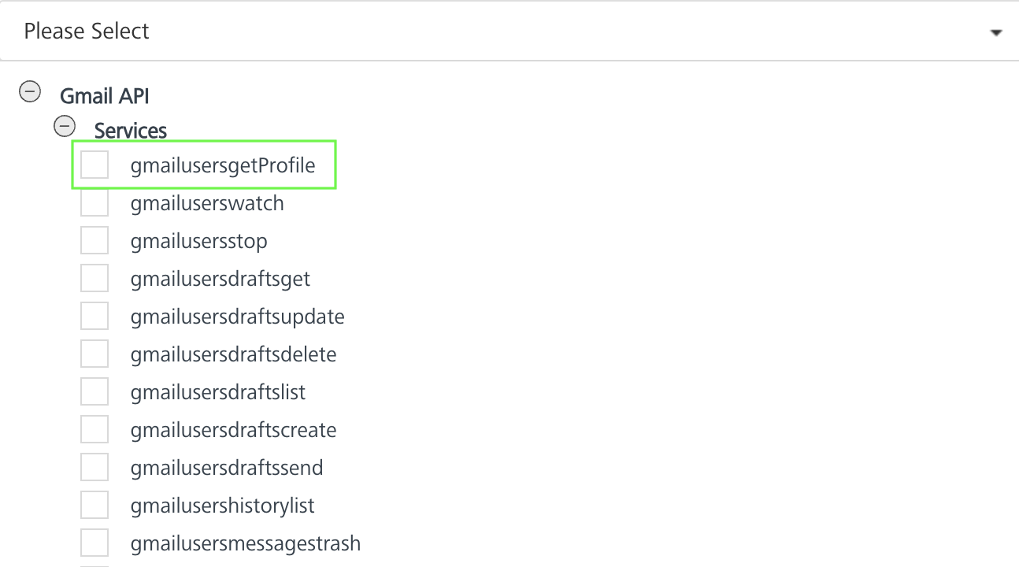

- On the Operation Page, in the Request Input tab, enter a TEST VALUE for all the fields.
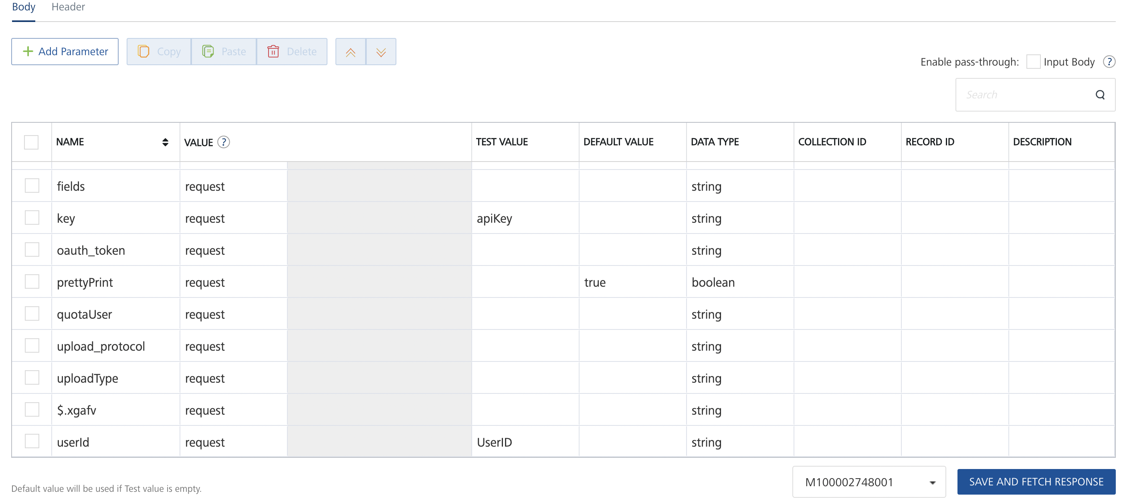
  - userId: The Email address of the User.
  - Key: API key obtained from Google developer console.
Note: Make sure that you do not save the UserID on any client device. Configure the UserID only on Volt Foundry.
- Select a run-time environment and click Save and Fetch Response to get a response from Gmail based on your inputs.
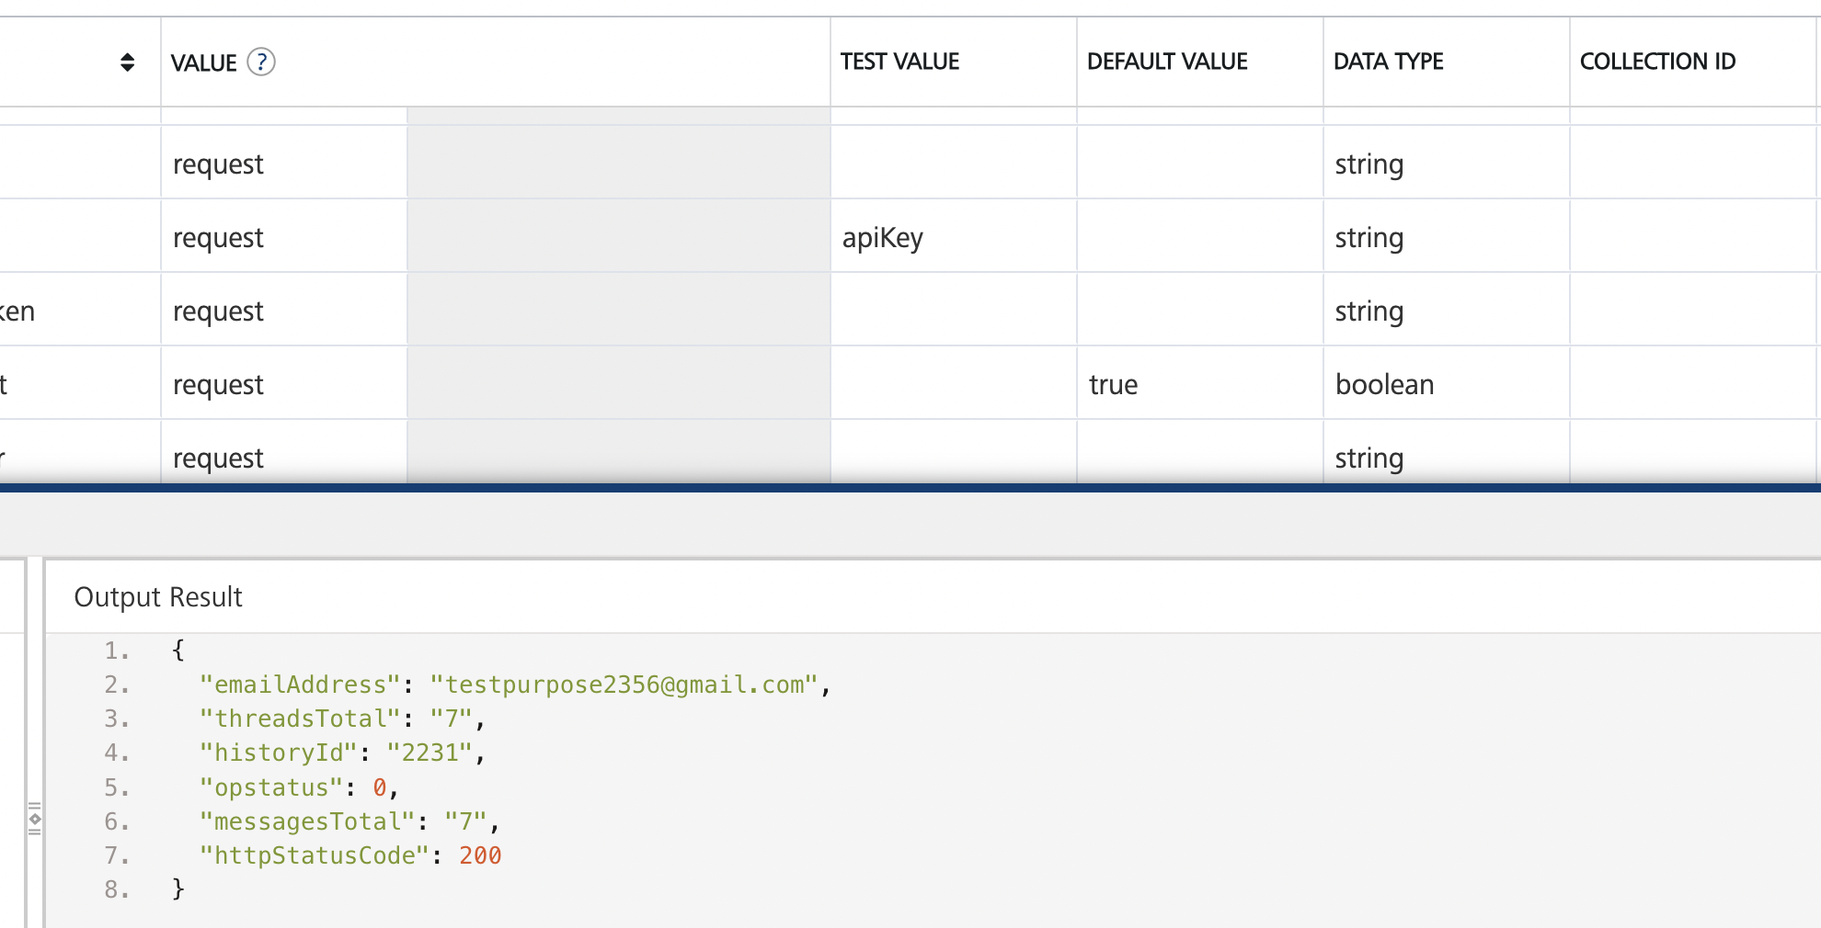
Publishing your application
If you want to use the services in client applications, you need to publish the app to a run-time environment.
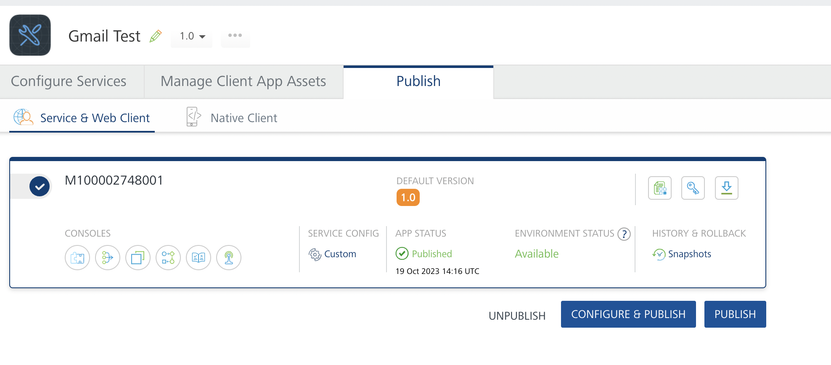
You can also link the Volt Foundry app to a client application.

References
Method | EndPoints | Documentation Link
users | getProfile  stop  watch | Users
users.drafts | create  delete  get  list  send  update | users.drafts
users.history | list | users.history
users.labels | create  delete  get  list  patch  update | users.labels
users.messages | batchdelete  batchmodify  delete  get  insert  list  modify  trash  untrash | users.messages
users.messages.attachments | get | users.messages.attachments
users.settings | getautoforwarding  getimap  getlanguage  getpop  getvacation  updateautoforwarding  updateimap  updatelanguage  updatepop  updatevacation | users.settings
users.settings.forwardingAddresses | create  delete  get  list | users.settings.forwardingAddresses
users.settings.sendAs | create  delete  get  list  patch  update  verify | users.settings.sendAs
users.threads | delete  get  list  modify  trash  untrash | users.threads

Note: For more information on the input requests, you can refer to the Gmail Documentation.

Known Issues
None

Limitations

Method | EndPoints | Documentation Link
users.settings.cse.identities | create  delete  get  list  patch | Users.settings.cse.identities
users.settings.cse.keypairs | create  disable  enable  get  list  obliterate | users.settings.cse.keypairs
users.settings.delegates | list  get  delete  create | users.settings.delegates
users.settings.sendas.smimeinfo | delete  get  insert  list  setdefault | users.settings.sendas.smimeinfo

Gmail imposes limitations on the number of delegates and delegators each user in a Google Workspace organization can have. These limits depend on your organization, but in general each user can have up to 25 delegates and up to 10 delegators.
Above methods are only available to service account clients that have been delegated domain-wide authority.

