15 May 2024

GEOLOCATION FEATURE APP

VERSION: 1.0.2

Overview
The GeoLocation Feature App highlights the usage and capabilities of the Geolocation API in Quantum stack.

This app highlights three basic functionalities of the API:
- Getting current position
- Watching position
- Clear Watch

GeoLocation Feature App Functionality

This section explains the functionality of the Geolocation Feature App. It is a feature app as it highlights the features and capabilities of the Geolocation API in the Quantum stack.

Geolocation API:

The Geolocation API defines a high-level interface to location information, such as latitude and longitude associated with the mobile device. The API uses the common sources of location information like Global Positioning System (GPS) to infer details like IP address, RFID, WIFI and Bluetooth MAC addresses, and GSM/CDMA cell IDs. This API does not always return the device's actual location.
For more information on Geolocation API, you can refer to the following documents:
- Geo Location Api
- Voltmx.location Namespace

The GeoLocation Feature App has two screens:
- Landing Screen - Contains all the features that the app highlights.
- Feature Screen - Shows the feature that is selected on the landing screen.
- Knowledge Framework - It is an additional layer that contains a list of key features covered in the app.
The features that this app highlights are:
- Get Current Position
- Watch Position and Clear Watch
Get Current Position
On tap of the Current Position row on the landing page, the app shows the Current Position Feature screen. The details present on the screen correspond to the current location of the user's device. This functionality makes use of the getCurrentPosition function in the voltmx.location namespace. The values that the function returns in the success call back are put on the screen.
These values are described in the following table.
Latitude: | The latitude of the device in decimal degrees.
Longitude: | The longitude of the device in decimal degrees.
Altitude: | The height of the location in meters. This height is calculated from the ellipsoid of the Earth.
Accuracy: | The accuracy level of the latitude and longitude coordinates in meters.
Heading: | The direction of travel in degrees. These degrees are counted clockwise relative to the true north.
Speeding: | The current ground speed of the device in meters per second.
Timestamp: | The time when the position object was acquired.

Watch Position and Clear Watch
On tap of the Watch Position row on the landing page, the app shows the Watch Position Page. The details present on the screen correspond to the current location of the user's device. This functionality makes use of the watchPosition function in the voltmx.location namespace. This function returns the same parameters as the getCurrentPosition function. The difference is that watchPosition returns these values every time the position of the devices changes. The watch operation continues till the clearWatch function is called with the corresponding identifier.

Knowledge Framework
The Knowledge Framework screen of the app is accessible by tapping on the blue floating button at the bottom right corner of the screen. On tap of the Knowledge Framework button, the app presents a layover screen with a list of the key features covered in the app.
Upon selecting an item from the list presented, you are navigated to a detailed page containing the What and How of the corresponding key feature along with the appropriate links to the documentation and tutorials.
The What s it? section provides an overview of the feature whereas the How to use? section contains usage information of the feature. The latter may include blogs, video tutorials or code fragments as applicable. This app carries all the code fragments used to render the UI or functionalities in the app.

Getting Started

Prerequisites
Before you start using the Geolocation Feature App, ensure you have the following:
• HCL Foundry
• Volt MX Iris

Platforms Supported

Mobile

iOS

Importing the GeoLocation Feature App to Visualizer
- Open a web browser and enter https://marketplace.hclvoltmx.com/ in the address field. The Forge page displays with the list of components.
- Search for GeoLocation Feature App and click the corresponding thumbnail. The GeoLocation Feature App detail page appears.
- Click Login to Download in case you are not logged in already. Otherwise, click Download. The app is downloaded to your local system in a zip format.
- Open VoltMX Iris App and Sign In.
- Starter:
  - On the Project menu, point to Import, and click Local Project., select Open as New Project and select From an Archive.
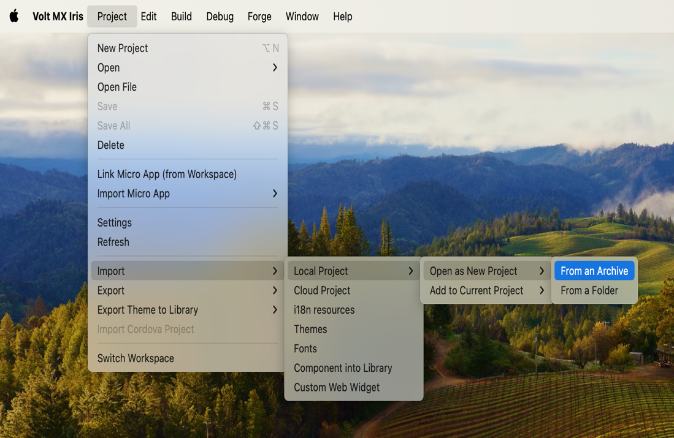
  - Browse and select the downloaded zip file.
  - Click Open.

Viewing the GeoLocation Feature App on your device

You can view the GeoLocation Feature App on your device by using the VoltMX Mobile App.

To view the GeoLocation Feature app on your device, do the following:

Once the app is imported into the iris, Click on Build > Publish Live Preview.

A dialog box appears with a set of channels. Select the appropriate channels and click on Publish.
- A dialog box will appear with a five digit preview code.

On the device open voltmx app, on the landing screen select cloud, Type in the five-digit preview code that you got from Voltmx iris then click Launch.

Configuring the UI of the GeoLocation Feature App
The GeoLocation Feature App comes with a pre-configured UI. You don't need to make any changes to the wiring or coding to make the app work. You can import the app to Visualizer Enterprise and build it to see it working. However, if you need to modify the UI of the app, you can follow the guidelines given below.
The UI of this app contains four forms:
- frmHome
- frmOptions
- frmGeoData
- frmKnowledgeFramework

To modify the UI of GeoLocation Feature App, you can follow the guidelines given below.
- Import the project to VoltMX Iris.
- Under the Project tab, expand Mobile > Forms. You will see all four forms as shown in the given image.
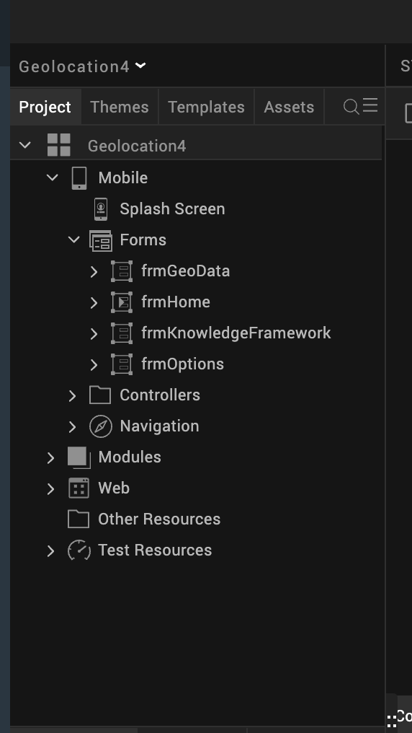

frmHome is used as a startup form. This form describes the app. Expand frmHome to see the detailed structure of the form, as shown in the given image.
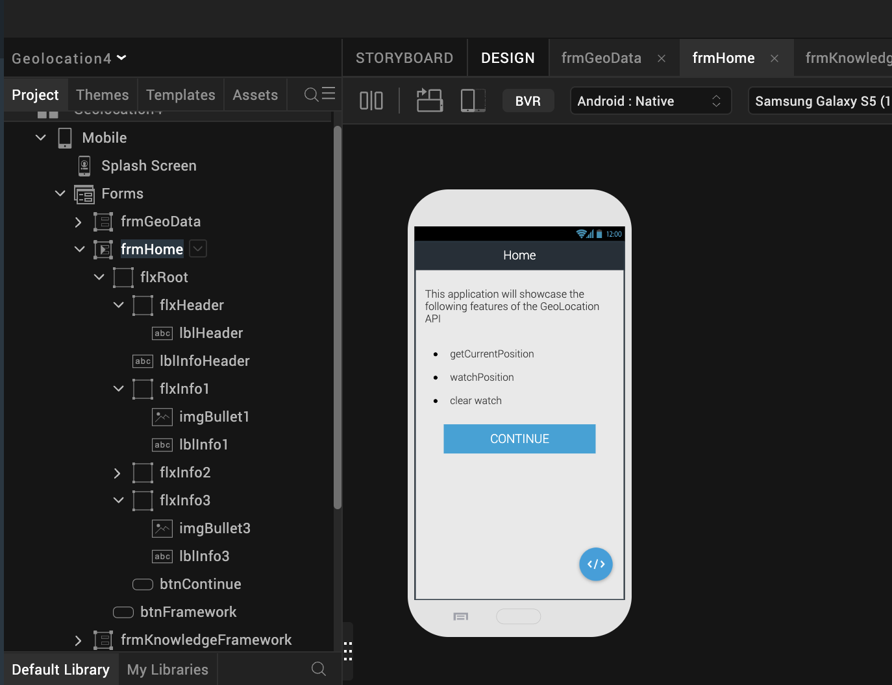

- flxRoot is a flex container in a Flow Vertical layout. This holds all other widgets on this form.
- flxHeader is a flex container that holds a label widget, lblHeader, to show the title of the form.
- lblInfoHeader is a label widget used to show the description of the app.
- flxInfo1, flxInfo2, and flxInfo3 are three flex containers that hold one image and one label widget to show a bullet list of options.
- btnContinue is a button widget used to navigate to the form frmOptions.
- btnFramework is a button used to navigate to the form frmKnowledgeFramework.
To change the positioning of any widget, follow these steps:
- Expand the widgets in the Project tab under Mobile > Forms > frmHome.
- Choose the widget for which you want to change the positioning.
- Go to the Look tab under the Properties window on the right side in Visualizer.
- Here, you can change the values for Left, Right, Top, Bottom, Width, Height, CenterX, CenterY, Z Index, and so on.
To change the skin of any widget, follow these steps:
- Expand the widgets in the Project tab under Mobile > Forms > frmHome.
- Choose the widget for which you want to change the skin.
- Go to the Skins tab under the Properties window on the right side in Visualizer.
- Here, you can change the values for Background Color, Background Opacity, Border Size, Border Color, Font Size, Font Family, Font Color, and so on.

The onClick action of the Continue button navigates to the form frmOptions. To achieve this, you can write the snippet given below to the onClick action of the Continue button.
var ntf = new voltmx.mvc.Navigation ("frmOptions");

ntf.navigate();

You can also use the Action Editor to navigate to frmOptions. To achieve this, follow these steps:
- Select the Widget.
- Click on the Action tab in the Properties window on the right side.
- Click on the Edit button that is opposite to onClick.
- Select Navigate to Form.
- Select frmOptions from the list.
The onClick action of the Knowledge Framework button in the application navigates to the form frmKnowledgeFramework. To achieve this, you can follow the same steps as navigating to frmOptions.
frmOptions is the form used to show the list of features that are available under the Geolocation API. Expand frmOptions to see a detailed structure of the form, as shown in the given image.
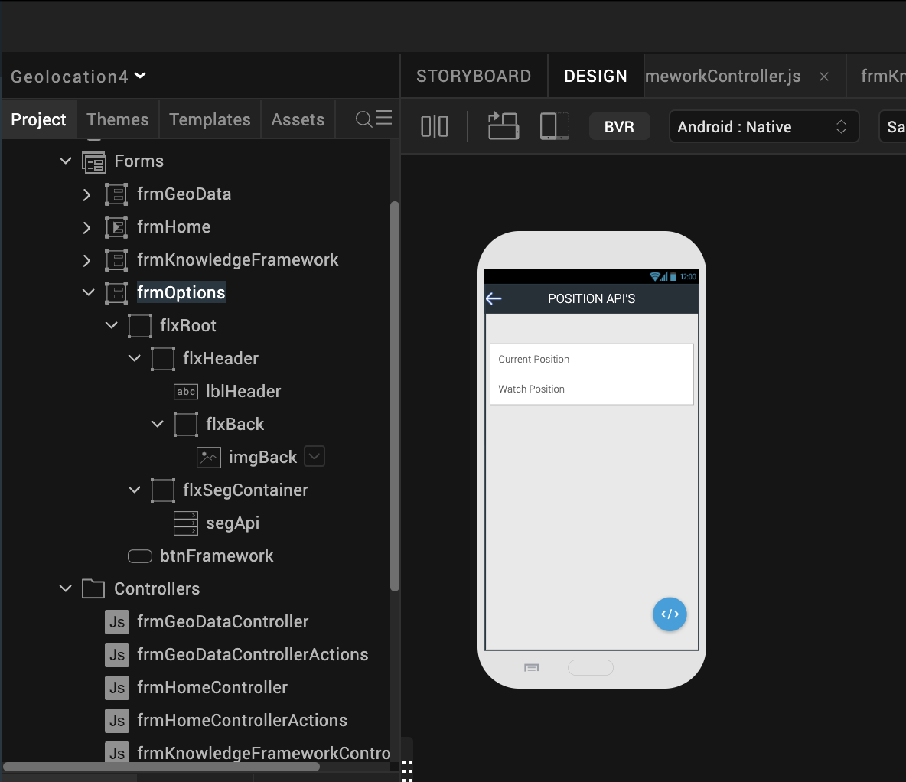
- flxRoot is a flex container in a Flow Vertical layout. This holds all other widgets on this form.
- flxHeader is a flex container that holds a label widget, lblHeader, to show the title of the form. It also holds a flex container, flxBack, to navigate to the previous form.
    - flxBack is a flex container that holds an image widget, imgBack, that holds the image for the back arrow.
- flxSegContainer is a flex container which holds a Segment widget, segApi.
  - segApi, is a segment widget used to show a list of APIs, which is a repetitive UI that is defined as tempSegTitle under the Templates tab in the Project Explorer window on the left side of Iris, as shown in the given image.
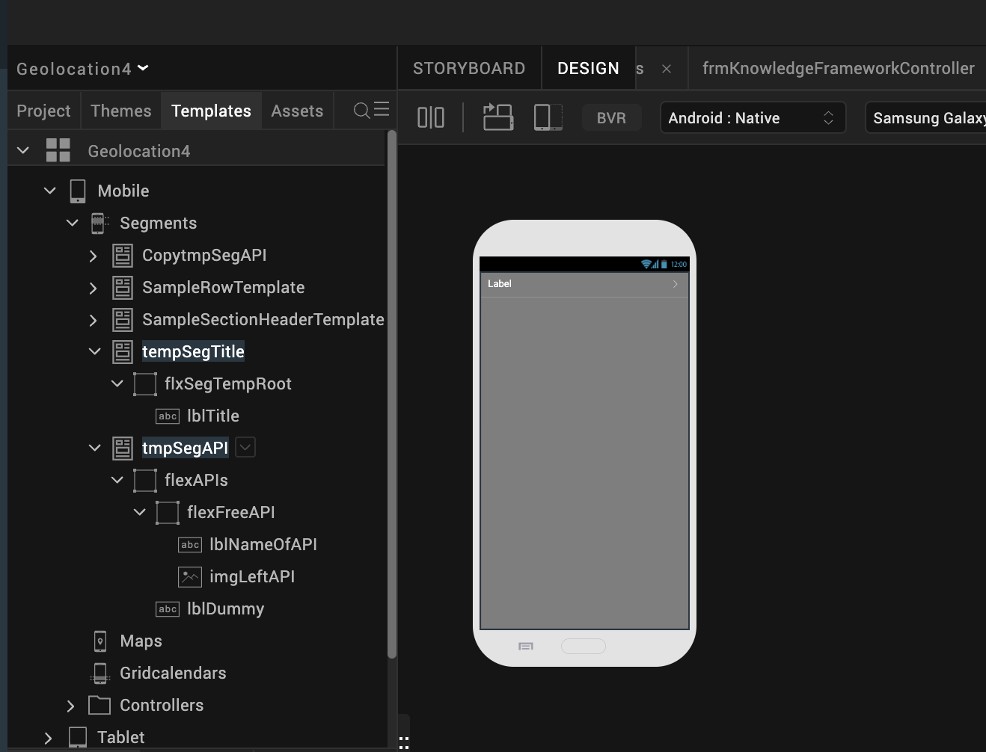
  - tempSegTitle contains one label widget, lblTitle to show the API name.
  - To set data into the segment, select the segment widget and click on the Edit option of the Master Data in the properties window.
  - A window will popup and you can provide the list of data in it, as shown in the given image.
- btnFramework is a button that has its onClick action set to navigate to frmKnowledgeFramework.
- The onRowClick action of the segment segApi navigates to the form frmGeoData. It also sends a parameter to invoke the appropriate API in frmGeoData.
- To configure the positioning or skin of any widget, you can follow the steps mentioned earlier.
- onSegRowClick is the function that is invoked in the onRowClick action of segApi.
The code for the onSegRowClick function can be found in the frmOptionsController.
onSegRowClick:function (eventobj)
{
var selectedIndex=this.view.segApi.selectedRowIndex[1];

if(selectedIndex===0)

{
this.navObj.navigate("GEO_POSITION");

}
else if(selectedIndex===1)
this.navObj.navigate("WATCH_POSITION");

}
- navObj is a global variable pointing to frmGeoData which gets initialized in the onNavigate event of frmOptions as shown in the given code snippet.
onNavigate: function()
{
this.navObj = new voltmx.mvc.Navigation ("frmGeoData");

}

frmGeoData is a form that shows the usage of the Geolocation APIs. Expand frmGeoData to see the detailed structure of the form, as shown in the given image.
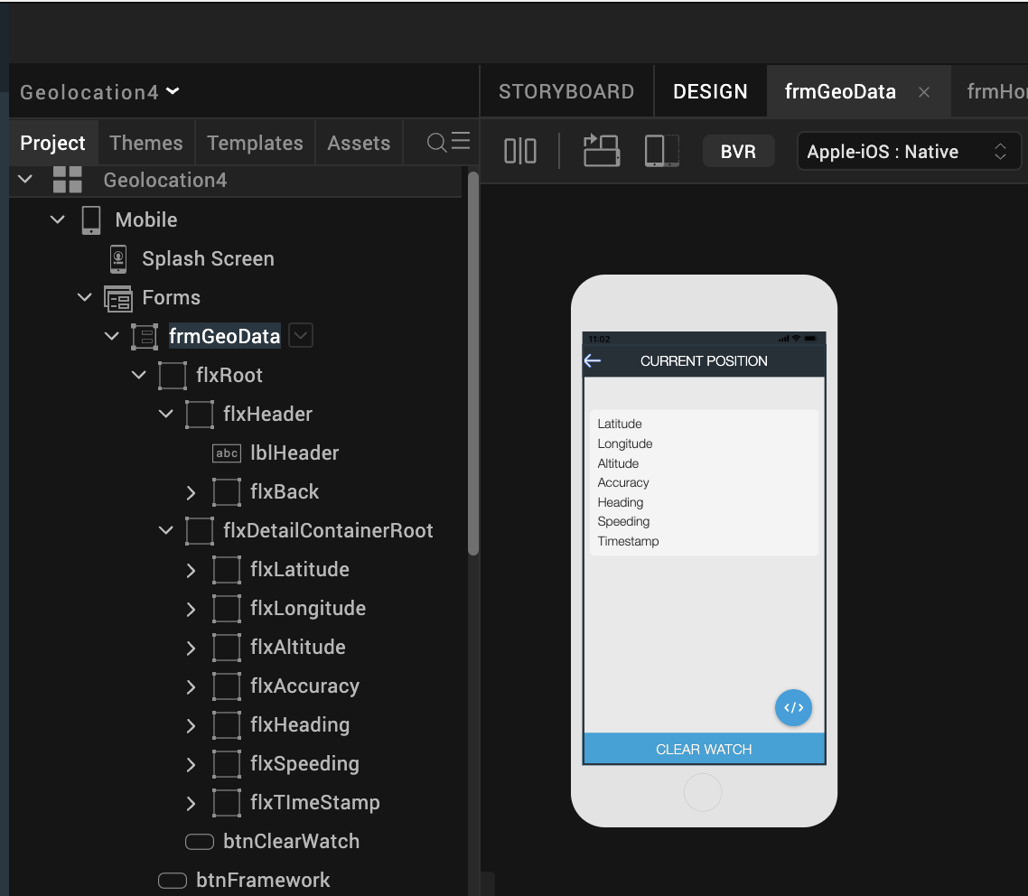
- flxRoot is a flex container in a Flow Vertical layout. This holds all other widgets on this form.
- flxHeader is a flex container that holds a label widget, lblHeader, to show the title of the form. It also holds a flex container, flxBack, to navigate to the previous form.
  - flxBack is a flex container that holds an image widget, imgBack, that holds the image for the back arrow.
- btnFramework is a button that has its onClick action set to navigate to frmKnowledgeFramework.
- flxDetailsContainerRoot is a flex container that holds two label widgets to show key and value pairs of the Geolocation response.
This includes latitude, longitude, Altitude, Accuracy, Heading, Speeding and Timestamp.
- The code snippet below gets invoked when the application navigates to the form frmGeoData to achieve the current position and watch position functionality.
onNavigate:function(param)
{

if(param==="GEO_POSITION")

{

this.view.lblHeader.text="CURRENT POSITION";

this.view.btnClearWatch.setVisibility(false);

this.getPosition();

}

else if(param==="WATCH_POSITION")

{

this.view.lblHeader.text="WATCH POSITION";

this.view.btnClearWatch.setVisibility(true);

this.watchPosition();

}

},

geoSuccessCallback:function(result)
{
try

{

//read latitude, longitude, altitude, accuracy, heading from result object

var lat =result.coords.latitude;

var lang=result.coords.longitude;

var alt=result.coords.altitude;

var acry=result.coords.accuracy;

var hedin= result.coords.heading;

var speed;

//set latitude, longitude, altitude, accuracy, heading values to corresponding labels to //show in UI.

if(lat!==null)

this.view.lblLatValue.text=": "+lat;

else

this.view.lblLatValue.text=": unavailable";

if(lang!==null)

this.view.lblLonValue.text=": "+lang;

else

this.view.lblLonValue.text=": unavailable";

if(alt!==null)

this.view.lblAltValue.text=": "+alt;

else

this.view.lblAltValue.text=": unavailable";

if(alt!==null)

this.view.lblAccValue.text=": "+acry;

else

this.view.lblAccValue.text=": unavailable";

if(hedin!==null)

this.view.lblHeadValue.text=": "+hedin;

else

this.view.lblHeadValue.text=": unavailable";

if(result.timestamp!==null)

this.view.lblTimeValue.text=": "+result.timestamp;

else

this.view.lblTimeValue.text=": unavailable";

// read speed from result object and set to label to show in UI.

speed=result.coords.speeding;

if(speed!==null&&speed!==undefined)

this.view.lblSpeedValue.text=": "+speed;

else

this.view.lblSpeedValue.text=": unavailable";

}

catch(excp

{

// alert(excp.message);

}

voltmx.application.dismissLoadingScreen();

//alert(JSON.stringify(result));

},
geoFailureCallback:function(result)

{
voltmx.application.dismissLoadingScreen();

//alert(JSON.stringify(result));

},
getPosition:function()
{
var self=this;

voltmx.application.showLoadingScreen("sknFrmLoading","please wait...",constants.LOADING_SCREEN_POSITION_ONLY_CENTER, false,true,null);

geoPosition(self.geoSuccessCallback.bind(this),self.geoFailureCallback.bind(this));

},
watchPosition:function()

{
var self=this;

voltmx.application.showLoadingScreen("sknFrmLoading","please wait...",constants.LOADING_SCREEN_POSITION_ONLY_CENTER, false,true,null);

this.watchID=watchPosition(self.geoSuccessCallback.bind(this),self.geoFailureCallback.bind(this));

}

The geoPosition and watchPosition functions are available in the module geo_module.js under the common modules folder. The code in the geo_module.js file is shown in the given snippet.
function geoPosition(successCallback,failureCallback)

{

//var positionoptions1={};

var positionoptions={};

positionoptions.enableHighAccuracy=true;

positionoptions.timeout=10000;

positionoptions.maximumAge=1000;

//watchFlag = false;

try
{
//geolocation API to get current position

voltmx.location.getCurrentPosition(successCallback, failureCallback,positionoptions);

}

catch(exception)

{

alert("Exception is ::"+exception.message);

}

}
function watchPosition(successCallback,failureCallback)

{

//var positionoptions1 = {};//maximumage: 3000;

var positionoptions={};

positionoptions.enableHighAccuracy=true;

positionoptions.timeout=20000;

positionoptions.maximumAge=1000;

positionoptions.minimumTime=2000;

positionoptions.minimumDistance=2;

//watchFlag = true;

var watchID=null;

try

{
watchID = voltmx.location.watchPosition(successCallback,failureCallback, positionoptions);

}

catch(err)

{
alert("Exception is ::"+err.message);

}

return watchID;

}

- REVISION HISTORY
Version 1.0.2

- KNOWN ISSUES
- “voltmx.phone.openEmail” api is Available on all platforms except Server-Side Mobile Web, SPA, and Desktop Web.

