Date :  27-02-2024

Gemini pro ai   
Version: 1.0.0

# **Overview**

Gemini is a family of generative AI models that lets developers generate content and solve problems. These models are designed and trained to handle both text and images as input.

# **Getting Started**

## **Prerequisites**

* Volt Foundry
* [Rapid API Account](https://rapidapi.com/swift-api-swift-api-default/api/gemini-pro-ai)
* X-RapidAPI-Key, X-RapidAPI-Host

## **Importing the adapter**

**To import the Data Adapter to Volt Foundry, do the following:**

1. Sign in to the  [HCL Foundry](https://manage.hclvoltmx.com/).
2. From the left navigation menu, select **API Management**.
3. In **API Management**, select **Custom Data Adapters**.

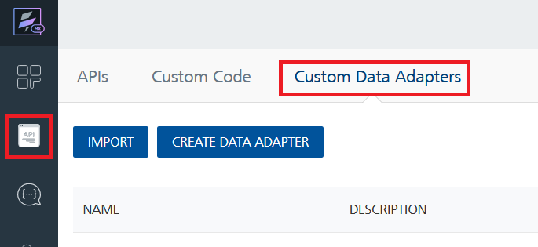

1. Click **IMPORT** to import a custom data adapter.

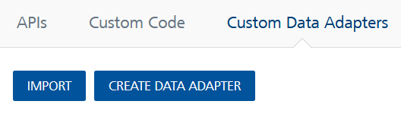

1. On the Import Data Adapter dialog box, click browser to import.

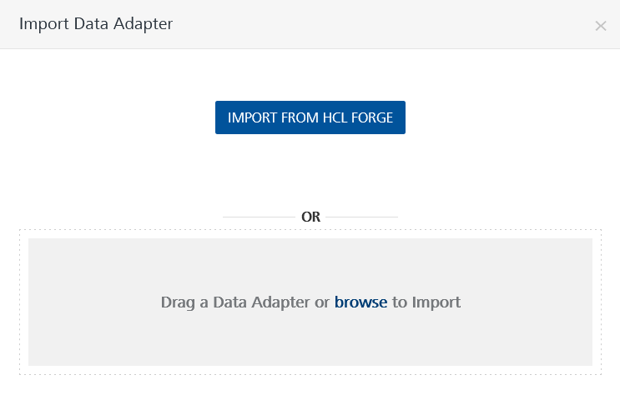

1. Select Gemini Pro AI API zip file and click **IMPORT**.

After you import the data adapter, Volt Foundry opens a window that shows the metadata of the data adapter.

After you import the data adapter, you can view it on the Custom Data Adapters page and use it to create services on Volt Foundry.

## **Creating an Integration service**

After you import the data adapter into Volt Foundry, you can use it to create an Integration Service.

Follow the given steps to create an Integration service using the Gemini Pro AI API Adapter.

1. Sign in to the [HCL Foundry](https://manage.hclvoltmx.com/).
2. From the left navigation menu, select **API Management**.
3. In **API Management**, select **Integration**.

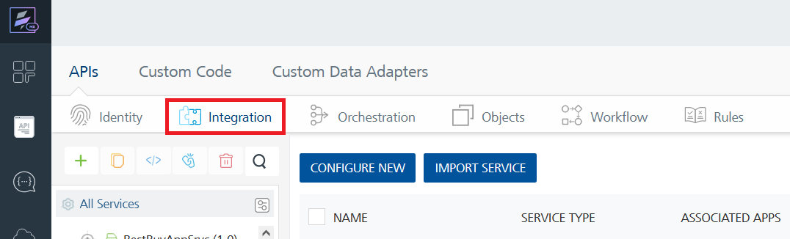

1. To create a new service, click the **+** button or the **CONFIGURE NEW** button.

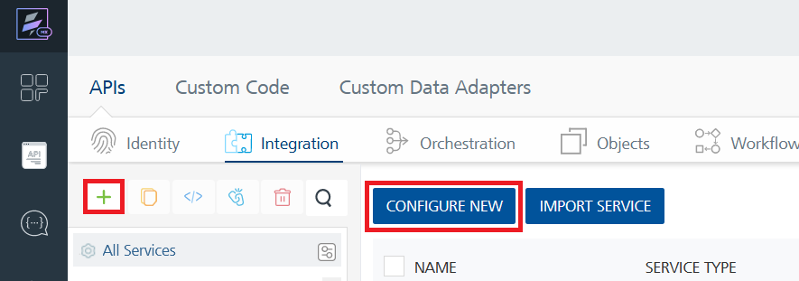

1. On the Service Definition tab, select the service type as Gemini Pro AI API and click **SAVE**.

Alternatively, you can also create a Foundry app and create an Integration service inside it.

1. **Creating and Executing operations**

After you create an integration service, you can create and execute operations using the service.

#### **Creating an operation**

* In **API Management/Foundry app you created**, in the **Integration** section, select the service that you created.
* After you select the service, navigate to the **Operation List** tab.

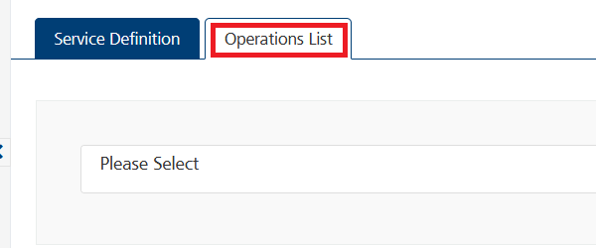

* From the drop down list, select an operation that you want to execute, and click **ADD OPERATION**.

#### **Executing an operation**

* From the **Operations List** tab, in the **Configured Operations** section, select the operation you want to execute.

* On the Operation Page, in the Request Input tab, enter a TEST VALUE for all the fields.

**Request Header:**

**Authorization:** X-RapidAPI-Key, X-RapidAPI-Host [in header]: API Key associated with your RapidAPI account, required for authentication. To get keys – Login in to [Rapid API Account](https://rapidapi.com/swift-api-swift-api-default/api/gemini-pro-ai) -> You can view your keys.  
  
* Select a run-time environment and click **Save and Fetch Response** to get a response based on your inputs.

## **Publishing your application**

If you want to use the services in client applications, you need to publish an app to a run-time environment. You can create the service (as described above) in an application or import the service into an application and publish the application.

# **References**

## **Endpoint Documentation**

### **Request Input Parameters for ChatConversations operation.**

| **Field** | **Description** | **Type** | **Required** | **Example** |
| --- | --- | --- | --- | --- |
| contents | An array of conversation contents exchanged between the user and the model. | array | required | See example below |
| contents.role | The role of the participant in the conversation (e.g., "user" or "model"). | string | required | "user" or "model" |
| contents.parts | An array of text parts exchanged by the participant. Each part represents a segment of text contributed by the participant. | array | required | See example below |
| contents.parts.text | The text content contributed by the participant. | string | required | "What is the result of 1 + 1" |

## **Request headers Parameters for ChatConversations operation**

| **Parameter** | **Description** |
| --- | --- |
| X-RapidAPI- Key(string) | [Required] [Header]API Key associated with your account. |
| X-RapidAPI-Host (string) | [Required] [Header]The host parameter specifies the domain name or IP address of the RapidAPI endpoint. In the context of the Gemini Pro AI API, the default host is set to 'gemini-pro-ai.p.rapidapi.com'. This parameter is necessary for routing the request to the appropriate API endpoint. |

## **Response Output Parameters for ChatConversations operation**

| **Field** | **Description** | **Type** |
| --- | --- | --- |
| candidates | An array of candidate responses generated by the model based on the conversation context. | array |
| candidates.finishReason | The reason why the model's response generation process ended (e.g., "STOP" indicates completion). | string |
| candidates.index | The index of the candidate response in the array. | integer |
| candidates.content | The content of the candidate response. | object |
| candidates.content.role | The role of the participant who generated the response (e.g., "user" or "model"). | string |
| candidates.content.parts | An array of text parts representing the response generated by the participant. | array |
| candidates.content.parts.text | The text content of the response generated by the participant. | string |

## **Reference Document:** Refer this document[Gemini Pro AI - Rapid API](https://rapidapi.com/swift-api-swift-api-default/api/gemini-pro-ai)for more information.

# **Revision History**

Adapter version 1.0.0:

## **Known Issues**

* No Known Issues

## **Limitations**

* No Limitations