Date : 20-10-2023

Free GEO IP LOOKUP (IP STACK API) (1.0.0)

# Overview

ipstack offers a powerful, real-time IP to geolocation API capable of looking up accurate location data and assessing security threats originating from risky IP addresses. Results are delivered within milliseconds in JSON or XML format. Using the ipstack API you will be able to locate website visitors at first glance and adjust your user experience and application accordingly.

# Getting Started

## Prerequisites

* Volt Foundry

## Importing the adapter

**To import the Data Adapter to Volt Foundry, do the following:**

1. Sign in to the  [HCL Foundry](https://manage.hclvoltmx.com/).
2. From the left navigation menu, select **API Management**.
3. In **API Management**, select **Custom Data Adapters**.  
   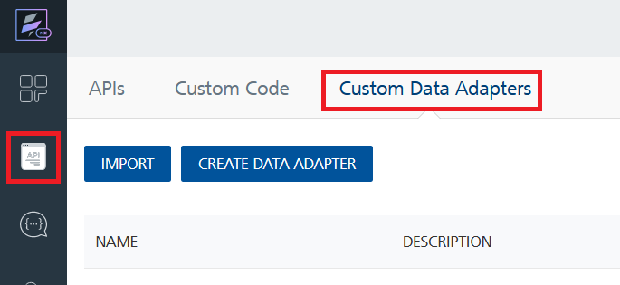
4. Click **IMPORT** to import a custom data adapter.  
   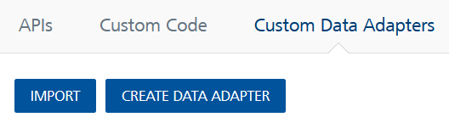
5. On the Import Data Adapter dialog box, click browser to import.  
   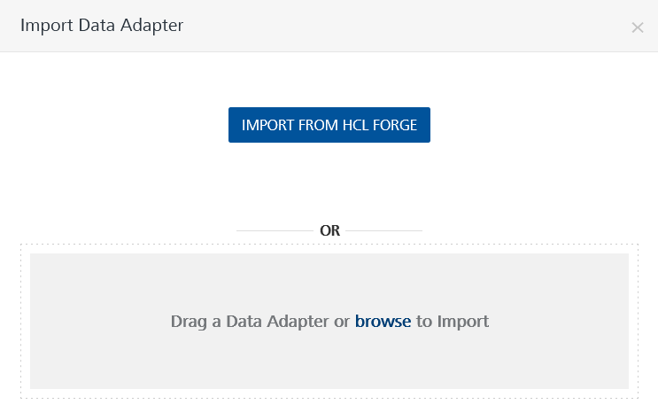
6. Select Free Geo Ip lookup zip file and click **IMPORT**.

After you import the data adapter, Volt Foundry opens a window that shows the metadata of the data adapter.

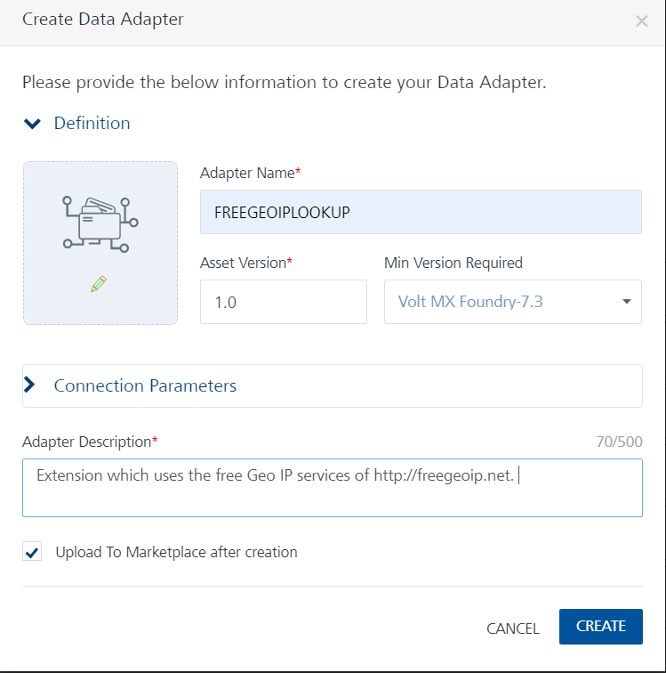

After you import the data adapter, you can view it on the Custom Data Adapters page and use it to create services on Volt Foundry.



## [Creating an Integration service](javascript:void(0);)

After you import the data adapter into Volt Foundry, you can use it to create an Integration Service.

Follow the given steps to create an Integration service using the Free Geo IP LookUp Adapter.

1. Sign in to the [HCL Foundry](https://manage.hclvoltmx.com/).
2. From the left navigation menu, select **API Management**.
3. In **API Management**, select **Integration**.  
   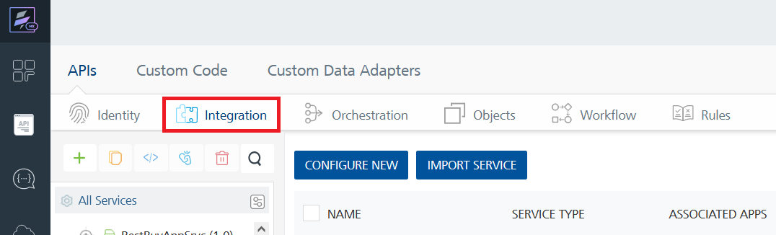
4. To create a new service, click the **+** button or the **CONFIGURE NEW** button.  
   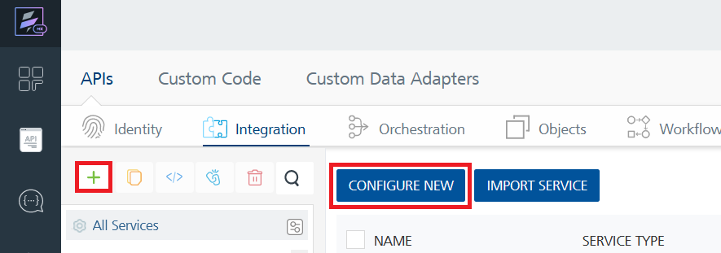
5. On the Service Definition tab, select the service type as Free Geo IP Lookup , and click **SAVE**.  
   A screenshot of a computer

   Description automatically generated

Alternatively, you can also create a Foundry app and create an Integration service inside it.

E. [Creating and Executing operations](javascript:void(0);)



After you create an integration service, you can create and execute operations using the service.

#### Creating an Operation

* In **API Management/Foundry app you created**, in the **Integration** section, select the service that you created.
* After you select the service, navigate to the **Operation List** tab.  
  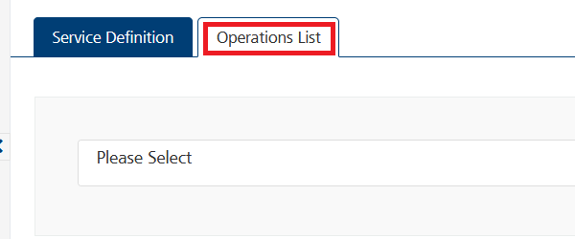
* From the drop down list, select an operation that you want to execute, and click **ADD OPERATION**.  
  A screenshot of a computer

  Description automatically generatedExecuting an Operation
* From the **Operations List** tab, in the **Configured Operations** section, select the operation you want to execute.  
  
* On the Operation Page, in the Request Input tab, enter a TEST VALUE for all the fields.  
  A screenshot of a computer

  Description automatically generated
* Select a run-time environment and click **Save and Fetch Response** to get a response based on your inputs.  
  A screenshot of a computer

  Description automatically generated

## [Publishing your application](javascript:void(0);)

If you want to use the services in client applications, you need to publish an app to a run-time environment. You can create the service (as described above) in an application or import the service into an application and publish the application.

# References

## Endpoint Documentation

|  |  |  |  |
| --- | --- | --- | --- |
| s.no | ENDPOINT NAME | ENDPOINT | DESCRIPTION |
| 1 | StandardIP Lookup | http://api.ipstack.com/134.201.250.155 ? access_key =YOUR_ACCESS_KEY | ipstack's primary endpoint is called Standard Lookup and is used to look up single IPv4 or IPv6 addresses. To call this endpoint, simply attach any IPv4 or IPv6 address to the API's base URL. |
| 2 | Requester IP Lookup | http://api.ipstack.com/check? access_key=your_acess_key | The ipstack API also offers a separate API endpoint capable of detecting the IP address which the current API request is coming from. In order to use this endpoint, simply append check to the API's base URL and specify your preferred optional parameters. |

## For more information regarding API endpoint please check out the [IPSTACK API ENDPOINT documentation](https://ipstack.com/documentation)

# Revision History

Adapter version 1.0.0:

## Limitations

It’s limitations include rate limits on the number of requests per minute or day, potential inaccuracies in geolocation data, restrictions on accessible data fields, concurrency limits for simultaneous connections, varying geographical coverage across plans, differences in service reliability between free and paid plans, and specific usage policies that must be adhered to. It's crucial to review the official documentation or the API provider's website for the most current information, as these limitations might have changed since my last update. Always stay informed about the API's terms of use to ensure compliance with their policies while utilizing their services.