Date :  12-10-2023

Free Dictionary API (1.0.0)

# Overview

The [Free Dictionary API](https://dictionaryapi.dev/) provides information about words, including their pronunciation, origin, and meanings. It offers details like the word's phonetic transcription, audio pronunciation, word origin, part of speech, and definitions with examples. It's a useful resource for accessing word-related data for various applications.

# Getting Started

## Prerequisites

* Volt Foundry

## Importing the adapter

**To import the Data Adapter to Volt Foundry, do the following:**

1. Sign in to the  [HCL Foundry](https://manage.hclvoltmx.com/).
2. From the left navigation menu, select **API Management**.
3. In **API Management**, select **Custom Data Adapters**.  
   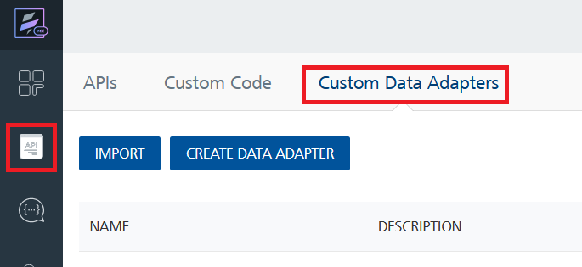
4. Click **IMPORT** to import a custom data adapter.  
   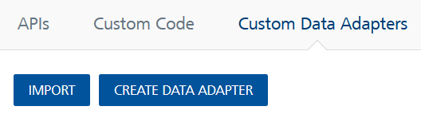
5. On the Import Data Adapter dialog box, click browser to import.  
   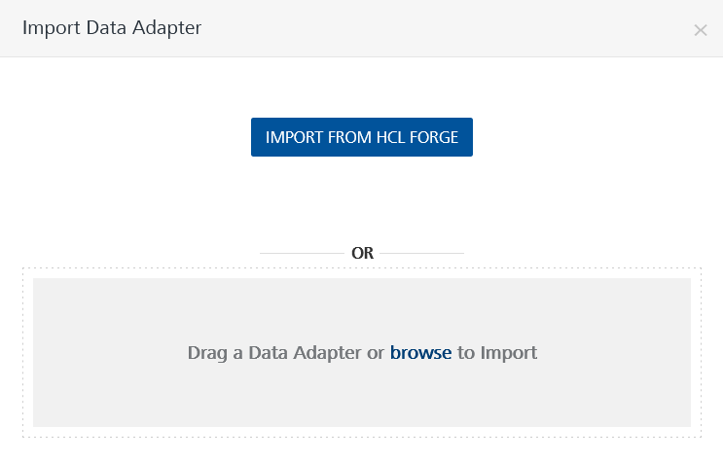
6. Select **FreeDictionaryAPI** zip file and click **IMPORT**.

After you import the data adapter, Volt Foundry opens a window that shows the metadata of the data adapter.

After you import the data adapter, you can view it on the Custom Data Adapters page and use it to create services on Volt Foundry.

## [Creating an Integration service](javascript:void(0);)

After you import the data adapter into Volt Foundry, you can use it to create an Integration Service.

Follow the given steps to create an Integration service using the **Free Dictionary API** Adapter.

1. Sign in to the [HCL Foundry](https://manage.hclvoltmx.com/).
2. From the left navigation menu, select **API Management**.
3. In **API Management**, select **Integration**.  
   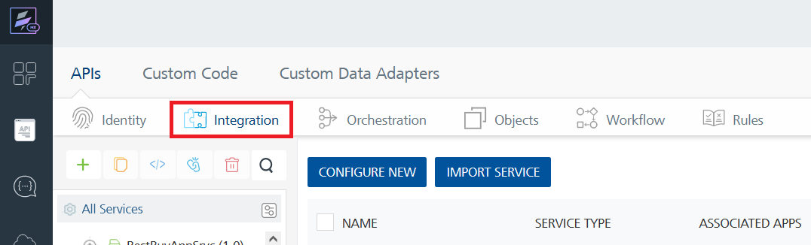
4. To create a new service, click the **+** button or the **CONFIGURE NEW** button.  
   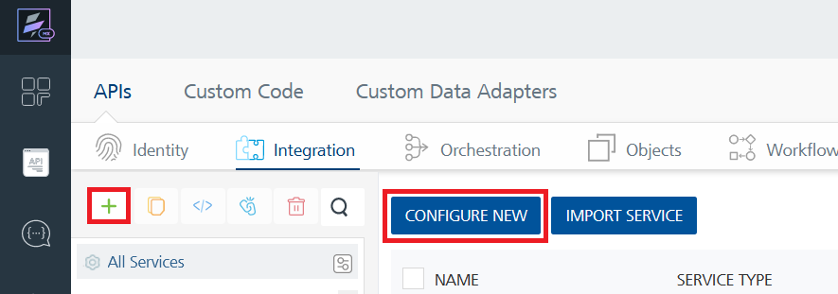
5. On the Service Definition tab, select the service type as **Free Dictionary API** and click **SAVE**.  
   A screenshot of a computer

   Description automatically generated

Alternatively, you can also create a Foundry app and create an Integration service inside it.

E. [Creating and Executing operations](javascript:void(0);)



After you create an integration service, you can create and execute operations using the service.

#### Creating an Operation

* In **API Management/Foundry app you created**, in the **Integration** section, select the service that you created.
* After you select the service, navigate to the **Operation List** tab.  
  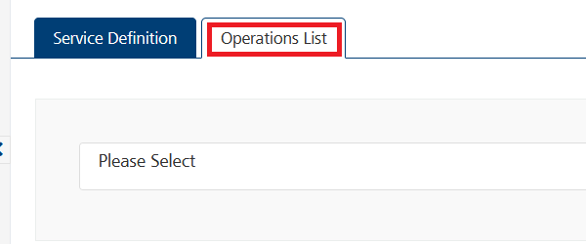
* From the drop down list, select an operation that you want to execute, and click **ADD OPERATION**.  
  A screenshot of a computer

  Description automatically generated

#### Executing an Operation

* From the **Operations List** tab, in the **Configured Operations** section, select the operation you want to execute.

* On the Operation Page, in the Request Input tab, enter a TEST VALUE for all the fields.  
  A screenshot of a computer

  Description automatically generated
* Select a run-time environment and click **Save and Fetch Response** to get a response based on your inputs.  
  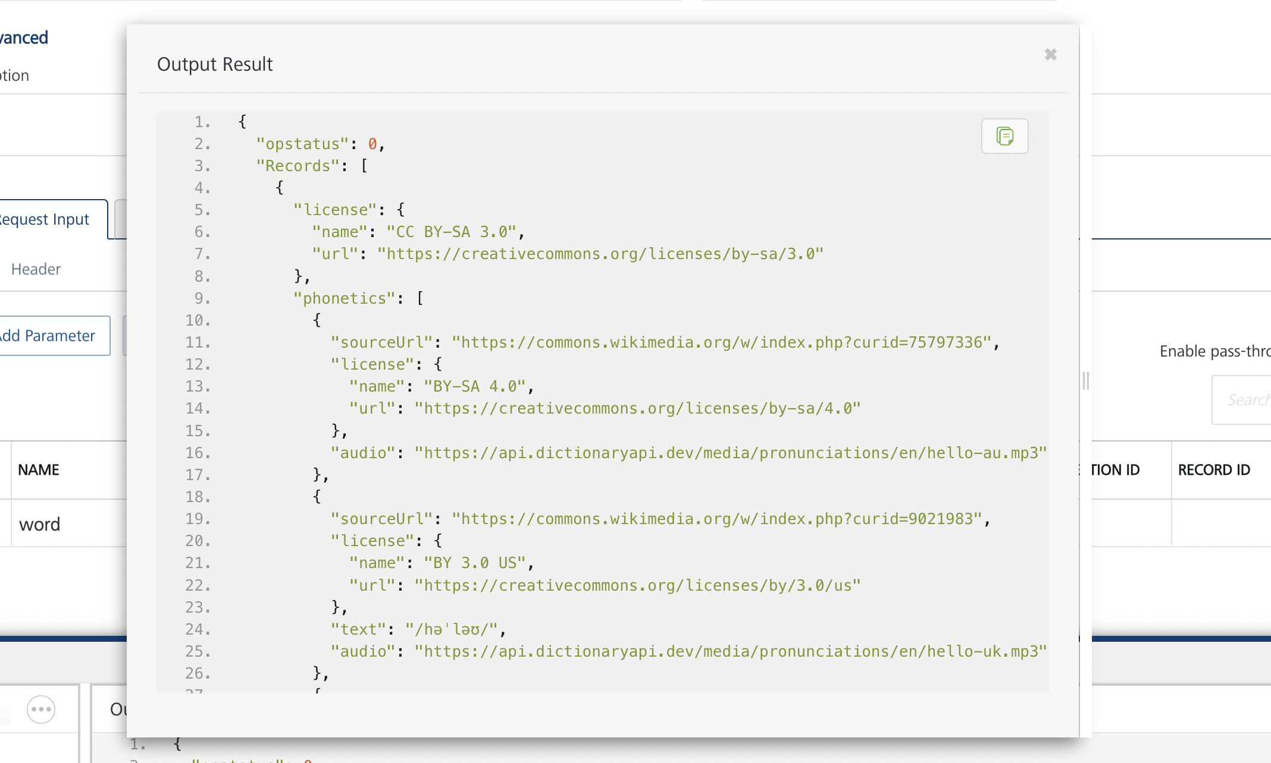

## [Publishing your application](javascript:void(0);)

If you want to use the services in client applications, you need to publish an app to a run-time environment. You can create the service (as described above) in an application or import the service into an application and publish the application.

# References

## Endpoint Documentation

### **Requests Input Parameters**

|  |  |
| --- | --- |
| **Parameter** | **Description** |
| **word** | **[Required] English word to be looked up** |

### **Response**

**As an example, to get definition of English word hello, you can send request to**

**Example Request:**

[**https://api.dictionaryapi.dev/api/v2/entries/en/hello**](https://api.dictionaryapi.dev/api/v2/entries/en/hello)

|  |  |
| --- | --- |
| **Parameter** | **Description** |
| **word** | **The English word being defined.** |
| **phonetic** | **The phonetic pronunciation of the word.** |
| **phonetics** | **Array containing different phonetic pronunciations.** |
| **origin** | **The etymology or origin of the word.** |
| **meanings** | **Array containing different meanings and their details.** |

**Each meaning object contains:**

* **partOfSpeech: The part of speech of the word (e.g., exclamation, noun, verb).**
  + **definitions: Array of definitions for the word.**
  + **definition: The definition of the word's meaning.**
  + **example: An example sentence demonstrating the usage of the word.**
  + **synonyms: Array of synonyms for the word's meaning (if available).**
  + **antonyms: Array of antonyms for the word's meaning (if available).**

**Reference Document:** <https://dictionaryapi.dev/>

# Revision History

Adapter version 1.0.0:

## Known Issues

* No Known Issues

## Limitations

* No limitations