Date: 13-Aug-26
FLOATING ACTION COMPONENT
VERSION: 1.0.5

OVERVIEW
A floating action represents/promotes the primary action in an application. It is essentially a circular button floating over the UI. When pressed, it may present more related actions.

Use case
- Consider a case where you are developing an email application that allows users to perform actions, such as compose, send, receive, and read emails. Using the Floating Action component, you can add a primary button in the app.
- When a user taps the primary button, a screen appears where the user can compose an email.
- The component helps the user to navigate directly to the desired screen in the emails list on a single click of the primary button instead of multiple clicks. This is one of the use cases of the Floating Action component.
- You can add multiple menu items to display when the primary button is clicked to perform multiple actions.
- You can import the Floating Action component into your app and make use of its features. The Floating Action component also facilitates a set of properties and events that helps you customize the fields and the functionality.

Percentage of re-use:
Approximate 85% of reuse.

Features
- Promote your app’s primary actions
- Add up to 5 floating actions
- Select from 3 prebuilt animations
- Customize UI with your own icons and text
- Option to set background overlay

GETTING STARTED

Prerequisites
Before you start using the Floating Action component, ensure the following:
• HCL Foundry
• Volt MX Iris

Platforms Supported

Mobile

iOS

Android

Tablet & iPad

PWA & Responsive Web

Importing the app

You can import the Forge components only into the apps that are of the Reference Architecture type.

To import the Floating Action component, do the following:

Open your app project in Volt MX Iris.

In the Project Explorer, click the Templates Tab
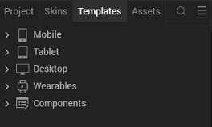
- Right-click Components, and then select Import Component. The Import Component dialog box appears.

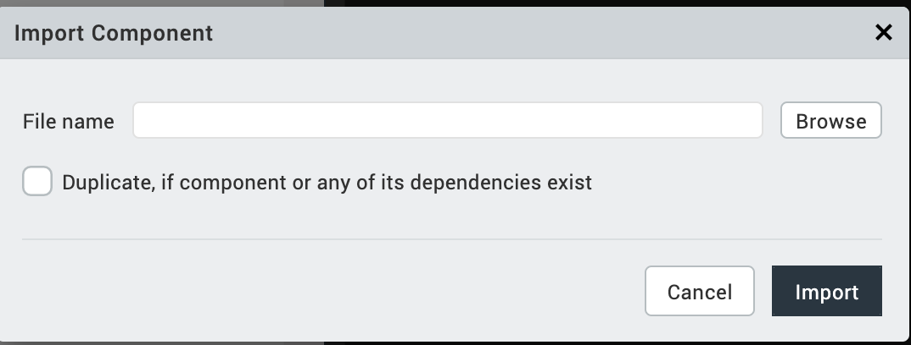
- Click Browse to navigate to the location of the component, select the component, and then click Import. The component and its associated widgets and modules are added to your project.

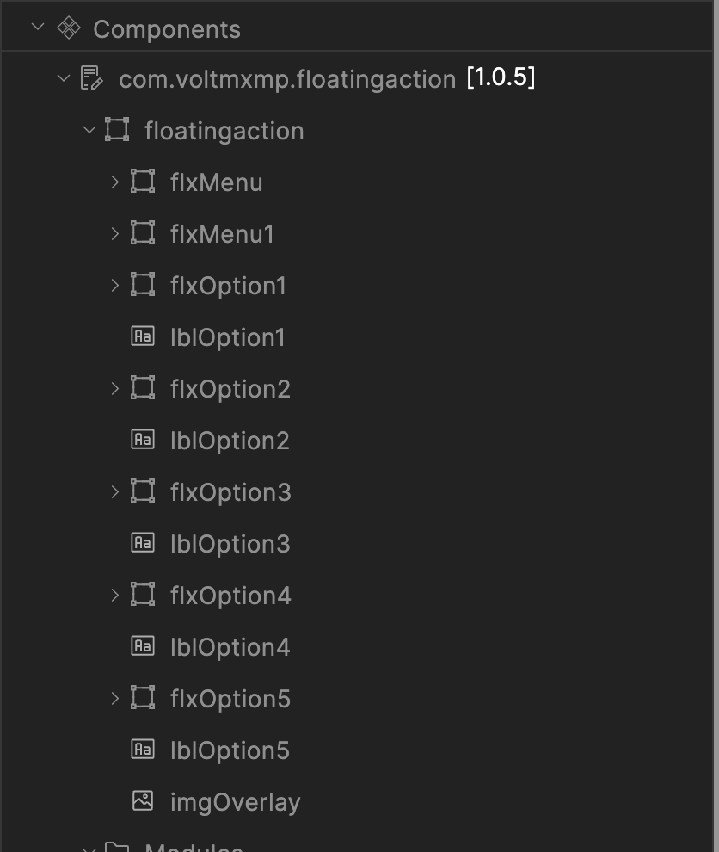
Once you have imported a component to your project, you can easily add the component to a form.

Building and previewing the app
After performing all the above steps, you can build your app and run it on your device.
You can then run your app to see the Floating Action work in real time.

REFERENCES

Dynamic Usage
You can also add a Floating Action component dynamically. To do so,
In the Project Explorer, on the Projects tab, click Controllers section to access the respective Form Controller. Create a method and implement the code snippet similar to the sample code mentioned below.
/*Creating Floating Action component instance*/
define({

//Type your controller code here
onNavigate : function(){
this.view.preShow=this.preshow;
},
preshow: function(){
this.createComponent();
},
createComponent : function(){
var floatingAction = new com.voltmxmp.floatingaction(
{
"clipBounds": true,
"skin":"sknFlxMenu",
"id": "floatingaction",
"height": "100%",
"width": "100%",
"top": "0dp",
"left": "0dp",
"isVisible": true,
"zIndex": 1
}, {}, {}
);

floatingAction.height = "79px";

floatingAction.width = "79px";

floatingAction.isVisibleMenuItem1 = true;

floatingAction.isVisibleMenuItem2 = true;

floatingAction.isVisibleMenuItem3 = true;

floatingAction.isVisibleMenuItem4 = true;

floatingAction.isVisibleMenuItem5 = true;

floatingAction.imgBGOverlaySrc = "voltmxmp_fa_fade_1.png";

floatingAction.menuItem1BGSrc = "voltmxmp_fa_itemiconbg_1.png";

floatingAction.menuItem1IconSrc = "voltmxmp_fa_itempen_1.png";

floatingAction.menuItem1Text = "Write a Message";

floatingAction.menuItem2BGSrc = "voltmxmp_fa_itemiconbg_1.png";

floatingAction.menuItem2IconSrc = "voltmxmp_fa_itemstar_1.png";

floatingAction.menuItem2Text = "Add to Favourites";

floatingAction.menuItem3BGSrc = "voltmxmp_fa_itemiconbg_1.png";

floatingAction.menuItem3IconSrc = "voltmxmp_fa_itemprofile_1.png";

floatingAction.menuItem3Text = "Send to Friend";

floatingAction.menuItem4BGSrc = "voltmxmp_fa_itemiconbg_1.png";

floatingAction.menuItem4IconSrc = "voltmxmp_fa_itemdel_1.png";

floatingAction.menuItem4Text = "Move to Bin";

floatingAction.menuItem5BGSrc = "voltmxmp_fa_itemiconbg_1.png";

floatingAction.menuItem5IconSrc = "voltmxmp_fa_itemprofile_1.png";

floatingAction.menuItem5Text = "My Profile";

floatingAction.enableOverlay = true;

floatingAction.menuItemType = "Image and Text";

floatingAction.animationType = "Default";

floatingAction.skin1="sknFlxMenu";

floatingAction.skin2="sknFlxMenu";

floatingAction.sknMenuItem1Text="voltmxmpfasknLblBlackSmallfork";

floatingAction.sknMenuItem2Text="voltmxmpfasknLblBlackSmallfork";

floatingAction.sknMenuItem3Text="voltmxmpfasknLblBlackSmallfork";

floatingAction.sknMenuItem4Text="voltmxmpfasknLblBlackSmallfork";

floatingAction.sknMenuItem5Text="voltmxmpfasknLblBlackSmallfork";

floatingAction.onClickMenuItem1 = function(){};

floatingAction.onClickMenuItem2 = function(){};

floatingAction.onClickMenuItem3 = function(){};

floatingAction.onClickMenuItem4 = function(){};

floatingAction.onClickMenuItem5 = function(){};

this.view.add(floatingAction);
}

});

In the code snippet, you can edit the properties of the component as per your requirement. For more information, see Setting Properties. And save the file

Properties
The properties provided on the Component tab allow you to customize the UI elements in the Floating Action component. You can set the properties directly on the Component tab or by writing a JavaScript. This section provides information on how to set the properties by writing a JavaScript.
- General Properties
- Menu Item Fields
Description: | Specifies the type of the menu items  - Image and Text: Menu Items will have both image and text.  - Only Image: Menu Items will have only image.
Syntax: | menuItemType
Type: | List Selector
Read/Write: | Read + Write
Remarks | The default value of the property is “Only Image”.
Example: | this.view.componentID.menuItemType= “Only Image”;

- Animation Type
Description: | Specifies the animation type of the menu items.  - Rise : Menu items move up from the bottom.  - Slide In: Menu items move in from right.  - Default: Menu items appear with default animation.
Syntax: | animationType
Type: | List Selector
Read/Write: | Read + Write
Remarks | The property requires a String value. You must handle the exceptions if you provide an invalid value.
Example: | this.view.componentID.animationType = “Default”;

- Enable Background Overlay
Description: | Controls the visibility of the background overlay.
Syntax: | enableOverlay
Type: | Boolean
Read/Write: | Read + Write
Remarks | The property requires a Boolean value. You must handle the exceptions if you provide an invalid value.
Example: | this.view.componentID.enableOverlay = true;

- Background Overlay Image
Description: | Specifies the name of the image to be set as the background overlay.
Syntax: | imgBGOverlaySrc
Type: | String
Read/Write: | Read + Write
Remarks | Before setting the property, do the following:  - Ensure that the image file exists in the workspace\resources\common directory.  - Do not add any uppercase characters in the file name of the image.  - Ensure that the image is in PNG format.  - Specify the file name of the image along with the extension.
Example: | this.view.componentID.imgBGOverlaySrc = “fade.png”;
- Primary Button Properties
- Background Image
Description: | Specifies the file name of the image to be set as the background for the Primary Button.
Syntax: | primaryButtonBGSrc
Type: | String
Read/Write: | Read + Write
Remarks | Before setting the property, do the following:  - Ensure that the image file exists in the workspace\resources\common directory.  - Do not add any uppercase characters in the file name of the image.  - Ensure that the image is in PNG format.  - Specify the file name of the image along with the extension.
Example: | this.view.componentID.primaryButtonBGSrc= “bg.png”;
- Icon
Description: | Specifies the file name of the image to be set as the Primary Button icon.
Syntax: | imgPrimaryIcon
Type: | String
Read/Write: | Read + Write
Remarks | Before setting the property, do the following:  - Ensure that the image file exists in the workspace\resources\common directory.  - Do not add any uppercase characters in the file name of the image.  - Ensure that the image is in PNG format.  - Specify the file name of the image along with the extension.
Example: | this.view.componentID.imgPrimaryIcon= “icon_plus.png”;

- Menu Item 1 Properties
- Visibility
Description: | Controls the visibility of Menu item 1.
Syntax: | isVisibleMenuItem1
Type: | Boolean
Read/Write: | Read + Write
Remarks | The default value of the property is true.
Example: | this.view.componentID.isVisibleMenuItem1 = true;
- Background Image
Description: | Specifies the file name of the image to be set as the background of Menu item 1.
Syntax: | menuItem1BGSrc
Type: | Image
Read/Write: | Read + Write
Remarks | Before setting the property, do the following:  - Ensure that the image file exists in the workspace\resources\common directory.  - Do not add any uppercase characters in the file name of the image.  - Ensure that the image is in PNG format.  - Specify the file name of the image along with the extension.
Example: | this.view.componentID.menuItem1BGSrc = “itemiconbg.png”;
- Icon
Description: | Specifies the file name of the image to be set as the Menu item 1 icon.
Syntax: | menuItem1IconSrc
Type: | Image
Read/Write: | Read + Write
Remarks | Before setting the property, do the following:  - Ensure that the image file exists in the workspace\resources\common directory.  - Do not add any uppercase characters in the file name of the image.  - Ensure that the image is in PNG format.  - Specify the file name of the image along with the extension.
Example: | this.view.componentID.menuItem1IconSrc = “itempen.png”;

- Text
Description: | Specifies the text to be displayed on the label of Menu item 1.
Syntax: | menuItem1Text
Type: | String
Read/Write: | Read + Write
Remarks | The default value of the property is “Label”.
Example: | this.view.componentID.menuItem1Text = “Label”;

- Menu Item 2 Properties
- Visibility
Description: | Controls the visibility of Menu item 2.
Syntax: | isVisibleMenuItem2
Type: | Boolean
Read/Write: | Read + Write
Remarks | The default value of the property is true.
Example: | this.view.componentID.isVisibleMenuItem2 = true;
- Background Image
Description: | Specifies the file name of the image to be set as the background of Menu item 2.
Syntax: | menuItem2BGSrc
Type: | Image
Read/Write: | Read + Write
Remarks | Before setting the property, do the following:  - Ensure that the image file exists in the workspace\resources\common directory.  - Do not add any uppercase characters in the file name of the image.  - Ensure that the image is in PNG format.  - Specify the file name of the image along with the extension.
Example: | this.view.componentID.menuItem2BGSrc = “itemiconbg.png”;
- Icon
Description: | Specifies the file name of the image to be set as the Menu item 2 icon.
Syntax: | menuItem2IconSrc
Type: | Image
Read/Write: | Read + Write
Remarks | Before setting the property, do the following:  - Ensure that the image file exists in the workspace\resources\common directory.  - Do not add any uppercase characters in the file name of the image.  - Ensure that the image is in PNG format.  - Specify the file name of the image along with the extension.
Example: | this.view.componentID.menuItem2IconSrc = “itemstar.png”;
- Text
Description: | Specifies the text to be displayed on the label of Menu item 2.
Syntax: | menuItem2Text
Type: | String
Read/Write: | Read + Write
Remarks | The default value of the property is “Label”.
Example: | this.view.componentID.menuItem2Text = “Label”;
- Menu Item 3 Properties
- Visibility
Description: | Controls the visibility of Menu item 3.
Syntax: | isVisibleMenuItem3
Type: | Boolean
Read/Write: | Read + Write
Remarks | The default value of the property is true.
Example: | this.view.componentID.isVisibleMenuItem3 = true;
- Background Image
Description: | Specifies the file name of the image to be set as the background of Menu item 3.
Syntax: | menuItem3BGSrc
Type: | Image
Read/Write: | Read + Write
Remarks | Before setting the property, do the following:  - Ensure that the image file exists in the workspace\resources\common directory.  - Do not add any uppercase characters in the file name of the image.  - Ensure that the image is in PNG format.  - Specify the file name of the image along with the extension.
Example: | this.view.componentID.menuItem3BGSrc = “itemiconbg.png”;

- Icon
Description: | Specifies the file name of the image to be set as the Menu item 3 icon.
Syntax: | menuItem3IconSrc
Type: | Image
Read/Write: | Read + Write
Remarks | Before setting the property, do the following:  - Ensure that the image file exists in the workspace\resources\common directory.  - Do not add any uppercase characters in the file name of the image.  - Ensure that the image is in PNG format.  - Specify the file name of the image along with the extension.
Example: | this.view.componentID.menuItem3IconSrc = “itemprofile.png”;
- Text
Description: | Specifies the text to be displayed on the label of Menu item 3.
Syntax: | menuItem3Text
Type: | String
Read/Write: | Read + Write
Remarks | The default value of the property is “Label”.
Example: | this.view.componentID.menuItem3Text = “Label”;

- Menu Item 4 Properties
- Visibility
Description: | Controls the visibility of Menu item 4.
Syntax: | isVisibleMenuItem4
Type: | Boolean
Read/Write: | Read + Write
Remarks | The default value of the property is false.
Example: | this.view.componentID.isVisibleMenuItem4 = false;
- Background Image
Description: | Specifies the file name of the image to be set as the background of Menu item 4.
Syntax: | menuItem4BGSrc
Type: | Image
Read/Write: | Read + Write
Remarks | Before setting the property, do the following:  - Ensure that the image file exists in the workspace\resources\common directory.  - Do not add any uppercase characters in the file name of the image.  - Ensure that the image is in PNG format.  - Specify the file name of the image along with the extension.
Example: | this.view.componentID.menuItem4BGSrc = “itemiconbg.png”;

- Icon
Description: | Specifies the file name of the image to be set as the Menu item 4 icon.
Syntax: | menuItem4IconSrc
Type: | Image
Read/Write: | Read + Write
Remarks | Before setting the property, do the following:  - Ensure that the image file exists in the workspace\resources\common directory.  - Do not add any uppercase characters in the file name of the image.  - Ensure that the image is in PNG format.  - Specify the file name of the image along with the extension.
Example: | this.view.componentID.menuItem4IconSrc = “itemdel.png”;
- Text
Description: | Specifies the text to be displayed on the label of Menu item 4.
Syntax: | menuItem4Text
Type: | String
Read/Write: | Read + Write
Remarks | The default value of the property is “Label”.
Example: | this.view.componentID.menuItem4Text = “Label”;

- Menu Item 5 Properties
- Visibility
Description: | Controls the visibility of Menu item 5.
Syntax: | isVisibleMenuItem5
Type: | Boolean
Read/Write: | Read + Write
Remarks | The default value of the property is false.
Example: | this.view.componentID.isVisibleMenuItem5 = false;
- Background Image
Description: | Specifies the file name of the image to be set as the background of Menu item 5.
Syntax: | menuItem5BGSrc
Type: | Image
Read/Write: | Read + Write
Remarks | Before setting the property, do the following:  - Ensure that the image file exists in the workspace\resources\common directory.  - Do not add any uppercase characters in the file name of the image.  - Ensure that the image is in PNG format.  - Specify the file name of the image along with the extension.
Example: | this.view.componentID.menuItem5BGSrc = “itemiconbg.png”;
- Icon
Description: | Specifies the file name of the image to be set as the Menu item 5 icon.
Syntax: | menuItem5IconSrc
Type: | Image
Read/Write: | Read + Write
Remarks | Before setting the property, do the following:  - Ensure that the image file exists in the workspace\resources\common directory.  - Do not add any uppercase characters in the file name of the image.  - Ensure that the image is in PNG format.  - Specify the file name of the image along with the extension.
Example: | this.view.componentID.menuItem5IconSrc = “itemprofile.png”;
- Text
Description: | Specifies the text to be displayed on the label of Menu item 5.
Syntax: | menuItem5Text
Type: | String
Read/Write: | Read + Write
Remarks | The default value of the property is “Label".
Example: | this.view.componentID.menuItem5Text = "Label";

- Skin
You can select skins from the Exposed Skins drop-down list on the Skin tab. This section provides information on how to set Skin by writing a JavaScript.
- Menu Item 1 Text
Description: | Specifies the skin for the text of Menu item 1.
Syntax: | sknMenuItem1Text
Type: | String
Read/Write: | Read + Write
Remarks | Before you set the property, ensure that the skin ID that you specify already exists in your app project.
Example: | this.view.componentID.sknMenuItem1Text= "skinname";
- Menu Item 2 Text
Description: | Specifies the skin for the text of Menu item 2.
Syntax: | sknMenuItem2Text
Type: | String
Read/Write: | Read + Write
Remarks | Before you set the property, ensure that the skin ID that you specify already exists in your app project.
Example: | this.view.componentID.sknMenuItem2Text= "skinname";
- Menu Item 3 Text
Description: | Specifies the skin for the text of Menu item 3.
Syntax: | sknMenuItem3Text
Type: | String
Read/Write: | Read + Write
Remarks | Before you set the property, ensure that the skin ID that you specify already exists in your app project.
Example: | this.view.componentID.sknMenuItem3Text= "skinname";
- Menu Item 4 Text
Description: | Specifies the skin for the text of Menu item 4.
Syntax: | sknMenuItem4Text
Type: | String
Read/Write: | Read + Write
Remarks | Before you set the property, ensure that the skin ID that you specify already exists in your app project.
Example: | this.view.componentID.sknMenuItem4Text= "skinname";
- Menu Item 5 Text
Description: | Specifies the skin for the text of Menu item 5.
Syntax: | sknMenuItem5Text
Type: | String
Read/Write: | Read + Write
Remarks | Before you set the property, ensure that the skin ID that you specify already exists in your app project.
Example: | this.view.componentID.sknMenuItem5Text= "skinname";

Events
You can define events to be executed when an action is performed. You can configure the events directly on the Actions tab or by writing a JavaScript. To configure the events on the Action tab, click Edit against each event.
- onClickMenuItem1
Description: | The event is invoked when a user clicks Menu item 1. Clicking the menu item invokes the assigned action and hides the menu items simultaneously.
Syntax: | onClickMenuItem1()
Example: | this.view.componentID.onClickMenuItem1= function()  {  alert( Menu item 1 Clicked );  }
- onClickMenuItem2
Description: | The event is invoked when a user clicks Menu item 2. Clicking on the Menu item invokes the assigned action and hides the menu icons.
Syntax: | onClickMenuItem2()
Example: | this.view.componentID.onClickMenuItem2= function()  {  alert( Menu item 2 Clicked );  }

- onClickMenuItem3
Description: | The event is invoked when a user clicks Menu item 3. Clicking the menu item invokes the assigned action and hides the menu items simultaneously.
Syntax: | onClickMenuItem3()
Example: | this.view.componentID.onClickMenuItem3= function()  {  alert( Menu item 3 Clicked );  }
- onClickMenuItem4
Description: | The event is invoked when a user clicks Menu item 4. Clicking the menu item invokes the assigned action and hides the menu items simultaneously.
Syntax: | onClickMenuItem4()
Example: | this.view.componentID.onClickMenuItem4= function()  {  alert( Menu item 4 Clicked );  }
- onClickMenuItem5
Description: | The event is invoked when a user clicks Menu item 5. Clicking the menu item invokes the assigned action and hides the menu items simultaneously.
Syntax: | onClickMenuItem5()
Example: | this.view.componentID.onClickMenuItem5= function()  {  alert( Menu item 5 Clicked );  }
- onClickPrimaryButton
Description: | The event is invoked when a user clicks the Primary Button. The Primary Button will show/hide the menu items.
Syntax: | onClickPrimaryButton()
Example: | this.view.componentID.onClickPrimaryButton= function()  {  alert( Primary button Clicked );  }

REVISION HISTORY
App version: 1.0.5

Known Issues
- Extra space is displayed next to the floating action Icons.
- UI is getting distorted at lower break points
- In iPhone safari background images width is compressed for each icon
- After changing a break point one must click on the primary button to make menu visible (even if it is ON previously)

Limitations

Landscape mode is not supported.

If browser height is minimized, the UI gets distorted.

