Date :  23-02-2024

expert.ai Natural Language API

Version: 1.0.0

# **Overview**

The expert.ai Natural Language API provides a comprehensive set of natural language understanding capabilities based on expert.ai technology:

* Context based document analysis, comprising:
  + Deep linguistic analysis, which, in turn, comprises:
    - Text subdivision
    - Part-of-speech tagging
    - Morphological analysis
    - Lemmatization
    - Syntactic analysis
    - Semantic analysis
  + Keyphrase extraction
  + Named entity recognition
  + Relation extraction
  + Sentiment analysis
* Taxonomy based document classification
* Information detection performed by detectors

# **Getting Started**

## **Prerequisites**

* Volt Foundry
* [Account - expert.ai](https://www.expert.ai/)
* Authorization token

## **Importing the adapter**

**To import the Data Adapter to Volt Foundry, do the following:**

1. Sign in to the  [HCL Foundry](https://manage.hclvoltmx.com/).
2. From the left navigation menu, select **API Management**.
3. In **API Management**, select **Custom Data Adapters**.  
   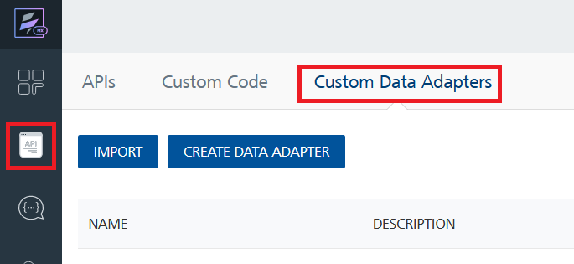
4. Click **IMPORT** to import a custom data adapter.  
   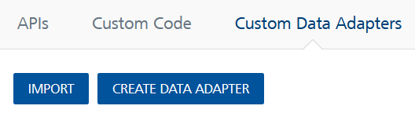
5. On the Import Data Adapter dialog box, click browser to import.  
   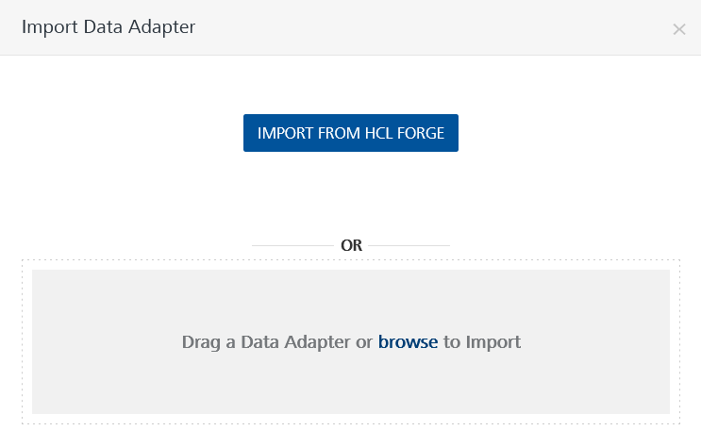
6. Select expert.ai Natural Language API zip file and click **IMPORT**.

After you import the data adapter, Volt Foundry opens a window that shows the metadata of the data adapter.

After you import the data adapter, you can view it on the Custom Data Adapters page and use it to create services on Volt Foundry.

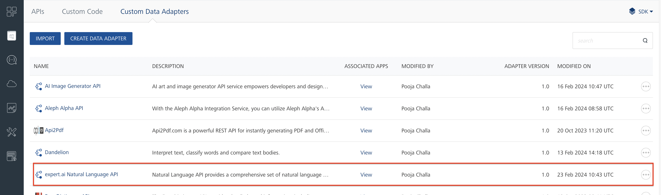

## **Creating an Integration service**

After you import the data adapter into Volt Foundry, you can use it to create an Integration Service.

Follow the given steps to create an Integration service using the expert.ai Natural Language API Adapter.

1. Sign in to the [HCL Foundry](https://manage.hclvoltmx.com/).
2. From the left navigation menu, select **API Management**.
3. In **API Management**, select **Integration**.  
   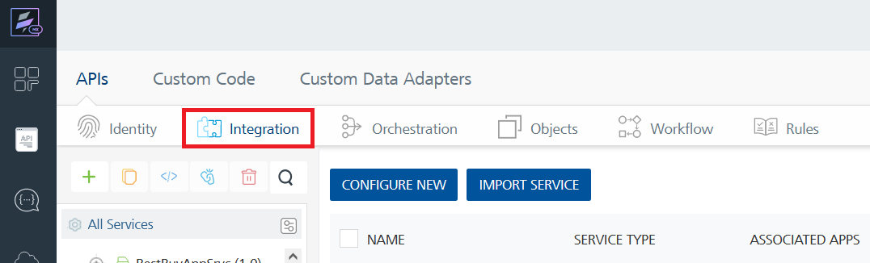
4. To create a new service, click the **+** button or the **CONFIGURE NEW** button.  
   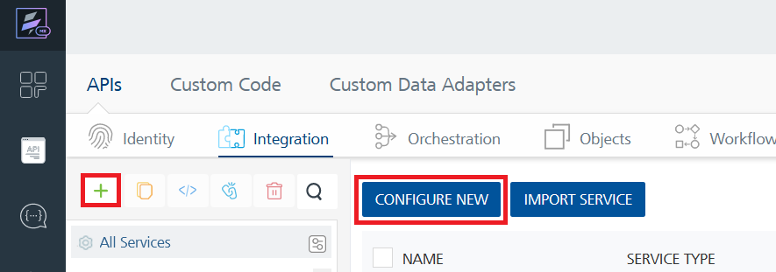
5. On the Service Definition tab, select the service type as expert.ai Natural Language API and click **SAVE**.

Alternatively, you can also create a Foundry app and create an Integration service inside it.

1. **Creating and Executing operations**

After you create an integration service, you can create and execute operations using the service.

#### **Creating an Operation**

* In **API Management/Foundry app you created**, in the **Integration** section, select the service that you created.
* After you select the service, navigate to the **Operation List** tab.  
  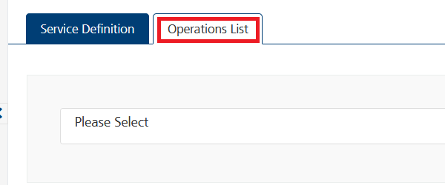
* From the drop down list, select an operation that you want to execute, and click **ADD OPERATION**.  
  A screenshot of a computer

  Description automatically generated

#### **Executing an operation**

* From the **Operations List** tab, in the **Configured Operations** section, select the operation you want to execute.

* On the Operation Page, in the Request Input tab, enter a TEST VALUE for all the fields.  
  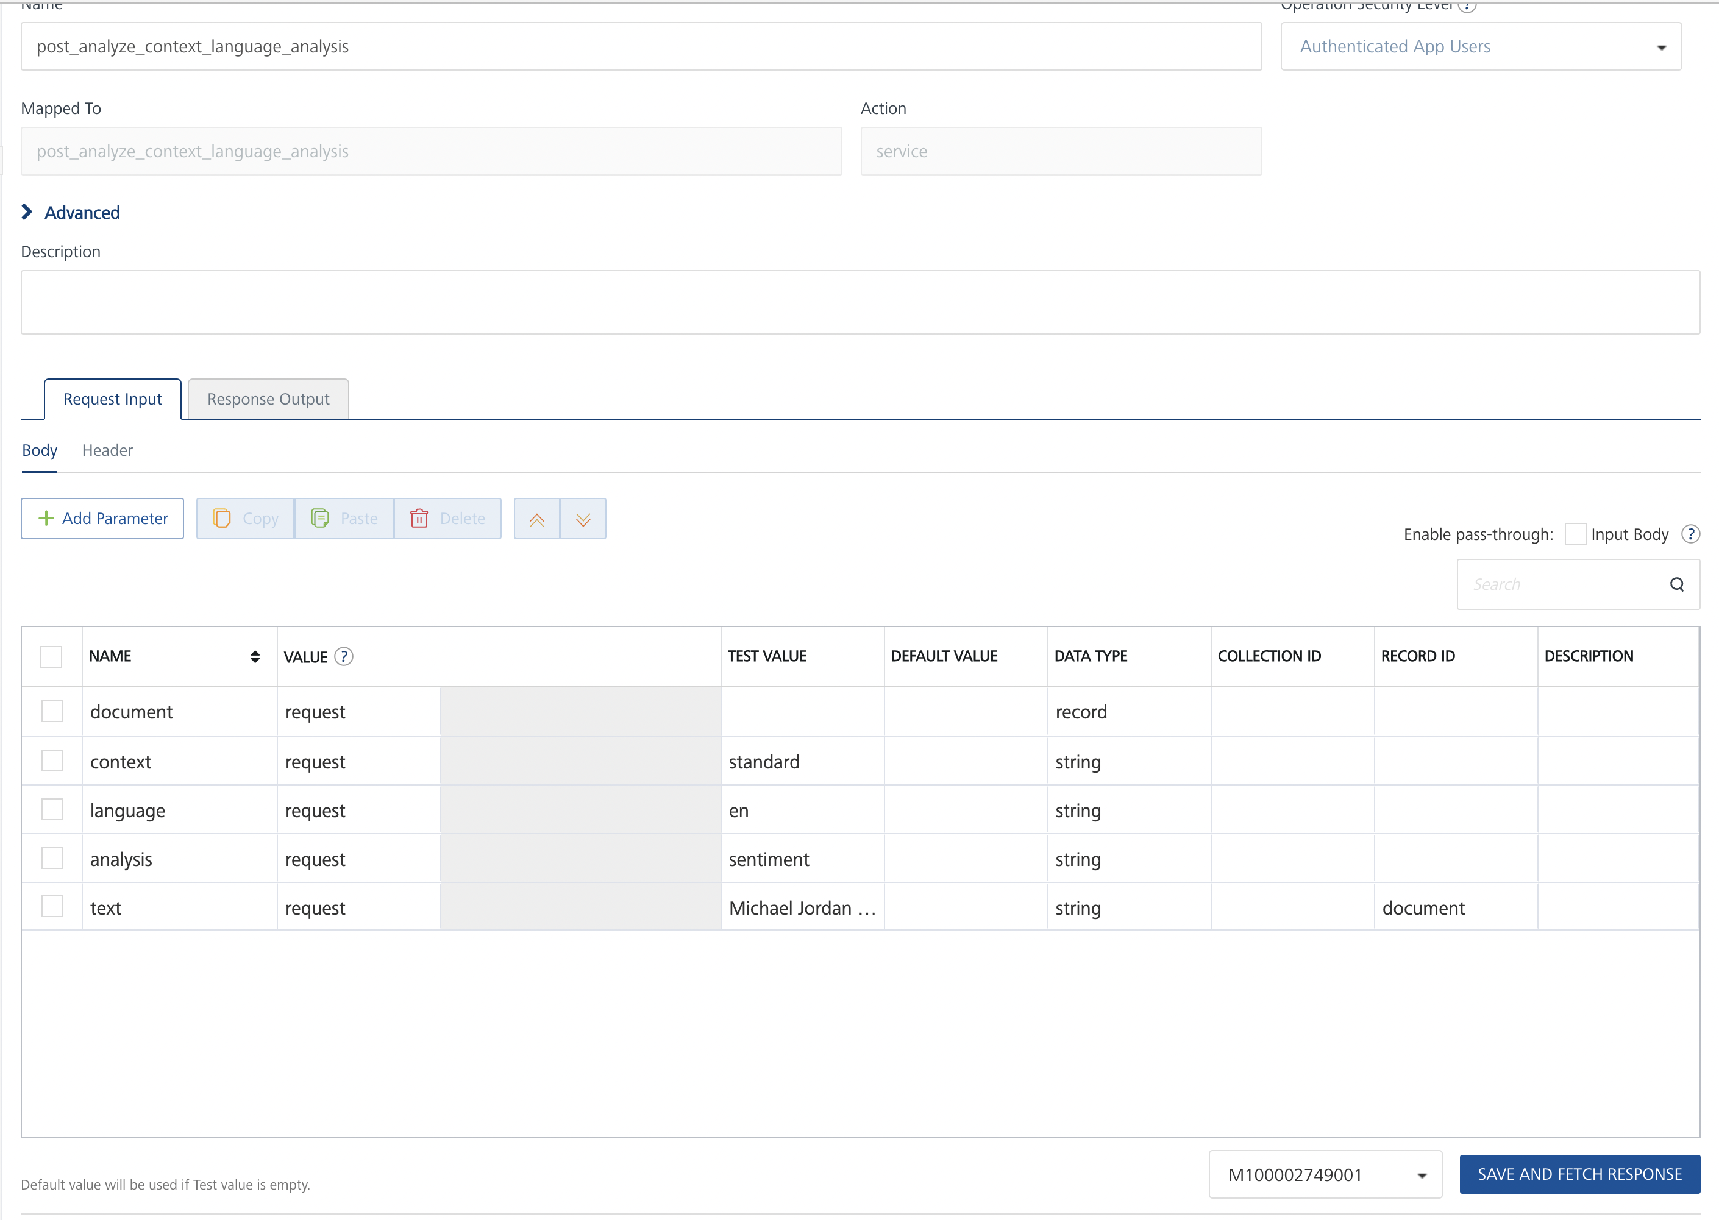

**Request Header:**

**Authorization:** The expert.ai Natural Language API uses valid authorization token.

To get the token you must have an expert.ai developer account. Visit the [developer portal](https://developer.expert.ai/) and sign up to get one. Go to security section <https://developer.expert.ai/ui/security> and generate a TOKEN.

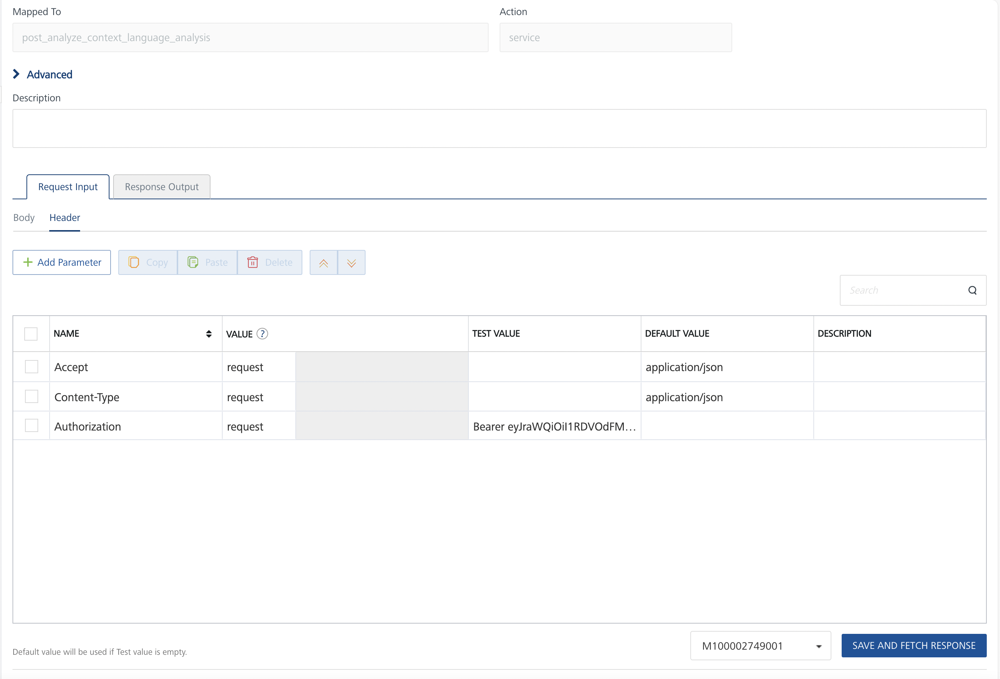

* Select a run-time environment and click **Save and Fetch Response** to get a response based on your inputs.

## **Publishing your application**

If you want to use the services in client applications, you need to publish an app to a run-time environment. You can create the service (as described above) in an application or import the service into an application and publish the application.

# **References**

## **Endpoint Documentation**

### **Requests Input Parameters for post_analyze_context_language_analysis**

| **Parameter** | **Type** | **Description** |
| --- | --- | --- |
| context | string | **[Required]** Context name; use the contexts resource to discover available contexts. |
| language | string | [**Required]** Document language (code)Available values: de, en, es, fr, it |
| analysis | string | **[Required]** Analysis name; use the contexts resource to determine if the context provides that analysis for the chosen language.Available values : disambiguation, relevants, entities, sentiment, relations |
| body | JSON object | The document to be analyzed.   Example: {"document": {"text": "Your text here."}} |

### **Request Headers for post_analyze_context_language_analysis**

| **Header** | **Value** |
| --- | --- |
| Content-Type | **[Required]** application/json |
| Accept | **[Required]** application/json |
| Authorization | **[Required]** This endpoint requires [bearerAuth](https://app.apimatic.io/api-docs-preview/dashboard/652630223129d0d2ff1e9884/v/v2#/http/step-by-step-tutorial/authorization/bearerauth-oauth-2-bearer-token) |

## **Response Output Parameters for post_analyze_context_language_analysis**

| **Field** | **Description** | **Type** |
| --- | --- | --- |
| success | Operation completed successfully | boolean |
| errors | Service errors | array of ServiceError objects |
| data | Analysis data | AnalyzeDocument object |
| data.version | Service version | string |
| data.content | Analyzed text | string |
| data.language | Text language | string |
| data.paragraphs | Paragraphs | array of Paragraph objects |
| data.sentences | Sentences | array of Sentence objects |
| data.phrases | Phrases | array of Phrase objects |
| data.tokens | Tokens | array |
| data.mainSentences | Main Sentences | array |
| data.mainPhrases | Main Phrases | array |
| data.mainLemmas | Main Lemmas | array |
| data.mainSyncons | Main Syncons | array |
| data.entities | Entities | array |
| data.topics | Topics | array |
| data.knowledge | Knowledge | array |
| data.sentiment | Sentiment | object |
| data.relations | Relations | array |

## **Reference Document:** Refer this document<https://docs.expert.ai/nlapi/v2/> to know the request input, request header and response output parameters for the other operations.

# **Revision History**

Adapter version 1.0.0:

## **Known Issues**

* No Known Issues

## **Limitations**

* No Limitations