May-2023

Event Display with date

Version: 1.0.1

# Description

This simple Event display design component has configurable inputs. You can also show as “selected” (blue border) if used in a list. Once imported in Volt Iris, this component can be further customized to suit developer’s needs.

# Properties & Methods

## Properties

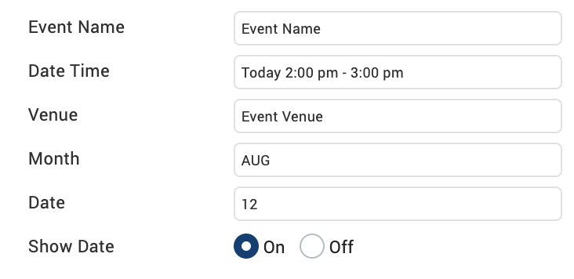

## Methods

### setStatus – true / false; If true, then border skin is set to “*sknFlxGreyRoundBlue*”, else to “*sknFlxWhiteRounded*”. Developer can modify this in EventController.js file.