05 June 2023

ESRIMAP(1.0.0)

# Overview

ESRI maps have a wide range of maps and topographies to meet any requirements for your application. The ESRI map component gives an example of how to use a small subset of ESRI mapping capabilities, to allow us to call the map based on the co-ordinates given. Place points on the map. View from a range of available map types.

## Use case

### Display a location on the ESRI map and addition map points

## Percentage of re-use:

Approximately 95% reusable.

## Features.

Enter map location.

Enter multiple map points.

Enter zoom level required.

User to select the map type they wish to view.

# Getting Started

## Prerequisites

Before you start using the ESRIMap component, ensure the following:

• [HCL Foundry](https://manage.hclvoltmx.com/)

• Volt MX Iris

## Platforms Supported

### PWA & Responsive Web

### Native

## Importing the app

You can import the Forge components only into the apps that are of the Reference Architecture type.

**To import the ESRIMap component, do the following:**

#### Open your app project in Volt MX Iris..

#### In the Project Explorer, click the **Templates** tab.

#### Right-click **Components**, and then select **Import Component**. The **Import Component** dialog box appears.

#### Click **Browse** to navigate to the location of the component, select the component, and then click **Import**. The component and its associated widgets and modules are added to your project.

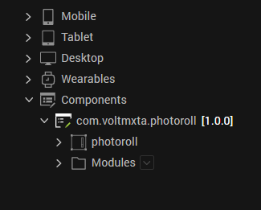

Once you have imported a component to your project, you can easily add the component to a form. For more information, refer [Add a Component to a Form](https://opensource.hcltechsw.com/volt-mx-docs/docs/documentation/Iris/iris_user_guide/Content/C_UsingComponents.html" \l "add-a-component-to-a-form)

## Add ESRI Key

## In order to call the ESRI API’s you need to pass your ESRI developer Key.

## To do this open the Web -> Localfiles -> ESRIMAP.js

## 

## On Line 27 you will fnd:

## esriConfig.apiKey = "”;

## Enter the apiKey you have received from ESRI between the “”.

## Building and previewing the app

After performing all the above steps, you can build your app and run .For more information, you can refer to the [Building and Viewing an Application](https://opensource.hcltechsw.com/volt-mx-docs/docs/documentation/Iris/iris_user_guide/Content/Cloud_Build_in_VoltMX_Iris.html#cloud) section of the Volt MX User Guide.

You can then run your app to see the ESRIMap work in real time

# Revision History

App version 1.0.0:

## Known Issues

NA

## Limitations

NA