05 June 2023

Encrypt Local(1.0.0)

# Overview

Use this component to calls the VoltMX.crypto API’s to generate an AES 128 encrypted key that will use your passphrase to encrypt your data.

This data is secured against the generated key on your device, so it can only be unencrypted from the same device, providing the best security for your sensitive data.

## Use case

### To encrypt data using an AES 128-bit encryption.

## Percentage of re-use:

Approximately 90% reusable.

## Features.

Simple function calls to encrypt and decrypt data.

# Getting Started

## Prerequisites

Before you start using the In Encrypt Local component, ensure the following:

• [HCL Foundry](https://manage.hclvoltmx.com/)

• Volt MX Iris

## Platforms Supported

### PWA & Responsive Web

### Native

## Importing the app

You can import the Forge components only into the apps that are of the Reference Architecture type.

**To import the EncryptLocal component, do the following:**

#### Open your app project in Volt MX Iris..

#### In the Project Explorer, click the **Templates** tab.

#### Right-click **Components**, and then select **Import Component**. The **Import Component** dialog box appears.

#### Click **Browse** to navigate to the location of the component, select the component, and then click **Import**. The component and its associated widgets and modules are added to your project.

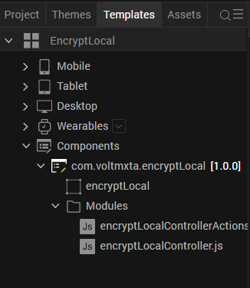

Once you have imported a component to your project, you can easily add the component to a form. For more information, refer [Add a Component to a Form](https://opensource.hcltechsw.com/volt-mx-docs/docs/documentation/Iris/iris_user_guide/Content/C_UsingComponents.html" \l "add-a-component-to-a-form)

## Building and previewing the app

After performing all the above steps, you can build your app and run .For more information, you can refer to the [Building and Viewing an Application](https://opensource.hcltechsw.com/volt-mx-docs/docs/documentation/Iris/iris_user_guide/Content/Cloud_Build_in_VoltMX_Iris.html#cloud) section of the Volt MX User Guide.

You can then run your app to see the EncryptLocal work in real time

# Use the component

# Add the component to your form, the component comes with 2 functions:

# Encrypt(text, passphrase) -> return encrypted text

# Decrypt(encryptedText, passphrase) -> return text

# Revision History

App version 1.0.0:

## Known Issues

NA

## Limitations

NA