05 June 2023

Encrypt Global(1.0.0)

# Overview

Use this component to call a simple encryption algorithm that will use your passphrase to encrypt your data and will allow the data to be unencrypted on another device that’s knows the passphrase.

## Use case

### To encrypt data that will be unencrypted on another device.

## Percentage of re-use:

Approximately 90% reusable.

## Features.

Simple function calls to encrypt and decrypt data.

# Getting Started

## Prerequisites

Before you start using the Encrypt Global component, ensure the following:

• [HCL Foundry](https://manage.hclvoltmx.com/)

• Volt MX Iris

## Platforms Supported

### PWA & Responsive Web

### Native

## Importing the app

You can import the Forge components only into the apps that are of the Reference Architecture type.

**To import the EncryptGlobal component, do the following:**

#### Open your app project in Volt MX Iris..

#### In the Project Explorer, click the **Templates** tab.

#### Right-click **Components**, and then select **Import Component**. The **Import Component** dialog box appears.

#### Click **Browse** to navigate to the location of the component, select the component, and then click **Import**. The component and its associated widgets and modules are added to your project.

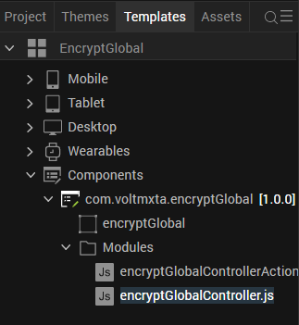

Once you have imported a component to your project, you can easily add the component to a form. For more information, refer [Add a Component to a Form](https://opensource.hcltechsw.com/volt-mx-docs/docs/documentation/Iris/iris_user_guide/Content/C_UsingComponents.html" \l "add-a-component-to-a-form)

## Building and previewing the app

After performing all the above steps, you can build your app and run .For more information, you can refer to the [Building and Viewing an Application](https://opensource.hcltechsw.com/volt-mx-docs/docs/documentation/Iris/iris_user_guide/Content/Cloud_Build_in_VoltMX_Iris.html#cloud) section of the Volt MX User Guide.

You can then run your app to see the EncryptGlobal work in real time

# Use the component

# Add the component to your form, the component comes with 2 functions:

# Encrypt(text, passphrase) -> return encrypted text

# Decrypt(encryptedText, passphrase) -> return text

# Revision History

App version 1.0.0:

## Known Issues

NA

## Limitations

NA