Date: 21-Oct-2021

Employee Directory
Asset Version: 3.3.1
The app lets you search, discover and know more about your co-workers. It comes in mobile, tablet as well as desktop web version. The mobile and tablet app comes preconfigured with Login, Menu, Filter and List/Detail interface with Search and Dictionary functionalities.

Requirements:

- Volt MX Iris
- Volt MX Foundry

Devices:
- Mobile
- Tablet
- Desktop

Platforms:
- Android
- IOS

Features:

- Includes sample employee data
- Easily configurable-customize as per your requirement
- List Details layout with Search, Filter, Dictionary and Sliding menu functionalities
- Progressive Web App:
  - Prompts option to add the app to home screen from browser
  - Responsive design supporting mobile, tablet, desktop.
  - Provide ability to create, edit and delete employee records (For Desktop)

Overview:
The Employee Directory app helps an employee of an organization to search and view other employee details, such as Full name, Profile image, Designation, Department, Reporting manager, and Contact details. You can set the required properties and events, map the app data model with your back-end service, and build the app.

App Functionality:

- When you log in to the app using your credentials, you can view your basic employee details. The basic details include Name, Designation, Department, ID and so on. This app is available in Mobile, Tablet and Desktop Web.

- Desktop Web App: For Desktop Web App we can remove or edit an employee's details. In Settings, we can create or remove any new designations, departments and location.

Set up the Foundry App

User Store Setup
You need to set up a few users to gain access to the Employee Directory app. Follow these steps to set up the user store:

Steps to set up User Store

- In The Volt MX Iris, Select Volt Foundry.

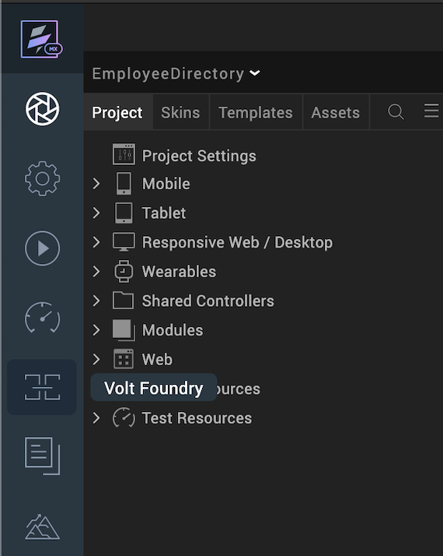

The Volt Foundry Console Screen appears with the Employee Directory App page. The Configure Services tab is selected by default.
- Click the Identity Tab.
- Select the userIdentityService

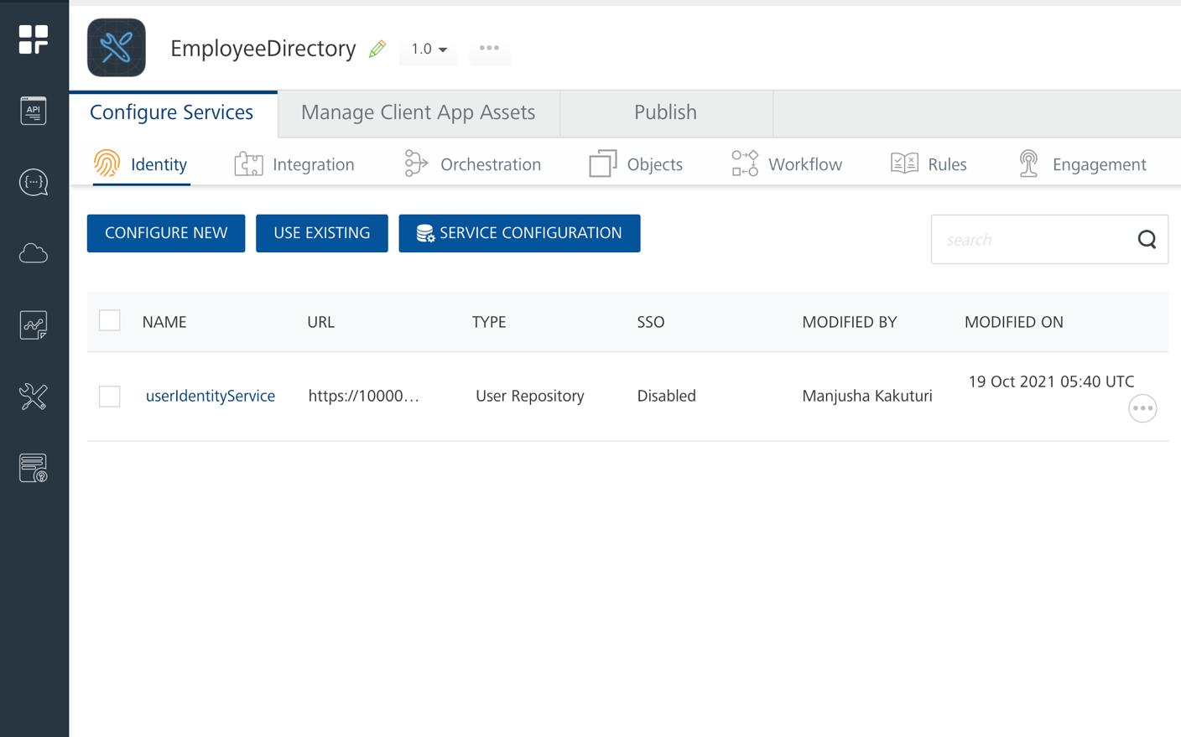

- Click ADD USER. Provide the user details in the Add User dialog that appears. You must use these user credentials for signing into the app.

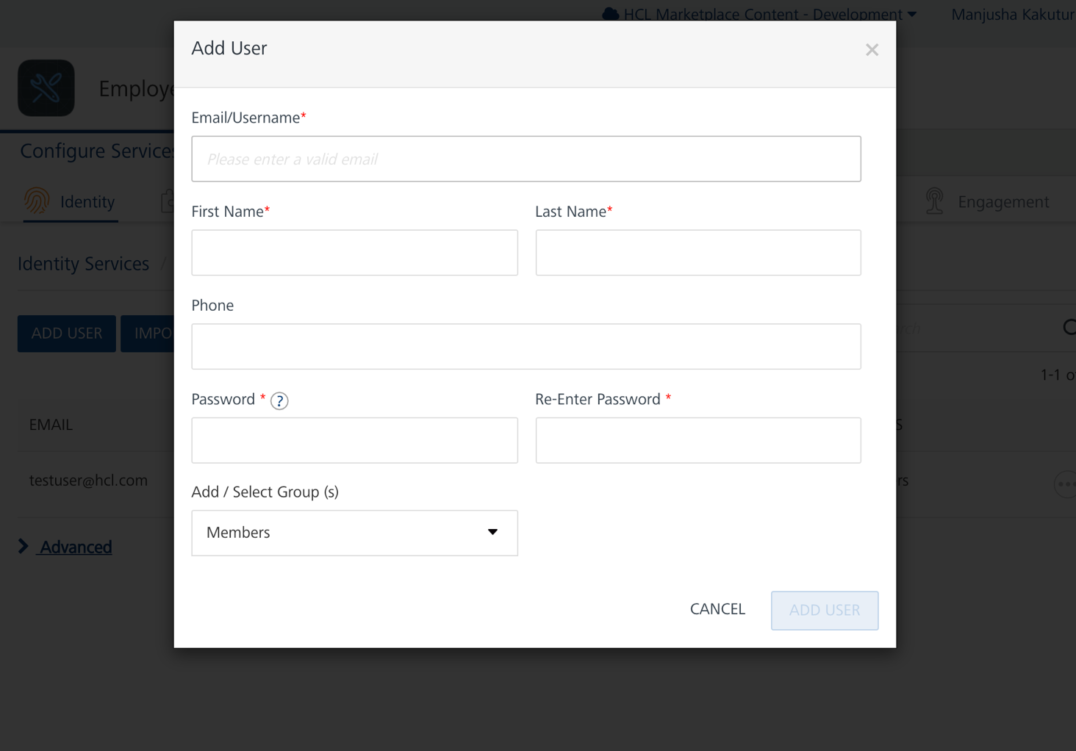

- In Add/ Select Group (s), click the drop-down and select the Members group. By using the Groups feature in Volt MX User Repository you can allow only a certain set of users who belong to a group such as Members to access the app. You can also create a new group to share your access. To create a new group, expand Add/ Select Group(s) and click Add Group. For more information on the Groups features in Volt MX User Repository, click here.

Publish the Foundry App
To publish the Foundry app to a run-time environment and also to allow the app to access the sample data from the run-time environment, follow these steps.
Steps to publish the Volt MX Foundry app
- Select the Publish Tab then Click Publish.
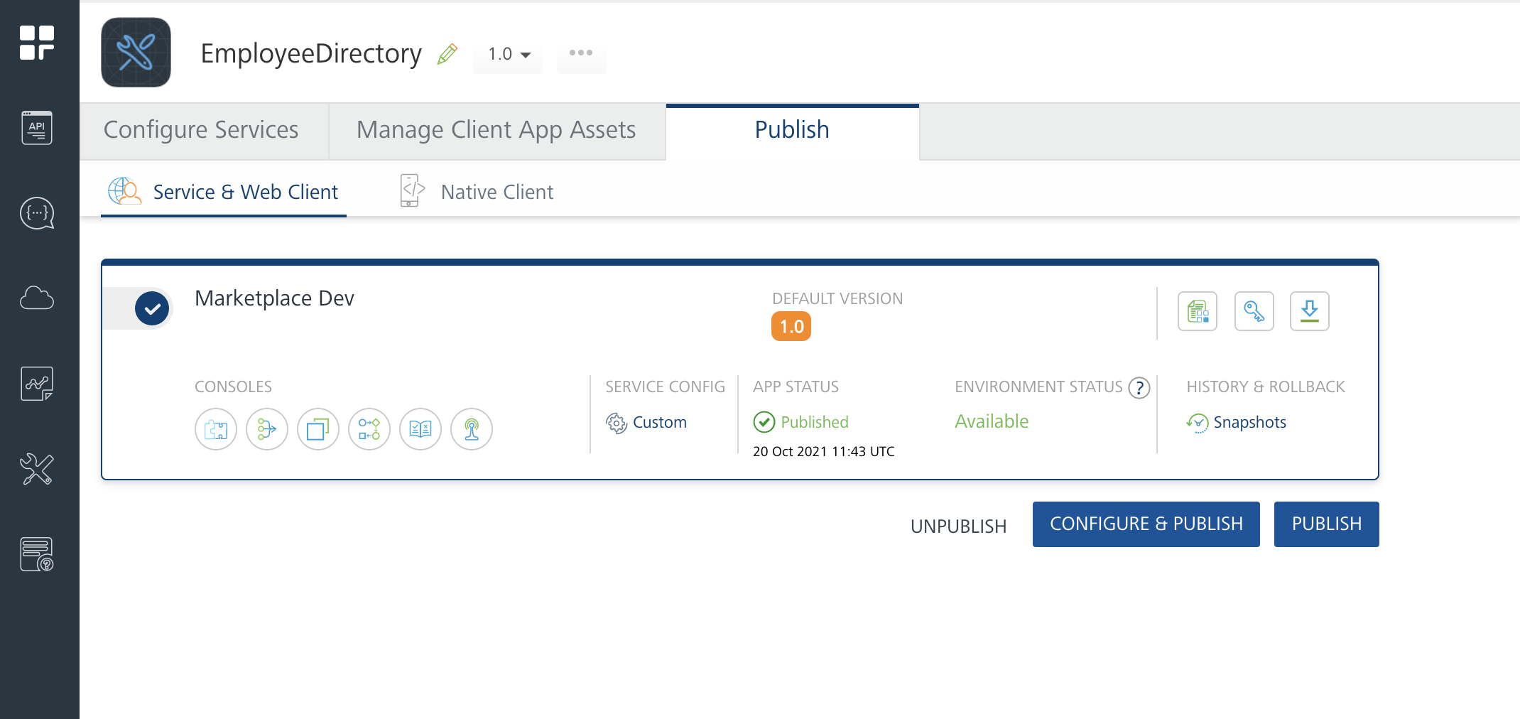

- A dialog box is generated which notifies you once the app is published.

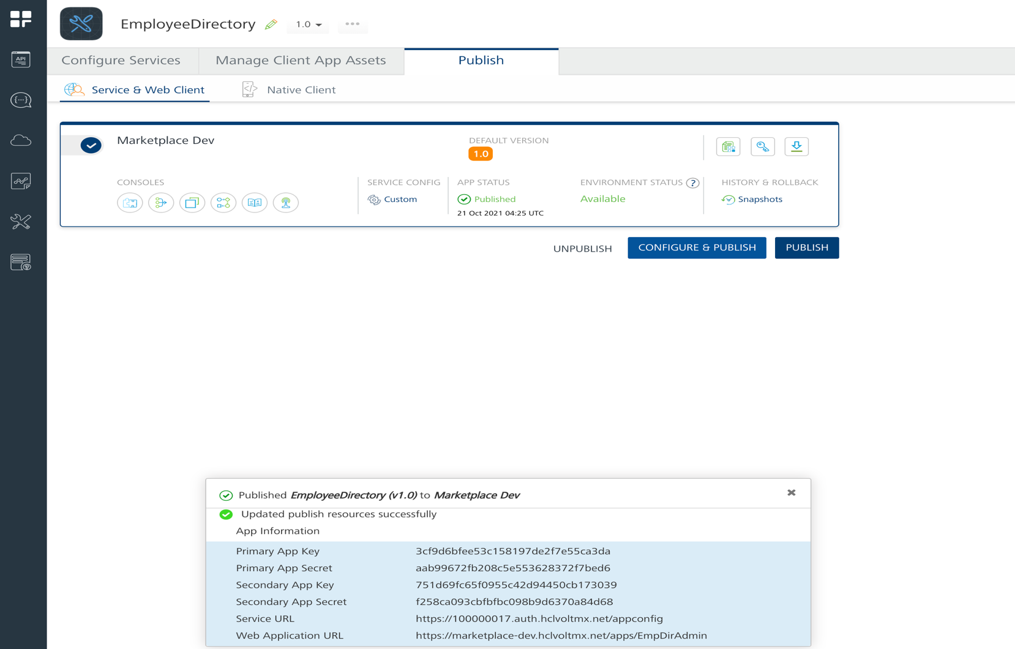

Configure the UI of the Employee Directory App
The Employee Directory app consists of the following components:
- Login component is a login form that every mobile and tablet app needs to authenticate its users.
- Sliding Menu component is a ready-to-use Hamburger Menu. The Sliding Menu component contains a Hamburger menu icon and a sliding menu. When a user clicks the Hamburger menu icon, the sliding menu slides on to the screen either from the right side or from the left side of the screen.
- List-Details component consists of two views, List view and Details view. List view displays a list of all employees. When a user selects an employee, additional information about the selected employee is displayed on the Details view. The component contains built-in features such as Search and Dictionary to quickly navigate through the list and find any employee.

Employee Directory App Volt MX Foundry Services:

When you import the Employee Directory app into Volt MX Iris, Volt MX Iris uploads a Foundry app (Employee Directory App).
Once you import the app to Volt MX Iris, you must publish the app in Foundry

Configure the User Credentials Authentication
User Repository is a repository service available in the Employee Directory App
Volt MX Foundry app. The repository service helps you authenticate employees when they try to log on to the Employee Directory app using the user credentials.

Configure the Integration Service
The Employee Directory app contains an Integration Service:
- fetchImageService
Operations:
  - getImage: Used to get the Profile Images of the Employees

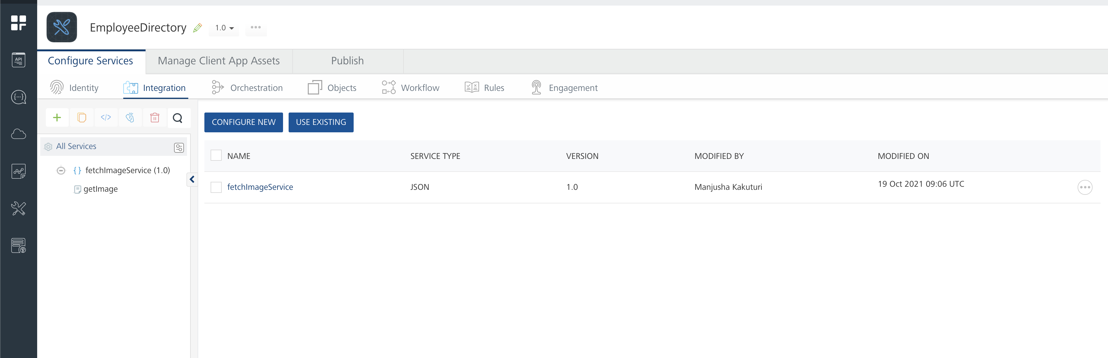

Configure the Orchestration Service
Orchestration services are used to integrate multiple services and form a single service. The EmployeeStorageObjects orchestration service is used to fetch all data objects in to the mobile/tablet app at one go to reduce the number of service calls.
Operations:
- EmployeeStorageObjects
  - getAllDetails: To get the whole information about the Employees.
For more information, refer to Orchestration Services.

Configure the Object Service
The object services help you define the app data model and map it with relevant backend services. In the object service, you can view all the objects of the data model and the default fields and relationships of each object.
- EmployeeModelSchema
Creates an employee object in the backend.
- StorageObjectServices
Fetching All the Employee Details.
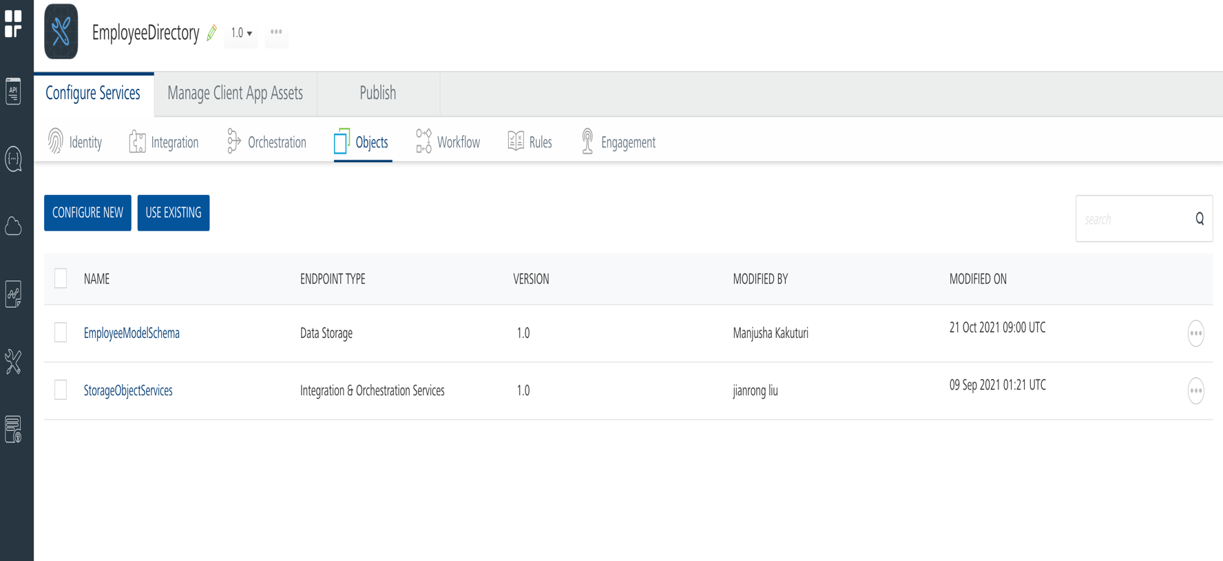

To learn more about object services and mapping, see Object Services.

Map the Employee Data Model (Object services) with a backend Data Source

The data model contains multiple objects and fields related to employee information.
The app data model is created as an object service. Using the Volt MX Foundry console, you can modify the fields and relationships of the objects in the data model. For example, you can add new fields to objects and define new relationships between objects.
By default, the EmployeeDirectoryApp Volt MX Foundry app is mapped to the
Volt MX Foundry storage. You can easily decouple the app data model with the
Volt MX Foundry storage and map it with another backend data source.

For more information, refer Mapping Employee Data Model.

Import the App

To import the Employee Directory app into your workspace, follow these steps:
- Open Volt MX Iris
- On the main menu select Forge → Browse.
- Search for the Employee Directory app, and then click Import to Workspace. The app is imported to your workspace. A dialog box appears, confirming that the app has been imported. Click OK.
4. Switch to your project containing the Employee Directory. To switch to your project, click File → Open → Reference Architecture → <project name>

Live Preview
After importing the Employee Directory app, you can preview the app on any channel by using Live Preview.
Note: To preview the app on your mobile or tablet device, ensure that you install the latest version of the Volt MX Iris App Viewer app on your mobile or tablet device from the App Store or from Google Play.
To preview the app by using Live Preview, follow these steps:
  - In Volt MX Iris Starter, click Build → Live Preview Settings from the main menu. The Live Preview Settings window opens.
Note: In Volt MX Iris Enterprise, click Preview → Run from the main menu to open the Live Preview Settings window.
- Select any application channel such as Mobile Native, Tablet Native, or Responsive Web along with the respective platform(s) on which you want to preview the app. Click Save & Run.
After a successful preview build for Mobile and Tablet channels, a window appears containing a QR code. You can scan this QR code from the Volt MX Iris App Viewer application on your mobile or tablet device to preview the app.
For more information on Volt MX Iris App Viewer, you can refer the Volt MX Iris App Viewer Documentation.

Employee Directory App (Mobile App):

This section explains the functionality of the Employee Directory app in Mobile platform.
The following is the login screen of the app:

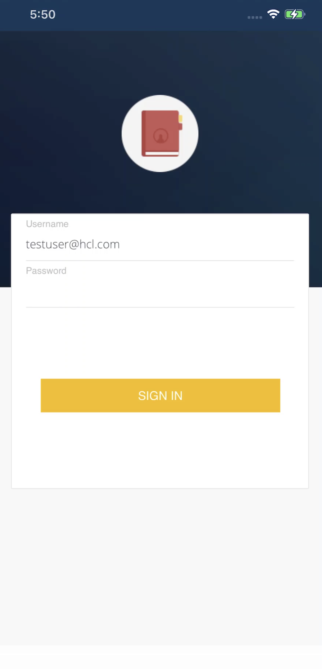

Once you log on to the app successfully, the Directory screen appears as shown in the following figure:

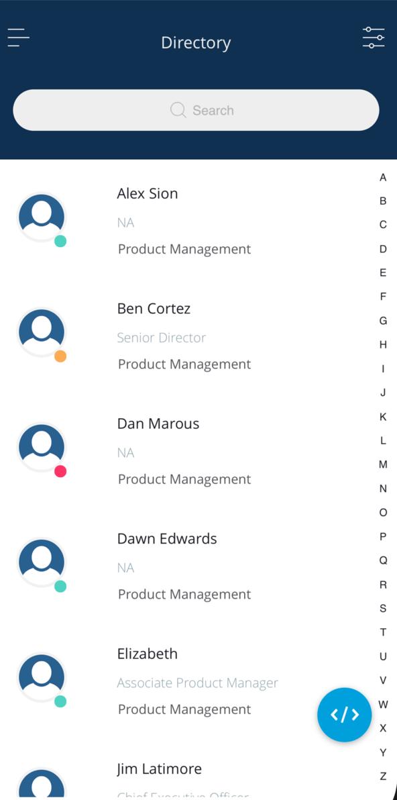

The Directory screen contains the following UI elements:
- Hamburger menu icon (upper left of the screen): When a user taps the menu icon, a sliding menu appears. The sliding menu contains user profile photo (who logged in to the app), menu items and Logout option at the bottom.

- Hamburger menu icon (upper right of the screen): When user taps the menu icon, the Filter By menu appears. The Filter By menu allows users to filter the search results by department and designation.

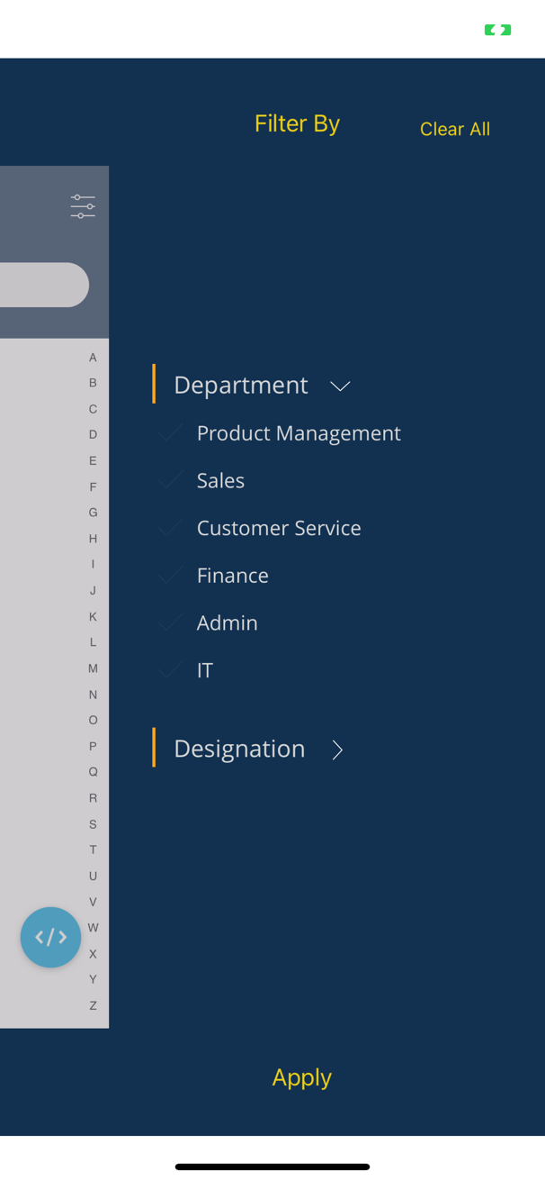

- Search box: Using the search box, a user can type the name of the employee and get the results.

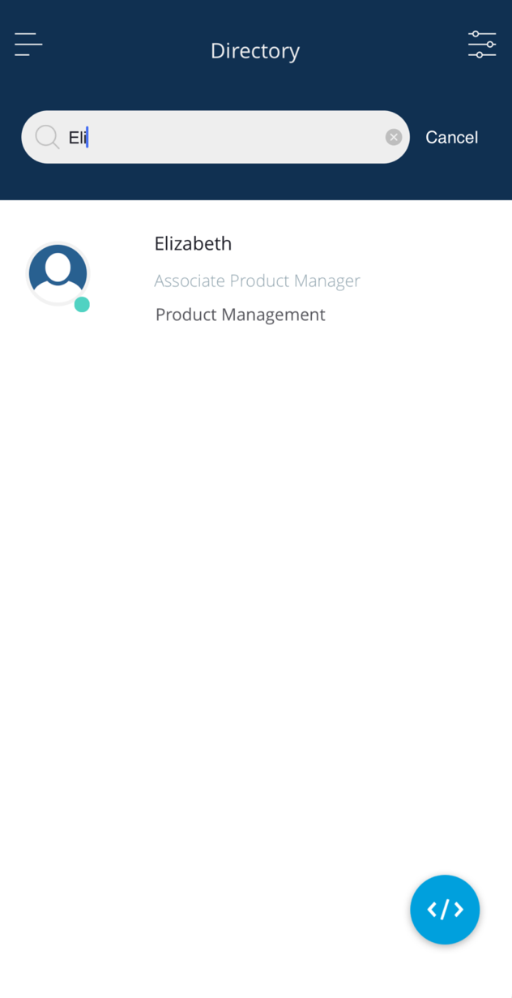

- List-Details: The Directory screen appears with the master list of employees. From the list of employees, when a user taps an employee, a screen appears showing all the details of the selected employee.

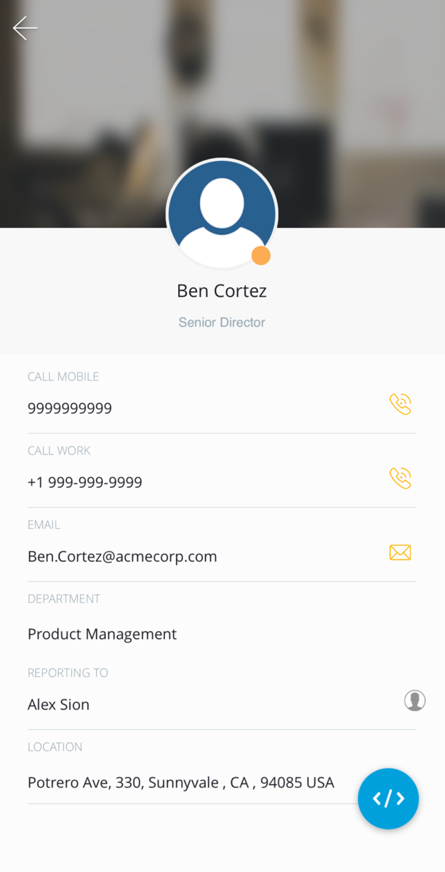

Desktop Web App
This section explains the functionality of the Employee Directory app in Desktop Web platform.
The following is the Login screen of the app:

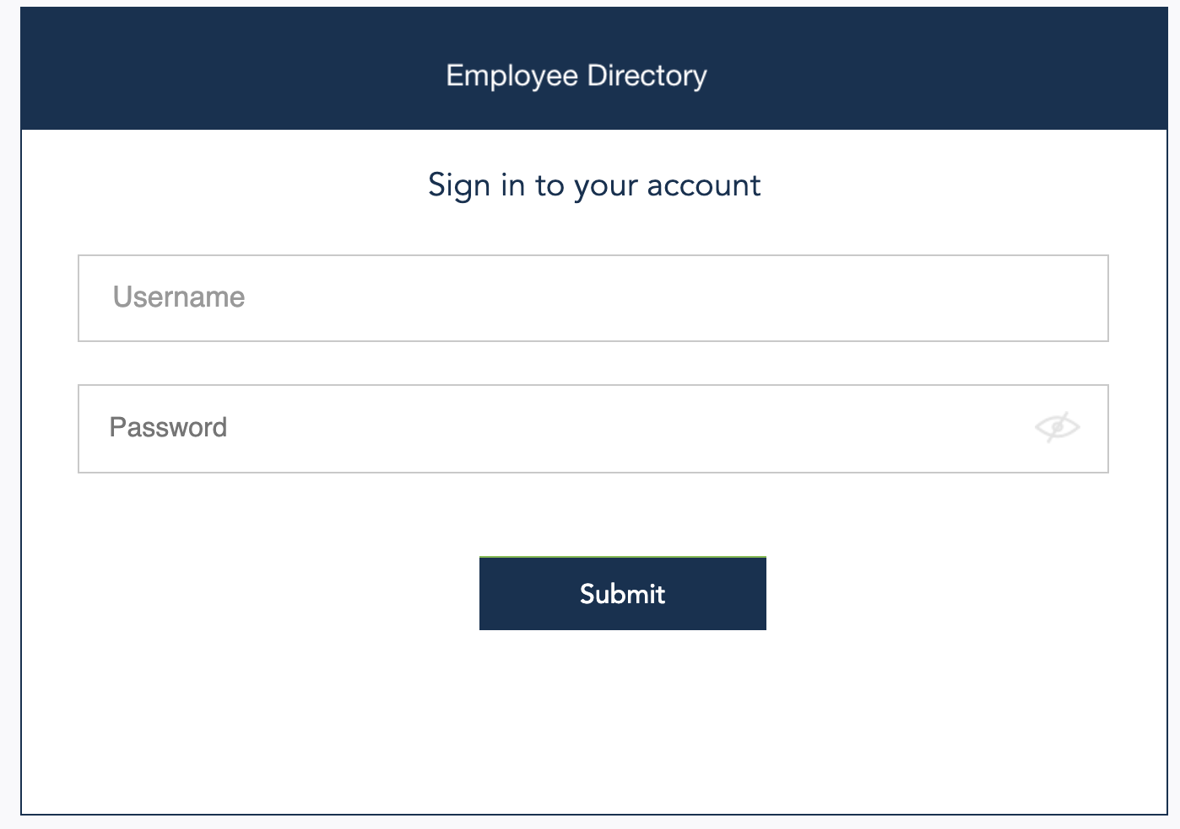

Once you log on to the app successfully, the Directory screen appears as shown in the following figure:

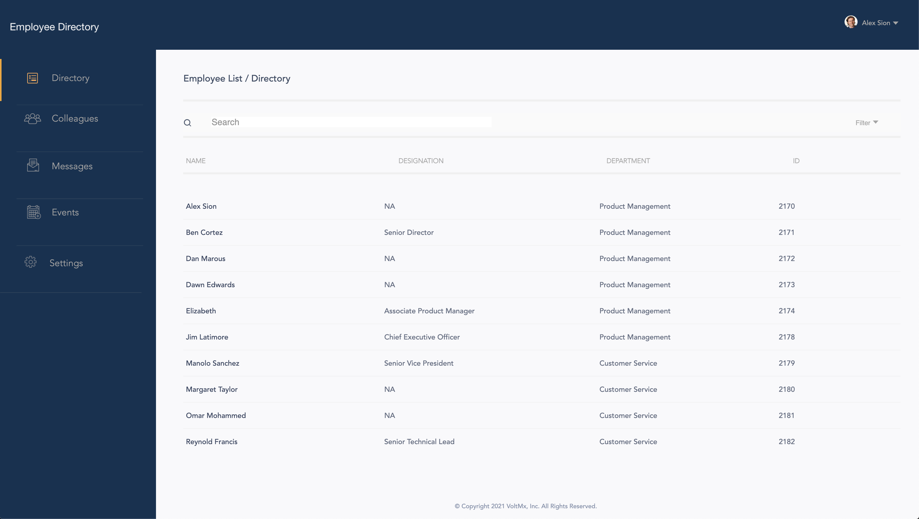

The Directory screen contains the following UI elements:
- Filter icon: When you click on the filter icon, a drop-down appears. This allows you to filter your employee details based on department and designation.
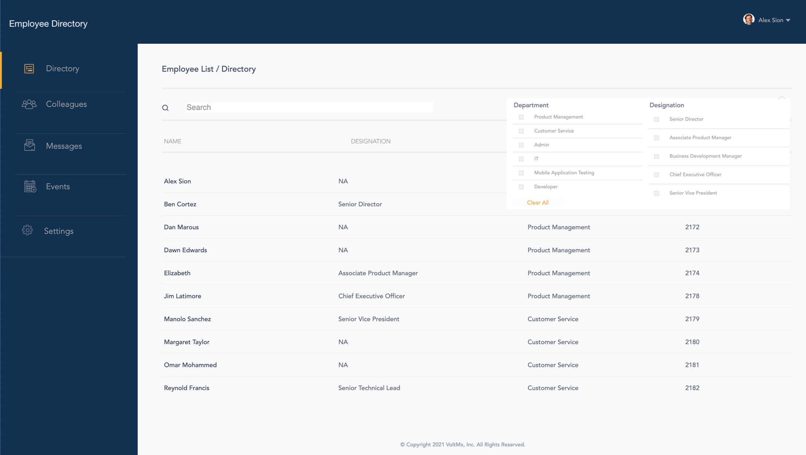
- Search box: Using the search box, a user can type the name of an employee and get the results.

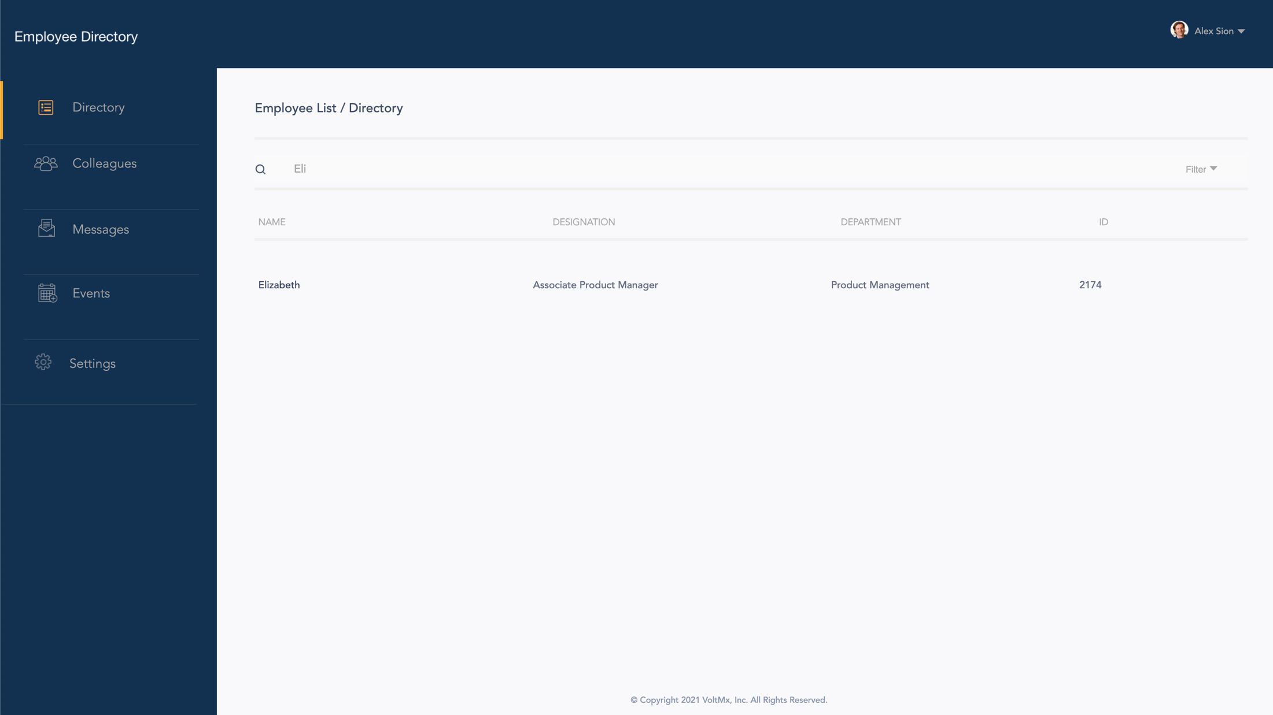

- List-Details: The Directory screen appears with the list of employees. From the list of employees, when a user taps an employee, a screen appears showing all the details of the selected employee.

- Menu (left of the screen): The menu contains user profile photo (who logged on to the app), menu items that navigate to the major modules of the app.

- Settings: When you click Settings, you navigate to a directory screen as shown in the following figure.

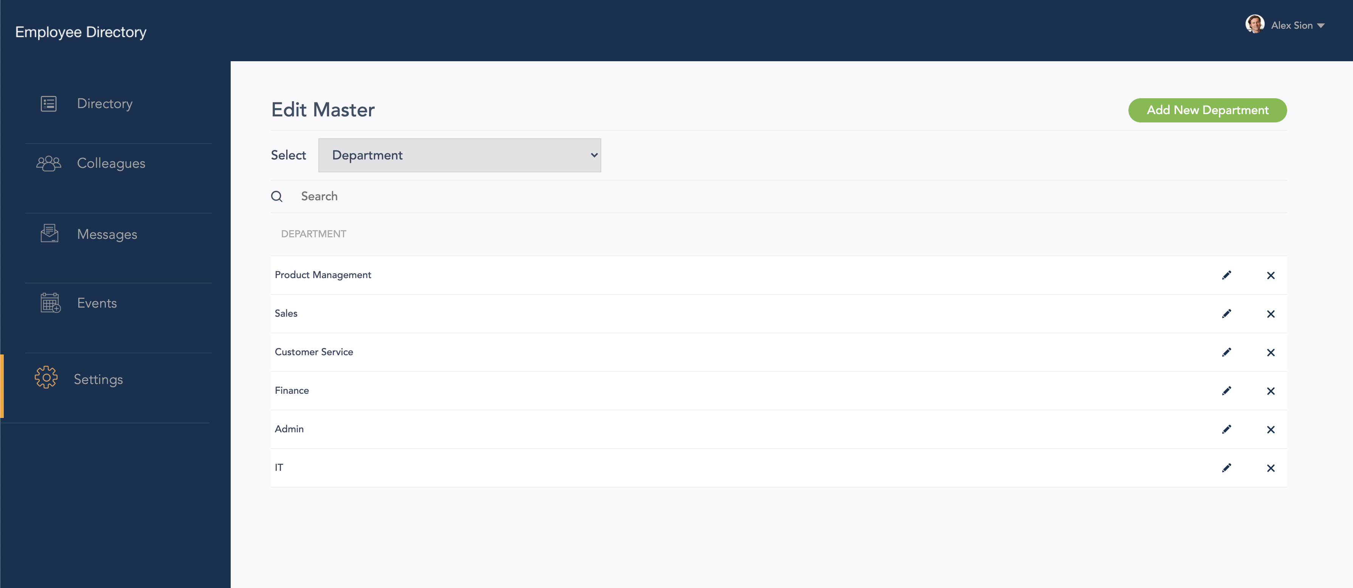

The settings screen again has the following UI elements:
- Select: Select helps you to toggle among various Departments, Designation and Location options in your employee directory.
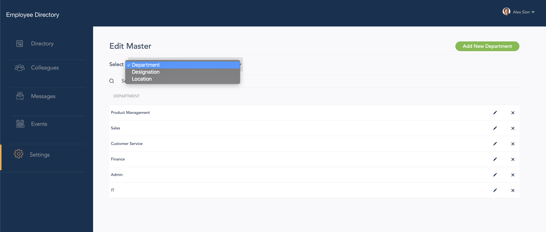

- List-Details: The Directory screen appears with the list of department, designation or location. (It depends on what you select).

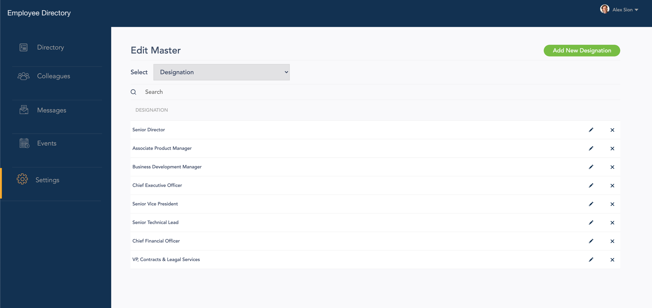

- Edit and Delete icons: Edit and Delete icons allow you to edit the designation, department names and location details as well as delete the created designation, department names and location details.

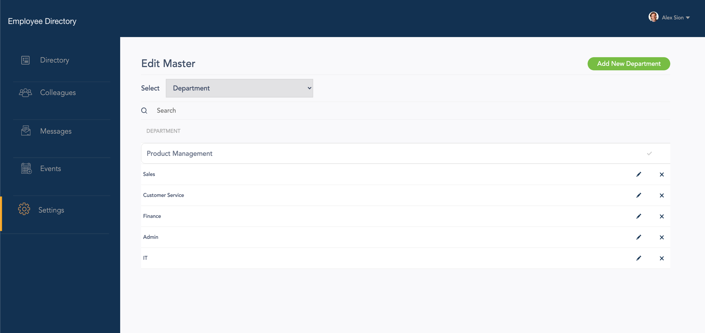

- Add New button: This button helps you to add new department, designation, if any new department and designation is introduced in your enterprise. You can also add a new location in the location section.

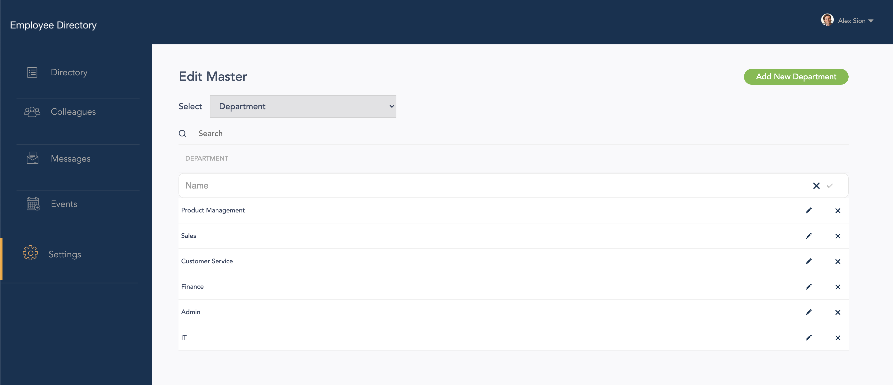

- Search box: Using the search box, a user can type the name of the designation, department or location and get the results.

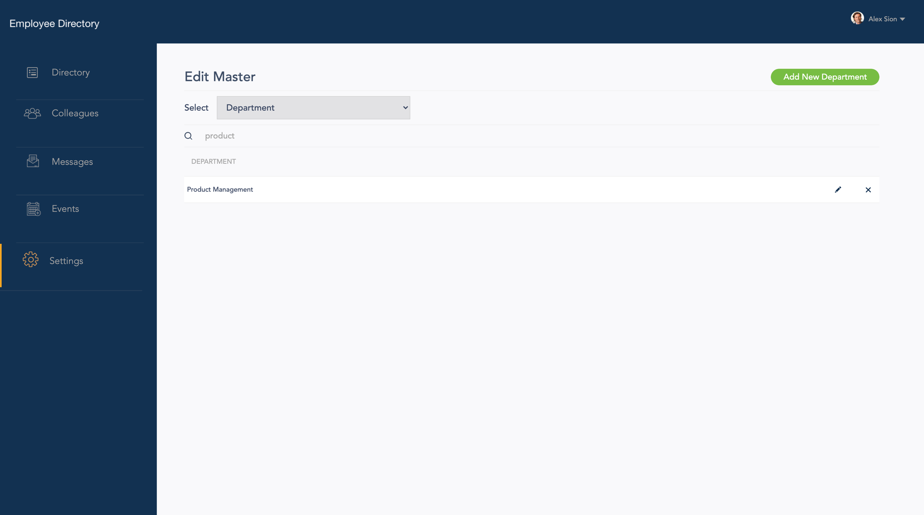

- To logout from your account in Desktop Web Platform follow these steps:
- Click on your profile icon.
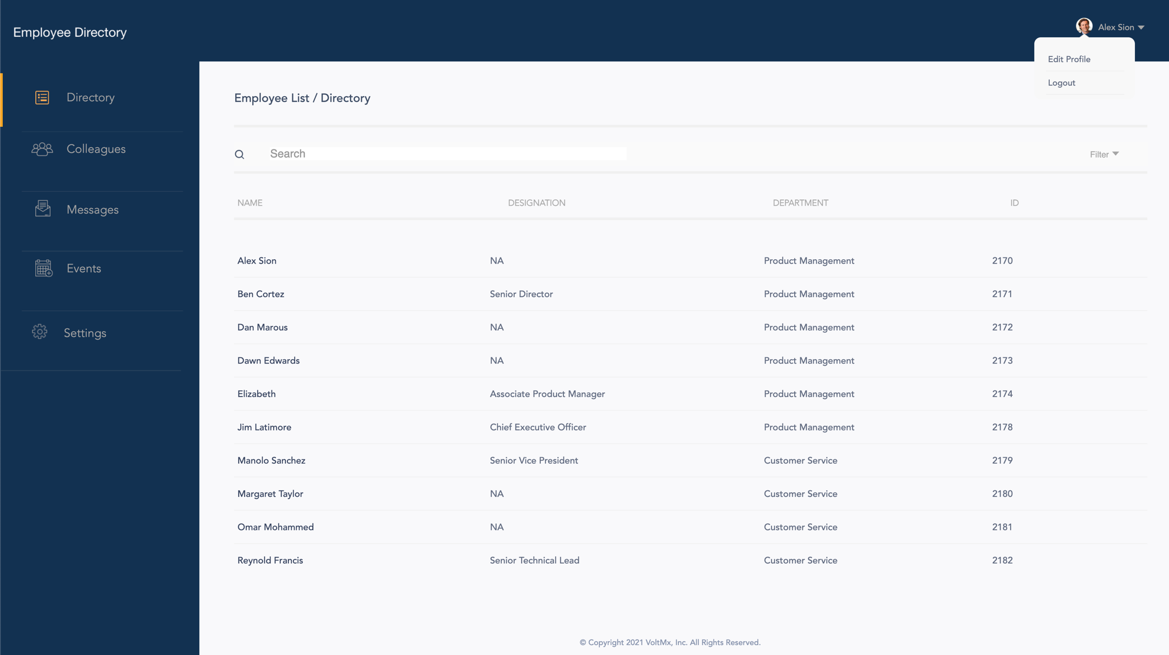

- Select Logout.

Limitations:

- If browser is minimized and for certain resolutions, UI can appear distorted

Known issues:

- Blinking issue is observed in android on clicking certain elements on the screen

