Date : 14 Aug 2023

Employee Data Model

version: 1.1.0

Overview
Employee App Data Model aims to provide a quick start point for building mobile apps dealing with employee data. The data model contains multiple objects and fields related to employee information. The following diagram illustrates the objects in the data model and relationships among them.

Use case:
When you import the app data model into VoltMX Foundry, the app data model is created as an object service. Using the VoltMX Foundry console, you can modify the fields and relationships of the objects in the data model. For example, you can add new fields to objects and define new relationships between objects.

Features

Quick reference app data model- Extend/ Reduce/ Modify based on your requirement.

Map to any backend data source

Map to any backend data source
You can also map Employee App Data Model to any back-end data source. For example, if you are using Oracle database to store your employee details, using the VoltMX Foundry console, you can connect Employee App Data Model with the Oracle database and map the fields of each object in the data model with the fields of the Oracle database.
The following sections help you use the Employee App Data Model:

Percentage of re-use:
70% (Data can be customizable and customer need to implement UI by themselves).

Getting Started

Prerequisites
Before you start using the Employee App Data Model, ensure you have the following:
- A HCL Foundry
- Volt MX Iris

Importing the Employee App Data Model
- Log on to your HCL Foundry. The Dashboard page appears by default.
- In the left pane, click the Apps menu. The Custom Apps page appears.
- Click Import. The Import dialog appears.
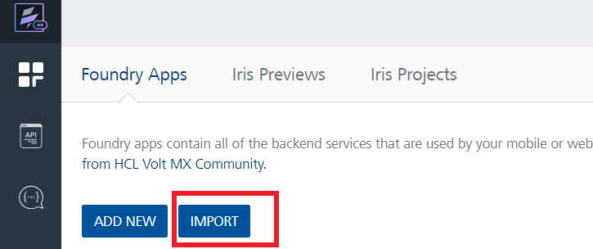
- Drag the zip file into the Import App dialog.
Alternatively, click browse. The Open dialog appears. Navigate to the location where you downloaded the data model (zip file) on your computer, select the zip file, and click Open. The zip file is selected, and the Import App dialog appears as shown in the following figure:

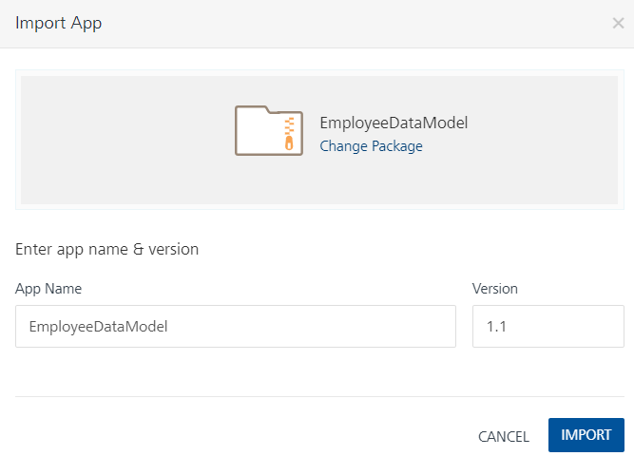
Note: If the selected component is not the one that you want to import, click Change Binary.
- In the App Name box, the EmployeeDataModel is displayed by default. You can change the name, if required.
- Click Import as new to create a new Foundry app. If there is an app exists with the same app name and if you want to overwrite it, click Overwrite existing app.
- Click Import. The EmployeeDataModel app is listed on the Custom Apps page.
Note: If you changed the name in the App Name box, the app with the updated name is listed on the Custom Apps page.

To import the data adapter zip file, do the following:

VIEWING THE OBJECT SERVICE
When you import Employee App Data Model into Foundry, the app data model is created as an object service. In the object service, you can view all the objects of the data model and the default fields and relationships of each object.
To view the object service, do the following:
- Log on to your HCL Foundry. The Dashboard page appears by default.
- In the left pane, click the Apps menu. The Custom Apps page appears.
- Find and click the EmployeeDataModel app. The EmployeeDataModel page appears along with the Configure Services tab and the Identity sub-tab opened by default.
Note: If you changed the name of the app while importing the app data model, find and click the app name that you specified using the search box on the Custom Apps page.

- Click the Objects sub-tab. The Objects sub-tab opens along with the UserDetailsSchemaED object service listed.
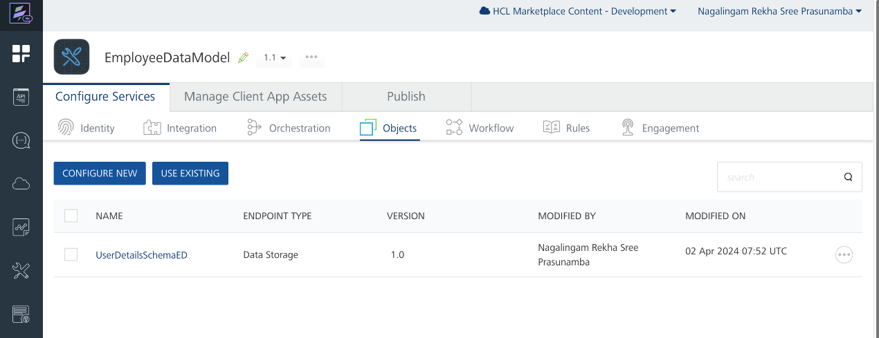
- Click UserDetailsSchemaED. The Configure page appears with all objects in the app data model.
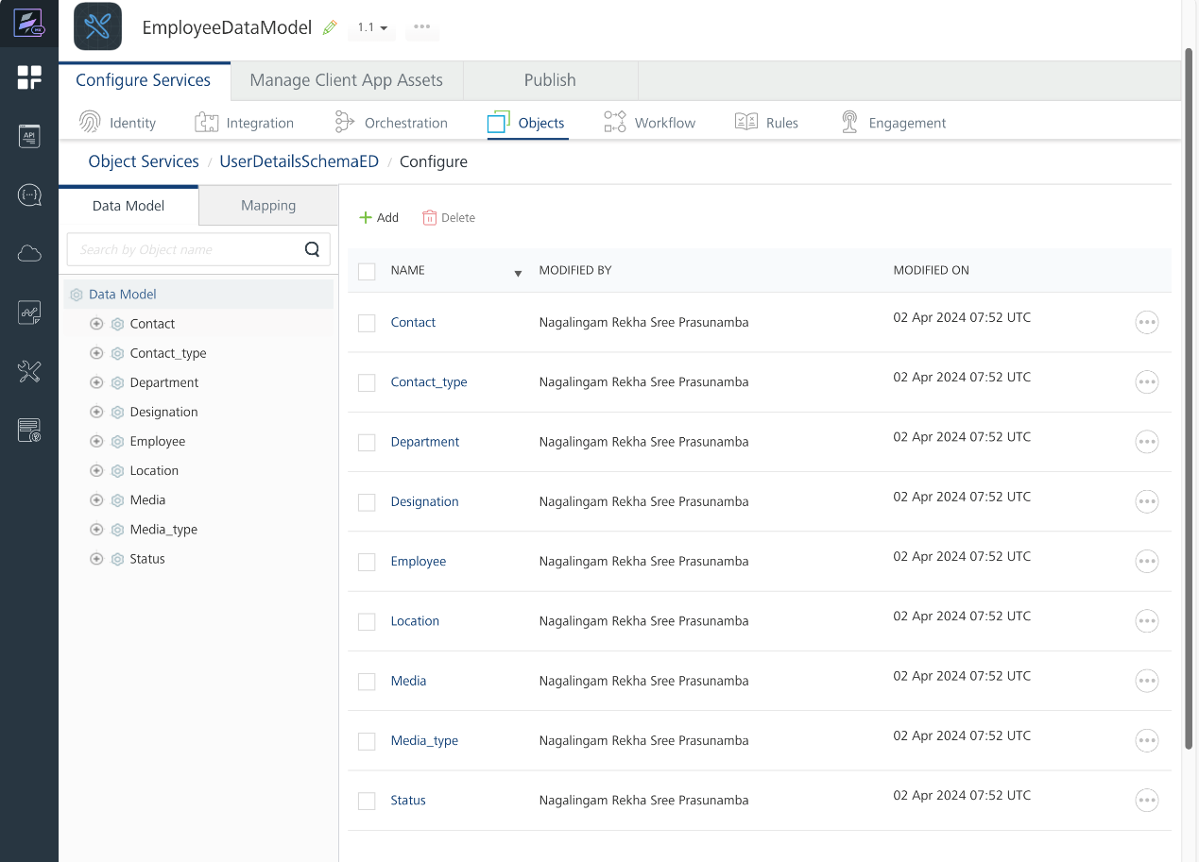

MAPPING EMPLOYEE APP DATA MODEL WITH A BACK-END DATA SOURCE
- On the EmployeeDataModel page, Click the Configure Services tab, and then click Objects sub-tab. The Objects sub-tab opens along with the UserDetailsSchemaED object service listed.
- Click the context menu icon of UserDetailsSchemaED as shown in the following figure. The context menu opens.
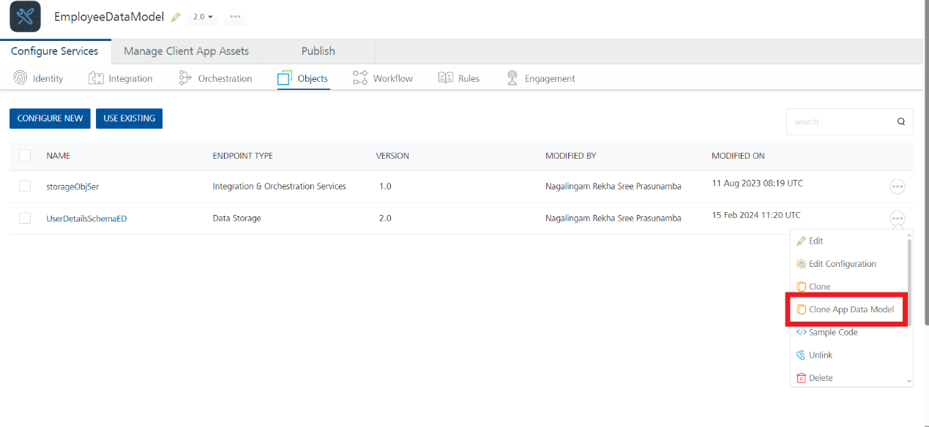
- Click Clone App Data Model. A copy of Employee App Data Model is created, and the New Object Service page appears.
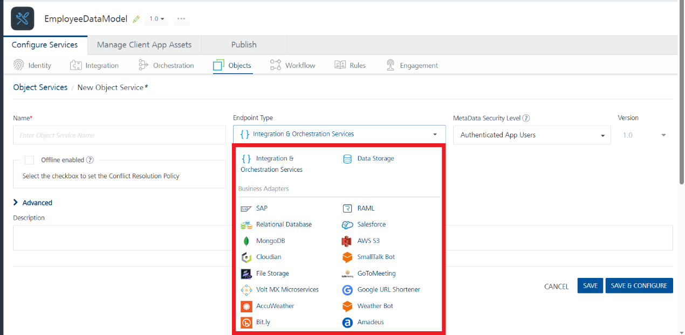
- In the Name box, type a name for a copy of Employee App Data Model.
- Click the context menu arrow to expand the Endpoint Type list. A drop-down list opens.
- Select the required back-end data source that you want to map and click SAVE & CONFIGURE.

mODIFYING EMPLOYEE APP DATA MODEL
The Employee App Data Model comes with a default set of objects. Every object in the data model contains a set of fields and a relationship with at least one object. The UserDetailsSchemaED object service allows you to modify the app data model as you require. Every object in the object service contains the following sections:
Fields
In the Fields section of an object, you can add new fields and edit and delete the fields associated with the object. Every object has a set of fields that you cannot edit or delete. For example, the createdBy and CreatedDataTime fields of the contact_type object cannot be modified.
Relationships
In the Relationships section of an object, you can define new relationships with other objects and edit and delete existing relationships of the object.
For more information, refer to Object Services.

Publishing the App in VoltMX Foundry
After adding the Employee App Data Model to your app and configuring the necessary configurations, you must publish the app to VoltMX Foundry. For more information, refer to Publish a Project to VoltMX Foundry.

Revision History
App version 1.1.0

Known Issues

N/A

Limitations

N/A

