Date :  17th Oct 2023

Email verification DATA ADAPTER (1.0.0)

# Overview

This Email Verification Data Adapter is the one and the only solid solution to verify that the e-mail address is valid, and reachable. This works by validation with regex, validating the DNS for MX records and then connecting the recipient's SMTP server for validation, without sending any email.

This email verification Data Adapter connects to the mail server and checks in real-time if the email exists. it doesn’t use historical data.

Getting Started

## Prerequisites

* Volt Foundry
* ApiLayer license key - <https://apilayer.com/marketplace/email_verification-api>

## Importing the adapter

**To import the Data Adapter to Volt Foundry, do the following:**

1. Sign in to the  [HCL Foundry](https://manage.hclvoltmx.com/).
2. From the left navigation menu, select **API Management**.
3. In **API Management**, select **Custom Data Adapters**.  
   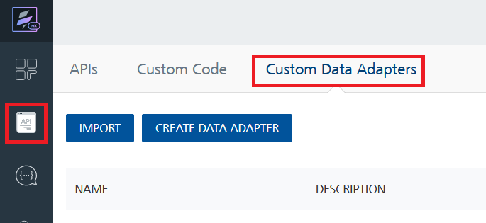
4. Click **IMPORT** to import a custom data adapter.  
   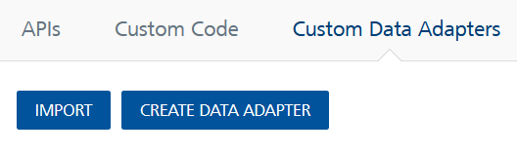
5. On the Import Data Adapter dialog box, click browser to import.  
   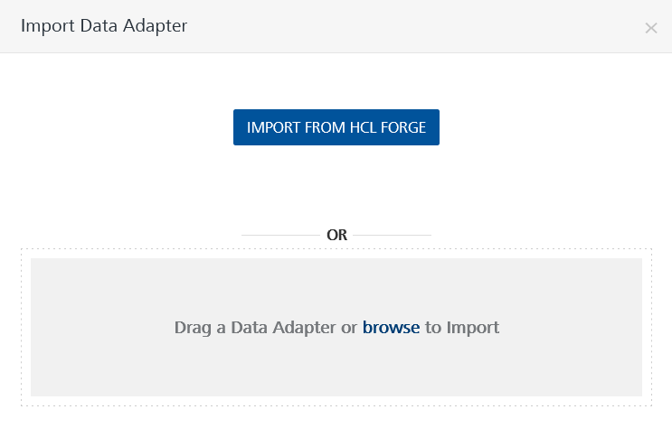
6. Select **EmailVerificationAPI** zip file and click **IMPORT**.

After you import the data adapter, Volt Foundry opens a window that shows the metadata of the data adapter.

After you import the data adapter, you can view it on the Custom Data Adapters page and use it to create services on Volt Foundry.

## [Creating an Integration service](javascript:void(0);)

After you import the data adapter into Volt Foundry, you can use it to create an Integration Service.

Follow the given steps to create an Integration service using the **Email Verification API** Adapter.

1. Sign in to the [HCL Foundry](https://manage.hclvoltmx.com/).
2. From the left navigation menu, select **API Management**.
3. In **API Management**, select **Integration**.  
   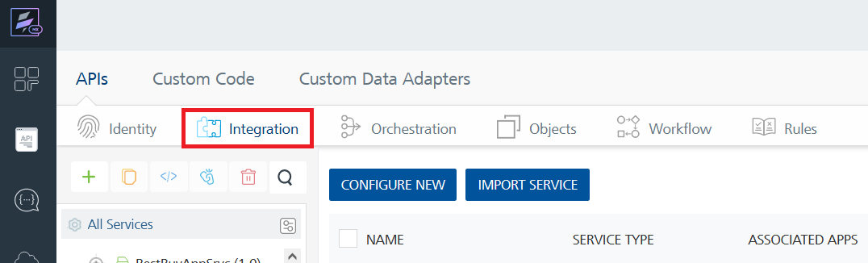
4. To create a new service, click the **+** button or the **CONFIGURE NEW** button.  
   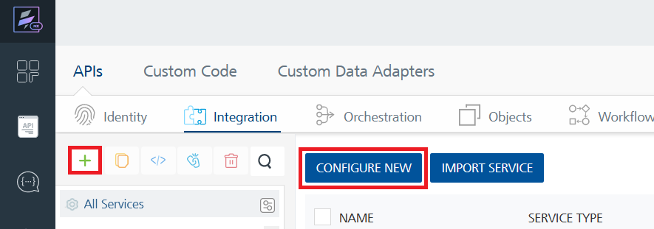
5. On the Service Definition tab, select the service type as **EmailVerificationAPI**, and click **SAVE**.A screenshot of a computer

   Description automatically generated

Alternatively, you can also create a Foundry app and create an Integration service inside it.

E. [Creating and Executing operations](javascript:void(0);)



After you create an integration service, you can create and execute operations using the service.

#### Creating an Operation

* In **API Management/Foundry app you created**, in the **Integration** section, select the service that you created.
* After you select the service, navigate to the **Operation List** tab.  
  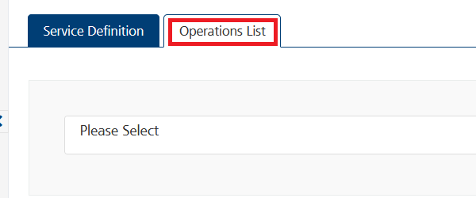
* From the drop down list, select an operation that you want to execute, and click **ADD OPERATION**.A screenshot of a computer

  Description automatically generated

#### Executing an Operation

* From the **Operations List** tab, in the **Configured Operations** section, select the operation you want to execute.  
  A screenshot of a computer

  Description automatically generated
* On the Operation Page, in the Request Input tab, enter a TEST VALUE for all the fields.A screenshot of a computer

  Description automatically generated  
    
  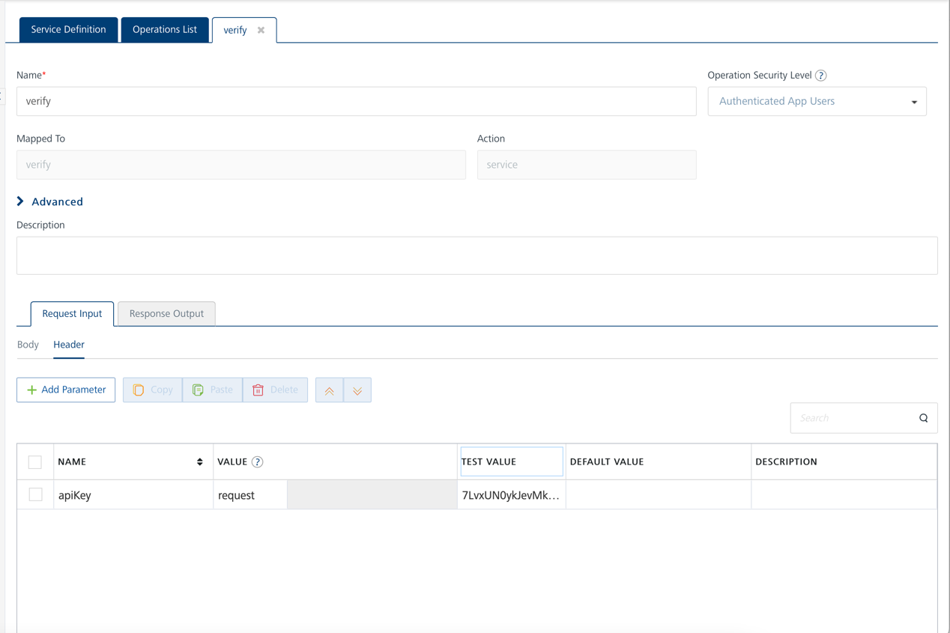
* Select a run-time environment and click **Save and Fetch Response** to get a response based on your inputs.  
    
    
  A screenshot of a computer

  Description automatically generated

## [Publishing your application](javascript:void(0);)

If you want to use the services in client applications, you need to publish an app to a run-time environment. You can create the service (as described above) in an application or import the service into an application and publish the application.

# References

## Endpoint Documentation

### Operations:

### i. verify

|  |  |
| --- | --- |
| **Description:** | Validates and verifies an email address measuring deliverability and quality |
| **Parameters:** | **Request Params:** i. email(required) - String - email to check **Header Params:**i. apiKey(required) - String - license key must be passed in the service header param |
| **Restrictions:** | NA |

# Revision History

Adapter version 1.0.0:

## Known Issues

## Limitations