Date :  16-Oct-23

email verification ADAPTER (1.0.0)

# Overview

This adapter uses Email Verification API by APILayer.com to validate and verify an email address assessing deliverability and quality.

This API verifies that the e-mail address is valid, and reachable. This is achieved by validation with regex, validating the DNS for MX records and then connecting the recipient's SMTP server for validation, without sending any email.

Yes! this email verification API connects to the mail server and checks in real-time if the email exists.

Here are some elements in API response:

**is_disposable:** Checks if the e-mail is from a disposable e-mail provider such as mailinator.com.

**is_role_account:** Role accounts are e-mail addresses such as support@domain.com and hello@blabla.com. If your intention is to reach real person only, use this flag.

**is_catch_all:** A catch-all address is meant to catch all email sent to any non-existing email accounts on your domain.

**is_inbox_full:** If the remote user's inbox is full, this may be the reason for bounced e-mails.

**is_disabled:** Tells us if the remote account is disabled and unable to accept the e-mail you've sent.

*Disclaimer: This adapter is built on using Email Verification API hosted by https://apilayer.com/. Any future change in how the APIs function may break the adapter and author of this adapter is not responsible for that.*

# Getting Started

## Prerequisites

1. Volt Foundry
2. APILayer.com Account
3. Subscription to Email Verification API

## Account Registration and API Subscription process

### Sign-up for an account at <https://apilayer.com/>

### Subscribe for the Email Verification API (<https://apilayer.com/marketplace/email_verification-api>)

### Copy your API key from “Account” section.

## Importing the adapter

**To import the Data Adapter to Volt Foundry, do the following:**

1. Sign in to the  [HCL Foundry](https://manage.hclvoltmx.com/).
2. From the left navigation menu, select **API Management**.
3. In **API Management**, select **Custom Data Adapters**.  
   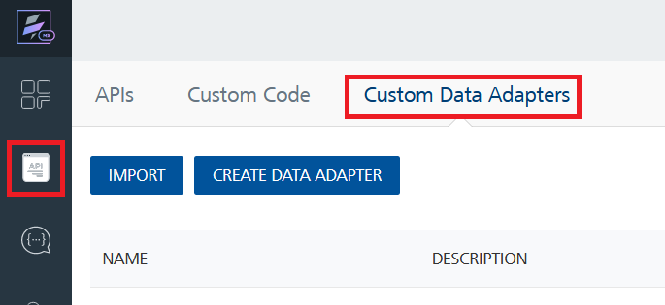
4. Click **IMPORT** to import a custom data adapter.  
   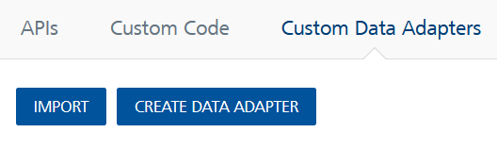
5. On the Import Data Adapter dialog box, click browser to import.  
   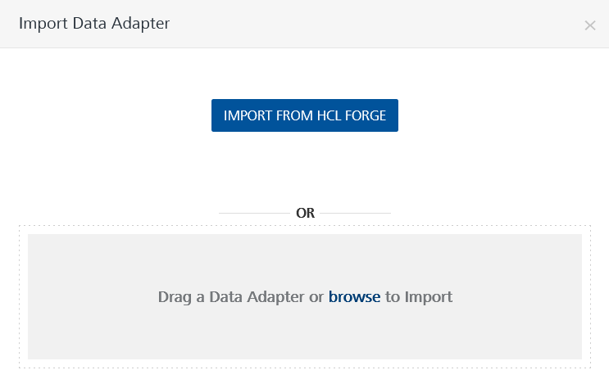
6. Select **EmailVerification.zip** file and click **IMPORT**.

After you import the data adapter, Volt Foundry opens a window that shows the metadata of the data adapter.

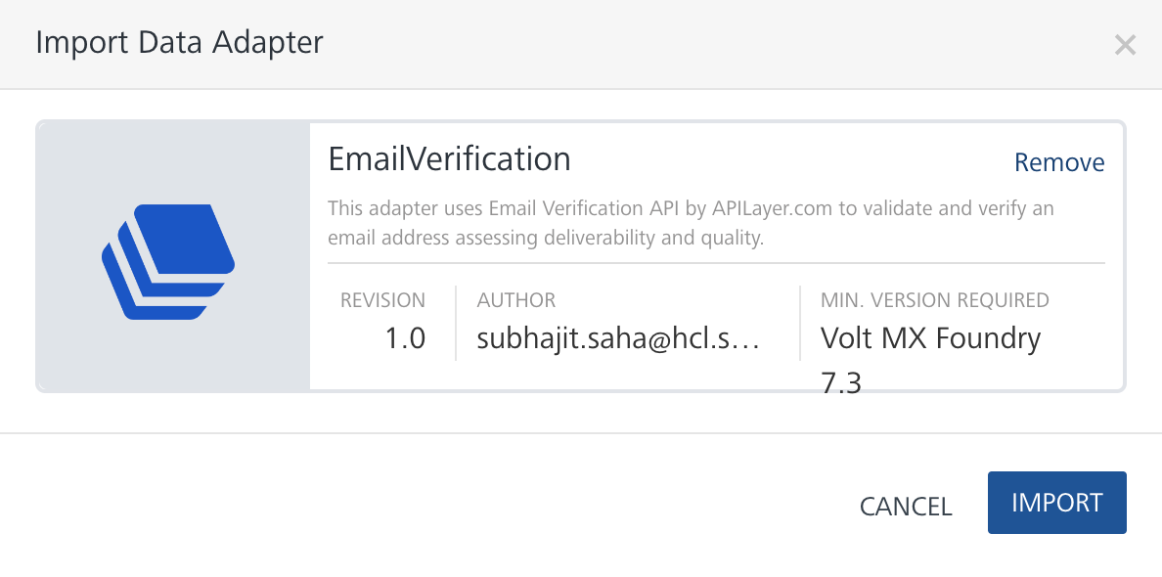

After you import the data adapter, you can view it on the Custom Data Adapters page and use it to create services on Volt Foundry.

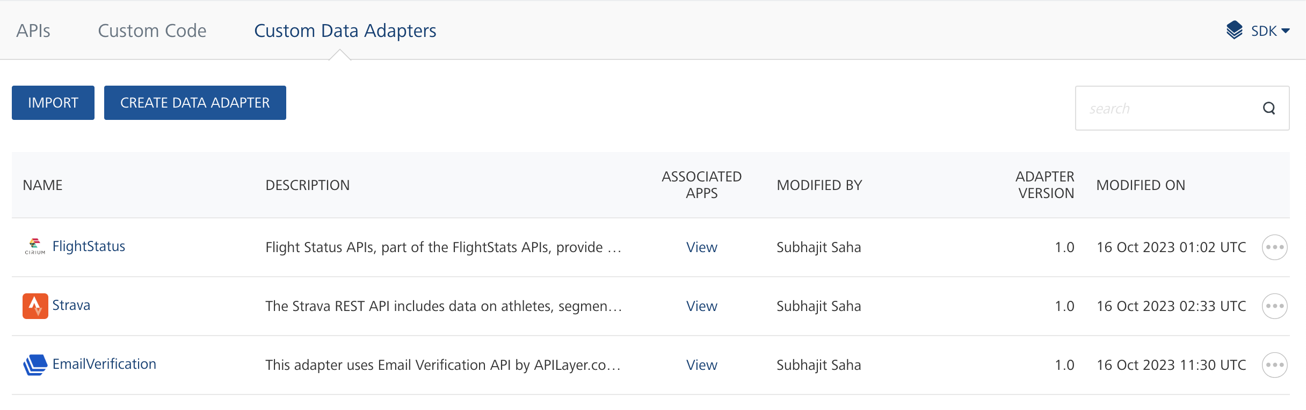

## [Creating an Integration service](javascript:void(0);)

After you import the data adapter into Volt Foundry, you can use it to create an Integration Service.

Follow the given steps to create an Integration service using the **Email Verification** Adapter.

1. Sign in to the [HCL Foundry](https://manage.hclvoltmx.com/).
2. From the left navigation menu, select **API Management**.
3. In **API Management**, select **Integration**.  
   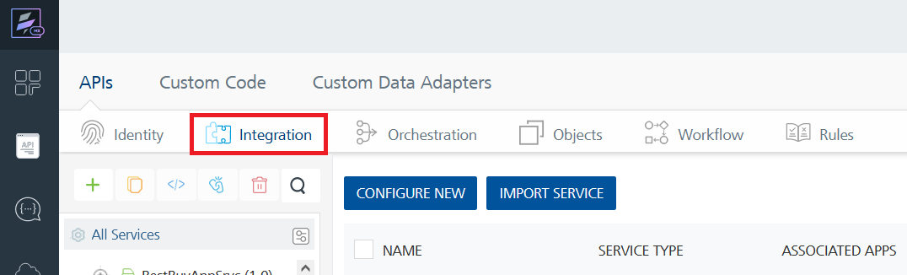
4. To create a new service, click the **+** button or the **CONFIGURE NEW** button.  
   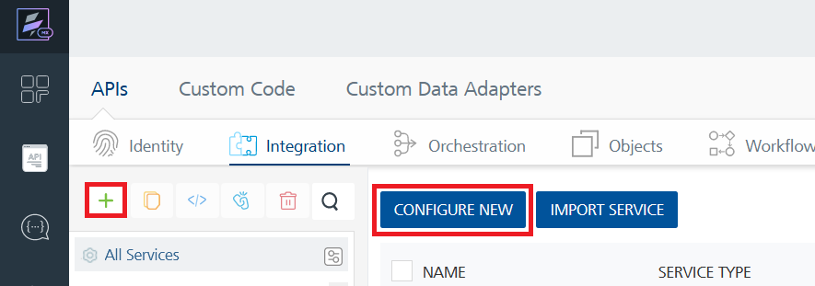
5. On the Service Definition tab, select the service type as **Email Verification** and click **SAVE**.  
   A screenshot of a computer

   Description automatically generated

Alternatively, you can also create a Foundry app and create an Integration service inside it.

E. [Creating and Executing operations](javascript:void(0);)



After you create an integration service, you can create and execute operations using the service.

#### Creating an Operation

* In **API Management/Foundry app you created**, in the **Integration** section, select the service that you created.
* After you select the service, navigate to the **Operation List** tab.  
  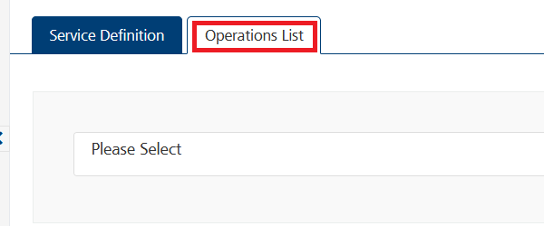
* From the drop-down list, select an operation that you want to execute, and click **ADD OPERATION**.  
  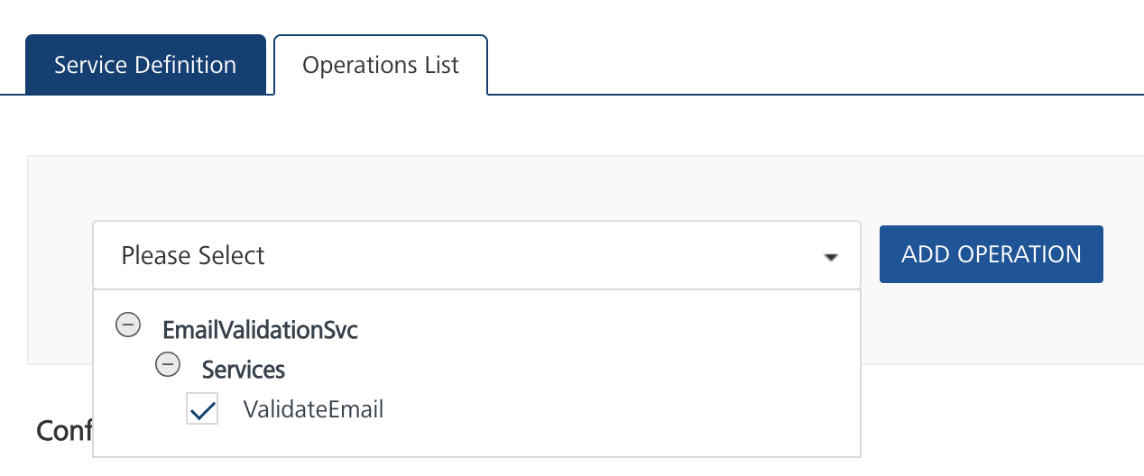

#### Executing an Operation

* From the **Operations List** tab, in the **Configured Operations** section, select the operation you want to execute.  
  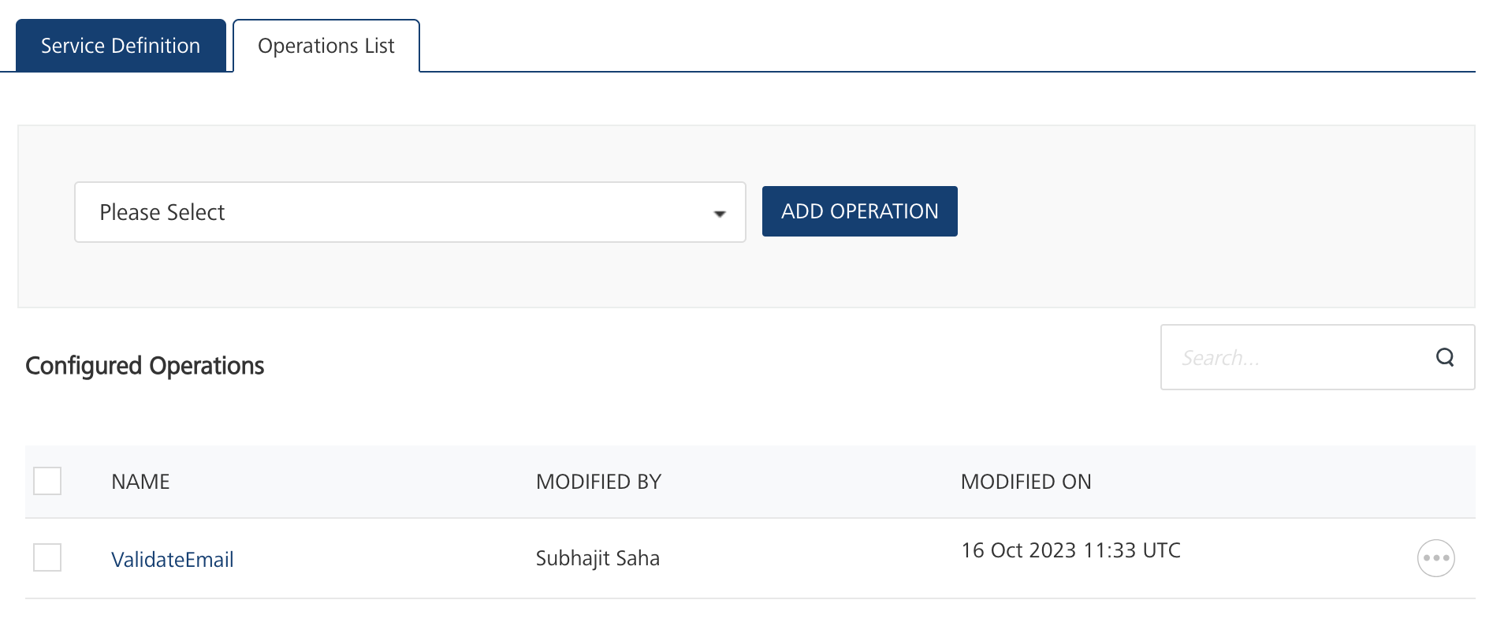
* On the Operation Page, in the Request Input tab, enter a TEST VALUE for all the fields under Body.  
  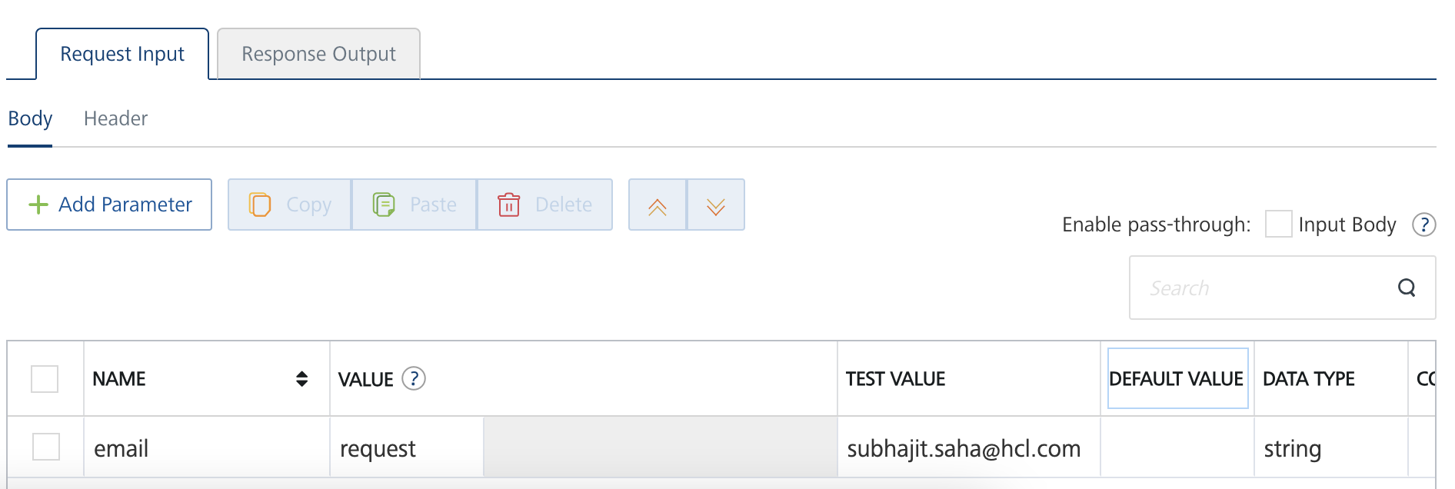
* Under the Header tab, add ***your APIKey*** as value of the key “apikey”. To get your APIKey, go to <https://apilayer.com/account>.

Ignore the “Accept” key or delete.

* Select a run-time environment and click **Save and Fetch Response** to get a response based on your inputs.  
  A blue rectangle with a black arrow

  Description automatically generated

## [Publishing your application](javascript:void(0);)

If you want to use the services in client applications, you need to publish an app to a run-time environment. You can create the service (as described above) in an application or import the service into an application and publish the application.

# References

## API Documentation: Email Verification API documentation can be found at <https://apilayer.com/marketplace/email_verification-api>

# Revision History

|  |  |  |  |
| --- | --- | --- | --- |
| Version | Date Uploaded | Uploaded By | Known Issues |
| 1.0.0 | 16-Oct-23 | Subhajit Saha (HCL Software) | - |