Date: 08-Feb-2024

Doughnut Chart - Full Circle version: 1.1.1

Overview
Doughnut Chart - Full Circle is a Volt MX Iris component that creates a donut chart, based on the data that you provide. You can use the component in your mobile app to represent the comparison between distinct items or data in the form of donut. For example, a company's profit percentage on annual basis.
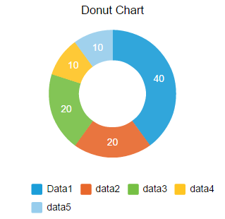

Use case:

Consider a scenario that you want to develop a mobile app to provide a company's sales information. In the app, you want to build a feature to represent a company's profit percentage over a few years in the form of donut. You can use the Donut Chart component to represent the profit percentage with respect to the years in the form of Donut chart.

You can also use the Donut Chart component to represent the department incomes.

Features:
- Ready-to-use Chart
- Useful component for project analysis
- Easy to plug into your app
- Facility to modify the UI

Percentage of re-use:
85%-90% (Data can be customizable and skins are customized and also can be changed manually).

Getting Started

Prerequisites
Before you start using the Doughnut Chart - Full Circle component, ensure you have the following:

- HCL Foundry
- Volt MX Iris

Platforms Supported

Mobile

iOS

Android

PWA

Importing the app
You can import the Forge components only into the apps that are of the Reference Architecture type.

To import the Doughnut Chart - Full Circle component, do the following:

- Open your app project in Volt MX Iris.
- In the Project Explorer, click the Templates tab.
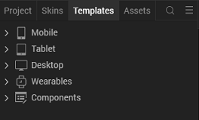

- Right-click Components, and then select Import Component. The Import Component dialog box appears.
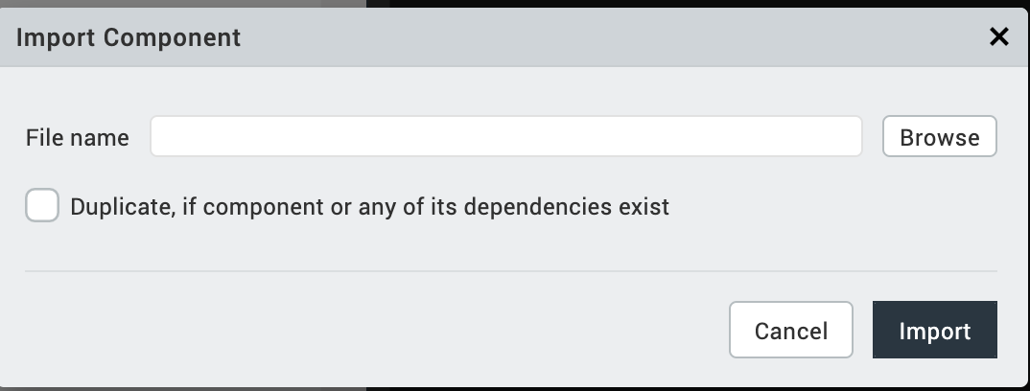

- Click Browse to navigate to the location of the component, select the component, and then click Import. The component and its associated widgets and modules are added to your project.

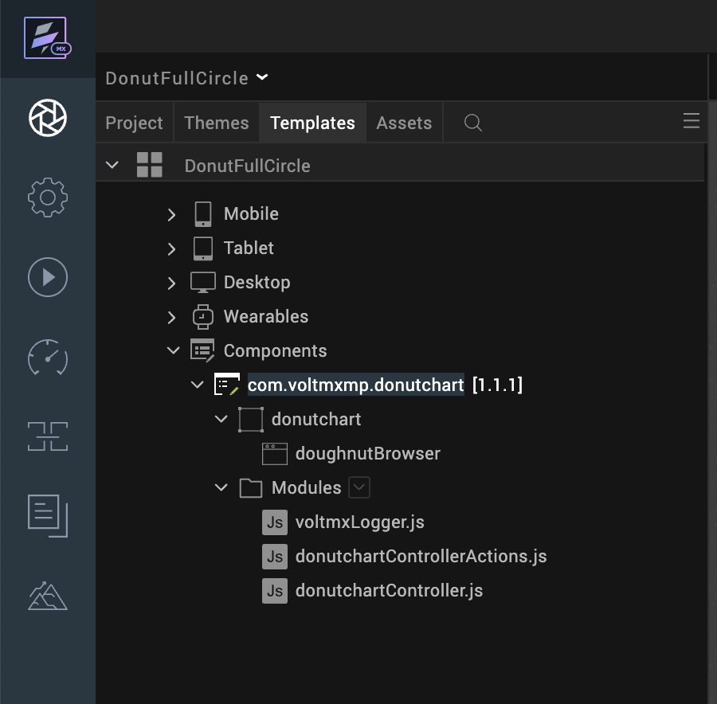

Once you have imported a component to your project, you can easily add the component to a form. For more information, refer Add a Component to a Form.
After adding a component to a form, you can configure the component the way you want it using the Look, Skin, and Action tabs on the Properties pane. Configuring the properties on the Properties pane is like configuring the properties of any widget in VoltMX Iris.
You can also see that a new tab, Component, is added on the Properties pane. The Component tab contains assorted properties relevant to the component that allow you to customize the component as required. The properties on the Component tab are categorized as General, Legends, and Title properties. The General properties are the default properties of individual widgets in the component.

References

Dynamic Usage
You can also add a Doughnut Chart - Full Circle component dynamically. To do so:
- In the Project Explorer, on the Projects tab, click Controllers section to access the respective formController. Create a method and implement the code snippet similar to the sample code mentioned below.
/* Creating the component s object */
var donutchart = new com.voltmxmp.donutchart(

{

"clipBounds": true,

"id": "donutchart",

"height": "100%",

"width": "80%",

"top": "0%",

"left": "0%",

"isVisible": true,

"centerX": "50%",

"zIndex": 1

}, {}, {});

/* Setting the component s properties */

donutchart.bgColor = "#FFFFFF";

donutchart.enableChartAnimation = true;

donutchart.enableStaticPreview = true;

donutchart.chartData =

{

"data":

[

{"colorCode": "#1B9ED9", "label": "Data1", "value": "40"},

{"colorCode": "#E8672B", "label": "Data2", "value": "20"},

{"colorCode": "#76C044", "label": "Data3", "value": "20"},

{"colorCode": "#FFC522", "label": "Data4", "value": "10"},

{"colorCode": "#97CDED", "label": "Data5", "value": "10"}

]

};

donutchart.enableLegend = true;

donutchart.legendFontColor= "#000000";

donutchart.legendFontSize= "8";

donutchart.chartTitle = "Donut Chart Full Circle";

donutchart.titleFontColor = "#000000";

donutchart.titleFontSize = 12;

/* Adding the component to the form */

this.view.add(donutchart);

In the code snippet, you can edit the properties of the component as per your requirement.
- Save the file.

Properties
The properties provided on the Component tab allow you to customize the UI elements in the Doughnut Chart - Full Circle component. You can set the properties directly on the Component tab or dynamically through code. This section provides information on how to set the properties dynamically through code.
- General

Background Color
Description: | Specifies background color of the chart.
Syntax: | bgColor
Type: | String
Read/Write: | Write
Example: | this.view.componentID.bgColor= "#FFFFFF";

Enable Chart Animation
Description: | Controls whether or not to enable the chart animation.
Syntax: | enableChartAnimation
Type: | Boolean
Read/Write: | Write
Remarks: | Disabling the chart animation will also disable the grid animation.
Example: | this.view.componentID.enableChartAnimation= true;

Chart Data
Description: | Enables a user to provide the data to generate the chart.
Syntax: | chartData
Type: | Data Grid
Read/Write: | Write
Remarks: | The property is static and cannot be assigned dynamically.

Enable Chart with Static Data
Description: | Specifies whether or not the chart should render in the data grids, with the given data.
Syntax: | enableStaticPreview
Type: | Boolean
Read/Write: | Write
Example: | this.view.componentID.enableStaticPreview = true;
- Legends

Enable Legends
Description: | Controls whether or not to enable the chart grid.
Syntax: | enableLegend
Type: | Boolean
Read/Write: | Write
Example: | this.view.componentID.enableLegend= true;

Legend Font Color

Description: | Specifies the font color of the Chart legend.
Syntax: | legendFontColor
Type: | String
Read/Write: | Write
Remarks: | The default value of the property is "#000000".
Example: | this.view.componentID.legendFontColor= "#000000";

Legend Font Size

Description: | Specifies the font size of the Chart legend.
Syntax: | legendFontSize
Type: | String
Read/Write: | Write
Remarks: | The default value of the property is "8".  The maximum and minimum recommended values are 12 and 8 respectively for better UI.
Example: | this.view.componentID.legendFontSize= "8";
- Title

Chart Title
Description: | Specifies the text to be displayed as the Chart title.
Syntax: | chartTitle
Type: | String
Read/Write: | Write
Example: | this.view.componentID.chartTitle = "Donut Chart";

Title Font Size
Description: | Specifies the font size of the Chart title.
Syntax: | titleFontSize
Type: | String
Read/Write: | Write
Example: | this.view.componentID.titleFontSize= "12";

Title Font Color
Description: | Specifies the font color of the Chart title.
Syntax: | titleFontColor
Type: | String
Read/Write: | Write
Example: | this.view.componentID.titleFontColor = "#000000";

Events
-- None of the events are exposed.

API’s
The following API pertains to the Doughnut Chart - Full Circle component.

createChart
The API creates a Donut Chart.
Syntax
createChart(data)
Parameters
data:
JSON array contains the data based on which the Donut Chart is generated. The JSON array should contain data of label names and the corresponding values to generate Donut Chart, in the key-value pair format. Here is the JSON array format:
var data =
[
{"colorCode": "#1B9ED9", "label": "data1", "value": "25"},
{"colorCode": "#76C044", "label": "data2", "value": "20"}
];
In the above format, label, value, colorCode are keys and they are case sensitive.
- label: The key accepts string values, so define the value within the qoutation marks. You can specify upto 04 characters as a column name. For example, "data1". Specifying more than 04 characters results distortion in the component UI.
- value: The key accepts integer values.
- colorCode: The key accepts color codes. The value of the key must be a 6-character Hex color code preceded by the number sign (#).
The component can conveniently handle a maximum of 07 key-value pairs in the JSON array. Defining more than 07 key-value pairs results distortion in the component UI.
Return Value
None
Example
var chartData =
[
{colorCode: "#f0f1f2", label: "Jan", value: 12},
{colorCode: "#f0f1f2", label: "Feb", value: 5}
];
this.view.componentID.chartData={data: chartData};
this.view.componentID.createChart(chartData);

Revision History
App version 1.1.1

Known Issues
Following are the known issues in the Doughnut Chart - Full Circle component:
- On Android, when adding the component dynamically, the layout of the component does not show up as expected.
- Cannot handle layout properties of the component as per the device orientation. You must handle the properties at the form level.
- If single data value is passed the data label is not visible if the background color is white.

Limitations
Following are the limitations in the Doughnut Chart - Full Circle component:
- The length of the data passed to the chart should be between one and seven. Exceeding the limit leads to UI distortions.

