Date : 26-Mar-24

DIALOGFLOW

version: 2.0.2

1.OVERVIEW
DialogFlow is a natural language understanding and machine learning platform that makes it easy for developers (and non-developers) to design and integrate intelligent and sophisticated conversational user interfaces into mobile apps, web applications, devices, and bots that continuously improve over time automatically. This Data Adapter lets you integrate the capabilities of DialogFlow into your Mobile application. Use this adapter to create delightful user interactions.

A.Use case:
You can use the Dialogflow Data Adapter to integrate with various types of applications like Customer support chatbot, voice assistant, Appointment Scheduling, room booking.

B.Percentage of re-use:
70% (Data can be customizable and customers need to implement UI by themselves).

2.GETTING STARTED

A.Prerequisites
Before you start using the Dialogflow data adapter, ensure you have the following:

- HCL Foundry

B.Importing the Adapter
To import the Data Adapter to Volt Foundry, do the following:
- Sign in to the HCL Foundry.
- From the left navigation menu, select API Management.
- In API Management, select Custom Data Adapters.
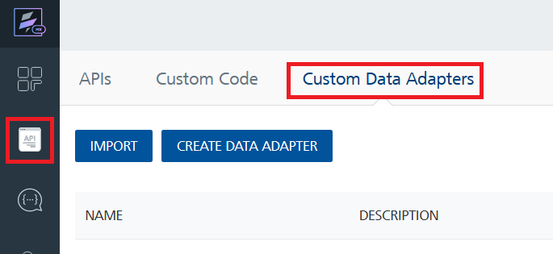
- Click IMPORT to import a custom data adapter.
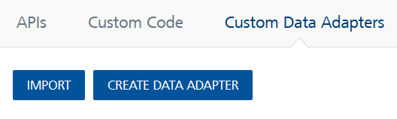
- On the Import Data Adapter dialog box, click browser to import.
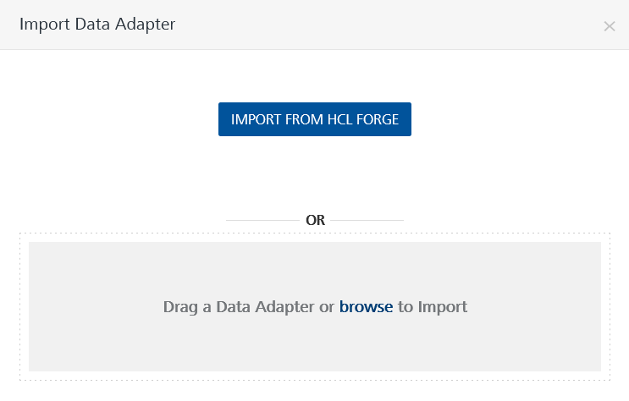
- Select Dialogflow data adapter zip file and click IMPORT.
After importing the data adapter, Volt Foundry opens a window that shows the metadata of the data adapter.

After you import the data adapter, you can view it on the Custom Data Adapters page and use it to create services on Volt Foundry.
After you add the data adapter to your Volt Foundry app. You can refer to below section for more information.
Follow the given steps to train your chatbot in Dialog Flow
1. Go to DialogFlow portal
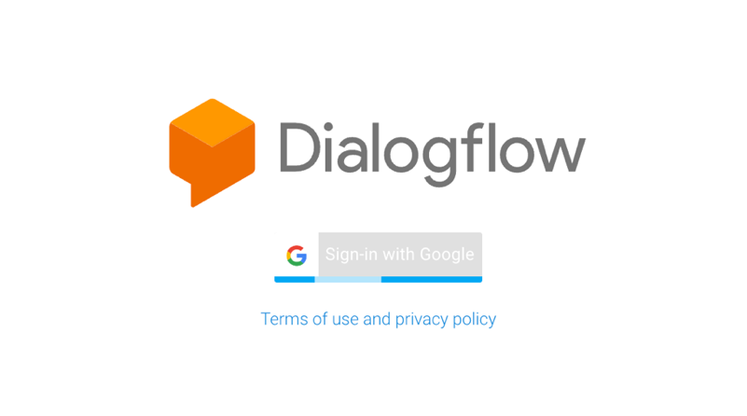
2. Click on create agent
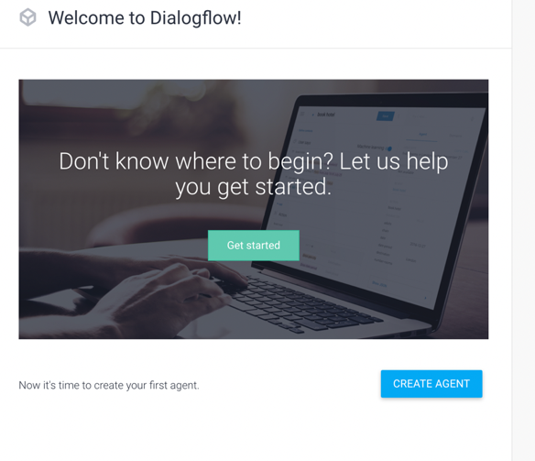
3. After creating agent, Train your bot with intents, entities according to your requirement for your chatbot
4. In the Integrations, click on web demo

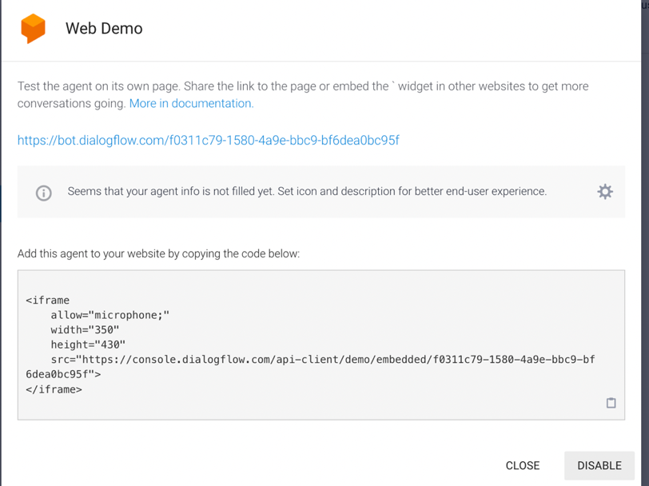

5. click on the link appear on the above screenshot and check whether your bot trained
6. After that click on gear icon (beside your agent name)
i. Go to General, click on projectID NAME, you will be redirecting to google cloud.
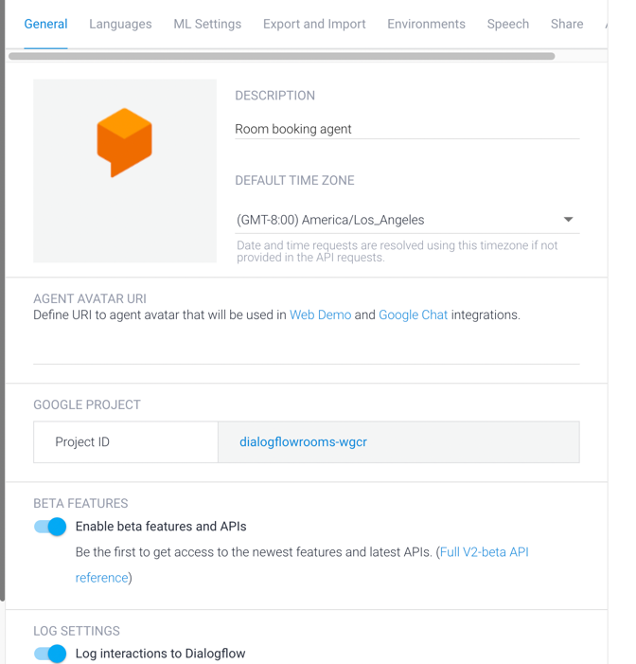
ii. There we need to go to API &Services and create an API key there after one .json file will be downloaded after creation of API key.for reference checkout -> CREATIONOFAPIKEY
iii. Go to Export and Import first export the .zip file and again import the same .zip file
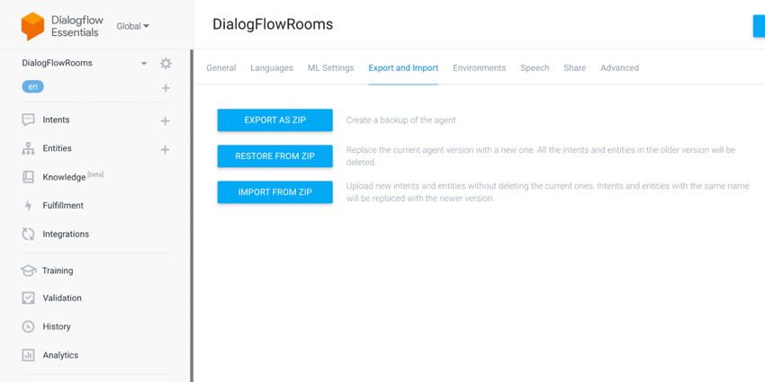

iv. Go to Environments and click on PUBLISH A VERSION
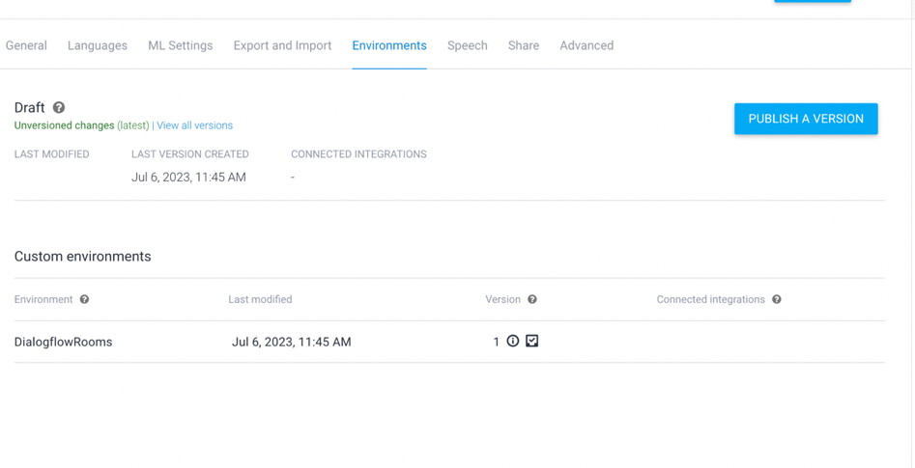

C.Creating an Identity Service
After you import the data adapter into Volt Foundry, you can use it to create an Identity Service. Select User Repository as type of Identity and click on add user.
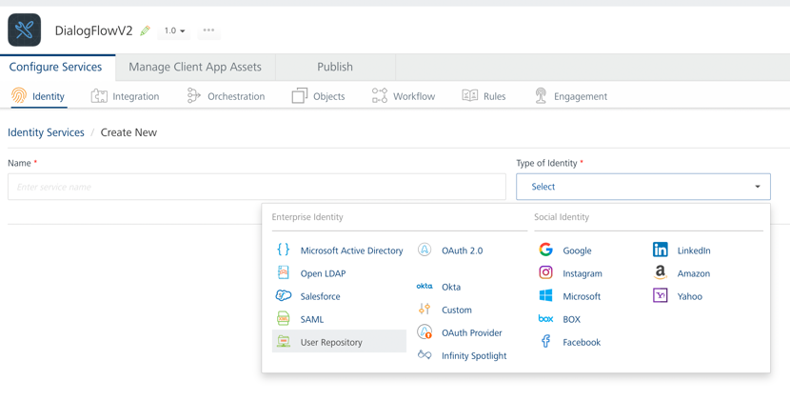

D. Creating an Integration Service
After creating the Identity service Volt Foundry, you can use it to create an Integration Service.
Follow the given steps to create an Integration service using the DAILOGFLOW Data Adapter.
- Sign in to the HCL Foundry.
- From the left navigation menu, select API Management.
- In API Management, select Integration.
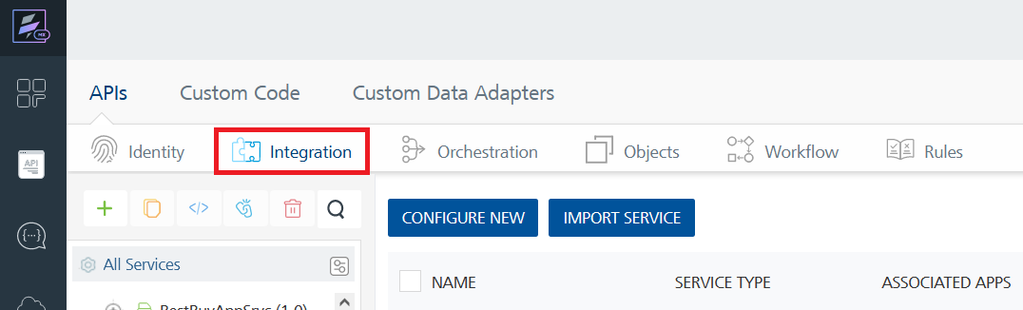
- To create a new service, click the + button or the CONFIGURE NEW button.
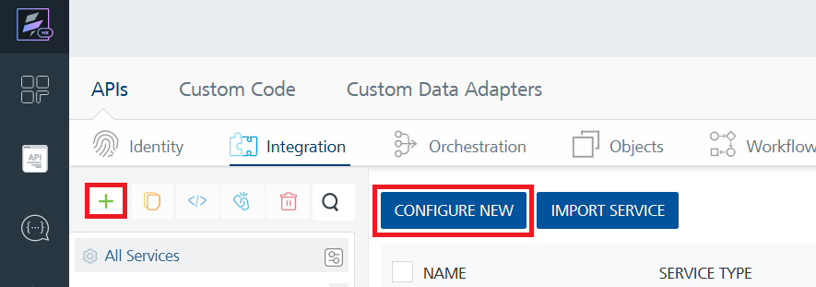
- On the Service Definition tab, select the service type as DAILOGFLOW, and click SAVE.
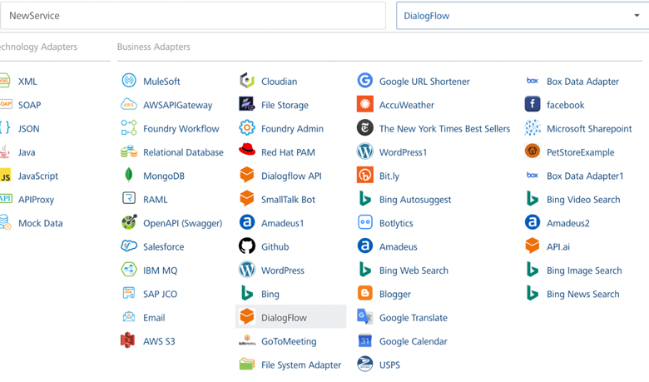

E. Creating and Executing operations
After you create an integration service, you can create and execute operations using the service.

1.Creating an operation
- In API Management, in the Integration section, select the service that you created.
- After you select the service, navigate to the Operation List tab.
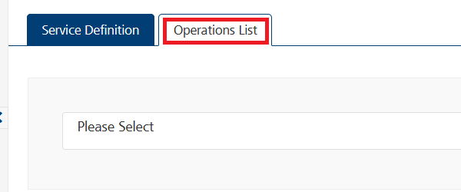
- From the drop-down list, select an operation that you want to execute, and click ADD OPERATION.
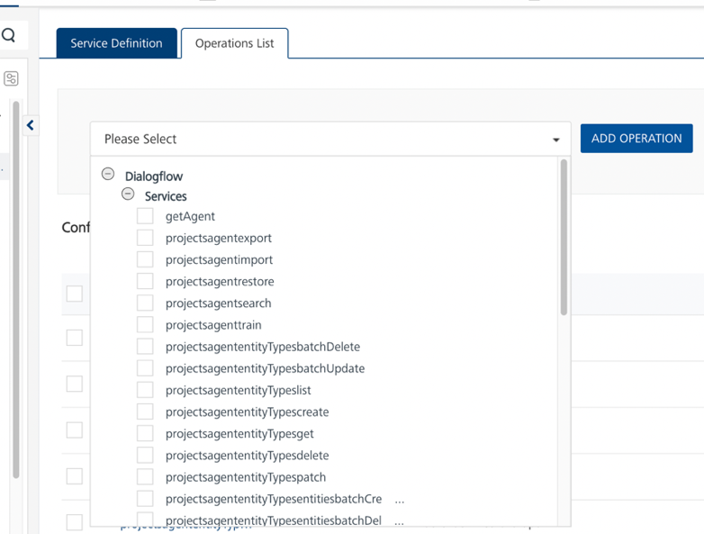
4.In Dialog flow we need two services to fetch our response.
i. First one, to generate an access token.
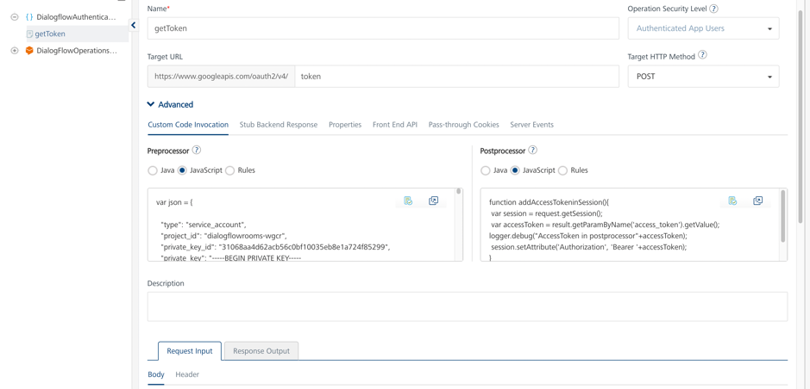
ii. In the preprocessor ->JavaScript add the .json file text which got above while creating API key.
iii. After that click on Save And Fetch Response,
iv. Below screenshot providing sample response output for Dialogflow authentication (i.e to generate access token).
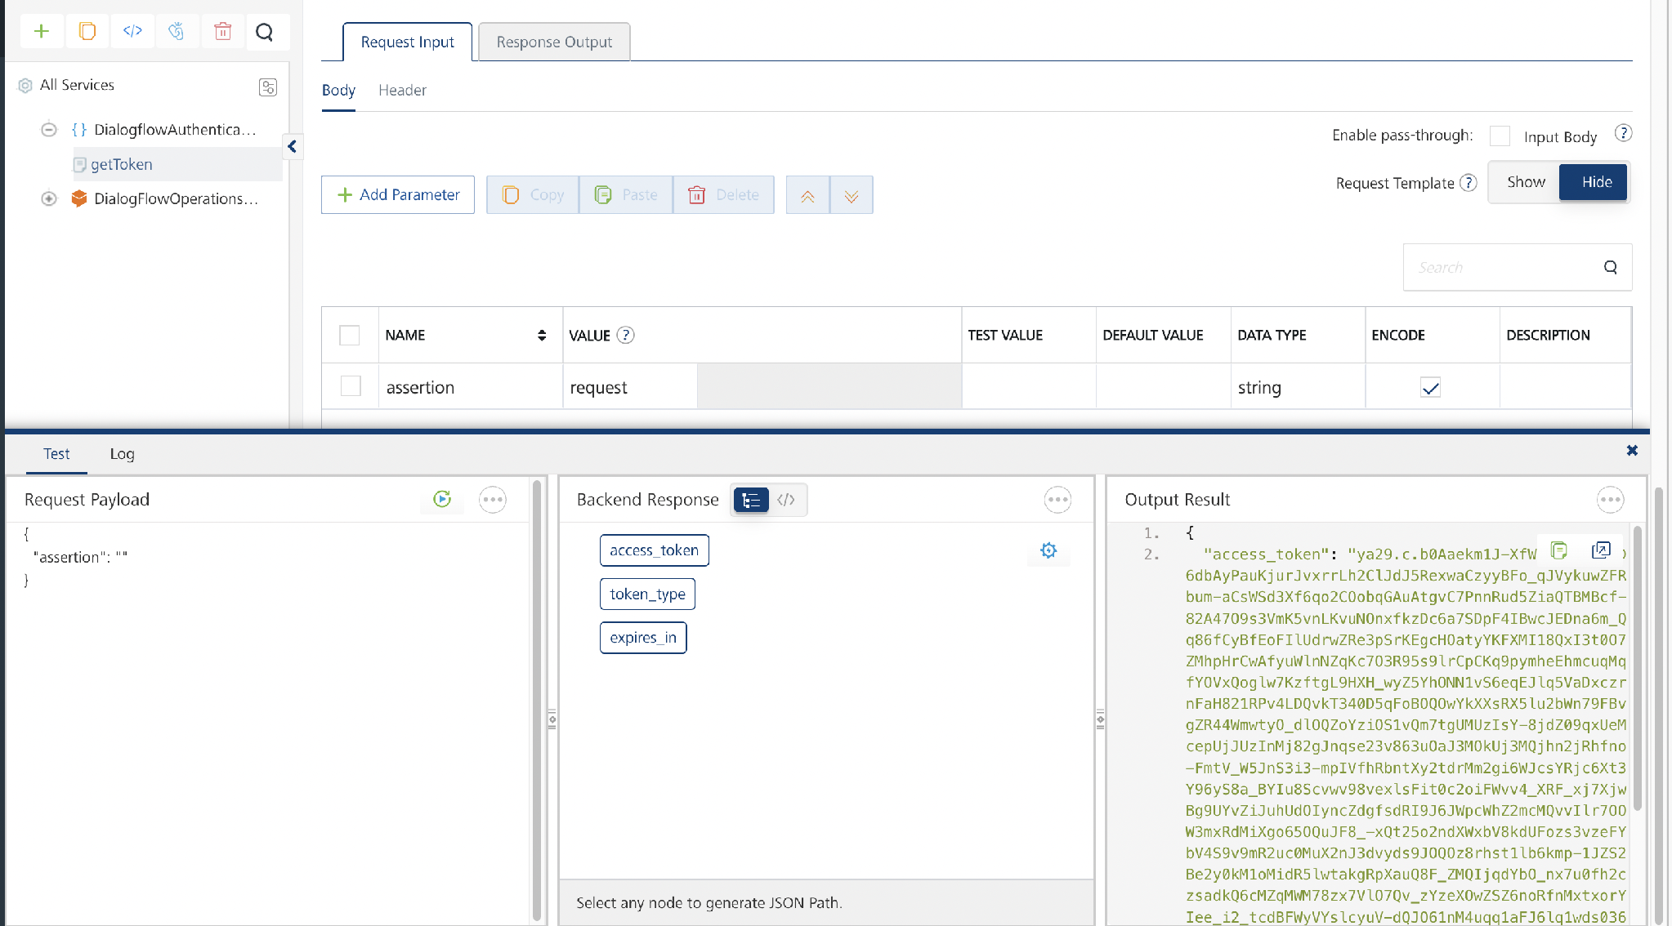
v. To fetch response from operations.

2. Executing an operation
  - From the Operations List tab, in the Configured Operations section, select the operation you want to execute.
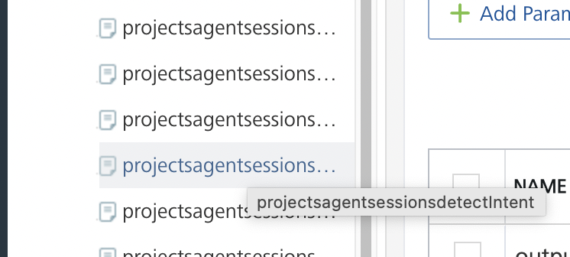
  - On the Operation Page, in the Request Input tab, enter a TEST VALUE for all the fields.
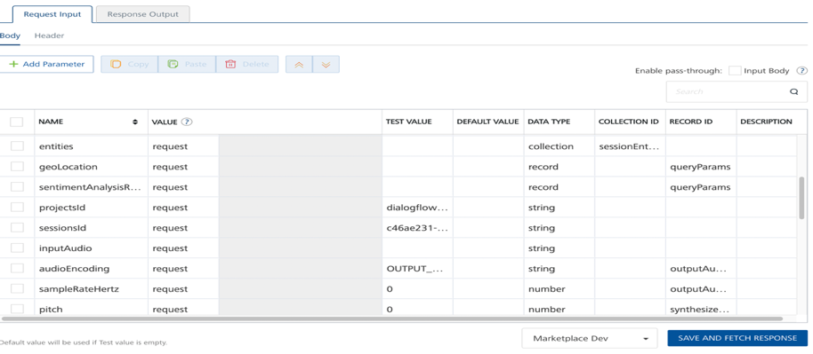
Reference:
Go to Method: projects.agent.environments.users.sessions.detectIntent | Dialogflow ES | Google Cloud and click on Try it present on righthand side of the screen
  - In the Header section, give Authorization as access token with token_type as “Bearer”
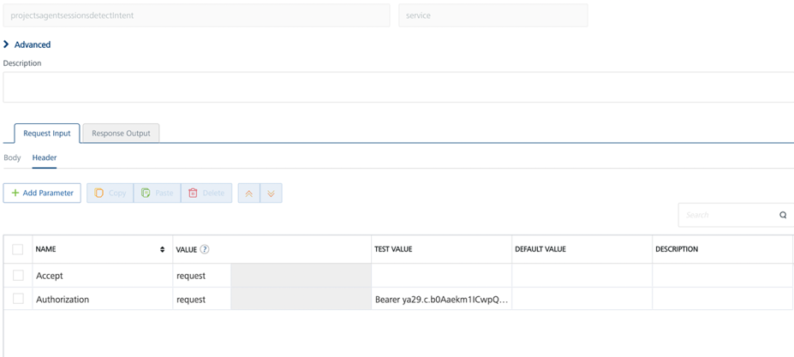

- Select a run-time environment and click Save and Fetch Response to get a response from DAILOGFLOW based on your inputs.
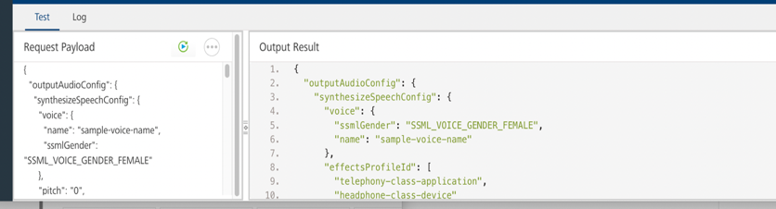

3.REFERENCES

Dynamic Usage
You need to configure the Request Input variables on Volt Foundry based on the operation you want to perform. You can refer to the following drop-down sections for sample requests and responses for the operations.

Dialogflowsessionsdetectintent

Description
You can use this operation to get a desired response.

Request Input Variables

Variable Name | Required/Optional | Description & Allowed Values
name | Required | Provide any voice name
ssmlGender | Required | speech synthesis gender for natural and lifelike conversational interactions
audioEncoding | Required | Converting spoken input into machine-readable format for accurate voice recognition.
text | Required | The text you want to give to chatbot to answer your query
languagecode | Required | chatbot's understanding and response language
entityOverrideMode | Required | chooses between user input and predefined values.
projectsId | Required | unique identification code to distinguish individual projects or applications within the platform
sessionsid | Required | allowing the system to distinguish and maintain context during conversational interactions
analyzeQueryTextSentiment | Required | evaluates the sentiment of input text.

Sample Request
{
"outputAudioConfig": {
"synthesizeSpeechConfig": {
"voice": {
"name": "sample-voice-name",
"ssmlGender": "SSML_VOICE_GENDER_FEMALE"
},
"pitch": "0",
"speakingRate": "0",
"volumeGainDb": "0",
"effectsProfileId": [
"telephony-class-application",
"headphone-class-device"
]
},
"audioEncoding": "OUTPUT_AUDIO_ENCODING_UNSPECIFIED",
"sampleRateHertz": "0"
},
"queryInput": {
"text": {
"text": "I want to book a room ",
"languageCode": "en"
}
},
"queryParams": {
"contexts": [
{
"name": "projects/dialogflowrooms-wgcr/agent/sessions/c46ae231-6585-445b-9a41-77f9f9d4a54a/contexts/my_context2",
"lifespanCount": "17"
}
],
"sessionEntityTypes": [
{
"entities": [
{
"value": "sample-entity-value",
"synonyms": [
"synonym1",
"synonym2"
]
}
],
"name": "projects/dialogflowrooms-wgcr/agent/sessions/9d5df4b2-2fa1-43a8-b3d5-b728c3934420/entityTypes/heyhola",
"entityOverrideMode": "ENTITY_OVERRIDE_MODE_OVERRIDE"
}
],
"geoLocation": {
"latitude": "45.67",
"longitude": "45.89"
},
"sentimentAnalysisRequestConfig": {
"analyzeQueryTextSentiment": "false"
},
"resetContexts": "false",
"timeZone": "America/Los_Angeles"
},
"projectsId": "dialogflowrooms-wgcr",
"sessionsId": "c46ae231-6585-445b-9a41-77f9f9d4a54a",
"inputAudio": ""
}

Sample Response

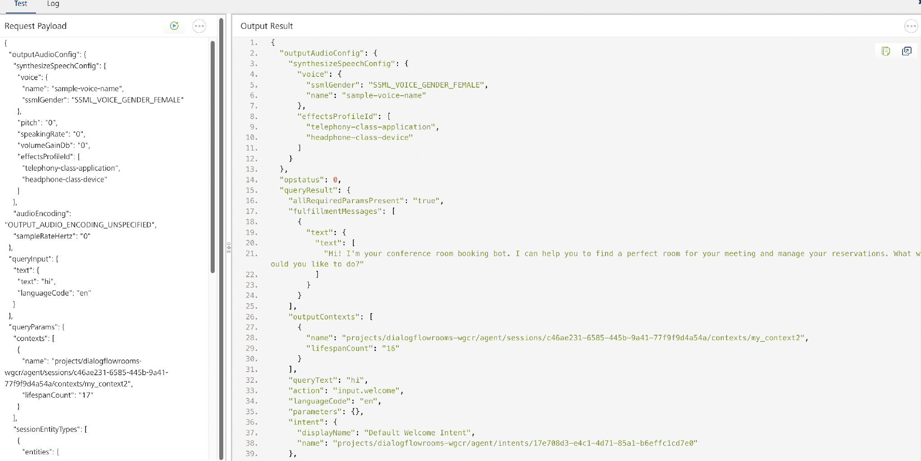
{
"outputAudioConfig": {
"synthesizeSpeechConfig": {
"voice": {
"ssmlGender": "SSML_VOICE_GENDER_FEMALE",
"name": "sample-voice-name"
},
"effectsProfileId": [
"telephony-class-application",
"headphone-class-device"
]
}
},
"opstatus": 0,
"queryResult": {
"fulfillmentMessages": [
{
"text": {
"text": [
"In what city would you like to reserve a room?"
]
}
}
],
"outputContexts": [
{
"name": "projects/dialogflowrooms-wgcr/agent/sessions/c46ae231-6585-445b-9a41-77f9f9d4a54a/contexts/e8f6a63e-73da-4a1a-8bfc-857183f71228_id_dialog_context",
"lifespanCount": "2",
"parameters": {
"duration": "",
"date": "",
"time.original": "",
"location.original": "",
"guests.original": "",
"date.original": "",
"guests": "",
"location": "",
"time": "",
"duration.original": ""
}
},
{
"name": "projects/dialogflowrooms-wgcr/agent/sessions/c46ae231-6585-445b-9a41-77f9f9d4a54a/contexts/room_reservation_dialog_context",
"lifespanCount": "2",
"parameters": {
"duration": "",
"date": "",
"time.original": "",
"location.original": "",
"guests.original": "",
"date.original": "",
"guests": "",
"location": "",
"time": "",
"duration.original": ""
}
},
{
"name": "projects/dialogflowrooms-wgcr/agent/sessions/c46ae231-6585-445b-9a41-77f9f9d4a54a/contexts/room_reservation_dialog_params_location",
"lifespanCount": "1",
"parameters": {
"date": "",
"duration": "",
"time.original": "",
"location.original": "",
"guests.original": "",
"date.original": "",
"guests": "",
"location": "",
"time": "",
"duration.original": ""
}
},
{
"name": "projects/dialogflowrooms-wgcr/agent/sessions/c46ae231-6585-445b-9a41-77f9f9d4a54a/contexts/my_context2",
"lifespanCount": "17",
"parameters": {
"duration": "",
"date": "",
"time.original": "",
"location.original": "",
"guests.original": "",
"date.original": "",
"guests": "",
"location": "",
"time": "",
"duration.original": ""
}
},
{
"name": "projects/dialogflowrooms-wgcr/agent/sessions/c46ae231-6585-445b-9a41-77f9f9d4a54a/contexts/__system_counters__",
"lifespanCount": "1",
"parameters": {
"duration": "",
"date": "",
"time.original": "",
"location.original": "",
"no-input": "0",
"guests.original": "",
"no-match": "0",
"date.original": "",
"guests": "",
"location": "",
"time": "",
"duration.original": ""
}
}
],
"queryText": "I want to book a room",
"action": "room.reservation",
"languageCode": "en",
"parameters": {
"duration": "",
"date": "",
"guests": "",
"location": "",
"time": ""
},
"intent": {
"displayName": "room.reservation",
"name": "projects/dialogflowrooms-wgcr/agent/intents/e8f6a63e-73da-4a1a-8bfc-857183f71228"
},
"fulfillmentText": "In what city would you like to reserve a room?",
"intentDetectionConfidence": "1"
},
"responseId": "d23e9fe1-cc0e-4c01-8f78-b45d5523c5bc-75295053",
"httpStatusCode": 200
}
}

PUBLISHING YOUR APPLICATION
After adding the Dialogflow Data Adapter to your app and configuring the necessary configurations, you must publish the app to VoltMX Foundry. For more information, refer to Publish a Project to VoltMX Foundry.
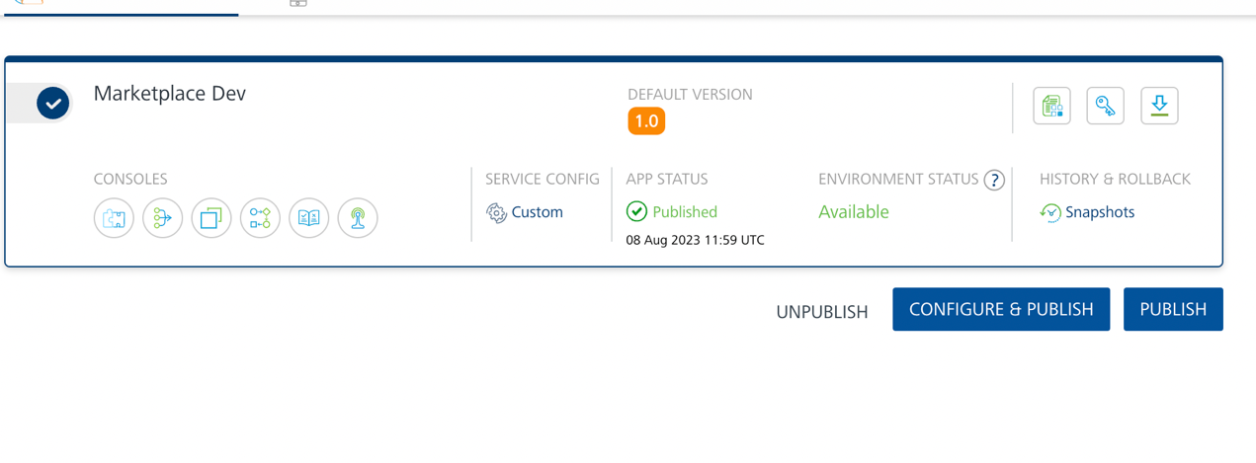

4. REVISION HISTORY
App version 2.0.2:

A. Known Issues
None

B. Limitations
- Limited support for languages, complex context handling, manual training, restricted customization, dependency on internet connectivity, potential privacy concerns.

