2nd May 2023

TextBOx component (1.0.o)

Overview
TextBox component is a Iris component that creates a Texbox with copy/paste options disabled and keyboard suggestions removal. Along with that Textbox component will support all the regular features same like Kony Textbox widget.

A. Use case
Consider a scenario that you want to have a Textbox which must restrict the copy/paste options. Since this is not supporting by the Kony Textbox widget, this component would fulfil that feature.

B. Percentage of re-use:
Approximate 90% of reuse. It sets an expectation of how much can be used out of the box, and how much needs to be customized for a specific app.

C. Features

- The component utilizes native methods to prevent the copy/paste options.
- It supports only Android
- Uses NFI 3.0

2. Getting Started

A. Prerequisites:
Before you start using the TextBox component, ensure the following:
• HCL Foundry
• Volt MX Iris

Platforms Supported

Mobile

Android

Tablets

Importing the app

You can import the Forge components only into the apps that are of the Reference Architecture type.

To import the Textbox component, do the following:

Open your app project in Volt MX Iris.
2. In the Project Explorer, click the Templates tab.
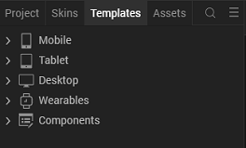
3.Right-click Components, and then select Import Component. The Import Component dialog box appears.
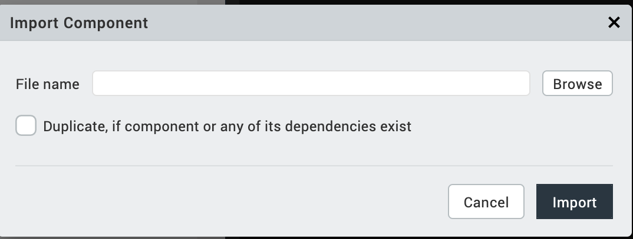
4.Click Browse to navigate to the location of the component, select the component, and then click Import. The component and its associated widgets and modules are added to your project.

Once you have imported a component to your project, you can easily add the component to a form. For more information, refer Add a Component to a Form

Building and previewing the app
After performing all the above steps, you can build your app and run it on your device. For more information, you can refer to the Building and Viewing an Application section of the Volt MX User Guide.
You can then run your app to see the Barcode/QR code Scanner work in real time.

3. References

1. Dynamic Usage:

You can also add TextBox component dynamically. To do so,

1. In the Project Explorer, on the Projects tab, click Controllers section to access the respective Form Controller. Create a method and implement the code snippet similar to the sample code mentioned below.

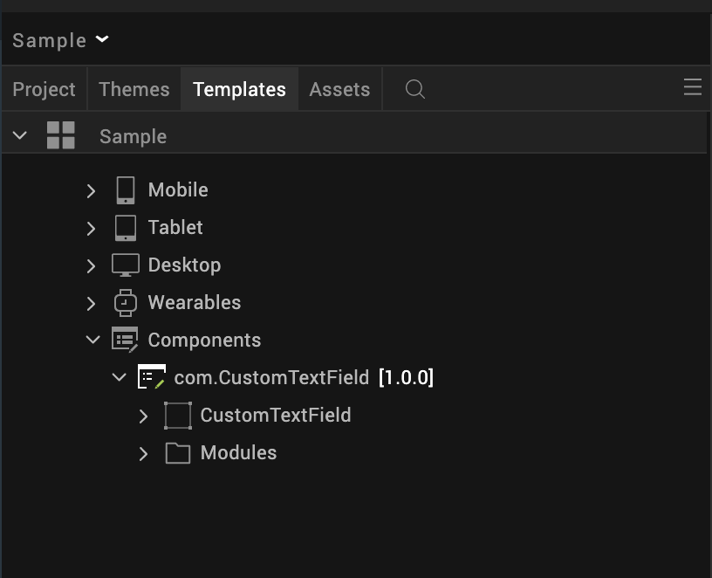

/* Creating CuustomTextField component instance */

var CustomTextField = new com.CustomTextField ({
"height": "50%",
"id": “CustomTextField",
"isVisible": true,
"left": "0dp",
"masterType": constants.MASTER_TYPE_USERWIDGET,
"isModalContainer": false,
"skin": "slFbox",
"top": "0dp",
"width": "100%",
"zIndex": 1,
"overrides": {
" CustomTextField": {
"right": "viz.val_cleared",
"bottom": "viz.val_cleared",
"minWidth": "viz.val_cleared",
"minHeight": "viz.val_cleared",
"maxWidth": "viz.val_cleared",
"maxHeight": "viz.val_cleared",
"centerX": "viz.val_cleared",
"centerY": "viz.val_cleared"
}
}
}, {
"overrides": {}
}, {
"overrides": {}
});

/*Adding the TextBox component to a Form*/

this.view.add(CustomTextField);
In the code snippet, you can edit the properties of the component as per your requirement. For more information, see Setting Properties.
2. Save the file

4.General Properties:

API

i. setHintAndText

Description: | Allows to set the hind and text.
Syntax: | setHintAndText(“Hint”, “Text”)
Parameters: | String – Hint, String - Text
Return Value: | None
Remarks: | NA.
Example: | this.view.CustomTextField.setHintAndText(“Hint”, “Text”);

ii. getText

Description: | Gives text entered in the Texbox.
Syntax: | getText()
Parameters: | None
Return Value: | None
Remarks: | NA.
Example: | this.view.CustomTextField.getText();

iii. setTextColor

Description: | Changes text color by accepting hex color string.
Syntax: | setTextColor(“hint color”)
Parameters: | String – Hint color
Return Value: | None
Remarks: | NA.
Example: | this.view.CustomTextField.setTextColor (“Hex text color”);

iv. setHintTextColor

Description: | Changes hint text color by accepting hex color string.
Syntax: | setHintextColor(“HEX Color String”)
Parameters: | String – hint Color
Return Value: | None
Remarks: | NA.
Example: | this.view.CustomTextField.setHintTextColor (“Hex text color”);

v. setTextLength
Description: | Restrict text length into method parameter number.
Syntax: | setTextLength(TextLength)
Parameters: | Int – text length
Return Value: | None
Remarks: | NA.
Example: | this.view.CustomTextField.setTextLength (TextSize);

vi. setInputType

Description: | Sets the input type for the textfield
Syntax: | setInputType(InputTypeConstant)
Parameters: | Int – input type constant
Return Value: | None
Remarks: | NA.
Example: | this.view.CustomTextField.setInputType(InputTypeConstant);

vii. dissmissKeyboard

Description: | Removes the presented keyboard
Syntax: | dissmissKeyboard()
Parameters: | NA
Return Value: | None
Remarks: | NA.
Example: | this.view.CustomTextField.dissmissKeyboard();

viii. setIMEOptions

Description: | Changes IME options for the Texbox
Syntax: | setIMEOptions (IME Constant)
Parameters: | Int – IMEI constants
Return Value: | None
Remarks: | NA.
Example: | this.view.CustomTextField.setIMEOptions (IMEConstant);

ix. setTextAlignment

Description: | Changes the text alignment
Syntax: | setTextAlignment(Alignment Value)
Parameters: | Int – Alignment value
Return Value: | None
Remarks: | NA.
Example: | this.view.CustomTextField.setTextAlignment (AlignmentValue);

x. setPadding

Description: | Modifies the padding for the Textfiled
Syntax: | setPadding(left, top, right, bottom)
Parameters: | Int – Padding values
Return Value: | None
Remarks: | NA.
Example: | this.view.CustomTextField.setPadding(left, top, right, bottom);

B. Events

i.OnDone

Description: | Enables a onDone callback..
Syntax: | registerOnDoneCallback(this.callback)
Parameters: | Function - callback
Return Value: | None
Remarks: | NA
Example: | onDoneAction() {  // Write on done logic  },  this.view.CustomTextField.registerOnDoneCallback(this.onDoneAction);

ii. OnTextChangeCallbackcallback

Description: | Enables a On Text Change callback.
Syntax: | registerOnTextChangeCallback(this.callback)
Parameters: | Function - callback
Return Value: | None
Remarks: | NA
Example: | onTextChange() {  // Write on onTextChangelogic  },  this.view.CustomTextField. registerOnTextChangeCallback(this.onTextChange);

App version 1.0.0:

Limitations

B. Known Issue

