Date :  20/10/2023

Deep L Translations (1.0.0)

# Overview

The DeepL translation adapter allows you to easily call the DeepL AI based translation tools, which will convert text and documents from multiple languages into other languages. You can define a glossary of languages which will allow you, with a single call to translate into multiple languages.

# Getting Started

## Prerequisites

* Volt Foundry
* Please register for your account with DeepL at <https://www.deepl.com>
* Make sure you choose the pick the tab for Developers as this will get you your API key.
* Once you are registered you can find your API Key in the Account tab of your Account page.

To use the API Key it is sent in the ‘Authorization’ header parameter as ‘DeepL-Auth-Key {your key}’

## Importing the adapter

**To import the Data Adapter to Volt Foundry, do the following:**

1. Sign in to the  [HCL Foundry](https://manage.hclvoltmx.com/).
2. From the left navigation menu, select **API Management**.
3. In **API Management**, select **Custom Data Adapters**.  
   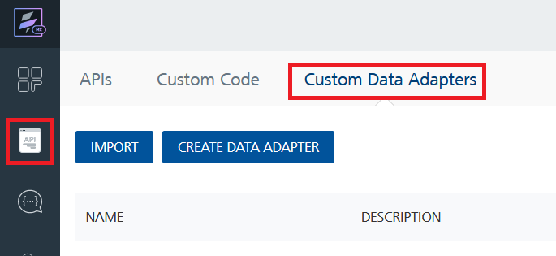
4. Click **IMPORT** to import a custom data adapter.  
   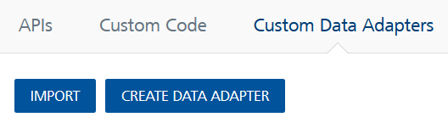
5. On the Import Data Adapter dialog box, click browser to import.  
   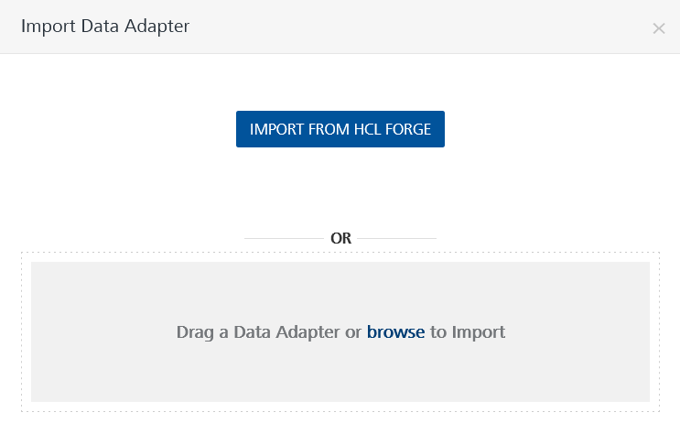
6. Select DeepLTranslations zip file and click **IMPORT**.

After you import the data adapter, Volt Foundry opens a window that shows the metadata of the data adapter.

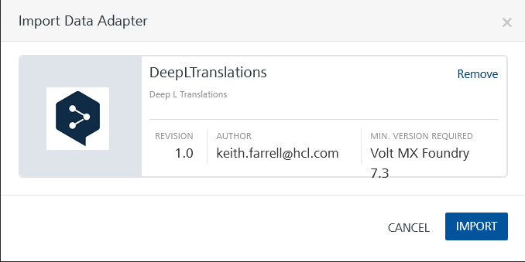

After you import the data adapter, you can view it on the Custom Data Adapters page and use it to create services on Volt Foundry.



## [Creating an Integration service](javascript:void(0);)

After you import the data adapter into Volt Foundry, you can use it to create an Integration Service.

Follow the given steps to create an Integration service using the DeepLTranslations Adapter.

1. Sign in to the [HCL Foundry](https://manage.hclvoltmx.com/).
2. From the left navigation menu, select **API Management**.
3. In **API Management**, select **Integration**.  
   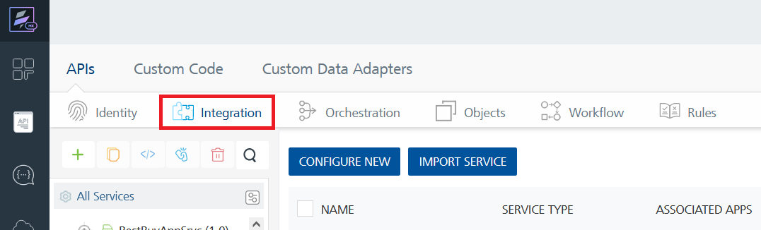
4. To create a new service, click the **+** button or the **CONFIGURE NEW** button.  
   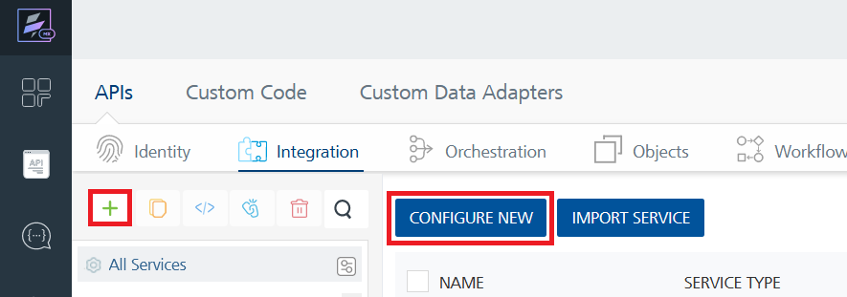
5. On the Service Definition tab, select the service type as DeepLTranslations and click **SAVE**.  
   A screenshot of a computer

   Description automatically generated

Alternatively, you can also create a Foundry app and create an Integration service inside it.

E. [Creating and Executing operations](javascript:void(0);)



After you create an integration service, you can create and execute operations using the service.

#### Creating an Operation

* In **API Management/Foundry app you created**, in the **Integration** section, select the service that you created.
* After you select the service, navigate to the **Operation List** tab.  
  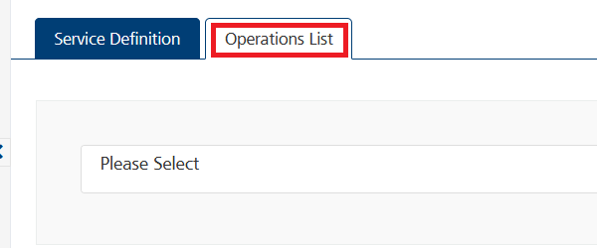
* From the drop down list, select an operation that you want to execute, and click **ADD OPERATION**.  
  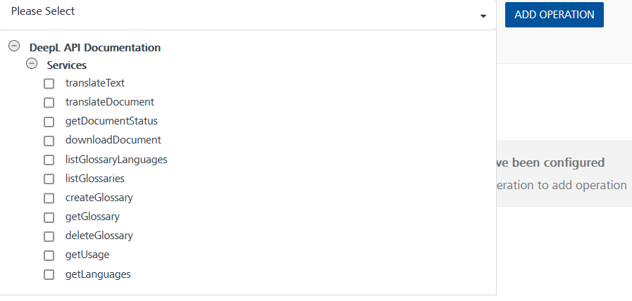

#### Executing an Operation

* From the **Operations List** tab, in the **Configured Operations** section, select the operation you want to execute.

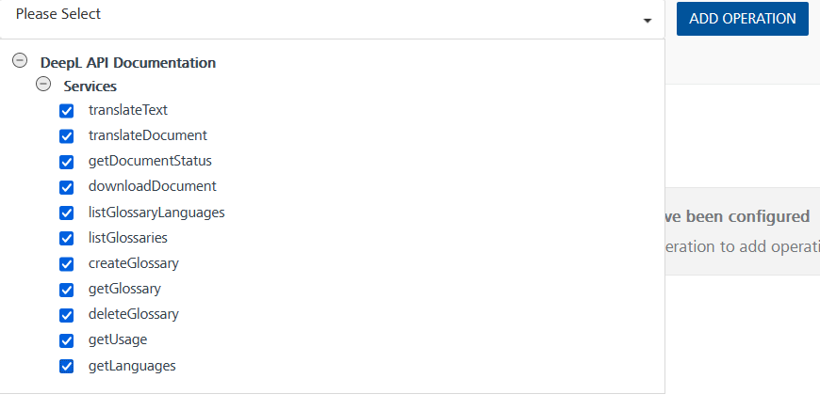

* On the Operation Page, in the Request Input tab, enter a TEST VALUE for all the fields.  
  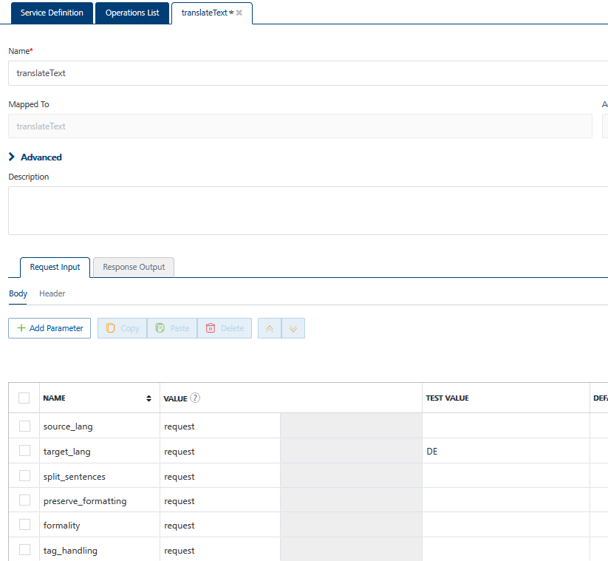



* Select a run-time environment and click **Save and Fetch Response** to get a response based on your inputs.  
  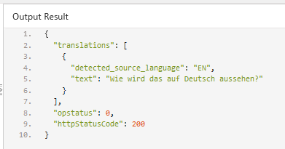

## [Publishing your application](javascript:void(0);)

If you want to use the services in client applications, you need to publish an app to a run-time environment. You can create the service (as described above) in an application or import the service into an application and publish the application.

# References

## Endpoint Documentation

## <https://www.deepl.com/docs-api/introduction> for API documentation.

## Adapter is automatically pointing at test account URL end-points, for fully paid accounts update the server URL to: <https://api.deepl.com/v2>

# Revision History

Adapter version 1.0.0:

## Known Issues

For the translateText operation, please remove the non_splitting_tags collection if it is not required for the test

## Limitations

translateDocument requires the uploaded document be sent with content type multipart/form-data, to perform this type of upload please follow the steps at: <https://opensource.hcltechsw.com/volt-mx-docs/docs/documentation/Iris/iris_api_dev_guide/content/httprequestobject.html#uploading-a-file>