Date : 19/10/2023

Bitly Adapter (1.0.0)

Overview
The Bitly adapter uses the Bitly.com rest APIs to generate and manage tiny URLs.

Getting Started

Prerequisites
- Volt Foundry
- In order to use the adapter you have to get an access key for the bitly.com site. Create an account and generate a free access-key. This will entitle you to produce 12 tiny URLs per month. Other paid plans are available.

The registration page to bitly.com to obtain an access key is available at the following URL:
https://bitly.com/pages/pricing

Importing the adapter
To import the Data Adapter to Volt Foundry, do the following:
- Sign in to the HCL Foundry.
- From the left navigation menu, select API Management.
- In API Management, select Custom Data Adapters.
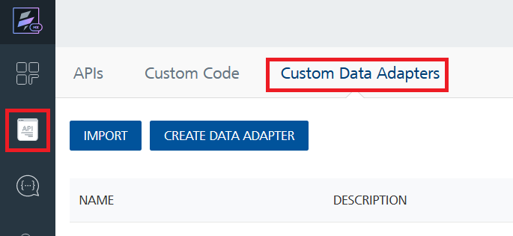
- Click IMPORT to import a custom data adapter.
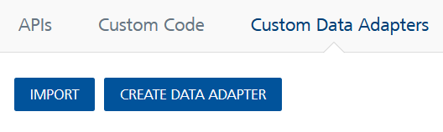
- On the Import Data Adapter dialog box, click browser to import.
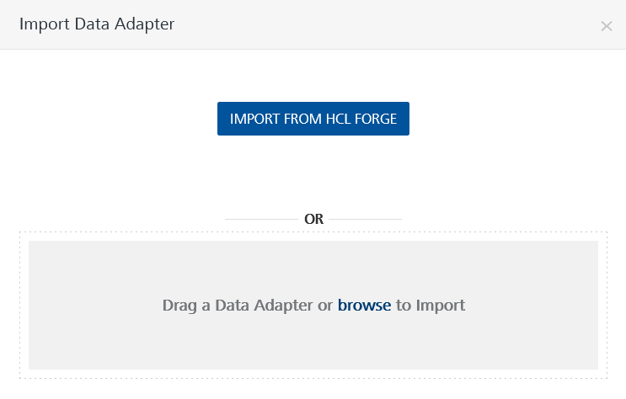
- Select bitly.zip file and click IMPORT.
After you import the data adapter, you can view it on the Custom Data Adapters page and use it to create services on Volt Foundry.

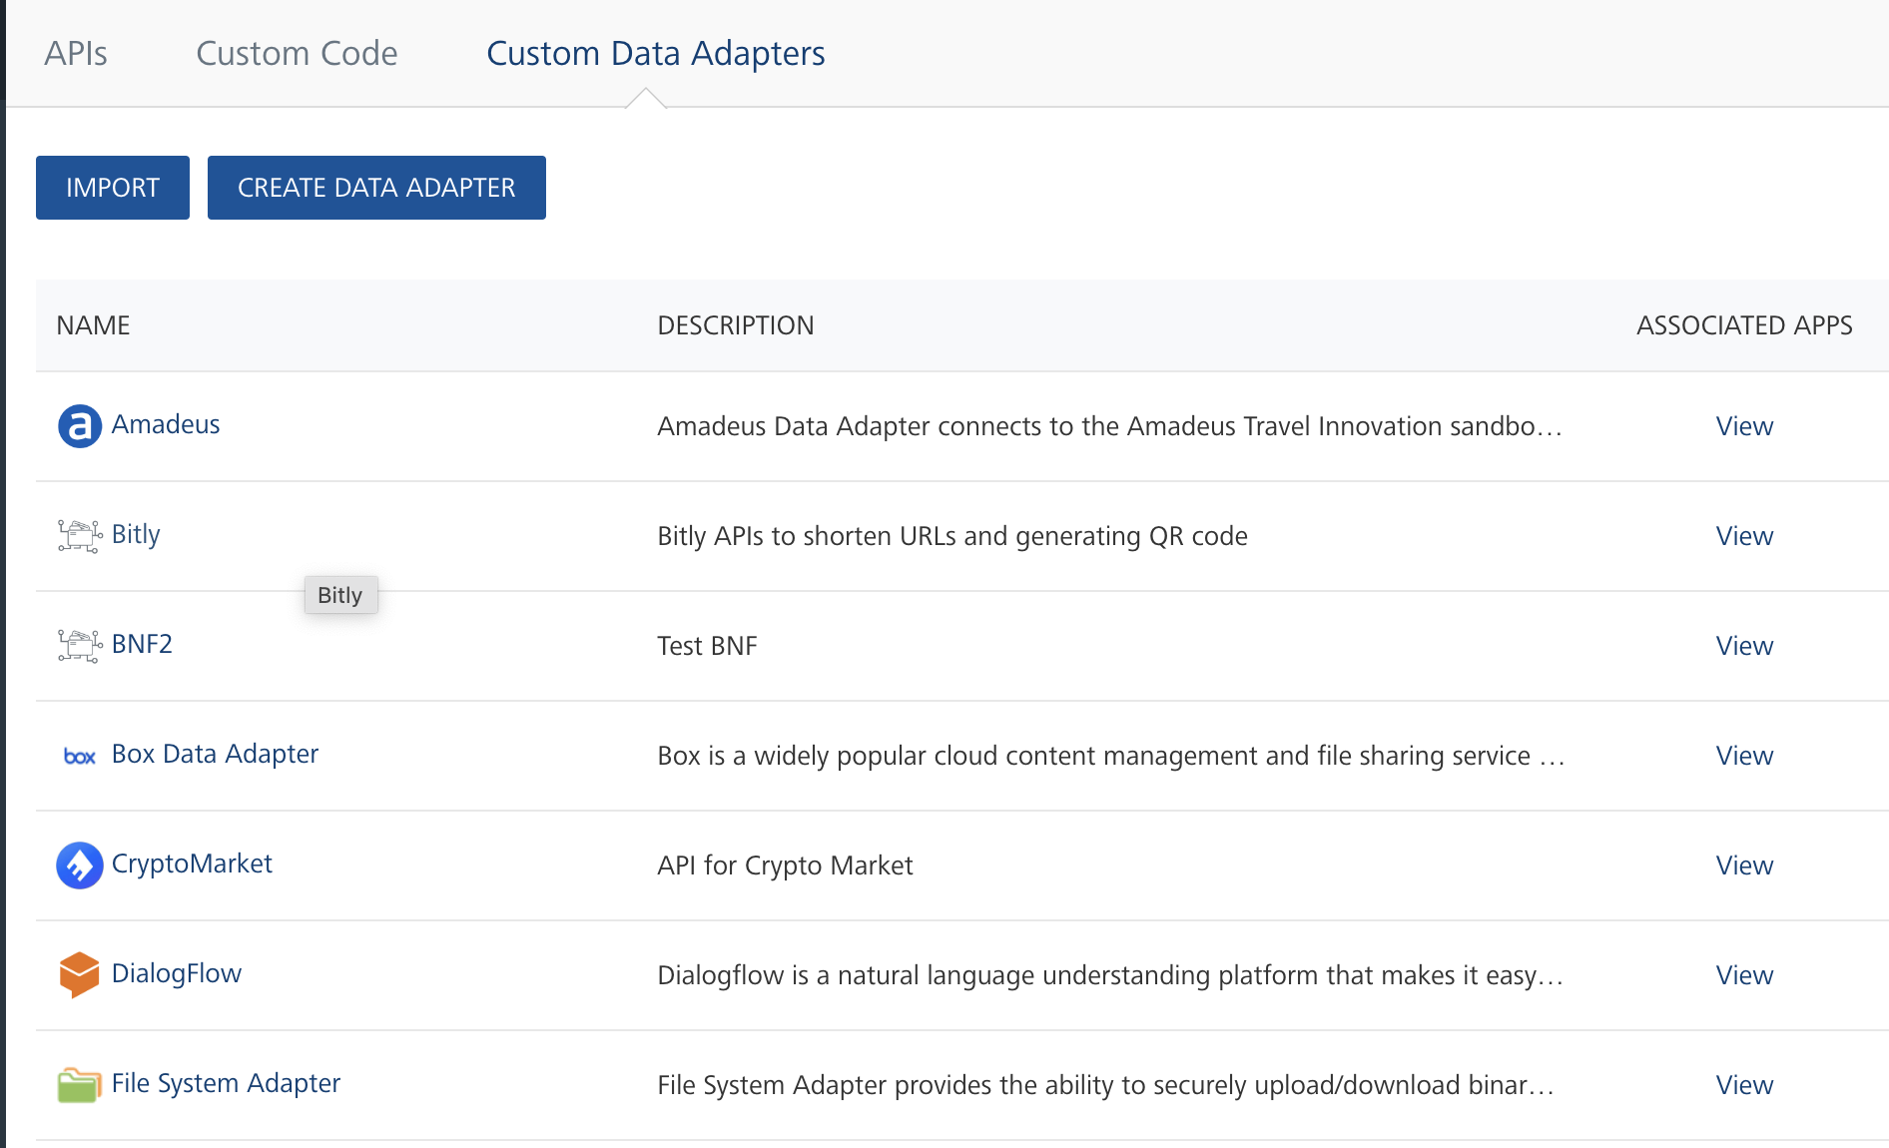Creating an Integration service
After you import the data adapter into Volt Foundry, you can use it to create an Integration Service.
Follow the given steps to create an Integration service using the Bitly Adapter.
- Sign in to the HCL Foundry.
- From the left navigation menu, select API Management.
- In API Management, select Integration.
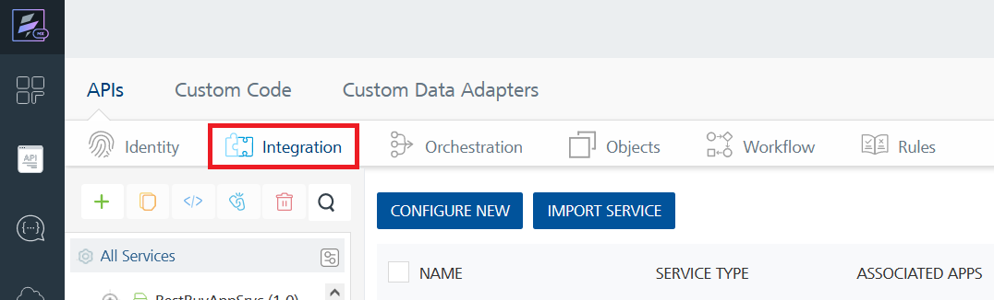
- To create a new service, click the + button or the CONFIGURE NEW button.
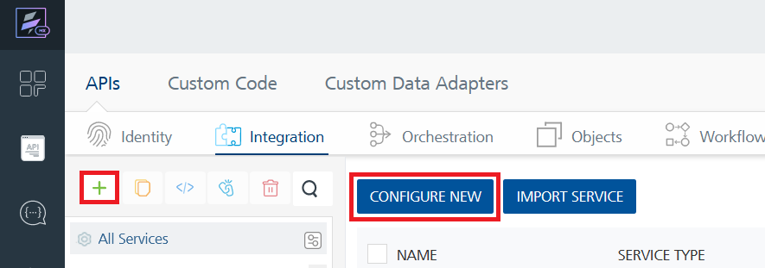
- On the Service Definition tab, select the service type as Bitly and click SAVE.
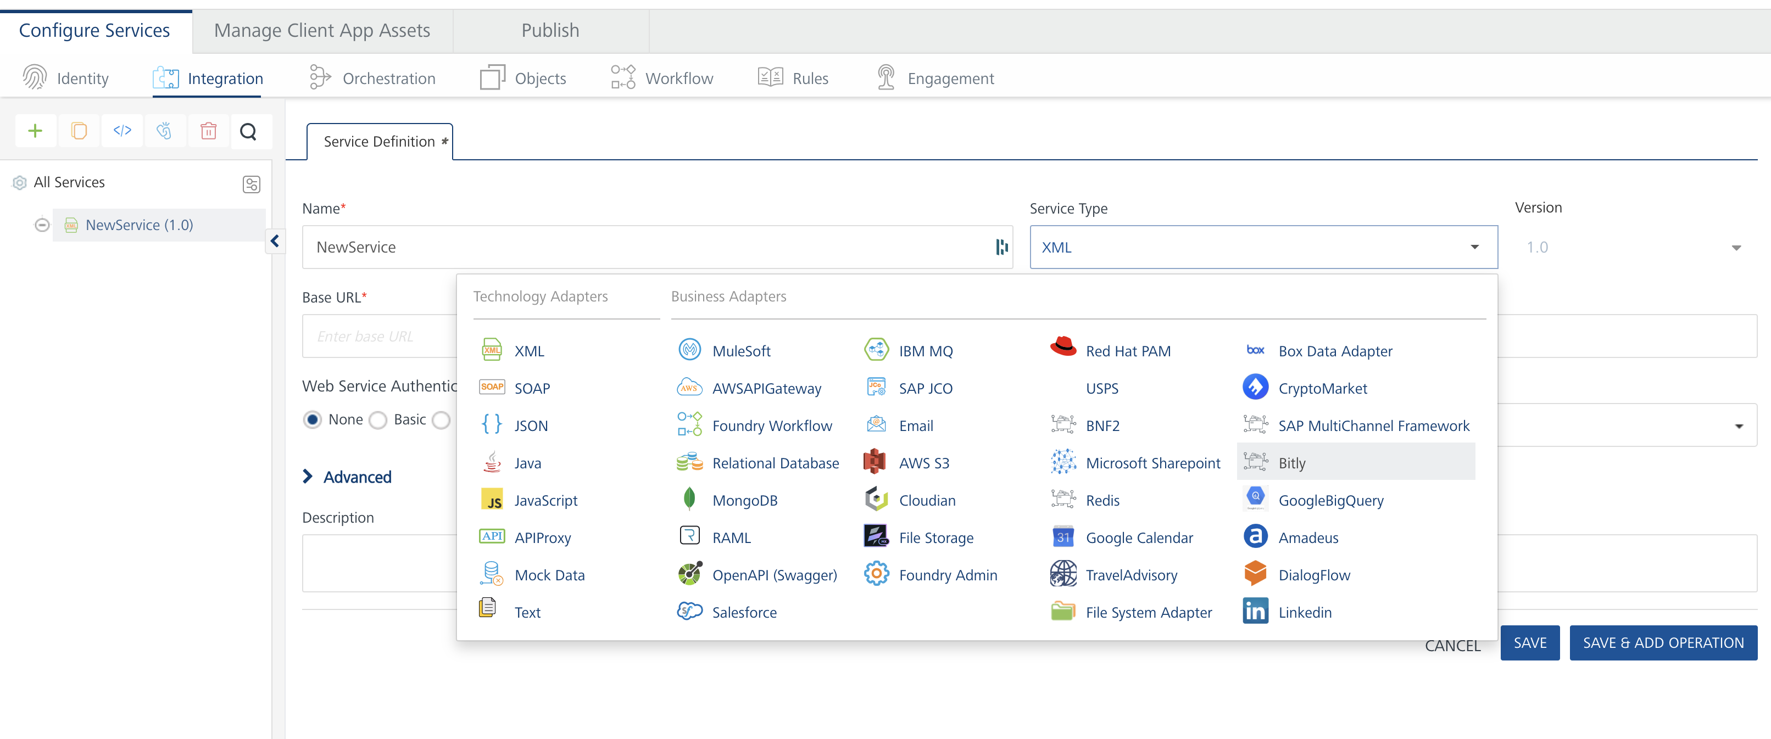
Alternatively, you can also create a Foundry app and create an Integration service inside it.
E. Creating and Executing operations
After you create an integration service, you can create and execute operations using the service.

Creating an Operation
- In API Management/Foundry app you created, in the Integration section, select the service that you created.
- After you select the service, navigate to the Operation List tab.
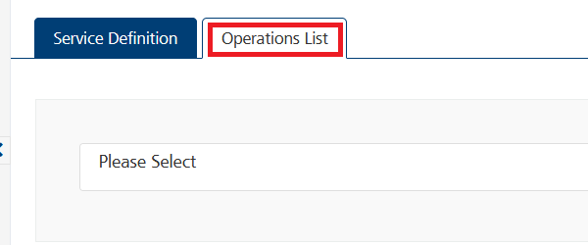
- From the drop down list, select an operation that you want to execute, and click ADD OPERATION.
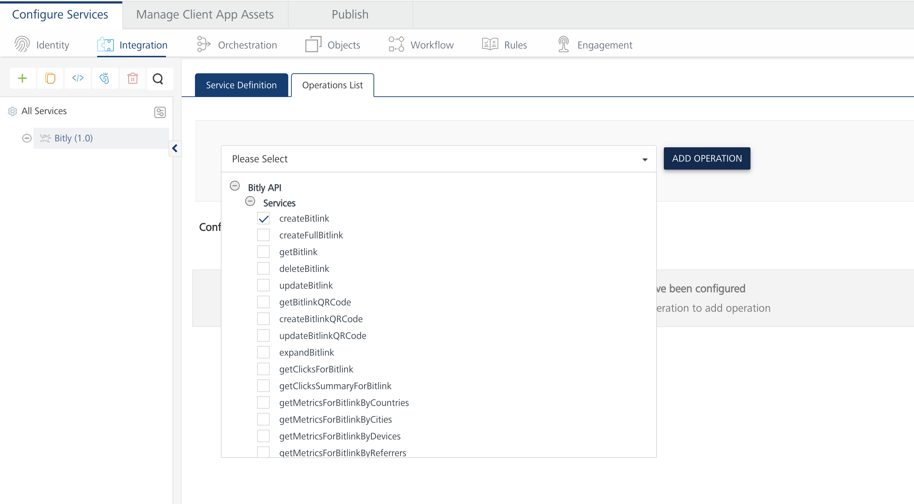
- From the Operations List tab, in the Configured Operations section, select the operation you want to execute.
- 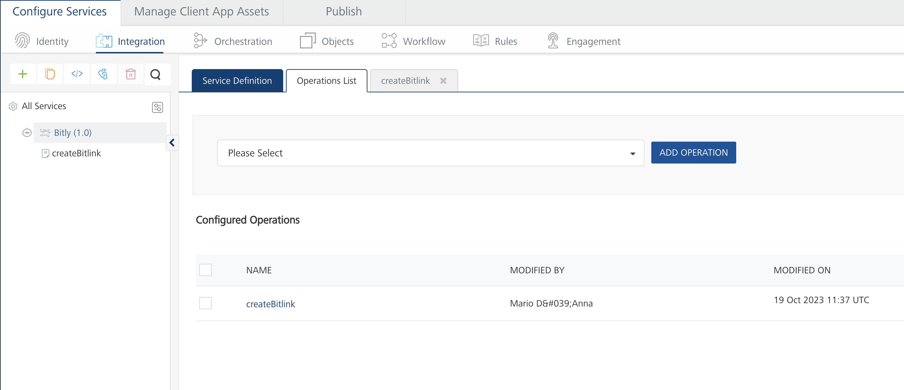On the Operation Page, in the Request Input tab, enter a TEST VALUE for the long_url field. It is not necessary to provide a value for the other two fields.
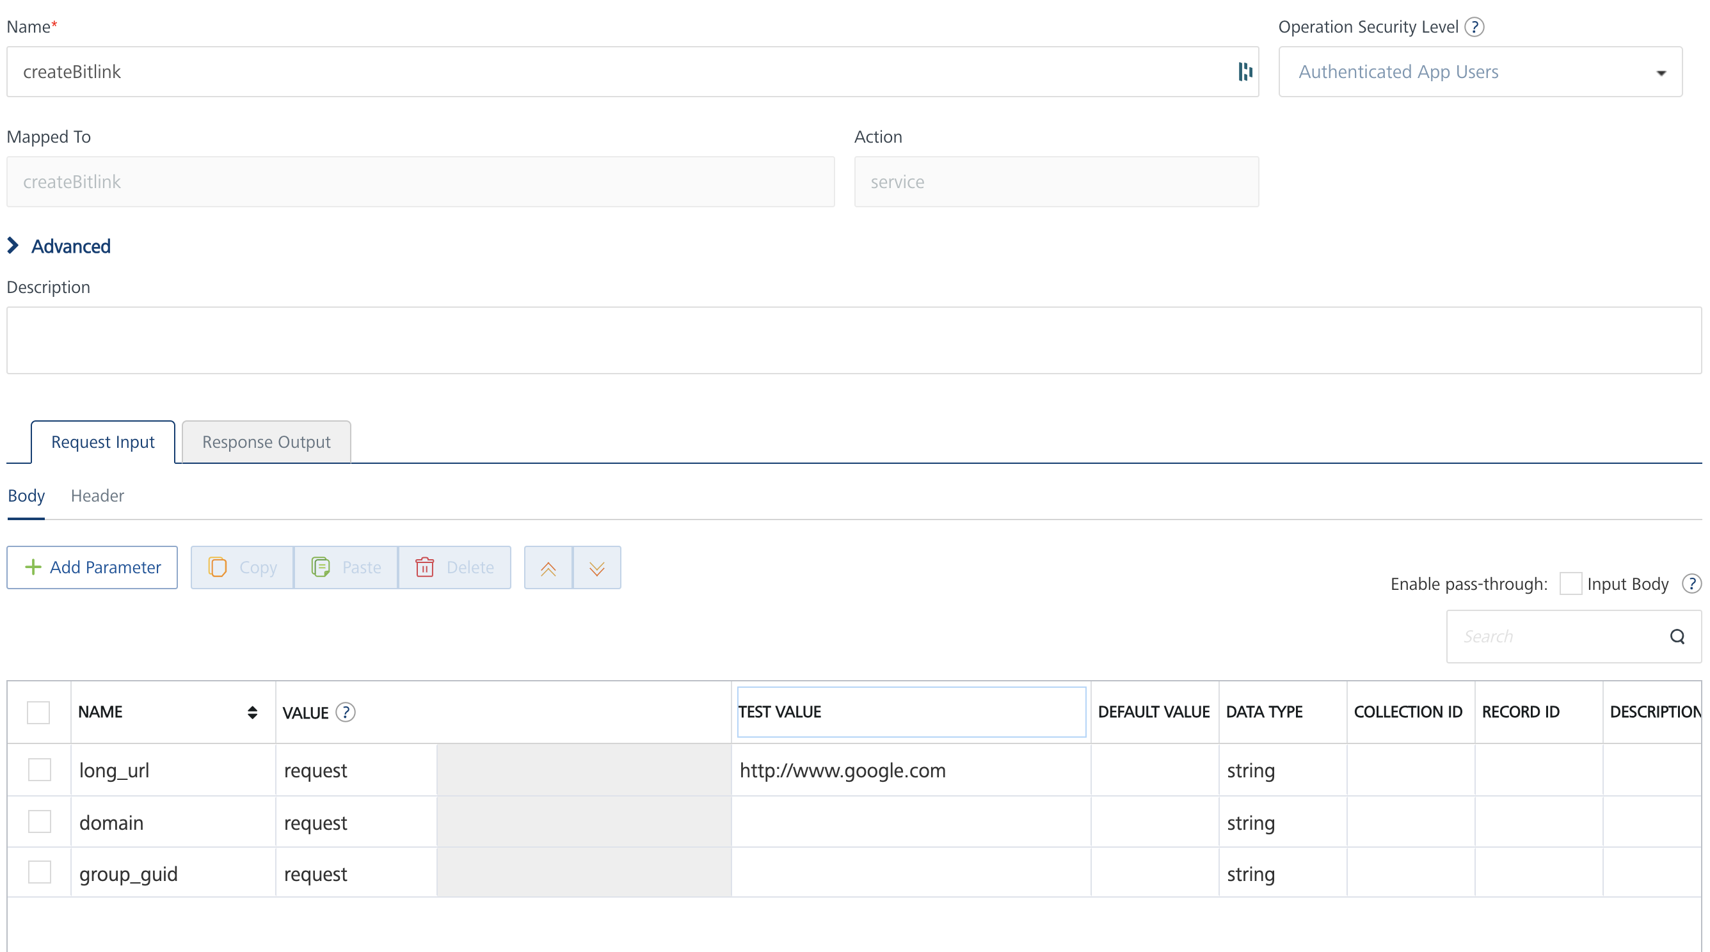
- In the Request Input Tab you must also provide a value for the Header parameter Authorization. You must enter your bitly access key.
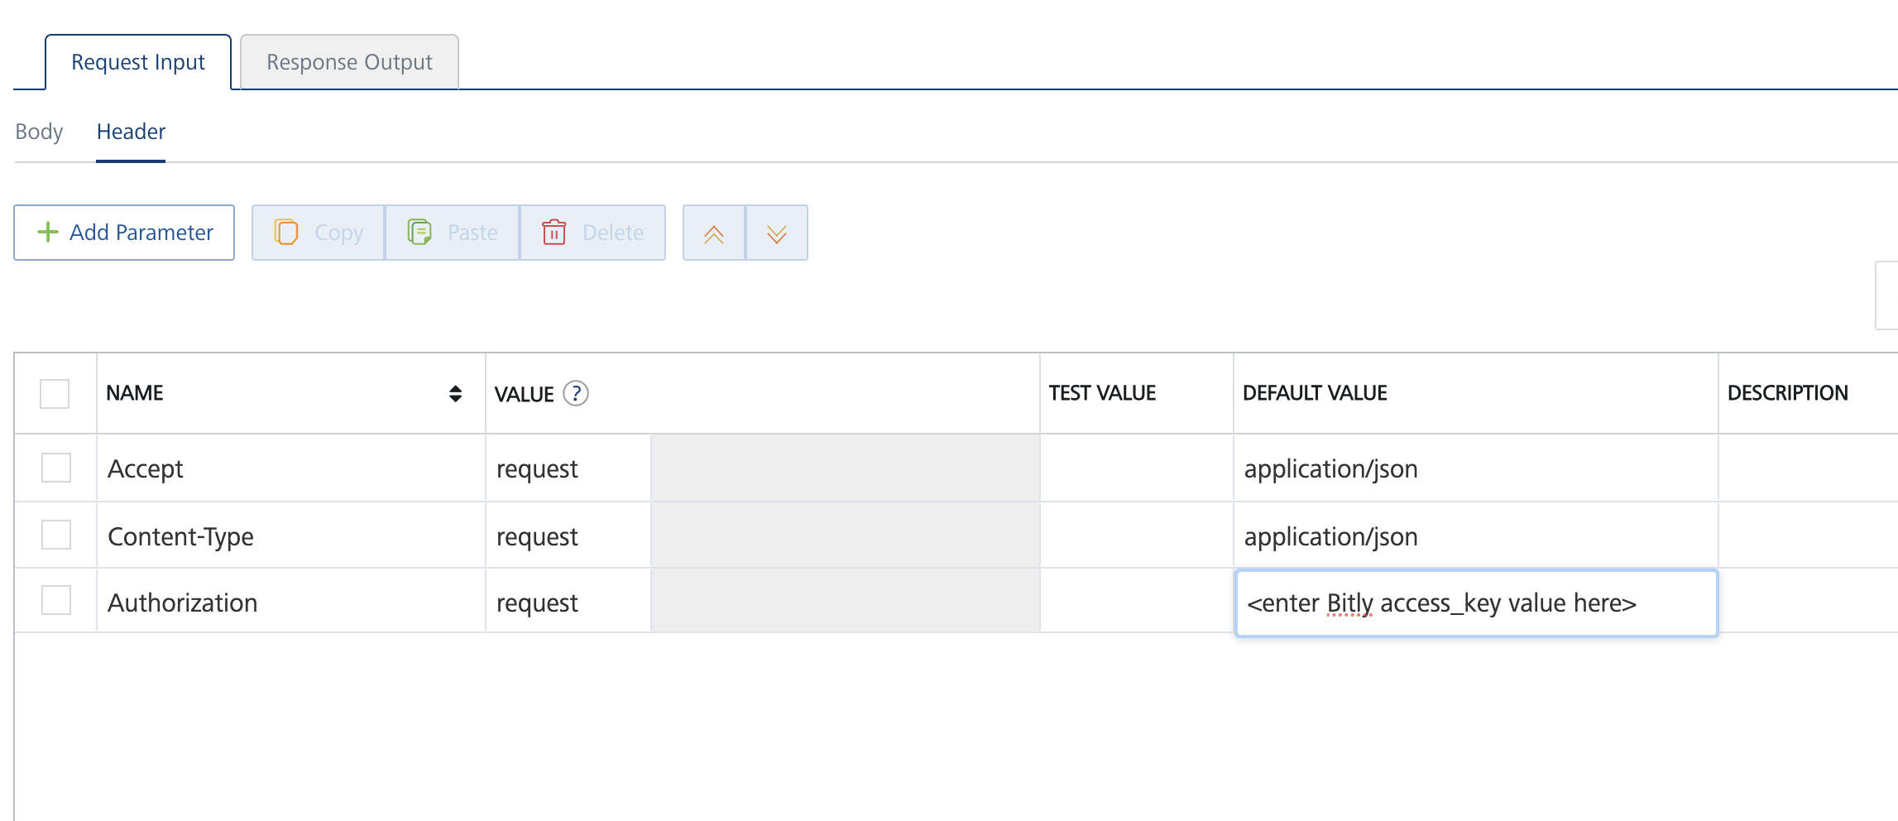
- Select a run-time environment and click Save and Fetch Response to get a response based on your inputs.

Publishing your application
If you want to use the services in client applications, you need to publish an app to a run-time environment. You can create the service (as described above) in an application or import the service into an application and publish the application.

References

Endpoint Documentation

Please refer to the bitly.com API documentation to see a list of all available endpoints. The API reference guide is available at this link
https://dev.bitly.com/api-reference/

Revision History
Adapter version 1.0.0:

Known Issues
The Bitly adapter uses a 3.0 Swagger file which works on Foundry 9.5.15 and later.

