Date : 22-02-2024

CURRENTS APi

version: 1.0.0

Overview

Currents API provides a simple mean of obtaining recent and historical news from a comprehensive coverage of sources.

Getting Started

A. Prerequisites

Volt Foundry
- Account and api key from Currents API.
- Sign up in Currents API - News data in JSON and login into the account and get the api key.

B. Importing the adapter:
To import the Data Adapter to Volt Foundry, do the following:
- Sign in to the HCL Foundry.
- From the left navigation menu, select API Management.
- In API Management, select Custom Data Adapters.
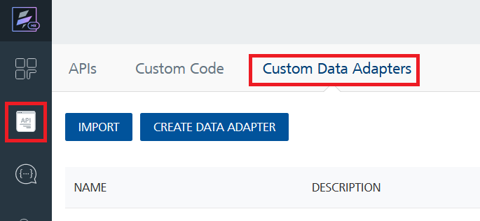
- Click IMPORT to import a custom data adapter.
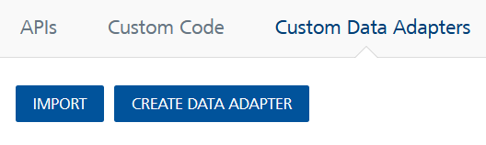
- On the Import Data Adapter dialog box, click browser to import.
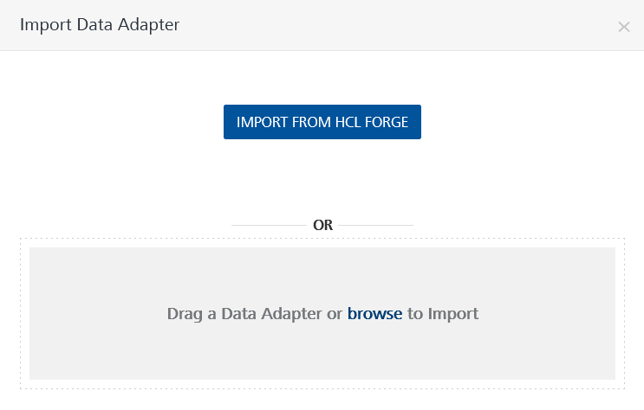
- Select Currents API zip file and click IMPORT.
After you import the data adapter, Volt Foundry opens a window that shows the metadata of the data adapter.
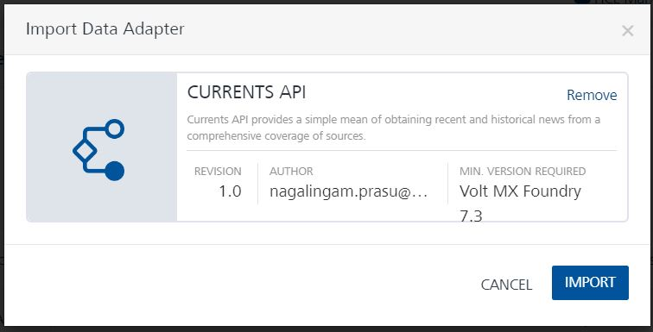

After you import the data adapter, you can view it on the Custom Data Adapters page and use it to create services on Volt Foundry.
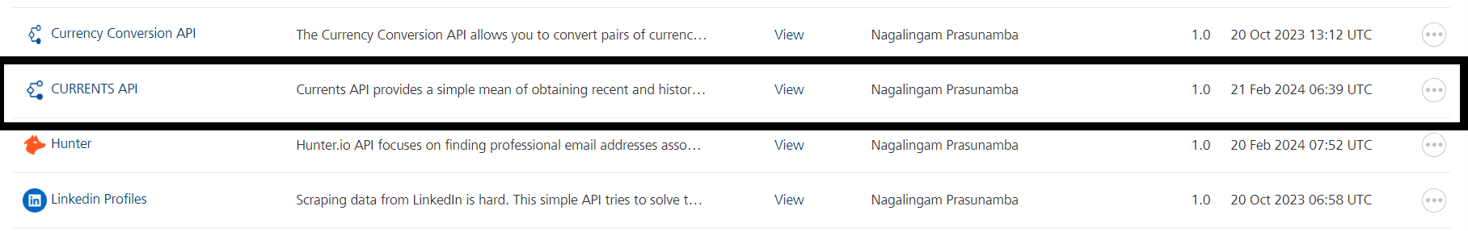

C. Creating an Integration service
After you import the data adapter into Volt Foundry, you can use it to create an Integration Service.
Follow the given steps to create an Integration service using the Currents API Adapter.
- Sign in to the HCL Foundry.
- From the left navigation menu, select API Management.
- In API Management, select Integration.
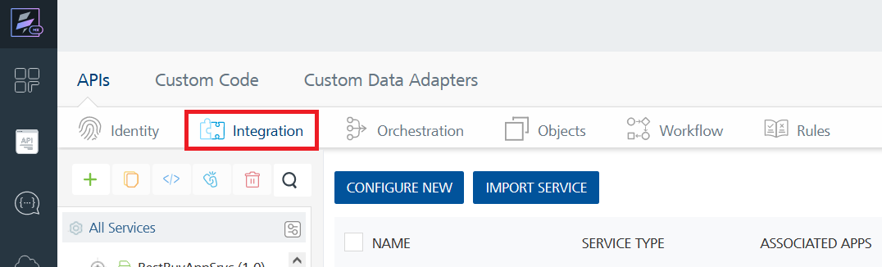
- To create a new service, click the + button or the CONFIGURE NEW button.
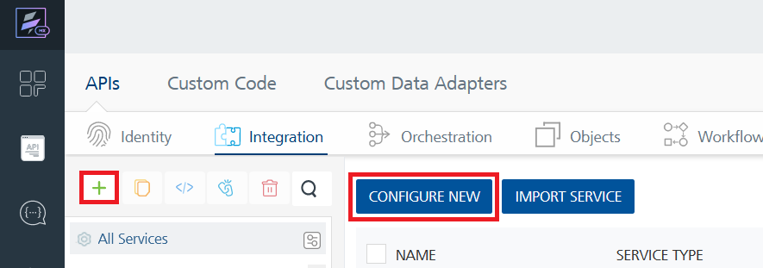
- On the Service Definition tab, select the service type as Currents API, and click SAVE.
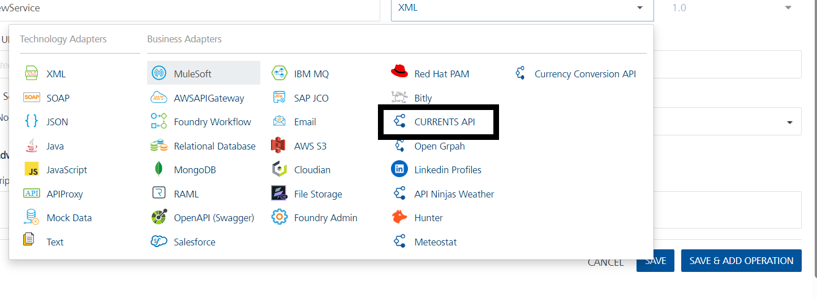

Alternatively, you can also create a Foundry app and create an Integration service inside it.
D. Creating and Executing operations
After you create an integration service, you can create and execute operations using the service.

Creating an operation
- In API Management/Foundry app you created, in the Integration section, select the service that you created.
- After you select the service, navigate to the Operation List tab.
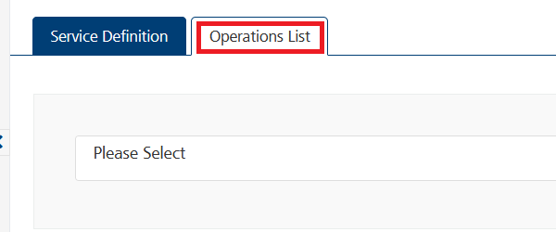
- From the drop-down list, select an operation that you want to execute, and click ADD OPERATION.
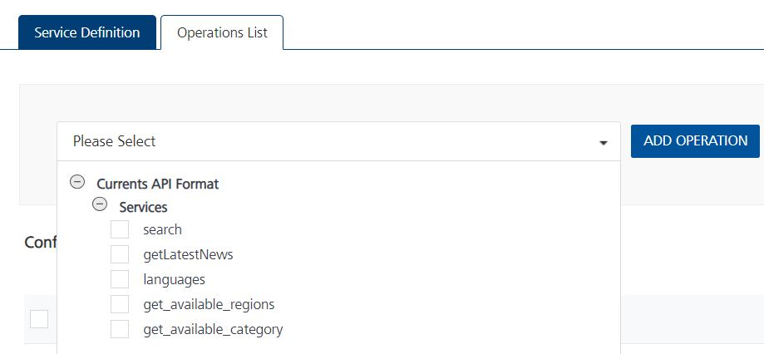

Executing an operation:
- From the Operations List tab, in the Configured Operations section, select the operation you want to execute.
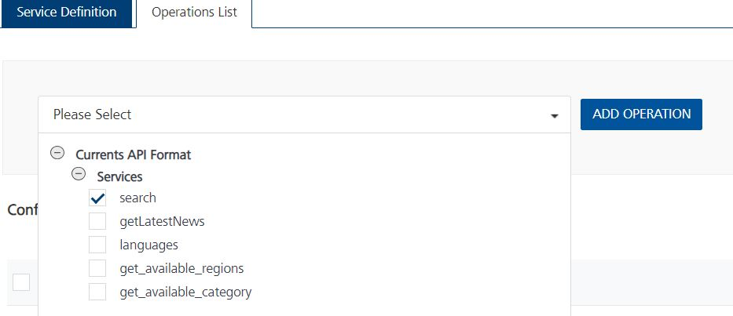
- On the Operation Page, in the Request Input tab, enter a TEST VALUE for all the fields.
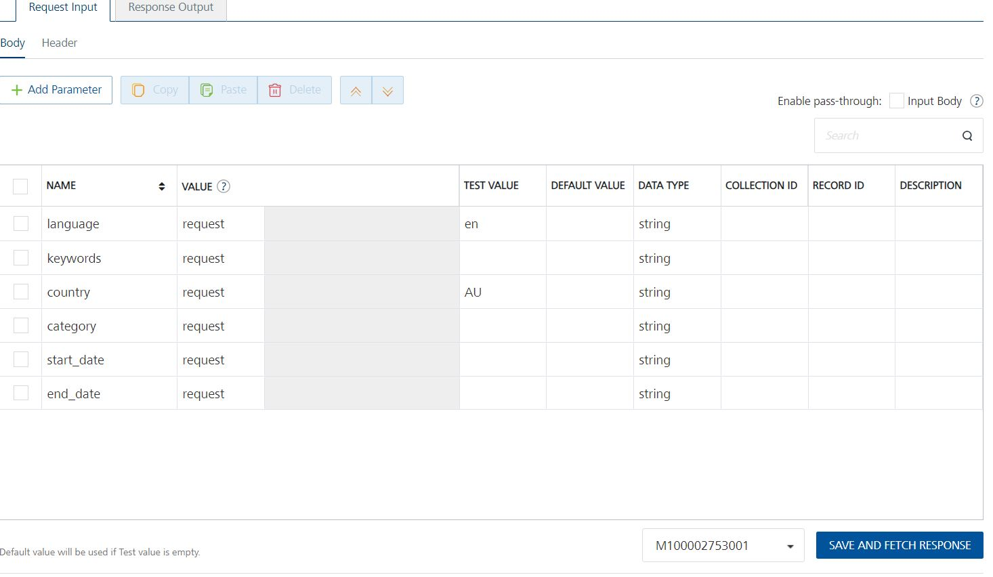

Request Header:
Authorization [in header]: API Key associated with your CurrentsAPI account, required for authentication. To get keys – Login in to Currents API - News data in JSON -> You can view your keys.
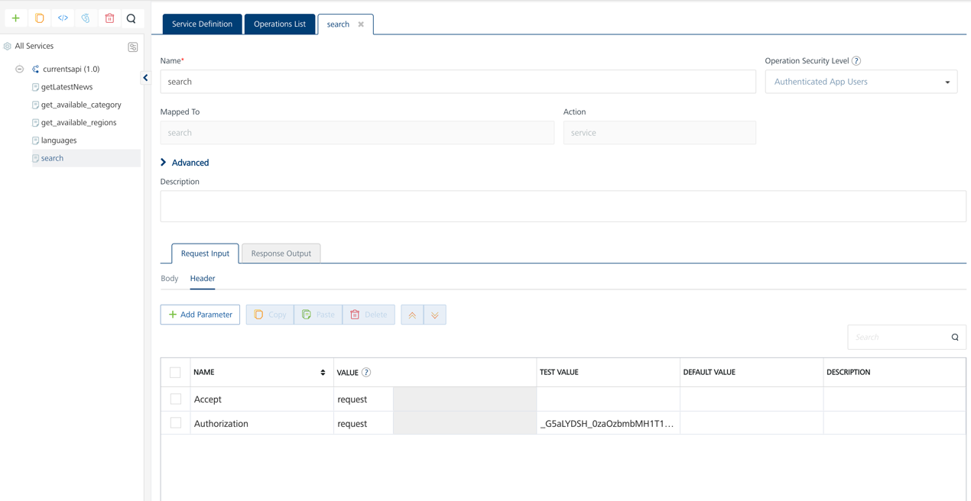
- Select a run-time environment and click Save and Fetch Response to get a response based on your inputs.
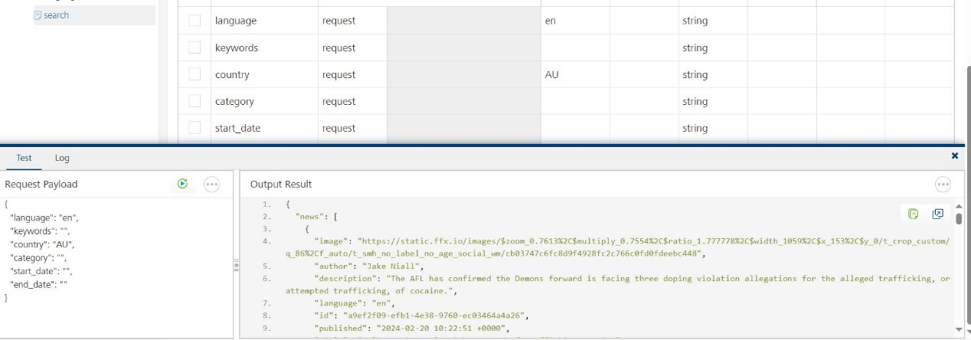

E. Publishing your application
If you want to use the services in client applications, you need to publish an app to a run-time environment. You can create the service (as described above) in an application or import the service into an application and publish the application.

3. References

Endpoint Documentation

/search

GET

https://api.currentsapi.services/v1/search?language=en

Search news by adding query such as language, category, keywords, published data etc.
Name | Description | Type | In
language | Language values that need to be considered for filter | string | query
keywords | Keyword values that need to be considered for filter | string | query
country | Country values that need to be considered for filter | string | query
category | Category values that need to be considered for filter | string | query
start_date | Starting Date format should follow: YYYY-MM-DDTHH:MM:SS+00:00 | string | query
end_date | End Date format should follow: YYYY-MM-DDTHH:MM:SS+00:00 | string | query

Name | In | Value
Authorization | header | [Your Value]

/latest-news

A stream of latest news around the world

GET

https://api.currentsapi.services/v1/latest-news?language=en
Name | Description | Type | In
language | Language values that need to be considered for filter | string | query

Name | In | Value
Authorization | header | [Your Value]

/available/languages

This API endpoint allows you to get available languages

GET

https://api.currentsapi.services/v1/available/languages

No parameters

/available/regions

This API endpoint allows you to get available regions.

GET

https://api.currentsapi.services/v1/available/regions

No parameters

/available/category

This API endpoint allows you to get available categories. At present it has some internal server error.

GET

https://api.currentsapi.services/v1/available/category

No parameters

Reference Document: Refer this document for more information.
Endpoints - Documentation - Currents API

4. Revision History
Adapter version 1.0.0

Known Issues
-

Limitations
-

