Date :  18-10-2023

CURRENCY API (1.0)

# Overview

**Free Currency Exchange Rates API with 150+ Currencies & No Rate Limits.**

Use Currency API to handle your exchange rate conversions. Our API helps you with current and historical foreign exchanges rates.

# Getting Started

## Prerequisites

* Volt Foundry

## Importing the adapter

**To import the Data Adapter to Volt Foundry, do the following:**

1. Sign in to the  [HCL Foundry](https://manage.hclvoltmx.com/).
2. From the left navigation menu, select **API Management**.
3. In **API Management**, select **Custom Data Adapters**.  
   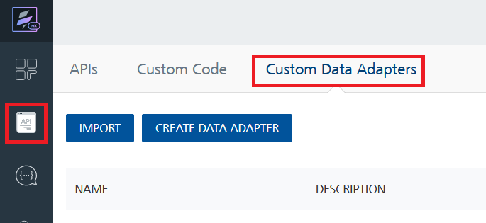
4. Click **IMPORT** to import a custom data adapter.  
   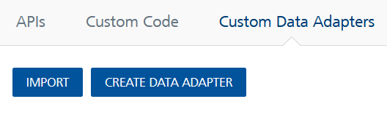
5. On the Import Data Adapter dialog box, click browser to import.  
   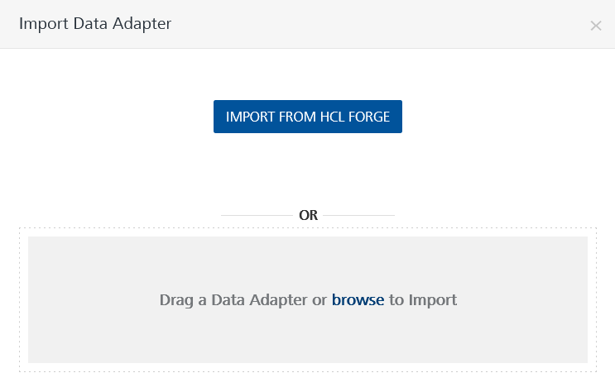
6. Select CURRENCYAPI zip file and click **IMPORT**.

After you import the data adapter, Volt Foundry opens a window that shows the metadata of the data adapter.



After you import the data adapter, you can view it on the Custom Data Adapters page and use it to create services on Volt Foundry.

## [Creating an Integration service](javascript:void(0);)

After you import the data adapter into Volt Foundry, you can use it to create an Integration Service.

Follow the given steps to create an Integration service using the Curency API Adapter.

1. Sign in to the [HCL Foundry](https://manage.hclvoltmx.com/).
2. From the left navigation menu, select **API Management**.
3. In **API Management**, select **Integration**.  
   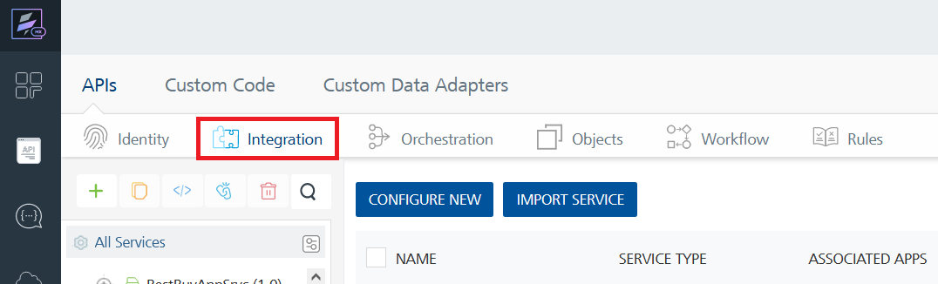
4. To create a new service, click the **+** button or the **CONFIGURE NEW** button.  
   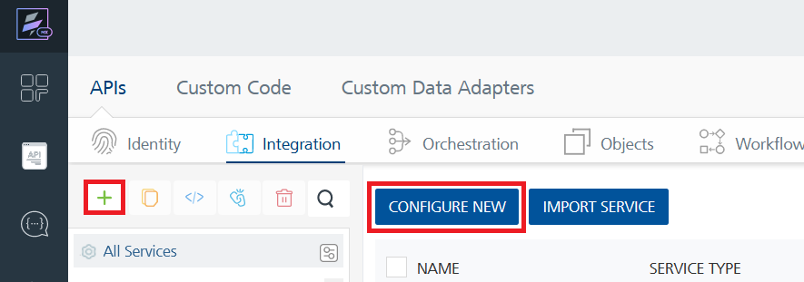
5. On the Service Definition tab, select the service type as CURRENCY API and click **SAVE**.  
   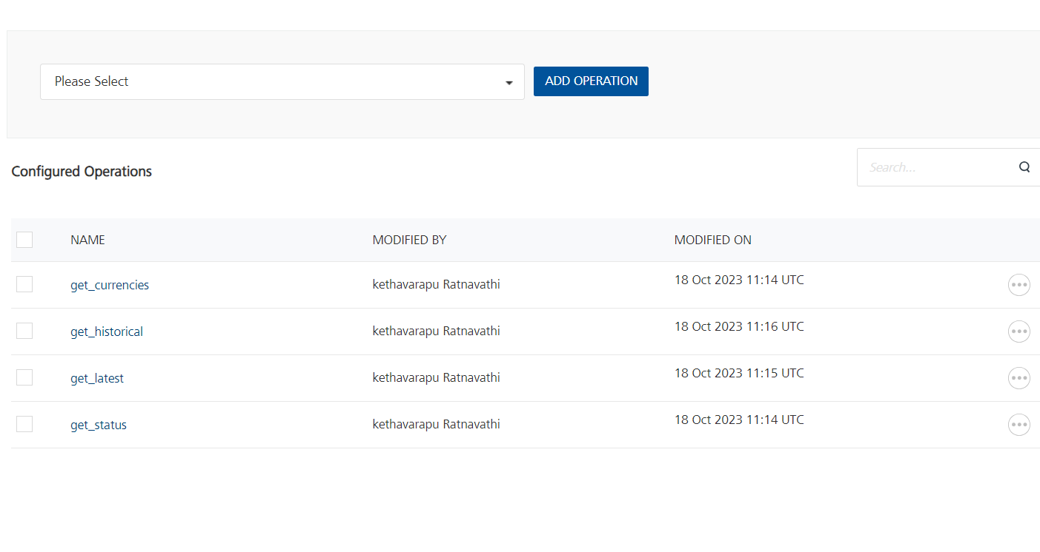

Alternatively, you can also create a Foundry app and create an Integration service inside it.

E. [Creating and Executing operations](javascript:void(0);)



After you create an integration service, you can create and execute operations using the service.

#### Creating an Operation

* In **API Management/Foundry app you created**, in the **Integration** section, select the service that you created.
* After you select the service, navigate to the **Operation List** tab.  
  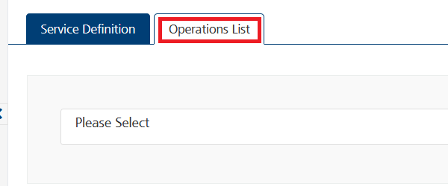
* From the drop-down list, select an operation that you want to execute, and click **ADD OPERATION**

#### Executing an operation

* From the **Operations List** tab, in the **Configured Operations** section, select the operation you want to execute.



* For the operation **get_currencies** On the Operation Page, in the Request Input tab, enter a TEST VALUE for all the apikey in the header part the process for generation of api key is mentioned in documentation.  
  A screenshot of a computer

  Description automatically generated
* Select a run-time environment and click **Save and Fetch Response** to get a response based on your inputs.  
  A screenshot of a computer

  Description automatically generated

## [Publishing your application](javascript:void(0);)

If you want to use the services in client applications, you need to publish an app to a run-time environment. You can create the service (as described above) in an application or import the service into an application and publish the application.

# References

## **Endpoint Documentation**

|  |  |  |  |  |
| --- | --- | --- | --- | --- |
| S.NO | ENDPOINT | ENDPOINT LINK | PLAN | Description |
| 1 | STATUS ENDPOINT | curl -G https://api.currencyapi.com/v3/status \-H "apikey: YOUR-API-KEY" | FREE | status endpoint returns information about your current quota. |
| 2 | CURRENCIES ENDPOINT | curl -G https://api.currencyapi.com/v3/currencies \-H "apikey: YOUR-API-KEY" | FREE | endpoint returns a list of all supported currencies that are available through our other endpoints. |
| 3 | LATEST EXCHANGE RATES | curl -G https://api.currencyapi.com/v3/latest \-H "apikey: YOUR-API-KEY" | FREE | This endpoint returns currency exchange data for any given base currency |
| 4 | HISTORICAL EXCHANGE RATES | curl -G https://api.currencyapi.com/v3/historical?date=2022-01-01 \-H "apikey: YOUR-API-KEY" | FREE | historical exchange rates endpoint provides currency rates for a specified date. |
| 5. | HISTORICAL EXCHANGE RATES | curl -G https://api.currencyapi.com/v3/range?datetime_start=2021-11-30T23:59:59Z&datetime_end=2021-12-31T23:59:59Z&accuracy=day \-H "apikey: YOUR-API-KEY" | STANDRAD PLAN | This historical exchange rates endpoint provides currency rates for a specified date range. |
| 6. | CONVERT EXCHANGE RATES | curl -G https://api.currencyapi.com/v3/convert?value=12 \-H "apikey: YOUR-API-KEY" | STANDRAD PLAN | Returns calculated values for today or any given date for all currencies. |

## For more details regarding parameters and endpoint, please checkout [currencyapi Documentation](https://currencyapi.com/docs/status)

# Revision History

Adapter version 1.0.0:

## Limitations

You can use a certain number of requests per month, defined by your plan.