2nd May 2023

Crop Image And annotate(1.0.o)

Overview
The CropImageAnnotate component can select and crop the image and then allows to annotate the image with the signature.

Use case
1. To confirm the Goods delivery from the customer takes the signature in the mobile with the help of this component.

B .Percentage of re-use:
Approximate 90% of reuse. It sets an expectation of how much can be used out of the box, and how much needs to be customized for a specific app.

C. Features

- The component utilizes SwiftyJot third party library to take the signature.
- Uses NFI 3.0

2. Getting Started

A. Prerequisites
Before you start using the CropImageAnnotate component, ensure the following:
• HCL Foundry
• Volt MX Iris

Platforms Supported

Mobile

iOS

Tablets

Importing the app

You can import the Forge components only into the apps that are of the Reference Architecture type.

To import the CropImageAnnotate component, do the following:

Open your app project in Volt MX Iris.
2. In the Project Explorer, click the Templates tab.
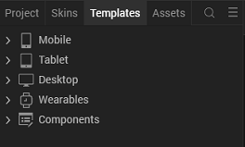
3.Right-click Components, and then select Import Component. The Import Component dialog box appears.
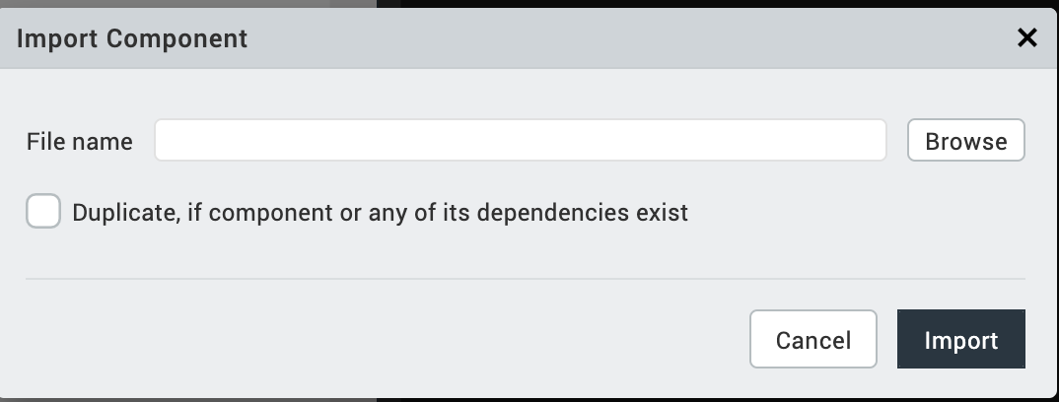
4.Click Browse to navigate to the location of the component, select the component, and then click Import. The component and its associated widgets and modules are added to your project.

Once you have imported a component to your project, you can easily add the component to a form. For more information, refer Add a Component to a Form

Building and previewing the app
After performing all the above steps, you can build your app and run it on your device. For more information, you can refer to the Building and Viewing an Application section of the Volt MX User Guide.
You can then run your app to see the CropImageAnnotate work in real time.

References

Dynamic Usage
You can also add CropImageAnnotate component dynamically. To do so,

1. In the Project Explorer, on the Projects tab, click Controllers section to access the respective Form Controller. Create a method and implement the code snippet similar to the sample code mentioned below.

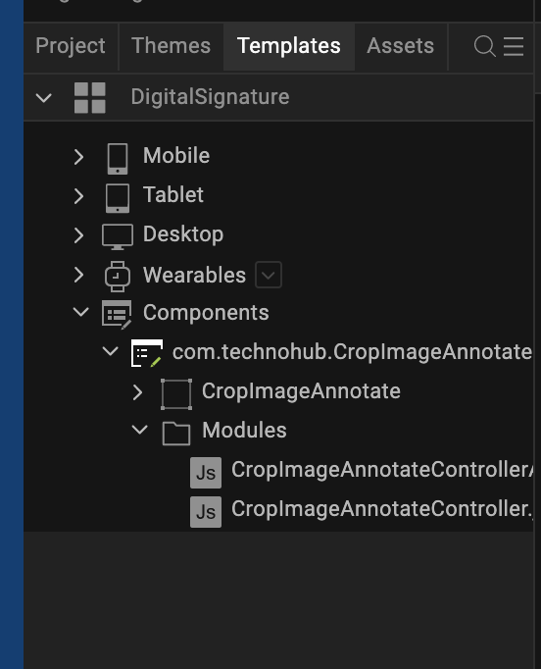

/* Creating CropImageAnnotate component instance */

var CropImageAnnotate = new com.technohub.CropImageAnnotate({
"height": "50%",
"id": “CropImageAnnotate",
"isVisible": true,
"left": "0dp",
"masterType": constants.MASTER_TYPE_USERWIDGET,
"isModalContainer": false,
"skin": "slFbox",
"top": "0dp",
"width": "100%",
"zIndex": 1,
"overrides": {
"CropImageAnnotate": {
"right": "viz.val_cleared",
"bottom": "viz.val_cleared",
"minWidth": "viz.val_cleared",
"minHeight": "viz.val_cleared",
"maxWidth": "viz.val_cleared",
"maxHeight": "viz.val_cleared",
"centerX": "viz.val_cleared",
"centerY": "viz.val_cleared"
}
}
}, {
"overrides": {}
}, {
"overrides": {}
});

/*Adding the CropImageAnnotate component to a Form*/

this.view.add(CropImageAnnotate);
In the code snippet, you can edit the properties of the component as per your requirement. For more information, see Setting Properties.
2. Save the file

Configuring Native Settings (iOS)
To configure the native settings for iOS, follow these steps:
- From the Project explorer, go to Assets and expand Media.
- Right-click Common, and then select Resource Location. Volt MX Iris opens the common resources folder in a file explorer.
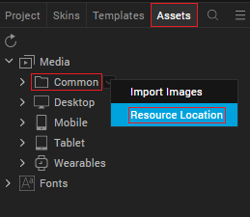
- Open the infoplist_configuration.json file with a text or code editor.
- At the end of the file, type the following code. You can change the description based on your preference.
"NSCameraUsageDescription" : "Your Description"

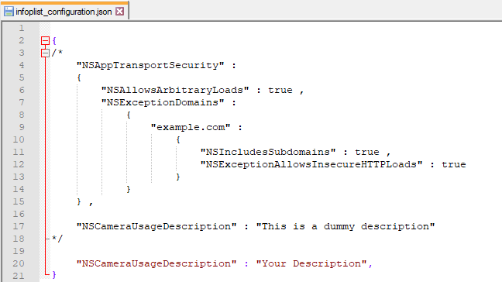

5. Save the file.

Configuring Deployment Target
- From the left navigation menu, click Project Settings.
- In the Project Settings window, go to Native → iPhone/iPad.
- Under Target Versions, from the iOS Version list, select 11.0 or higher.
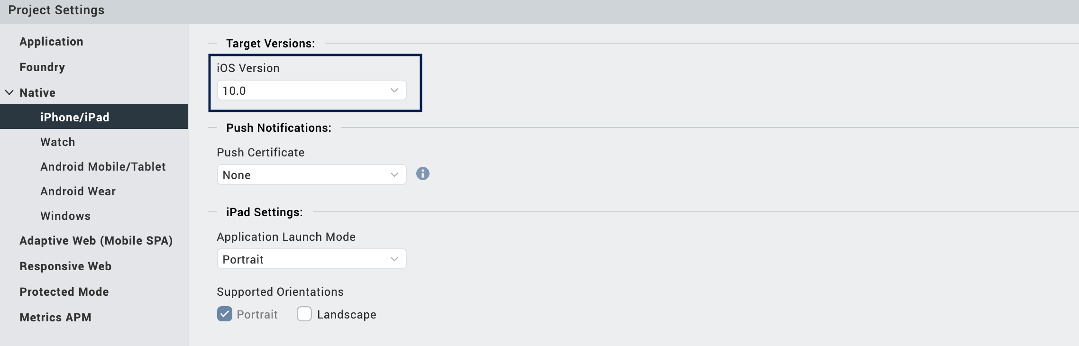

General Properties

API

i. startGallary

Description: | Opens the gallery to pick the image.
Syntax: | startGallary()
Parameters: | None
Return Value: | None
Remarks: | Call this API to open the gallery and pick the image, and annotate picked image.
Example: | this.view.CropImageAnnotate.startGallary ();

ii. startCamera

Description: | Opens the Camera to pick the image from the Camera
Syntax: | startCamera ()
Parameters: | None
Return Value: | None
Remarks: | Call this API to open the Camera and pick the image, and annotate picked image.
Example: | this.view.CropImageAnnotate.stopSession();

C. Events

1. resultCallback

Description: | Returns the modified image as a base64 image within this callback.
Syntax: | resultCallback
Parameters: | Callback as a parameter
Remarks: | None
Example: | postShow(){  kony.runOnMainThread(function(){  this.view.CropImageAnnotate.resultCallback(this.callBackHandler);  }.bind(this), []);  },  callBackHandler: function(data) {  var self = this;  kony.runOnMainThread(function() {  self.view.imgResult.base64 = data;  }, []);  }

App version 1.0.0:

Limitations

B. Known Issue

