Date : 23-Jul-25

CORTICAL.IO

VERSION: 1.0.0

1.OVERVIEW
Cortical.io data adapter provides Semantic Folding technology through its APIs, converting text into Semantic Fingerprints for advanced Natural Language Understanding (NLU).
A. Features:
Semantic Fingerprint API: Creates semantic fingerprints from text in English, Spanish, French, and German for language model training, search, and classification.
- Fingerprint Creation (/fp/fingerprint): Converts input text into a semantic fingerprint by aggregating and sparsifying word representations. Supports options like using phrase fingerprints, part-of-speech filtering, stopword removal, and various weighting methods.
Natural Language Processing API: Offers functionalities for extracting keywords, detecting languages, comparing documents, generating labels, and segmenting text.

B. Percentage of re-use:
Approximately 80% of reuse

2. GETTING STARTED
  - Prerequisites
Before you start using the Cortical.io data adapter, ensure you have the following:

- HCL Foundry
- Volt MX Iris

PLATFORMS SUPPORTED

Foundry

Importing the adapter
To import the Data Adapter to Volt Foundry, do the following:
- Sign in to the HCL Foundry.
- From the left navigation menu, select API Management.
- In API Management, select Custom Data Adapters.
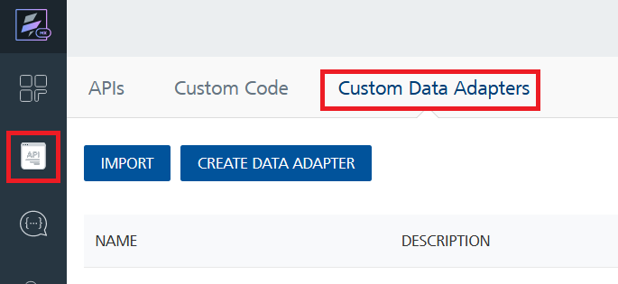
- Click IMPORT to import a custom data adapter.
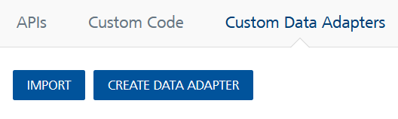
- On the Import Data Adapter dialog box, click browser to import.
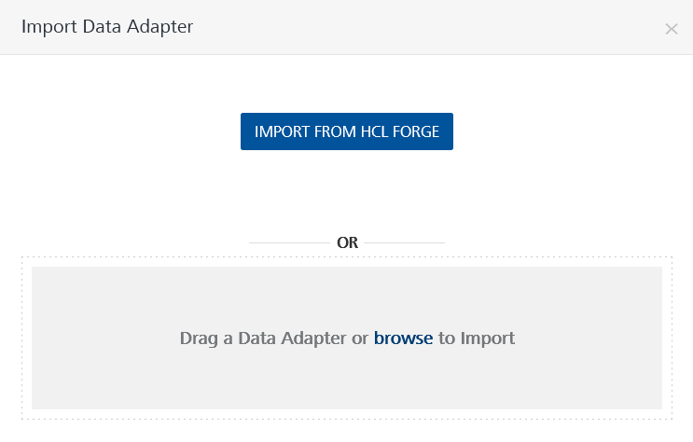
- Select Cortical.io data adapter zip file and click IMPORT.
After importing the data adapter, Volt Foundry opens a window that shows the metadata of the data adapter.
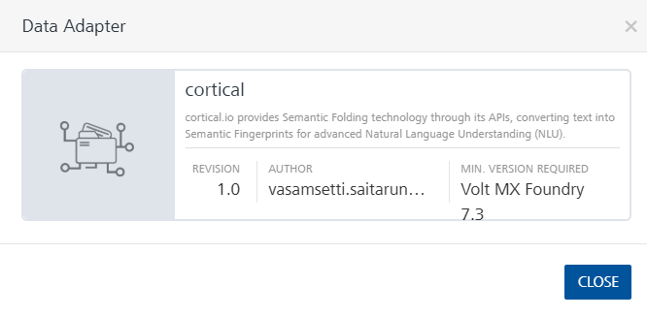

After you import the data adapter, you can view it on the Custom Data Adapters page and use it to create services on Volt Foundry.
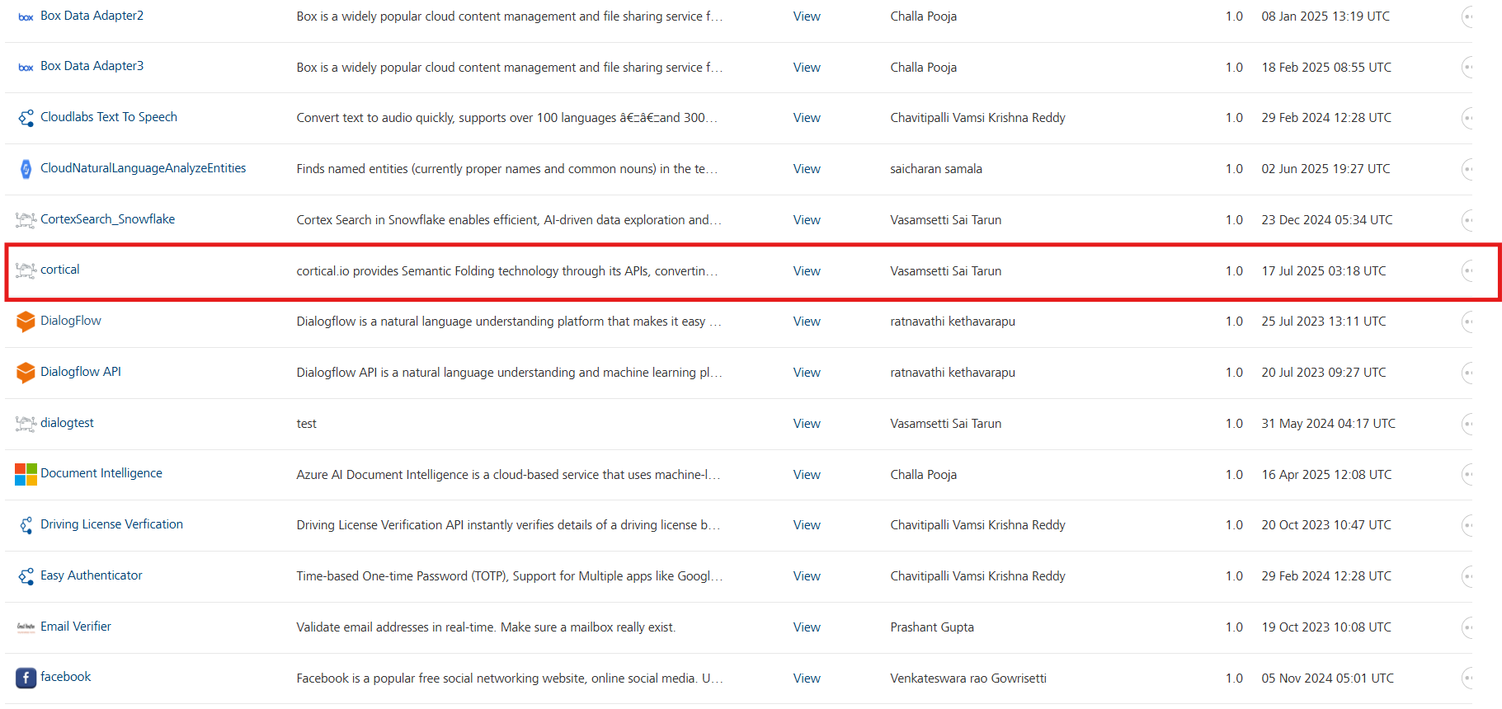
After you add the data adapter to your Volt Foundry app. You can refer to the section below for more information.

Creating an Integration service
Follow the steps given to create an Integration service using the Cortical.io Data Adapter.
- Sign in to the HCL Foundry.
- From the left navigation menu, select API Management.
- In API Management, select Integration.
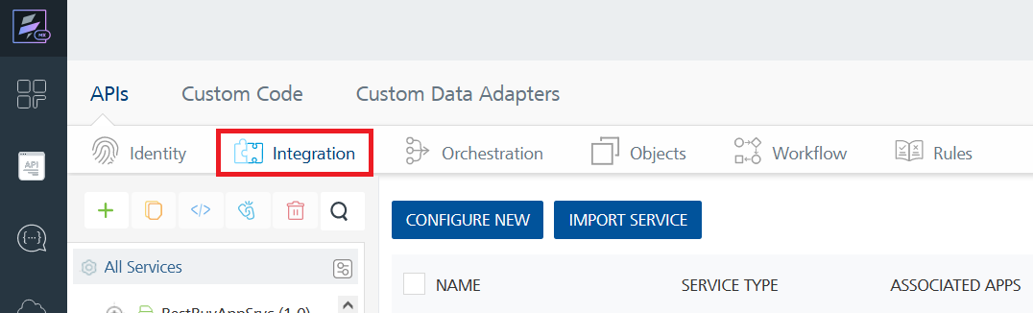
- To create a new service, click the + button or the CONFIGURE NEW button.
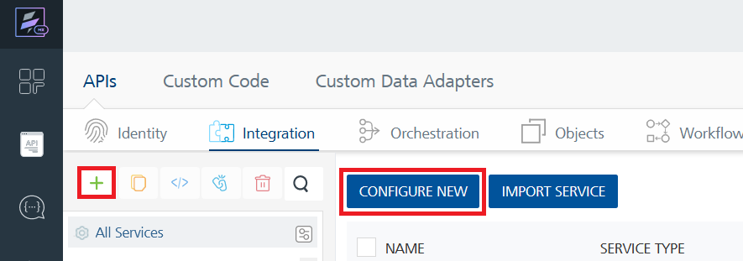
- On the Service Definition tab, select the service type as Cortical.io, and click SAVE.
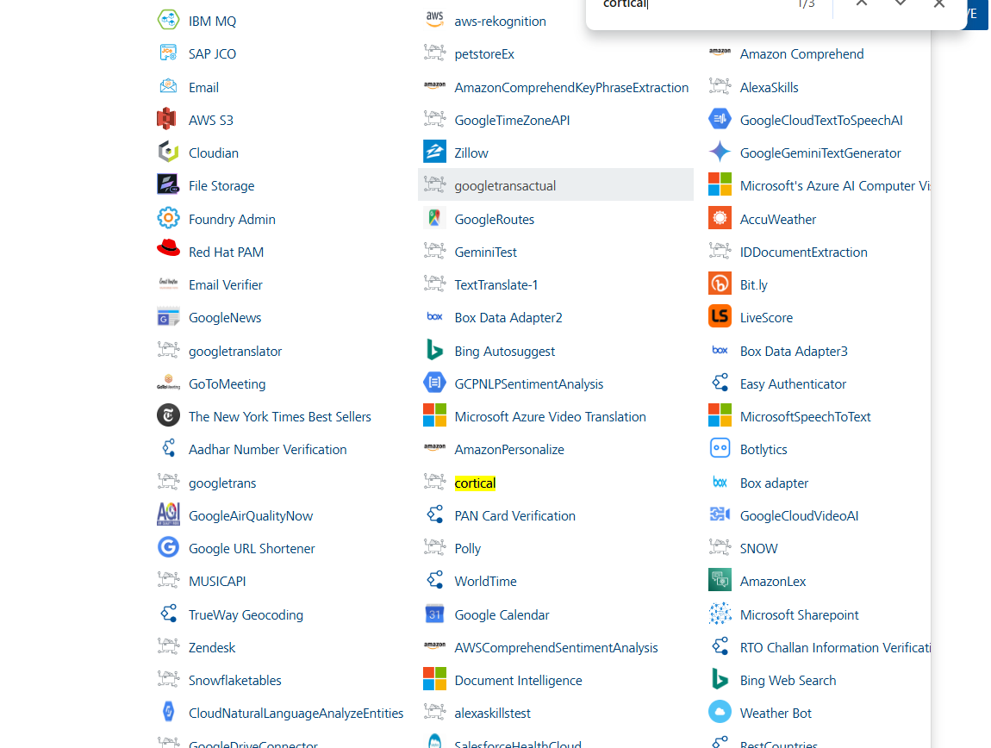
Creating and Executing operations
After you create an integration service, you can create and execute operations using the service.

Creating an operation
- In the API Management/Foundry app you created, in the Integration section, select the service that you created.
- After you select the service, navigate to the Operation List tab.
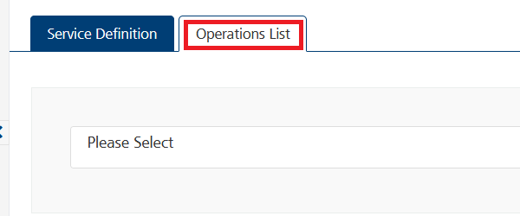
- From the drop-down list, select an operation that you want to execute, and click ADD OPERATION.
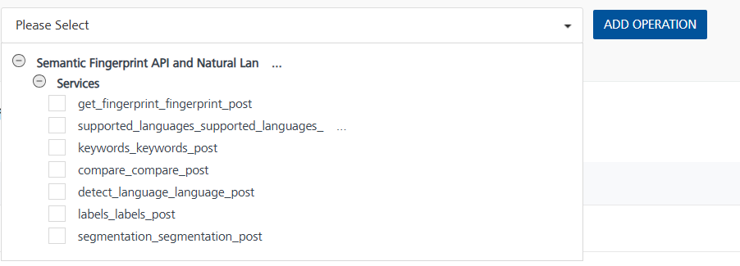

Executing an Operation
- From the Operations List tab, in the Configured Operations section, select the operation you want to execute.
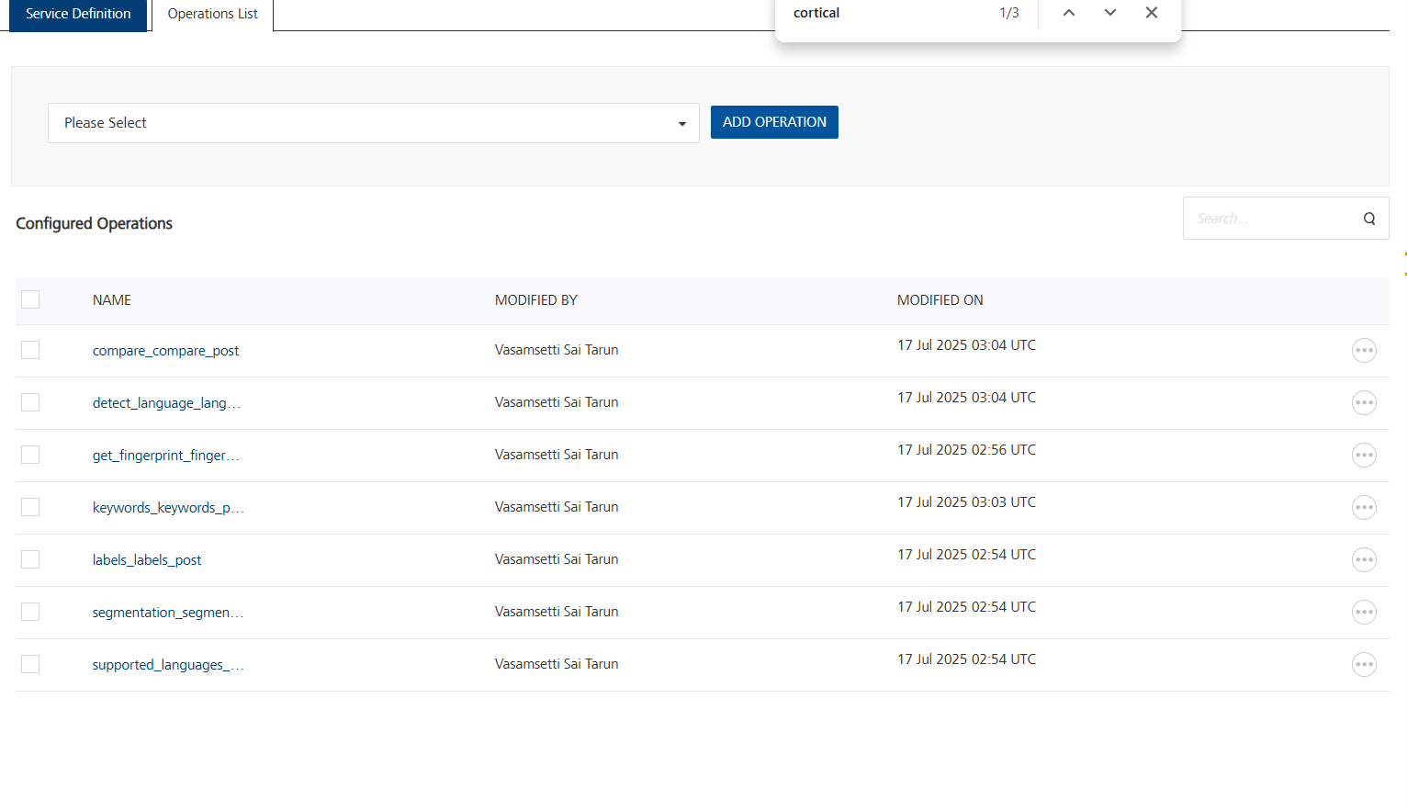
- On the Operation Page, in the Request Input tab, enter a TEST VALUE for all the fields.
Sample Test case.

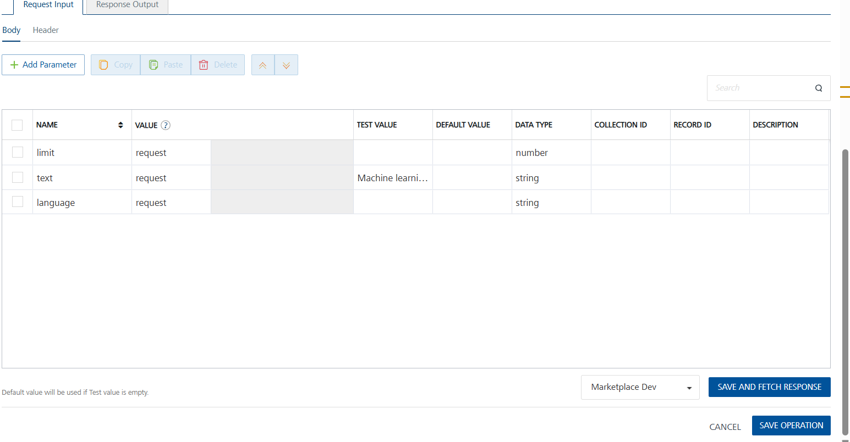

- Select a run-time environment and click Save and Fetch Response to get a response based on your inputs.
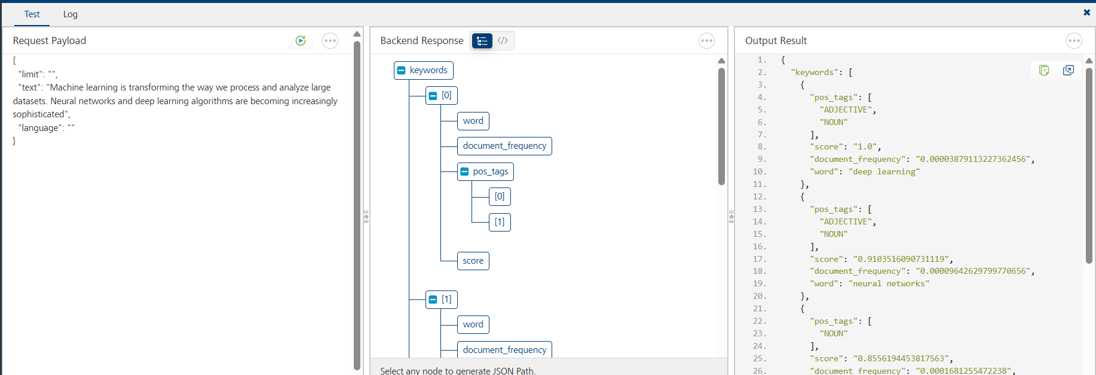

Publishing your application
If you want to use the services in client applications, you need to publish an app to a run-time environment. You can create the service (as described above) in an application or import the service into an application and publish the application.

3. Revision History
Adapter version 1.0.0

