Date : 28-Feb-26
CHART.JS
VERSION: 2.0.0

- OVERVIEW
Chart.js is an open-source JavaScript library that can help you to draw several types of charts. The Chart.js component brings this functionality to VoltMX Iris. You can use this component in scenarios where you want to display data in your app by using charts. This component supports Mobile, Tablet, and Web application channels.
In this component, only bare essential functionalities of the Chart.js library have been exposed by using Component Properties. However, you can access the entire Chart.js library by using the createChart() API.
Note: When you use createChart() API, the values provided through component properties are invalid.
You can use this component to display one chart or a bunch of charts as per your requirement. The component generates as many charts as you specify by using the DataSet property or the createChart() API.
This upgrade from v2.8 to v4.5 introduces major improvements such as modular plugin management, simplified configuration syntax, and enhanced rendering performance.

- Usecase:
I. Draw several types of charts.

B. Percentage of re-use:
90% (Data and skins can be customizable)

GETTING STARTED
A. Prerequisites
Before you start using the Chart.js component, ensure you have the following:
- HCL Foundry
- Volt MX Iris

B. Platforms Supported

i. Mobile

1. iOS

2. Android

ii. Tablets

iii. PWA

Importing the Component

You can import the Forge components only into the apps that are of the Reference Architecture type.

To import the Chart.js component, do the following:

Open your app project in Volt MX Iris.
- In the Project Explorer, click the Templates tab.

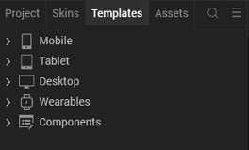

3.Right-click Components, and then select Import Component. The Import Component dialog box appears.
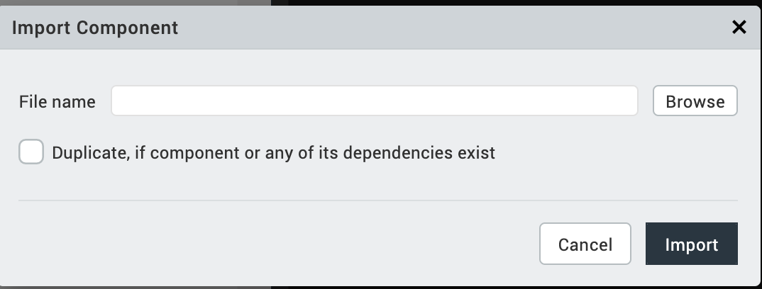

4.Click Browse to navigate to the location of the component, select the component, and then click Import. The component and its associated widgets and modules are added to your project.

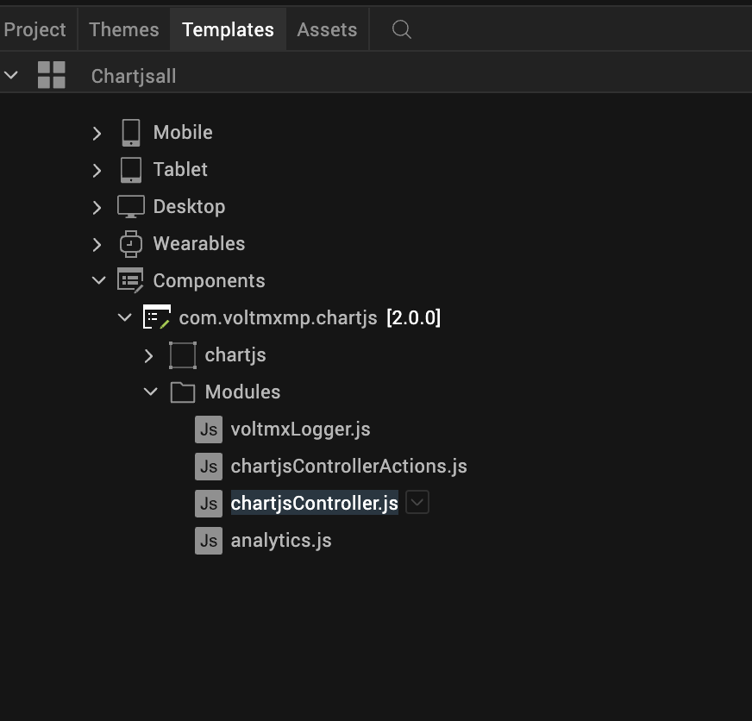

Once you have imported a component to your project, you can easily add the component to a form. For more information, refer Add a Component to a Form.

3.REFERENCES

A. Dynamic Usage
You can also add an Chart.js component dynamically. To do so:
- In the Project Explorer, on the Projects tab, click Controllers section to access the respective Form Controller. Create a method and implement the code snippet similar to the sample code mentioned below.
In the code snippet, you can edit the properties of the component as per your requirement. For more information, see Setting Properties.

//Type your controller code here
onNavigate: function() {
this.createComponent();
},
createComponent: function() {
/* Creating the component's object */
var chartjs = new com.voltmxmp.chartjs({
"height": "100%",
"id": "chartjs",
"isVisible": true,
"left": "0dp",
"masterType": constants.MASTER_TYPE_USERWIDGET,
"isModalContainer": false,
"skin": "slFbox",
"top": "0dp",
"width": "100%",
"appName": "Testchart",
"viewType": "chartjs",
"overrides": {}
}, {}, {});
chartjs.enableTitle = true;
chartjs.enableLegend = true;
chartjs.duration = 1000;
chartjs.noOfColumns = "2";
chartjs.gridChartDataSet = {
"data": [
// 1. Single Line Chart
{
"bgColor": "#ffffff",
"chartType": "Line",
"color": "#169fda",
"data": "[3000,2900,3300,3400,2800,2780,2550]",
"labels": "[January,February,March,April,May,June,July]",
"title": "Spending Trend (USD)"
},

// 2. Multi-Line Chart (2 lines)
{
"bgColor": "#ffffff",
"chartType": "Line",
"color": "Budget:[#169fda],Actual:[#ff6384]",
"data": "Budget:[3000,2900,3300,3400,2800,2780,2550],Actual:[3200,3100,3500,3600,3000,2900,2700]",
"labels": "[January,February,March,April,May,June,July]",
"title": "Budget vs Actual Spending (Multi-Line)"
},
// 3. Single Vertical Bar Chart
{
"bgColor": "#ffffff",
"chartType": "Vertical Bar",
"color": "#77be43",
"data": "[4500,4000,3500,3600,3400,3350,3800]",
"labels": "[January,February,March,April,May,June,July]",
"title": "Net Income over time (USD)"
},

// 4. Multi-Vertical Bar Chart (2 bars)
{
"bgColor": "#ffffff",
"chartType": "Vertical Bar",
"color": "2023:[#4bc0c0],2024:[#ff6384]",
"data": "2023:[500,450,600,550,480,520,590],2024:[520,480,650,580,510,560,620]",
"labels": "[Jan,Feb,Mar,Apr,May,Jun,Jul]",
"title": "Revenue by Year (Multi-Bar)"
},
// 5. Scatter chart
{
"chartType": "scatter",
"title": "Height vs Weight",
"labels": "[]",
"data": "[{\"x\":65,\"y\":75},{\"x\":59,\"y\":49},{\"x\":80,\"y\":90},{\"x\":81,\"y\":29},{\"x\":56,\"y\":36}]",
"color": "rgba(255,99,132,1)"
},

// 6. Single Horizontal Bar Chart
{
"bgColor": "#ffffff",
"chartType": "Horizontal Bar",
"color": "#77be43",
"data": "[199,250,220,255,230]",
"labels": "[Travel,Food & Dining,Shopping,Bills,Health]",
"title": "Budget (USD)"
},

// 7. Multi-Horizontal Bar Chart (2 bars)
{
"bgColor": "#ffffff",
"chartType": "Horizontal Bar",
"color": "Planned:[#77be43],Actual:[#ff6384]",
"data": "Planned:[199,250,220,255,230],Actual:[210,240,230,260,220]",
"labels": "[Travel,Food & Dining,Shopping,Bills,Health]",
"title": "Budget vs Actual (Multi-Horizontal Bar)"
},

// 8. Single Area Chart
{
"bgColor": "#ffffff",
"chartType": "Area",
"color": "#FF6B6B",
"data": "[8000,1900,3700,3400,2900,6200,8500]",
"labels": "[January,February,March,April,May,June,July]",
"title": "Spending Trend by Month (Area)",
"fillType": "origin"
},

// 9. Multi-Area Chart (2 areas)
{
"bgColor": "#ffffff",
"chartType": "Area",
"color": "Revenue:[#4bc0c0],Expenses:[#ff6384]",
"data": "Revenue:[8000,8500,9000,8800,9200,9500,9800],Expenses:[9000,8600,9100,5300,5600,5800,6000]",
"labels": "[Jan,Feb,Mar,Apr,May,Jun,Jul]",
"title": "Revenue vs Expenses (Multi-Area)",
"fillType": "origin"
},

// 10. Mixed Chart: Line + Bar
{
"bgColor": "#ffffff",
"chartType": "bar",
"color": "Temperature:[#ff6384],Rainfall:[#36a2eb]",
"data": "Temperature:[25,28,30,32,35,33,30],Rainfall:[50,45,60,55,70,65,60]",
"labels": "[Week1,Week2,Week3,Week4,Week5,Week6,Week7]",
"title": "Weather Data (Mixed: Line + Bar)",
"chartTypes": "Temperature:line,Rainfall:bar"
},

// 11. Doughnut Chart (for variety)
{
"bgColor": "#ffffff",
"chartType": "Doughnut",
"color": "[#169fda,#f36b25,#77be43,#ffc522,#97cce9]",
"data": "[250,190,120,100,80]",
"labels": "[Travel,Food & Dining,Shopping,Bills,Health & Fitness]",
"title": "Spend by Category (USD)"
},

// 12. Radar Chart (Multi-dataset)
{
"bgColor": "#ffffff",
"chartType": "Radar",
"color": "Budget:[#77be43],Spending:[#169fda]",
"data": "Budget:[199,250,220,255,230],Spending:[250,190,120,100,80]",
"labels": "[Travel,Food & Dining,Shopping,Bills,Health]",
"title": "Budget vs Spending (Radar)"
},

// 13. Pie Chart
{
"bgColor": "#ffffff",
"chartType": "Pie",
"color": "[#97cce9,#ffc522,#77be43,#f36b25,#169fda]",
"data": "[45,60,80,110,145]",
"labels": "[Starbucks,iTunes,Uber,Amazon,Walmart]",
"title": "Spend by Merchants (USD)"
},
//14.Polararea Chart
{
"bgColor": "",
"chartType": "PolarArea",
"color": "[#f36b25,#77be43,#ffc522,#97cce9]",
"data": "[190,170,140,115]",
"labels": "[Week 1, Week 2,Week 3,Week 4]",
"title": "Week over Week Spending (USD)"
}
]
};
chartjs.fontsize = "12";
chartjs.renderType = true;
chartjs.titlePosition = "top";
chartjs.legendPosition = "top";
chartjs.easing = "easeOutQuart";
chartjs.fontfamily = "Helvetica";
chartjs.fontstyle = "normal";
chartjs.fontcolor = "black";

this.view.add(chartjs);
}
});

- Save the file.
B. Properties
The properties provided on the Component tab allow you to customize the UI elements in the Chart.js component. You can set the properties directly on the Component tab or by writing a JavaScript.
1. Render Automatic
Category: | Custom
Description: | Specifies the type of rendering (automatic or forced). If you use a true component, the chart is rendered automatically. But in other cases, the render API must be called to display the charts.
Syntax: | renderType
Type: | boolean
Read/Write: | Write
Example: | this.view.<component_id>.renderType = true;
2. Data set
Category: | Custom
Description: | Specifies the input data set such as color, labels, and chart type. The data is then displayed in a chart format. Every row in the datagrid generates a chart.
Syntax: | gridChartDataSet
Type: | Data Grid
Read/Write: | Read + Write
Example:
  this.view. < component_id > .gridChartDataSet = {
  "data":
  [ "data": [
  // 1. Single Line Chart
  {
  "bgColor": "#ffffff",
  "chartType": "Line",
  "color": "#169fda",
  "data": "[3000,2900,3300,3400,2800,2780,2550]",
  "labels": "[January,February,March,April,May,June,July]",
  "title": "Spending Trend (USD)"
  },
  // 2. Multi-Line Chart (2 lines)
  {
  "bgColor": "#ffffff",
  "chartType": "Line",
  "color": "Budget:[#169fda],Actual:[#ff6384]",
  "data": "Budget:[3000,2900,3300,3400,2800,2780,2550],Actual:[3200,3100,3500,3600,3000,2900,2700]",
  "labels": "[January,February,March,April,May,June,July]",
  "title": "Budget vs Actual Spending (Multi-Line)"
  },
  // 3. Single Vertical Bar Chart
  {
  "bgColor": "#ffffff",
  "chartType": "Vertical Bar",
  "color": "#77be43",
  "data": "[4500,4000,3500,3600,3400,3350,3800]",
  "labels": "[January,February,March,April,May,June,July]",
  "title": "Net Income over time (USD)"
  },
  //4 . Scatter Chart
  {
  "chartType": "scatter",
  "title": "Height vs Weight",
  "label": "Student Data",
  "data": "[{\"x\":150,\"y\":50},{\"x\":160,\"y\":60},{\"x\":170,\"y\":65},{\"x\":175,\"y\":72},{\"x\":180,\"y\":80}]",
  "color": "rgba(255,99,132,1)",
  "backgroundColor": "rgba(255,99,132,0.2)"
  },
  //5. Multi-Vertical Bar Chart (2 bars)
  {
  "bgColor": "#ffffff",
  "chartType": "Vertical Bar",
  "color": "2023:[#4bc0c0],2024:[#ff6384]",
  "data": "2023:[500,450,600,550,480,520,590],2024:[520,480,650,580,510,560,620]",
  "labels": "[Jan,Feb,Mar,Apr,May,Jun,Jul]",
  "title": "Revenue by Year (Multi-Bar)"
  },
  // 6. Single Horizontal Bar Chart
  {
  "bgColor": "#ffffff",
  "chartType": "Horizontal Bar",
  "color": "#77be43",
  "data": "[199,250,220,255,230]",
  "labels": "[Travel,Food & Dining,Shopping,Bills,Health]",
  "title": "Budget (USD)"
  },
  // 7. Multi-Horizontal Bar Chart (2 bars)
  {
  "bgColor": "#ffffff",
  "chartType": "Horizontal Bar",
  "color": "Planned:[#77be43],Actual:[#ff6384]",
  "data": "Planned:[199,250,220,255,230],Actual:[210,240,230,260,220]",
  "labels": "[Travel,Food & Dining,Shopping,Bills,Health]",
  "title": "Budget vs Actual (Multi-Horizontal Bar)"
  },
  // 8. Single Area Chart
  {
  "bgColor": "#ffffff",
  "chartType": "Area",
  "color": "#FF6B6B",
  "data": "[8000,1900,3700,3400,2900,6200,8500]",
  "labels": "[January,February,March,April,May,June,July]",
  "title": "Spending Trend by Month (Area)",
  "fillType": "origin"
  },
  // 9. Multi-Area Chart (2 areas)
  {
  "bgColor": "#ffffff",
  "chartType": "Area",
  "color": "Revenue:[#4bc0c0],Expenses:[#ff6384]",
  "data": "Revenue:[8000,8500,9000,8800,9200,9500,9800],Expenses:[9000,8600,9100,5300,5600,5800,6000]",
  "labels": "[Jan,Feb,Mar,Apr,May,Jun,Jul]",
  "title": "Revenue vs Expenses (Multi-Area)",
  "fillType": "origin"
  },
  // 10. Mixed Chart: Line + Bar
  {
  "bgColor": "#ffffff",
  "chartType": "bar",
  "color": "Temperature:[#ff6384],Rainfall:[#36a2eb]",
  "data": "Temperature:[25,28,30,32,35,33,30],Rainfall:[50,45,60,55,70,65,60]",
  "labels": "[Week1,Week2,Week3,Week4,Week5,Week6,Week7]",
  "title": "Weather Data (Mixed: Line + Bar)",
  "chartTypes": "Temperature:line,Rainfall:bar"
  },
  // 11. Doughnut Chart (for variety)
  {
  "bgColor": "#ffffff",
  "chartType": "Doughnut",
  "color": "[#169fda,#f36b25,#77be43,#ffc522,#97cce9]",
  "data": "[250,190,120,100,80]",
  "labels": "[Travel,Food & Dining,Shopping,Bills,Health & Fitness]",
  "title": "Spend by Category (USD)"
  },
  // 12. Radar Chart (Multi-dataset)
  {
  "bgColor": "#ffffff",
  "chartType": "Radar",
  "color": "Budget:[#77be43],Spending:[#169fda]",
  "data": "Budget:[199,250,220,255,230],Spending:[250,190,120,100,80]",
  "labels": "[Travel,Food & Dining,Shopping,Bills,Health]",
  "title": "Budget vs Spending (Radar)"
  },
  // 13. Pie Chart
  {
  "bgColor": "#ffffff",
  "chartType": "Pie",
  "color": "[#97cce9,#ffc522,#77be43,#f36b25,#169fda]",
  "data": "[45,60,80,110,145]",
  "labels": "[Starbucks,iTunes,Uber,Amazon,Walmart]",
  "title": "Spend by Merchants (USD)"
  },
  //14.Polarareachart
  {
  "bgColor": "",
  "chartType": "PolarArea",
  "color": "[#f36b25,#77be43,#ffc522,#97cce9]",
  "data": "[190,170,140,115]",
  "labels": "[Week 1, Week 2,Week 3,Week 4]",
  "title": "Week over Week Spending (USD)"
  }
  ]
- No of Columns

Category: | Custom
Description: | Specifies the number of columns to be displayed in Responsive Web and Tablet. Not applicable for Mobile. In Mobile, the charts are always displayed in one column.
Syntax: | noOfColumns
Type: | String/Integer
Read/Write: | Write
Example: | this.view.<component_id>.noOfColums = 2;
- Enable Legend
Category: | Custom
Description: | Enables the visibility of the chart legends.
Syntax: | enableLegend
Type: | Boolean
Read/Write: | Write
Example: | this.view.<component_id>.enableLegend = true;
- Legend Position
Category: | Custom
Description: | Enables you to set the position of the legends in the chart.
Syntax: | legendPosition
Type: | String
Read/Write: | Write
Example: | this.view.<component_id>.legendPosition = "top";
- Enable Title
Category: | Custom
Description: | Enables the visibility of the chart title.
Syntax: | enableTitle
Type: | Boolean
Read/Write: | Write
Example: | this.view.<component_id>.enableTitle = true;

7. Title Position
Category: | Custom
Description: | Enables you to set the position of the title in the chart.
Syntax: | titlePosition
Type: | String
Read/Write: | write
Example: | this.view.<component_id>.titlePosition= "top";
8. Duration
Category: | Custom
Description: | Specifies the time taken by the animation in milliseconds. If animation is not required, you must set the value of duration as 0.
Syntax: | duration
Type: | Integer
Read/Write: | write
Example: | this.view.<component_id>.duration = 1000;
9. Easing
Category: | Custom
Description: | Sets the type of animation in the chart.
Syntax: | easing
Type: | String
Example: | this.view.<component_id>.easing = "easeOutQuart";
Read/Write: | write

10. Font Color
Category: | Custom
Description: | Specifies the font color of the displayed text.
Syntax: | fontcolor
Type: | String
Example: | this.view.<component_id>.fontcolor = "#232425";
Read/Write: | write

10. Font Size
Category: | Custom
Description: | Specifies the font size of the displayed text. By default, the size is measured in pixels (px).
Syntax: | fontsize
Type: | String
Example: | this.view.<component_id>.fontsize = "12";
Read/Write: | write
11. Font Family
Category: | Custom
Description: | Specifies the font family of the displayed text.
Syntax: | fontfamily
Type: | String
Read/Write: | write
Example: | this.view.<component_id>.fontfamily = "Arial";
12. Font Style
Category: | Custom
Description: | Specifies the font style of the displayed text.  Note:  The fontstyle property does not apply to tooltip, footer, and title of the chart.
Syntax: | fontstyle
Type: | String
Read/Write: | write
Example: | this.view.<component_id>.fontstyle = "normal";
C. Events
The Chart.js component invokes events when its corresponding action is performed. You can configure any logic that you want the component to perform whenever an event occurs. The events can be configured directly from the Actions tab or by writing a JavaScript snippet.1. errorCallback
Category: | Custom
Description: | The event is invoked when an error occurs.
Syntax: | errorCallback
Example: | this.view. < component_id > .errorCallback = function(errorObject) {  alert(errorObject);  }
- APIs
You can use the following APIs for Chart.js component:
1. render
Description: | Renders or displays the charts as per the data provided through Properties. This API is called initially to render any chart.
Syntax: | render()
Example: | this.view.<component_id>.render();
2. createChart
Description: | Creates and displays charts based on the data that you provide in the parameters.  The createChart API helps you to create
Syntax: | createChart(noOfColumns,dataObject,globalConfigurations)
Parameters: | - noOfColumns  Specifies the number of columns to be displayed in Responsive Web and Tablet.  - dataObject  Specifies the data and other configuration options for every chart. For more information on configuration options for different chart types.  dataObject : {  "<chart_ID>" : {  "type" : "chart type",  "data" : "chart Data",  "options" : "chart options"  }  }  - globalConfigurations  Global configurations allow you to change options globally across all the charts generated using the component, avoiding the need to specify options for each instance. These properties control styling, fonts, legends, and more. For more information on the globalConfigurations parameter.  {  "defaultColor" : "#234354",  "defaultFontColor" : "#000000",  "animation" : {  "duartion" : 1000,  "easing" : "easeOutQuart"  },  "events" : ["mosuemove"],  "hover" : {  "animationDuration" : 400,  "mode" : "nearest"  },  "layout" : {  "padding" : {  "top" : 0  }  },  "legend" : {  "display" : true  },  "plugins" : {  "responsive" : true  },  "title" : {  "display" : true,  "fontStyle" : "bold"  },  "tooltips" : {  "backgroundColor" : "#000000",  "caretSize" : 5  }  }
Example: | define({  onBtnRenderChartClick: function() {  try {  this.renderCharts();  } catch(e) {  alert("Error in button click: " + e.message);  }  },  renderCharts: function() {  try {  var chartjs = new com.voltmxmp.chartjs({  "clipBounds": true,  "height": "80%",  "id": "chartjs",  "isVisible": true,  "left": "0dp",  "top": "100dp",  "width": "100%",  "zIndex": 1  }, {}, {});  this.view.add(chartjs);  chartjs.enableTitle = true;  chartjs.titlePosition = "top";  chartjs.enableLegend = true;  chartjs.legendPosition = "top";  var chartData = [  // ---- Existing Charts ----  {  title: "Spending Trend (USD)",  chartType: "area",  labels: "[January,February,March,April,May,June,July]",  data: "[3000,2900,3300,3400,2800,2780,2550]",  color: "rgba(32, 99, 155, 0.8)",  fillType: "origin"  },  {  title: "Spend by Category (USD)",  chartType: "doughnut",  labels: "[Travel,Food & Dining,Shopping,Bills,Health & Fitness]",  data: "[250,190,120,100,80]",  color: "[#ED553B,#F6D55C,#3CAEA3,#20639B,#172F5F]"  },  {  title: "Net Income over time (USD)",  chartType: "vertical",  labels: "[January,February,March,April,May,June,July]",  data: "[4500,4000,3500,3600,3400,3350,3800]",  color: "#3CAEA3"  },  {  title: "Budget (USD)",  chartType: "horizontal",  labels: "[Travel,Food & Dining,Shopping,Bills,Health & Fitness]",  data: "[199,250,220,255,230]",  color: "#3CAEA3"  },  {  title: "Budget vs Spending (USD)",  chartType: "radar",  labels: "[Travel,Food & Dining,Shopping,Bills,Health & Fitness]",  data: "Budget:[199,250,220,255,230],Spending:[250,190,120,100,80]",  color: "Budget:[rgba(60,174,163,0.5)],Spending:[rgba(237,85,59,0.5)]"  },  {  title: "Week over Week Spending (USD)",  chartType: "polar",  labels: "[Week 1,Week 2,Week 3,Week 4]",  data: "[190,170,140,115]",  color: "[#F6D55C,#3CAEA3,#20639B,#172F5F]"  },  {  title: "Spend by Merchants (USD)",  chartType: "pie",  labels: "[Starbucks,iTunes,Uber,Amazon,Walmart]",  data: "[45,60,80,110,145]",  color: "[#ED553B,#F6D55C,#3CAEA3,#20639B,#172F5F]"  },  // ---- NEW SCATTER CHART ----  {  title: "Height vs Weight (Scatter)",  chartType: "scatter",  labels: "[Point1,Point2,Point3,Point4,Point5]",  data: "[{x:150,y:50},{x:160,y:60},{x:170,y:65},{x:180,y:75},{x:190,y:85}]",  color: "rgba(54,162,235,0.8)"  },  // ---- NEW MIXED CHART (Bar + Line) ----  {  title: "Revenue vs Profit (Mixed)",  chartType: "mixed",  labels: "[Jan,Feb,Mar,Apr,May]",  data: "Revenue:[5000,6000,7000,6500,7200],Profit:[1200,1500,1700,1600,1800]",  color: "Revenue:[rgba(54,162,235,0.5)],Profit:[rgba(255,99,132,0.8)]",  mixedTypes: "Revenue:bar,Profit:line"  }  ];  var dataObject = {  data: chartData  };  var globalConfig = {  animation: {  duration: 1000,  easing: "easeOutQuart"  }  };  chartjs.createChart(2, dataObject, globalConfig);  alert("Charts rendered successfully!");  } catch (exception) {  alert("Error rendering charts: " + exception.message);  }  }  });
For more information on how to create a chart by using Chart.js, click here.

4. REVISION HISTORY
App version :2.0.0

- Known Issues
No known issues
B. Limitations

1. Mobile & Tablet Constraint: On smaller screens (mobile ~375px, tablet ~768px), the component automatically reduces columns to 1-2 regardless of the configured "Number of Columns" property, as more columns cannot physically fit within the available viewport width.

2.Desktop Variation: Desktop displays show the full configured column count (e.g., 4 columns) only when sufficient screen width is available. macOS screens (~1400px) support up to 5 columns, while Windows screens may cap at 4 columns depending on resolution and scaling.

