Date : 19-DEC-25

CEREBRAS APPLICATION

VERSION: 1.0.0

OVERVIEW
The Cerebras API provides advanced text generation and completion capabilities, enabling applications to produce high-quality, contextually accurate text. It supports fine-grained control over output style, length, creativity, and formatting using natural language instructions. Cerebras is optimized for interactive text generation—making it ideal for applications such as content creation, summarization, question-answering, and conversational AI.

Use case:
- Content Creation & Writing Assistance: Generate high-quality text for articles, blogs, or creative writing with controlled style and tone.
- Conversational AI & Chatbots: Provide contextually accurate, human-like responses for virtual assistants or customer support.
- Summarization & Knowledge Extraction: Condense long documents or extract key insights efficiently.
- Education & E-Learning: Produce clear explanations, tutorials, or interactive learning content.
- Marketing & Media Production: Create engaging copy for ads, social media, or scripts with consistent quality

Features:
- Controllable Text Generation: Adjust style, tone, creativity, and structure using natural language prompts.
- Context-Aware Responses: Maintain coherence and relevance across multi-turn interactions.
- High-Quality, Natural Text: Delivers accurate, human-like writing output.
- Fine-Grained Output Control: Ideal for structured scenarios like storytelling, summarization, or guided dialogues.
- Seamless API Integration: Easily integrates with applications for automated text generation.

Percentage of re-use:
80%

GETTING STARTED

Prerequisites
Before you start using the Cerebras App, ensure you have the following:
- HCL Foundry
- Volt MX Iris
- https://cloud.cerebras.ai/platform/org_nf9cpwh9tckcfx2vd28hc333/apikeys

Devices
- Mobile

Platforms
- Android
- IOS

Importing the App
To import the Cerebras App to Volt MX Iris, do the following:

To import the Cerebras App, do the following:
- Launch Volt MX Iris.
- Click project, and then select Import. The Import dialog box appears.
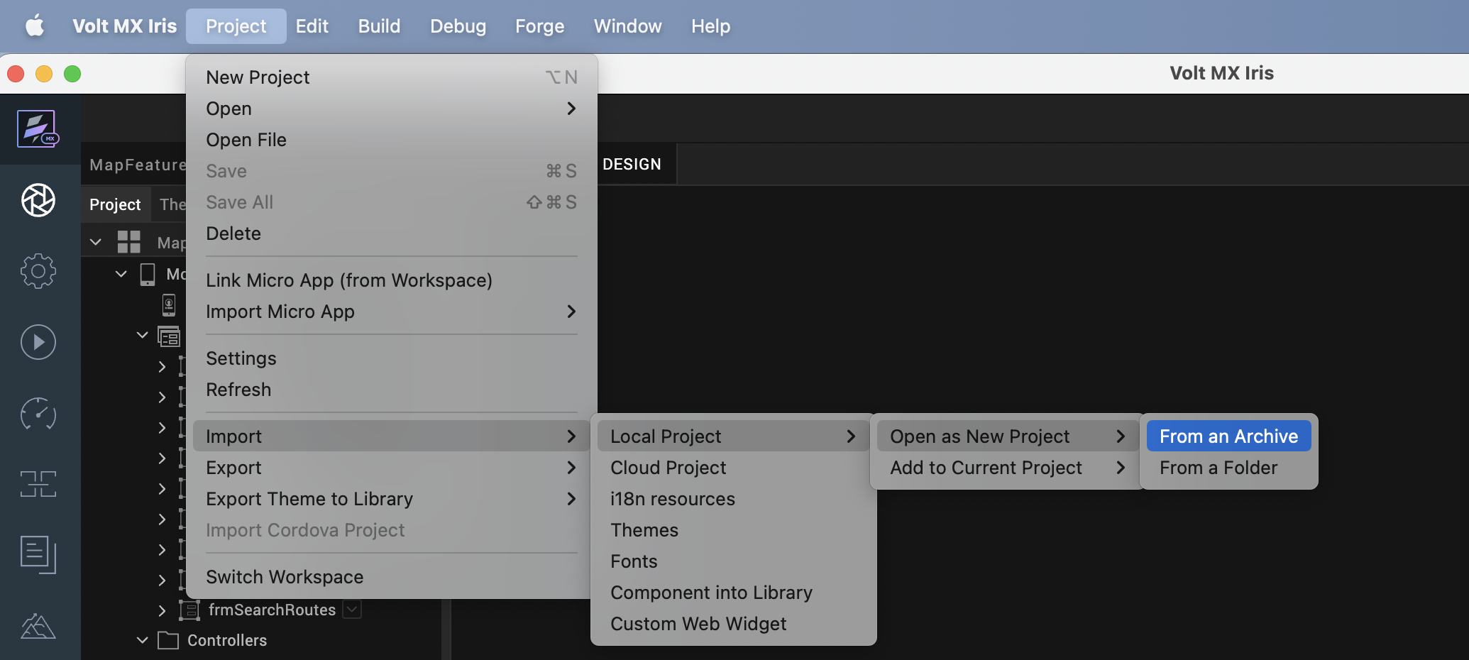

- Click From an Archive to navigate to the location of the project, select the files, and then click Import.
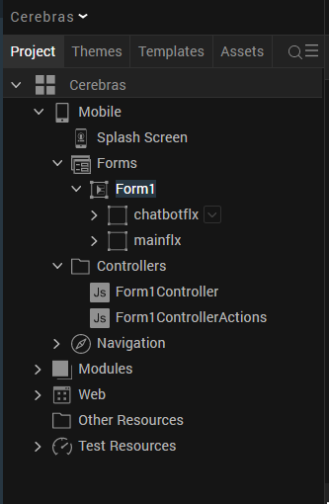
After you import the application, you can view the associated Foundry app connected at the in Data & Services section.
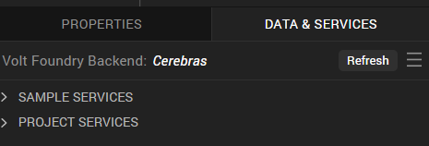

Cerebras Volt MX Foundry Services:
The Cerebras app contains an Integration Service:
Cerebras: The Cerebras API offers advanced text generation and completion capabilities, producing high-quality, contextually accurate text. It allows fine-grained control over style, tone, creativity, and structure using natural language instructions. Cerebras is optimized for interactive text generation—ideal for applications like content creation, chatbots, summarization, and educational materials.
Operations
createChatCompletion
This operation invokes foundation models hosted on Cerebras Inference to generate AI responses for tasks such as text generation, summarization, and conversational AI.
Inputs include:
- prompt / messages – User input or conversation history
- model – Selected Cerebras-supported model
- temperature – Controls randomness of the output
- top_p – Controls nucleus sampling
- max_tokens – Maximum number of tokens to generate
- stop sequences (optional) – Tokens that stop generation
The operation processes the input using the selected Cerebras model and returns a generated response optimized for speed and scalability.

Building the app
From the menu bar, go to Build and then select Build Native Local.
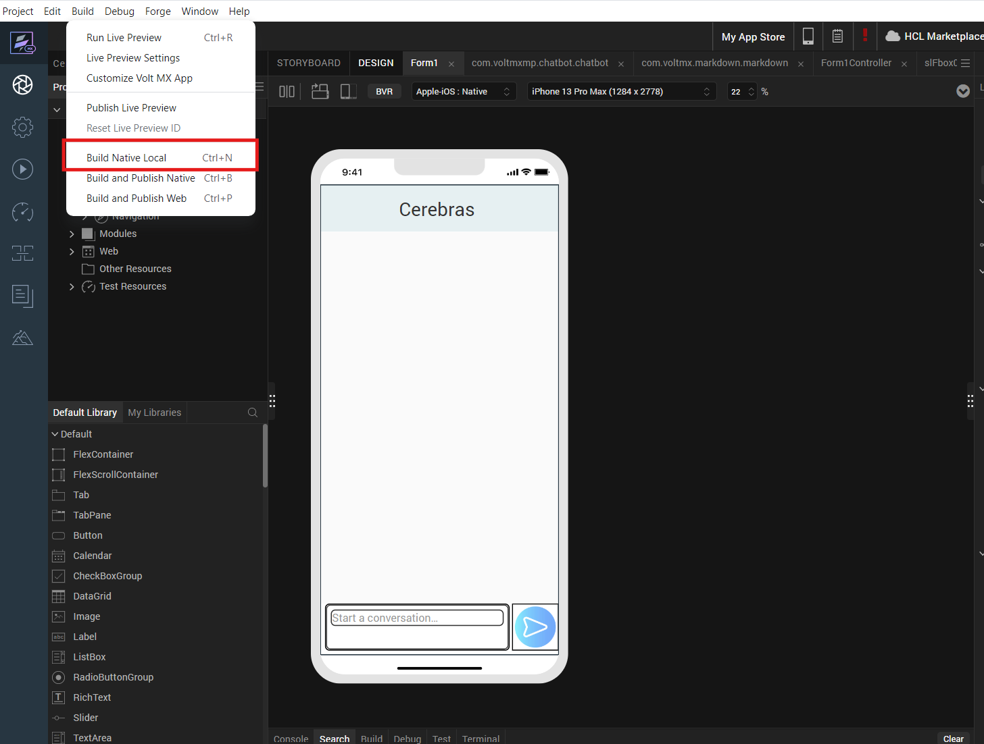

For Mobile, select Android and iOS. Click Build.
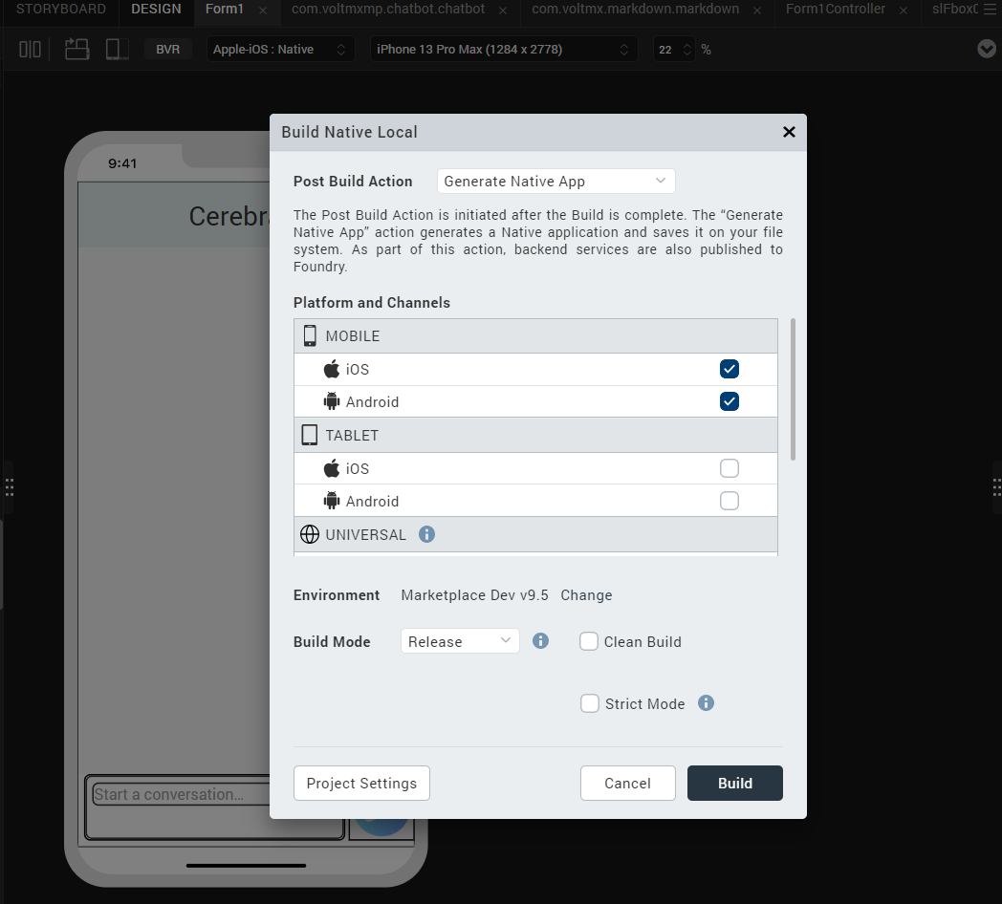

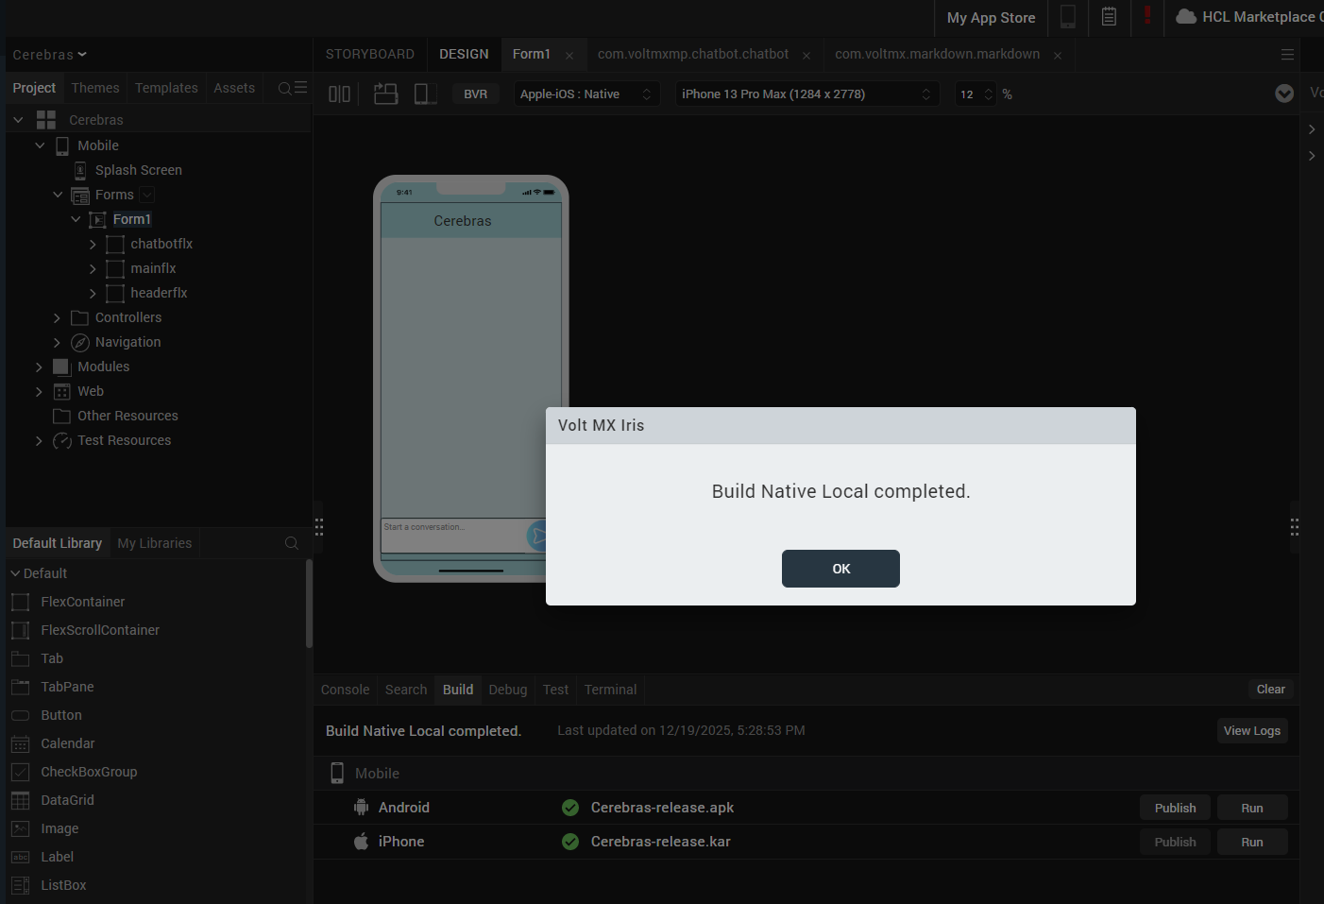

After the build is successful, run the app on your mobile device.

G. Application Flow
The landing page for the app is as follows:

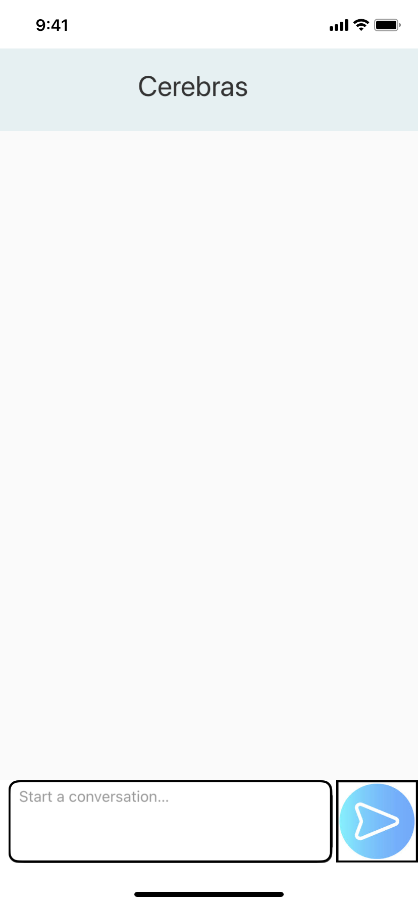
Enter text to generate text generation and summarization questions.

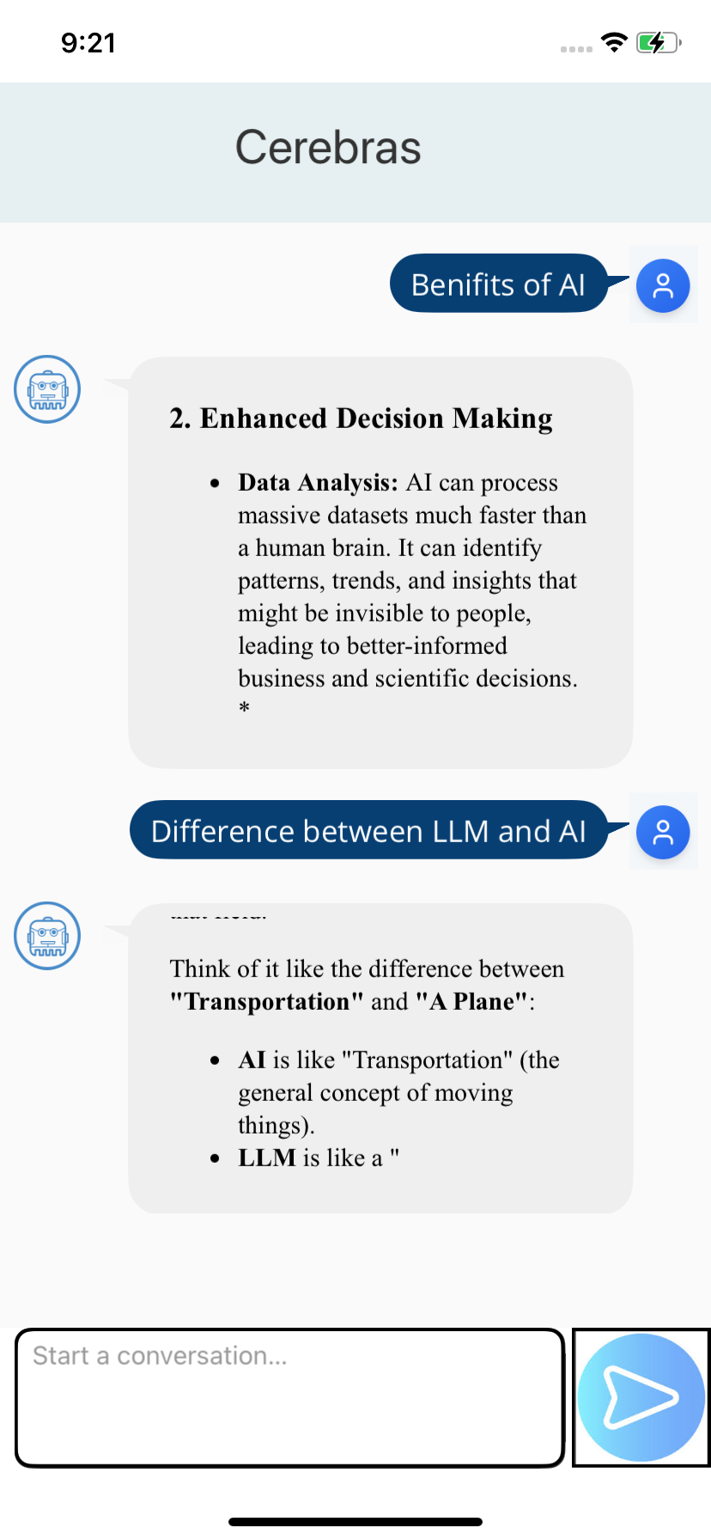
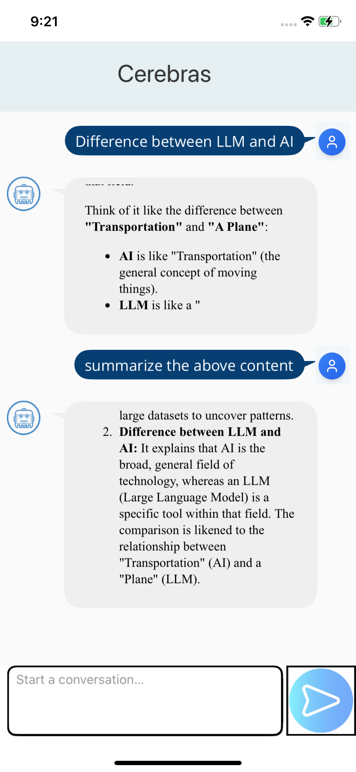

REVISION HISTORY
App version 1.0.0:

A. Limitations
1. Do not have support for Landscape mode.

B. Known Issue
- NA

