Date : 29/9/2021

Carousel (1.0.1)
- Overview For Carousel
Carousel is a front-end component that displays a list of images in the form of a scrollable catalog. The component supports automatic scrolling and infinite scrolling.
You can customize the size, scrolling direction, animation speed, and the delay for automatic scrolling. You can use the component in scenarios where you want to add a list of images in a fixed space such as an item catalog or an image gallery.

Use case
The component can be used in scenarios where you want to add a list of images in a fixed space such as an item catalog or an image gallery

Features
- The component supports automatic scrolling and infinite scrolling
- The size, scrolling direction, animation speed, and the delay for automatic scrolling are customizable as required

Percentage of re-use:
80-90% re-use.

Getting Started

Prerequisites
Before you start using the CarouselVue component, ensure the following:
- HCL Foundry
- Volt MX Iris

Note: In this component we can see the Carousel and Vue Carousel Components Carousel Component is for Mobiles & Tablets.
Vue carousel Component is for PWA (Overview Of Vue Carousel)

Platforms Supported

Mobile

iOS

Android

Tablets

PWA

Importing the Component

You can import the Forge components only into the apps that are of the Reference Architecture type.

To import the CarouselVue component, do the following:

Open your app project in Volt MX Iris.
- In the Project Explorer, click the Templates tab.

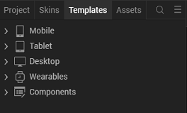

3.Right-click Components, and then select Import Component. The Import Component dialog box appears.
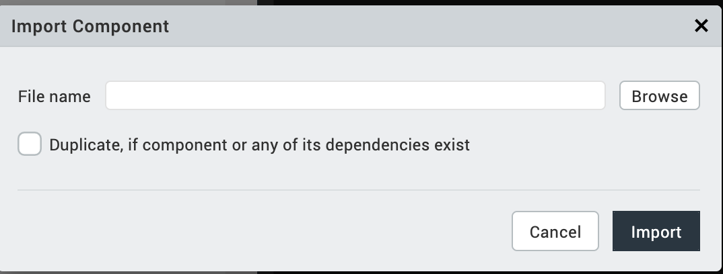
4.Click Browse to navigate to the location of the component, select the component, and then click Import. The component and its associated widgets and modules are added to your project.

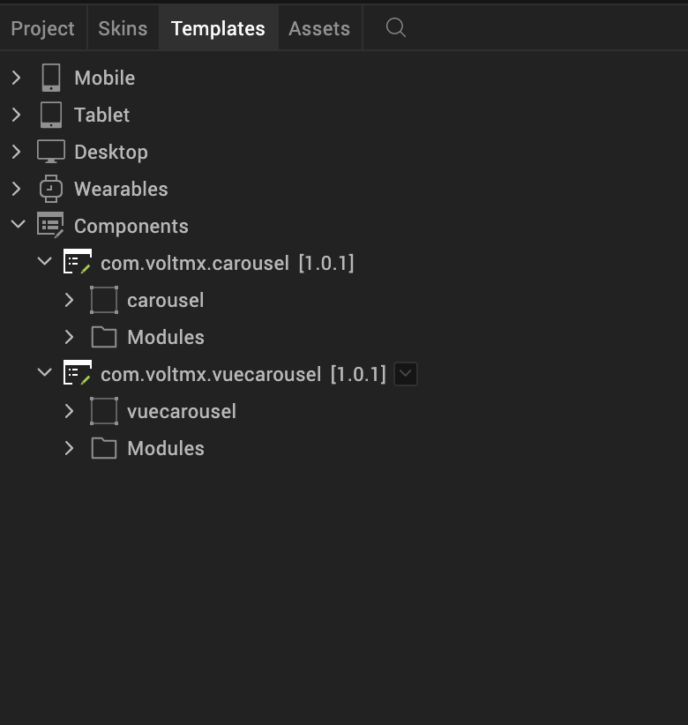

Once you have imported a component to your project, you can easily add the component to a form. For more information, refer Add a Component to a Form.

Building and previewing the app
After performing all the above steps, you can build your app and run it on your device. For more information, you can refer to the Building and Viewing an Application section of the VoltMx Iris User Guide.
You can then run your app to see the CarouselVue work in real time.

References

Dynamic Usage of Carousel
You can also add a Carousel component dynamically. To do so,
- In the Project Explorer, on the Projects tab, click Controllers section to access the respective Form Controller. Create a method and implement the code snippet similar to the sample code mentioned below.
createComponent: function()
{
/* Creating the component's object */
var carousel = new com.voltmx.carousel(
{
"clipBounds": true,
"height": "100%",
"id": "carousel",
"isVisible": true,
"left": "0dp",
"top": "0dp",
"width": "100%",
"zIndex": 1
}, {}, {});

/* Setting the component's properties */
carousel.data =
{
"data":
[
{"DefaultColumn": "Image1.png"},
{"DefaultColumn": "Image2.png"},
{"DefaultColumn": "Image3.png"},
{"DefaultColumn": "Image4.png"}
]
};
carousel.flexTop = "10";
carousel.flexLeft = "30";
carousel.flexWidth = "40";
carousel.flexHeight = "70";
carousel.animationSpeed = "Medium";
carousel.animationDirection = "Horizontal";
carousel.autoScroll = true;
carousel.autoScrollDelay = 1;
carousel.animateInLoop = false;
this.view.add(carousel);

}
In the code snippet, you can edit the properties of the component as per your requirement. For more information, see Setting Properties.
- Save the file.

.

Properties
You can use a component's Properties to customize and configure the elements. These elements can be UI elements, service parameters, and so on. For more information about properties, you can refer to the Components Overview section of the VoltMx Iris User Guide.
You can set the properties from the VoltMx Iris's Properties panel on the right hand side. You can also configure these properties using a JavaScript code.

General Properties
1. Data(data)
Description: | Specifies the list of images that you want to display on the carousel.
Syntax: | data
Type: | - Data Grid  - Array of JSON
Read/Write: | Write
Remarks: | - You can provide the images as local files or URLs.  - If you want to use local files, make sure that the files exist in the resources\common folder.
Example: | var imageData =  [  {  "MyColumnOne": "Image1.png"  },  {  "MyColumnOne": "Image2.png"  },  {  "MyColumnOne": "Image3.png"  },  {  "MyColumnOne": "Image4.png"  }  ]  this.view.componentID.data = imageData;

2. Animation Speed(animationSpeed)
Description: | Specifies the speed that you want to set for the scrolling animation.
Syntax: | animationSpeed
Type: | 1 . List Selector  2 . String
Read/Write: | Write
Values: | 1 . Medium  2 . Slow  3 . Fast
Default Value: | Medium
3. Animation Direction(animationDirection)
Description: | Specifies the direction that you want to set for the scrolling animation.
Syntax: | animationDirection
Type: | 1. List Selector  2. String
Read/Write: | Write
Values: | 1 .Horizontal  2 .Vertical
Default Value: | Horizontal
Example: | this.view.componentID.animationDirection = "Horizontal";

4. Auto Scroll(autoSroll)
Description: | Enables or disables the automatic scrolling of the carousel.
Syntax: | autoScroll
Type: | Boolean
Read/Write: | Write
Default Value: | false

5. Auto Scroll Delay(autoSrollDelay)

Description: | Specifies the time that you want to set before the carousel automatically scrolls.
Syntax: | autoScrollDelay
Type: | Integer
Read/Write: | Write
Default Value: | 1
Remarks: | The component uses the Auto Scroll Delay value only when Auto Scroll is enabled.

6.Animate In Loop(animateInLoop)
Description: | Enables or disables the infinite scrolling feature of the carousel.
Syntax: | animateInLoop
Read/Write: | Write

Default Value: | false
Example: | this.view.componentID.animateInLoop = true;

Flex Properties In Percentage

1 . Top(flexTop)
Description: | Specifies the position of the top edge of the carousel (in percentage).
Syntax: | flexTop
Type: | String
Read/Write: | Write
Example: | this.view.componentID.flexTop = "10";

2 . Left(flexLeft)
Description: | Specifies the position of the left edge of the carousel (in percentage).
Syntax: | flexLeft
Type: | String
Read/Write: | Write
Example: | this.view.componentID.flexLeft = "30";

3 . Width(flexWidth)
Description: | Specifies the width of the carousel (in percentage).
Syntax: | flexWidth
Type: | String
Read/Write: | Write
Example: | this.view.componentID.flexWidth = "40";

4 . Height(flexHeight)
Description: | Specifies the height of the carousel (in percentage).
Syntax: | flexHeight
Type: | String
Read/Write: | Write
Example: | this.view.componentID.flexHeight = "70";

Events

----No events

APIs

--No APIs are exposed.

Overview Of Vue Carousel

Carousel - vue.js is a catalog of slides that is created by using vue.js. Under the hood, the component uses resources from Vue Carousel 3D.
The component contains set of images that can scroll horizontally. Clicking a slide scrolls the carousel in the specified direction and brings the selected slide to the front.
The carousel also supports touch inputs, therefore, on Adaptive Web (Mobile SPA), dragging the images in one direction scrolls the carousel.
You can add custom images on the carousel by using local files or by using URLs. You can also customize the UI of the carousel by using CSS.
You can use the component in scenarios such as: a retail app, where you want to include a catalog of product categories.

1.References

A. Dynamic Usage of Carousel
createComponent: function()
{
/* Creating the component's object */
var vueCarousel = new com.voltmx.vuecarousel(
{
"clipBounds": true,
"height": "100%",
"id": "vueCarousel",
"isVisible": true,
"left": "0dp",
"top": "0dp",
"width": "100%",
"zIndex": 1
}, {}, {});

/* Setting the component's properties */
vueCarousel.masterData =
{
"data":
[
{
"image": "https://i1.wp.com/www.centralofsuccess.com/wp-content/uploads/2019/03/25-Great-Inspirational-Quotes-and-Motivational-Quotes-8.jpg"
},
{
"image": "https://i.pinimg.com/originals/95/cb/ab/95cbab34670fac85105457fc949a70eb.png"
},
]
};

/* Adding the component to a form */
this.view.add(vueCarousel);
}

To execute the code, you need to call the createComponent function.

2.Save the file.

.

B. Properties of Vue carousel

1. Master Data
Description : Specifies the URLs of the images that you want to display on the carousel.

Syntax: masterData

Type: 1 . Data Grid

2 .JSON
Read/Write: Write
Example:
this.view.componentID.masterData =
{
"data":
[
{
"image": "img1.png"
},
{
"image": "img2.png"
},
]
};

Images for Vue Carousel should either be remote, or imported into Web > LocalFiles > VueCarousel

c. Events Of Vue Carousel

1. onAfterSlideChange
Description: | Invoked after the slide-change transition ends.
Syntax: | onAfterSlideChange
Parameters: | param [Number] :  The ID of the slide that is selected from the carousel.
Example: | this.view.componentID.onAfterSlideChange = function(param)  {  alert("Slide Changed. Slide ID: "+param);  }.bind(this);

2 . onBeforeSlideChange
Description: | Invoked when the user selects a slide and scrolls the carousel.
Syntax: | onBeforeSlideChange
Parameters: | param [Number] :  The ID of the slide that is selected from the carousel.
Example: | this.view.componentID.onBeforeSlideChange = function(param)  {  alert("Changing Slides. Slide ID: "+param);  }.bind(this);

3 . onlastSlide
Description: | Invoked when the user selects the last slide in the carousel.
Syntax: | onLastSlide
Parameters: | param [Number] :  The ID of the last slide in the carousel.
Example: | this.view.componentID.onLastSlide = function(param)  {  alert("Scrolled to last slide. Slide ID: "+param);  }.bind(this);

4 . errorCallback
Description: | Invoked when an error occurs in the component.
Syntax: | errorCallback
Parameters: | errObj [JSON] :  Contains information about the error, such as the error code and the error message.
Example: | this.view.componentID.errorCallback = function(errObj)  {  alert("Error: "+JSON.stringify(errObj));  }.bind(this);

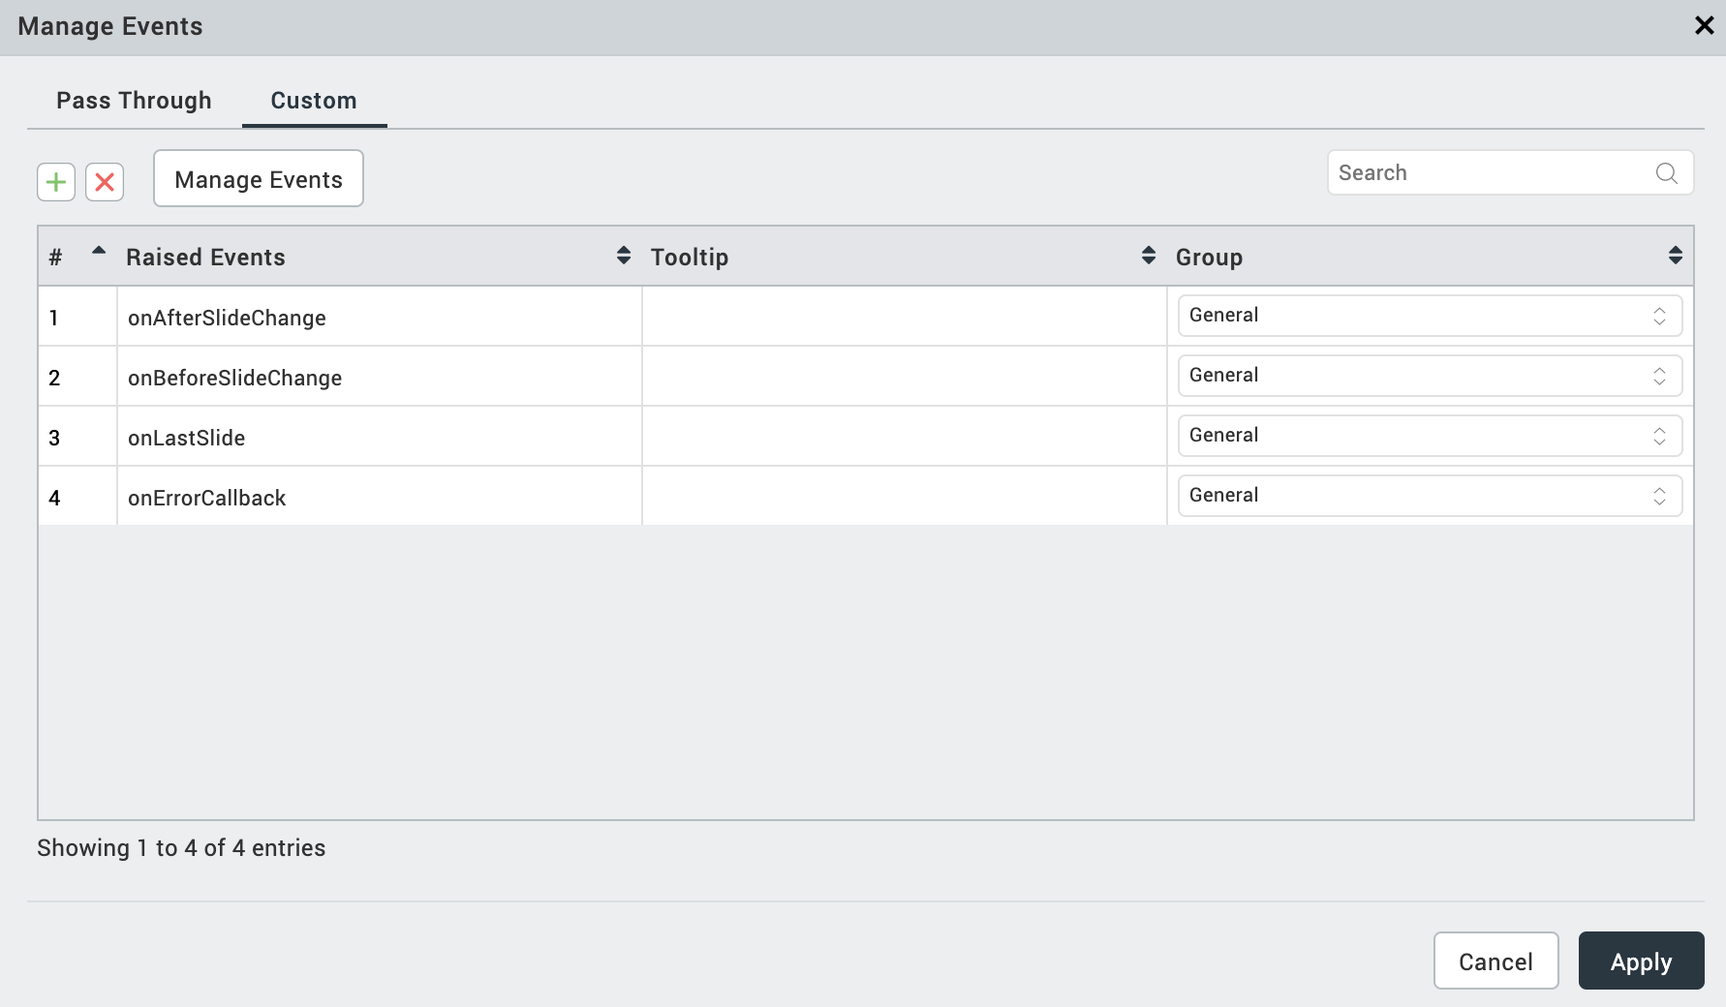
D. APIs

1.setData
Description: Displays the specified images on the slides of the carousel.
Syntax: setData(param)

Parameters: Param[Array of JSON]

Contains the URLs of images that you want to diplay on the caurousle
Return Value: None

Example:
var param =
[
{
"image": "https://i1.wp.com/www.centralofsuccess.com/wp-content/uploads/2019/03/25-Great-Inspirational-Quotes-and-Motivational-Quotes-8.jpg"
},
{
"image": "https://i.pinimg.com/originals/95/cb/ab/95cbab34670fac85105457fc949a70eb.png"
}
];

this.view.vuecarousel.setData(param);
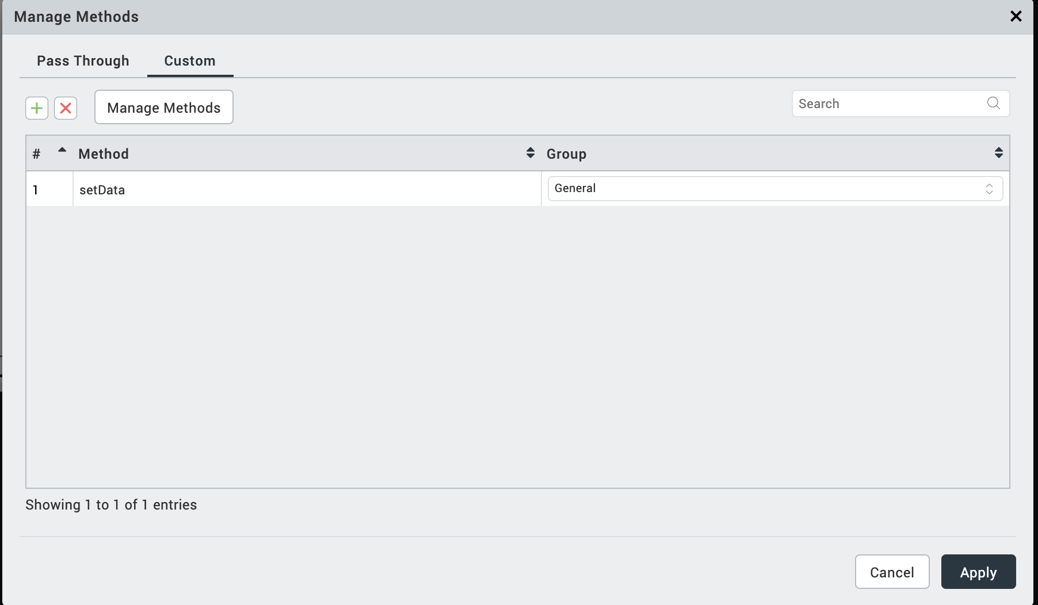

Revision History
App version 1.0.1

