Date :  19-10-2023

CAR Data (1.0.0)

# Overview

* Use this API to pull relevant automobile data such as the car make, model, type, and year.
* Car data, automobile data, auto data.

# Getting Started

## Prerequisites

* Volt Foundry

## Importing the adapter

**To import the Data Adapter to Volt Foundry, do the following:**

1. Sign in to the  [HCL Foundry](https://manage.hclvoltmx.com/).
2. From the left navigation menu, select **API Management**.
3. In **API Management**, select **Custom Data Adapters**.  
   A screenshot of a computer

   Description automatically generated
4. Click **IMPORT** to import a custom data adapter.  
   A blue and white box with text

   Description automatically generated
5. On the Import Data Adapter dialog box, click browser to import.  
   A screen shot of a computer

   Description automatically generated
6. Select Car Data zip file and click **IMPORT**.

After you import the data adapter, Volt Foundry opens a window that shows the metadata of the data adapter.

After you import the data adapter, you can view it on the Custom Data Adapters page and use it to create services on Volt Foundry.

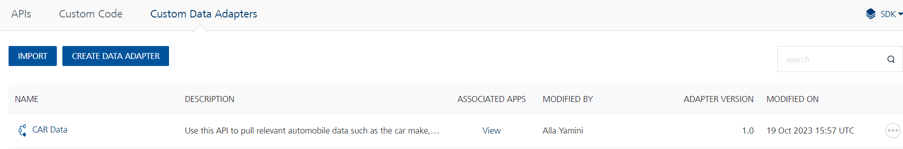

## [Creating an Integration service](javascript:void(0);)

After you import the data adapter into Volt Foundry, you can use it to create an Integration Service.

Follow the given steps to create an Integration service using the CAR DATA Adapter:

1. Sign in to the [HCL Foundry](https://manage.hclvoltmx.com/).
2. From the left navigation menu, select **API Management**.
3. In **API Management**, select **Integration**.  
   A screenshot of a computer

   Description automatically generated
4. To create a new service, click the **+** button or the **CONFIGURE NEW** button.  
   A screenshot of a computer

   Description automatically generated
5. On the Service Definition tab, select the service type as CAR DATA and click **SAVE**.  
   A screenshot of a computer

   Description automatically generated

Alternatively, you can also create a Foundry app and create an Integration service inside it.

[Open](javascript:void(0);)E. [Creating and Executing operations](javascript:void(0);)

After you create an integration service, you can create and execute operations using the service.

#### Creating an Operation

* In **API Management/Foundry app you created**, in the **Integration** section, select the service that you created.
* After you select the service, navigate to the **Operation List** tab.

* From the drop-down list, select an operation that you want to execute, and click **ADD OPERATION**.

#### Executing an Operation

* From the **Operations List** tab, in the **Configured Operations** section, select the operation you want to execute.

* On the Operation Page, in the Request Input tab, enter a TEST VALUE for all the fields in body and header.  
  A screenshot of a computer

  Description automatically generated

* Select a run-time environment and click **Save and Fetch Response** to get a response based on your inputs.  
  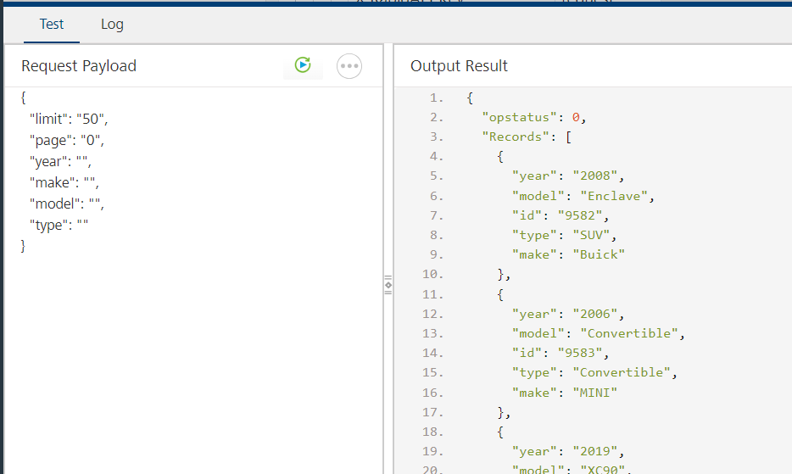

## [Publishing your application](javascript:void(0);)

If you want to use the services in client applications, you need to publish an app to a run-time environment. You can create the service (as described above) in an application or import the service into an application and publish the application.

# References

## Endpoint Documentation

## Reference Link: [Car Data API Documentation (principalapis) | RapidAPI](https://rapidapi.com/principalapis/api/car-data)

# Get Cars

## This endpoint Retrieve and filter lists of cars.

## The endpoint is available through this URL:

GET https://car-data.p.rapidapi.com/cars

## **Parameters**

When calling this endpoint, please refer to the following parameters.

|  |  |  |  |  |
| --- | --- | --- | --- | --- |
| **Parameter** | **Description** | **Types** | **Required** | **Default** |
| limit | Give the limit within 50 | Number | Yes | Max 50 |
| page | Page info | Number | Yes | 0 |
| year | Year info | String | optional |  |
| make | make information of car | String | optional |  |
| model | Model of the car | String | optional |  |
| type | Type of car | String | optional |  |
| X-RapidAPI-Key | Give details of the rapid Api key | String | Yes |  |
| X-RapidAPI-Host | Give details of the rapid Api host | String | Yes |  |

# Get Types

1. This endpoint gets a list of supported types.
2. The endpoint is available through this URL:

GET https://car-data.p.rapidapi.com/cars/types

## **Parameters**

When calling this endpoint, please refer to the following parameters.

|  |  |  |  |  |
| --- | --- | --- | --- | --- |
| **Parameter** | **Description** | **Types** | **Required** | **Default** |
| X-RapidAPI-Key | Give details of the rapid Api key | String | Yes |  |
| X-RapidAPI-Host | Give details of the rapid Api host | String | Yes |  |

# Get MAKES

1. This endpoint get a list of supported makes.
2. The endpoint is available through this URL:

GET https://car-data.p.rapidapi.com/cars/makes

## **Parameters**

When calling this endpoint, please refer to the following parameters.

|  |  |  |  |  |
| --- | --- | --- | --- | --- |
| **Parameter** | **Description** | **Types** | **Required** | **Default** |
| X-RapidAPI-Key | Give details of the rapid Api key | String | Yes |  |
| X-RapidAPI-Host | Give details of the rapid Api host | String | Yes |  |

# Get years

1.This endpoint get a list of supported years.

2.The endpoint is available through this URL:

GET https://car-data.p.rapidapi.com/cars/years

## **Parameters**

When calling this endpoint, please refer to the following parameters.

|  |  |  |  |  |
| --- | --- | --- | --- | --- |
| **Parameter** | **Description** | **Types** | **Required** | **Default** |
| X-RapidAPI-Key | Give details of the rapid Api key | String | Yes |  |
| X-RapidAPI-Host | Give details of the rapid Api host | String | Yes |  |

# Revision History

Adapter version 1.0.0:

## Known Issues

-

B. Limitations

-