05 June 2023

Calendar selection(1.0.0)

# Overview

Use this component to have a calendar on the screen to allow for easy selection of dates, where you can enter in already selected date ranges, prevent users from selecting in the past or at the weekend and decide if the calendar display will be for one month or two.

## Use case

### To easily select dates for a calendar display.

## Percentage of re-use:

Approximately 90% reusable.

## Features.

Prevent the selection of dates in the past.

Prevents the selection of weekends.

To provide already selected dates and prevent the date range to include these selected dates.

Specify the start date of the calendar display or default to today’s date.

Smooth animation to move between months.

# Getting Started

## Prerequisites

Before you start using the Calendar Selection component, ensure the following:

• [HCL Foundry](https://manage.hclvoltmx.com/)

• Volt MX Iris

## Platforms Supported

### PWA & Responsive Web

### Native

## Importing the app

You can import the Forge components only into the apps that are of the Reference Architecture type.

**To import the calendarSelection component, do the following:**

#### Open your app project in Volt MX Iris..

#### In the Project Explorer, click the **Templates** tab.

#### Right-click **Components**, and then select **Import Component**. The **Import Component** dialog box appears.

#### Click **Browse** to navigate to the location of the component, select the component, and then click **Import**. The component and its associated widgets and modules are added to your project.

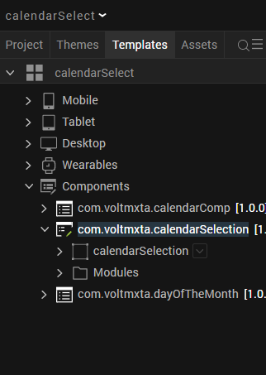

Once you have imported a component to your project, you can easily add the component to a form. For more information, refer [Add a Component to a Form](https://opensource.hcltechsw.com/volt-mx-docs/docs/documentation/Iris/iris_user_guide/Content/C_UsingComponents.html" \l "add-a-component-to-a-form)

## Building and previewing the app

After performing all the above steps, you can build your app and run .For more information, you can refer to the [Building and Viewing an Application](https://opensource.hcltechsw.com/volt-mx-docs/docs/documentation/Iris/iris_user_guide/Content/Cloud_Build_in_VoltMX_Iris.html#cloud) section of the Volt MX User Guide.

You can then run your app to see the CalendarSelection work in real time

# Use the component

# 

# The settings for the component are as follows:

# Current Date allows you to enter in the start date that the calendar should display, if this is blank then the devices current date is selected.

# Start Date and End Date are already selected dates that can be defaulted into the calendar, when the user has selected or confirmed these dates then these two fields will show the selected dates.

# Selected Date ranges allows you to enter in date ranges that have already been selected, this allows the user to see what dates have been picked already but will also prevent the user from selecting dates that include these ranges.

# Selected Weekend Date, when set to off does not allow the use to select dates on the weekend

# Select Past Dates, when set to false, prevents users from selecting dates in the past.

# Display Number of Months, only 1 or 2 is valid here and it stipulates how many months are displayed for the user to see during their selection, 1 or 2 months.

# Revision History

App version 1.0.0:

## Known Issues

NA

## Limitations

NA