Date :  13-10-2023

Calendarific Global Holidays (1.0.0)

# Overview

Calendarific is a powerful API that provides comprehensive holiday data and business hours for over 230 countries worldwide. It allows developers and businesses to integrate holiday information seamlessly into their applications, websites, or services. Calendarific offers a vast array of holiday data, including national holidays, local observances, religious holidays, and more. You can obtain details such as holiday names, dates, types, and even customize the data based on specific countries or regions.

# Getting Started

## Prerequisites

* Volt Foundry
* Account and api key from Calenderific.
* Sign up in <https://calendarific.com> and login into the account and get the api key.

## Importing the adapter

**To import the Data Adapter to Volt Foundry, do the following:**

1. Sign in to the  [HCL Foundry](https://manage.hclvoltmx.com/).
2. From the left navigation menu, select **API Management**.
3. In **API Management**, select **Custom Data Adapters**.  
   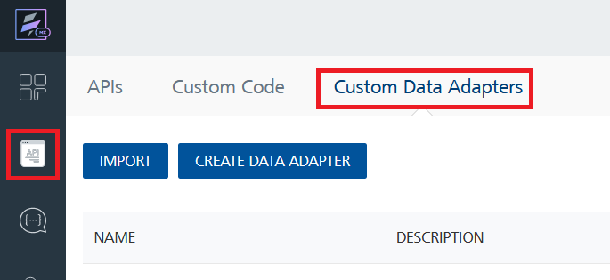
4. Click **IMPORT** to import a custom data adapter.  
   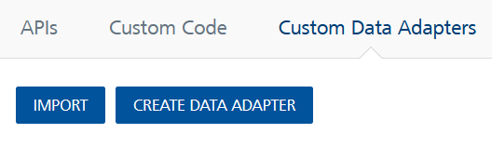
5. On the Import Data Adapter dialog box, click browser to import.  
   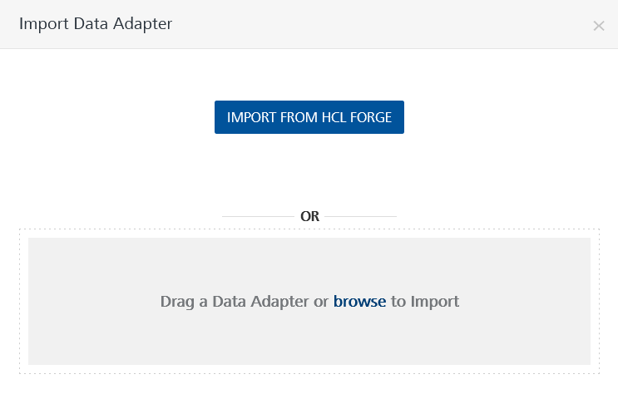
6. Select Calenderific zip file and click **IMPORT**.

After you import the data adapter, Volt Foundry opens a window that shows the metadata of the data adapter.

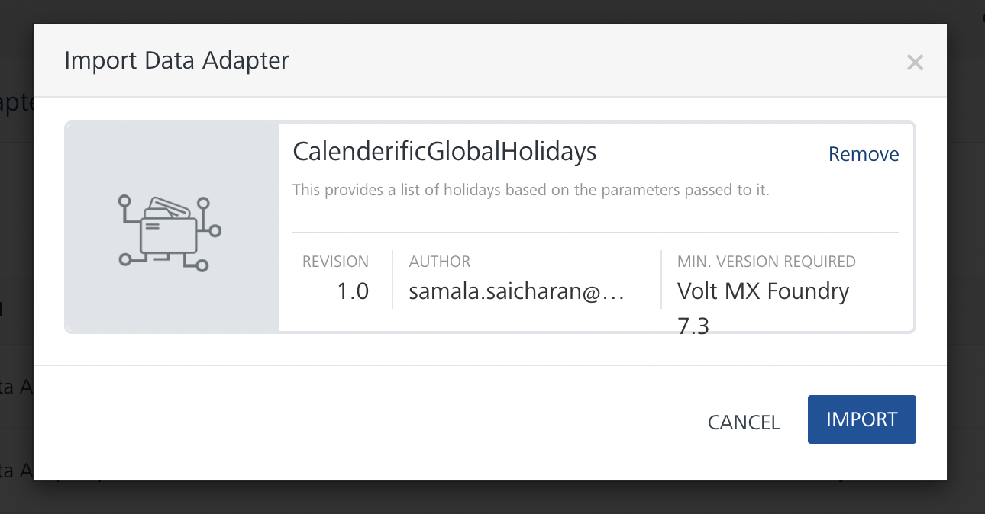

After you import the data adapter, you can view it on the Custom Data Adapters page and use it to create services on Volt Foundry.



## [Creating an Integration service](javascript:void(0);)



After you import the data adapter into Volt Foundry, you can use it to create an Integration Service.

Follow the given steps to create an Integration service using the API CalenderificGlobalHoliday Adapter.

1. Sign in to the [HCL Foundry](https://manage.hclvoltmx.com/).
2. From the left navigation menu, select **API Management**.
3. In **API Management**, select **Integration**.  
   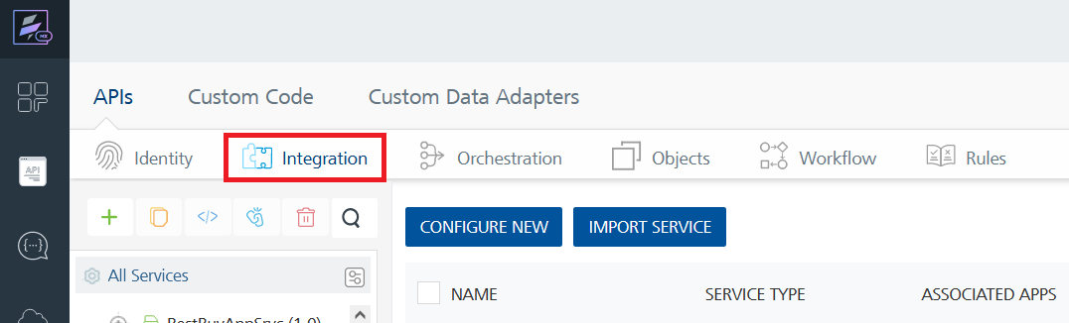
4. To create a new service, click the **+** button or the **CONFIGURE NEW** button.  
   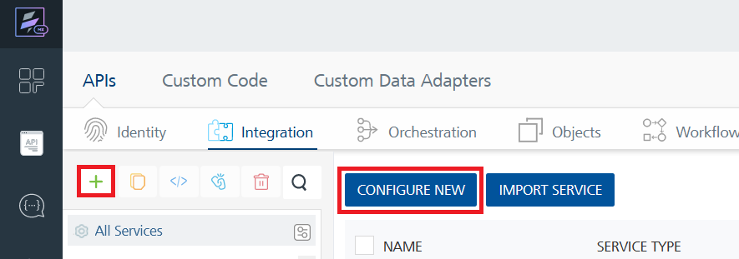
5. On the Service Definition tab, select the service type as **CalenderificGlobalHolidays**, and click **SAVE**.

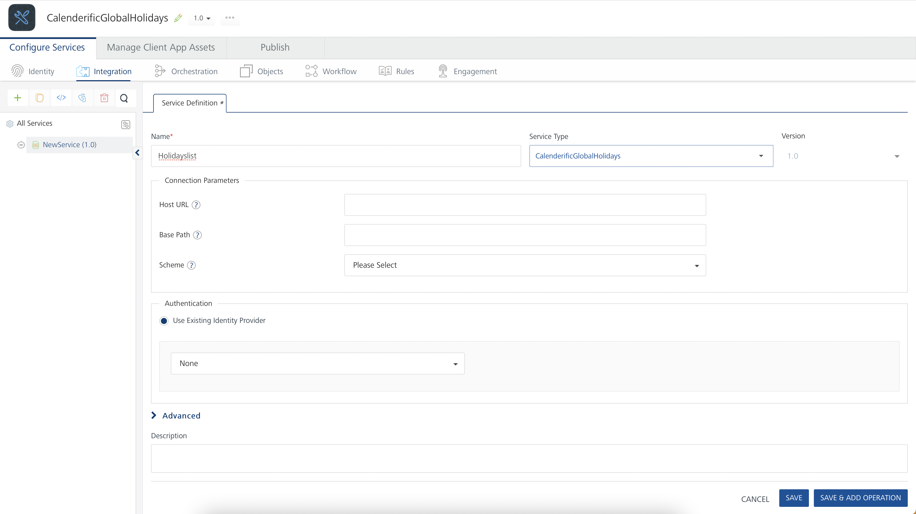

Alternatively, you can also create a Foundry app and create an Integration service inside it.

E. [Creating and Executing operations](javascript:void(0);)



After you create an integration service, you can create and execute operations using the service.

#### Creating an Operation

* In **API Management/Foundry app you created**, in the **Integration** section, select the service that you created.
* After you select the service, navigate to the **Operation List** tab.  
  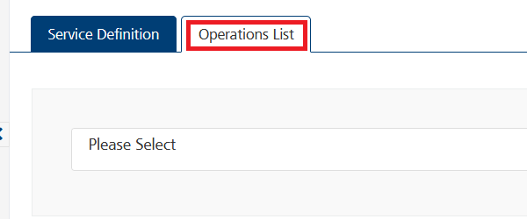
* From the drop down list, select an operation that you want to execute, and click **ADD OPERATION**.

#### Executing an Operation

* From the **Operations List** tab, in the **Configured Operations** section, select the operation you want to execute.

* On the Operation Page, in the Request Input tab, enter a TEST VALUE for all the fields.

* Select a run-time environment and click **Save and Fetch Response** to get a response based on your inputs.

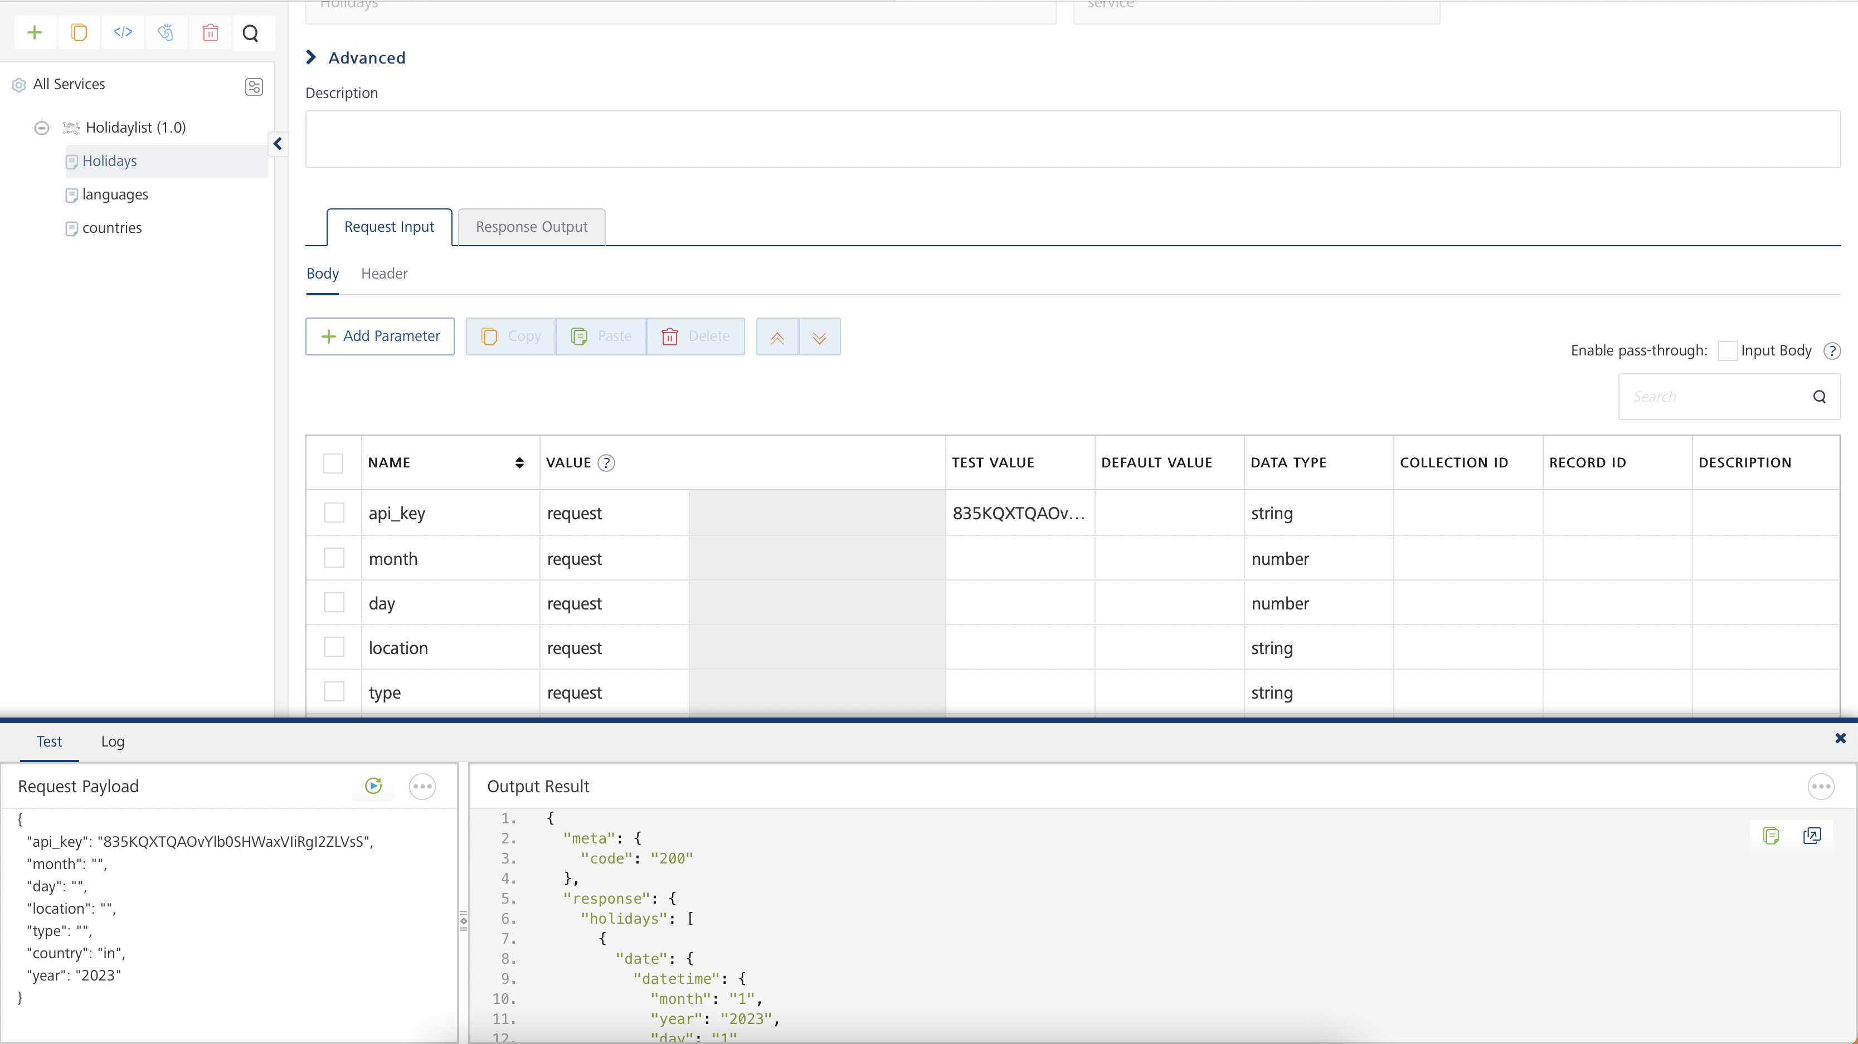

## [Publishing your application](javascript:void(0);)

If you want to use the services in client applications, you need to publish an app to a run-time environment. You can create the service (as described above) in an application or import the service into an application and publish the application.

# References

## Endpoint Documentation

| **Field** | **Type** | **Description** |
| --- | --- | --- |
| HTTP Method | GET |  |
| **Endpoint** | https://calendarific.com/api/v2/holidays | This provides a list of holidays based on the parameters passed to it. |
|  | https://calendarific.com/api/v2/languages | This endpoint provides the list of languages we support. |
|  | https://calendarific.com/api/v2/countries | This endpoint provides a list of countries and languages that we support. This is useful for getting an index of all countries and the ISO codes programmatically. |
| **Parameters** |  |  |
| - api_key | string | This is the value of the API that is used to authenticate every request to our API. You can access this once you sign up and login into your account. This is the only required parameter for the /countries endpoint (required) |
| - country | string | The country parameter must be in the iso-3166 format as specified in the [document here. To view a list of countries and regions we support, visit our list of](https://en.wikipedia.org/wiki/List_of_ISO_3166_country_codes)[supported countries](https://calendarific.com/supported-countries). (required) |
| - year | string | The year you want to return the holidays. We currently support both historical and future years until 2049. The year must be specified as a number eg, 2019(required) |
| - day | Integer | Limits the number of holidays to a particular day. Must be passed as the numeric value of the day [1..31]. (Optional) |
| - month | Integer | Limits the number of holidays to a particular month. Must be passed as the numeric value of the month [1..12]. (optional) |
| - location | string | We support multiple counties, states and regions for all the countries we support. This optional parameter allows you to limit the holidays to a particular state or region. The value of field is iso-3166 format of the state. View a list of supported [countries and states](https://calendarific.com/supported-countries). An example is, for New York state in the United States, it would be us-ny. (optional) |
| - type | string | We support multiple types of holidays and observances. This parameter allows users to return only a particular type of holiday or event. By default, the API returns all holidays. Below is the list of holiday types supported by the API and this is how to reference them.   * national - Returns public, federal and bank holidays * local - Returns local, regional and state holidays * religious - Return religious holidays: buddhism, christian, hinduism, muslim, etc * observance - Observance, Seasons, Times (optional) |
| **Responses** |  |  |
| - 200 |  | Successful response |
| - 401 |  | Unauthorized Missing or incorrect API token in header. |
| - 500 |  | Internal Server Error This is an issue with Calendarific's servers processing your request. In most cases the message is lost during the process, and we are notified so that we can investigate the issue. |

Top of Form

## These are List of all endpoints, input params and description of the fields in tabular format.

## Data for this will be available in the original API documentation

# Revision History

Adapter version 1.0.0:

## Known Issues

- This API supports premium parameters, including "language" and "uuid," which are available to all users on the Professional plan and above. These parameters have not been tested in Foundry as it requires a paid subscription.

## Limitations

-