14 Mar 2023

BROWSER FEATURE APP

version: 1.0.1

1. OVERVIEW

Browser Feature app highlights the usage and capabilities of the Browser widget in Iris. Browser Widget in Iris provides the feature of loading HTML content in context of the native application without navigating away from the native app or opening the native browser app. The app provides you with the following options:

Features:

The app provides you with the following options:

- To view Static content
- To view Dynamic content
- To navigate within an inline browser
- To detect a telephone number from the browser by adding the number to the dial pad
- To enlarge the browser view by zooming
- For more information, you can refer to Browser widget.

For information on how to import the Browser Feature app to Iris, visit the Getting Started page.

Percentage of re-use:
Approximate 80 % of reuse.

2. Getting Started

A. Prerequisites:
Before you start using the Browser Feature app, ensure the following:
• HCL Foundry
• Volt MX Iris

B. Platforms Supported:
- Mobile
- iOS
- Android

C. Import the app:

To import the Browser Feature App into your workspace, follow the given steps:

Open Volt MX Iris.

On the menu bar select Forge → Browse. The Forge dialog appears.
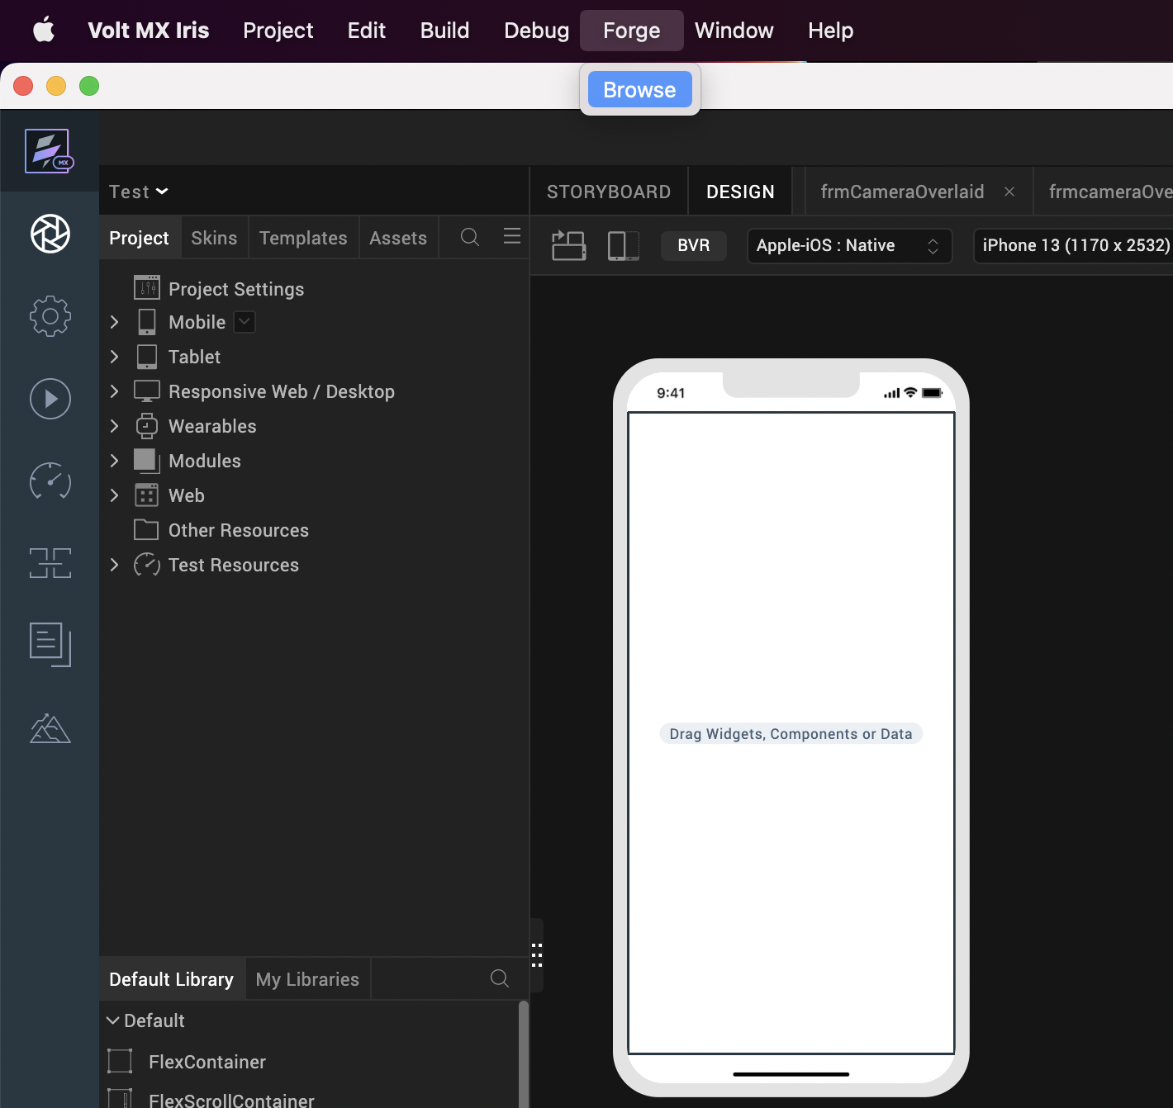

3. Search for the Browser Feature app and click Import to Workspace. This imports the app to your workspace.

4. You receive a dialog box confirming that the app is Imported. Click OK.

Switch to your project containing the Browser Feature app. To switch to your project click File → Open → Reference Architecture → <project_name>

D. Building and previewing the app:

After performing all the above steps, you can build your app and run it on your device. For more information, you can refer to the Building and Viewing an Application section of the Volt MX User Guide.
You can then run your app to see the Segment Feature App Functionality

3. App Functionality

The landing page of the Browser Feature app is the Widget Home screen. The Widget Home screen displays five buttons.

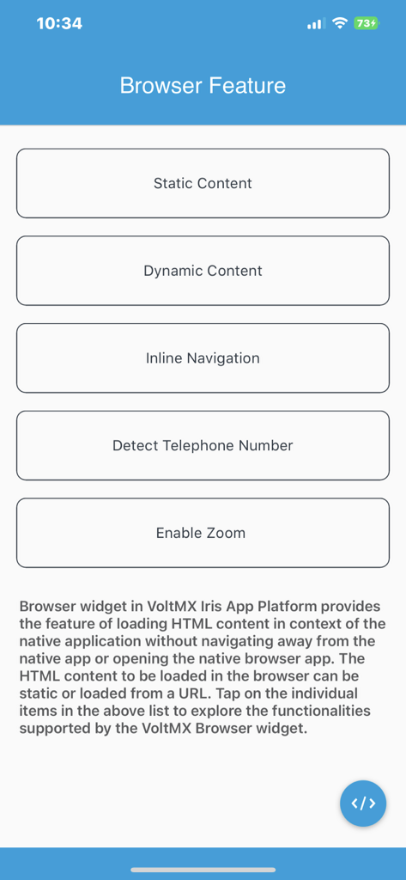

Based on the button you select; the app navigates you to the following screens:

• Static Content Screen

• Dynamic Content Screen

• Inline Navigation

• Detect Telephone Number

• Enable Zoom

i. Static Content Screen

Static Content Screen displays Static HTML content. The Static content on a browser does not change based on your inputs or preferences. Static content is less interactive, but the browser widget performance is greatly enhanced with the presence of Static HTML content. The Browser widget uses the htmlString Property to load Static content.

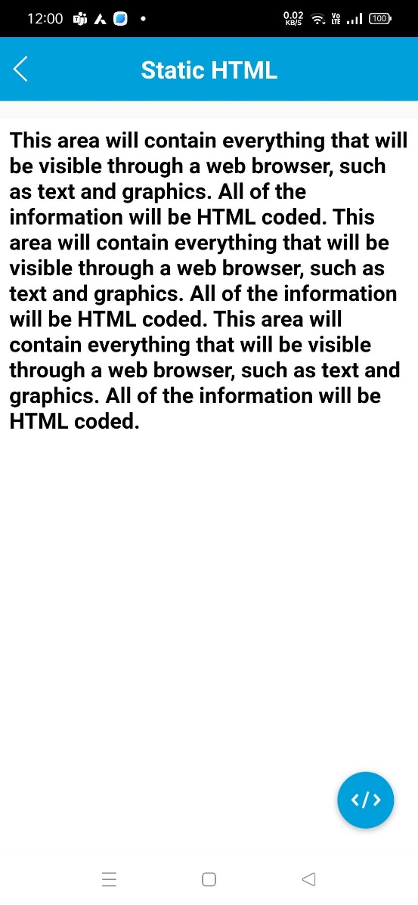

ii. Dynamic Content Screen

Dynamic Content Screen loads Dynamic HTML content when you specify a URL. The Dynamic content on a browser changes or adapts based on your inputs. Dynamic content is more interactive in nature as the HTML content varies as per the user preferences. This URL can be set in the Browser widget by using the baseURL Property of the Browser widget.

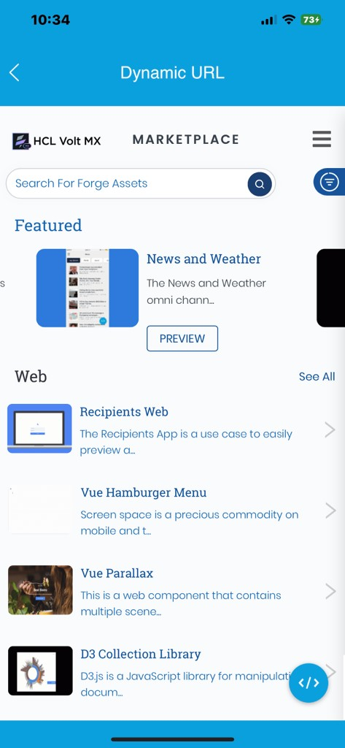

iii. Inline Navigation

Inline Navigation Screen displays an embedded Google search engine. The Browser widget allows you to navigate within the browser pages through the search engine. Inline Navigation screen also consists of three buttons that have the following functionality:

• Back and Forward: Click the Back or Forward button to navigate between the pages that you visited. To navigate between the pages, the Browser widget uses goBack and goForward methods.

• Reload: Click the Reload button to refresh the browser. To refresh the browser , the Browser widget uses reload method.

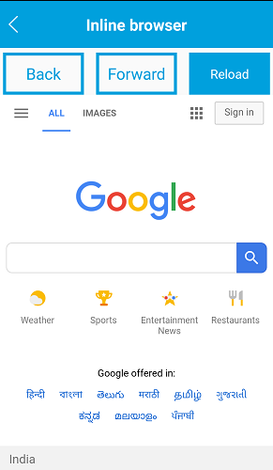

iv. Detect Telephone Number

Detect Telephone Number screen displays dynamic content which contains a telephone number. Browser widget supports the detection of phone numbers on the web page and displays them as links. When you click on the Telephone number, the app navigates you to the dialpad where the corresponding telephone number gets added to your dialpad. You can add telephone number to the dialpad by making use of the detectTelNumber Property of the Browser widget.

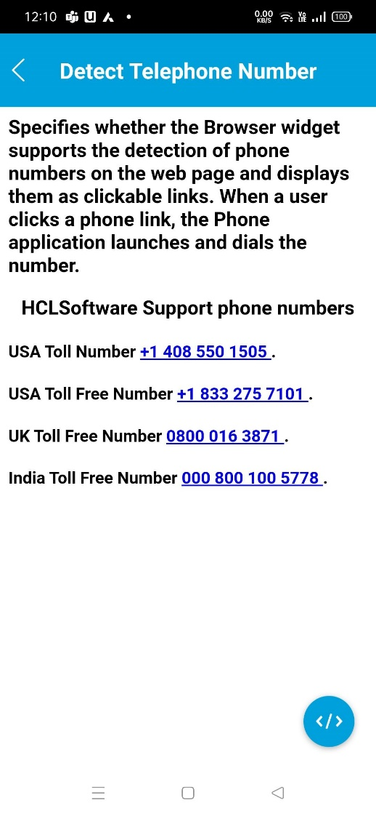

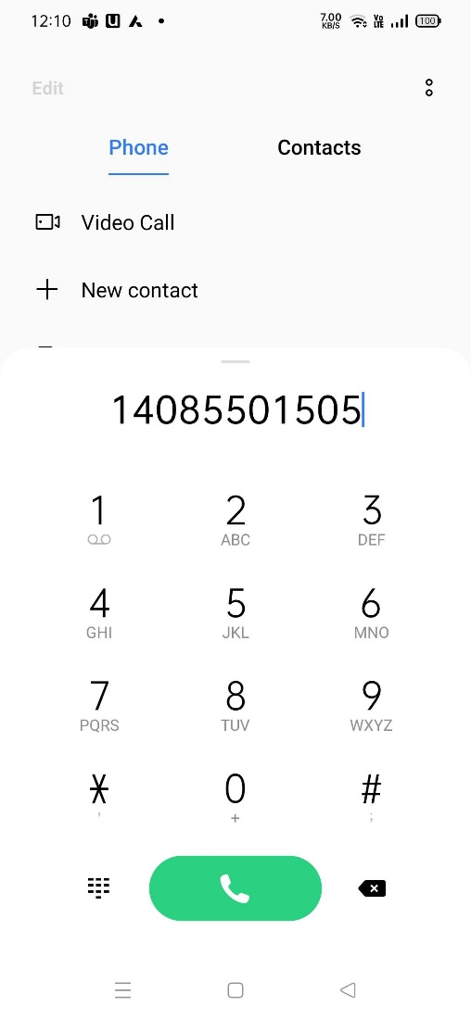

v. Enable Zoom

Enable Zoom screen displays dynamic content along with a toggle button to zoom. The zoom feature provides the ability to change the scale of the view area. You can use the toggle button or your fingers to zoom in or zoom out of the screen. You can enable the zoom feature by making use of the enableZoom Property of the Browser widget.

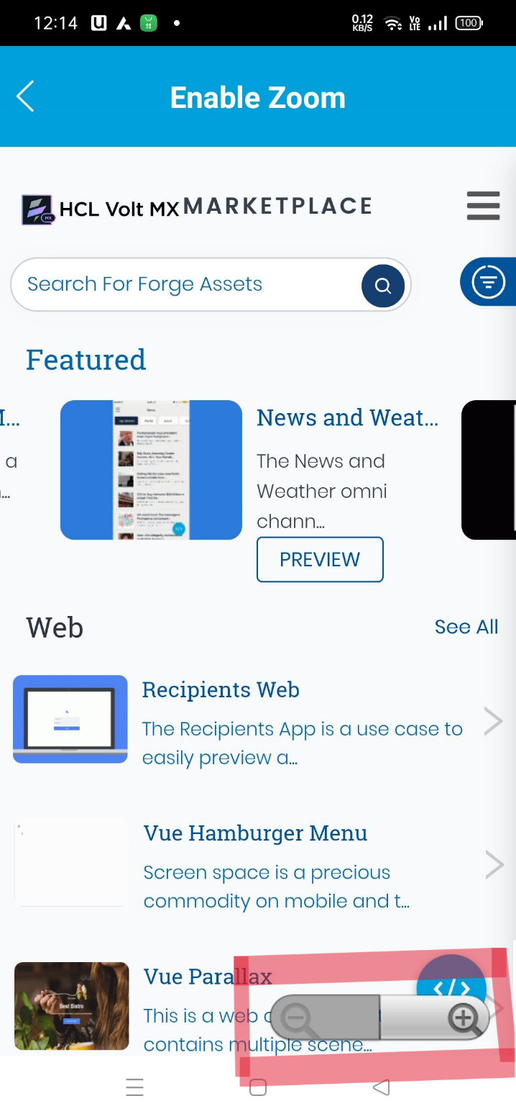

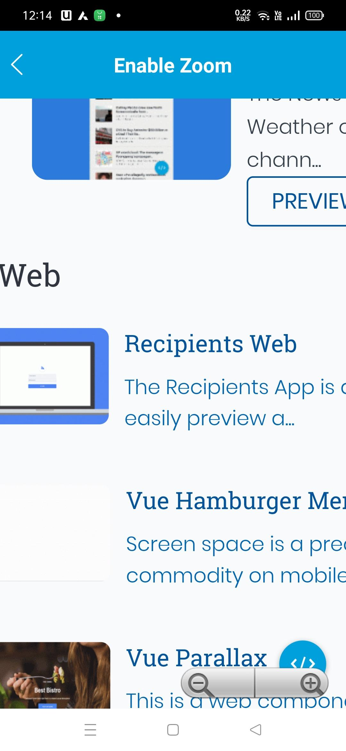

4. Revision History
App version 1.0.1

