Date: 25 Feb 2025

BOX DATA ADAPTER

VERSION: 1.0.1

OVERVIEW
Box is a cloud content management and file sharing service for businesses. The company uses a freemium business model to provide cloud storage and file hosting for personal accounts and businesses. Official clients and apps are available for Windows, mac OS, and several mobile platforms.
You can read more about this service in Box Reference Documentation.
The following sections help you use the Box Data Adapter:

Features
- Ready-to-use adapter and simple to import.
- Easy to make API calls through simple interaction directly from MobileFabric.
- Facilitates easy interaction with the other groups and profiles from within the App.
- Secure and authentic.

Percentage of re-use:
70% (Data can be customizable and customers need to implement UI by themselves).

GETTING STARTED

Prerequisites

Before you start using the Box Data Adapter, ensure you have the following:
- A Box developer account
- API-Key and API-Secret that are generated
- A HCL Foundry

Importing the Box Data Adapter
You can import Box Data Adapter into Volt MX Foundry directly from the from HCL Forge website.
To import the data adapter zip file, do the following:
- Log on to your HCL Foundry. The Dashboard page appears by default.
- From the left navigation bar, navigate to API Management and open the Custom Data Adapters tab.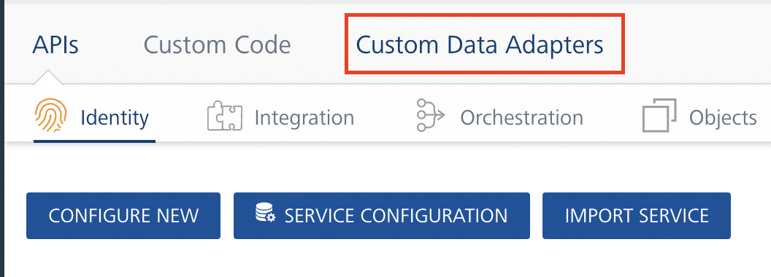

- Click IMPORT to import a custom data adapter.
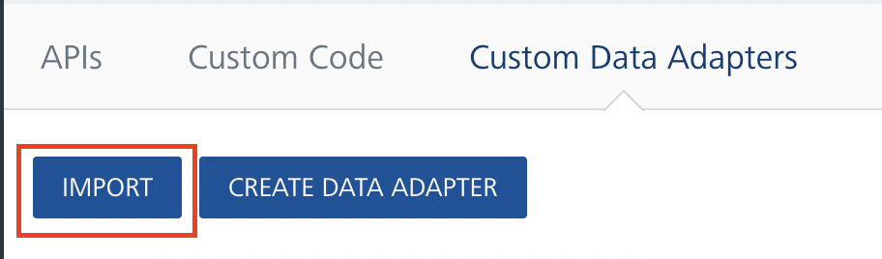

- On the Import Data Adapter dialog box, click IMPORT FROM HCL FORGE. The Import Data Adapter from HCL Forge dialog appears with a list of available data adapters.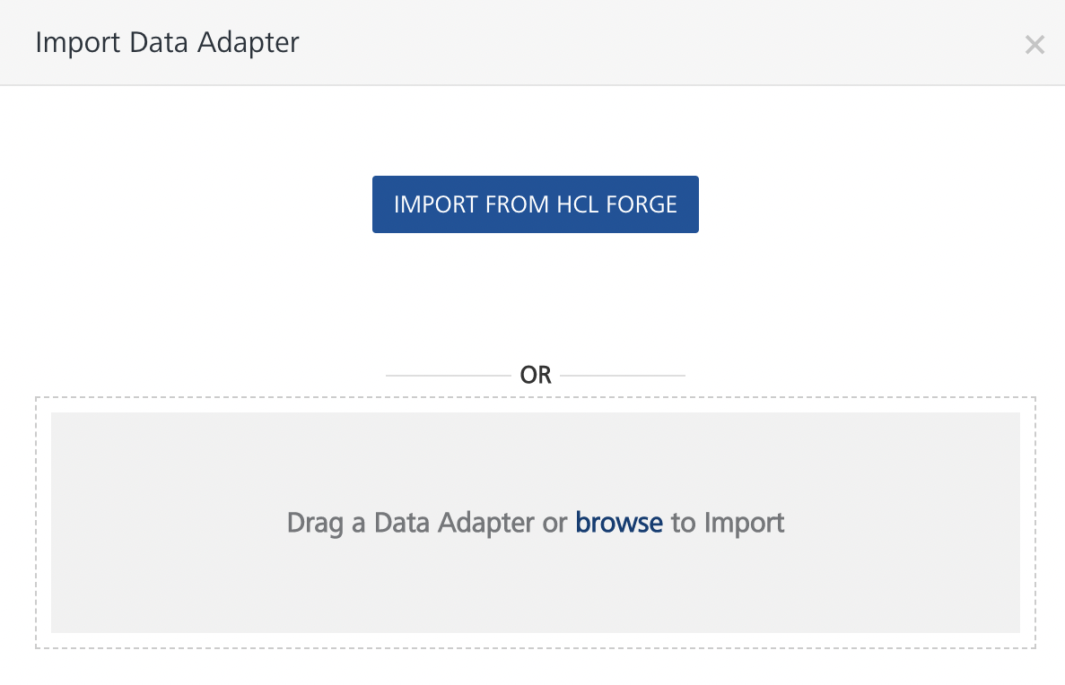
- Find and select the Box Data Adapter, and click IMPORT. The Box data adapter is listed on the Custom Data Adapters page.

CREATING IDENTITY SERVICE FOR AUTHORIZATION
Every request your application sends to the Box API must include an authorization token. The token also identifies your application to Box.
Your application must use Box to authorize requests. No other authorization protocols are supported.
On Volt MX Foundry, follow these steps to create an Identity Service:
- Create an app in Volt MX Foundry with a suitable name.
- By default, you will see the Configure Services tab with Identity selected.
- Click on the Configure New button.
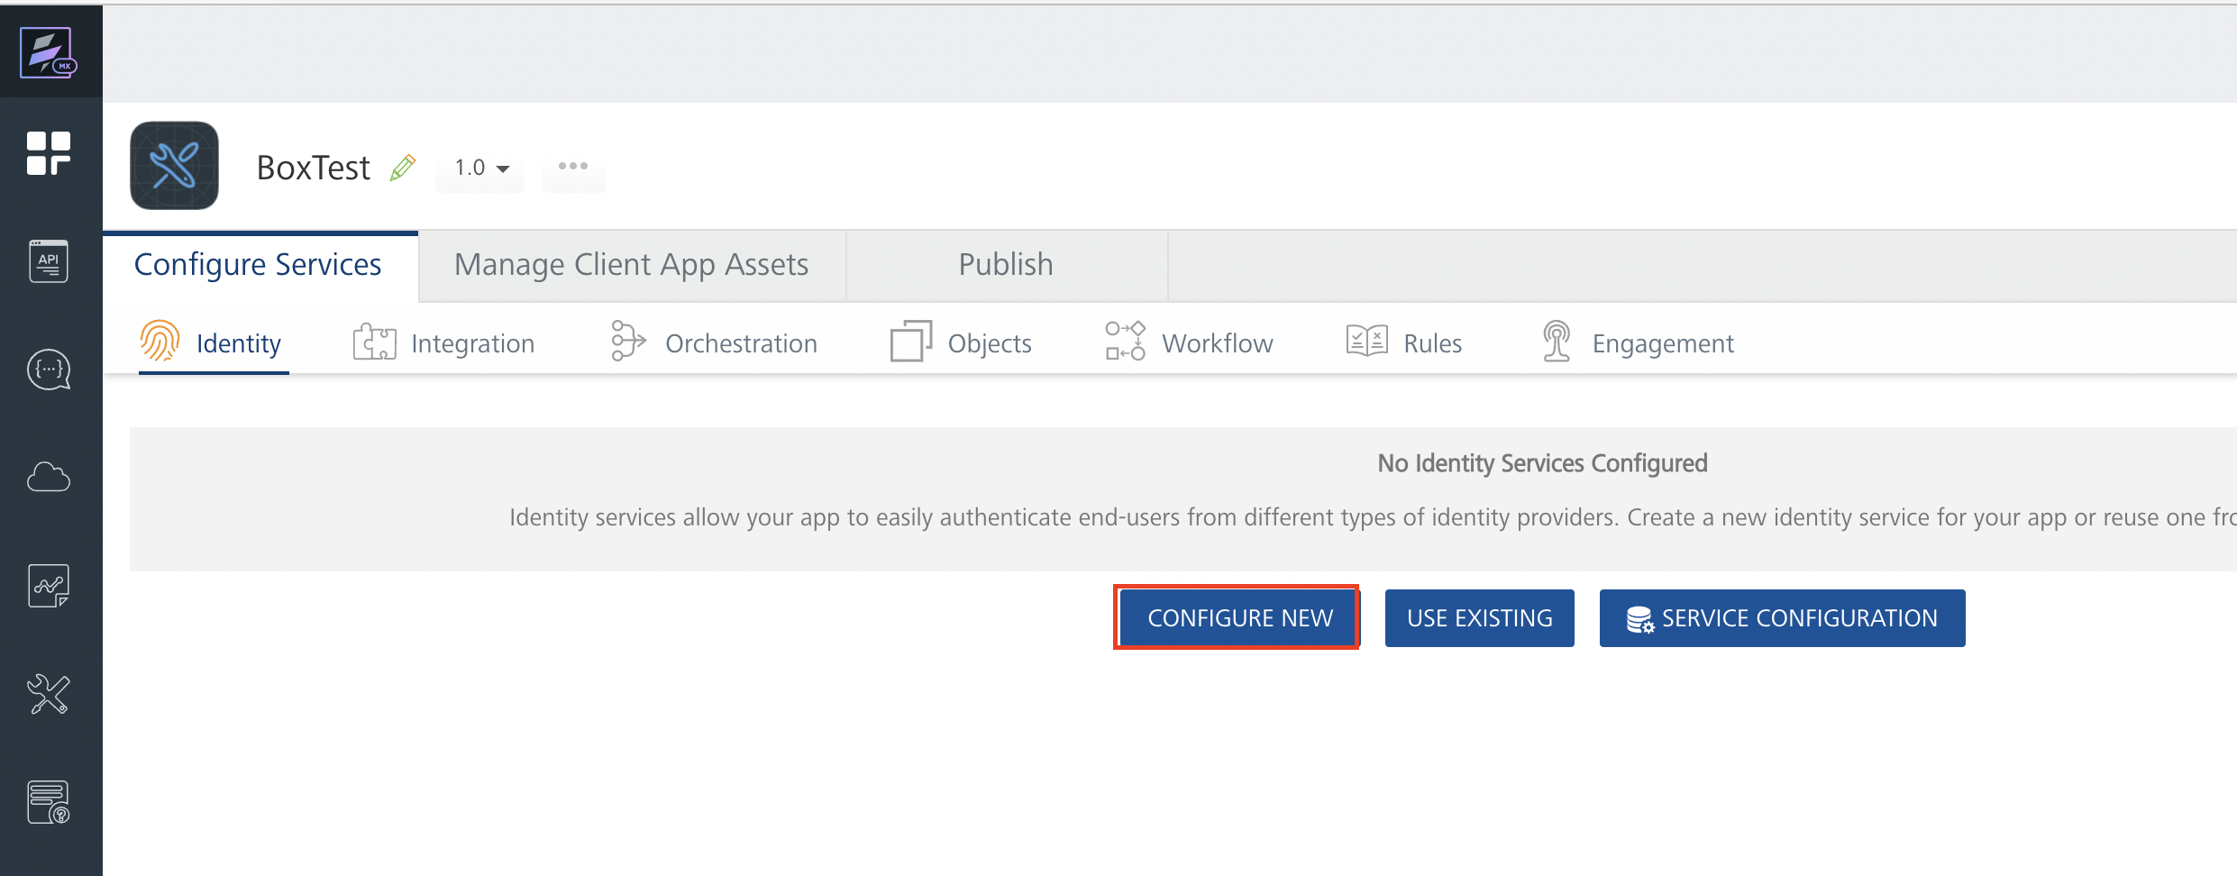
- Provide an appropriate Service Name and select the Type of Identity as Box.
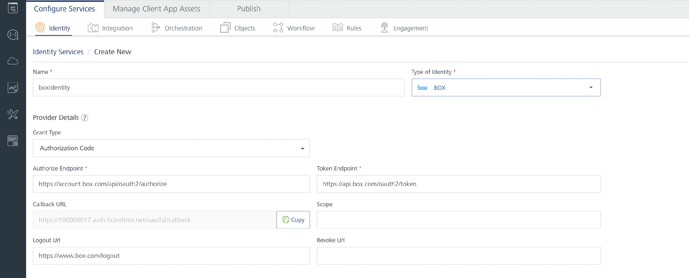
- A section called Provider Details shows up.
  - Copy the callback URL that is generated.
  - Go to https://app.box.com/developers/console and click Create New App.
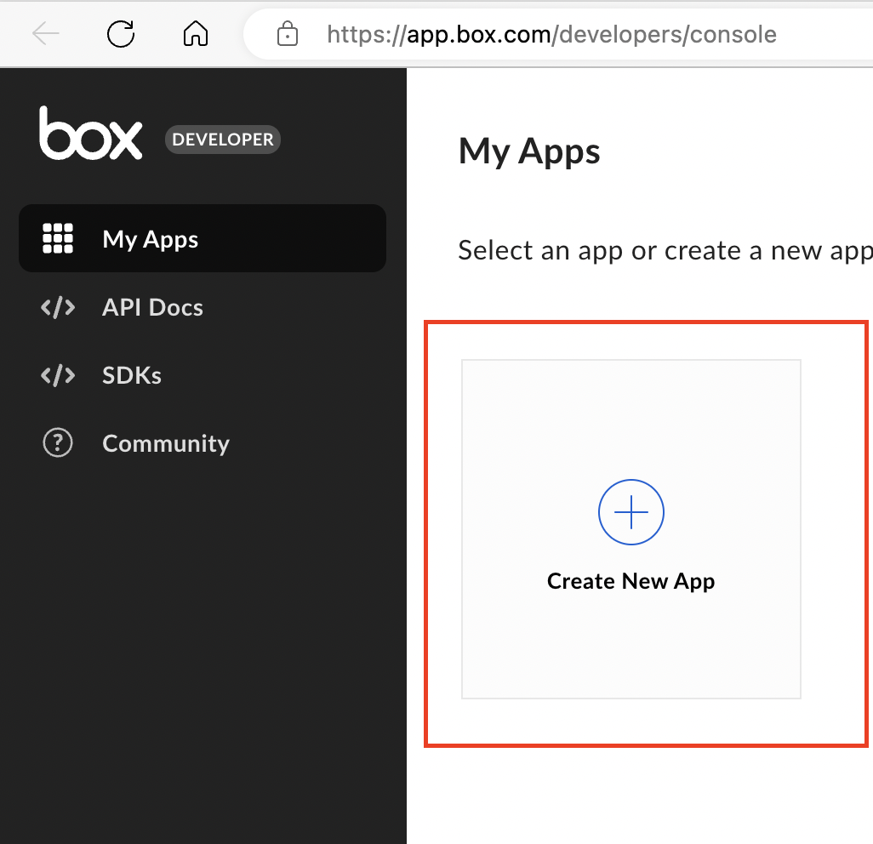

  - Choose the type of app and click Next.
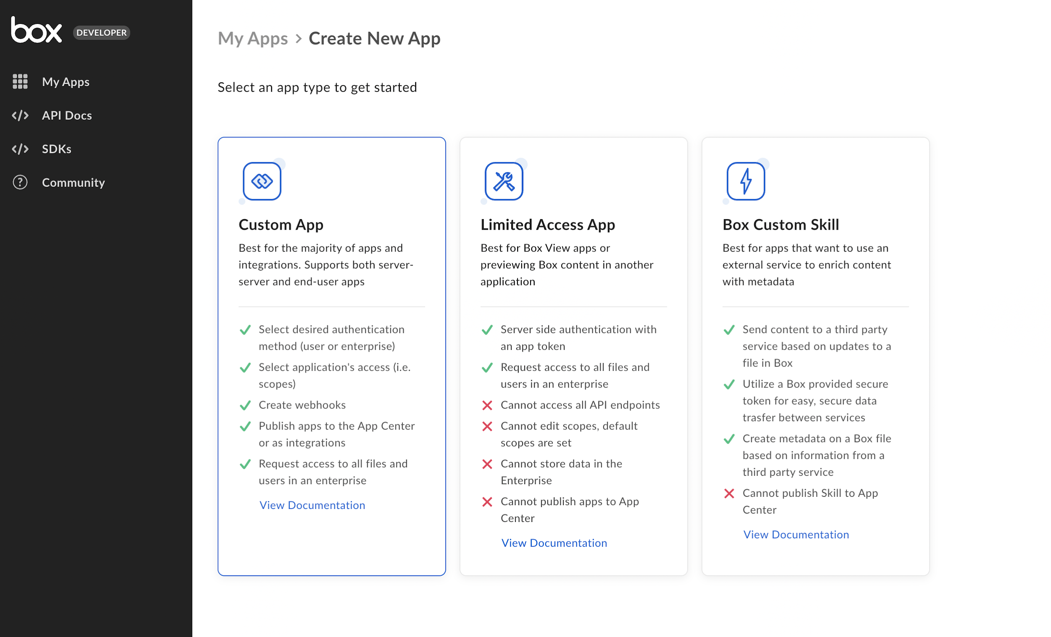
  - Give your app a name and click Next.
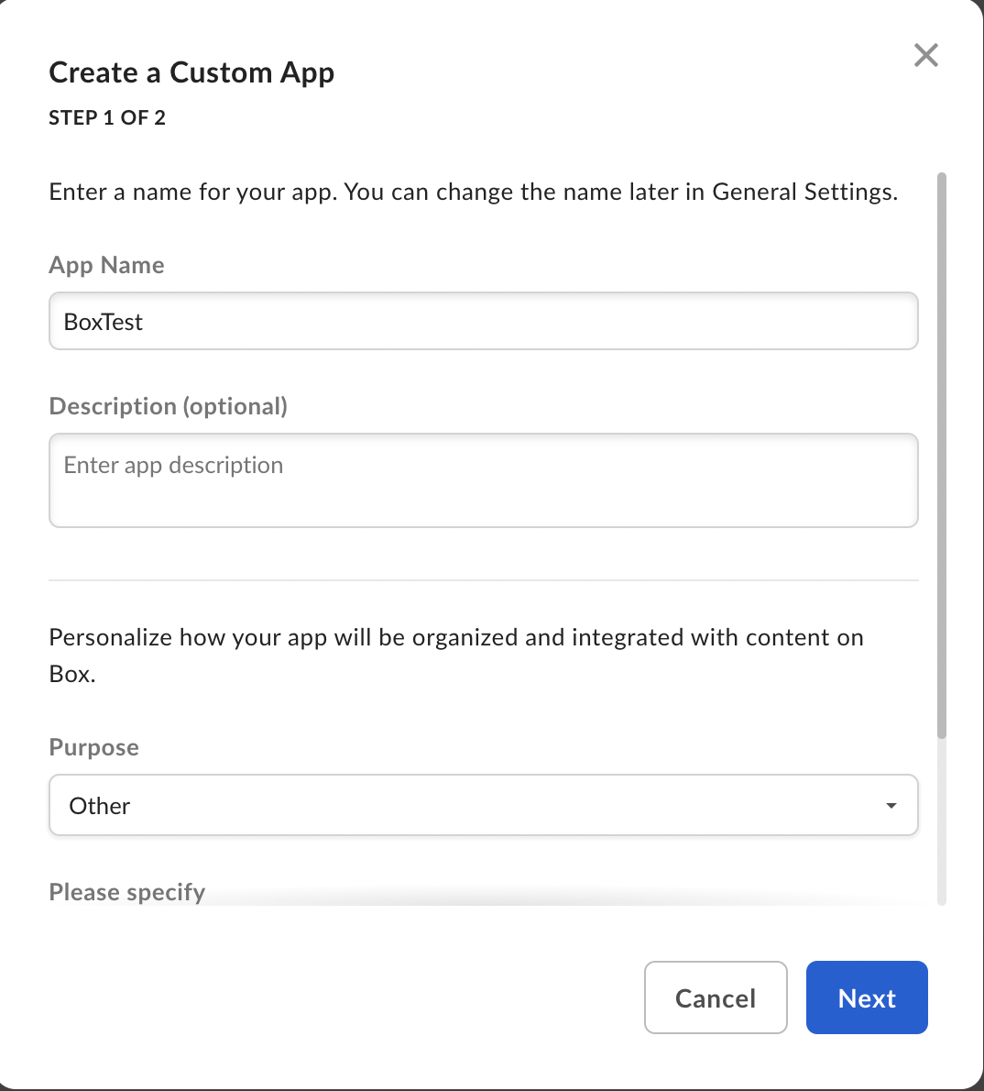
  - Select Authentication Method as Standard OAuth 2.0 and click Create New App.
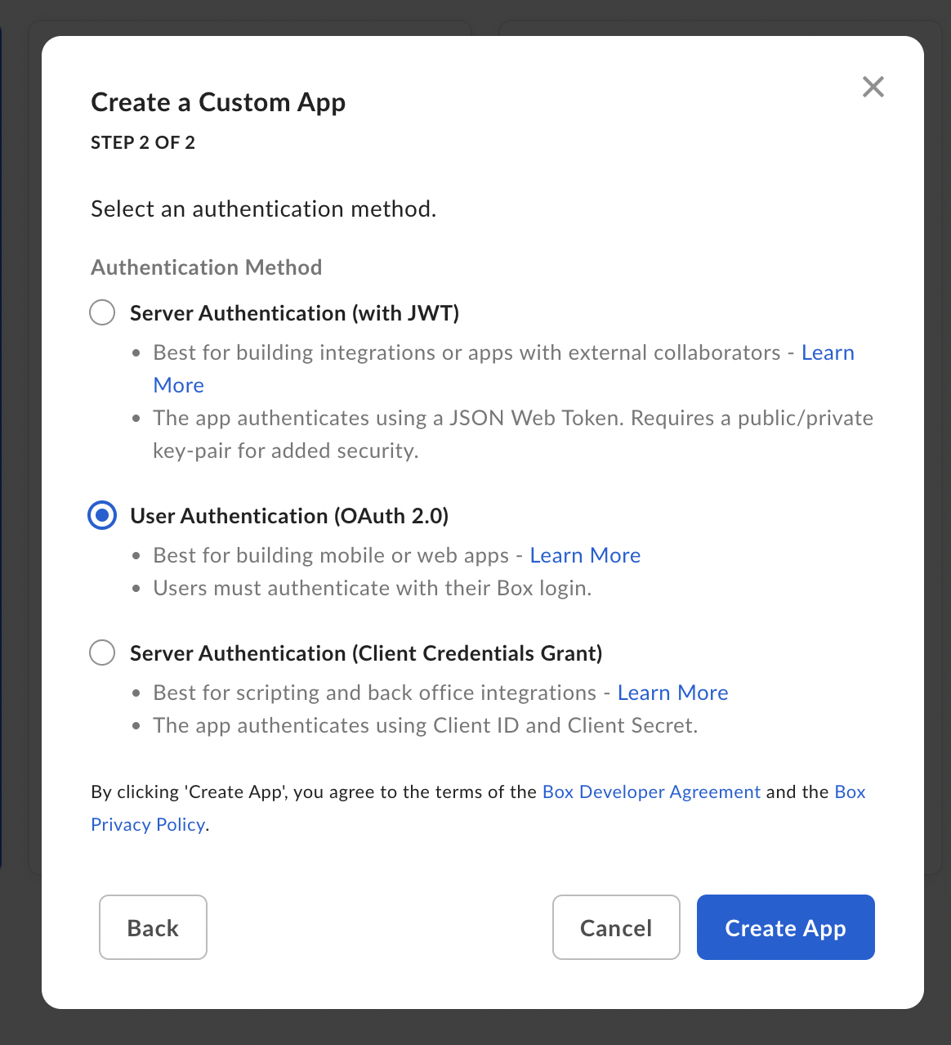

  - On successful creation of your app, click View your App.
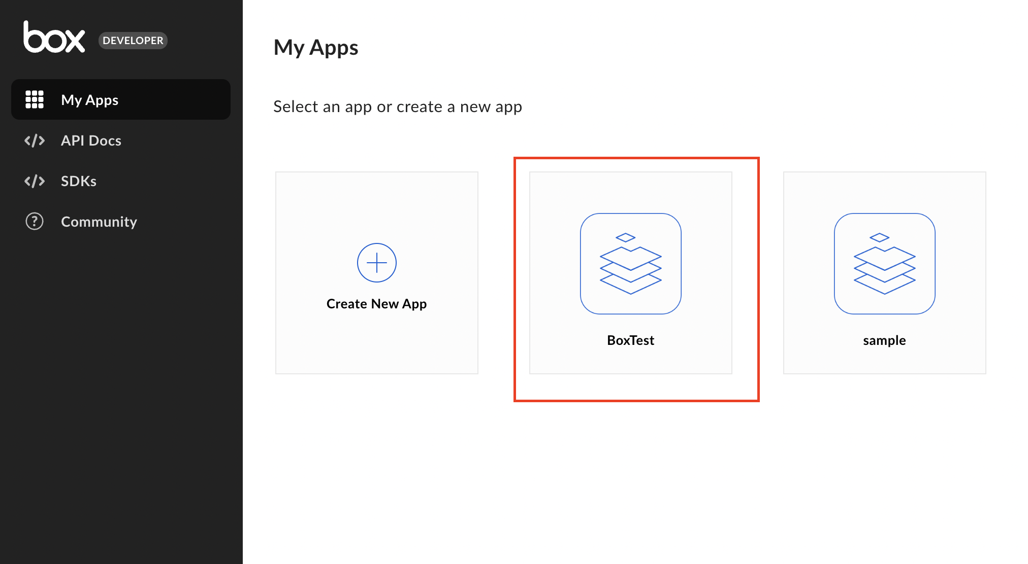

  - Paste your callback URI in OAuth 2.0 Redirect URI and click Save Changes.
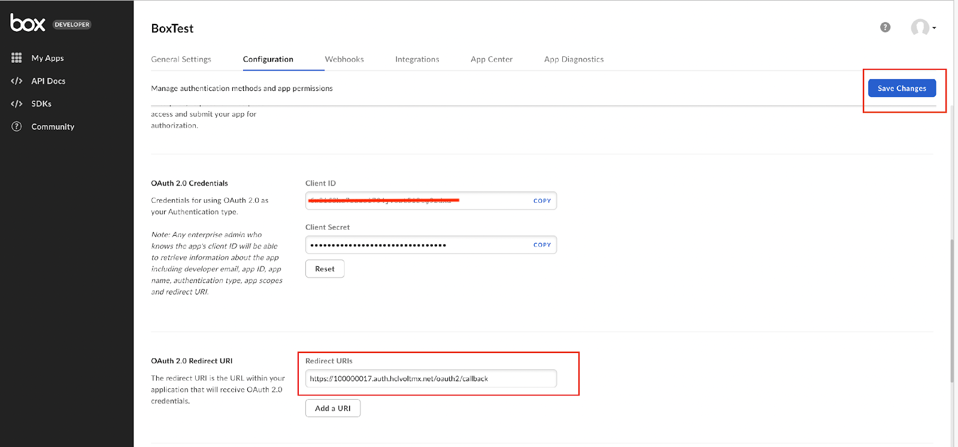

  - Copy the Client ID and Client Secret that you get.
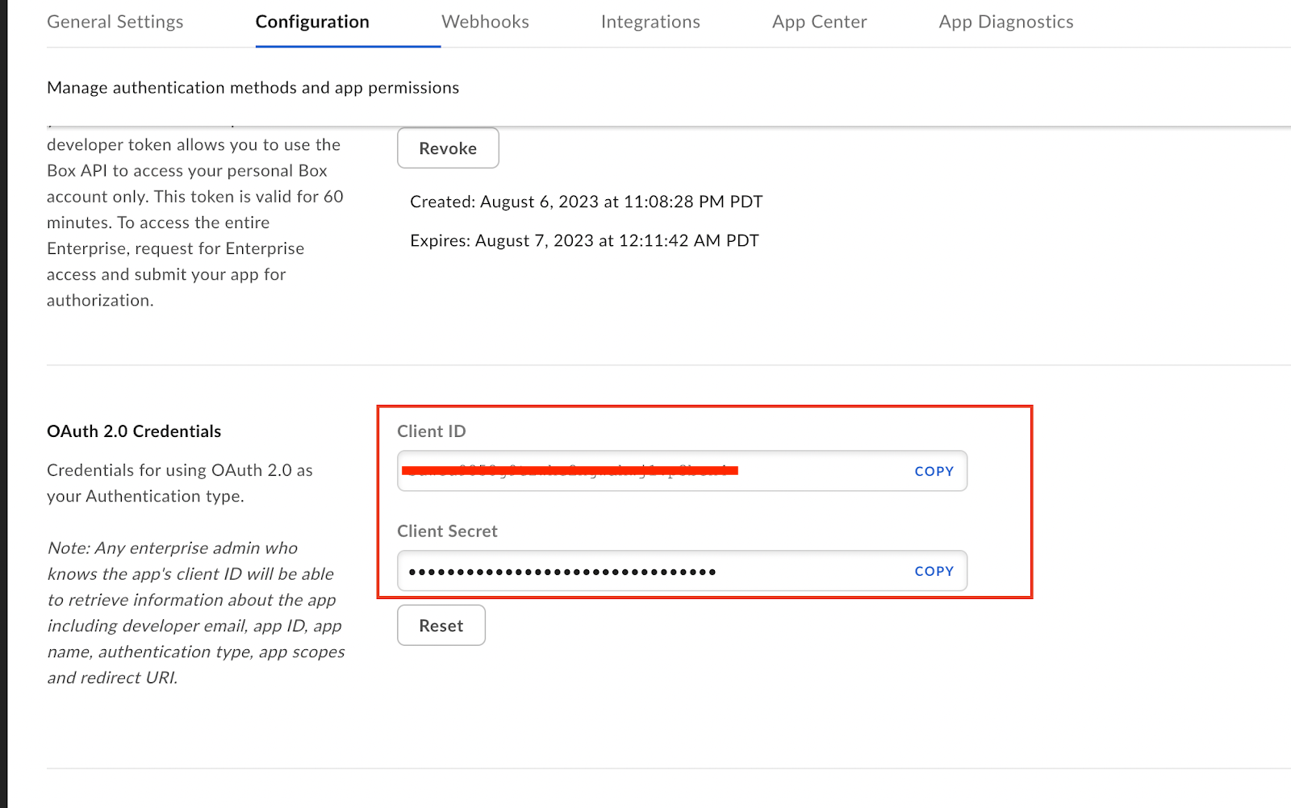

  - Go back to Volt MX Foundry.
- Under the Client Details section, enter the Client ID and Client Secret obtained in Step viii.
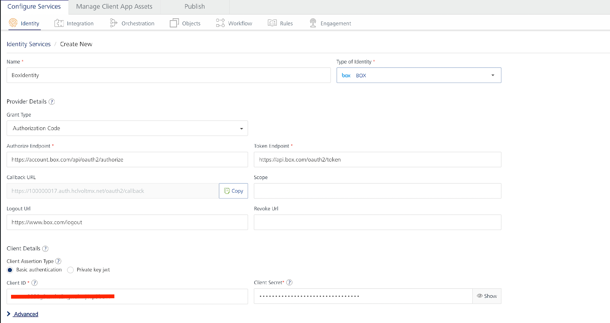

- Click on Test Login and make sure you get a response like the one shown in the image.
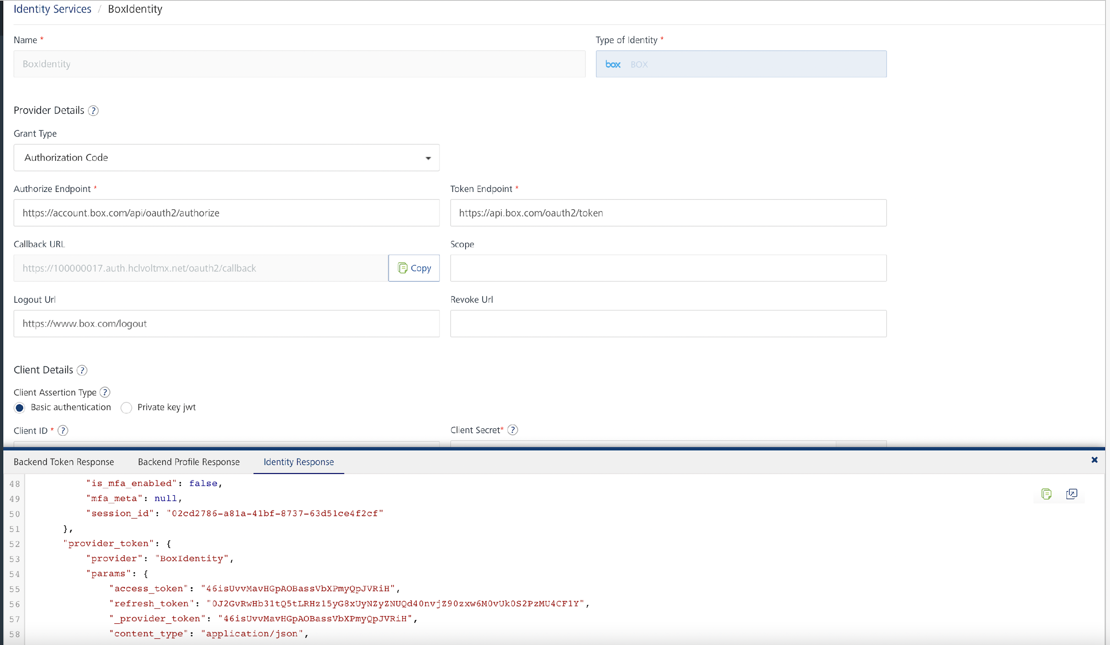
Note:
The above image shows just a part of the entire response. The response continues further which can be seen on scrolling through.
- Click on Save.

CREATING AN INTEGRATION SERVICE WITH BOX DATA ADAPTER
To create an integration service with Box, do the following:
- Log on to your HCL Foundry. The Dashboard page appears by default.
- In the left pane, click the API Management menu. The APIs tab opens by default.
- Click the Integration tab. The Integration tab opens with a list of existing integration services.
- Click CONFIGURE NEW. The Service Definition tab opens.
- In the Name box, type a unique name for your service.
- From the Service Type list, select Box Data Adapter.
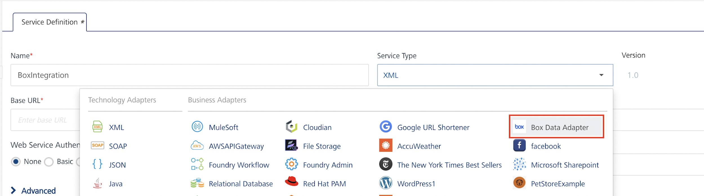

Note: The Box Data Adapter is listed only after you import the Box Data Adapter into Volt MX Foundry.
- Choose an Existing identity provider from the dropdown.
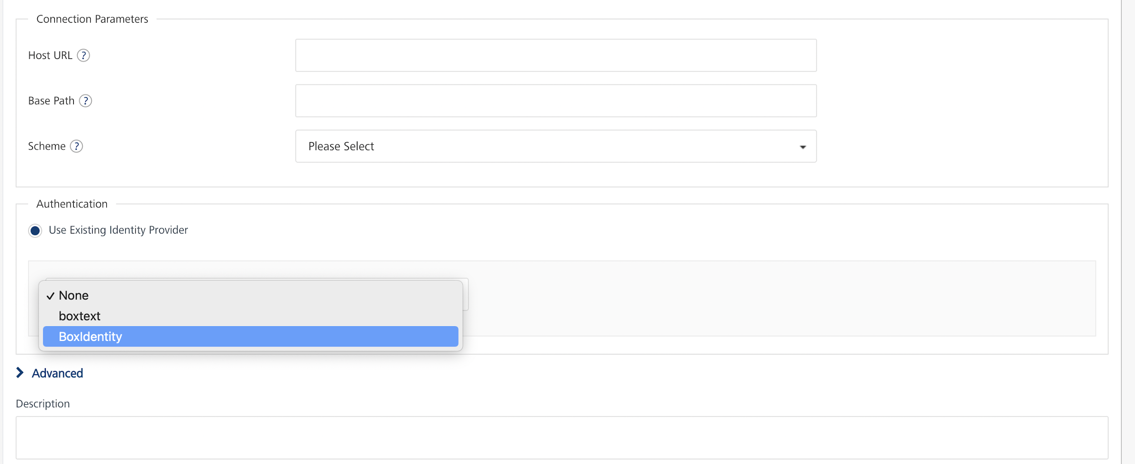

- Click on Test Login.
- On a successful login, Click Save.
If the details provided are valid, the Volt MX Foundry service connects to Box and allows you to make the API calls.
Refer to Integration Services for more information on creating and using integration services.

CREATING AN OPERATION
To make any API call in the Volt MX Foundry console, you must create an operation for the respective API and then execute the operation. Executing an operation involves making the API call and displaying the response. For more information, see Executing an Operation.
Steps to create an operation for the Box API:
- Log on to your HCL Foundry. The Dashboard page appears by default.
- In the left pane, click the API Management menu. The APIs tab opens by default.
- Click the Integration tab. The Integration page appears with a list of existing integration services.
- From the list of integration services, select the integration service that you have created with service type as Box. The Service Definition tab of the selected integration service opens by default.
- Click the Operations List tab. The Operations List tab opens.
- Click the context menu arrow to expand the Please Select list. The Box 2.0 and Binary are displayed.
- Click the plus icon to expand the Box 2.0 list.
- Click the plus icon to expand the Services list. A list of APIs available in Box are listed.
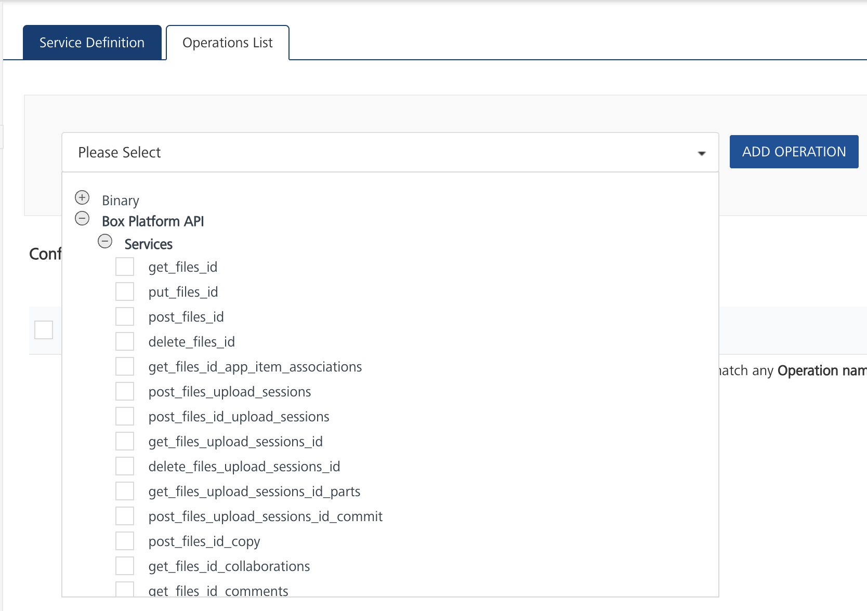
- Select get_users_me and click ADD OPERATION. The get_users_me operation is listed in the Configured Operations section.
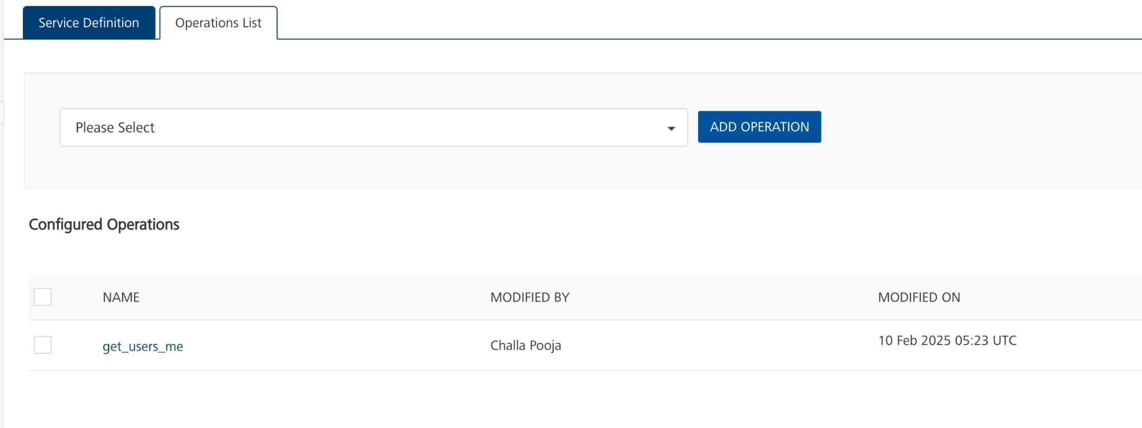

Note: You can follow the same steps to create operations for other APIs.

You can create multiple operations with required APIs and save them in the Configured Operations section. You can then execute the operations whenever required.

EXECUTING AN OPERATION
Executing an operation involves making the API call by setting the necessary parameters and displaying the response. The procedure to execute any operation is the same, but the request parameters of the APIs vary.
Steps to execute the getCurrentUser operation:
- Log on to your HCL Foundry. The Dashboard page appears by default.
- In the left pane, click the API Management menu. The APIs tab opens by default.
- Click the Integration tab. The Integration tab opens with a list of existing integration services.
- From the list of integration services, select the integration service that you have created with service type as Box. The Service Definition tab of the selected integration service opens by default.
- Click the Operations List tab.
- Under the Configured Operations section, click the get_users_me operation. The get_users_me tab opens with the Request Input sub-tab and Body section opened by default.
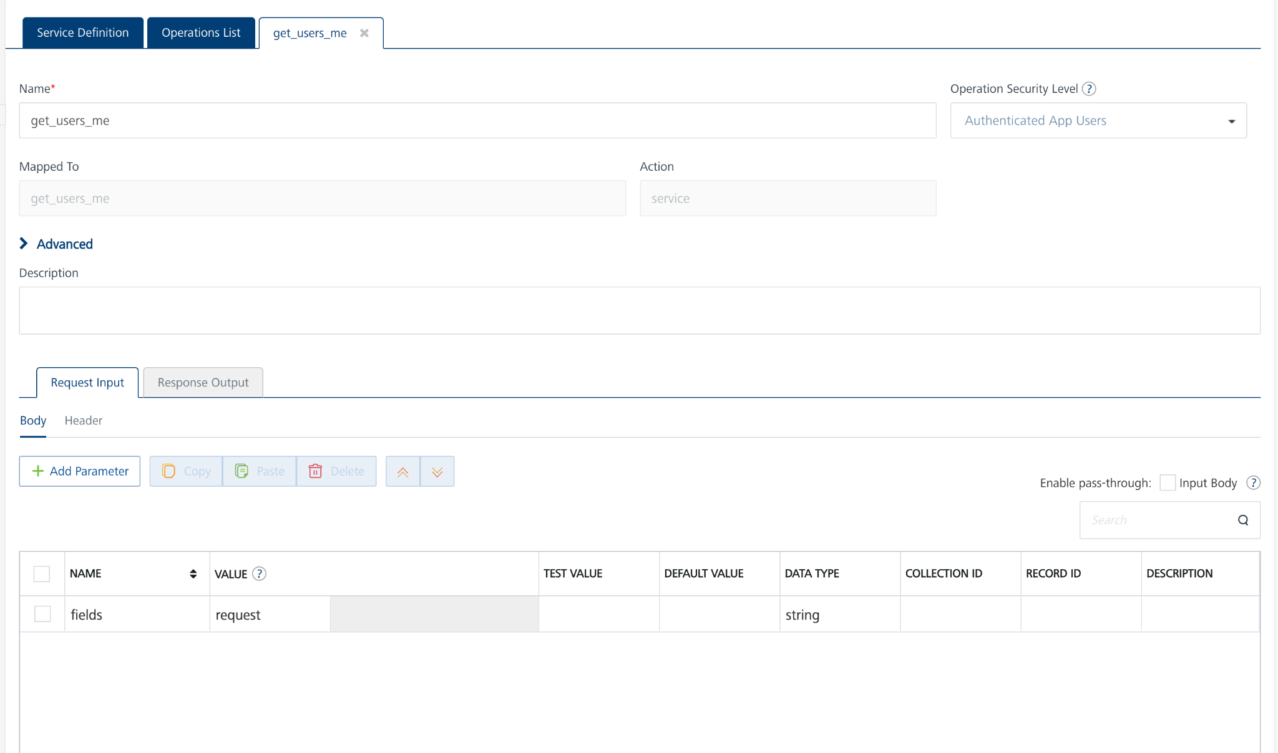
- In the Name box, the name of the operation is displayed by default. If you want, you can change the name.
- Click SAVE OPERATION.
- Click the Test tab, and then click SAVE AND FETCH RESPONSE. The Output Result dialog appears with a response.
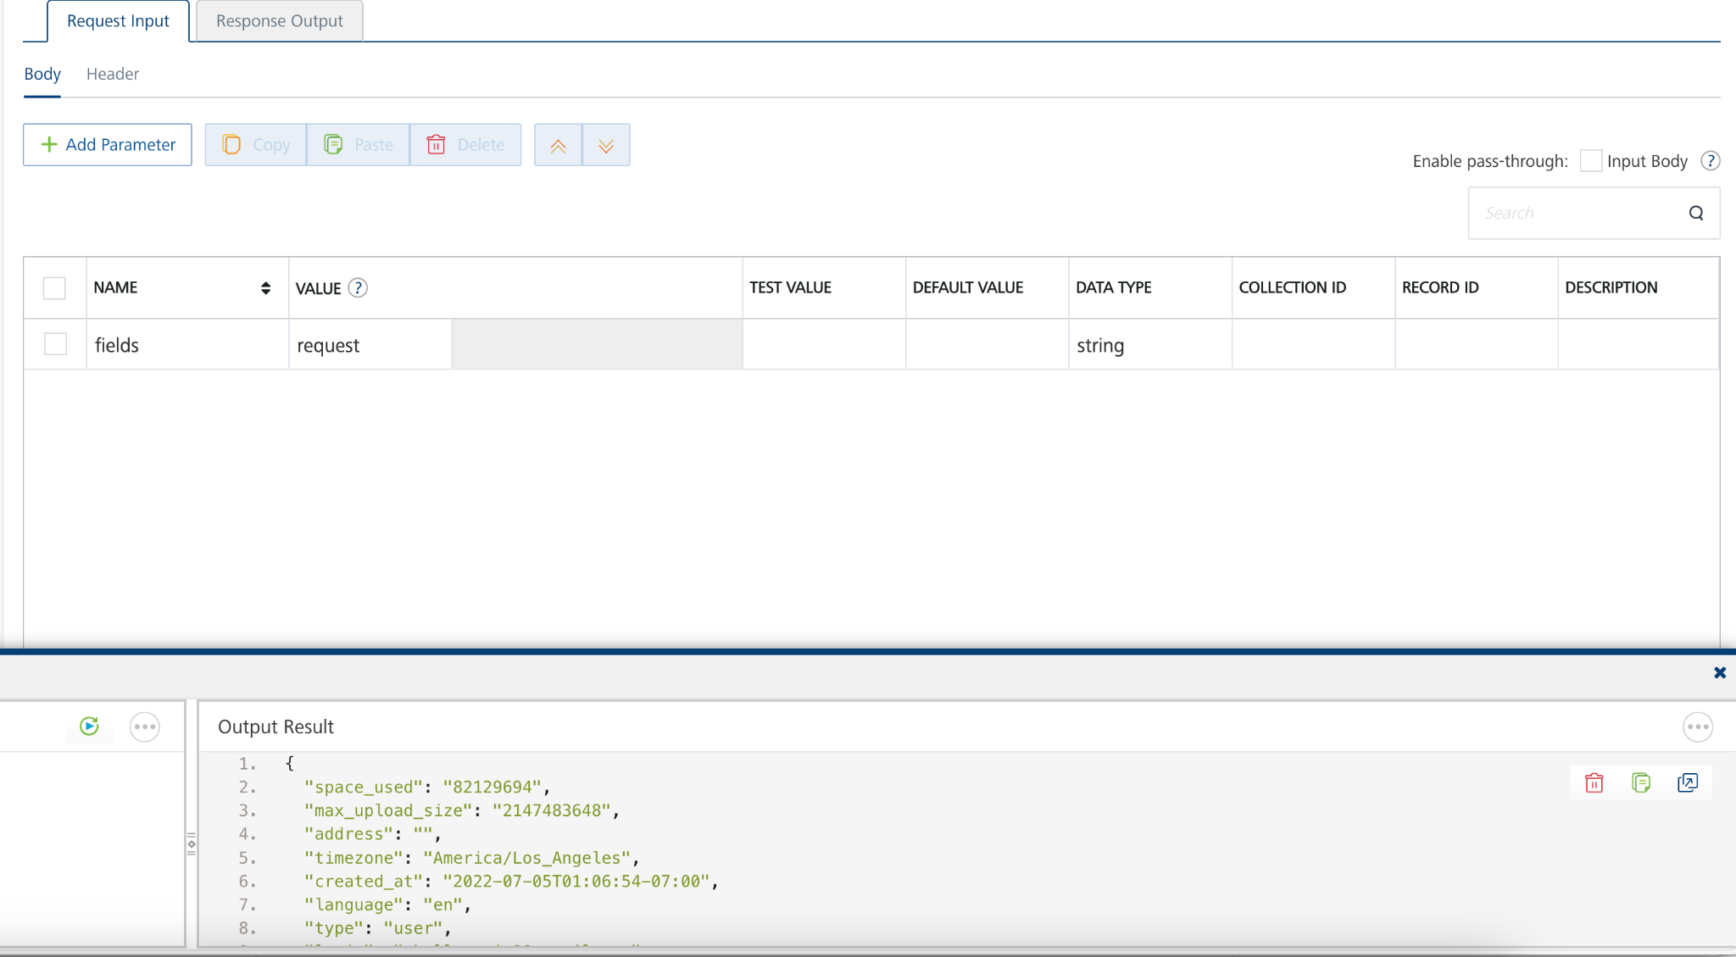

CREATING A BINARY OPERATION
To create a Binary operation to make API calls, to the following:
- Log on to your HCL Foundry. The Dashboard page appears by default.
- In the left pane, click the API Management menu. The APIs tab opens by default.
- Click the Integration tab. The Integration page appears with a list of existing integration services.
- From the list of integration services, select the integration service that you have created with service type as Box adapter. The Service Definition tab of the selected integration service opens by default.
- Click the Operations List tab.
- Click the context menu arrow to expand the Please Select list. The Box 2.0 and Binary are displayed.
- Click the plus icon to expand the Binary list.
- A list of APIs available in Box Binary are listed.
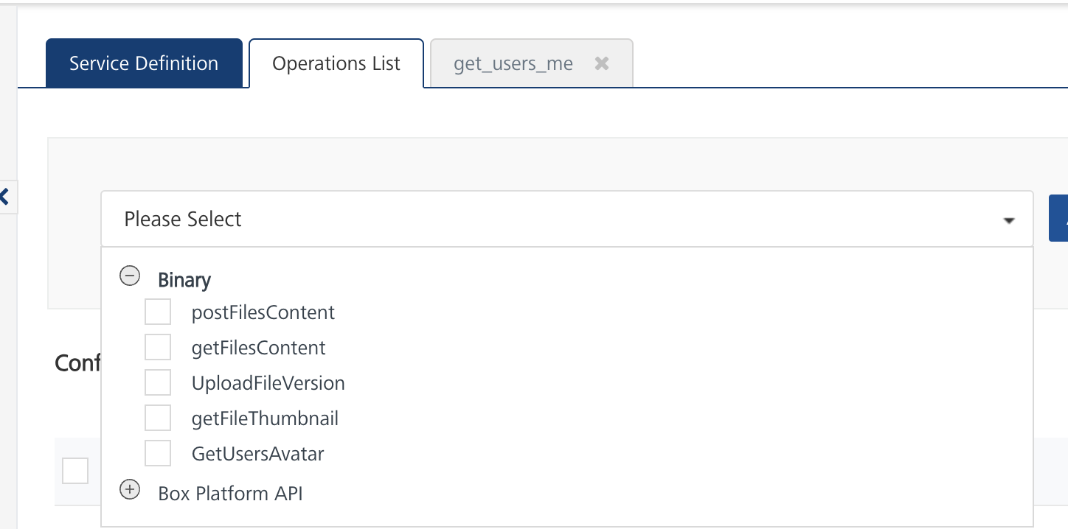
- Select getFilesContent and click ADD OPERATION. The getFilesContent operation is listed in the Configured Operations section.
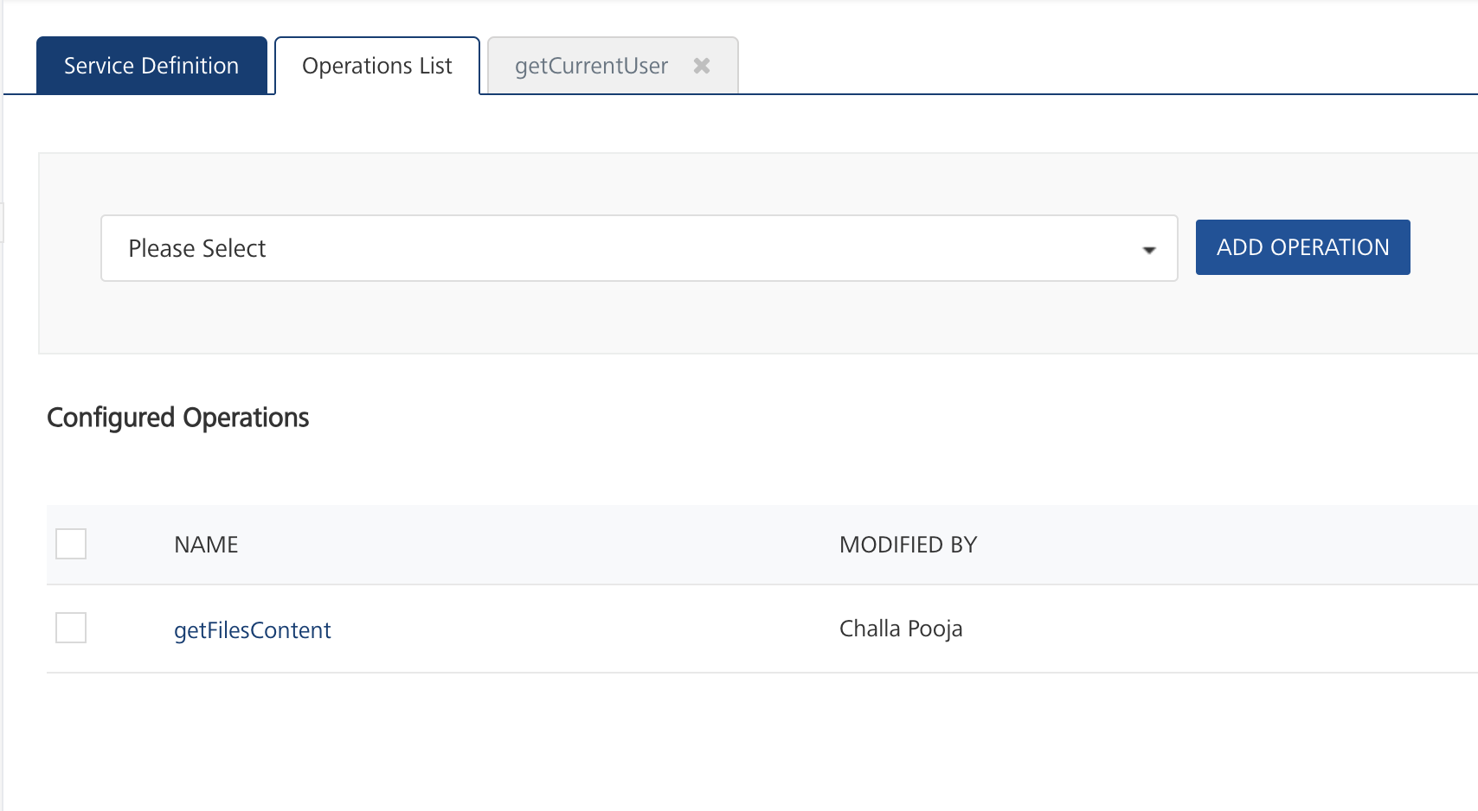

Note:
You can follow the same steps to create operations for other APIs

You can create the operations with required APIs and save them in the Configured Operations section. You can then execute the operations whenever required.

EXECUTING BINARY DOWNLOAD OPERATION
To execute the created Binary operation, do the following:
- Log on to your HCL Foundry. The Dashboard page appears by default.
- In the left pane, click the API Management menu. The APIs tab opens by default.
- Click the Integration tab. The Integration page appears with a list of existing integration services.
- From the list of integration services, select the integration service that you have created with service type as Box adapter. The Service Definition tab of the selected integration service opens by default.
- Click the Operations List tab.
- Under the Configured Operations section, click the getFilesContent operation. The getFilesContent tab opens with the Request Input sub-tab and Body section opened by default.
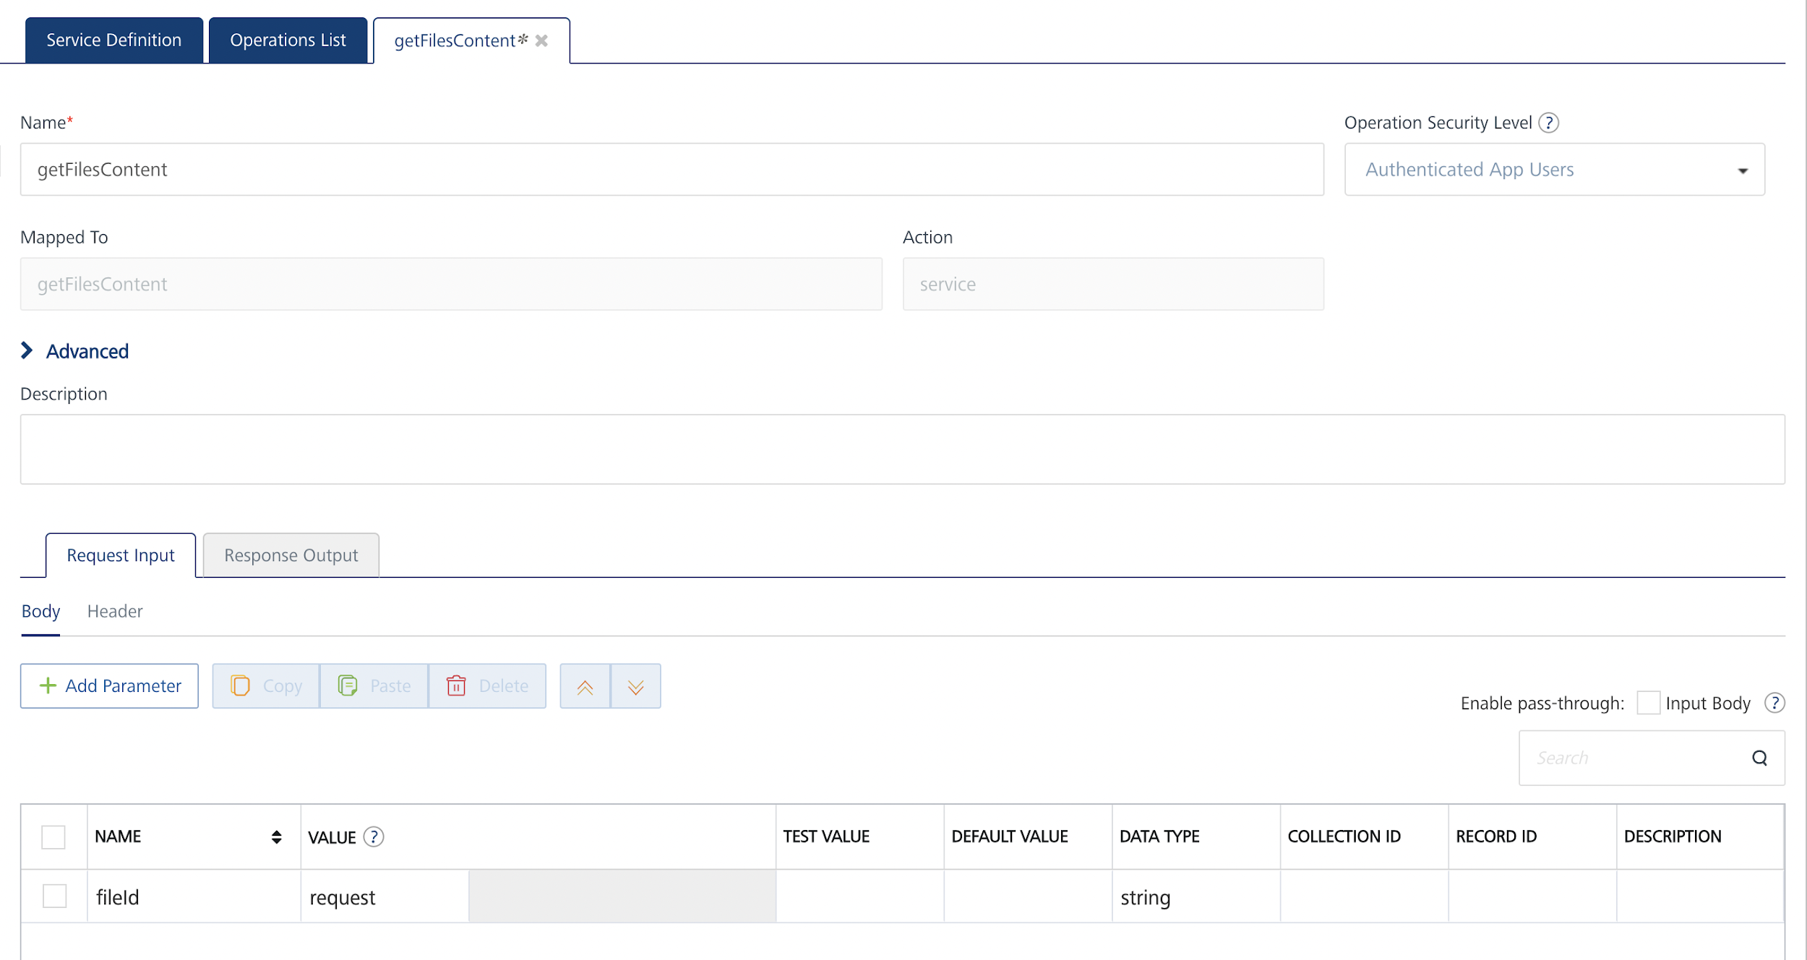
- In the Name box, the name of the operation is displayed by default. If you want, you can change the name.
- Give valid request parameters for the parameters listed in the Request Input tab.
- Click Save Operation.
- Click the Test tab, and then click SAVE AND FETCH RESPONSE. The Output Result dialog appears with a response.
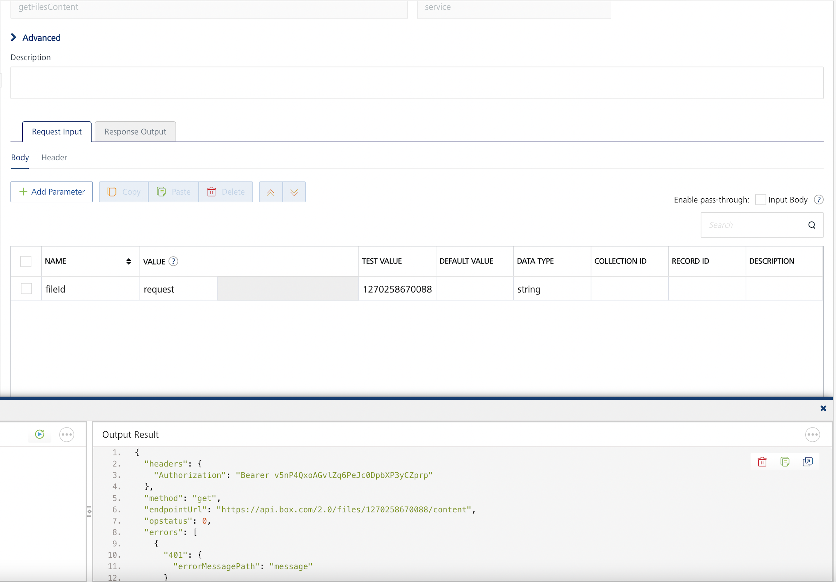
- The response for the binary operation is a template in which all the required parameters are specified based on the binary services integration requirement in Volt MX Iris.
- INVOKE BINARY INTEGRATION FROM CHANNEL
To invoke Binary operations from Volt MX Iris, do the following:
- Open Volt MX Iris and open your project.
- Connect the project to your corresponding Volt MX Foundry instance from Window > Preferences > Volt MX Foundry.
- Give your Volt MX Foundry instance in the requested text box and click on Validate, after the validation is successful, click on Ok.
- Click on Login and login to your Volt MX Foundry.
- Write a code inside a JS Module or a formController like the sample code given below to call the binary download operation.
function getBinaryFromBox()

{

integrationSvc = voltmx.sdk.getCurrentInstance().getIntegrationService( INTEGRATION_SERVICE_NAME );

integrationSvc.getBinaryData

(

<OPERATION_NAME> ,

{

"fileId": <FILE_ID>

},

streaming,

{}, // True will download the file and gives filepath in the response and false will give the chunk response

onFileDownloadStartedCallback,

onChunkDownloadCompleteCallback,

onFileDownloadCompleteCallback,

onFileDownloadFailureCallback,

{

"ChunkSize : <SIZE_IN_BYTES> //default 1MB

}

);

}

function onFileDownloadStartedCallback(res)

{

alert("onFileDownloadStartedCallback: " + JSON.stringify(res));

}

function onChunkDownloadCompleteCallback(res)

{

alert("onChunkDownloadCompleteCallback: " + JSON.stringify(res));

}

function onFileDownloadCompleteCallback(res)

{

alert("onFileDownloadCompleteCallback: " + JSON.stringify(res));

}

function onFileDownloadFailureCallback(err)

{

alert("onFileDownloadFailureCallback: " + JSON.stringify(err));
}
- Give your Integration Service name and Operation name in the specified places.
- Give the file ID in the fileId request parameter and the chunk size in the last parameter of the function call.
- Build and Run the project.
For more information on invoking services, you can go through the Appendix.
- EXECUTING BINARY UPLOAD OPERATION
- Log on to your HCL Foundry. The Dashboard page appears by default.
- In the left pane, click the API Management menu. The APIs tab opens by default.
- Click the Objects tab. The Objects tab opens with a list of existing object services.
- From the list of object services, select the object service that you have created with Endpoint Type as Integration & Orchestration. The Service Definition tab of the selected object service opens by default.
For more information on object services, refer to the Object Services documentation.
- Create required data models for upload operations.
- Create mappings for respective data models with their integration service operation with Data Model verb as post (create) and mapped with your respective integration service.
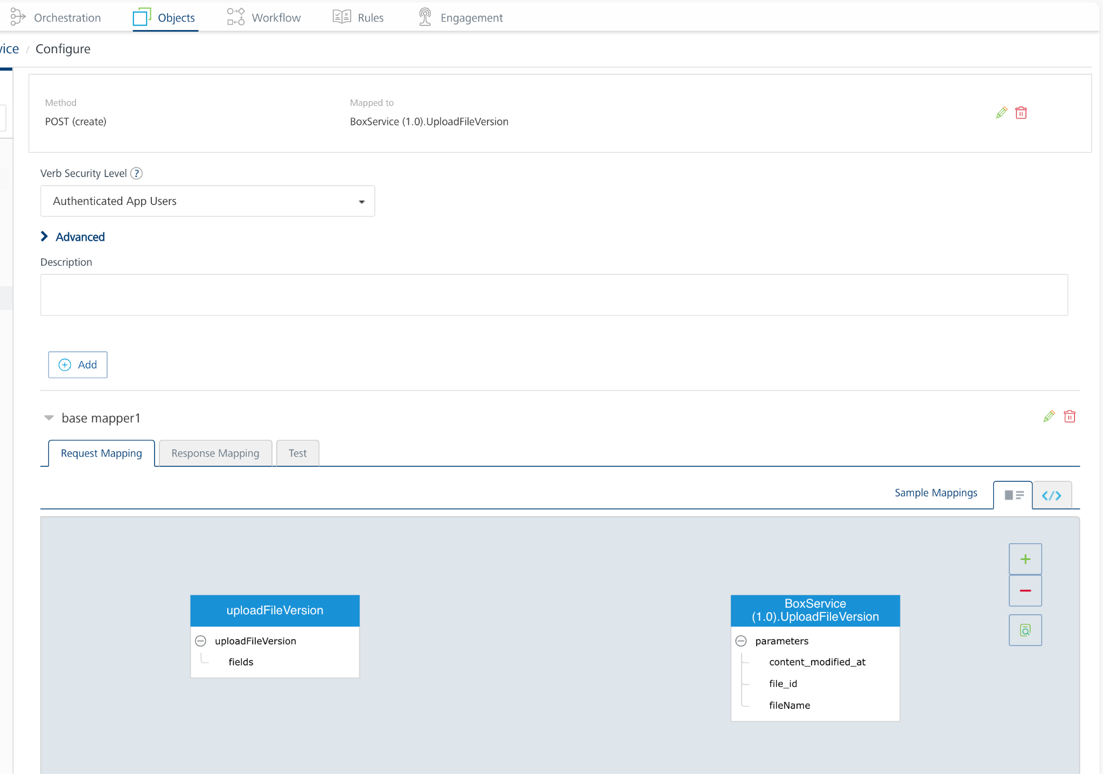
- Click SAVE OPERATION.
- Click on the Test tab and then give the Request Payload in its section.
- Click on Send.
- On a successful hit, you will receive a template which is handled by Volt MX Iris.
- INVOKE BINARY OBJECT SERVICE FROM CHANNEL
To invoke Binary object service from Volt MX Iris do the following:
- Open Volt MX Iris and open your project.
- Connect the project to your corresponding Volt MX Foundry instance from Window > Preferences > Volt MX Foundry.
- Give your Volt MX Foundry instance in the requested text box and click on Validate, after the validation is successful, click on Ok.
- Click on Login and login to your Volt MX Foundry.
- Write a code inside a JS Module or a formController like the sample code given below to call the binary download operation.
function uploadToBox()

{

var dataObject = new voltmx.sdk.dto.DataObject("<Binary_Object_Name> ");

// The parameters folderId and fileName are specific to the backend (Box).

// In case of box, if folderId is not specified, a default value of "0" is used - which corresponds to the root folder of Box.

// If fileName is not specified, then a UUID (GUID) is used as filename without any extension.

dataObject.setRecord(

{

"folderId":"<A valid folder id>",

"fileName":"<A filename with extension this is used by backend to store the file>",

"FilePath":"<Fully qualified path of a valid file present on the mobile device>"

});

var objectSvc = voltmx.sdk.getCurrentInstance().getObjectService("<Name of object service>");

objectSvc.uploadBinaryData(

{

"dataObject":dataObject

},

function(res)

{

alert("onFileUploadStartedCallback : " + JSON.stringify(res));

},

function(res)

{

alert("onChunkUploadCompleteCallback : " + JSON.stringify(res));

},

function(res)

{

alert("onFileUploadCompleteCallback : " + JSON.stringify(res));

},

function(res)

{

alert("onFileUploadFailureCallback : " + JSON.stringify(res));

}

);

}
- Give your Object Service name and Binary Object name in the specified places.
- Give the folder ID in the folderId request parameter, file name in the fileName parameter, and the file path in the FilePath parameter of the function call.
- Build and Run the project.
For more information on invoking services, you can go through the Appendix

KNOWN ISSUES
- Null parameters should not be sent through the request payload as Box doesn't accept null parameters and throws and error.
- The Upload File Version API does not have the optional header parameters. They have been removed.

APPENDIX

Download APIs

Integration Service APIs
      - getBinaryData
This API gets the data from the Integration Service.
Syntax
getBinaryData(operationName, fileparams, streaming, headers, fileDownloadStartedCallback, chunkDownloadCompletedCallback, fileDownloadCompletedCallback, downloadFailureCallback, options);
Parameters
- operationName - Integration Service Operation which gives the binary details.
- fileparams - File related details required for download.
- streaming - Boolean flag to determine whether the data needed to be given to chunks or a file after download.
- headers - Provision for sending custom headers
- fileDownloadStartedCallback - Callback to be invoked after file download starts, this callback is optional.
- chunkDownloadCompletedCallback - Callback invoked after each successful chunk download, this is invoked only when streaming is true. This callback is mandatory if streaming is true
- fileDownloadCompletedCallback - Callback invoked after successful file download, with the file path. This is mandatory if streaming is false.
- downloadFailureCallback - Callback invoked in case of download failure.
- options - Provision for specifying httpRequestOptions if any.
Return Value
None
Example
function onFileDownloadStartedCallback(res)

{

//Callback

}

function onChunkDownloadCompleteCallback(res)

{

//Callback

}

function onFileDownloadCompleteCallback(res)

{

//Callback

}

function onFileDownloadFailureCallback(err)

{

//Callback

}

function getBinaryFromBox()

{

integrationSvc = client.getIntegrationService("<Integration_Service_Name>");

integrationSvc.getBinaryData(

"<Operation_Name>",

{"fileId": "<file_id>"},

streaming,

{}, //Provision for user defined headers

onFileDownloadStartedCallback,

onChunkDownloadCompleteCallback,

onFileDownloadCompleteCallback,

onFileDownloadFailureCallback

);

}

Online Object Service APIs

      - getBinaryData - for Box
This API downloads data from Box.
Syntax
getBinaryData(options,fileDownloadStartedCallback, chunkDownloadCompletedCallback, fileDownloadCompletedCallback, downloadFailureCallback)
Parameters
- options - Accepts a json object based on which binary is downloaded.
- fileDownloadStartedCallback - Callback to be invoked after file download starts, this callback is optional.
- chunkDownloadCompletedCallback - Callback invoked after each successful chunk download, this is invoked only when streaming is true. This callback is mandatory if streaming is true
- fileDownloadCompletedCallback - Callback invoked after successful file download, with the file path. This is mandatory if streaming is false.
- downloadFailureCallback - Callback invoked in case of download failure.
Return Value
None
Example
function onFileDownloadStartedCallback(res)

{

//Callback

}

function onChunkDownloadCompleteCallback(res)

{

//Callback

}

function onFileDownloadCompleteCallback(res)

{

//Callback

}

function onFileDownloadFailureCallback(err)

{

//Callback

}

function getBinaryFromBox()

{

integrationSvc = client.getIntegrationService("<Integration_Service_Name>");

integrationSvc.getBinaryData(

"<Operation_Name>",

{"fileId": "<file_id>"},

streaming,

{}, //Provision for user defined headers

onFileDownloadStartedCallback,

onChunkDownloadCompleteCallback,

onFileDownloadCompleteCallback,

onFileDownloadFailureCallback

);

}
2. getBinaryData - for Traditional Backend
This API downloads data from traditional backend services like RDBMS, Storage, SAP and so on.
Syntax
getBinaryData(options,binaryAttributeName,fileDownloadStartedCallback, chunkDownloadCompletedCallback, fileDownloadCompletedCallback, downloadFailureCallback)
Parameters
- options - Accepts a json object based on which binary is downloaded.
- binaryAttributeName - Binary field name in the object
- fileDownloadStartedCallback - Callback to be invoked after file download starts, this callback is optional.
- chunkDownloadCompletedCallback - Callback invoked after each successful chunk download, this is invoked only when streaming is true. This callback is mandatory if streaming is true
- fileDownloadCompletedCallback - Callback invoked after successful file download, with the file path. This is mandatory if streaming is false.
- downloadFailureCallback - Callback invoked in case of download failure.
Return Value
None
Example
function getBinaryContent()

{

var objSvc = voltmx.sdk.getCurrentInstance().getObjectService("<Object_Service_Name>");

var dataObject = new voltmx.sdk.dto.DataObject("<Binary_Object_Name>");

dataObject.setRecord(

{

//<FileParams>

//Primary Key is required

}

);

objSvc.getBinaryData(

{

"dataObject": dataObject

},

"<binary_attribute_name>",

function (res)

{

//Callback for fileDownloadStartedCallback

},

function (res)

{

//Callback for chunkDownloadCompletedCallback

},

function (err)

{

//Callback for fileDownloadCompletedCallback

},

function (res)

{

//Callback for downloadFailureCallback

});

}

3. Key-Value Pairs
Key Value Pairs accepted as part of options in Online Object Services
Key | Value | Mandatory | Default
dataObject | Instance of voltmx.sdk.dto.DataObject | Yes | -
streaming | Boolean flag to determine whether the data needs to be given in chunks or a file after downloading. | No | false
queryParams | Provision for user to specify additional query parameters that need to be sent in the download call. | No | null
headers | Provision for sending custom headers. | No | null

UPLOAD APIS

Object Service APIs

uploadBinaryData
This API uploads data from the device to the backend.
Syntax
uploadBinaryData(options, onFileUploadStartedCallback, onChunkUploadCompletedCallback, onFileUploadCompletedCallback, onFileUploadFailureCallback)
Parameters
- options: This is a JSON object, based on which the binary is uploaded.
- onFileUploadStartedCallback: Optional Callback to be invoked when the upload starts.
- onChunkUploadCompletedCallback: Optional Callback to be invoked when the upload of a chunk is completed. This is applicable for backends which support chunked upload
- onFileUploadCompletedCallback: Optional Callback to be invoked when the upload completes.
- onFileUploadFailureCallback: Optional Callback to be invoked when the upload fails for any reason.
The JSON object specified under options is a voltmx.sdk.dto.DataObject containing relevant parameters for upload.
It is mandatory to specify either FilePath or rawBytes for upload. Only one parameter out of these two can be specified both parameters are NOT allowed together.
Return Value
None
- Example 1
Uploading a local file from device to backend
var dataObject = new voltmx.sdk.dto.DataObject("<Binary_Object_Name>");

// The parameters folderId and fileName are specific to backend (Box).

// In case of box, if folderId is not specified, a default value of "0" is used - which corresponds to the root folder of Box.

// If fileName is not specified, then a UUID (GUID) is used as filename without any extension.

dataObject.setRecord(

{

"folderId":"<A valid folder id>",

"fileName":"<A valid filename with extension this name is used in the backend to store the file>",

"FilePath":"<Full path of a valid file present on the mobile device>"

});

var objectSvc = voltmx.sdk.getCurrentInstance().getObjectService("<Name of object service>");

objectSvc.uploadBinaryData(

{"dataObject":dataObject},

function(res)

{

alert("onFileUploadStartedCallback : " + JSON.stringify(res));

},

function(res)

{

alert("onChunkUploadCompleteCallback : " + JSON.stringify(res));

},

function(res)

{

alert("onFileUploadCompleteCallback : " + JSON.stringify(res));

},

function(res)

{

alert("onFileUploadFailureCallback : " + JSON.stringify(res));

}

);
            - Example 2
Uploading raw bytes to backend
var dataObject = new voltmx.sdk.dto.DataObject("<Binary_Object_Name>");

// The parameters folderId and fileName are specific to backend (Box).

dataObject.setRecord(

{

"folderId":"<A valid folder id>",

"fileName":"<A valid filename with extension this name is used in the backend to store the file>",

"rawBytes":currentForm.cameraWidget.rawBytes //image clicked from camera

});

var objectSvc = voltmx.sdk.getCurrentInstance().getObjectService("<Name of object service>");

objectSvc.uploadBinaryData(

{"dataObject":dataObject},

function(res)

{

alert("onFileUploadStartedCallback : " + JSON.stringify(res));

},

function(res)

{

alert("onChunkUploadCompleteCallback : " + JSON.stringify(res));

},

function(res)

{

alert("onFileUploadCompleteCallback : " + JSON.stringify(res));

},

function(res)

{

alert("onFileUploadFailureCallback : " + JSON.stringify(res));

}

);

REVISION HISTORY
App version 1.0.1:

Known Issues

N/A

Limitations

N/A

