Date :  20-Oct-23

**Body Mass Index (BMI) Calculator (1.0.0)**

# Overview

* Use this Adaptor to calculate the Body Mass Index of an individual based on their height and weight.

## Use case.

* You can use this Body Mass Index (BMI) Calculator adaptor in fitness apps.

# Getting Started

## Prerequisites

Before you start using the Body Mass Index (BMI) Calculator data adapter, ensure you have the following:

* [HCL Foundry](https://manage.hclvoltmx.com/)
* Volt MX Iris
* An account with [rapidapi](https://rapidapi.com/hub) and X-RapidAPI-Key, X-RapidAPI-Host

## Platforms Supported

### Mobile

#### iOS

#### Android

### Tablets

### PWA

## Importing the adapter

**To import the Data Adapter to Volt Foundry, do the following:**

1. Sign in to the  [HCL Foundry](https://manage.hclvoltmx.com/).
2. From the left navigation menu, select **API Management**.
3. In **API Management**, select **Custom Data Adapters**.  
   A screenshot of a computer

   Description automatically generated
4. Click **IMPORT** to import a custom data adapter.  
   A blue and white box with text

   Description automatically generated
5. On the Import Data Adapter dialog box, click browser to import.  
   A screen shot of a computer

   Description automatically generated
6. Select  data adapter zip file and click **IMPORT**.

After importing the Body Mass Index (BMI) Calculator data adapter, Volt Foundry opens a window that shows the metadata of the data adapter.

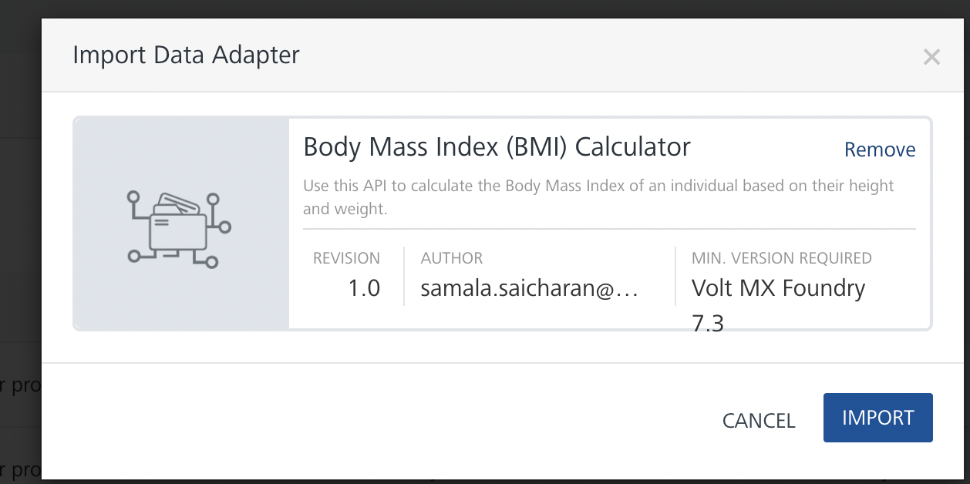

After you import the data adapter, you can view it on the Custom Data Adapters page and use it to create services on Volt Foundry.

After you add the data adapter to your Volt Foundry app. You can refer to the section below for more information.

[**Creating an Integration service**](javascript:void(0);)

Follow the given steps to create an Integration service using the Body Mass Index (BMI) Calculator Data Adapter.

1. Sign in to the [HCL Foundry](https://manage.hclvoltmx.com/).
2. From the left navigation menu, select **API Management**.
3. In **API Management**, select **Integration**.

1. To create a new service, click the **+** button or the **CONFIGURE NEW** button.

1. On the Service Definition tab, select the service type as Body Mass Index (BMI) Calculator, and click **SAVE**.

[**Creating and Executing operations**](javascript:void(0);)



After you create an integration service, you can create and execute operations using the service.

#### Creating an operation

* In **the API Management/Foundry app you created**, in the **Integration** section, select the service that you created.
* After you select the service, navigate to the **Operation List** tab.  
  A screenshot of a computer

  Description automatically generated
* From the drop-down list, select an operation that you want to execute, and click **ADD OPERATION**.

#### Executing an Operation

* From the **Operations List** tab, in the **Configured Operations** section, select the operation you want to execute.

* On the Operation Page, in the Request Input tab, enter a TEST VALUE for all the fields.

* Select a run-time environment and click **Save and Fetch Response** to get a response based on your inputs.

## [Publishing your application](javascript:void(0);)

If you want to use the services in client applications, you need to publish an app to a run-time environment. You can create the service (as described above) in an application or import the service into an application and publish the application.

# References

**Base url :** [https://body-mass-index-bmi-calculator.p.rapidapi.com](https://body-mass-index-bmi-calculator.p.rapidapi.com/)

## **Endpoint Documentation**

| **Endpoints** | **Input params-Type** | **Description** |
| --- | --- | --- |
| /metric | weight  height  HEADERS: X-RapidAPI-Key,  X-RapidAPI-Host | This endpoint will calculate the BMI of an individual using the imperial measurement system.  Weight = The weight of someone in kilograms (kgs)  Height =The height of someone in meters (m) |
| /imperial | weight  height  HEADERS: X-RapidAPI-Key,  X-RapidAPI-Host | This endpoint will calculate the BMI of an individual using the imperial measurement system.  Weight = The weight of someone in kilograms (lbs)  Height =The height of someone in meters (in) |
| /weight-category | bmi  HEADERS: X-RapidAPI-Key,  X-RapidAPI-Host | Retrieve the weight category of an individual based on their BMI |

Top of Form

## These are List of all endpoints, input params of the fields in tabular format.

## Refer [the link](https://rapidapi.com/principalapis/api/body-mass-index-bmi-calculator/) for more information about API endpoints.

# Revision History

Adapter version 1.0.0